Bi-grams Generated from Phoenix Grammars and Sparse Data for the Universal Speech Interface

Language and Statistics Class Project

May 2002

Carnegie Mellon University

Thomas K Harris
tkharris@cs.cmu.edu

Abstract
I describe algorithms and their implementation for the generation of n-gram language models for the Universal Speech Interface. The software trains probabilities for context free grammars (PCFGs), smoothes the grammars, and imputes bi-grams directly from the probabilistic grammar. Its usefulness should generalize to any controlled-grammar language modeling problem. I discuss some experimental results, comparing the perplexities of the language model generated by the PCFG software against some standard language model generation methods.

1 Introduction
The Universal Speech Interface (USI) [1] is a framework and a toolkit for building speech enabled dialog systems. As a framework for speech interfaces, it addresses several speech interface related issues. One of the goals addressed by the USI is to reduce the high word-error rate often seen in speaker-independent, large vocabulary speech recognition.

In addressing this problem while attempting to maintain other qualities desirable in speech interfaces, the USI’s approach to solving this problem has been to design a simple and intuitive language for the speech interface that can be taught to a prospective user within five minutes. The user is then expected to use that language in her communications with the system.

The language itself if formalized by a context-free grammar in Phoenix notation [2]. A USI study [3] estimated that among the trained population, x% of utterances can be completely parsed, x% are partially parsed and have usable components, and the remaining x% are not parsable and hence not usable.

The speech decoder [4] uses n-gram language models, so the USI system builds those language models as follows:

- Randomly generate a large synthetic corpus from the grammar.
- Use the CMU-Cambridge SLM toolkit [5] to create a tri-gram model from the synthetic corpus.

There are some obvious problems with this method, which I will henceforth refer to as the pure-grammar method. One, it is unlikely that the production rules are evenly distributed in actual usage. If we could influence the production rule decision toward the more likely choices, then our language model would more accurately describe the language. Two, even if we generated sentences with the correct distribution of production rules, it takes a large amount of synthetic data and much CPU time to generate a small number of the possible n-grams. Furthermore, due to the requisite random choices made during synthesis, there is no guarantee that those n-grams represent the most likely n-grams.

2 The PCFG Method

I attempt to address these issues and to build a better language model by training rule probabilities for the context-free grammar, smoothing over the PCFG, and then computing the precise n-gram probabilities from that grammar. I refer to this method henceforth as the PCFG method.

Details of the method are outlined below.

- Parse the Phoenix grammar into a context-free grammar representation.
- Convert into Chomsky Normal Form.
- Train the probabilities from some data.
- Smooth the probabilities.
- Generate pseudo-bi-gram counts from the PCFG.
- Generate a usable language model from the pseudo-bi-gram counts

Steps 1-5 are compiled into a C++ program, making use of two classes, a PCFG class, and an NGram class. Step 6 involves the use of several programs from the CMU-Cambridge SLM toolkit. The entire sequence is coordinated in a Make script, and takes about 2 minutes to run on a 1500MHz machine with a grammar size with around 800 terminals and 1100 rules.

2.1 Parsing the Phoenix Grammar

A method in the PCFG class reads a Phoenix grammar, parses it, and stores the parsed results into a probabilistic context free grammar data structure. The distinction between nets and other rewrite rules are ignored. Extra non-terminals and rules are generated for Phoenix’s omitable word marker ‘*’, and well as the repeatable marker ‘+’. As of this writing the Kleen closure marker ‘*+’ is not handled, but it is just another kind of introducible rule. The parsing is done in C++, with help from the Perl Compatible Regular Expression library [6].

2.2 Converting into Chomsky Normal Form

Later stages of processing depend on the grammar being in Chomsky Normal Form (CNF). Although this dependency may or may not be necessary for all of the further processing, it does make their implementations much simpler, and so all of the grammar processing methods make the assumption that the grammars are in the CNF.

The Conversion is a method of the PCFG class and is implemented in a four step process.

- remove ε productions
- remove unit productions
- rewrite non-initial terminals as non-terminals and a single terminating rule
- recursively shorten the rules with more than two right-hand non-terminals

The process is exactly as described in [7].

2.3 Generating the PCFG
Another method of PCFG reads in a data file containing sentences of the language and trains the probabilities.

2.3.1 Training a PCFG from a Phoenix Grammar
An inside-out algorithm and an underlying chart parser as described in [8] trains the probabilities of the PCFG in the following way.

- Rule probabilities are initialized to an even distribution
- Initialize a count for each rule count(A→λ) to zero.
- Initialize the log-likelihood of the corpus to 0.
- For every sentence in the corpus
2.1) Fill the chart (parse), while keeping track of the inside probabilities α_{ij}(A).
2.2) Since α_{nn}(S) represents the likelihood of the sentence, we add log(α_{nn}(S)) to the log-likelihood of the corpus.
2.3) Backtrack down the chart, computing the outside probabilities β_{ij}(A).
2.4) Using the inside and outside probabilities, compute the expected number of times each rule is used in generating the sentence, and add these to the counts count(A→λ).
- If the new log-likelihood is not much better than the old one, that means that we are nearing the locally best solution and we re-estimate the probabilities and quit. If we are still making good progress, we re-estimate the probabilities and repeat from step 2.

The inside probabilities computed in step 2.1 above are:

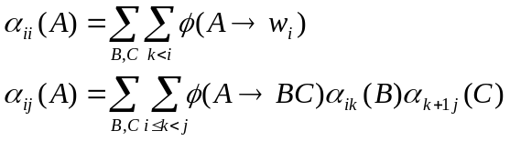

and the outside probabilities computed in step 2.3 above are:

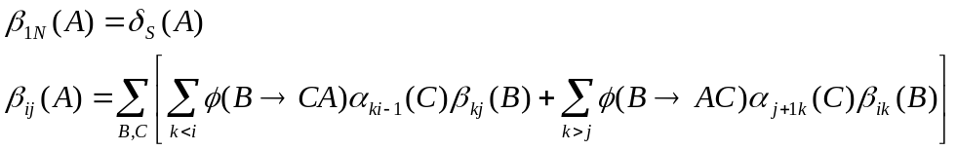

where 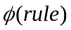is the current probability of that rule, and 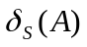is 1 if A is S and 0 otherwise.

The expected number of times a rule is used to generate a sentence computed in step 2.4 above is:

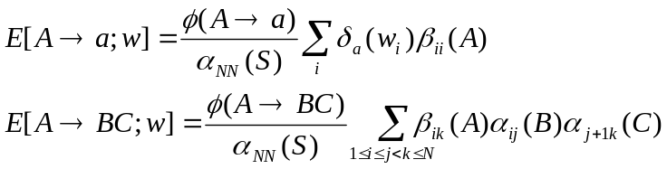

The re-estimated probabilities are simply

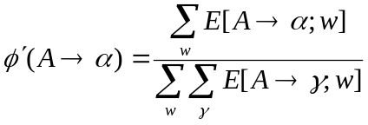

2.3.2 Smoothing the Probabilities
We assume that there is sparse data, and as such, infrequent rules are underrepresented. After the probabilities are computed from the data, a certain probability mass is discounted and redistributed evenly over all of the possible productions for a non-terminal. The smoothing method takes a parameter from zero to one. After smoothing, the resulting probabilities are

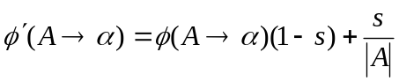

where s is the smoothing factor and 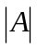 is the number of rules with A on the left-hand side.

2.4 Generating Pseudo-bi-gram Counts from a PCFG
A method of the NGram class is computes the expected frequency of all possible bi-grams of a PCFG for a sentence, and multiplies that number by a fake number of “observed” sentences to generate a count of “observed” bi-grams. Matrix manipulations are handled by the GNU Scientific Library [9].

Computing the expected frequency of a particular bi-gram for a PCFG is done as follows [10].

We realize that there are three ways in which a non-terminal A in a CNF PCFG can generate a bi-gram.
- A→BC and B generates the bi-gram w.
- A→BC and C generates the bi-gram w.
- A→BC, B generates a string that ends in w₁, and C generates a string that starts with w₂.

2.4.1 Generating initial sub-string probabilities

So it follows that to compute expected bi-gram frequencies we first need to know the likelihood that a non-terminal starts and ends with a particular word. We also notice that the problem is symmetrical, that is, one simply needs to reverse the grammar and finding initial sub-strings is the same as finding final sub-strings. So we only describe finding initial sub-strings. A method to accomplish this is described in [11], but this method doesn’t scale well for longer initial sub-strings or larger grammars, so I’ve chosen to implement a version [12] that uses a modified Early parser. This method does Early generation (Early parsing where every scannable terminal is scanned), while keeping track of the forward and inner probabilities.

The forward probability 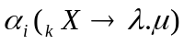 is the expected number of occurrences of the given state set of the Early generator.

The inner probability 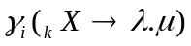 is the probability of a non-terminal generating a sub-string of the input using a particular production.

In particular, these probabilities can be computed for each new state in an Early parse from previous states, and the prefix probability

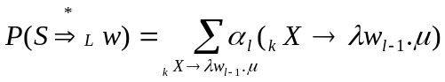

where l is the length of w.

So for each non-terminal in the grammar we send the probabilistic Early generator a version of the grammar where it is the root node, and a reversed version of the grammar where it is the root node. Thus we have initial and final sub-string probabilities for each non-terminal.

2.4.2 Solving the system
Now that we have the initial and final sub-string expectations, we can use the recursive definition described above to compute anywhere sub-string expectations.

which reads, “the expected number of times the sub-string w is generated by X is the sum over all of the productions X→YZ of the probability of that production times the expected number of times Y generates w plus the expected number of times Z generates that sub-string plus the expected number of times that the sub-string is split amongst Y and Z.” This is a recursive definition, but there is no necessary bottoming out of the recursion. Fortunately, there is a definition for each equation, which leads to a system of equations with the number of equations and the number of variables both being the same number, namely, the number of non-terminals in the grammar. To solve the system, rearrange the equations by moving all of the variables (the counts) to one side.

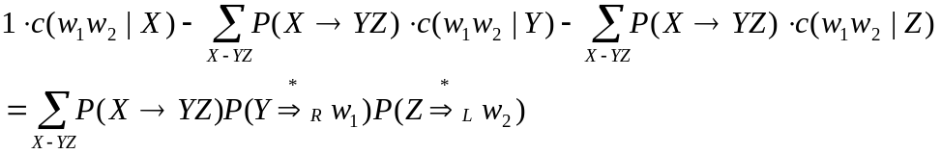

which, in matrix notation, is

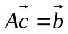

where we wish to solve for c. Once we have solved for the c vector, we pick the c for the non-terminal S, and call that the number of expected occurrences of the sub-string w. By multiplying that number by a fake number of sentences, we get a pseudo-count of bi-grams. Note that since the coefficients of the A matrix are independent of the particular sub-string, LU factorization needs only be done once for a particular grammar.

2.5 Generating a Language Model from the Pseudo-bi-gram Counts
I generated the bi-gram counts in the format that the CMU-Cambridge SLM toolkit uses for word n-gram files, so that it can be picked up by the wngram2idngram program. A Make file coordinates the building of word n-gram file from the PCFG software, the id n-gram file from the word n-gram file, and finally the language model from the id n-gram file. Good-Turing smoothing was used on the bi-grams.

3 Experiments
As part of Arthur Toth’s ongoing master’s thesis work, some 10,000 USI utterances have been collected and transcribed. The grammar had varied as the system was being updated during this collection, and the largest amount of parsable utterances that corresponded to a single grammar consisted in a set of 1956 utterances. This represented the pool of data that I used for my experiment. Of those 1956 utterances, I randomly selected about 60% to train the grammar on and about 40% to test against the resulting language model. I guessed that a redistribution of rule probabilities should be about 20%, so that is the level that I set the smoothing at for the PCFG smoothing. I used the SLM toolkit’s evallm program to compute perplexity values of the language model and 40% test data.

As a comparison, I did the same perplexity evaluation with two other language models, one is the pure-grammar language model that the USI project normally uses. It consists of a tri-gram language model that is derived from a synthetic corpus of 30,000 sentences. The synthetic corpus is in turn derived from a random synthesis of the Phoenix grammar. The other language model I compared against was a pure-data tri-gram model derived directly from the training data using the SLM toolkit. Also, since the PCFG software used bi-grams, I also generated bi-gram versions of the other two language models.

Language Model | Perplexity | Entropy
pure-grammar tri-grams | 781 | 9.61
pure-grammar bi-grams | 619 | 9.28
pure-data tri-grams | 19.0 | 4.25
pure-data bi-grams | 18.9 | 4.24
PCFG bi-grams | 5.5 | 2.46

4 Future Work
Although the experimental results are quite encouraging, there is some amount of further validation that needs to take place. We would like to see how the lowered perplexity affects actual word-error rates. All of the recordings are archived, so this is possible to do with the very same data set. The data set itself is of some concern. In reality, not all utterances are going to be parsable. We would like to test the performance of the model against a more natural set of utterances.

Tri-grams (even 4-grams!) would not be much more difficult. In fact, much of the code to generate tri-grams (including generating initial and final sub-strings expectations of length 2) has been written and is in the tool.

More investigation is needed with regard to the PCFG smoothing. As it stands, the smoothing parameter is untuned. My intuition is that strategies analogous to n-gram smoothing techniques like Good-Turing will be applicable.

Early parsing could be the basis of the training as well as the initial sub-string expectation analysis. Currently the training uses a CYK chart parser and the initial sub-string expectation computer uses an Early parser. It would make sense from both an efficiency and a software engineering perspective to use the Early parser for both applications.

It would be nice if this tool were integrated into some existing language modeling toolset. When I started the language modeling project I thought that it would be easy to find code to do most of constituent parts of the task, converting grammars into Chomsky Normal, training probabilistic grammars, computing initial sub-string probabilities, probabilistic early parsing... I was disappointed to discover that none of these things were available and I had to implement them all, which basically took two hard weeks of coding. I'm thinking that the SRILM toolkit would be a good home for it, as it's also in C++ and the author of the toolkit is also the author of the primary algorithms that I implemented.

Acknowledgements
Thanks are due to Arthur Toth for some of the original ideas and discussions on the topic, and to John Lafferty for some helpful advice and general encouragement. All of the data for training and testing was collected by Stefanie Shriver and Arthur Toth. The bulk of the algorithms implemented here were conceived by Andreas Stolcke.

References
1. Rosenfeld, R., Zhu, X., Shriver, S., Toth, A., Lenzo, K., and Black, A.W. “Towards a Universal Speech Interface”. In Proc. ICSLP 2000.

2. Ward, W. (1991). Understanding spontaneous speech: the Phoenix System. In Proceedings of International Conference on Acoustics, Speech, and Signal Processing, 365--367.

3. Toth, A. (2002). Unpublished Masters Thesis. Carnegie Mellon University, Pittsburgh, PA.

4. CMU Sphinx. (http://www.speech.cs.cmu.edu/sphinx/).

7. Clarkson, P.R. and Rosenfeld, R. (1997). Statistical Language Modeling Using the CMU-Cambridge Toolkit From Proceedings ESCA Eurospeech.

8. Hazel, P. Perl Compatible Regular Expressions Library (http://www.pcre.org/).

9. Hopcroft, J.E. and Ullman, J.D. (1979). Introduction to Automata Theory, Languages and Computation. Reading, MA: Addison-Wesley.

10. Lafferty, J.D. (2002). “Notes on probabilistic context-free grammars”. Unpublished class notes for 11-761: Language and Statistics, Carnegie Mellon University, 1-21.

11. GNU Scientific Library (http://sources.redhat.com/gsl/).

12. Stolcke, A. and Segal, J. (1994). “Precise n-gram probabilities from stochastic context-free grammars”. In Proceedings of the 32nd Annual Meeting of the Association for Computational Linguistics, 74-79, New Mexico State University, Las Cruces, NM.

13. Jelinek, F. and Lafferty, J.D. (1991). “Computation of the probability of initial substring generation by stochastic context-free grammars”. Computational Linguistics, 17(3): 315-323.

14. Stolcke, A. (1995). “An efficient probabilistic context-free parsing algorithm that computes prefix probabilities”. Computational Linguistics, 21(2). 165-200.

