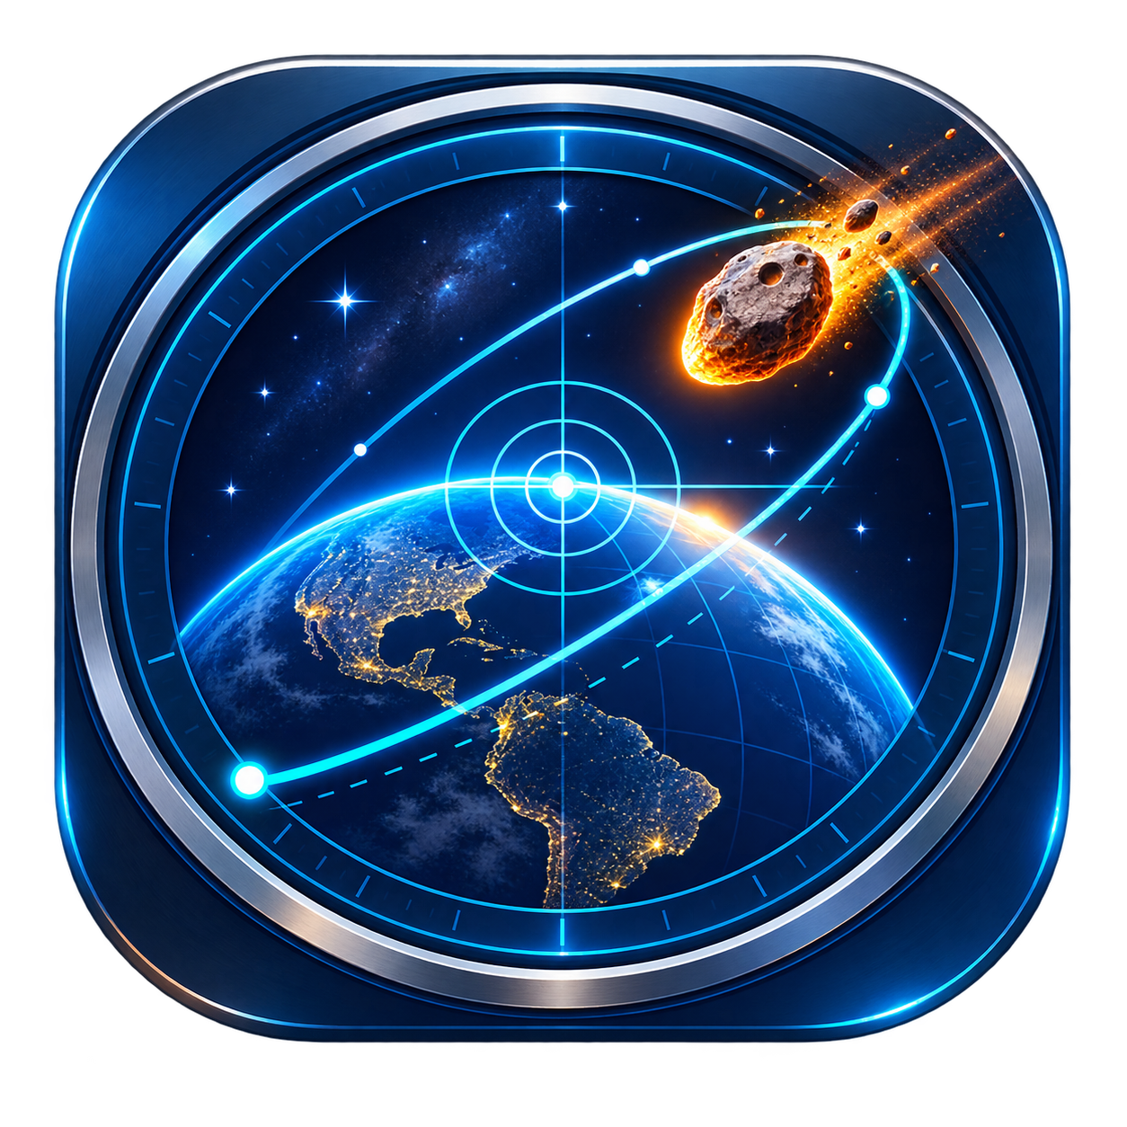

NEOMapper User Manual
  - Astronomical consultation and observational planning
Version 4.2.0 Windows September 2026

This manual follows the current flow of the NEOMapper: selecting an object, consulting its data, evaluating altitude and orbital events, configuring maps, generating animations and exporting reports.

Responsible scientific use. The NEOMapper helps planning and dissemination. Confirm critical observations with official sources and do not use the program as the sole system for security decisions.

Content and workflow
The program organizes work into six tabs, always visible in the side column.
Order | Tab | Purpose
1 | Object | Enter designation and date, search, use favorites and plot the Solar System.
2 | Observing Information | Generate altitude graph, observational window and Orbital Summary.
3 | Layers | Define instant, map type, layers and open ephemeris.
4 | Animation | Set interval, step, speed and output format.
5 | Adjustments | Configure location, time, language, unit, image and limits.
6 | On | Consult version, credits, channel AstroNEOS and contextual help.

Recommended flow
- Open Settings and confirm the location, UTC or LOCAL, language and distance unit.
- In Object, enter the designation and date of observation and click Search.
- Go to Observing Information, generate the altitude plot and, if desired, the Orbital Summary.
- In Layers, confirm the date and time, choose the map and click Generate map.
- Use Animation when you need to follow evolution over time.
Blue buttons indicate main actions. During queries and renderings, keep track of the central message and lower status bar.

Installation and first adjustments

Installer
Download the NEOMapper-4.2.0-Windows-x64-Setup.exe file from the official Releases page. Run the installer and open the program via the Start menu or optional Desktop shortcut.

Portable Edition
Extract the entire contents of NEOMapper-Windows-x64.zip to a folder and run NEOMapper.exe. Don't just move the executable, as it depends on the internal folder it comes with.

Windows Warning
Version 4.2.0 does not have a digital signature. Windows may show a reputation warning. Confirm that the file came from the official page and compare its SHA 256 with SHA256SUMS.txt.

Before the first search
- Open Adjustments and review the reference location.
- Choose UTC or LOCAL; This selection affects displayed entries and times.
- Choose AU or km for all astronomical distances.
- Keep HD for speed; use FHD, 2K, or 4K only when necessary.
Consultations require internet. NEOMapper tries JPL Horizons first and uses MPES of Minor Planet Center as a contingency when applicable.

Object Tab
This is the input of the stream. Enter a recognized designation, such as 99942, 1P or 2026 RW3, select the date and click Search.
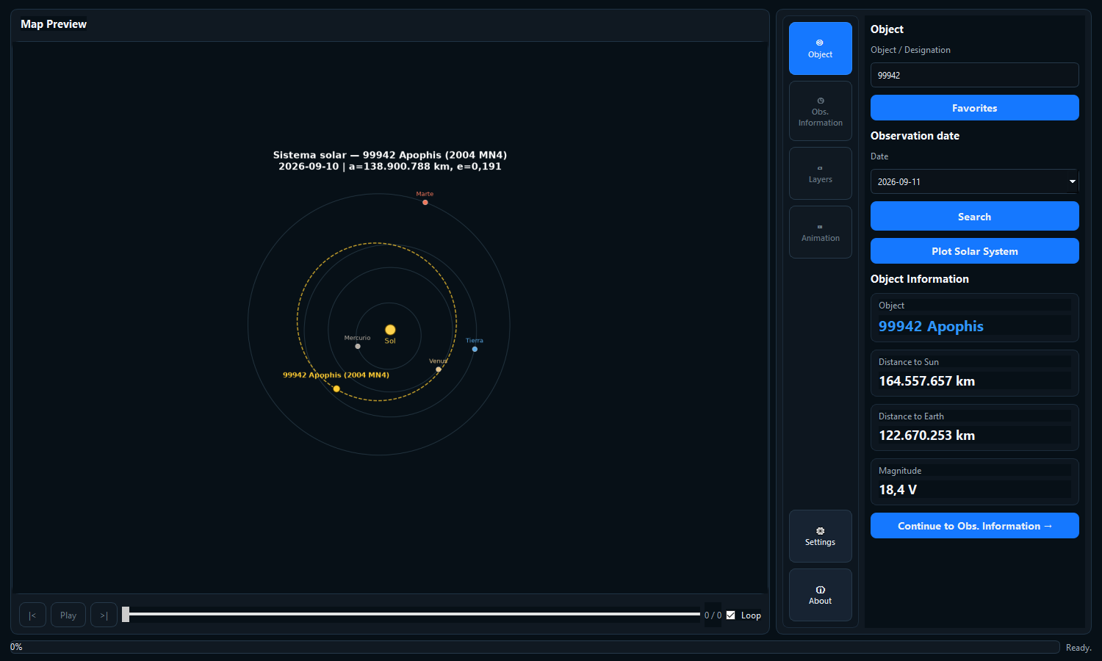
Figure 1 Object Tab of version 4.2.0

Search result
A successful search shows the resolved name, distance to the Sun, distance to Earth, and magnitude. It also enables Plot Solar System and Continue to Observing Information. Changing the object or date invalidates the previous result and requires a new search.

Plot Solar System
The scheme uses the heliocentric position and osculating orbit of the object on the selected date. Planets and object appear in the same ecliptic projection. The drawing serves a geometric context; it is not a numerical integration of the future orbit.

Favorites
The Favorites button is always available. The window saves designation, name and notes on the computer and does not initiate a network query.
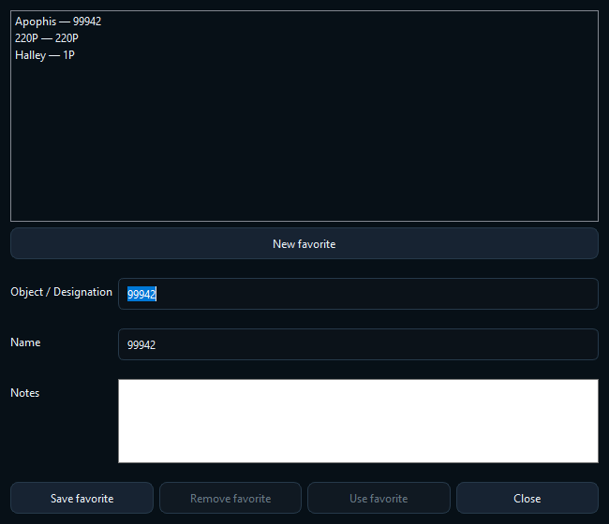
Figure 2 Registration and selection of favorites
- To register, click on New favorite, fill in the fields and choose Save favorite.
- To update, select an entry, change name or notes, and save again.
- To populate the Object tab, select the entry and click Use Favorite.
- To delete, select the entry and click Remove Favorite.
Saving the same designation again updates the existing record. New favorite clears the form so that another object can be registered.

Observing Information tab
This tab brings together the night's planning. The altitude graph and Orbital Summary have independent buttons.
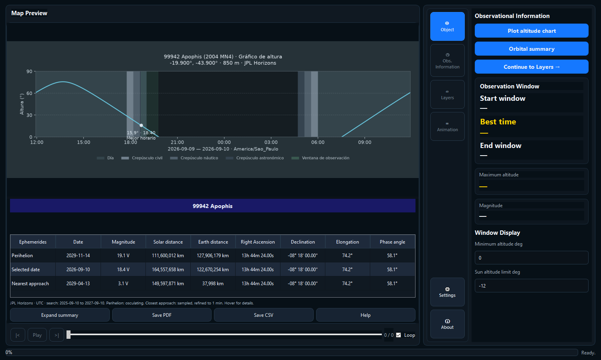
Figure 3 Altitude graph and Orbital Summary in the central panel

Altitude chart
Plot 24-hour query altitude graph in five-minute samples. The graph shows the object's altitude, day and twilight ranges, and the window that meets the chosen thresholds. The side panel receives start, best time, end and maximum altitude from the same samples.
- Minimum Window Height defines the minimum acceptable elevation for the object.
- Sun height limit defines required darkness; minus 12 degrees corresponds to nautical twilight.
- Show Moon appears below the graph and toggles the moon curve without recalculating the object.

Orbital Summary
Orbital summary can be used even without generating the altitude graph. During calculation, the program shows Calculating orbital summary below the graph or in the center of the preview area.
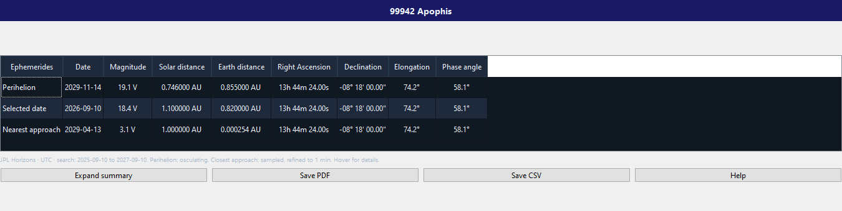
Figure 4 Orbital Summary enlarged in astronomical units
Line | Meaning
Perihelion | Closest pass to the Sun provided or refined for the orbital solution.
Selected date | Ephemeris at the instant chosen for the map.
Closer approach | Shortest distance to Earth found in the range reported in the table.

The table includes magnitude, distances, right ascension, declination, elongation, and phase angle. Tail PA appears only for comets. Distances follow UA or km defined in Settings.

Long periods
For most objects, the closest approximation is searched within plus or minus 365 days of the selected date. For long-period bound orbits, such as 1P Halley, the osculating period locates the next pass and Horizons is queried around it. The range actually searched appears under the table. The result does not represent the shortest distance of the entire orbit.
- Enlarge summary opens the same table in a larger window.
- Save PDF and Save CSV export already calculated data without requerying.
- Help opens explanations of scientific terms and conventions.

Layers Tab
Layers controls the timing and content of the map. The date initially comes from the Object tab, but can be changed here without modifying the original search date.
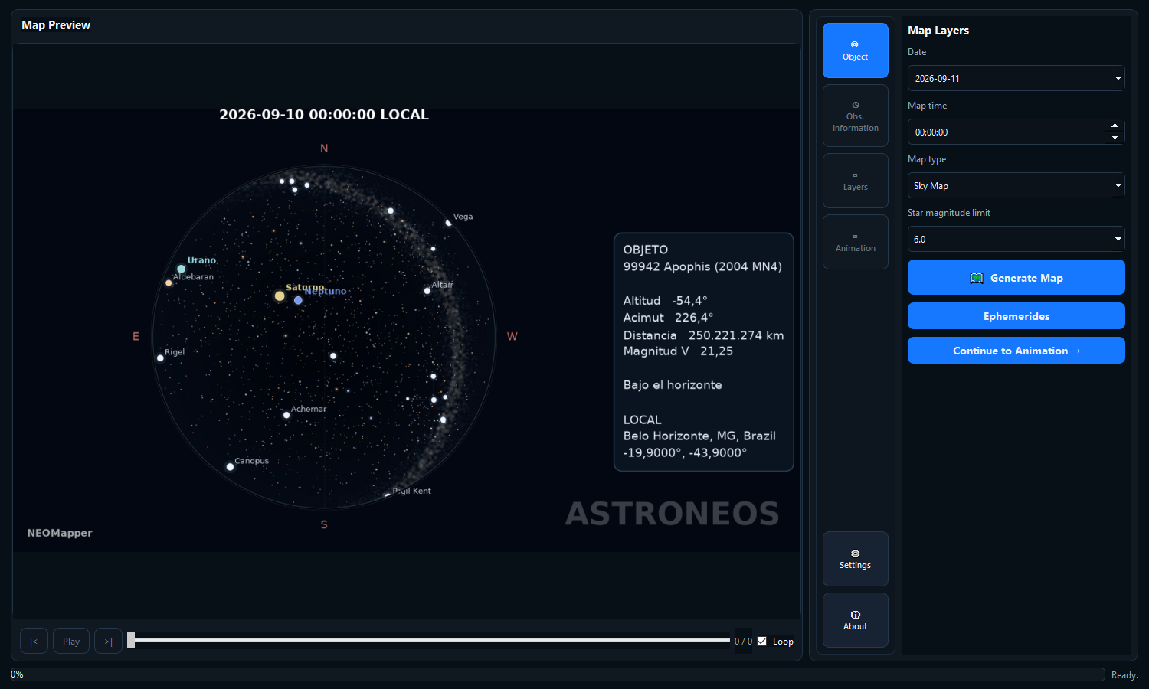
Figure 5 Layers with the Sky Map type

Visibility map
Shows in which regions the object is above the horizon and allows you to combine Day and Night, civil, nautical and astronomical twilight, terminator, reference point, altitude lines and observational window frame.

Celestial map
Shows the sky of the configured location. The center represents the zenith and the edge, the horizon. The limiting magnitude controls how many stars appear. The object is not artificially drawn on the horizon when it is below zero degrees.

Generate map
Confirm date, time and type and click Generate map. The central message informs the current step. The PNG is automatically saved to the object folder and displayed in the preview.

Ephemeris and report
The Ephemeris button is in the Layers tab. Enter the requested interval and step in the ephemeris window. The maximum row limit is defined in Settings and is checked before the query.
- Right Ascension is displayed in hours, minutes and seconds.
- Declination is displayed with sign, degrees, minutes and seconds.
- Motion appears in arc seconds per minute and the position angle is measured from north to east.
- Magnitude V or cometary total magnitude T is identified in the table.
View Report generates a PDF preview of all pages. In preview, use Save PDF, Print PDF, or Close. Saving and printing use the already assembled report and do not repeat the query.
Ephemeris reports use UTC times. Check the object, range, number of lines and origin before archiving or printing.

Animation Tab
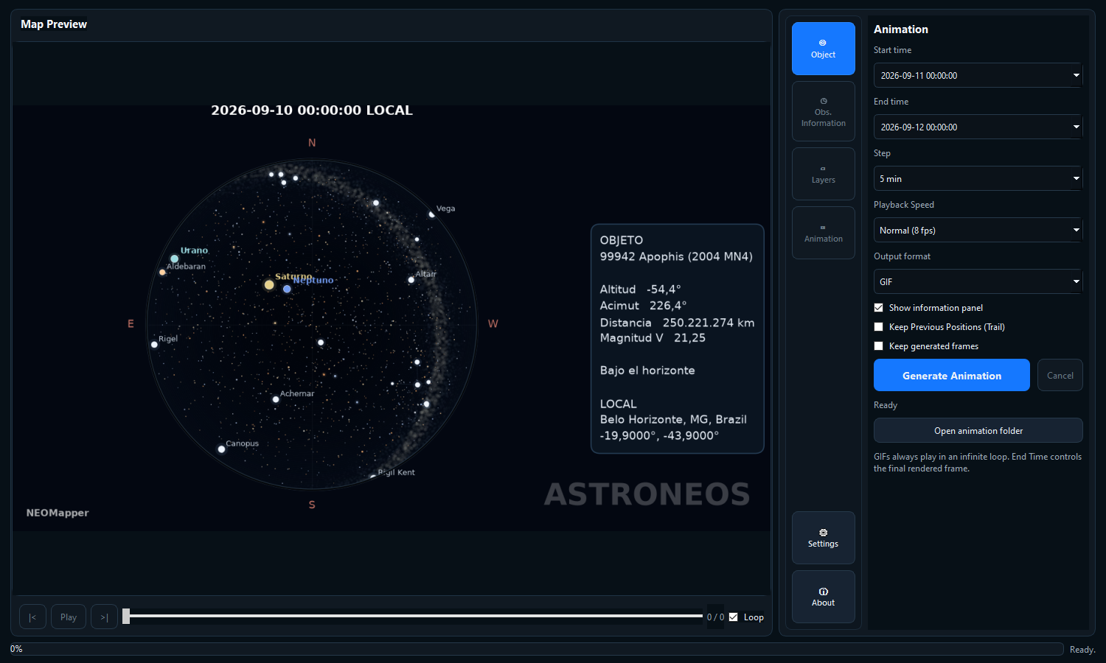
Figure 6 Current animation controls
Control | Use
Start and end time | They define the range in UTC or LOCAL mode chosen in Settings.
Step | Accepts minutes, hour, day, week, month or year; Smaller steps generate more frames.
Speed | Controls the playback and rate of the GIF or MP4, without changing the calculated times.
Format | Generates GIF, MP4, both or just PNG frames.
Information panel | Includes object data in the visual product.
Trail | Maintains previous positions of the object on the sky map.
Maintain frames | Preserves individual PNGs after animation.

Generating animation previously validates the number of frames. Canceling stops a generation in progress. Progress appears in the dashboard and bottom bar. Opening the animations folder shows the object's output directory.

Player
After generating, use Play, Previous Frame, Next Frame, Slider and Repeat. Exported GIFs repeat continuously. On the sky map, the sequence uses a continuous window above the horizon and ends when the object is no longer visible.

Settings tab
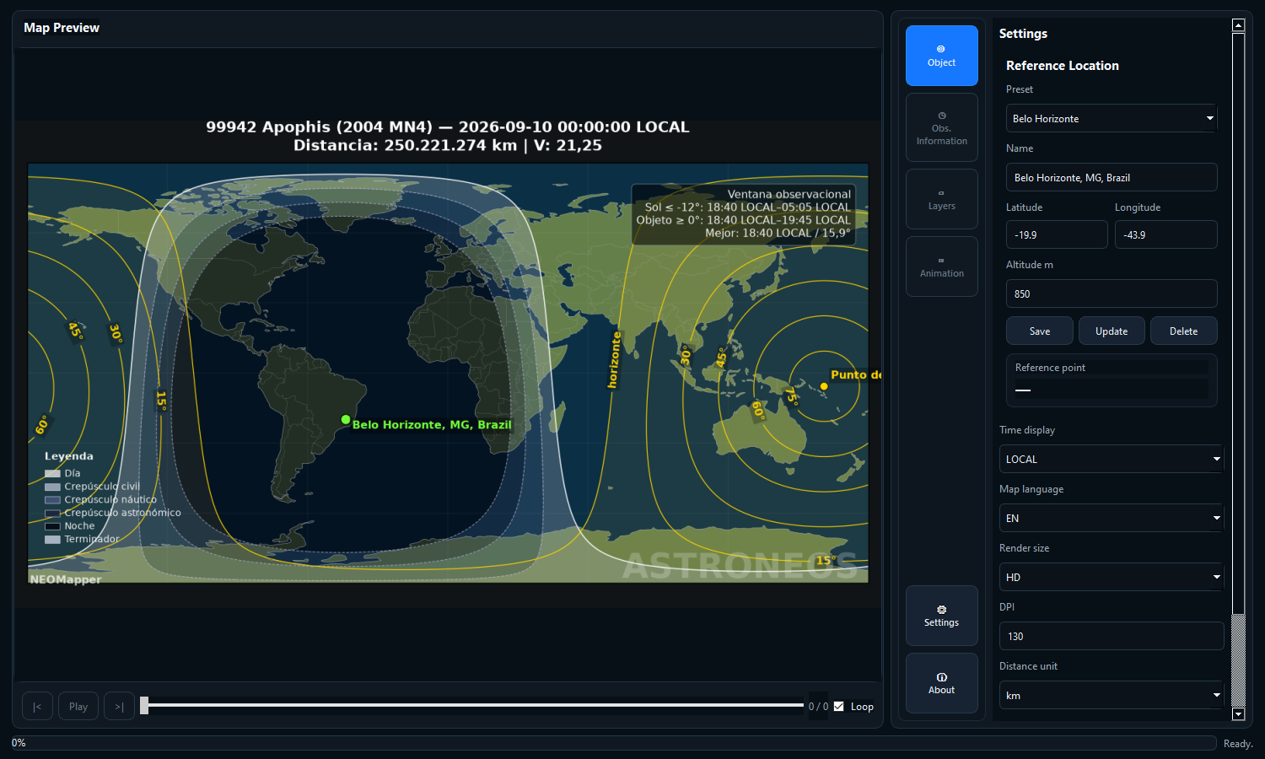
Figure 7 Reference location and preferences combined in Settings

Reference location
The location defines the topocentric horizon, the LOCAL zone and the reference point. Choose a preset or enter name, latitude, longitude and altitude in meters.
Action | Result
Save | Creates a new preset with the given values.
To update | Overrides the values ​​of the selected preset.
Delete | Removes a user-created preset.
Custom | Uses coordinates without relying on a saved preset.

Positive latitude indicates north; positive longitude indicates east. Review signs and altitude before interpreting the horizon or local time.

Preferences and limits
Adjustment | Effect
Time display | UTC or LOCAL for entries, titles and dates displayed.
Map language | EN, PT or ES for interface, maps, help and reports.
Image size | HD, FHD, 2K or 4K; Larger sizes require more memory and time.
DPI | Sets the density of the rendered file.
Distance unit | AU or km on cards, maps, Solar System, summary and new animations.
Frame Limit | Stops excessive animation requests before rendering.
Ephemeris limit | Stop orders with too many lines before querying.

Preferences are saved automatically. Changing the unit updates already loaded static cards and graphics; Old animations need to be generated again to change their texts.

UTC and LOCAL
UTC is the universal presentation scale. LOCAL uses the zone determined by the observer coordinates. When planning an observation near midnight, check the full date displayed, as the conversion may change the calendar day.

About and help tab
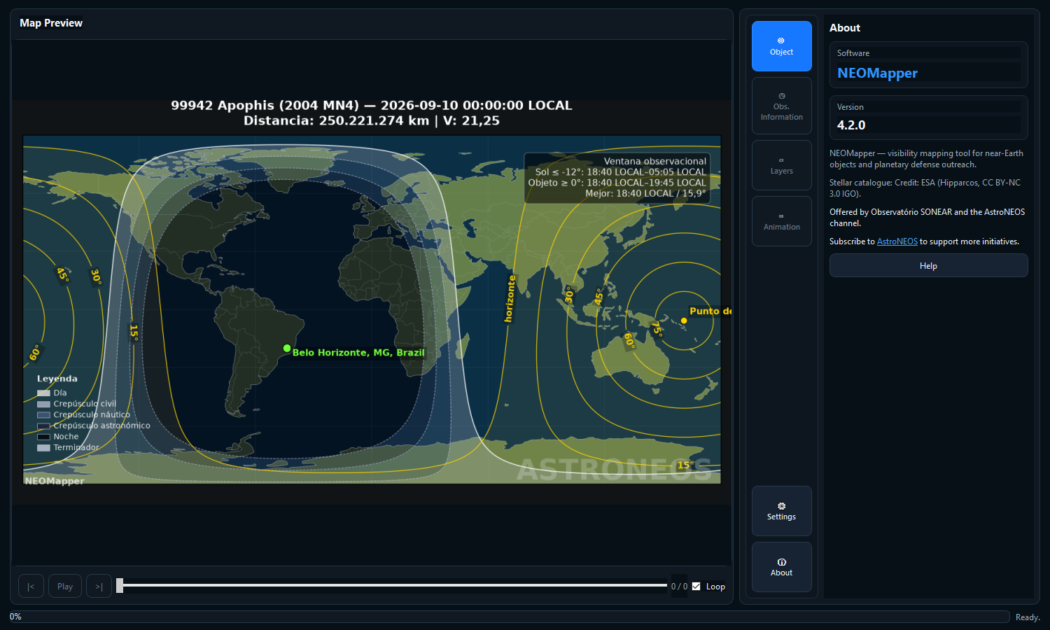
Figure 8 About with version, credits and access to help
About presents the installed version, the purpose of the software and the Hipparcos catalog credits. The stellar subset is credited to ESA and is subject to the CC BY NC 3.0 IGO license.
NEOMapper is brought to you by the SONEAR Observatory and the AstroNEOS channel. The subscribe link opens the channel in your default browser.

Contextual help
The Help button opens a glossary with right ascension, declination, elongation, phase angle, tail PA, magnitude, times, Orbital Summary references, observation limits and units. Headers and scientific cells also have hover explanations.
Help follows the language selected in Settings.

User files and data
NEOMapper writes settings, favorites, logs and products outside the installed folder.
Content | Default location
Settings | %LOCALAPPDATA%\NEOMapper\NEOMapper_config.ini
Favorites | %LOCALAPPDATA%\NEOMapper\favorites.json
Maps and animations | %LOCALAPPDATA%\NEOMapper\output\<object>-<date>
Logs | %LOCALAPPDATA%\NEOMapper\logs

Each output folder combines a Windows-safe designation with the local generation date. Images, graphics and animations of the same object and day are brought together.

Privacy and network
The application does not have its own account or telemetry. When querying an object, it sends the designation, time and necessary parameters to JPL Horizons or Minor Planet Center. Error logs are on the computer and may contain technical details of the query.

Troubleshooting
Symptom | Recommended Action
Object not found | Review the designation and connection. Please wait and try again if the provider is unavailable.
Next buttons disabled | Click Search again after changing object or date.
Chart without green window | Review minimum altitude and solar limit; the object may not meet both criteria.
Summary delay | The search can consult hundreds of epochs and, in long periods, the next orbital passage.
Closer approximation does not appear | The compact table must show three rows; Maximize the window and confirm that you are using version 4.2.0.
Sky map without object | Check the altitude. Below the horizon, the marker is not artificially shifted to the edge.
Animation refused | Increase the pitch, decrease the interval, or consciously raise the frame limit in Adjustments.
MP4 fails | Check the animation log and try GIF; the encoder may be unavailable.
Unexpected time | Confirm UTC or LOCAL and review the observer's latitude and longitude.
Laptop won't open | Extract the entire ZIP and keep NEOMapper.exe in the internal folder.

Quick reference
Objective | Path
Query object | Object → designation and date → Search
Save object | Object → Favorites → New Favorite → Save Favorite
See orbit | Object → Search → Plot Solar System
Plan the night | Observing Information → limits → Plot altitude graph
Calculate events | Observing Information → Orbital Summary
Export summary | Calculated Summary → Save PDF or Save CSV
Generate map | Layers → date and time → type → Generate map
See ephemeris | Layers → Ephemeris → View report
Create animation | Animation → range and step → Generate animation
Change location | Settings → Reference location
Change language or unit | Settings → Map language or Distance unit
Consult terms | About → Help or Orbital Summary → Help

Limitations
- There is no complete local ephemeris bank; most queries are network dependent.
- Orbits and future predictions may change when providers update the orbital solution.
- The closest approximation of the summary is valid for the displayed range, not for the entire history of the object.
- The program does not control telescopes and does not publish products directly to the web.
End of NEOMapper 4.2.0 User Manual

