**CS573 Data Visualization   
Final Project Process Book (Draft)**  
*By Christina Aiello*

# Week 1: Just Implementing the Visualizations

During week 1 I wanted to just implement the basics for the visualizations I would be using (and not add in any extra features yet). Some of my code that I reused from previous assignments already had some extra features in it (ones I created previously), so I chose to keep those features in my code but didn’t add any new features to start. The charts I’ve chosen to implement are bar graphs, pie charts, tree maps, and word clouds.



Figure : Bar graphs and pie charts?

## Preprocessing the Data

The data I have had to be preprocessed to some extent. Changes I made were:

1. Changing all instances of the ampersand (&) in the “Question” column to be the word “and.”
2. Removing any quotation marks from all values in the “Question” column.
3. Removing the dollar signs from the values of questions to allow d3 to sort the values in numerical order.
4. Changing the “Air Date” attribute to just be a “Year” attribute to make graphing the data easier.
5. Removing the exclamation points from the “Round” attribute (no real need, just done for aesthetics).

## Bar Graph

I’ve worked with Bar Graphs this entire term, so getting these to work did not take much time thankfully. The bar graphs I had at this point would filter the data based on certain attributes (first by round, then by year, and lastly by value). If you hover over one of the bars in the first bar graph, the middle bar graph appears with a further breakdown of the data. The same occurs if you hover over the middle bar graph: A final bar graph appears to the right with even more specific data.

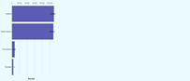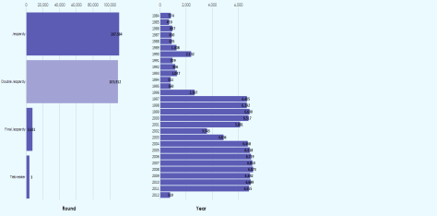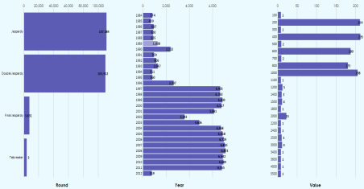

Figure : These three images show the process of making the various graphs appear on the screen. The leftmost image shows just the first graph that appears. The middle and rightmost images show how to make the second and third graphs appear on the screen.

Below I show the three graphs in closer detail.

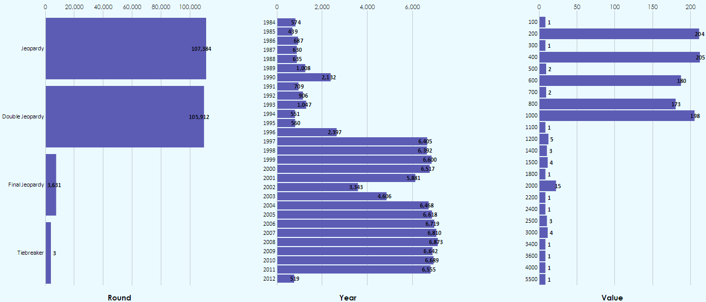

Figure : The leftmost graph is broken down by the "round" attribute. The middle graph is broken down by year. The rightmost graph is broken down by the question's value.

## Pie Charts

I have also used pie charts in previous assignments, so getting these two work was also not too complicated. One change I did have to make was to, rather than change the color of a pie slice that is hovered over, change the color of that pie slice’s label. (Changing the colors of a pie slice can get messy since not every pie slice is the same color to start with, which the way bar charts can be.) Another change I needed to make was in regards to the labels on my data in the pie charts. With some pie charts having dramatically different slice sizes (one value may be 400 and the other may be 1 or 2), the labels for the pie charts became very hard to read. The image below depicts this.

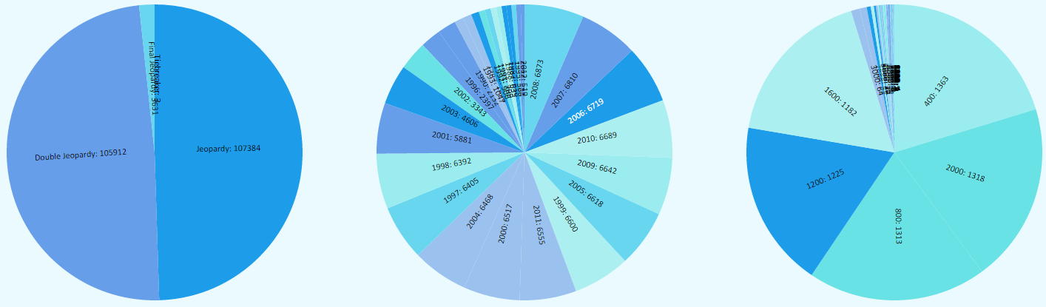

Figure : Unfortunately the labels are no longer readable. They need to be moved outside of the pie charts.

I tried a workaround to get the label for the pie chart to show up outside of the pie slices, however that didn’t end well. The image below depicts the result. While I could create a legend for the data, this would require having a set of over 30 or so colors, and I feel as though legends with that many colors are overwhelming. I think I will partially scratch the pie chart idea – I’ll only allow the user to use a pie chart in the first visualization, the leftmost one.

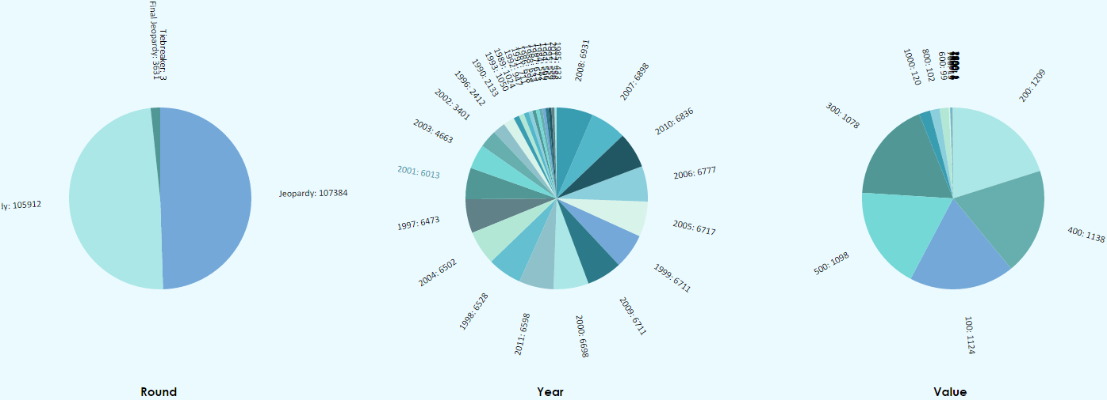

Figure : Even after moving the labels outside of the pie slices, the labels were unfortunately still unreadable.

## Tree Map

## Word Cloud

With words being such a valuable part of my data set, I knew I wanted to include a Word Cloud in my project in some way. I first found this Word Cloud instance, which was created by Jason Davies (<https://www.jasondavies.com/wordcloud/#%2F%2Fwww.jasondavies.com%2Fwordcloud%2Fabout%2F>).

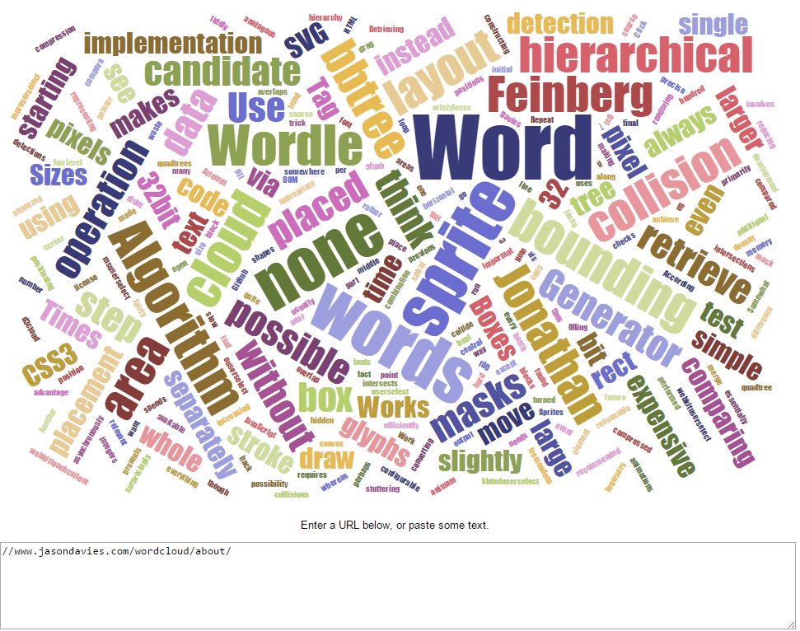

Figure : I really liked how this looked, and I thought it could be an interesting way to show which words most frequently appear in Jeopardy questions.

Which lead me to the creator’s website, which explained how the Word Cloud library he had created worked in more detail (<https://www.jasondavies.com/wordcloud/about/>).

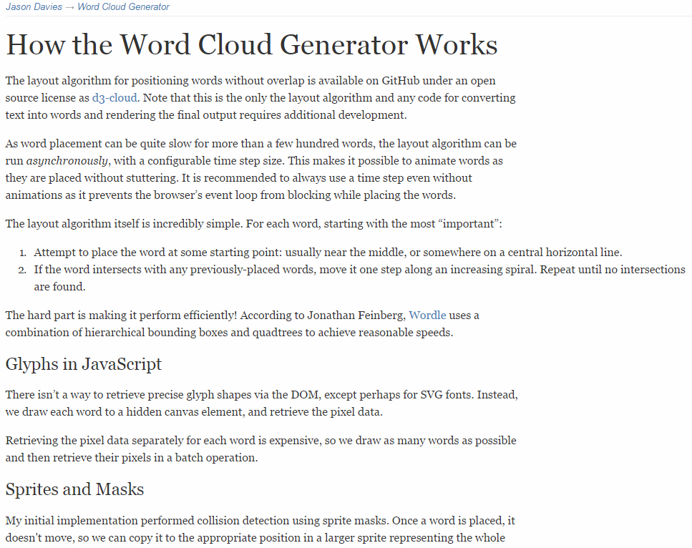

Figure : Jason’s website about the Word Cloud he had created.

Jason did a wonderful job of explaining his d3 Word Cloud library, however I tend to work best by example, so I kept searching. What I then found to be the most helpful was this implementation of their library (<http://bl.ocks.org/ericcoopey/6382449>).

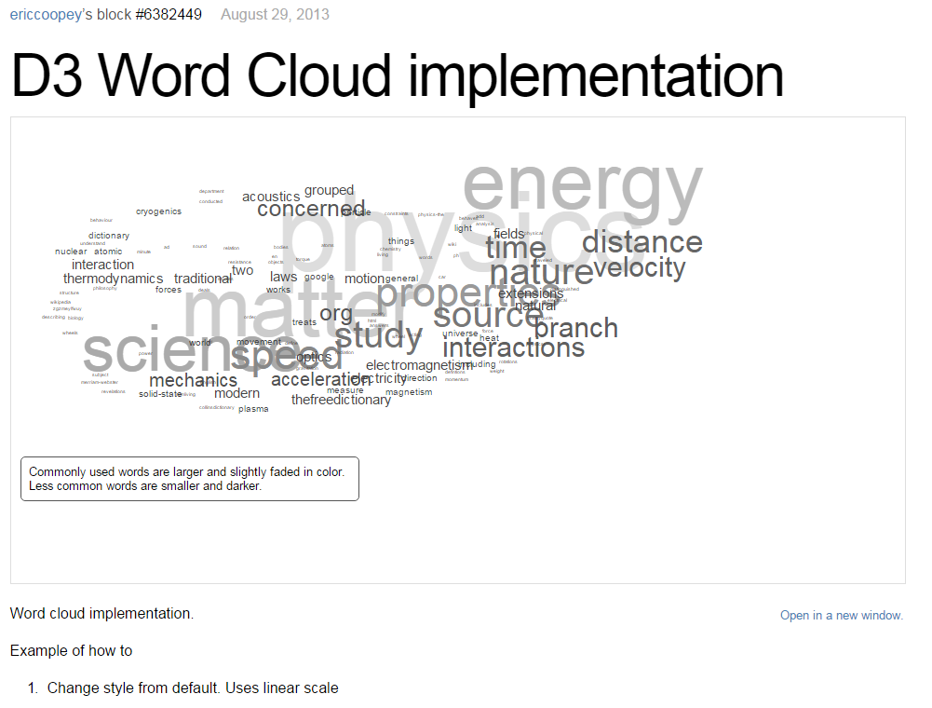

Figure : This example Word Cloud was the most straightfoward and understandable for me, so I used this as my reference.

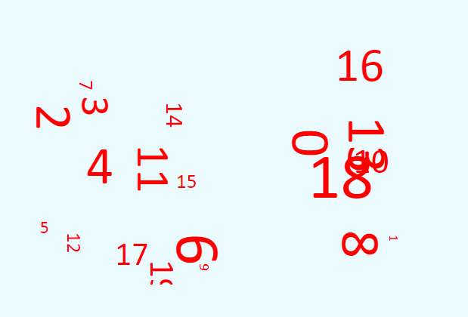

Figure : My first attempt at getting the Word Cloud working. This should have had actual words in it. Well... it’s something...

Eventually I did get the Word Cloud working, and it looked something like the image below. While I was happy with it, I realized that a lot of words I deemed “boring” (prepositions, for example) ended up being the most frequently seen words, and I feel as though these aren’t words people are curious about. Because of this, I chose to create an array of filtered words. If any of the words in any questions are in the filtered word list, they were skipped over and weren’t added to the Word Cloud.

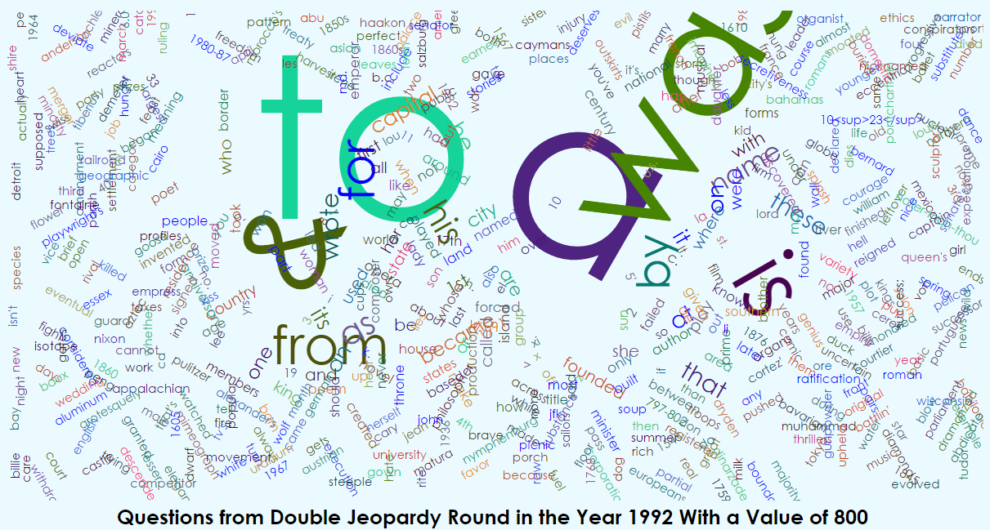

Figure : I was just so curious about how many times the word "a" appeared in questions, right?... Probably not.

In addition to filtering out words, I also had to turn all words to lowercase using JavaScript’s .toLowerCase() method due to the same word showing up in the Word Cloud in different cases (Example: “He” versus “he”). Next I wanted to give the Word Cloud some sort of title, so I chose to construct a title in the format “Questions from ROUND in the Year YEAR With a Value of VALUE,” filling in “ROUND,” “YEAR,” and “VALUE” with their respective values from the data set. Eventually I had created the visualization below.

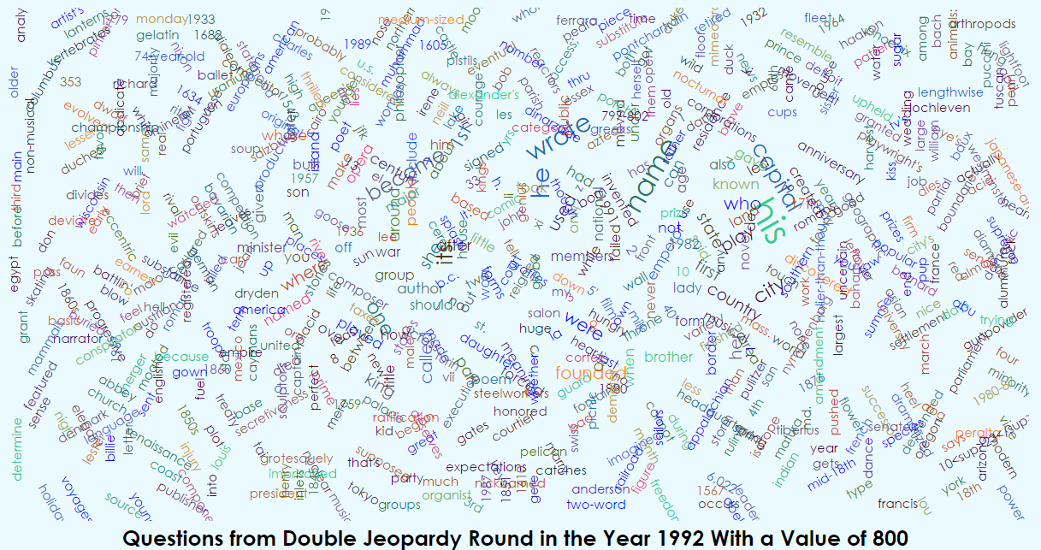

Figure : My eventual Word Cloud, which I felt was much more interesting after removing prepositions and other more "plain" (in my opinion) words. This is the same data set as the previous image, just with the filtered words removed.

I then had to hook together the Word Cloud and the bar graphs I’d created. Hovering over a data point in the rightmost bar graph still changes its color to a lighter purple (which happens with all three graphs). However, when a user clicks (not hovers over, but actually clicks on) a data point (a bar) in the rightmost graph, a Word Cloud would be generated below. Once the Word Cloud had loaded, the selected bar will turn green:

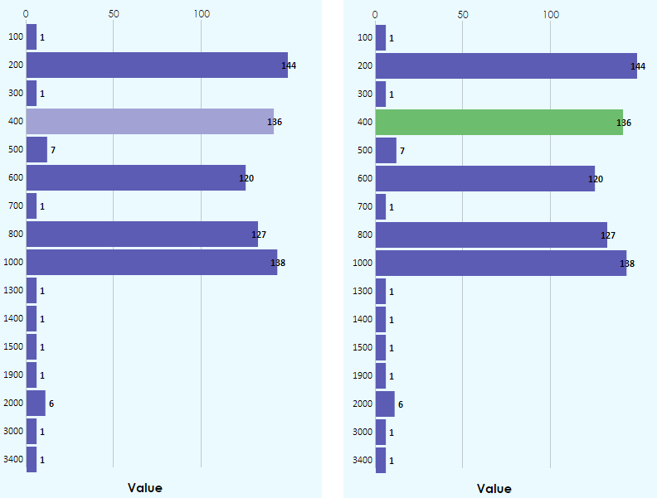

Figure : The left image shows what the bar graph looks like when the data is loading for the selected data point. The right image shows that the chosen data point turns green to confirm that the Word Cloud finished loading below.

Originally my plan wasn’t to add extra features, just implement the graphs, however this was a very trivial change that I was able to make in a few minutes due to previous code that I’d written.