Project Management Tool by  
Deloitte Digital SEA  
*previously known as TrackerSEA

Release Guide

**MAY 2022**

Contents

1. Creation of ProTrack Community Users 3

2. Accessing ProTrack Experience Cloud 5

3. Personalized List Views 7

4. Test Execution 8

5. Tickets 8

6. Branded Email Communications 9

7. Streamlined Branding across Platforms 10

# Creation of ProTrack Community Users

Creating community users are different to creating internal Salesforce users. Here are the steps to create a Community User:

* 1. **Create an Account record** in the internal ProTrack platform. This Account record would store all Community Users (Contacts). Example, an Account name “Project ProTrack” has been created:  
     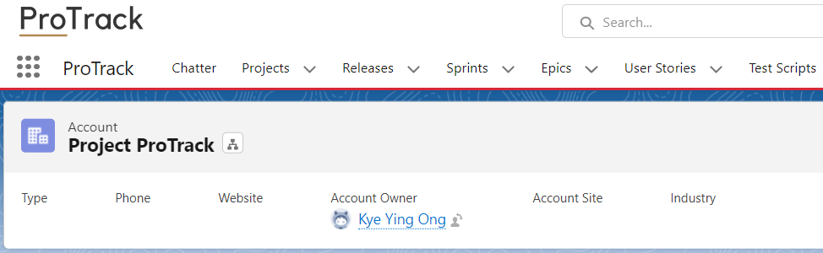
  2. **Create a Contact** under the Account record created in step 1, and save  
     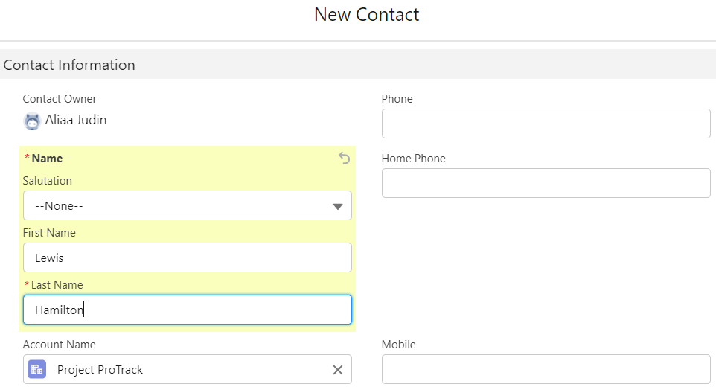
  3. Navigate to the Contact record and on the right-most section of the page, click on the drop-down menu, and then click **“Enable Customer User”**  
     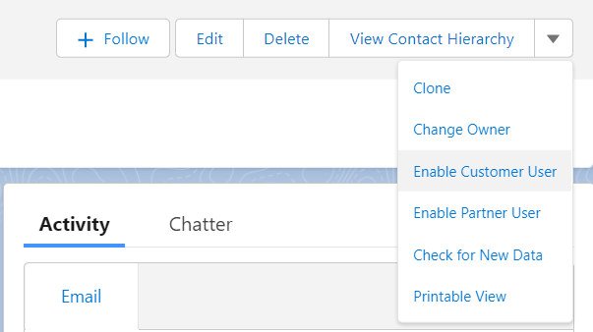
  4. Once you have clicked the “Enable Customer User” button, you will be directed to the User Setup page. Here, you will key in the following details:
     1. Email
     2. Username
     3. **User License:** Customer Community Plus
     4. **Profile:** ProTrack Community Plus User
     5. **Role:** Project ProTrack Customer User

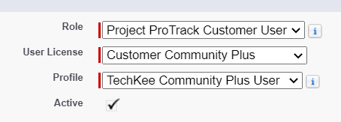  
*Screenshot shows Profile: Techkee Community Plus User, upon deployment the Profile name will reflect ProTrack instead of Techkee

1. Upon clicking Save, assign the User with the **Permission Set:** ProTrack Community Testing PS  
   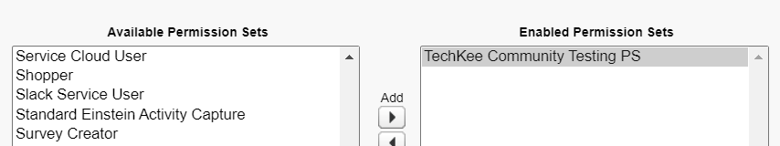

*Upon deployment, Permission Set name will reflect ProTrack instead of Techkee

1. After executing steps I to V the Community User Setup has complete. The Community User will receive a **Welcome to ProTrack email** which consists of all the details needed and hyperlinks to verify their account  
   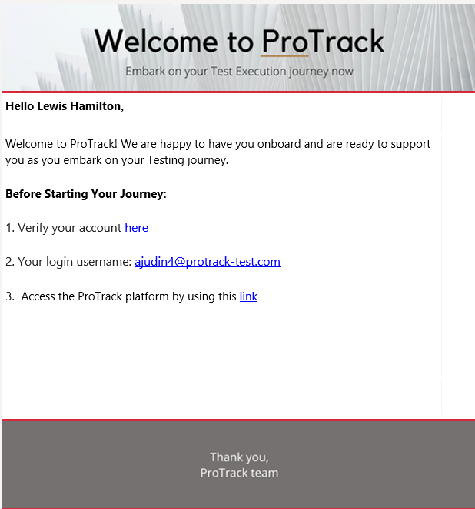

# Accessing ProTrack Experience Cloud

1. Community Users will receive a “Welcome to ProTrack” email upon completion of user setup. From the Welcome email, the user would firstly need to **verify their account** through the first hyperlink populated in the email. Clicking the link will prompt them to set up their account password:  
   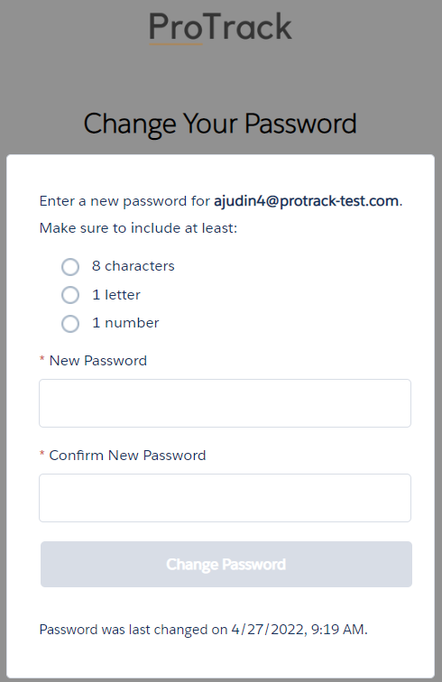
2. Upon setting up the password, the user would directly be navigated to the ProTrack homepage. If they would like to **log into ProTrack** again, they will visit the ProTrack link (also found in the Welcome email) and will see this interface:  
   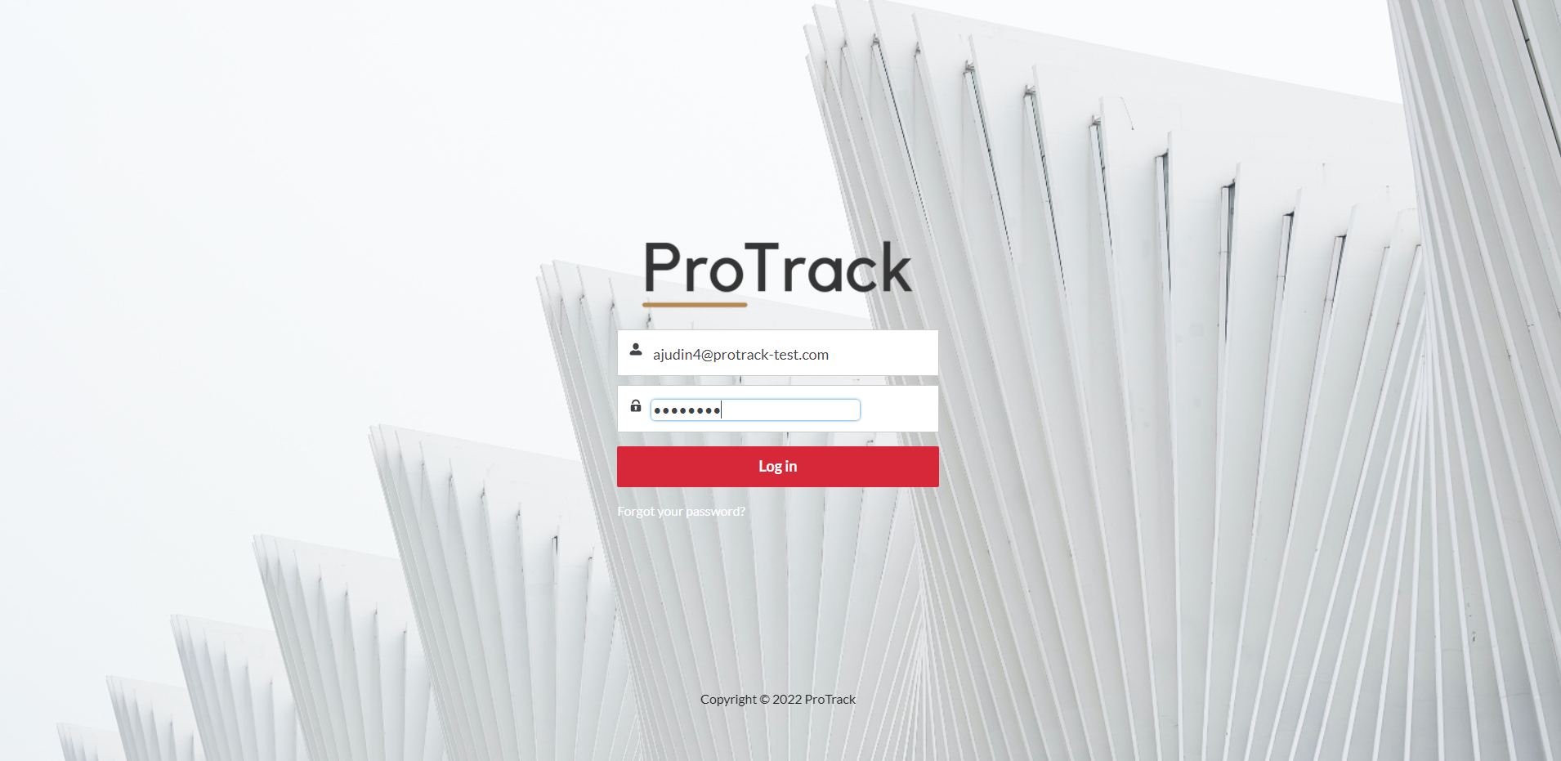
3. The **ProTrack homepage** would look like this, where the user will be able to automatically view the count of their pending task (My Pending Task) and the list of tasks needed to be done (My Tests & Tickets)   
   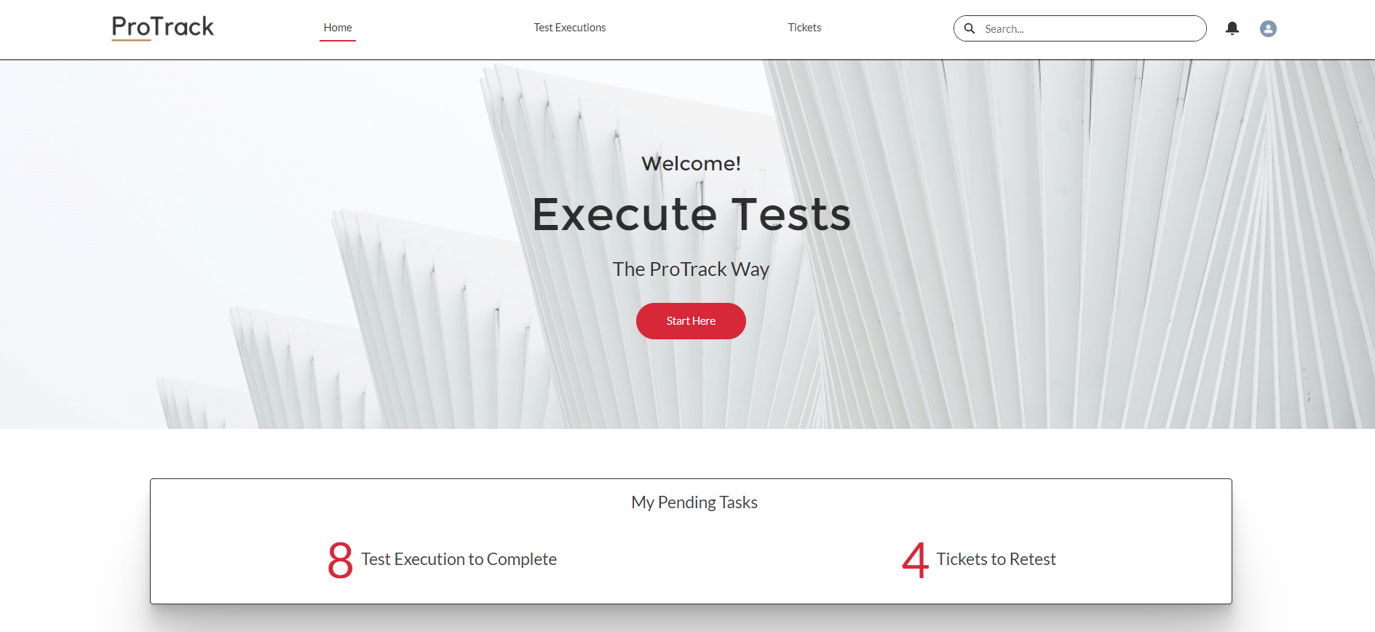  
   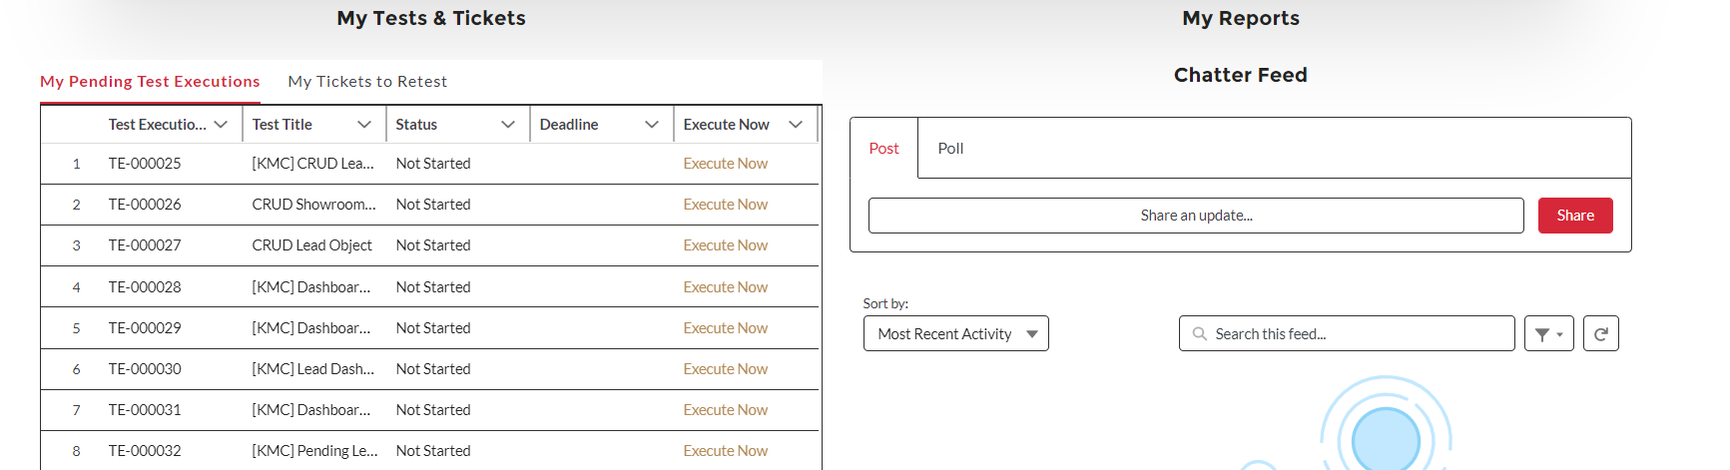

# Personalized List Views

* 1. The homepage provides two personalized list for the Community User. First is the “My Pending Test Executions” and second, “My Tickets to Retest”.   
     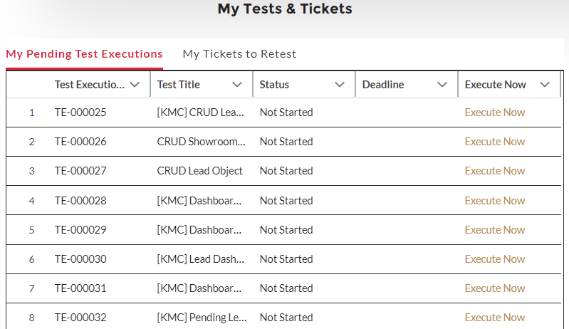
  2. The personalized list view will also be shown when the Community user clicks “Test Execution” on the navigation pane:  
     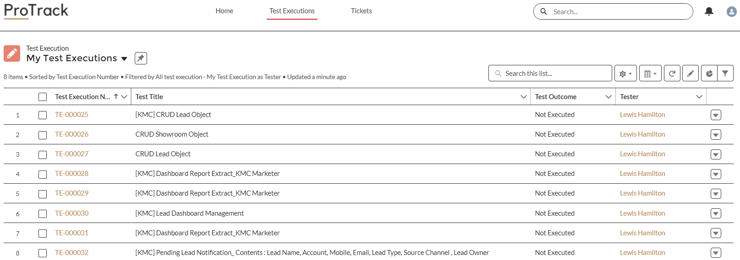
  3. The personalized list view will also be shown when the Community user clicks “Tickets” on the navigation pane:  
     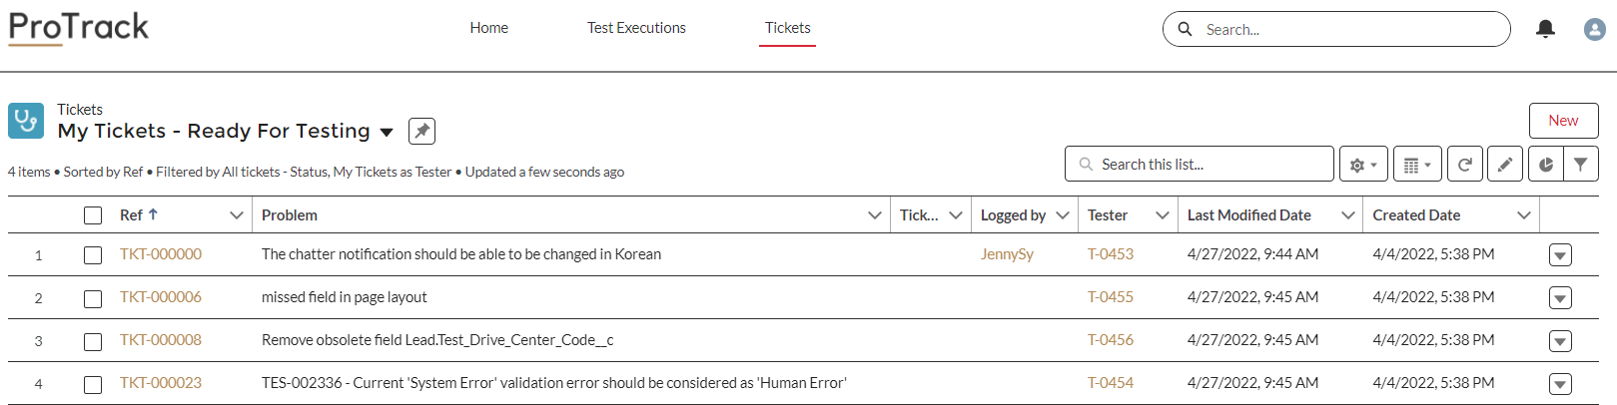

# Test Execution

* 1. When the Community User clicks “Execute Now” on the homepage or “Execute Test” button on the Test Execution record, this will be interface that follows:  
     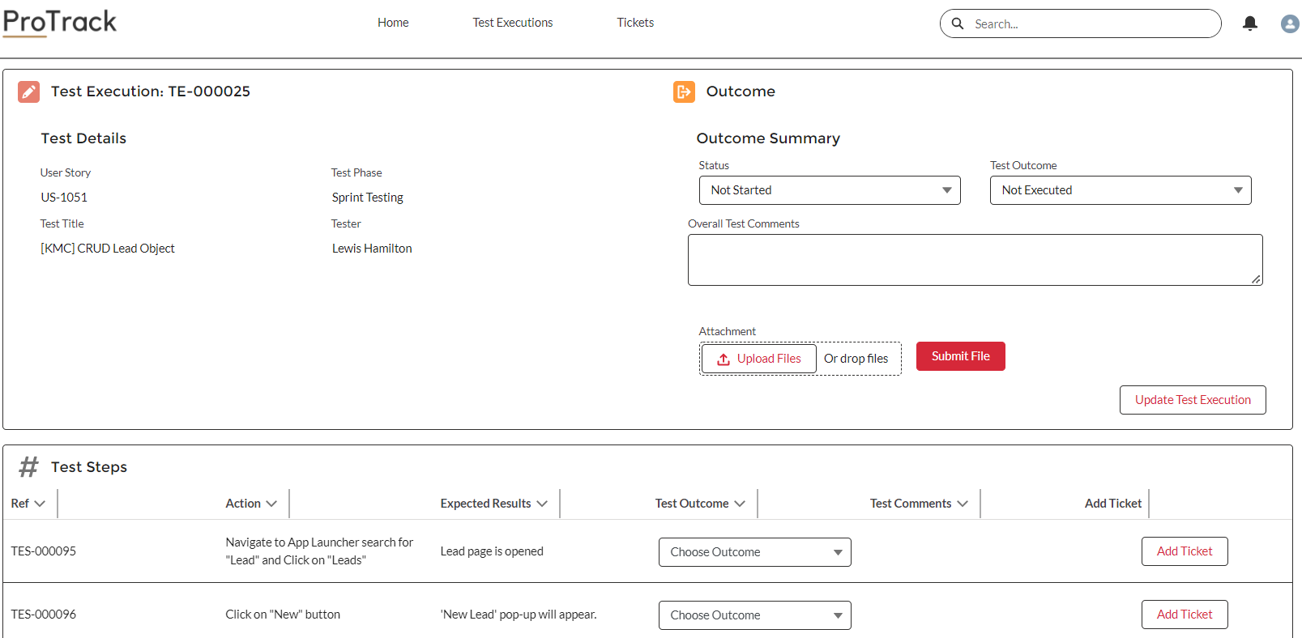  
     Users are able to:
     1. Update Test Outcomes
     2. Raise Tickets
     3. Update Overall Test Outcome under “Outcome Summary”
     4. Upload file attachments

# Tickets

* 1. When the Community User clicks the Ready for Testing Ticket records, this will be the interface that follows:  
     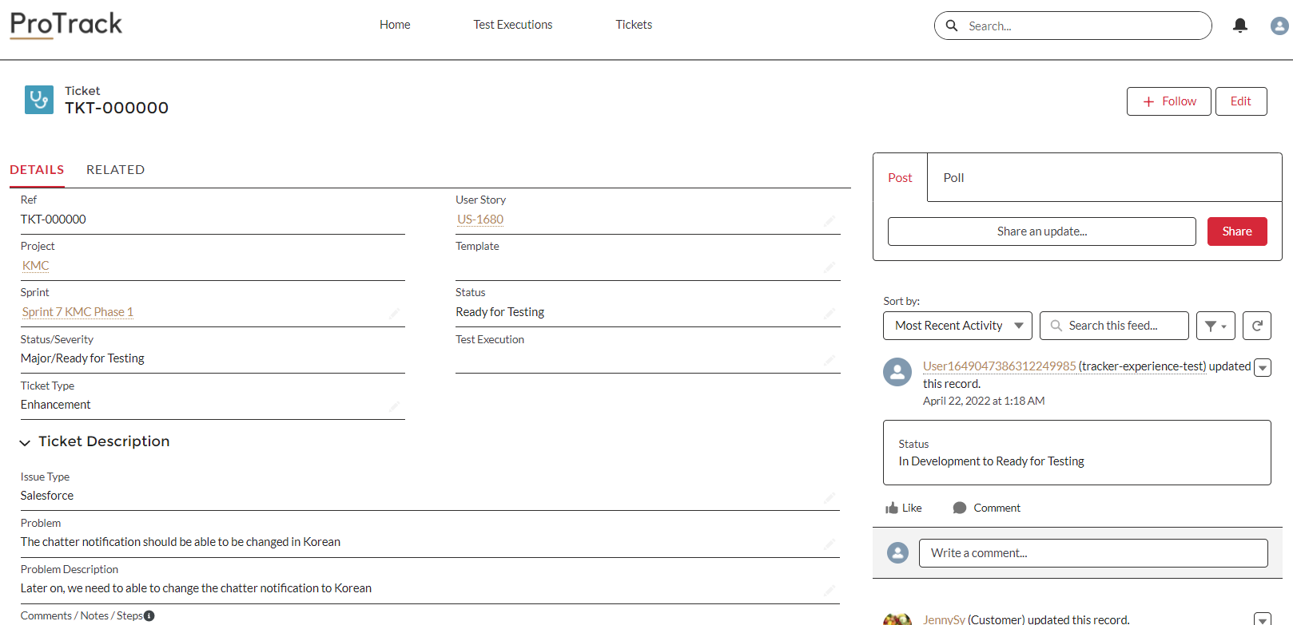

Users are able to execute the test and update the test outcomes, collaborate with Deloitte through Chatter.

# Branded Email Communications

Two Email templates have been defined as part of the release.

* 1. First, the “Welcome to ProTrack” email with Email Subject: Welcome to ProTrack  
     
  2. Second, the Reset Password email when System Admins trigger Password Reset from the internal ProTrack platform. Email Subject: Your New ProTrack Password  
     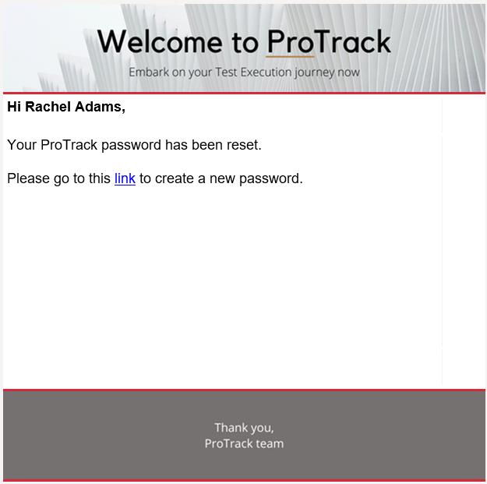

# Streamlined Branding across Platforms

With defining a new name and color scheme for our Project Management tool, we have decided to streamline our branding across both platforms – internal and external. For the internal ProTrack platform, we have tweaked the interface to include the logo as well as color scheme.  
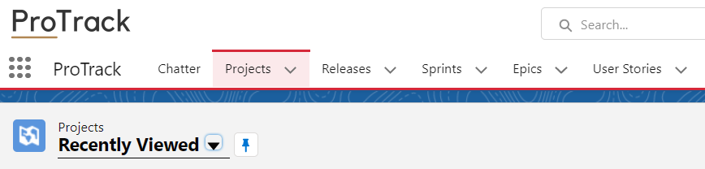

**End of Document**