Dog Disease Content Management System Version 1.0

A simple CMS about dog diseases and it’s corresponding symptoms using PHP PDO and MySQL. A start-up project for learning web development.

Tools:

* Install xampp <https://www.apachefriends.org/download.html>
* Sublime text or any text editor. <https://www.sublimetext.com/>
* Download repository

Installation:

1. 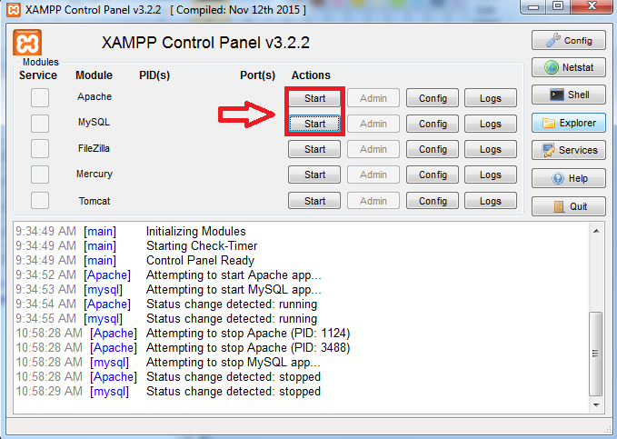Start apache web server.
2. Open browser type in localhost then go to phpMyadmin link create new database named meddog.

* Create three table named diseases, dise_symp, symptoms.

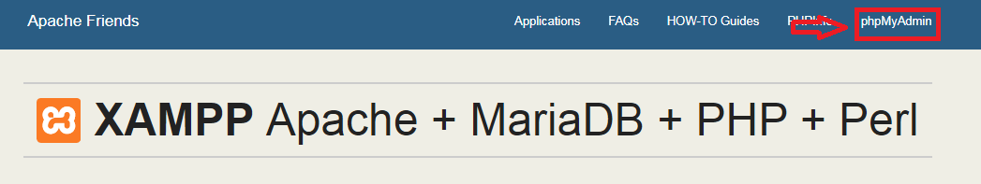

1. diseases table structure

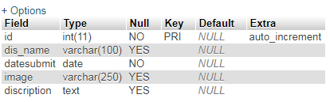

1. dise_symp table structure.

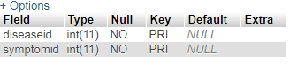

1. symptoms table structure.

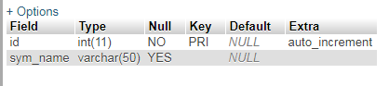

1. Go to browser type in “localhost/project”
2. Go to Manage Diseases link a start adding disease details
3. Then go to Manage Symptoms to add symptoms corresponds to the disease you Entered.
4. The Manage Diseases UI

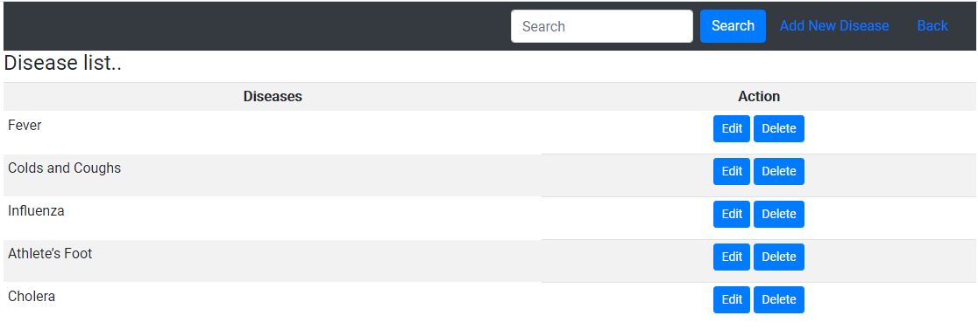

1. Add new disease.

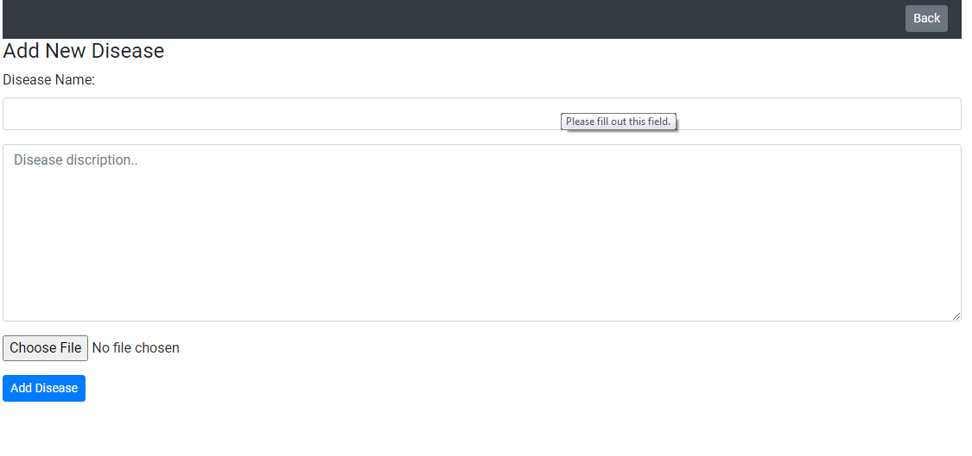

1. 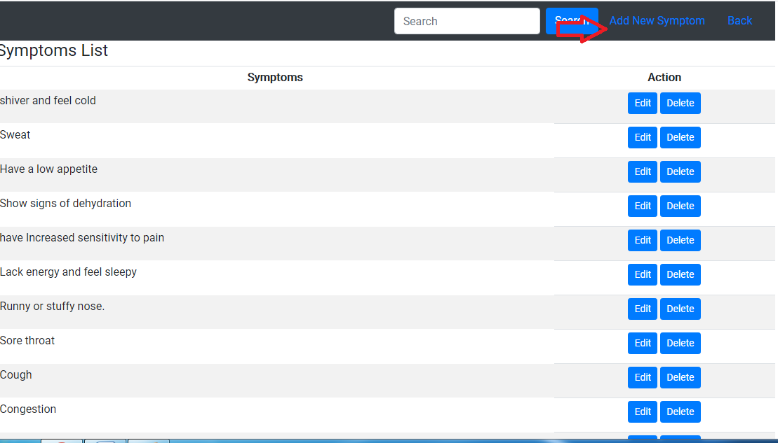Click add new symptoms
2. 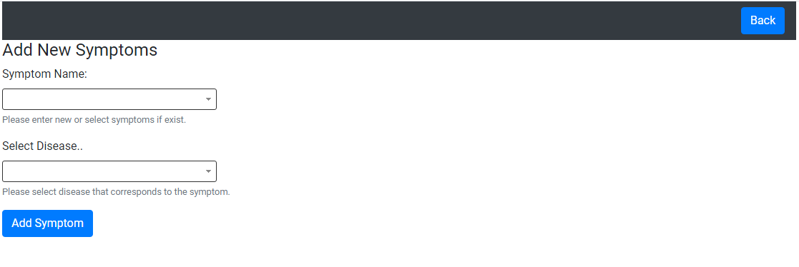Add new or select symptoms to relate it on the disease that you have inserted.

You can start searching for symptoms or diseases and it will show query results click on view details for information about the disease.