You are helping report on enrollment metrics for a medical study investigating the effectiveness of different treatments for Canine Influenza for different dog breeds.
The research group is requesting your help to better understand how the enrollment process is going.
You are given the included spreadsheet and asked to create several queries and visuals to help answer their questions.
Please note that each tab represents a table, and the ID field should be used to link records across tables. Each ID represents a distinct dog.

Please answer the following questions with a SQL Query:
- How Many Dogs Were Successfully Screened? (Screened defined as having a valid date in form_completion_date)
12
- How Many Dogs Are Eligible? (Eligible defined as having a value of 1 for all elig_question columns and having any value for the inelig_question columns aside from 1 (must not be missing))
4
  - If missing values could be considered for the ineligibility questions how would you rewrite this query?
7
- How Many Dogs Are Ready To Be Enrolled In The Study? (Ready To Be Enrolled being defined as being Eligible and not having a value of 1 or 2 under withdrawal_status)
4
- How Many Dogs Were Withdrawn From the Study? (Withdrawn being defined as having a value of 1 or 2 under withdrawal_status)
2
- How many screened dogs are over the age of 5?
6
- Write a query that designates the order in which those ready to enroll should be contacted (Those with the oldest form_completion_dates should be contacted first)
id name form_completion_date
58 Bear 2025-08-10
4 Buddy 2025-08-25
5 Luna 2025-09-03
40 Leo 2025-09-15

Please develop the following visuals in tableau based on this data:
- Please replicate the below visual that depicts category counts. The eligible category will also need a percentage out of those screened and Ready To Be Enrolled will need a percentage out of those Eligible.

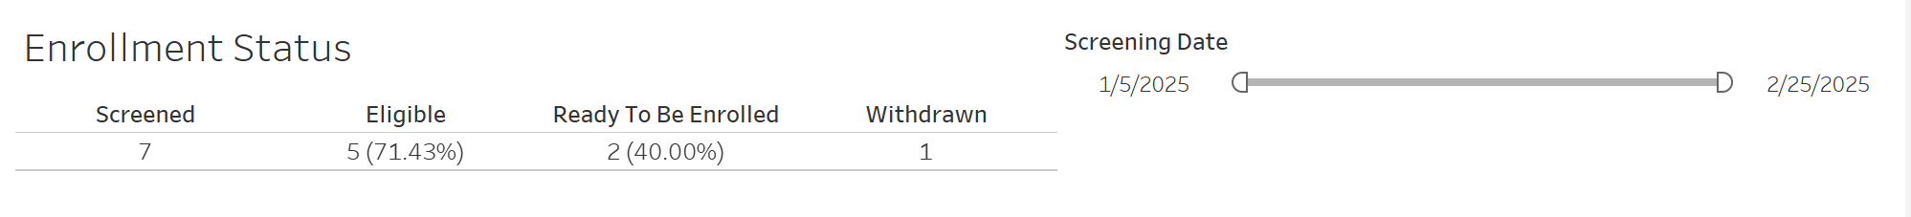
Please also include a screening date filter based on form_completion_date that will dynamically filter the values. (Please note actual count/percentage values will likely be different from those in the example image)

My recreation:

- Develop a visual that the organization can use to answer the following questions?
- How many screened dogs were under 25 pounds? 25 or more pounds?
Of the screened dogs, 4 were under 25 pounds and 8 were 25 pounds or over.
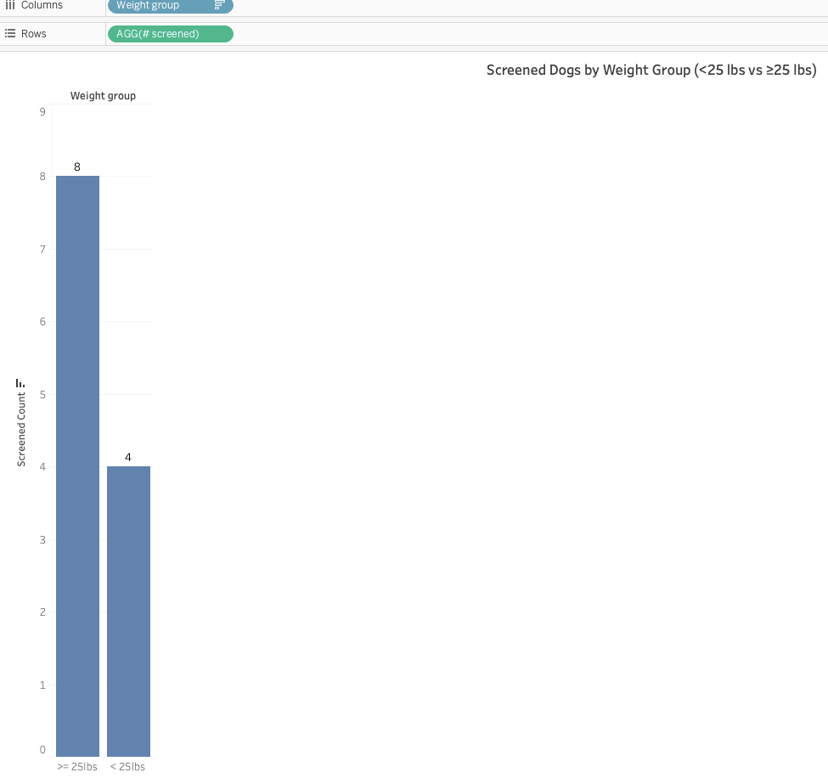
- BONUS: Create an additional visual in tableau you feel would be helpful for those managing the study. Please describe why you feel the visual would be helpful.
I created an enrollment funnel that shows how many dogs are at each step of the study funnel: screened, eligible, ready to be enrolled, and withdrawn. It lets study managers identify where the most drops off. By comparing how the dogs progress through the funnel, managers can assess whether recruitment strategies are effective or if certain steps create bottlenecks. It also helps guide operational decisions like recruitment targets, modifying screening procedures, or implementing retention strategies to reduce withdrawals.
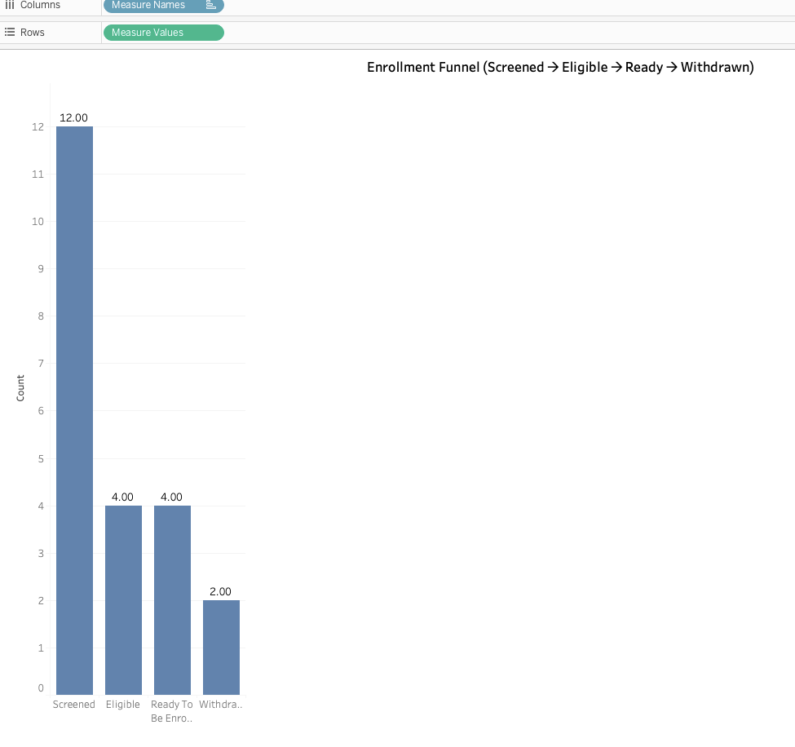
- Are there any other data points you would recommend that the study track? If so, why?
  - Screening failure reasons
Understanding why dogs don’t pass the criteria is just as important as counting how many do. Maybe there is a trend in eligibility questions that failed. Maybe it is an owner related reason or just an accidental incomplete form. Tracking can highlight patterns of eliminating the most dogs and help the team refine the process, instructions, or communication with owners.
  - Time from screening to enrollment
The time it takes for a screened dog to be enrolled can help figure out the study’s operational efficiency. Long delays might lead to confusion or loss of interest. Monitoring it can give the team a chance to streamline steps and for the team to predict timelines and resource needs.
  - Reasons for withdrawal
Knowing why a dog has withdrawn is something the team can act on. Tracking the reasons like scheduling issues, owner concerns, dog no longer meets criteria, etc. helps focus on preventable problems, improve retention, and can create better communication with the owners. This can also help estimate how many additional participants might be needed to hit the right sample size.
  - Site level performance
Each site operates differently. Tracking number of screened, eligibility rate, enrollment rate, and withdrawal rate by site can help the team understand where the recruitment process is best and where some more training might be needed.

