These are components of the original train remote.

Manual Override Switch

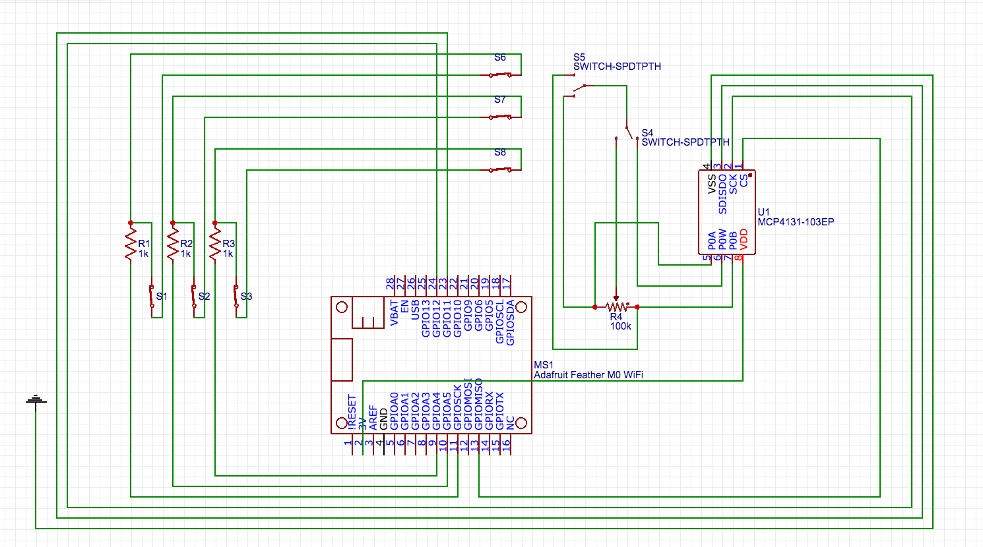
Feather Board M0 WiFi

Digital Potentiometer 10k Ohm

