Demo R Markdown for CS Class

Christopher Barrie

2022-10-04

## R Markdown

### R Markdown subhead

This is an R Markdown document. Markdown is a simple formatting syntax for authoring HTML, PDF, and MS Word documents. For more details on using R Markdown see <http://rmarkdown.rstudio.com>.

When you click the **Knit** button a document will be generated that includes both content as well as the output of any embedded R code chunks within the document. You can embed an R code chunk like this:

And this is a demo document

summary(cars)

## speed dist   
## Min. : 4.0 Min. : 2.00   
## 1st Qu.:12.0 1st Qu.: 26.00   
## Median :15.0 Median : 36.00   
## Mean :15.4 Mean : 42.98   
## 3rd Qu.:19.0 3rd Qu.: 56.00   
## Max. :25.0 Max. :120.00

## Including Plots

You can also embed plots, for example:

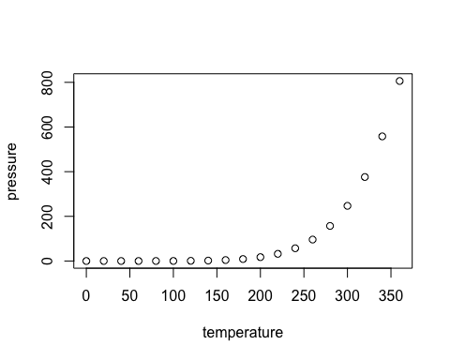

Note that the echo = FALSE parameter was added to the code chunk to prevent printing of the R code that generated the plot.

Now I’m going to introduce some of my own data.

I’ll first load the packages:

##   
## Attaching package: 'dplyr'

## The following objects are masked from 'package:stats':  
##   
## filter, lag

## The following objects are masked from 'package:base':  
##   
## intersect, setdiff, setequal, union

wbdata <- jsonlite::fromJSON(gzcon(url("https://github.com/cjbarrie/CS-ED/blob/main/data/web_historian_data.json?raw=true")))

And now I’m going to count some of its properties:

wbdata_mp <- wbdata %>%   
 group_by(domain) %>%  
 count() %>%  
 filter(n >5)

And now I’m going to plot it

wbdata_mp %>%  
 ggplot() +  
 geom_bar(aes(domain, n), stat = "identity") +  
 coord_flip()

