­Clio Linearity Calibration: November 2014 Data

Chris Bohlman

5/15/2017

Context:

The Clio infrared camera is an instrument used in the Magellan Adaptive Optics system, located at the Las Campanas Observatory, at the Atacama Desert in Chile. Clio specializes in infrared photometry, and adaptive optics are used to ensure that the turbulence of the atmosphere are corrected for so clearer images can be taken. Specifically, Clio is sensitive from the wavelengths 1 µm to 5 µm.

Now, the goal of this report was to initially analyze a set of flat images to come up with a set of coefficients to calibrate the data from infrared camera Clio. The code to calibrate this flat data set was written in Python from August 2016 – January 2017 and adapted from code that I have previously wrote to analyze another data set from the Clio camera. One the flat data set was calibrated, we could take those same coefficients used to calibrate and apply them to another data set that had a star in it, which was then corrected as well. The code to correct the next data set was written in Python from January 2017 – March 2017.

In the end, linearity is what we want to achieve with the data set. The supposed relationship in the data between the integration time and counts readings should be linear, however, due to saturation from increased brightness, non-linearity appears within the data trends. Thus, the nonlinear parts of the data are rendered useless. It is therefore the objective of this report to demonstrate that through curve fitting and other programming tools, we can correct this data and make sure that a larger portion of it turns out to be linear. This is known as linearity, and it is crucial to preserving the viability of the data.

This data was originally gathered in November of 2014, with the Clio camera in the MagAO system at the Las Campanas observatory in Chile.+

Ints vs. Counts of Flat Data Set:

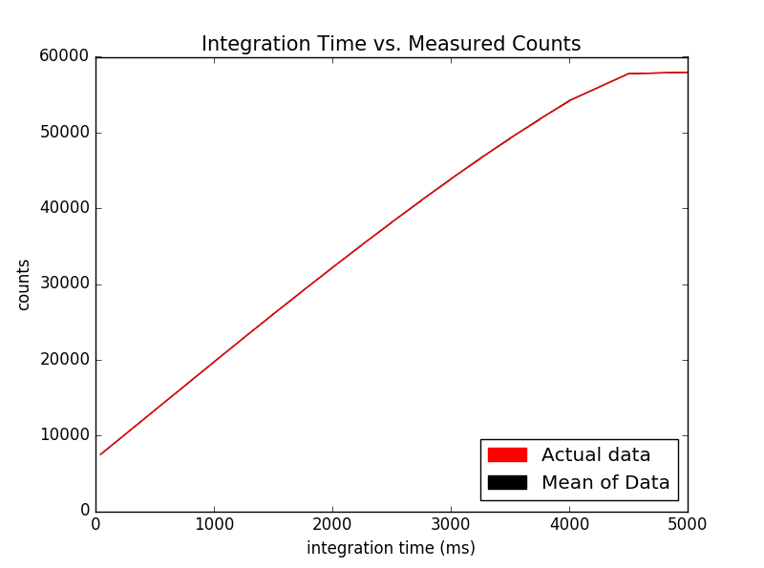

Initially, we found the ints and counts of each image. The ints, or integration time, is the exposure time for the detector. Therefore, an increasing amount of ints means that the camera was recording data for longer. The counts are a measure of the number of photoelectrons, but in this case, they can best be thought of as the brightness of a section of an image. To determine the integration time vs the counts of each image, I read files in through the FITS package from astropy in Python and recorded the counts of each image from pixels 33 to 180 in x axis and 20 to 180 in y axis. These parameters are due to the bright side of the images always being on the right half, so we only wanted to process that part for data. The program I wrote analyzed counts in that section of the image for each image, and got the integration time from the specific header for each image. In the context of this project, the data was stored in ‘int’ and ‘counts’ arrays, respectively. I graphed the integration time of each image, which were in milliseconds, on the x axis and I graphed the counts on the y axis.

Example flat image:

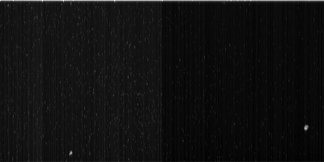

Ints vs. Counts with Linear Relationship of Flat Data Set:

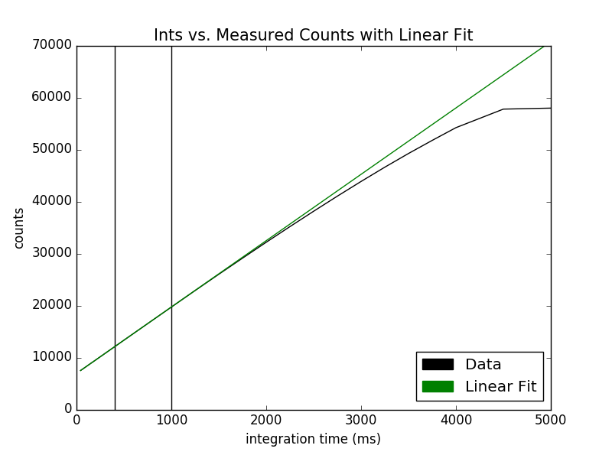

The first step in correcting for linearity was trying to find the straightest part of the data to add a linear fit to demonstrate the supposed linearity we were trying to achieve. I determined that the straightest part was between 400 ms and 1000 ms, making sure to not use the very low-int data (due to dark current making noise). The region of 400 ms and 1000 ms is represented in between the vertical bars above. I chose this region among others because after graphing the linear fit in relation to other regions in the straight-line section of this graph, I zoomed into each of the fits, and found that this fit’s separation was minimal enough to provide a good fit for the rest and was a stellar fit.

The coefficients of the line were m = 12.76 and b= 6946.92 in terms of y = mx + b.

This line graphed with the ints and counts of each image show that the data is only strictly linear up to about 20,000 counts, so the linearity correction must be applied to any values above this.

True counts vs. Measured Counts with Linear Relationship of Flat Data Set:

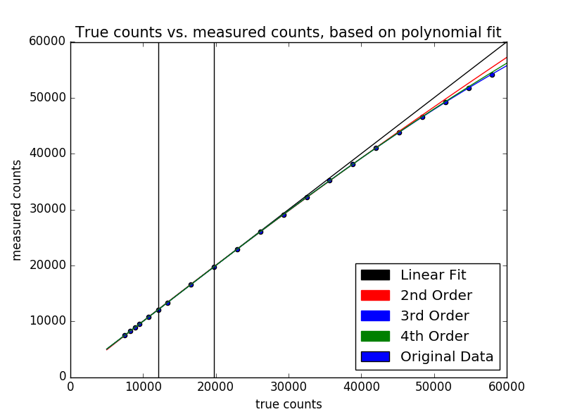

Next, I calculated the true counts for 2nd, 3rd and 4th order polynomials. I took the set of data up to about 44,000 counts, and created an equation in each of those orders that would convert counts to true counts. To do that, for each of the orders, I took the 2nd, 3rd, or 4th order coefficients from that order’s best fit of the counts up to 44,000, and made true counts with those coefficients. By applying these function coefficients that were generated to counts for each order, 3 more true counts graphs were generated. Therefore, measured counts were plotted for each order on the y axis, and true counts were graphed on the x axis. By plotting the original data on the same graph, we could see the third and fourth order fits were the most accurate in this case. The bars in the graph also represent where the linear fit was chosen from for all orders of the fits.

True counts vs. Measured Counts with Linear Relationship of Flat Data Set:

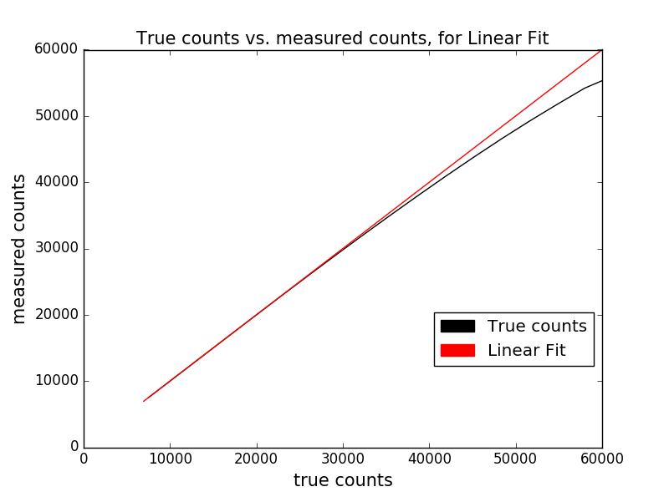

The next step was to find a way to convert the measured counts into true counts. The true counts represented what the data would look like if it was perfectly linear, and there was no calibration needed. Initially, I did this for only the linear fit of the data. To do this, I took the measured counts for all images inside of the linear region between 400 ms and 1000 ms, and obtained coefficients from that section only to convert ints to measured counts. I then applied every ints value to the coefficients generated to create a new array of true counts. Therefore, what I have graphed here is a demonstration of the true counts graphed versus the measured counts.

Error of Linearity vs. True Counts of Flat Data Set:

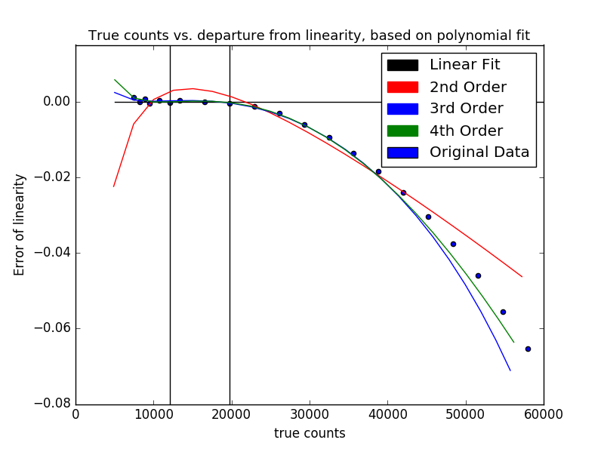

To confirm the results from the previous page that the third order fit was superior, we decided to calculate the error of linearity for each of the different polynomial fits. The error of linearity was calculated by:

Error of linearity = $\frac{true counts-measured counts}{true counts}$

With true counts referring to the specific true counts of each fit, calculated earlier.

As seen from the graph, 3rd and 4th order come very close to the fit, and diverge at about the same point from the original data. However, the fourth order fit is closer to the data, so I chose that order to correct the counts. After adjusting formulae and boundaries within my program, I have concluded this is the closest to the data error of linearity I could possibly get.

Corrected Counts vs Ints of Flat Data Set:

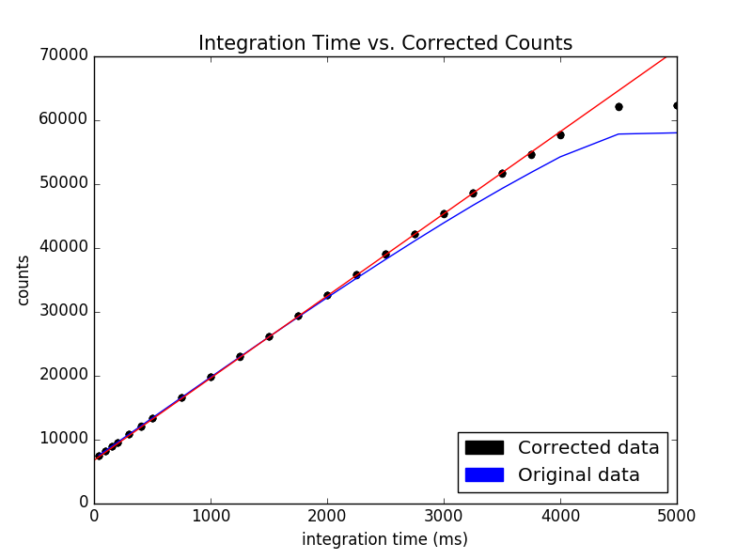

This is the graph for 4th order corrected data, which happens to be linear up to ~50,000 counts. Now, the process for this was as follows:

First, I made sure that the 4th order coefficients were converting counts to true counts, so I personally had to recalculate my coefficients with counts in the x axis, and true counts in the y axis in the coefficients-calculating function in Python. I then reopened all the images back up, and calculated the ints as I did previously, reading them in through each image header. However, for the counts, if the counts read in were above 20,000, I took the counts from the image and applied my calculated fourth order coefficients to output a corrected and calibrated value for counts. I then graphed the resulting new counts, and found out that the corrected data was linear up to about 50,000 counts.

Equation that linearized the data: $y=ax^{4}+bx^{3}+cx^{2}+dx+e$

Where x is the measurement of counts from the image, y is the corrected counts, and with:

a = 3.67e-16, b = -7.58e-11, c = 2.69e-06, d = 9.66e-01, e = 1.39e+02

Calibrating Different Data Set:

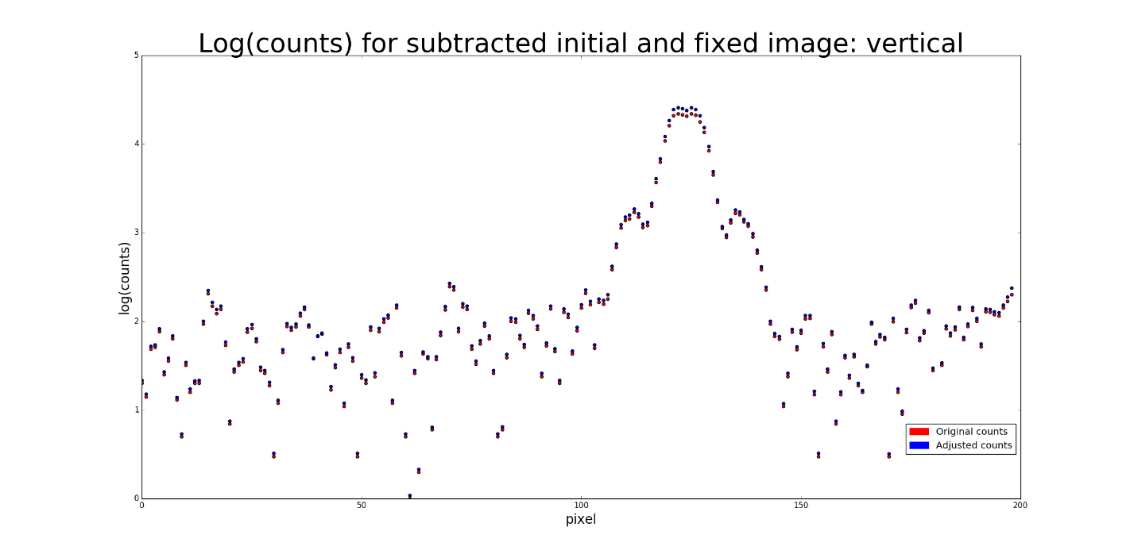

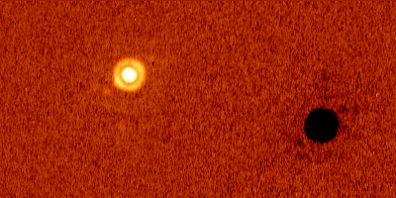

To calibrate another data set (that had a star in it this time and wasn’t just a flat set), I read in each of the images in the set, and looked at each pixel individually. I first wrote a new image that was a duplicate of the original I was reading in, and if the count of a pixel was over 20,000, then I applied the correction with the equation I previously mentioned to the new image. Once I did the pixel correction for every single image, I now had a set of uncorrected images and a set of corrected images. I then looked at each image pair and then subtracted one image from the other. Therefore, as of now, I had an uncorrected data set, a corrected data set, a corrected subtracted data set, and an uncorrected subtracted data set. To generate the graph of counts vs pixel, I took a vertical slice (containing a portion of the star) off a corrected subtracted image, and read in the same vertical slice from the corresponding uncorrected subtracted image. This graph demonstrates that the higher the original counts were of a pixel, the more of a correction there was, which makes sense in the context of my project. A corrected subtracted image is also shown, illustrating the other data set that I was working with.