
Live → VOD
Every live hour becomes a library.
Volt Streaming records every channel as it airs. Clip and publish while the channel is still live, then turn the library back into a channel.
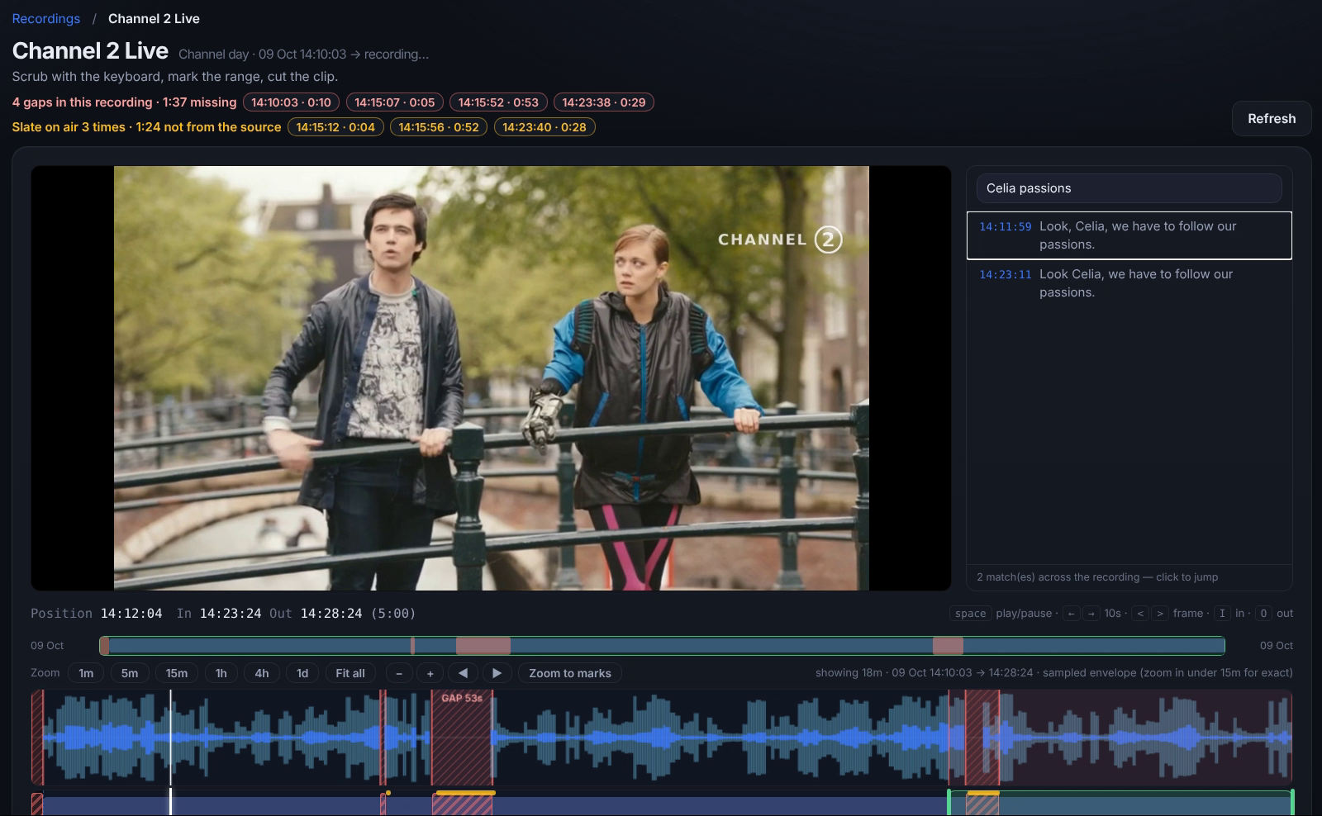
The recording workbench: search the captions, mark in and out, create the clip.
  Go live. Stay live.  Primary and backup inputs over SRT or RTMP. Volt switches to the backup automatically and puts the slate on air if both are lost. |  |   Live → VOD in one take  Recording starts when the channel goes on air. Find the moment by caption, cut the clip and publish it to the media library. |  |   Turn your archive into a channel  Build a FAST channel or a loop from the library. Schedule it in the EPG or import XMLTV, and deliver it in HLS and DASH.

 | See it live on your own channels.  Live channels, events, radio, FAST and loops on one platform.
  Book a demo

