


Platform overview

Volt Streaming platform overview
Live channels, events and radio, with every live hour recorded into a library that can go back on air.

Version | 1.0
Date | 19 October 2026
Author | Christian Budden
Status | Draft
Contents
Introduction 3
Who uses Volt 3
Live channels and failover 3
Primary and backup inputs 3
Monitoring the pipeline 3
Captions and translation 4
Live → VOD 4
The recording workbench 4
Publishing from the library 4
VOD → Live 5
How the signal flows 6
Specification 6
Next steps 7

Introduction
Volt Streaming is a live-first streaming platform. It runs live channels, live events, radio stations, FAST channels and loops from one place, and it records what goes on air so that every live hour becomes part of a media library.
Two workflows sit at the centre of Volt:
- Live → VOD. Volt records every channel as it airs. Operators clip and publish from the recording while the channel is still live.
- VOD → Live. Volt turns a media library into a scheduled channel, so an archive can go back on air as a FAST channel.
This document describes how Volt handles live channels and failover, how the two workflows run, and what the platform supports. It is written for broadcast engineers and operators who are planning a move to Volt.

Who uses Volt
Operators use Volt to take channels on and off air, watch the signal, handle failover and cut clips. Editors and producers use the media library to review and publish. Administrators manage tenants, users, roles and API keys for each app.

Live channels and failover
A Volt live channel takes a contribution feed over SRT or RTMP, encodes it into renditions and delivers it in HLS and DASH. Each channel can have a primary and a backup input.

Primary and backup inputs
When the primary input fails, Volt switches to the backup automatically and keeps the channel on air. If both inputs are lost, Volt puts the slate on air so viewers see a holding image rather than a frozen picture. When the signal returns, the operator takes the channel back to live.

Monitoring the pipeline
Every channel shows a five-gate pipeline strip: Server → Input → Encoder → Output → On air. Each gate carries its own state, so an operator can see where a problem starts before viewers notice it. Monitoring collects the same states across all channels, and Multiview shows the encoder output of each channel side by side.
Calm on the bad night. Volt explains what happened and what it did. For example: “No signal on the primary input. Volt switched to the backup at 14:02:11.”
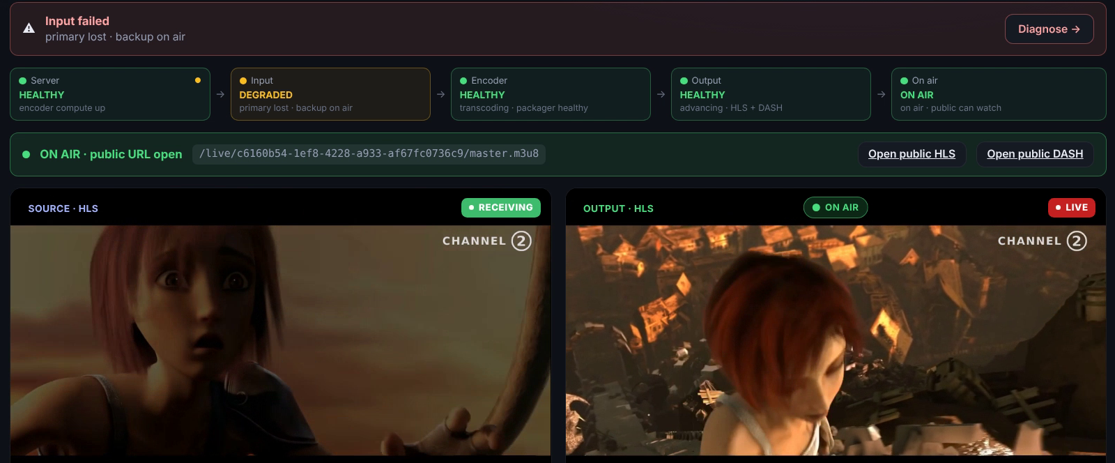
Figure 1. Channel 2 Live after the primary input failed. The backup is on air and the Input gate shows the degraded state.

Captions and translation
Volt adds live subtitles to a channel as it airs and can translate them into other languages. Viewers choose a caption language in the player, and the captions stay in the recording for later use.

Live → VOD
Recording starts when the channel goes on air. Volt records every channel continuously and shows each recording on a timeline, with gaps and slate periods marked so that an editor knows exactly what is in the recording.

The recording workbench
The recording workbench is where clips are made. The editor scrubs with the keyboard, finds a moment by searching the captions, marks the in and out points and creates the clip. Volt does this while the channel is still live, so a goal or a quote can be published within minutes.

Publishing from the library
New clips go to the media library. Publishing rules decide where each item goes and when it is available, and every app is a publishing point with its own access rules. The image library holds thumbnails and artwork for each item.
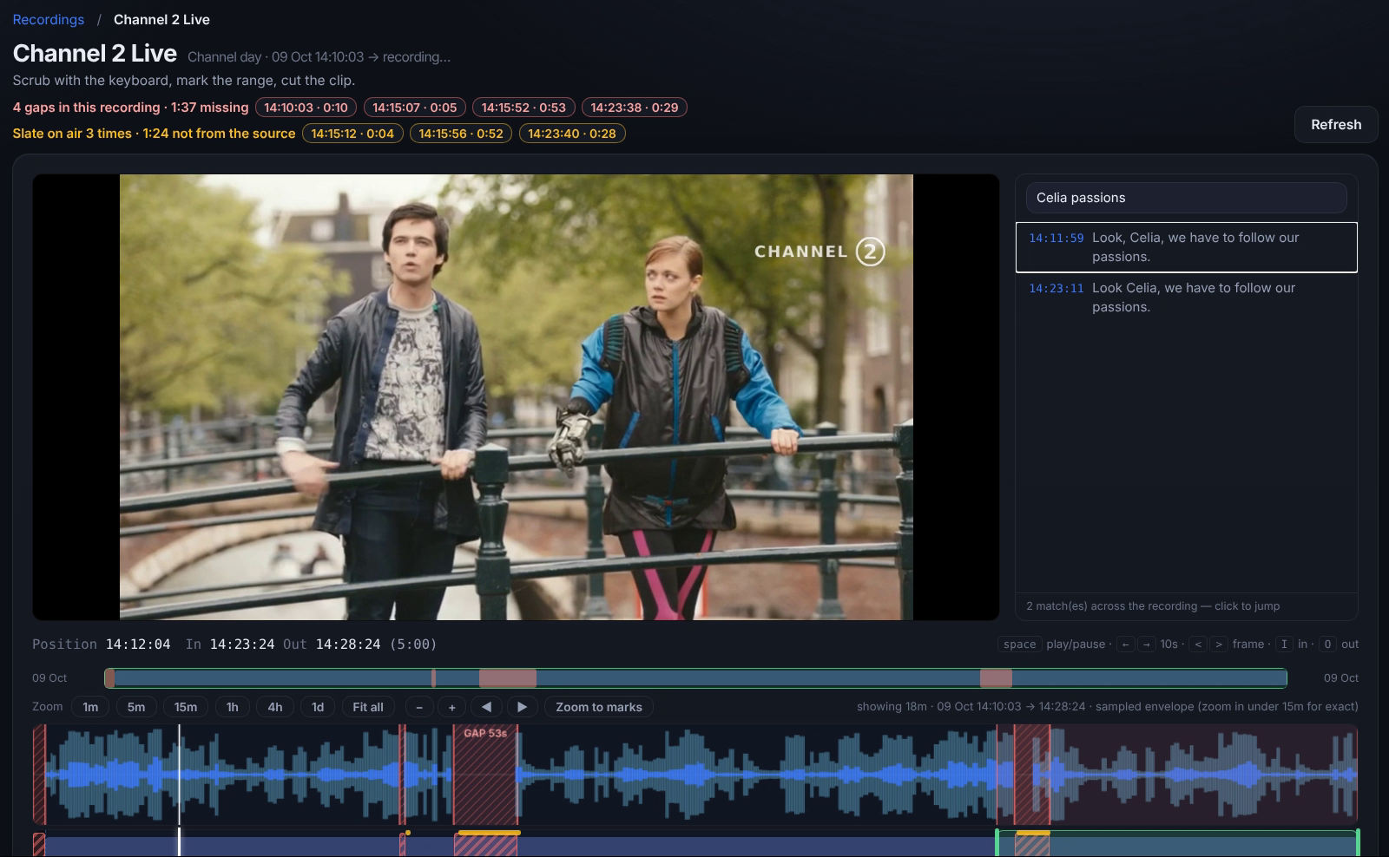
Figure 2. The recording workbench for Channel 2 Live, with caption search, the gap markers and the audio envelope.

VOD → Live
The second workflow runs the other way. Volt turns items in the media library into a scheduled channel: a FAST channel built from a playlist, or a loop that repeats a set of programmes.
- Build the schedule in the EPG, or import it from an XMLTV file.
- Add programmes from the media library, including clips made from recordings.
- Volt plays the schedule out as a channel, delivered in HLS and DASH like any live channel.
Watchfolders and ingest bring new files into the library, so a channel can be fed from the same place the editors already work.
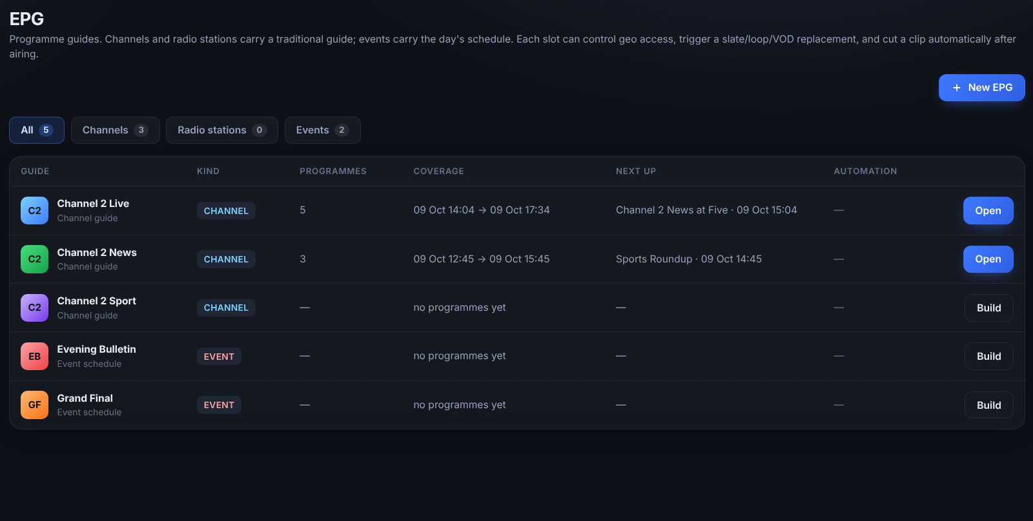
Figure 3. The EPG lists channels, radio stations and events with what is on now and next.

How the signal flows
The diagram shows a live channel from camera to viewer, and the two workflows inside the Volt platform. The live signal runs left to right along the top. Recordings and the library sit below it, and the FAST channel joins the delivery path.
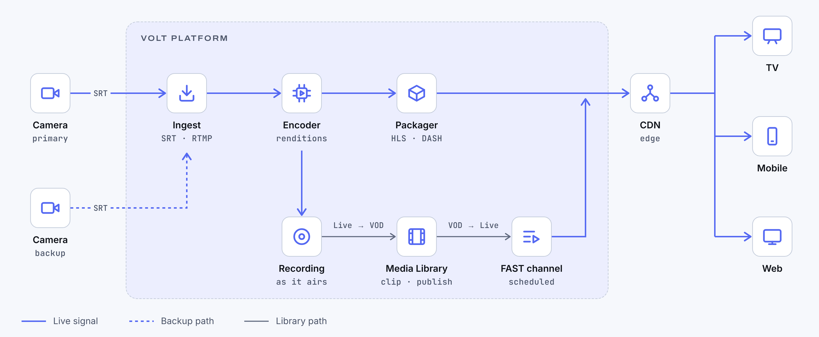
Figure 4. Signal flow for a live channel with a backup input, Live → VOD recording and a VOD → Live FAST channel.

Specification
The table summarises what Volt supports today.
Area | What Volt provides
Stream types | Live channels, live events, radio stations, FAST channels and loops
Ingest | SRT and RTMP contribution, watchfolders and file ingest
Delivery | HLS and DASH output, player SDK and embeds
Failover | Primary and backup inputs with automatic switch, and a slate when both inputs are lost
Captions | Live subtitles and captions, with translation
Monitoring | Five-gate pipeline strip per channel, monitoring across channels and Multiview
Scheduling | EPG with XMLTV import
Recordings | Recordings timeline and recording workbench with clip creation
Media Library | Publishing rules, image library and apps as publishing points
Analytics | Audience and quality of service (QoS)
Platform | Multi-tenant SaaS with roles, and an API with keys per app
Table 1. Volt platform capabilities.

Next steps
A Volt evaluation usually follows four steps:
- Agree the channels, events and radio stations to bring across, and their inputs.
- Set up a tenant with demo channels and connect a test feed over SRT or RTMP.
- Run Live → VOD on one channel: record, clip and publish while it is on air.
- Build a FAST channel from the library and review the analytics together.
See it live. Book a demo to see Volt running Channel 2, Sports Live and Radio One, including a failover to backup and a clip published while the channel is on air.

