CS 1632 – Deliverable 2: Unit Testing Ruby Rush

Corey Catalogna

GitHub User: cjc162

GitHub Repo: <https://github.com/cjc162/D2>

**Summary and Issues**

When writing my unit tests, I did not encounter too many issues. For those issues that I did run into, they were very minor. One issue for example was determining which tests were corner cases and which were not. It seemed like I was labeling a decent amount of my tests as corner cases, which made me stop and think if all of them truly were corner cases. Another issue I had ran into was with rubocop. Rubocop prefers if you use two spaces for indentation. When writing my code, I forgot about this and used tabs for idents. This made it a pain to go back and change all the tabs to two spaces when I was running rubocop.

I believe that my program works correctly and meets all the requirements. All the tests that I have written pass as well. All my different tests can be ran by ruby all_tests.rb. There are well over 3 edge cases as well as 4 test cases with the use of stubbing methods. To run the program, simply run the ruby_rush.rb file.

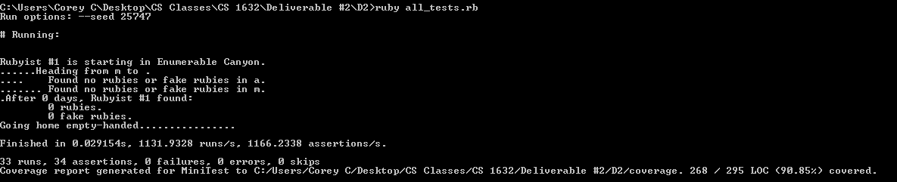**Screenshot of Execute Unit Tests**