CS 1632 – DELIVERABLE 3: Automated System Testing of a Web Application

Corey Catalogna

GitHub: cjc162

<https://github.com/cjc162/D3>

Extra Credit #1 Completed

**Summary**

When working on this project, I first looked to get a rough draft of the web application working. This involved looking back over notes and the sample of how Sinatra works. When creating the web app, I first ran into some difficulty in getting parameters to work. After cloning down the guesser.rb example code from Dr. Laboon’s GitHub, I was able to work out how to use parameters. The second issue I faced was generating the correct bits for the truth table based on the size. After doing some research, I was able to come up with a loop/formula that creates the correct bits for the truth table. I did not find generating the results of the truth table very challenging.

After I had a functional website, I went to the testing phase. I had relatively no issues downloading or getting started with Katalon. One issue I did face was the direction were not particularly clear on what to submit for the test suite. I ended up saving the test suite and submitting the html file that was saved. A final issue I found was testing what URL was currently opened. The solution I cam up with was to test for text or elements that was on the expected page. If the elements were on the page, the URL was correct. If not, the URL was not correct.

**Passed Tests:**

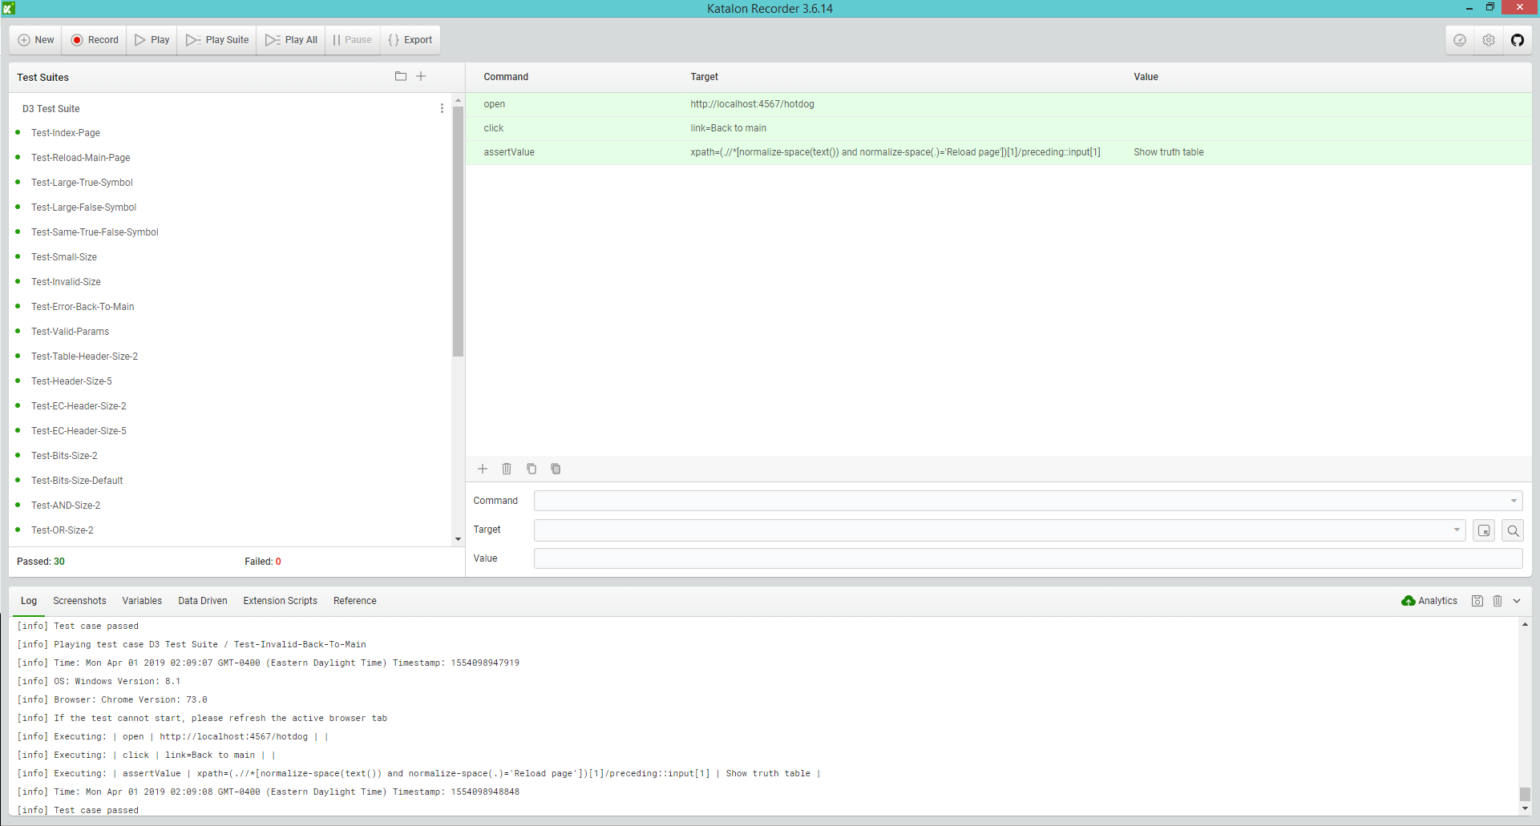

**Traceability Matrix:**

Requirement #1: Test-Index-Page

Requirement #2: Test-Reload-Main-Page, Test-Error-Back-To-Main, Test-Table-Back-To-Main, Test-Invalid-Back-To-Main

Requirement #3: Test-Large-True-Symbol, Test-Large-False-Symbol, Test-Same-True-False-Symbol, Test-Small-Size, Test-Invalid-Size

Requirement #4: Test-Valid-Params

Requirement #5: Test-Header-Size-2, Test-Header-Size-5

Requirement #6: Test-Bits-Size-2, Test-AND-Size-2, Test-OR-Size-2, Test-NAND-Size-2, Test-NOR-Size-2

Requirement #7: Test-Bits-Size-Default, Test-AND-Size-Default, Test-OR-Size-Default, Test-NAND-Size-Default, Test-NOR-Size-Default

Requirement #8: Test-Invalid-URL

Extra Credit: Test-EC-Header-Size-2, Test-EC-Header-Size-5, Test-XOR-Size-2, Test-SINGLE-Size-2, Test-XOR-Size-Default, Test-SINGLE-Size-Default