|  |
| --- |
| University of Northampton | HND Computer Game Development |
| CSY1018 Web Development Assignment 1 |
| CSY1018 Assignment 1 |

|  |
| --- |
| Callum  15-1-2017 |

Contents

Git Hub Links 1

Introduction 1

Home Page 1

Biography 2

CV 3

Contact 4

# Git Hub Links

<https://github.com/cjc1996/csy1018-assign1>

<https://cjc1996.github.io/csy1018-assign1/>

# Introduction

All of the submitted web pages are using flex box within the CSS, in addition they are also using media queries in order to optimize the pages for mobile devices. All of the pages have noteworthy changes within the media queries when the webpages are displayed in a small viewing window.

# Home Page

The home page has three main columns containing information about the website and myself. This information is displayed in the form of the different types of media I handle. The three columns are for software, games and web.

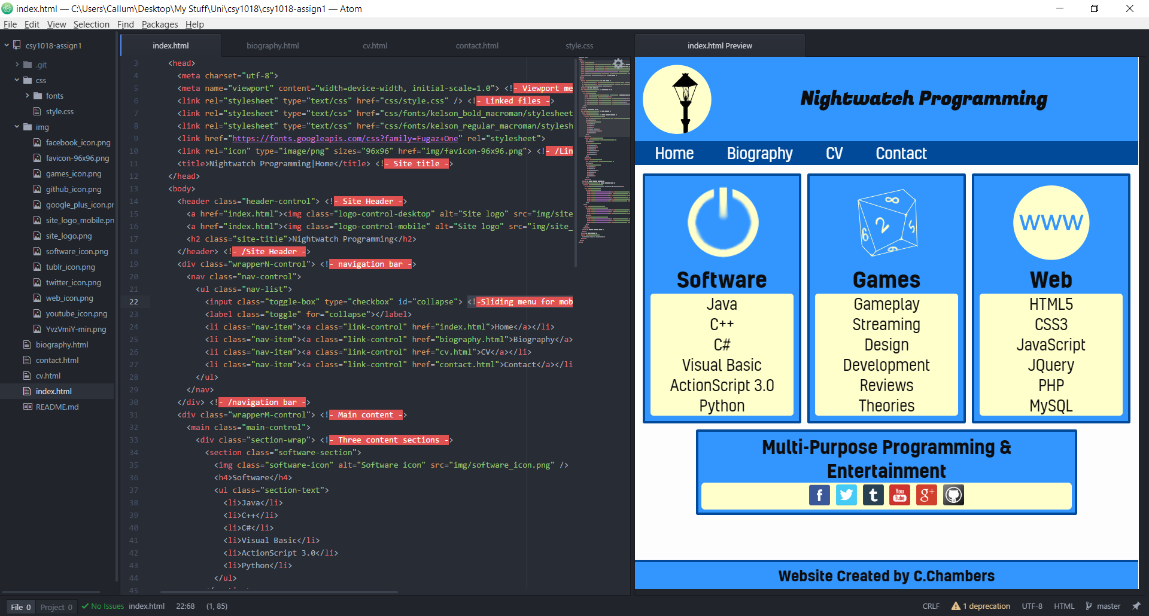

The mobile version of the page changes the flex direction of the content from row to column, laying the three columns above one another. In addition, the social media links also change in format.

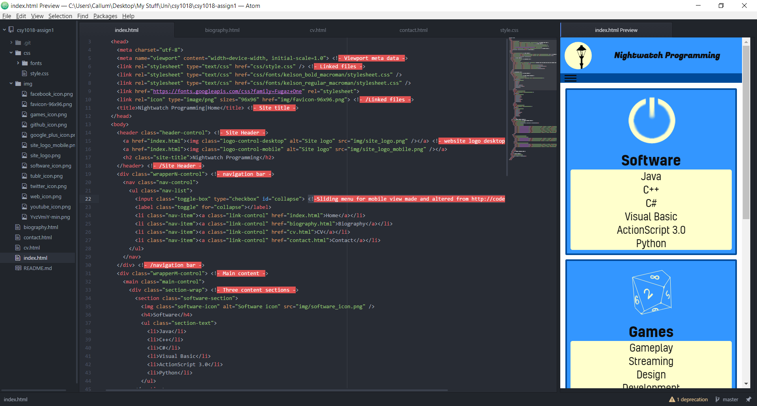

# Biography

The biography page has two sections, one contains the text content and one simply containing a photo, name and tagline. The format for the desktop version has the photo content to the right of the text content. They are both under the flexbox styling using display row. They also both have a percentage width.

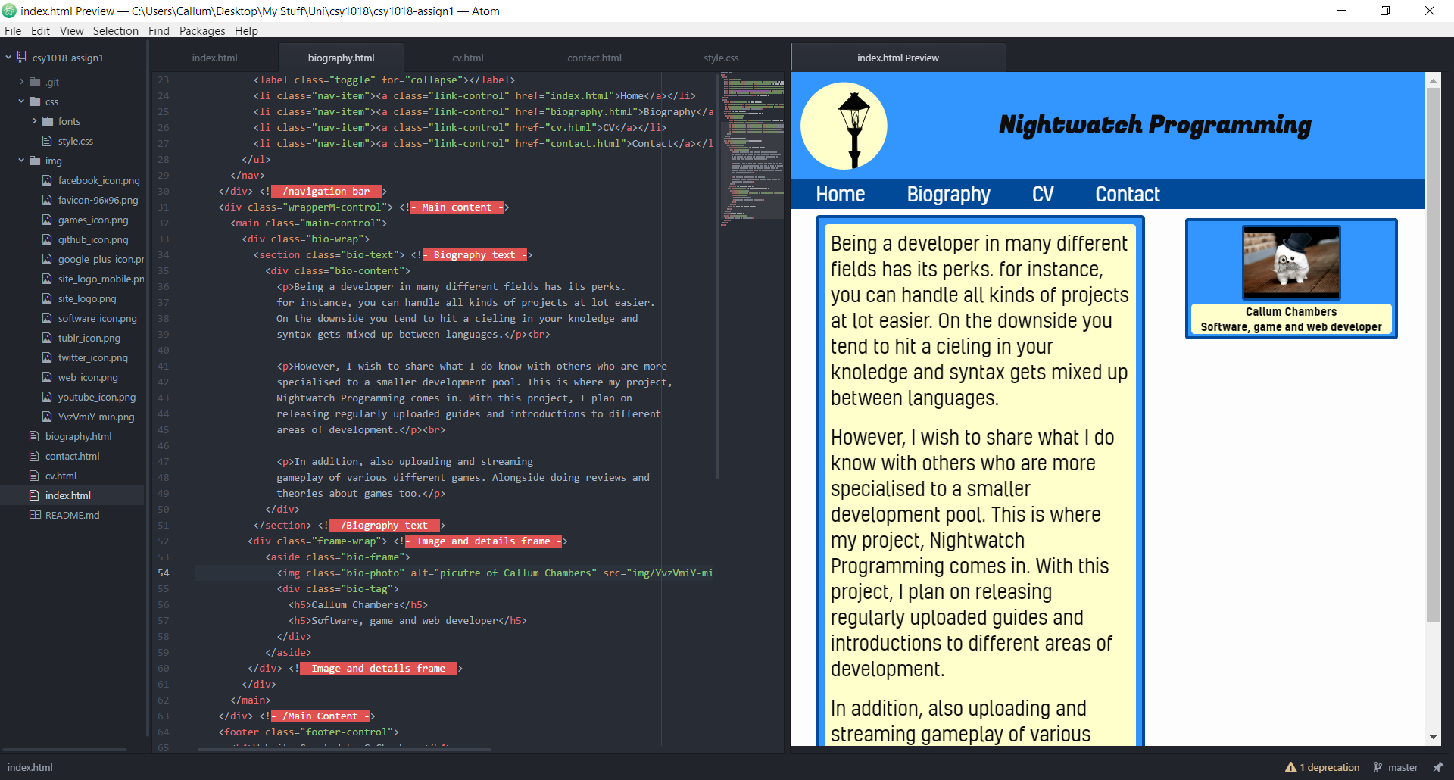

The mobile version, changes the row to a column and changes the order property of the photo content to -1 in order to make it display above the text content. The text content is also cantered to the middle of the page using margin auto.

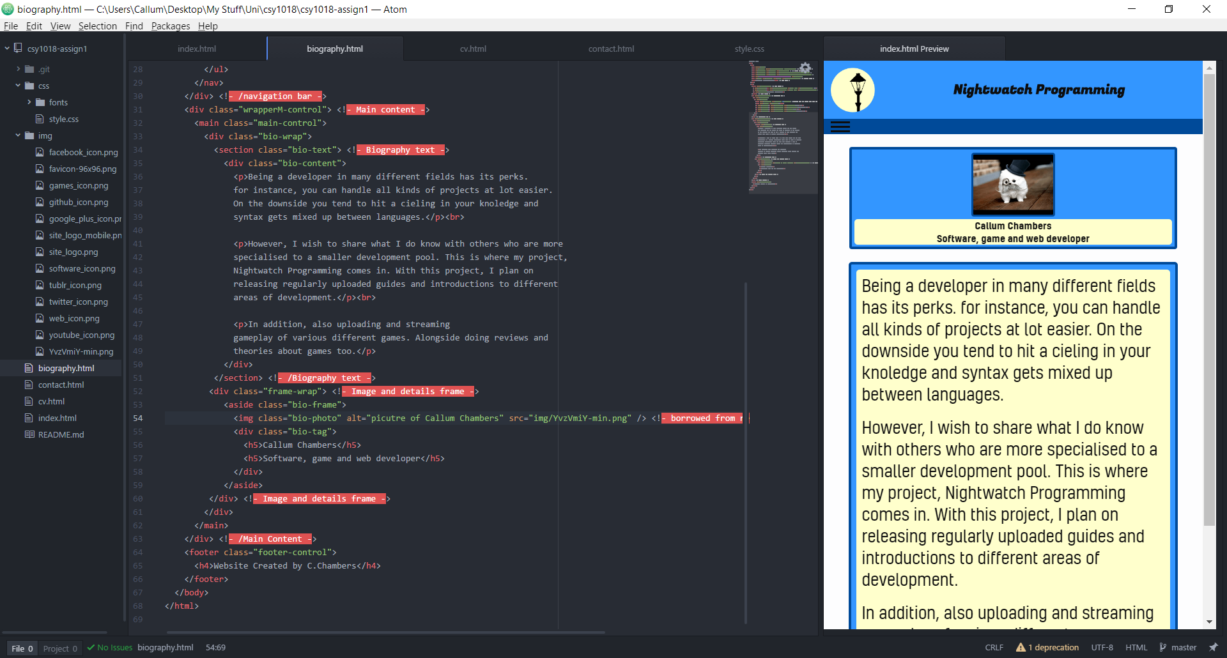

# CV

The CV page has many sections all containing different content. This is done in order to break-up the different content and make it easier to point out the different sections. All of these boxes are still using flexbox. There are two different main divs, using flexbox in order to create the split down the middle between the boxes.

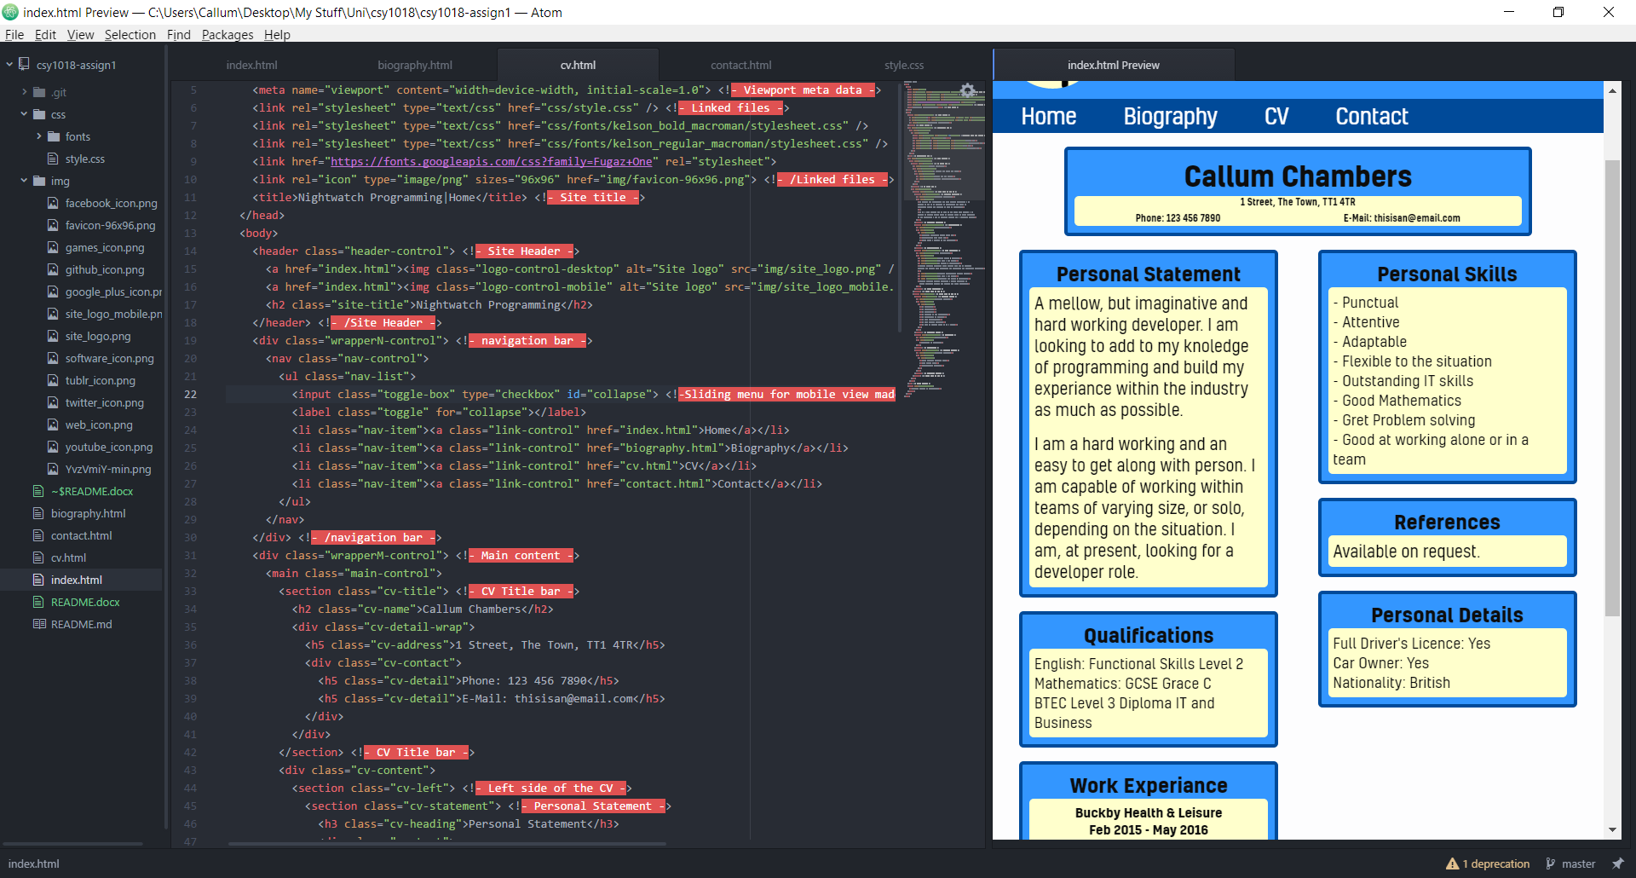

The mobile version of this page removes the split down the middle and aligns all of the sections in a vertical line, it also makes sure all of the sections are centred to the middle of the page. This was done in order to save space on smaller viewing devices, since they typically struggle with displaying content side-by-side.

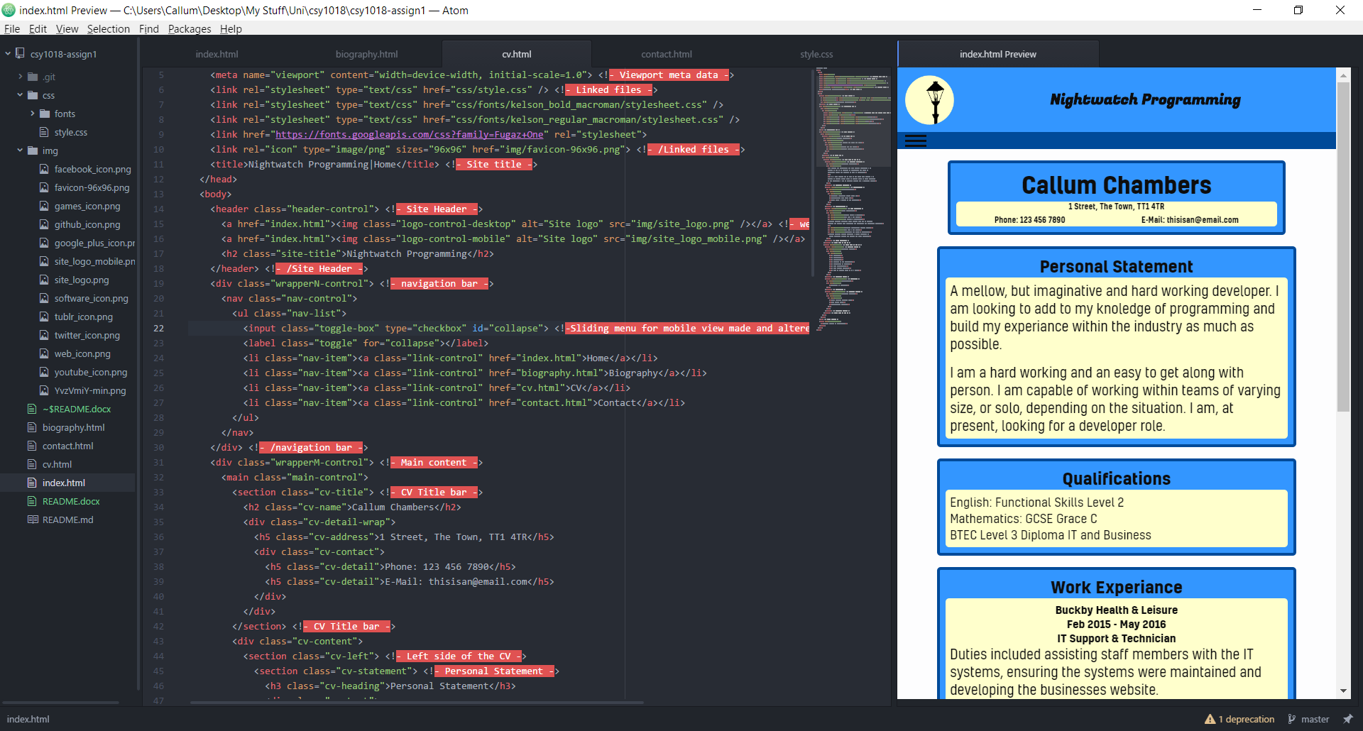

# Contact

The contact page has a form located on it. This form contains three different text field, name, E-mail and message. All three of these fields have been set to take what they need and are also all required. For example, the email field will only except a valid email address into it and none of the fields can be left blank. There is also another set of social network links located on this page.

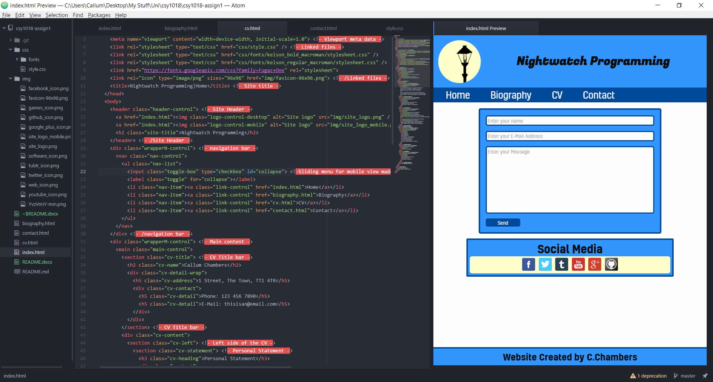

The mobile version of this page does not change too drastically. The main change is that the send button is made wider in order to compensate for smaller devices and touch controls. The social media links also reformat slightly in order to fit more effectively onto the smaller viewport.

