Introduction
Data were collected through a Qualtrics survey between November 13, 2025 and December 31, 2025 (48 days). A total of 166 responses were recorded.
This analysis is broken into seven distinctive sections with analysis focused within their respective topics.
- Load And Clean: Initial cleaning of data. Provides a foundational data frame for further cleaning and analysis of data in future sections.
- Demographics: The demographic data related to each of the survey participants.
- Age Perception: How the survey participants view the subjective concept of age and the age at which the survey taker understands someone to be “old”.
- Fraboni Analysis: Results from participants taking the original Fraboni Scale of Ageism questionnaire.
- Ageism and Employment: Understanding how survey participants understand ageism in the Information Technology field.
- Personal Experience: The personal experience survey participants have had in relation to ageism in their employment career.
- Correlation Analysis: Final overall correlation analysis along with overall assessments.

Session Information
Included are the versions of all tools and packages used in this analysis.
devtools::session_info()
─ Session info ───────────────────────────────────────────────────────────────
setting value
version R version 4.6.0 (2026-04-24 ucrt)
os Windows 11 x64 (build 26300)
system x86_64, mingw32
ui RTerm
language (EN)
collate English_United States.utf8
ctype English_United States.utf8
tz America/Chicago
date 2026-11-12
pandoc 3.8.3 @ C:/Program Files/RStudio/resources/app/bin/quarto/bin/tools/ (via rmarkdown)
quarto 1.10.18 @ C:\\Users\\cjcar\\AppData\\Local\\Programs\\Quarto\\bin\\quarto.exe
─ Packages ───────────────────────────────────────────────────────────────────
package * version date (UTC) lib source
cachem 1.1.0 2024-05-16 [1] CRAN (R 4.6.0)
cli 3.6.6 2026-04-09 [1] CRAN (R 4.6.0)
devtools 2.5.2 2026-04-30 [1] CRAN (R 4.6.0)
digest 0.6.39 2025-11-19 [1] CRAN (R 4.6.0)
ellipsis 0.3.3 2026-04-04 [1] CRAN (R 4.6.0)
evaluate 1.0.5 2025-08-27 [1] CRAN (R 4.6.0)
fastmap 1.2.0 2024-05-15 [1] CRAN (R 4.6.0)
fs 2.1.0 2026-04-18 [1] CRAN (R 4.6.0)
glue 1.8.1 2026-04-17 [1] CRAN (R 4.6.0)
htmltools 0.5.9 2025-12-04 [1] CRAN (R 4.6.0)
jsonlite 2.0.0 2025-03-27 [1] CRAN (R 4.6.0)
knitr 1.51 2025-12-20 [1] CRAN (R 4.6.0)
lifecycle 1.0.5 2026-01-08 [1] CRAN (R 4.6.0)
magrittr 2.0.5 2026-04-04 [1] CRAN (R 4.6.0)
memoise 2.0.1 2021-11-26 [1] CRAN (R 4.6.0)
otel 0.2.0 2025-08-29 [1] CRAN (R 4.6.0)
pkgbuild 1.4.8 2025-05-26 [1] CRAN (R 4.6.0)
pkgload 1.5.3 2026-06-15 [1] CRAN (R 4.6.0)
purrr 1.2.2 2026-04-10 [1] CRAN (R 4.6.0)
R6 2.6.1 2025-02-15 [1] CRAN (R 4.6.0)
ragg 1.5.2 2026-03-23 [1] CRAN (R 4.6.0)
rlang 1.3.0 2026-07-05 [1] CRAN (R 4.6.1)
rmarkdown 2.31 2026-03-26 [1] CRAN (R 4.6.0)
rstudioapi 0.19.0 2026-06-11 [1] CRAN (R 4.6.1)
sessioninfo 1.2.4 2026-06-04 [1] CRAN (R 4.6.0)
systemfonts 1.3.2 2026-03-05 [1] CRAN (R 4.6.0)
textshaping 1.0.5 2026-03-06 [1] CRAN (R 4.6.0)
usethis 3.2.1 2025-09-06 [1] CRAN (R 4.6.0)
vctrs 0.7.3 2026-04-11 [1] CRAN (R 4.6.0)
xfun 0.60 2026-07-09 [1] CRAN (R 4.6.1)
yaml 2.3.12 2025-12-10 [1] CRAN (R 4.6.0)
[1] C:/Users/cjcar/AppData/Local/R/win-library/4.6
[2] C:/Program Files/R/R-4.6.0/library
──────────────────────────────────────────────────────────────────────────────

Load and Clean the Data
This section focuses on loading and performing an initial cleaning of the data. I limit the processing here to data cleaning which can be utilized by all the following sections. Final data cleaning will occur within their respective analysis sections.

Load & Process Data Frame
Load the final data set received from the Qualtrics survey. I let readr try to guess the column types, disable the output from that guessing, and set blanks, ‘NA’, and ‘N/A’ values to the internal R value of NA.
file_path <- "data_final.csv" # Final Data File
# Read in the full CSV into a dataframe.
full_df <- read_csv(file_path, # File Path
col_types = NULL, # Type Guessing Column Types
show_col_types = FALSE, # Suppress Output of Col Types
na = c("", "NA", "N/A") # Set these values to NA
)

Initial Data Frame Processing
A character vector is created to hold the columns I will not be using in this analysis. I then create a new data frame called ‘main_df’ with the following modifications made:
- Removing the top 2 header rows
- Removing unwanted/unnecessary columns
- Rename a column that has potentiall problematic characters: ‘Duration (in seconds)’ to ‘Duration’
- Update the columns Finished, Progress, and Duration to their respected data types
- Add an index value and make it the first column in the data frame
columns_to_remove <- c("Q_RelevantIDDuplicate",
"Q_RelevantIDDuplicateScore",
"Q_RelevantIDFraudScore",
"Q_RelevantIDLastStartDate",
"ResponseId",
"UserLanguage")
# Create a data frame with only the data we want to process
main_df <- full_df |>
slice(3:n()) |> # 3rd Observation Onward
select(-any_of(columns_to_remove)) |> # Remove Unwanted Variables
rename(Duration = `Duration (in seconds)`) |> # Rename Variable
mutate(
ID = 1:n(), # Index Value Auto-Increment
Finished = as.logical(Finished), # Set to Boolean
Progress = as.numeric(Progress), # Set to Numeric
Duration = as.numeric(Duration) # Set to Numeric
) |>
relocate(ID) # Make Index First

Understand Current Observation Counts
I will want to understand how the number of observations changes while I clean the data frame. I will keep two variables and update and report on them for every step of the cleaning process. I initialize the variables ‘old_count’ and ‘new_count’ with the current number of records.
old_count <- nrow(main_df)
new_count <- nrow(main_df)
- Current Observations: 166
This represents the number of survey participants before any cleaning has been completed.

Remove Underage Participants
Due to complexities and legalities when working with individuals under 18 years of age, I am going to remove them.
main_df |>
filter(Age == 'Under 18') |>
nrow()
[1] 0
We have no survey participants who self-reported as Under 18.
- Removed Observations: 0
- New Observation Count: 166

Remove Duplicates
I remove any duplicates that Qualtrics has flagged as a duplicate response. I also remove the column from the data frame after this process is completed.
main_df <- main_df |>
filter(is.na(Q_DuplicateRespondent)) |>
select(-Q_DuplicateRespondent)
old_count <- new_count
new_count <- nrow(main_df)
- Removed Observations: 1
- New Observation Count: 165

Remove Significant NAs
Each of the four survey sections (Age_Perception, Ageism_Employment, Fraboni_Scale, Personal_Experience) is scored and cleaned independently using methods appropiate for the data in their sections. Survey takers who enter data in a single section is potentially meaningful, and a respondent should not be disqualified from the overall results because they skipped other sections.
For that reason, at this stage I only remove respondents who provided no usable data across any of the four sections. These represent participants who essentially abandoned the survey immediately after the demographic questions and have nothing for any downstream section to analyze.
survey_question_prefixes <- c("Age_Perception",
"Ageism_Employment",
"Fraboni_Scale",
"Personal_Experience")
# Per-section NA proportion for every respondent (one column per section)
section_na_pct <- map(
survey_question_prefixes, function(p) {
main_df |>
select(starts_with(p)) |>
is.na() |>
rowMeans()
}
) |>
set_names(survey_question_prefixes) |>
as_tibble()
# Keep respondents unless they are 100% missing in every single section
main_df <- main_df |>
filter(rowSums(section_na_pct == 1) < length(survey_question_prefixes))
old_count <- new_count
new_count <- nrow(main_df)
- Removed Observations: 24
- New Observation Count: 141

Remove Speed-Through & Abandoned
Participants who completed the survey in under 3 minutes likely represent click-through respondents where the quality of the received data are likely very poor. Responses exceeding 4 hours suggest the survey was abandoned. Both are removed from the data frame due to potential low-quality responses.
main_df <- main_df |>
filter(Duration >= 180, Duration <= 14400)
old_count <- new_count
new_count <- nrow(main_df)
- Removed Observations: 6
- New Observation Count: 135

Examine no response for Age
I want to look for any participants who did not specify an age after all the previous cleaning was performed.
main_df |>
filter(is.na(Age)) |>
nrow()
[1] 0
Since no further participants remain that did not specify an age, the data frame at this time contains participants who provided an age.

Update The Date Format
Update all date variables to the R standard format using the lubridate package with the timezone set to America/Chicago which is the timezone set in my Qualtrics profile.
main_df <- main_df |>
mutate(across(c(StartDate, EndDate, RecordedDate),
~ ymd_hms(.x, tz = "America/Chicago")))

Factor The Character Columns
Most character columns are categorical and can take advantage of being factored. I create a character vector with the variables I plan to factor. I then perform the factoring of the variables.
vars_to_factor <- c("Age",
"Gender",
"Country",
"Education",
"IT_Field",
"IT_Industry",
"Status")
main_df <- main_df |>
mutate(across(all_of(vars_to_factor), as.factor))

Set Ordered Levels For Ordinal Factors
Unlike the previous factored variables, the variables Age and Education are ordinal variables — their categories have a meaningful low-to-high order. Setting them as ordered factors here ensures all downstream analyses and graphs sort and interpret them correctly without additional recoding. This will be especially important in the Spearman correlations later.
main_df <- main_df |>
mutate(
Age = factor(Age,
levels = c(
"18-24 years old",
"25-34 years old",
"35-44 years old",
"45-54 years old",
"55-64 years old",
"65+ years old"
),
ordered = TRUE
),
Education = factor(Education,
levels = c(
"Some high school or no formal schooling",
"High school diploma, GED or equivalent",
"Some college, but no degree",
"Associates, vocational, technical degree or equivalent",
"Bachelor's degree or equivalent",
"Graduate degree (MA, MS, MBA, etc.)",
"Terminal degree (PhD, EdD, JD, MD, DDS, etc.)"
),
ordered = TRUE
)
)

Inspect The data frame
At this point, I display a summary of the data frame I have performed the initial cleaning on to see if there are any issues that should be addressed.
summary(main_df)
ID StartDate EndDate
Min. : 1.00 Min. :2025-11-13 14:45:15 Min. :2025-11-13 14:49:58
1st Qu.: 34.50 1st Qu.:2025-11-17 10:23:43 1st Qu.:2025-11-17 10:31:50
Median : 68.00 Median :2025-11-17 15:02:45 Median :2025-11-17 16:23:02
Mean : 72.61 Mean :2025-11-19 19:07:16 Mean :2025-11-19 19:28:21
3rd Qu.:105.00 3rd Qu.:2025-11-19 12:07:43 3rd Qu.:2025-11-19 13:07:30
Max. :166.00 Max. :2025-12-31 05:46:49 Max. :2025-12-31 05:50:31
Status Progress Duration Finished
IP Address:135 Min. : 73.00 Min. : 212 Mode :logical
1st Qu.:100.00 1st Qu.: 481 FALSE:19
Median :100.00 Median : 681 TRUE :116
Mean : 97.03 Mean : 1264
3rd Qu.:100.00 3rd Qu.: 963
Max. :100.00 Max. :14388
RecordedDate DistributionChannel Age
Min. :2025-11-13 15:40:49 Length :135 18-24 years old: 2
1st Qu.:2025-11-17 10:58:41 N.unique : 1 25-34 years old: 7
Median :2025-11-18 08:16:16 N.blank : 0 35-44 years old:25
Mean :2025-11-20 19:07:11 Min.nchar: 9 45-54 years old:52
3rd Qu.:2025-11-21 12:12:57 Max.nchar: 9 55-64 years old:41
Max. :2025-12-31 05:50:31 65+ years old : 8
Gender
Female : 32
Male :101
Prefer not to say: 1
NAs : 1
Country
United States of America :117
India : 6
Ireland : 2
Netherlands : 2
United Kingdom of Great Britain and Northern Ireland: 2
(Other) : 4
NAs : 2
Education
Some high school or no formal schooling : 0
High school diploma, GED or equivalent : 0
Some college, but no degree :18
Associates, vocational, technical degree or equivalent: 6
Bachelor's degree or equivalent :58
Graduate degree (MA, MS, MBA, etc.) :49
Terminal degree (PhD, EdD, JD, MD, DDS, etc.) : 4
IT_Field IT_Industry
Software Development :31 Healthcare & Life Science :74
Cloud Infrastructure & DevOps :17 Information Technology :29
Database Management & ERP :14 Education : 7
Systems & Network Administration:14 Government & Public Sector: 5
Data & Analytics :11 Finance & Banking : 3
Product & Project Management :10 Manufacturing & Industrial: 3
(Other) :38 (Other) :14
Age_Perception_1 Age_Perception_2 Age_Perception_3 Age_Perception_4
Length :135 Length :135 Length :135 Length :135
N.unique : 3 N.unique : 3 N.unique : 4 N.unique : 2
N.blank : 0 N.blank : 0 N.blank : 0 N.blank : 0
Min.nchar: 5 Min.nchar: 3 Min.nchar: 3 Min.nchar: 5
Max.nchar: 11 Max.nchar: 10 Max.nchar: 11 Max.nchar: 11
NAs : 3 NAs : 5 NAs : 4 NAs : 4
Age_Perception_5 Age_Perception_6 Age_Perception_7 Age_Perception_8
Length :135 Length :135 Length :135 Length :135
N.unique : 2 N.unique : 2 N.unique : 3 N.unique : 2
N.blank : 0 N.blank : 0 N.blank : 0 N.blank : 0
Min.nchar: 5 Min.nchar: 5 Min.nchar: 3 Min.nchar: 3
Max.nchar: 11 Max.nchar: 11 Max.nchar: 11 Max.nchar: 11
NAs : 4 NAs : 3 NAs : 3 NAs : 4
Age_Perception_9 Age_Perception_10 Age_Perception_11 Age_Perception_12
Length :135 Length :135 Length :135 Length :135
N.unique : 3 N.unique : 4 N.unique : 4 N.unique : 3
N.blank : 0 N.blank : 0 N.blank : 0 N.blank : 0
Min.nchar: 3 Min.nchar: 3 Min.nchar: 3 Min.nchar: 3
Max.nchar: 11 Max.nchar: 11 Max.nchar: 11 Max.nchar: 11
NAs : 4 NAs : 3 NAs : 2 NAs : 3
Age_Perception_13 Age_Perception_14 Ageism_Employment_1 Ageism_Employment_2
Length :135 Length :135 Length :135 Length :135
N.unique : 3 N.unique : 2 N.unique : 5 N.unique : 5
N.blank : 0 N.blank : 0 N.blank : 0 N.blank : 0
Min.nchar: 3 Min.nchar: 3 Min.nchar: 14 Min.nchar: 14
Max.nchar: 11 Max.nchar: 8 Max.nchar: 26 Max.nchar: 26
NAs : 4 NAs : 1 NAs : 6 NAs : 6
Ageism_Employment_3 Ageism_Employment_4 Ageism_Employment_5
Length :135 Length :135 Length :135
N.unique : 4 N.unique : 4 N.unique : 5
N.blank : 0 N.blank : 0 N.blank : 0
Min.nchar: 14 Min.nchar: 14 Min.nchar: 14
Max.nchar: 26 Max.nchar: 26 Max.nchar: 26
NAs : 6 NAs : 7 NAs : 6
Ageism_Employment_6 Ageism_Employment_7 Ageism_Employment_8
Length :135 Length :135 Length :135
N.unique : 4 N.unique : 5 N.unique : 5
N.blank : 0 N.blank : 0 N.blank : 0
Min.nchar: 14 Min.nchar: 14 Min.nchar: 14
Max.nchar: 26 Max.nchar: 26 Max.nchar: 26
NAs : 7 NAs : 6 NAs : 6
Ageism_Employment_9 Ageism_Employment_10 Ageism_Employment_11
Length :135 Length :135 Length :135
N.unique : 5 N.unique : 5 N.unique : 5
N.blank : 0 N.blank : 0 N.blank : 0
Min.nchar: 14 Min.nchar: 14 Min.nchar: 14
Max.nchar: 26 Max.nchar: 26 Max.nchar: 26
NAs : 6 NAs : 6 NAs : 7
Ageism_Employment_12 Ageism_Employment_13 Ageism_Employment_14
Length :135 Length :135 Length :135
N.unique : 5 N.unique : 5 N.unique : 5
N.blank : 0 N.blank : 0 N.blank : 0
Min.nchar: 14 Min.nchar: 14 Min.nchar: 14
Max.nchar: 26 Max.nchar: 26 Max.nchar: 26
NAs : 6 NAs : 6 NAs : 8
Ageism_Employment_15 Ageism_Employment_16 Ageism_Employment_17
Length :135 Length :135 Length :135
N.unique : 5 N.unique : 5 N.unique : 5
N.blank : 0 N.blank : 0 N.blank : 0
Min.nchar: 14 Min.nchar: 14 Min.nchar: 14
Max.nchar: 26 Max.nchar: 26 Max.nchar: 26
NAs : 6 NAs : 9 NAs : 6
Ageism_Employment_18 Ageism_Employment_19 Fraboni_Scale_1 Fraboni_Scale_2
Length :135 Length :135 Length :135 Length :135
N.unique : 5 N.unique : 5 N.unique : 4 N.unique : 4
N.blank : 0 N.blank : 0 N.blank : 0 N.blank : 0
Min.nchar: 14 Min.nchar: 14 Min.nchar: 5 Min.nchar: 5
Max.nchar: 26 Max.nchar: 26 Max.nchar: 17 Max.nchar: 17
NAs : 6 NAs : 6 NAs : 17 NAs : 18
Fraboni_Scale_3 Fraboni_Scale_4 Fraboni_Scale_5 Fraboni_Scale_6
Length :135 Length :135 Length :135 Length :135
N.unique : 4 N.unique : 3 N.unique : 4 N.unique : 3
N.blank : 0 N.blank : 0 N.blank : 0 N.blank : 0
Min.nchar: 5 Min.nchar: 5 Min.nchar: 5 Min.nchar: 5
Max.nchar: 17 Max.nchar: 17 Max.nchar: 17 Max.nchar: 17
NAs : 17 NAs : 17 NAs : 17 NAs : 18
Fraboni_Scale_7 Fraboni_Scale_8 Fraboni_Scale_9 Fraboni_Scale_10
Length :135 Length :135 Length :135 Length :135
N.unique : 3 N.unique : 3 N.unique : 4 N.unique : 3
N.blank : 0 N.blank : 0 N.blank : 0 N.blank : 0
Min.nchar: 5 Min.nchar: 5 Min.nchar: 5 Min.nchar: 5
Max.nchar: 17 Max.nchar: 17 Max.nchar: 17 Max.nchar: 17
NAs : 17 NAs : 18 NAs : 18 NAs : 18
Fraboni_Scale_11 Fraboni_Scale_12 Fraboni_Scale_13 Fraboni_Scale_14
Length :135 Length :135 Length :135 Length :135
N.unique : 4 N.unique : 4 N.unique : 4 N.unique : 4
N.blank : 0 N.blank : 0 N.blank : 0 N.blank : 0
Min.nchar: 5 Min.nchar: 5 Min.nchar: 5 Min.nchar: 5
Max.nchar: 17 Max.nchar: 17 Max.nchar: 17 Max.nchar: 17
NAs : 17 NAs : 18 NAs : 17 NAs : 18
Fraboni_Scale_15 Fraboni_Scale_16 Fraboni_Scale_17 Fraboni_Scale_18
Length :135 Length :135 Length :135 Length :135
N.unique : 4 N.unique : 4 N.unique : 4 N.unique : 3
N.blank : 0 N.blank : 0 N.blank : 0 N.blank : 0
Min.nchar: 5 Min.nchar: 5 Min.nchar: 5 Min.nchar: 5
Max.nchar: 17 Max.nchar: 17 Max.nchar: 17 Max.nchar: 17
NAs : 19 NAs : 19 NAs : 20 NAs : 18
Fraboni_Scale_19 Fraboni_Scale_20 Fraboni_Scale_21 Fraboni_Scale_22
Length :135 Length :135 Length :135 Length :135
N.unique : 4 N.unique : 3 N.unique : 4 N.unique : 4
N.blank : 0 N.blank : 0 N.blank : 0 N.blank : 0
Min.nchar: 5 Min.nchar: 5 Min.nchar: 5 Min.nchar: 5
Max.nchar: 17 Max.nchar: 17 Max.nchar: 17 Max.nchar: 17
NAs : 19 NAs : 19 NAs : 19 NAs : 18
Fraboni_Scale_23 Fraboni_Scale_24 Fraboni_Scale_25 Fraboni_Scale_26
Length :135 Length :135 Length :135 Length :135
N.unique : 4 N.unique : 4 N.unique : 4 N.unique : 4
N.blank : 0 N.blank : 0 N.blank : 0 N.blank : 0
Min.nchar: 5 Min.nchar: 5 Min.nchar: 5 Min.nchar: 5
Max.nchar: 17 Max.nchar: 17 Max.nchar: 17 Max.nchar: 17
NAs : 19 NAs : 20 NAs : 19 NAs : 19
Fraboni_Scale_27 Fraboni_Scale_28 Fraboni_Scale_29 Personal_Experience_1
Length :135 Length :135 Length :135 Length :135
N.unique : 4 N.unique : 4 N.unique : 4 N.unique : 3
N.blank : 0 N.blank : 0 N.blank : 0 N.blank : 0
Min.nchar: 5 Min.nchar: 5 Min.nchar: 5 Min.nchar: 4
Max.nchar: 17 Max.nchar: 17 Max.nchar: 17 Max.nchar: 22
NAs : 18 NAs : 18 NAs : 18 NAs : 20
Personal_Experience_2 Personal_Experience_3 Personal_Experience_4
Length :135 Length :135 Length :135
N.unique : 3 N.unique : 3 N.unique : 3
N.blank : 0 N.blank : 0 N.blank : 0
Min.nchar: 4 Min.nchar: 4 Min.nchar: 4
Max.nchar: 22 Max.nchar: 22 Max.nchar: 22
NAs : 20 NAs : 20 NAs : 21
Personal_Experience_5 Personal_Experience_6 Personal_Experience_7
Length :135 Length :135 Length :135
N.unique : 3 N.unique : 3 N.unique : 3
N.blank : 0 N.blank : 0 N.blank : 0
Min.nchar: 4 Min.nchar: 4 Min.nchar: 4
Max.nchar: 22 Max.nchar: 22 Max.nchar: 22
NAs : 20 NAs : 20 NAs : 21
Personal_Experience_8 Personal_Experience_9 Personal_Experience_10
Length :135 Length :135 Length :135
N.unique : 3 N.unique : 3 N.unique : 3
N.blank : 0 N.blank : 0 N.blank : 0
Min.nchar: 4 Min.nchar: 4 Min.nchar: 4
Max.nchar: 22 Max.nchar: 22 Max.nchar: 22
NAs : 20 NAs : 20 NAs : 20
Comments
Length : 135
N.unique : 30
N.blank : 0
Min.nchar: 4
Max.nchar:1113
NAs : 105

Save out the Data Frame
The data frame has been cleaned to a point where the data are usable in future analysis. I save out the data frame in RDS format for input into each of the different sections of this analysis so they can be independently processed.
saveRDS(main_df, "main_df.rds")

Conclusion
Data from Qualtrics were loaded and an initial cleaning was performed. At this point not all NA values have been addressed as they will be looked at and addressed appropriately in their respective sections.

Cleaning Performed:
- Removed CSV headers
- Removed unwanted and unnecessary columns
- Updated column names to address problematic characters
- Updated the columns Finished, Progress, and Duration to their data types
- Added an index and made it the first column in the data frame
- Removed ineligible participants (under 18 and unidentified)
- Removed duplicates identified by Qualtrics
- Removed observations with excessive NAs
- Removed outlier timed submissions
- Standardized all date formats
- Factored character columns
- Set ordered levels for ordinal factors

Final Response Counts:
Table 1: Participant Survey Results
 | Count
Original responses | 166
Removed during initial cleaning | 31
Final analytic sample | 135

Participant Demographics
This section focuses on the demographics of the survey participants. I will use the data frame provided earlier to analyze and report on the demographics of survey participants. No further cleaning of the data frame occurs in this section.

Participant Age Grouping Demographics
The age demographics of participants is fairly well spread out with most of the people reporting an age of 45-54 years old. This is a bell curve that is weighted a bit more towards the 65+ over the 18-24 year old participants. As previously indicated, all participants reporting ages under 18 or skipped reporting their age were removed from this research analysis.
graph_bar_chart(main_df,
'Age',
'Age Grouping',
'Participant Count')
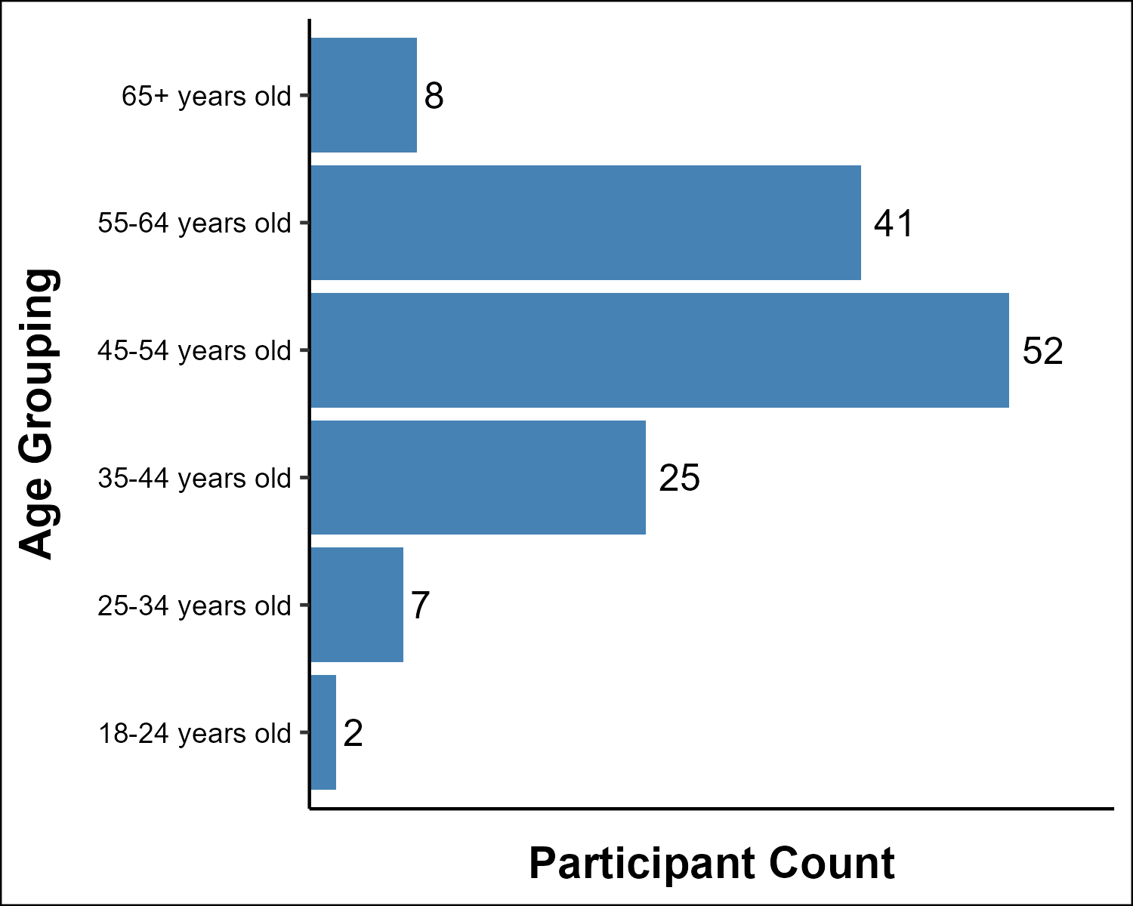
Figure 1: Survey Participants by Age Group

Participant Gender Demographics
Male participants represent approximately 76% of respondents with Female participants at roughly 24%. One respondent did not report gender and is excluded from gender-based comparisons. This gender skew is consistent with the broader gender imbalance in the IT industry and should be considered when interpreting results.
NEED BETTER STATEMENT AND CITATION. Gender imbalance is well documented through research. The WorldBank 2025 report on Digital Progress and Trends notes that women only make up 24 percent of Information and Communication Technology professionals world-wide.
https://openknowledge.worldbank.org/server/api/core/bitstreams/99474f35-6a0c-48c3-9104-7b693e04313e/content
graph_bar_chart(main_df,
'Gender',
'Gender',
'Participant Count')
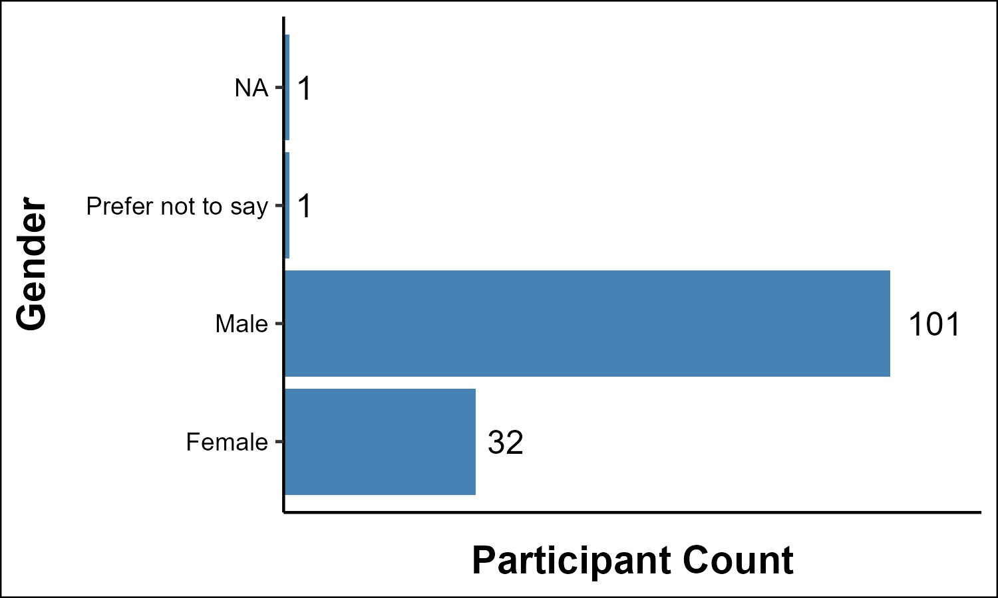
Figure 2: Survey Participants By Gender
The table below restricts the comparison to respondents who identified as Male or Female, excluding those who did not report a gender or selected “Prefer not to say.”
main_df |>
filter(Gender %in% c("Male", "Female")) |>
count(Gender, name = "n") |>
mutate(Percent = paste0(round(n / sum(n) * 100, 1), "%")) |>
knitr::kable(col.names = c("Gender", "Count", "Percent"),
align = c("l", "r", "r"))
Table 2: Male vs. Female Participants (Excluding NA and Prefer Not to Say)
Gender | Count | Percent
Female | 32 | 24.1%
Male | 101 | 75.9%

Participant Country Demographics
The United States accounts for the large majority of respondents. The remaining participants represent eight other countries, none exceeding 5% of the sample individually. Given this concentration, country of residence is not examined as an independent variable in the analysis.
main_df |>
mutate(Country = recode(Country,
"United Kingdom of Great Britain and Northern Ireland" = "United Kingdom"
)) |>
count(Country, name = "n") |>
mutate(
Country = tidyr::replace_na(as.character(Country), "Not Reported"),
Percent = paste0(round(n / nrow(main_df) * 100, 1), "%")
) |>
arrange(desc(n)) |>
knitr::kable(col.names = c("Country", "Count", "Percent"),
align = c("l", "r", "r"))
Table 3: Participants By Country
Country | Count | Percent
United States of America | 117 | 86.7%
India | 6 | 4.4%
Ireland | 2 | 1.5%
Netherlands | 2 | 1.5%
United Kingdom | 2 | 1.5%
Not Reported | 2 | 1.5%
Australia | 1 | 0.7%
Canada | 1 | 0.7%
Ghana | 1 | 0.7%
Switzerland | 1 | 0.7%

Participant Education Level Demographics
This analysis shows a fairly diverse education level for the participants. Bachelor’s (or equivalent) and Graduate Degree holders representing the majority of survey participants with almost 80% of respondents.
graph_bar_chart(main_df,
'Education',
'Education Level',
'Participant Count')
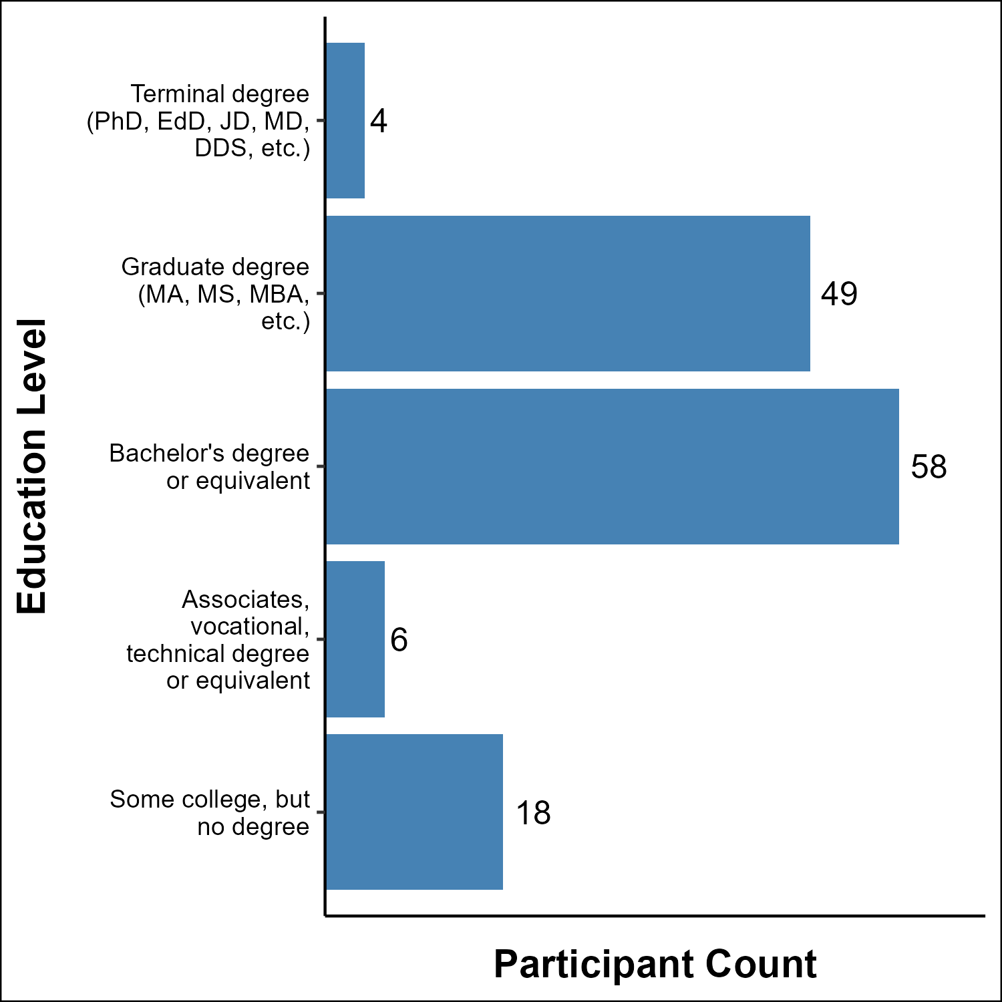
Figure 3: Survey Participants By Education Level

Participant IT Field Demographics
Participants represent a wide range of IT specializations. Software Development is the most common field at 22% of respondents, followed by Cloud Infrastructure & DevOps (11%), Database Management & ERP (9%), and Systems & Network Administration (9%). Data & Analytics and IT Support & Help Desk each account for roughly 7-8%. The remaining participants are distributed across eight other specializations.
graph_bar_chart(main_df,
'IT_Field',
'IT Field',
'Participant Count')
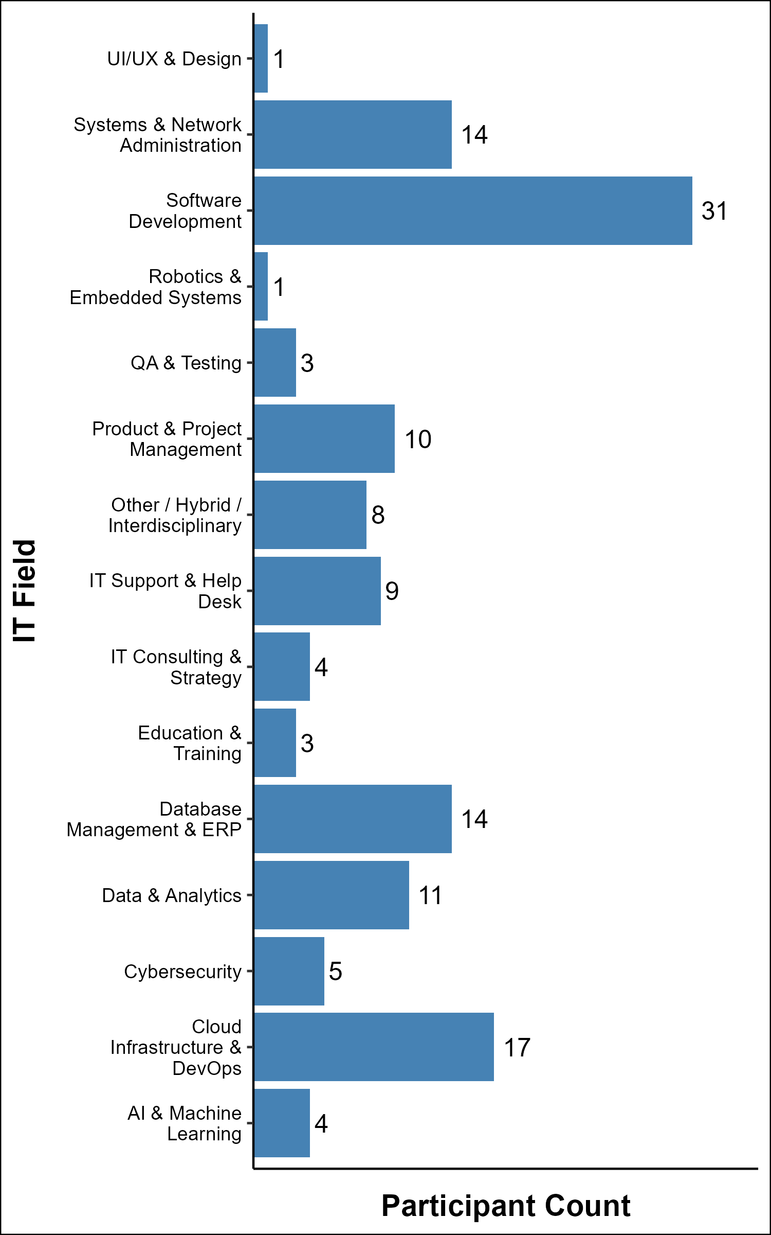
Figure 4: Survey Participants By IT Field

Participant IT Industry Demographics
The sample is heavily concentrated in two industries. Healthcare & Life Science account for 51% of respondents. Information Technology accounts for an additional 20%. The remaining 29% are distributed across twelve other industries, with Education and Government & Public Sector each representing about 4%. The concentration in Healthcare & Life Science likely reflects the distribution channels I used to recruit participants.
graph_bar_chart(main_df,
'IT_Industry',
'IT Industry',
'Participant Count')
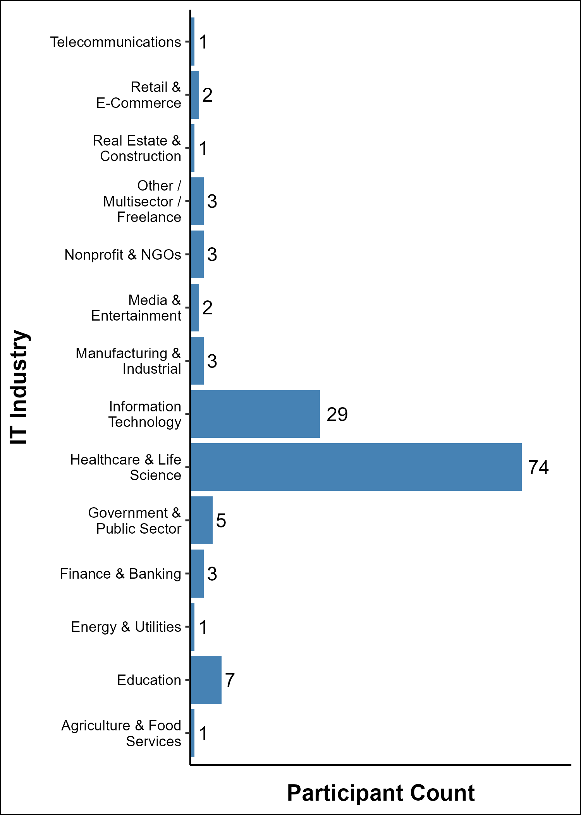
Figure 5: Survey Participants By IT Industry

Conclusion
This section highlights the demographics of the survey participants. Notable results from this section include:
- Age Groups are represented with a bell curve weighted more towards the older groups than younger groups.
- Gender imbalance reflects the IT Industry as a whole.
- The United States represents the largest number of survey takers.
- Education has most respondents reporting Bachelor or Graduate degrees.
- A diverse representation from different IT Fields are represented.
- The IT Industry is heavily represented by Healthcare and Life Science jobs.

Age Perception
This section focuses on the perception of old age to determine at what point a person is identified as old with respect to the respondents own age. I wish to answer Research Question 1: What is the correlation, if any, between an IT worker’s own age and the age at which they feel a person is deemed “old”.

Vector Definitions
I define the named and character vectors here to assign the labels in the survey with numbers so we can perform statistical analysis on the results along with definitions to better understand data.
# Map for converting Age_Perception section answers to Likert scale numbers.
age_perception_map <- c(
"Very Young" = 1,
"Young" = 2,
"Middle Aged" = 3,
"Old" = 4,
"Very Old" = 5
)
# Map of the Respondent Age Levels based on the Survey
# Note: All respondents under 18 have been removed.
respondent_age_levels <- c(
"18-24 years old",
"25-34 years old",
"35-44 years old",
"45-54 years old",
"55-64 years old",
"65+ years old"
)
# Map for better formatting of labels.
respondent_age_labels <- c(
"18-24",
"25-34",
"35-44",
"45-54",
"55-64",
"65+"
)
# Age Labels for Questions
age_labels <- c(
"18-21",
"22-25",
"26-30",
"31-35",
"36-40",
"41-45",
"46-50",
"51-55",
"56-60",
"61-65",
"66-70",
"71-75",
"76-80",
"81+"
)
# Rating Labels
rating_labels = c(
'1 - Very\nYoung',
'2 - Young',
'3 - Middle\nAged',
'4 - Old',
'5 - Very\nOld'
)

Age Perception dataframe
I create an Age Perception data frame with ID and answers to the Ageism Perception questions.
# Build data frame with only the variables that are valuable in this analysis.
age_perception_df <- main_df |>
select(ID, Age, starts_with("Age_Perception_"))
# Factor Age and Map the Perception to a Number.
age_perception_df <- age_perception_df |>
mutate(
respondent_age = factor(
respondent_age_labels[match(Age, respondent_age_levels)],
levels = respondent_age_labels
),
across(starts_with("Age_Perception_"),
~ age_perception_map[.x]))
# Drop Age Column in favor of respondent_age
age_perception_df <- age_perception_df |>
select(-Age)

Inspect Rows With Missing Values
There will be two strategies used to address NA values. If a row doesn’t start with NA, I can make logical determinations as to what the values would be with a forward fill strategy. If the row starts with NA, I make a decision between using an imputation strategy or dropping the row completely.
Before making these decisions, I want to see which respondents have any NAs across the Age_Perception items, how many NAs each has, and specifically how many begin with an NA in the first item.
na_inspect <- age_perception_df |>
mutate(
na_count = rowSums(is.na(across(starts_with("Age_Perception_")))),
starts_na = is.na(Age_Perception_1)
) |>
filter(na_count > 0) |>
select(ID, respondent_age, na_count, starts_na)
na_inspect |>
knitr::kable(col.names = c("ID",
"Respondent Age",
"Num Missing",
"Starts With NA"))
ID | Respondent Age | Num Missing | Starts With NA
18 | 65+ | 9 | FALSE
32 | 55-64 | 1 | TRUE
55 | 35-44 | 4 | TRUE
65 | 35-44 | 1 | FALSE
70 | 55-64 | 10 | FALSE
90 | 45-54 | 9 | FALSE
157 | 55-64 | 13 | TRUE
- Rows with any NA: 7
- Rows starting with NA (leading NA, unfixable by forward fill): 3

Dropping Rows
There is a fairly significant cutoff seen in the data. There are only 7 rows with missing data at all, and the rows with 9, 10, and 13 missing values represent significant missing values. I choose to drop these completely.
age_perception_df <- age_perception_df |>
mutate(
na_count = rowSums(is.na(across(starts_with("Age_Perception_"))))
)|>
filter(na_count < 9 ) |>
select(-na_count)

Forward Fill
I use tidyr to fill in the missing values with the previously recorded value.
The reasoning behind filling with previous numbers is the nature of the question. If a blank exists in the results, we can imply the previous value is correct. Only when the survey participant changes their answer does the next value take place.
For example:
1 1 1 X 2 2 3
In this example, we can assume X to be 1.
1 2 2 3 X X 4
In this example, we can assume X to be 3.
age_perception_df <- age_perception_df |>
# Reshape the Age_Perception columns to long format
pivot_longer(
cols = starts_with("Age_Perception_"),
names_to = "item",
values_to = "response"
) |>
# Group by survey taker
group_by(ID) |>
# Forward fill missing values within each respondent
fill(response, .direction = "down") |>
# Reshape back to wide format
pivot_wider(
names_from = item,
values_from = response
)

Address NA Starts
To address rows that start with NA, I use MICE to impute the missing values.
Note: This analysis only averages the values of the 5 MICE iterations. Since all downstream analysis against this data uses Spearman or Kruskal-Wallis rank-based tests which depend only on value ordering rather than exact magnitudes, averaging is appropriate even when imputation uncertainty exists. Combined with sparse missing data (confined to a small number of leading NAs in a 14-item sequence) and a focus on central tendency rather than precise confidence intervals, this approach is a deliberate choice that balances rigor with simplicity for exploratory analysis.
I create a method vector to tell MICE not to use the ID column as a predictor. It will never be NA, so I don’t need to worry about being imputed itself.
pred <- make.predictorMatrix(age_perception_df)
pred[,"ID"] <- 0
pred[, "respondent_age"] <- 0

Run mice with 5 Iterations
I run MICE to create 5 iterations of analysis where missing items are filled. I specify a seed so I can always be given matching results.
imputed <- mice(age_perception_df,
method = "pmm",
predictorMatrix = pred,
m = 5,
seed = 53421)

Extract the completed data back into our age_perception dataframe.
Here I take values from the MICE iterations and replace the NA values with the averaged predictions.
age_perception_df <- complete(imputed, "long") |>
group_by(.id) |>
summarise(
ID = first(ID),
respondent_age = first(respondent_age),
across(starts_with("Age_Perception_"), ~ round(mean(.x)))
) |>
select(-'.id')

Post Data Frame Manipulation Information:
Any NAs in age perception data frame: FALSE
Number of Research Participants for Age Perception Analysis is: 131

Save Out Age Perception Data Frame
We will be using this cleaned data frame in our Correlation Analysis.
saveRDS(age_perception_df,
"age_perception_df.rds")

Create Pivot Of Data Frame
I pivot the data frame in a format where I can group by the different age groupings.
# Reshape to long format
df_long <- age_perception_df |>
pivot_longer(
cols = starts_with("Age_Perception_"),
names_to = "group",
values_to = "rating"
) |>
mutate(
group_num = as.integer(str_extract(group, "\\d+")),
age_group = factor(age_labels[group_num], levels = age_labels)
) |>
filter(!is.na(rating))

Build Summary Dataframe
Build summary data frame for analysis and graphing.
df_summary <- df_long |>
group_by(age_group) |>
summarise(
mean_score = mean(rating),
)

Participant Average Age Perception Data
This graph shows the average score for all survey participants with respect to the presented age group and their age scale rating. This is an expected semi-linear line that increases as the age group being presented increases.
Important Note: This does not take into consideration the participants own age.
graph_line_chart(df_summary,
'age_group',
'mean_score',
'Age Group Being Rated',
'Age Scale Rating',
y_breaks = 1:5,
y_labels = rating_labels,
y_limits = c(1,5))
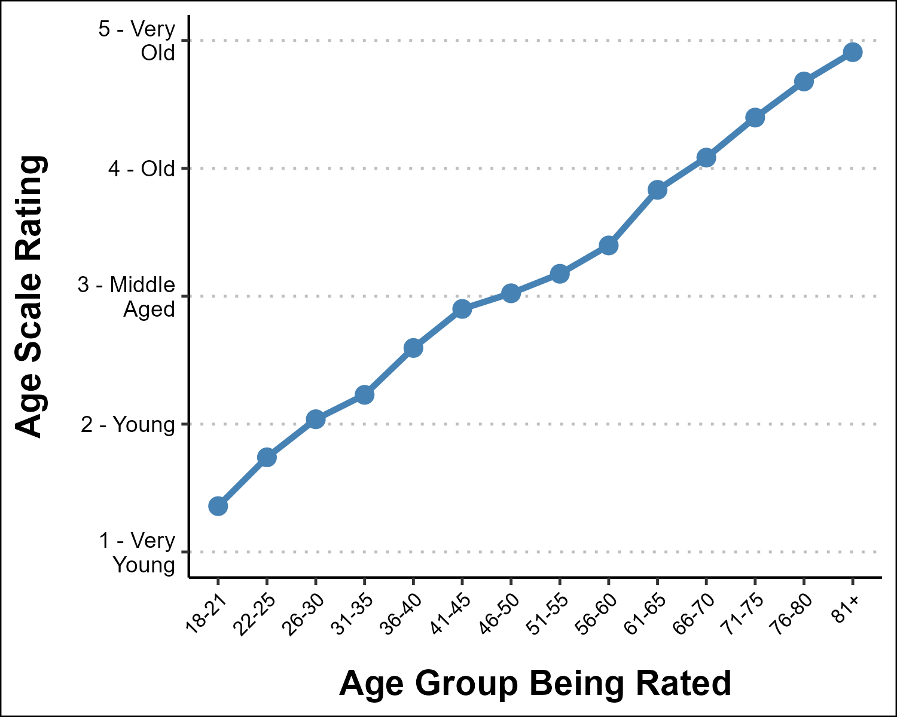
Figure 6: At What Age Is Old?

Heatmap of Respondents
This heatmap gives a better understanding of how each respondent rated the age group. From it there is the same somewhat linear grouping of most of the respondents, however there are some outliers exposed by this graph.
Again, this graph does not take into consideration the participants own age.
graph_heatmap(
df = df_long,
x_category = "age_group",
y_category = "rating",
x_label = "Age Group Being Rated",
y_label = "Age Scale Rating",
y_labels = rating_labels
)
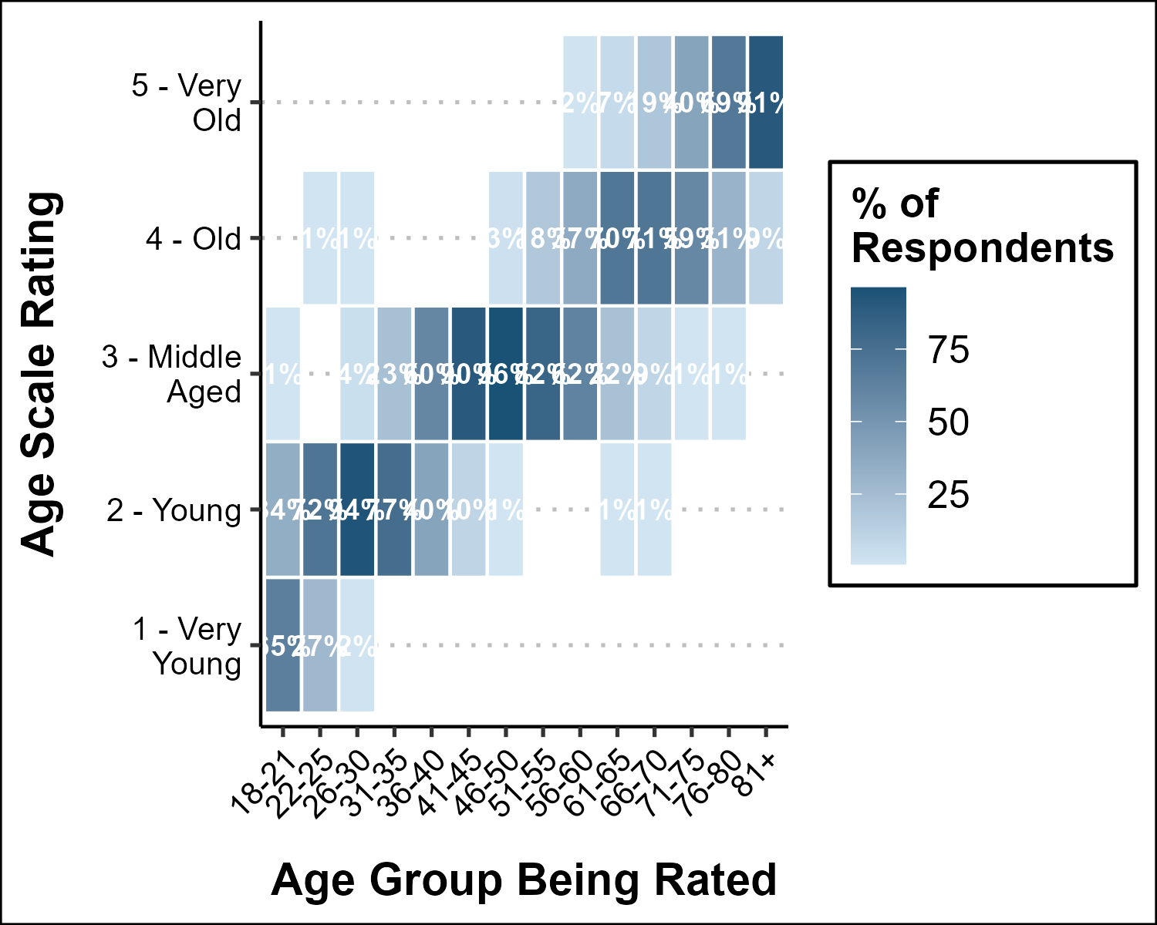
Figure 7: Heatmap of Distribution of Age Perception Ratings

Age Group Counts
Again, it is important to reiterate the number of people represented in each of the age groups. Because the respondents in the 18-24, 25-34 and 65+ were much smaller than the other age groups, the following analysis of age based results must be interpreted with caution.
age_perception_df |>
count(respondent_age, name = "Count") |>
mutate(Percentage = round(Count / sum(Count) * 100, 1)) |>
knitr::kable(col.names = c("Age Group", "N", "%"))
Table 4: Number of Participants by Age Group
Age Group | N | %
18-24 | 2 | 1.5
25-34 | 7 | 5.3
35-44 | 25 | 19.1
45-54 | 51 | 38.9
55-64 | 39 | 29.8
65+ | 7 | 5.3

Age Perception based on own age
These graphs show how each age group rated the age groupings. The number of respondents in the 18-24 range, 25-34 range, and 65+ range were limited which introduces a larger confidence interval in their graphs.
df_summary <- df_long |>
filter(!is.na(respondent_age)) |>
group_by(respondent_age, age_group) |>
summarise(
mean_score = mean(rating, na.rm = TRUE),
se = sd(rating, na.rm = TRUE) / sqrt(n()),
ci_lo = mean_score - 1.96 * se,
ci_hi = mean_score + 1.96 * se,
.groups = "drop"
)
graph_line_chart(
df = df_summary,
x_category = "age_group",
y_category = "mean_score",
x_label = "Age Bracket Being Rated",
y_label = "Mean Perception Score",
subtitle = paste0(
""),
facet_var = "respondent_age",
ci_lo = "ci_lo",
ci_hi = "ci_hi",
y_limits = c(1, 5),
y_breaks = 1:5,
y_labels = rating_labels
)
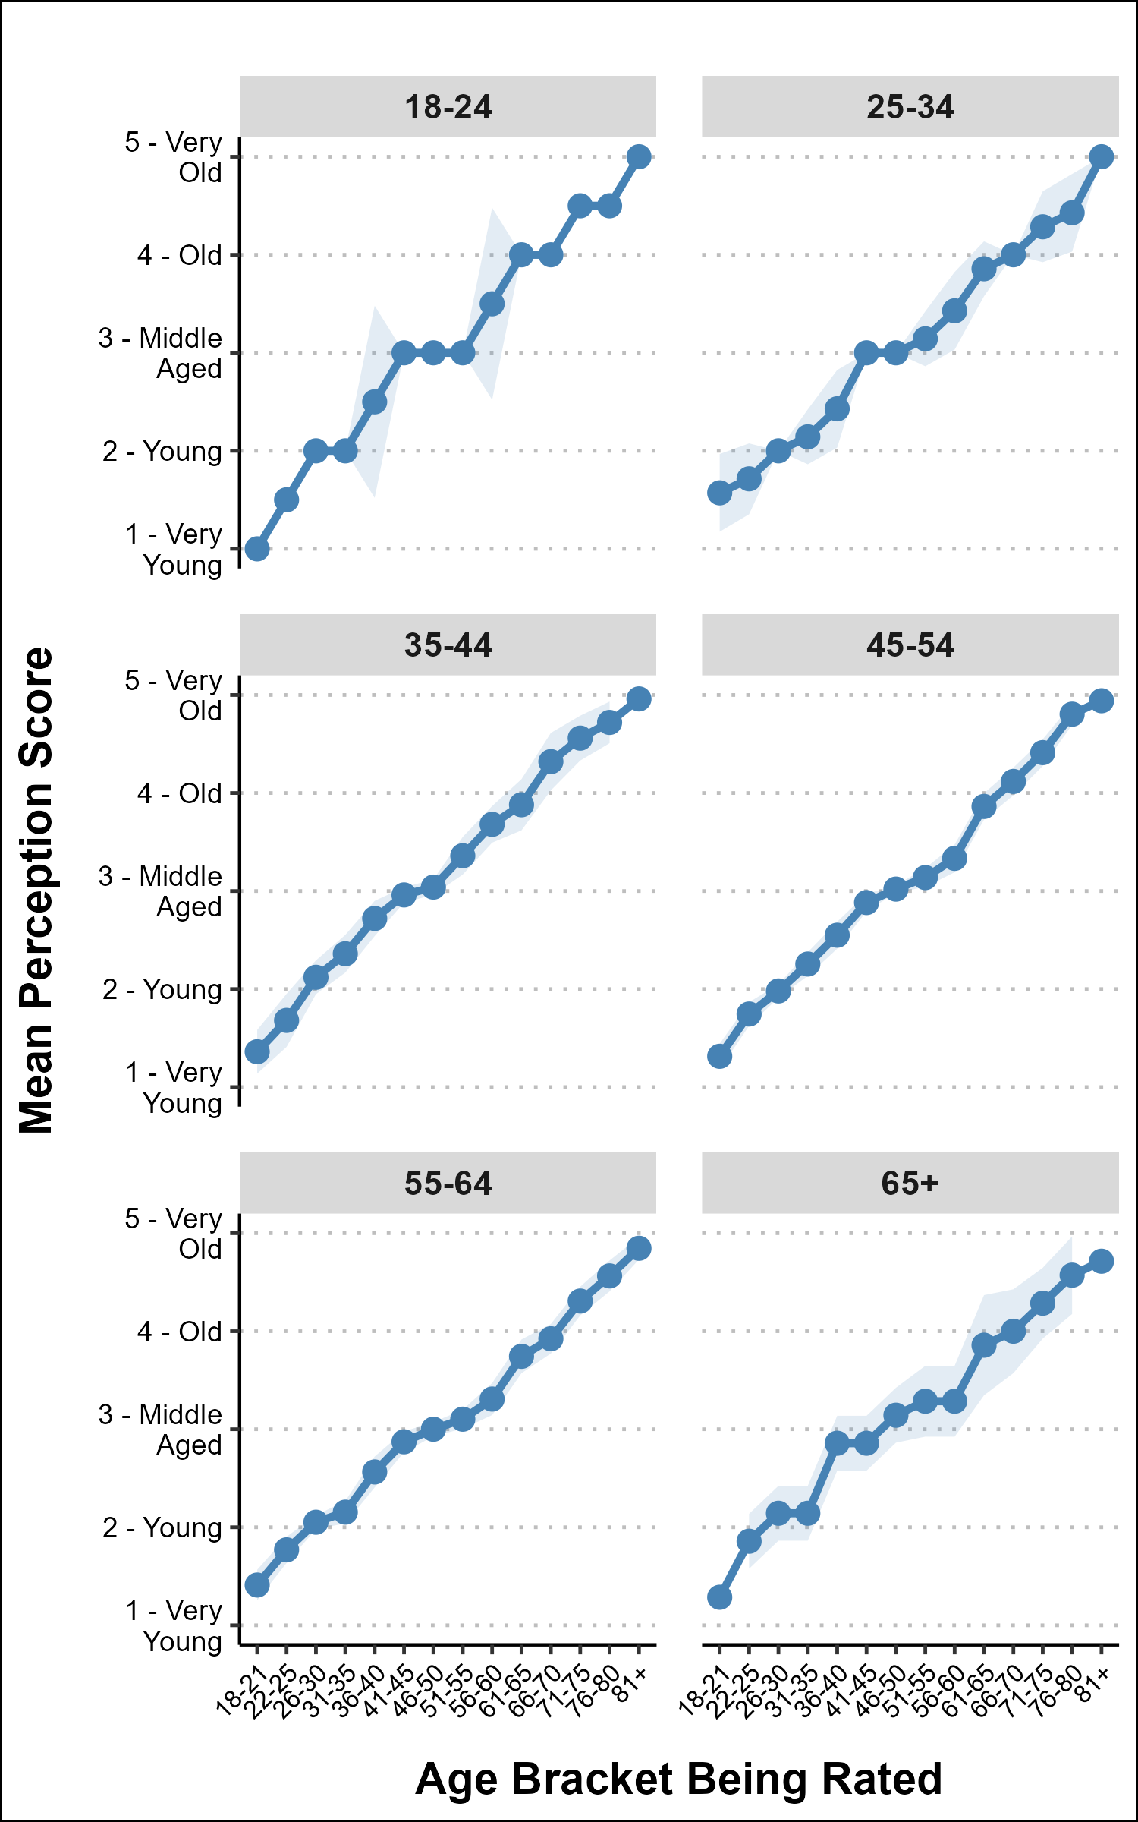
Figure 8: Perception of Age by Respondent’s Own Age Each panel shows how that age group rated the 5 age brackets Shaded band = 95% Confidence Interval

Overlaid Line Chart: Perception of “Old” by Respondent Age
I take the previous graphs and overlay them into one graph so it is easier to see how the age groups compare to each other.
graph_line_chart(
df = df_summary,
x_category = "age_group",
y_category = "mean_score",
x_label = "Age Bracket Being Rated",
y_label = "Mean Perception Score",
color_var = "respondent_age",
ci_lo = "ci_lo",
ci_hi = "ci_hi",
y_limits = c(1, 5),
y_breaks = 1:5,
y_labels = rating_labels
)
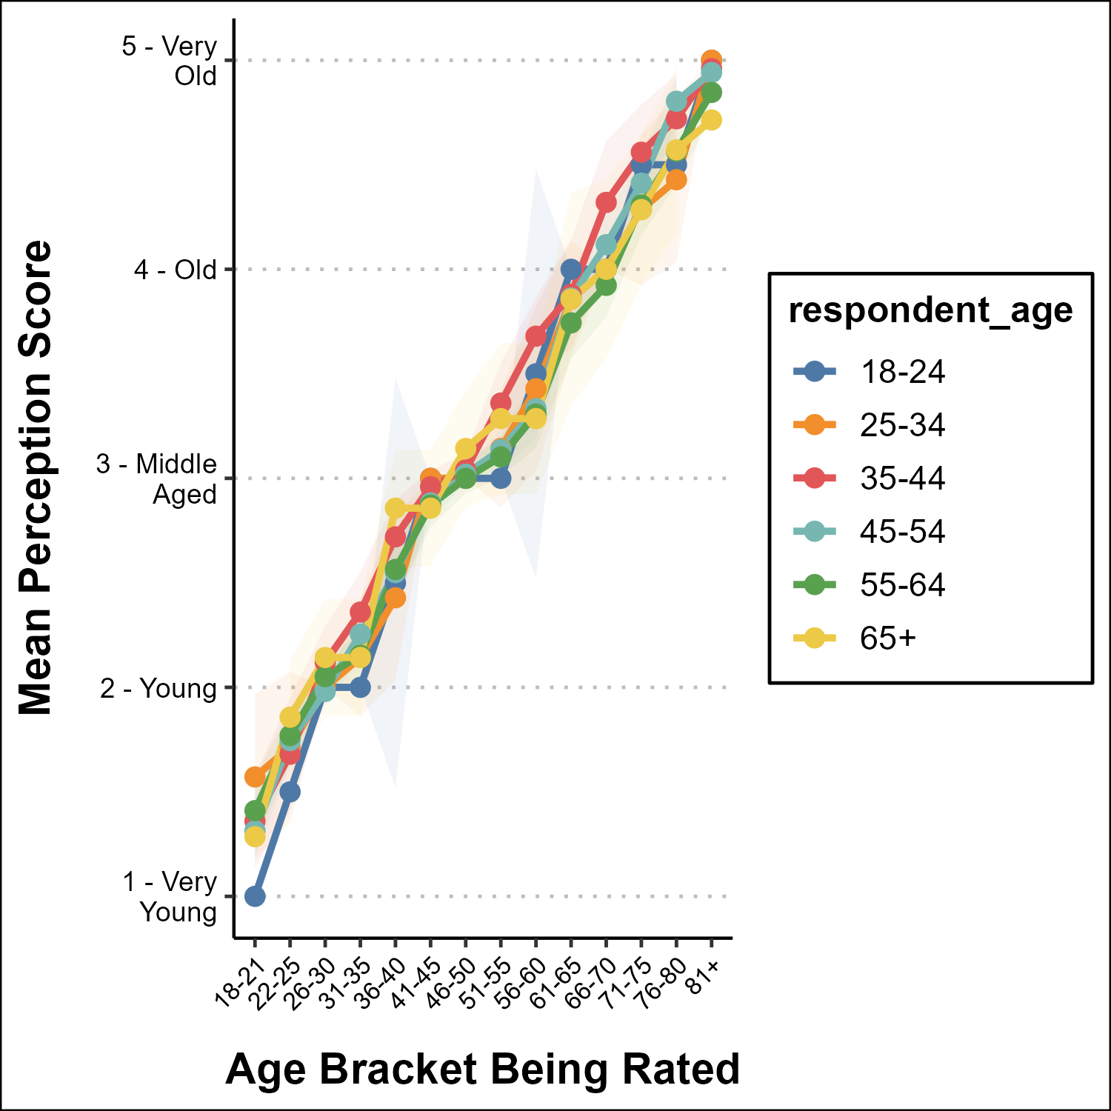
Figure 9: Overlay of Repondents Perception of Age by Age Group Lines show mean perception score across 14 age brackets and shaded bands represent 95% confidence interval

How the groups responded by the numbers
The below table breaks down the survey taker’s own age group and how they rated each of the other age groups in terms of old. with the following age labels and their values:
- 1 - Very Young
- 2 - Young
- 3 - Middle Age
- 4 - Old
- 5 - Very Old
df_summary |>
mutate(mean_score = round(mean_score, 2)) |>
select(respondent_age, age_group, mean_score) |>
tidyr::pivot_wider(
names_from = respondent_age,
values_from = mean_score
) |>
rename("Age Group Rated" = age_group) |>
knitr::kable()
Table 5: Ratings of Each Age Group by Respondents Own Age Group
Age Group Rated | 18-24 | 25-34 | 35-44 | 45-54 | 55-64 | 65+
18-21 | 1.0 | 1.57 | 1.36 | 1.31 | 1.41 | 1.29
22-25 | 1.5 | 1.71 | 1.68 | 1.75 | 1.77 | 1.86
26-30 | 2.0 | 2.00 | 2.12 | 1.98 | 2.05 | 2.14
31-35 | 2.0 | 2.14 | 2.36 | 2.25 | 2.15 | 2.14
36-40 | 2.5 | 2.43 | 2.72 | 2.55 | 2.56 | 2.86
41-45 | 3.0 | 3.00 | 2.96 | 2.88 | 2.87 | 2.86
46-50 | 3.0 | 3.00 | 3.04 | 3.02 | 3.00 | 3.14
51-55 | 3.0 | 3.14 | 3.36 | 3.14 | 3.10 | 3.29
56-60 | 3.5 | 3.43 | 3.68 | 3.33 | 3.31 | 3.29
61-65 | 4.0 | 3.86 | 3.88 | 3.86 | 3.74 | 3.86
66-70 | 4.0 | 4.00 | 4.32 | 4.12 | 3.92 | 4.00
71-75 | 4.5 | 4.29 | 4.56 | 4.41 | 4.31 | 4.29
76-80 | 4.5 | 4.43 | 4.72 | 4.80 | 4.56 | 4.57
81+ | 5.0 | 5.00 | 4.96 | 4.94 | 4.85 | 4.71

“Old” Threshold by Respondent Age Group
To directly address my first Research Question, the following analysis identifies the first age bracket each respondent rates as “Old” (score ≥ 4) and summarizes those thresholds by the respondent’s own age group. If a person’s own age influences their perception of oldness, we would expect older respondents to set that threshold later than younger ones.
I build the threshold data frame to hold the information for the analysis and pivot the group by ratings.
threshold_df <- age_perception_df |>
# Reshape from wide (One Column per age bracket) to long (one row per rating)
pivot_longer(
cols = starts_with("Age_Perception_"),
names_to = "item", # Ex: Age_Perception_4
values_to = "rating"
) |>
mutate(
rating = as.numeric(rating),
# Grab the trailing number from the column name to help us sort the results
# based on the age.
group_num = as.integer(str_extract(item, "\\d+")),
#Map position to human-readable label.
age_bracket = factor(age_labels[group_num], levels = age_labels)
) |>
# Drop NA Rows or rating is out of allowable numbers
filter(!is.na(respondent_age), rating >= 4) |>
# For each survey participant, keep the row with the lowest group_numb that is
# still labeled as 'old'.
group_by(ID, respondent_age) |>
slice_min(group_num, n = 1, with_ties = FALSE) |>
ungroup()
# Afterword, we summarize the data by grouping by the respondent age group and
# finding the average threshold of the determination of an age being 'old'.
threshold_summary <- threshold_df |>
group_by(respondent_age) |>
summarise(
n = n(), # Number of participants in this group
median_num = median(group_num), # Median threshold
.groups = "drop"
) |>
# Round median to nearest integer for consistent
# y-axis positioning and labeling.
mutate(
median_num = round(median_num),
median_label = age_labels[median_num]
)

Age Threshold Chart
Here I graph the data that I previously built.
threshold_summary <- threshold_summary |>
mutate(n_label = paste0("n=", n))
graph_bar_chart(
df = threshold_summary,
x_category = "respondent_age",
y_category = "median_num",
label_col = "median_label",
inside_label_col = "n_label",
x_label = "Respondent Age Group",
y_label = "First Age Bracket Rated 'Old'",
horizontal = FALSE,
y_limits = c(0, 14),
y_breaks = 1:14,
y_labels = age_labels
)
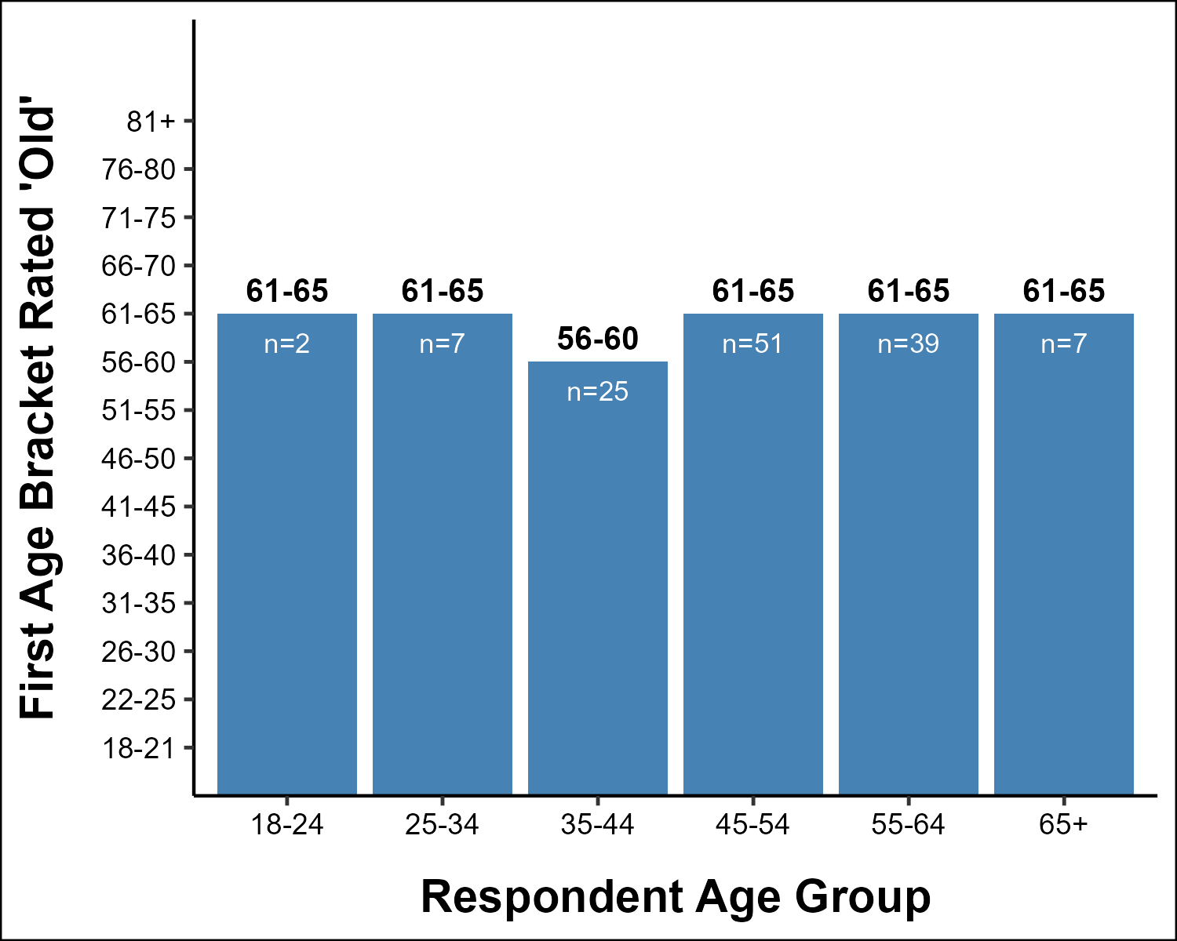
Figure 10: Threshold of ‘Old’ by Age Median first age bracket rated ≥ 4 (Old) by respondent age group
Respondents in the 35–44 age group set the “old” threshold at 56–60, while all other groups converge on 61–65. The direction is consistent with what Research Question 1 would predict — younger respondents label “old” slightly earlier — though the difference is modest (one age bracket). Note that the 18–24 and 25–34 groups have very small sample sizes (n=2 and n=7 respectively), so those results should be interpreted with caution.
Further investigation is performed during Correlation Analysis.

Individual Threshold Scatter Plot
The bar chart above summarizes each age group down to a single median threshold, which can obscure how much individual respondents actually vary. The scatter plot below shows every respondent’s own individual threshold (the first age bracket they rated “Old”) against their own age group, with a loess trend line to visualize the overall direction of the relationship. Both variables are ordinal with a limited number of levels, so points are jittered slightly to keep overlapping respondents visible.
Because a straight linear regression line would imply a linear relationship between two ordinal variables — an assumption not required for the Spearman correlation used to test Research Question 1 — a loess smoother is used here instead, purely as a visual aid rather than a fitted statistical model.
Statistical analysis will be undertaken in the Correlation section.
threshold_scatter_df <- threshold_df |>
mutate(
# Numeric position of the respondent's own age group (1 = 18-24 ... 6 = 65+)
respondent_age_num = as.integer(respondent_age),
# Small jitter so overlapping respondents remain visible
respondent_age_jit = jitter(respondent_age_num, amount = 0.15),
group_num_jit = jitter(group_num, amount = 0.3),
# Add age bracket label for Y-axis
group_label = age_labels[group_num]
)
graph_scatter(
df = threshold_scatter_df,
x_category = "respondent_age_jit",
y_category = "group_num_jit",
x_label = "Respondent Age Group (1 = 18-24, 6 = 65+)",
y_label = "First Age Bracket Rated 'Old'",
trend_line = TRUE,
trend_method = "loess",
x_breaks = 1:6,
x_limits = c(0.5, 6.5),
y_breaks = 1:14,
y_labels = age_labels
)
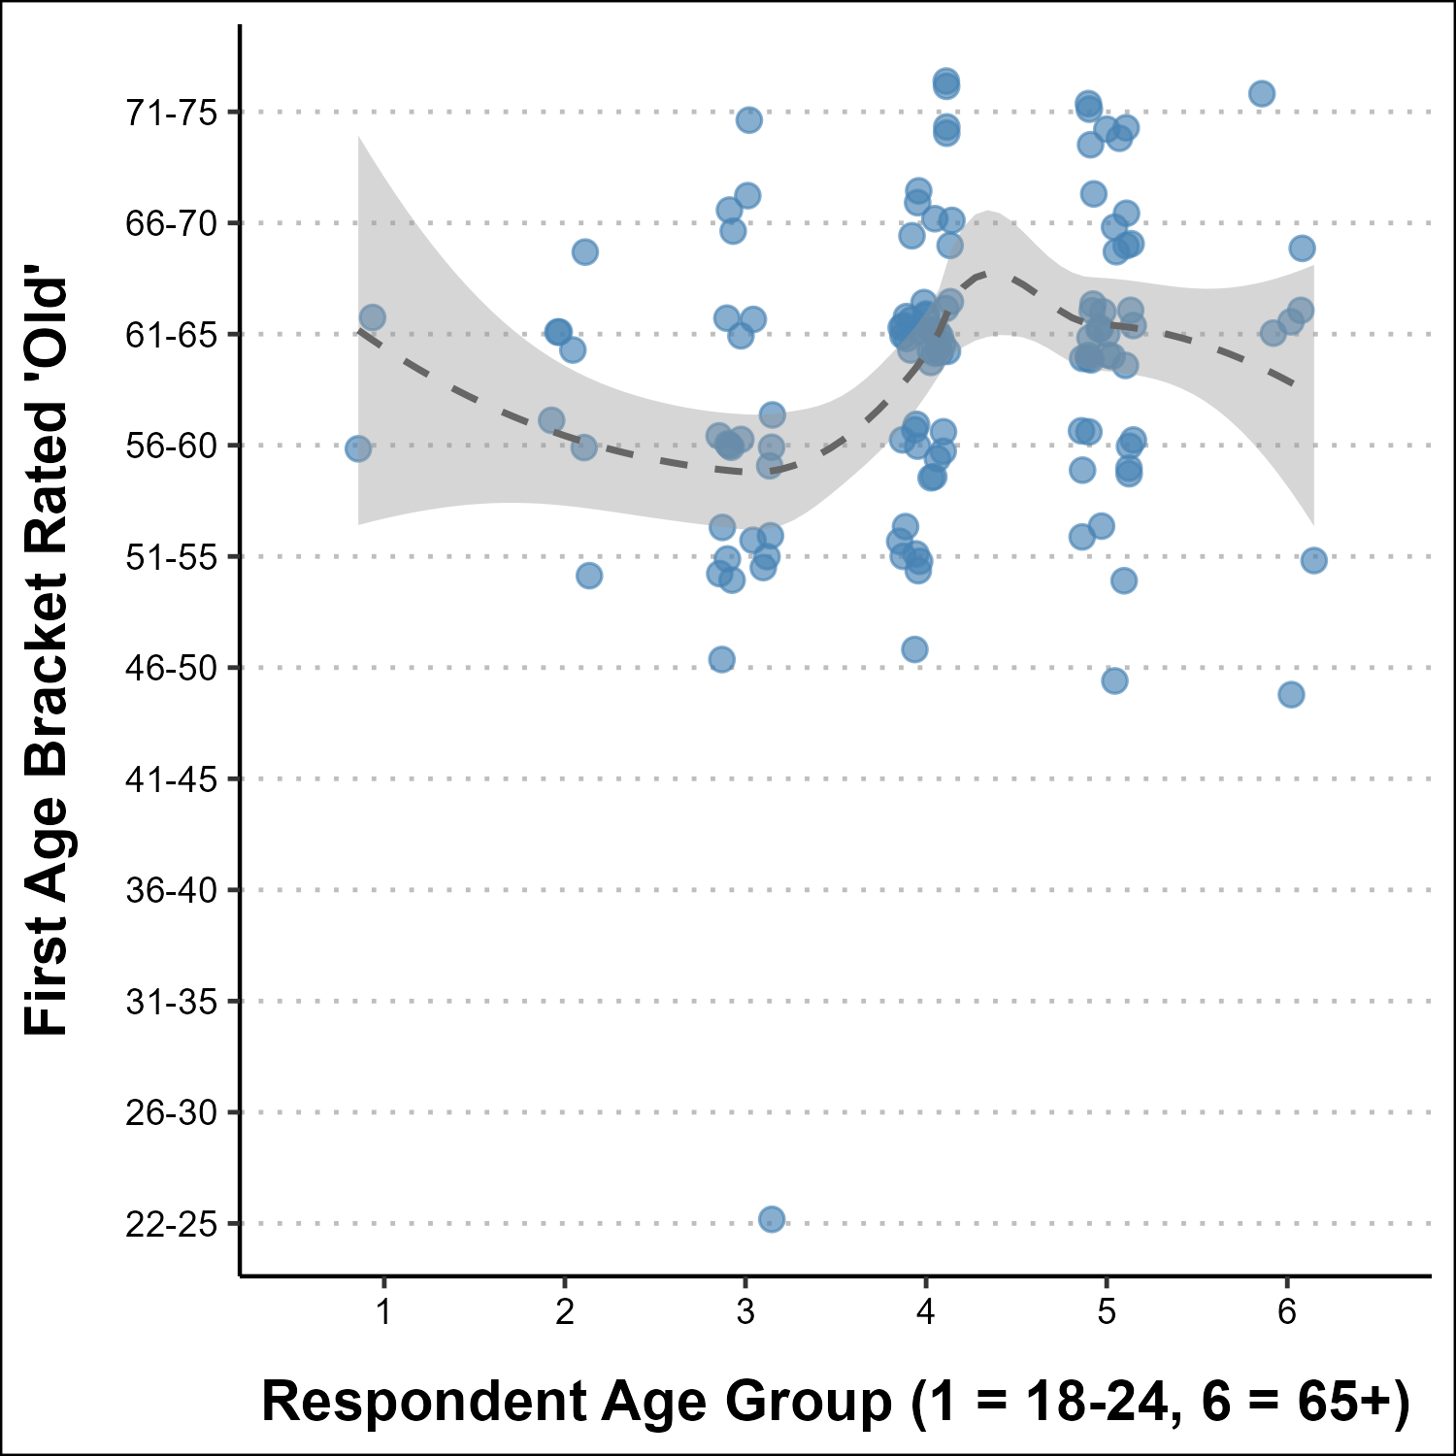
Figure 11: Individual “Old” Threshold by Respondent Age (Jittered) Each point is one respondent’s first age bracket rated “Old” (≥ 4); dashed line is a loess trend, shown for visual reference only

Conclusion
Having limited participation from the 18-24 age group limits the ability to provide better analysis. The participation in the 25-35 and 65+ also leads to caution in the interpretation of the results.
There is a strong linear relationship between the age scale rating and the age group being rated. I also start to see some visual elements that support Research Question 1 in the Individual Threshold Scatter Plot. Further correlation analysis is needed and performed in the Correlation section.

Fraboni Scale on Ageism
This section focuses on asking participants to participate in the actual Fraboni Scale on Ageism questions. The results from this will allow me to compare the IT industry to other industries where the same test has been taken.

Character Vectors

Reverse Score Character Vector Creation
To help add to the validity of the Fraboni Scale, the authors introduced reverse scale questions. This helps to prevent a participant from quickly ranking all choices based on the first few questions without reading what is being asked. To score these appropriately, I create a character vector with the questions that contains the questions I will score in reverse order.
reverse_scale_variables <- c("Fraboni_Scale_8",
"Fraboni_Scale_12",
"Fraboni_Scale_14",
"Fraboni_Scale_21",
"Fraboni_Scale_22",
"Fraboni_Scale_23",
"Fraboni_Scale_24")

Character Vectors For Fraboni Subgroup Questions
The Fraboni Scale of Ageism addresses three distinct subgroups of ageism. These are:
- Antilocution: Negative verbal remarks toward the elderly
- Discrimination: Prejudicial treatment of the elderly
- Avoidance: Action of Avoiding activities with the elderly
These are identified by distinct questions related to each and are broken out here.
# Fraboni Questions related to Antilocution
# Q 1,3,4,5,9,16,25,27,28,29
fraboni_antilocution <- c("Fraboni_Scale_1",
"Fraboni_Scale_3",
"Fraboni_Scale_4",
"Fraboni_Scale_5",
"Fraboni_Scale_9",
"Fraboni_Scale_16",
"Fraboni_Scale_25",
"Fraboni_Scale_27",
"Fraboni_Scale_28",
"Fraboni_Scale_29")
# Fraboni Questions related to Discrimination
# Q 2,8,17,18,20,21,22,23,24
fraboni_discrimination <- c("Fraboni_Scale_2",
"Fraboni_Scale_8",
"Fraboni_Scale_17",
"Fraboni_Scale_18",
"Fraboni_Scale_20",
"Fraboni_Scale_21",
"Fraboni_Scale_22",
"Fraboni_Scale_23",
"Fraboni_Scale_24")
# Fraboni Questions related to Avoidance
# Q 6,7,10,11,12,13,14,15,19,26
fraboni_avoidance <- c("Fraboni_Scale_6",
"Fraboni_Scale_7",
"Fraboni_Scale_10",
"Fraboni_Scale_11",
"Fraboni_Scale_12",
"Fraboni_Scale_13",
"Fraboni_Scale_14",
"Fraboni_Scale_15",
"Fraboni_Scale_19",
"Fraboni_Scale_26")

Response to Number Mapping
The Fraboni Scale uses a 4 point Likert Scale with the following point values when in normal form. The values are reversed when the reverse scale is used.
- 1: Strongly Disagree
- 2: Disagree
- 3: Agree
- 4: Strongly Agree
I create the maps to associate the numbers with the responses for both normal and reverse scales.
fraboni_map <- list(
normal = c(
"Strongly Disagree" = 1,
"Disagree" = 2,
"Agree" = 3,
"Strongly Agree" = 4
),
reverse = c(
"Strongly Agree" = 1,
"Agree" = 2,
"Disagree" = 3,
"Strongly Disagree" = 4
)
)

Main Processing

Recode the DataFrame
I recode the dataframe with the answers to the Fraboni_Scale_ questions and the mappings we created for the Normal and Reverse scales.
fraboni_df <- recode_likert(main_df,
"Fraboni_Scale_",
fraboni_map$normal,
fraboni_map$reverse,
reverse_scale_variables)

Create a Dataframe from our cleaned data for Fraboni Analysis
I Create a Fraboni data frame with User ID and their answers to the Fraboni Scale questions. I made the decision to drop any rows where there is an NA because of the way the score is calculated and compared.
Fraboni scores are a sum of all the numerical representation of the answers. I can not just ignore the NA due to the fact it hurts the final score and I do not want to average or infer anything due to the nature of these questions.
I first print how many rows are impacted and then remove them from the data frame.
fraboni_df |>
select(ID, starts_with("Fraboni_scale_")) |>
filter(if_any(-ID, is.na)) |>
nrow()
[1] 25
fraboni_df <- fraboni_df |>
select(ID, starts_with("Fraboni_Scale_")) |>
# Drop row if ANY answers are NA
filter(!if_any(-ID, is.na))

Post Data Frame Manipulation Information:
Any NAs in fraboni data frame: FALSE
Number of Research Participants for fraboni analysis is: 110

Add a Columns for the different Fraboni Scores.
fraboni_df <- fraboni_df |>
mutate(
Total_Score = rowSums(
across(starts_with("Fraboni_Scale_"), ~as.numeric(.x))
),
Disc_Score = rowSums(
across(all_of(fraboni_discrimination), ~as.numeric(.x))
),
Avoid_Score = rowSums(
across(all_of(fraboni_avoidance), ~as.numeric(.x))
),
AntiLoc_Score = rowSums(
across(all_of(fraboni_antilocution), ~as.numeric(.x))
)
)

Save Out Fraboni Data Frame
We will be using this cleaned data frame in our Correlation Analysis.
saveRDS(fraboni_df,
"fraboni_df.rds")

Summary Statistics for calculated scores
fraboni_df |>
select(Total_Score, Disc_Score, Avoid_Score, AntiLoc_Score) |>
pivot_longer(everything(), names_to = "Score", values_to = "Value") |>
group_by(Score) |>
summarise(
N = n(),
Mean = round(mean(Value), 2),
SD = round(sd(Value), 2),
Median = round(median(Value), 2),
Min = min(Value),
Max = max(Value),
.groups = "drop"
) |>
mutate(Score = dplyr::recode(Score,
"Total_Score" = "Total",
"Disc_Score" = "Discrimination",
"Avoid_Score" = "Avoidance",
"AntiLoc_Score" = "Antilocution"
)) |>
knitr::kable(col.names = c("Score", "N", "Mean", "SD",
"Median", "Min", "Max"),
align = c("l", "r", "r", "r", "r", "r", "r"))
Table 6: Statistics of Fraboni Scores for Total and each Element
Score | N | Mean | SD | Median | Min | Max
Antilocution | 110 | 18.72 | 3.94 | 19.0 | 10 | 31
Avoidance | 110 | 16.71 | 3.89 | 16.0 | 10 | 28
Discrimination | 110 | 15.35 | 2.70 | 15.0 | 10 | 22
Total | 110 | 50.77 | 9.09 | 50.5 | 30 | 77

Histogram of Data Sets
Histograms show the number of participants who score certain point groupings in the Fraboni scale.

Total Score Histogram
Histogram representing the Fraboni Total Score of survey participants.
- Questions: 29
- Bin Size: 5
- Max Possible Score: 116 (Most Ageist)
- Min Possible Score: 29 (Least Ageist)
graph_histogram(fraboni_df,
"Total_Score",
"Total Score",
"Count",
lower_x = 29,
upper_x = 116,
binwidth = 5)
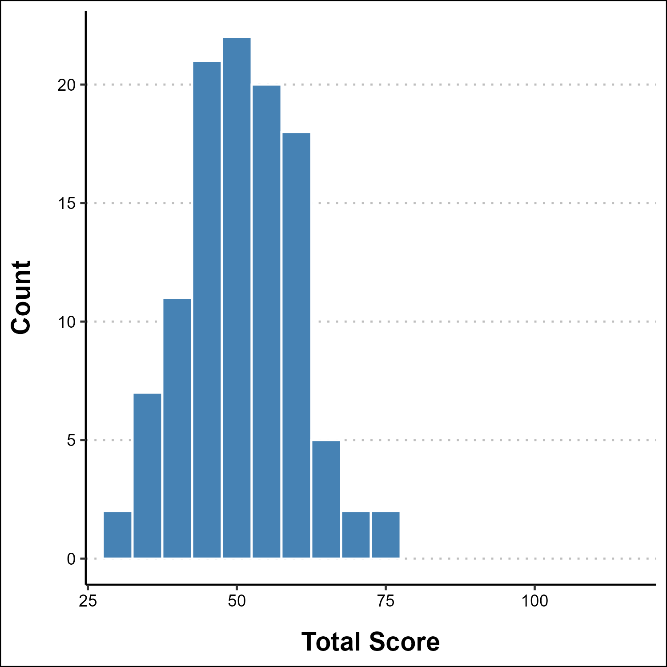
Figure 12: Histogram of Total Fraboni Score

Discrimination Score Histogram
Histogram representing the Fraboni Discrimination Score of survey participants.
- Questions: 9
- Bin Size: 3
- Max Possible Score: 36 (Most Ageist)
- Min Possible Score: 9 (Least Ageist)
graph_histogram(fraboni_df,
"Disc_Score",
"Discrimination Score",
"Count",
lower_x = 9,
upper_x = 36,
binwidth = 3)
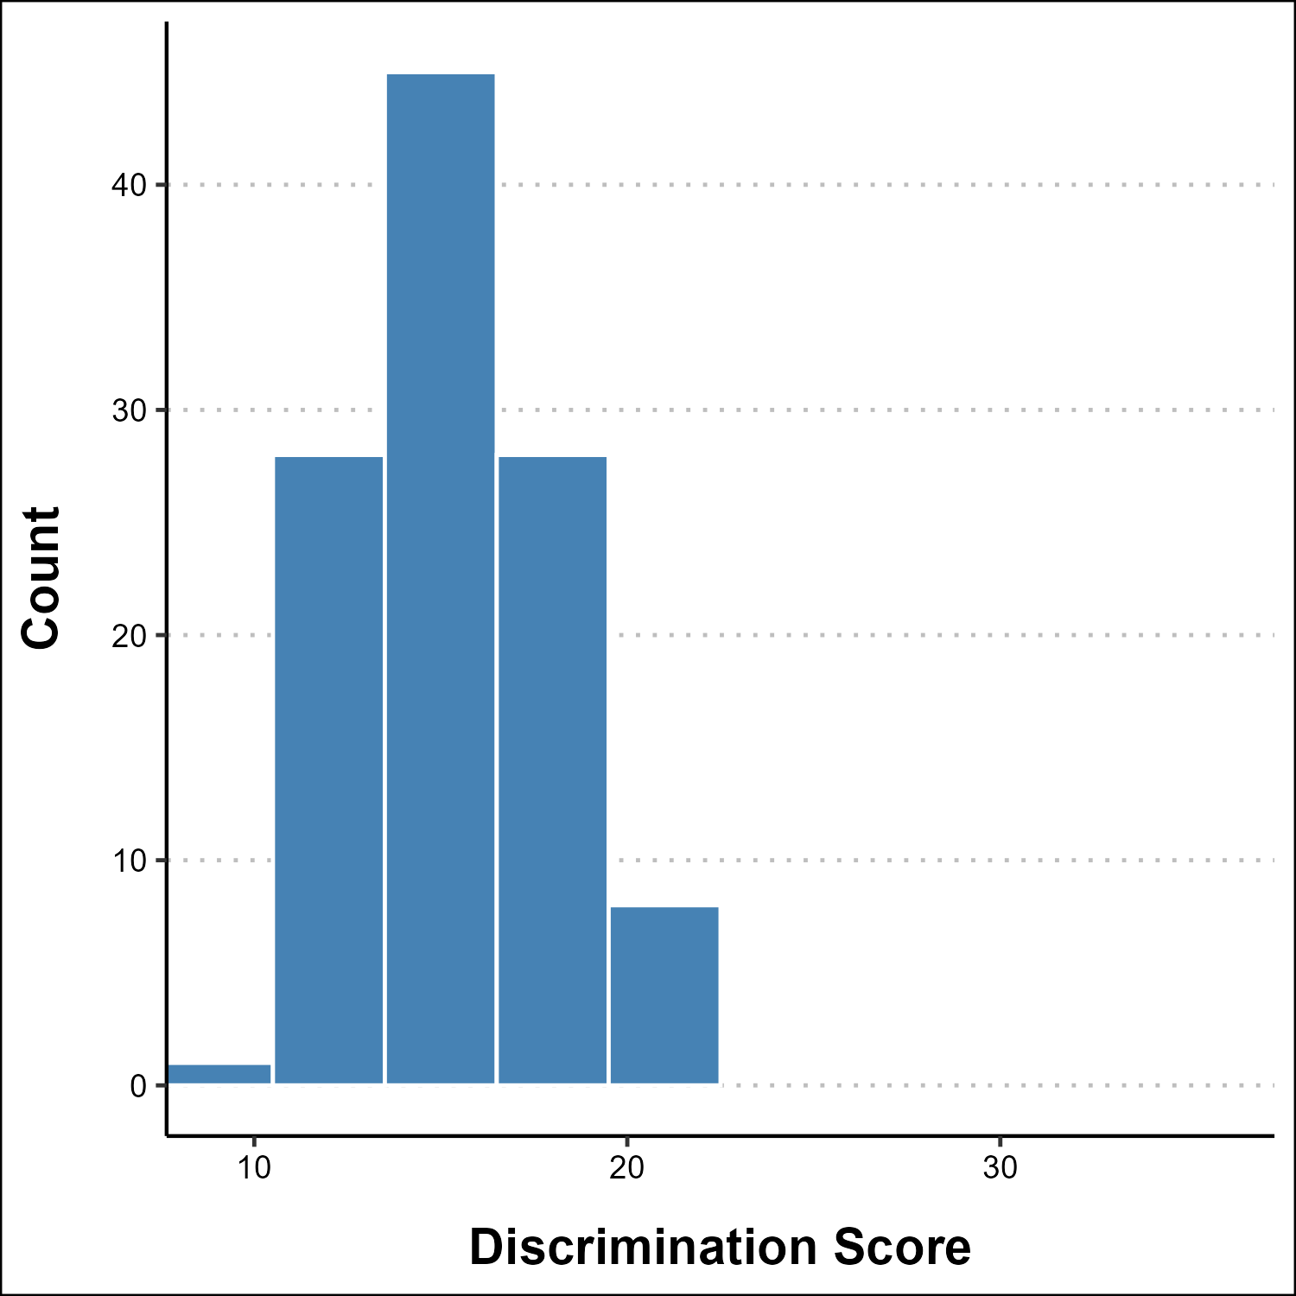
Figure 13: Histogram of Discrimination Fraboni Score

Avoidance Score Histogram
- Questions: 10
- Bin Size: 3
- Max Possible Score: 40 (Most Ageist)
- Min Possible Score: 10 (Least Ageist)
Histogram representing the Fraboni Avoidance Score of survey participants.
graph_histogram(fraboni_df,
"Avoid_Score",
"Avoidance Score",
"Count",
lower_x = 10,
upper_x = 40,
binwidth = 3)
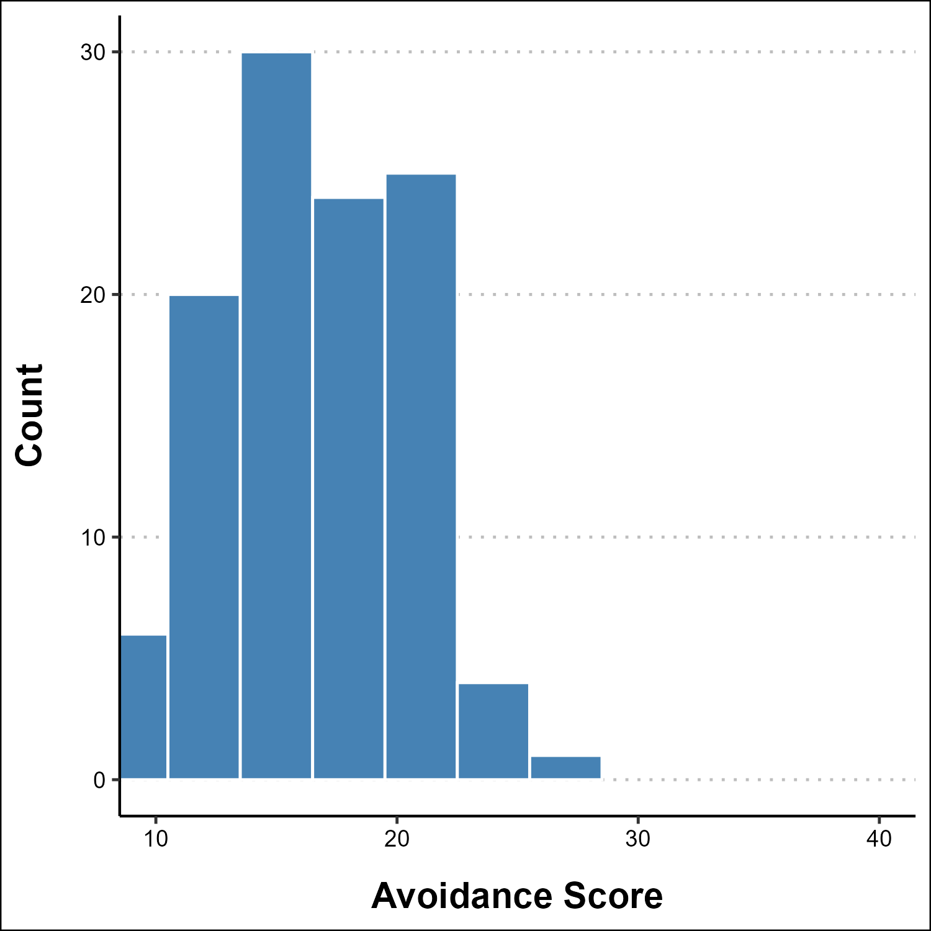
Figure 14: Histogram of Avoidance Fraboni Score

Antilocution Score Histogram
- Questions: 10
- Bin Size: 3
- Max Possible Score: 40 (Most Ageist)
- Min Possible Score: 10 (Least Ageist)
Histogram representing the Fraboni Antilocution Score of survey participants.
graph_histogram(fraboni_df,
"AntiLoc_Score",
"Antilocution Score",
"Count",
lower_x = 10,
upper_x = 40,
binwidth = 3)
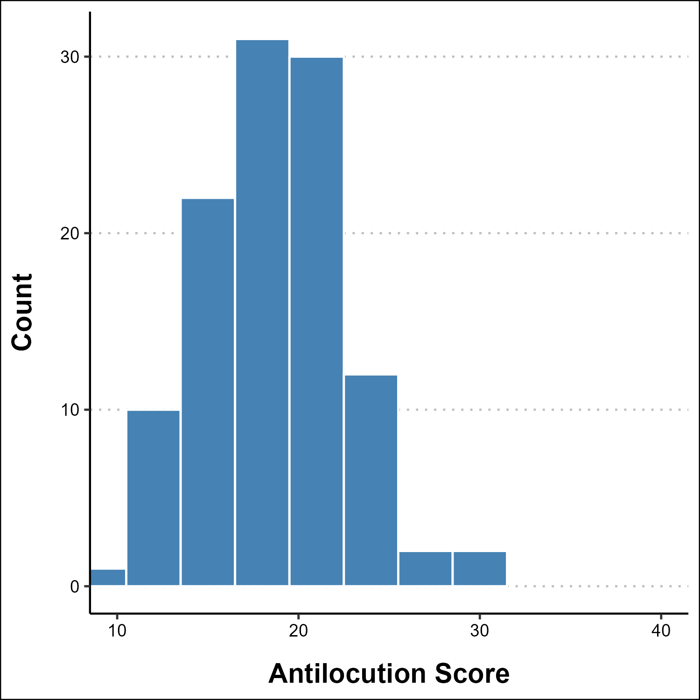
Figure 15: Histogram of Antilocution Fraboni Score

ANOVA Assumptions Testing
Before running the ANOVA analysis, I verify that the key assumptions are met:
- normality of residuals
- homogeneity of variance
- independence (guaranteed by study design since each respondent contributes one score).
age_fraboni <- fraboni_df |>
select(ID, Total_Score) |>
left_join(main_df |>
select(ID, Age), by = "ID")
# Fit initial ANOVA model for diagnostics
anova_model_temp <- aov(Total_Score ~ Age, data = age_fraboni)

Normality of Residuals
The Shapiro-Wilk test evaluates whether residuals follow a normal distribution. A p-value > 0.05 suggests normality is a reasonable assumption.
par(mfrow = c(1, 2))
# Q-Q plot
qqnorm(residuals(anova_model_temp),
main = "Q-Q Plot of Residuals",
ylab = "Residuals")
qqline(residuals(anova_model_temp), col = "red", lwd = 2)
# Histogram of residuals
hist(residuals(anova_model_temp),
main = "Histogram of Residuals",
xlab = "Residuals",
breaks = 15,
col = "steelblue")
par(mfrow = c(1, 1))
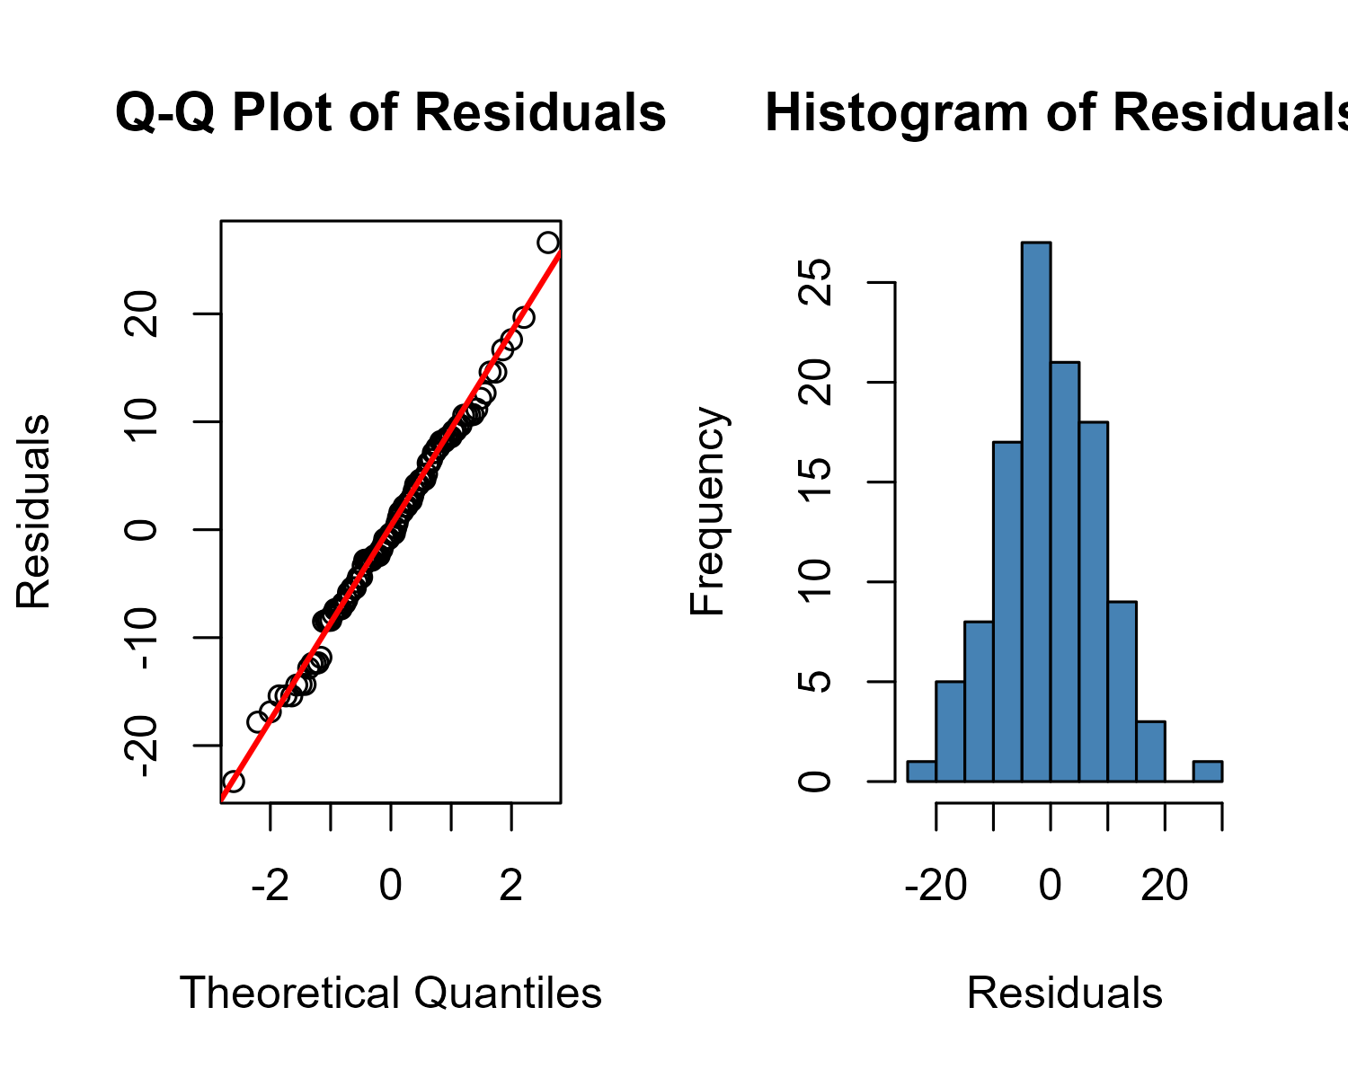
Figure 16: Q-Q Plot of ANOVA Residuals
shapiro_test <- shapiro.test(residuals(anova_model_temp))
data.frame(
Statistic = round(shapiro_test$statistic, 4),
p.value = round(shapiro_test$p.value, 4)
) |>
knitr::kable()
Table 7: Shapiro-Wilk Test for Normality of Residuals
 | Statistic | p.value
W | 0.9942 | 0.9258

I have a p-value of 0.9258. To assume normality I need the p-value to be greater than 0.05. With this data set we can assume normality.

Homogeneity of Variance
Levene’s test evaluates whether the variance of Fraboni scores is equal across age groups. A p-value > 0.05 suggests the homogeneity assumption is met.
levene_test <- leveneTest(Total_Score ~ Age, data = age_fraboni)
data.frame(
Test_Statistic = round(levene_test$`F value`[1], 4),
p.value = round(levene_test$`Pr(>F)`[1], 4)
) |>
knitr::kable()
Table 8: Levene’s Test for Homogeneity of Variance
Test_Statistic | p.value
1.4183 | 0.2238

I have a p-value of .2238 and to assume homogeneity of variance, I would again need a p-value greater than 0.05. Therefore I can assume homogeneity of variance with this data set.

Assumption Summary
Based on these tests: - Normality: Reasonable - Homogeneity of Variance: Reasonable - Independence: By design (each respondent = one observation)
ANOVA is reasonably robust to violations of normality with moderate sample sizes, and we report results below with these caveats noted.

How much does Participant Age impact Fraboni Ageism Score?
I create a one-way ANOVA to determine if the age of the participant impact their Fraboni Ageism Score.
For our analysis, we will assume a P-Value of < .05 to be statistically significant.
To accomplish this I:
- Add the Participant Age column from the main_df to the fraboni_df.
- Average the Score based on Participant Age
- Build the ANOVA model
Note: Scaling the score from 0-100 from 29-116 is not necessary for the ANOVA process.
average_scores_by_age <- age_fraboni |>
group_by(Age) |>
summarise(Average_Score = mean(Total_Score, na.rm = TRUE),
N = n())
# Use an ANOVA model to determine if there is a significant statistical
# difference between the different age groups.
anova_model <- aov(Total_Score ~ Age, data = age_fraboni)
knitr::kable(summary(anova_model)[[1]])
Table 9: Fraboni ANOVA Summary
 | Df | Sum Sq | Mean Sq | F value | Pr(>F)
Age | 5 | 395.6927 | 79.13854 | 0.9559542 | 0.4484322
Residuals | 104 | 8609.6255 | 82.78486 | NA | NA

ANOVA Analysis
This shows weak evidence and the data does not show the age of the participant has an impact on the Fraboni Score. We Fail to reject the null hypothesis.
An F Statistic of 0.9559542 indicates the variance between age groups is slightly less than the variance within the age groups.
A P-Value of 0.4484322 indicates that we fail to reject the null hypothesis theory. There is no statistical significance between the age group of the person and their score. There is a good probability that these results occurred by chance.
Based on this information, we can not say that age has any impact on levels of ageism when we are basing it on the age of the individual.
It is important to reiterate the comparatively small sample size for younger individuals in this analysis and the impact on the validity to this research.

Significance of Ageist Types
The Fraboni Scale of Ageism defines three different types of Ageist Discrimination. They are:
- Discrimination: Patterns of unfair, prejudicial, or unequal treatment due to ones age.
- Avoidance: Patterns to avoid interactions with someone because of their age.
- Antilocution: Patterns of negative verbal remarks or hateful speech towards an individual due to their age.
To determine of there is any correlation with these individual ageist types, I will perform the same ANOVA analysis specifically towards the questions associated with these ageist types.

Discrimination
age_disc_fraboni <- fraboni_df |>
select(ID, Disc_Score) |>
left_join(main_df |>
select(ID, Age), by = "ID")
average_disc_scores_by_age <- age_disc_fraboni |>
group_by(Age) |>
summarise(Average_Score = mean(Disc_Score, na.rm = TRUE),
N = n())
# Use an ANOVA model to determine if there is a significant statistical
# difference between the different age groups.
anova_model <- aov(Disc_Score ~ Age, data = age_disc_fraboni)
knitr::kable(summary(anova_model)[[1]])
Table 10: Fraboni ANOVA Discrimination Summary
 | Df | Sum Sq | Mean Sq | F value | Pr(>F)
Age | 5 | 37.88349 | 7.576697 | 1.040935 | 0.3977107
Residuals | 104 | 756.98924 | 7.278743 | NA | NA

Discrimination ANOVA Analysis
Again for the Discrimination Questions, we see weak evidence and the data does not show the age of the participant has an impact on the Fraboni questions related to Discrimination. We Fail to reject the null hypothesis.
An F Statistic of 1.0409349 indicates the variance between age groups almost equal to the variance within the age groups.
A P-Value of 0.3977107 indicates that we fail to reject the null hypothesis theory. There is no statistical significance between the age group of the person and their discrimination score.

Avoidance
age_avoid_fraboni <- fraboni_df |>
select(ID, Avoid_Score) |>
left_join(main_df |>
select(ID, Age), by = "ID")
average_avoid_scores_by_age <- age_avoid_fraboni |>
group_by(Age) |>
summarise(Average_Score = mean(Avoid_Score, na.rm = TRUE),
N = n())
# Use an ANOVA model to determine if there is a significant statistical
# difference between the different age groups.
anova_model <- aov(Avoid_Score ~ Age, data = age_avoid_fraboni)
knitr::kable(summary(anova_model)[[1]])
Table 11: Fraboni ANOVA Avoidance Summary
 | Df | Sum Sq | Mean Sq | F value | Pr(>F)
Age | 5 | 35.15067 | 7.030135 | 0.4525632 | 0.810575
Residuals | 104 | 1615.54024 | 15.534041 | NA | NA

Avoidance ANOVA Analysis
For the Avoidance Questions, we see weak evidence and the data does not show the age of the participant has an impact on the Fraboni questions related to Avoidance We Fail to reject the null hypothesis.
An F Statistic of 0.4525632 indicates the variance between age groups is less than half the variance within the groups. Age groups are all similar to each other.
A P-Value of 0.810575 indicates that we fail to reject the null hypothesis theory. There is no statistical significance between the age group of the person and their avoidance score.

Antilocution
age_antiloc_fraboni <- fraboni_df |>
select(ID, AntiLoc_Score) |>
left_join(main_df |>
select(ID, Age), by = "ID")
average_antiloc_scores_by_age <- age_antiloc_fraboni |>
group_by(Age) |>
summarise(Average_Score = mean(AntiLoc_Score, na.rm = TRUE),
N = n())
# Use an ANOVA model to determine if there is a significant statistical
# difference between the different age groups.
anova_model <- aov(AntiLoc_Score ~ Age, data = age_antiloc_fraboni)
knitr::kable(summary(anova_model)[[1]])
Table 12: Fraboni ANOVA Antilocution Summary
 | Df | Sum Sq | Mean Sq | F value | Pr(>F)
Age | 5 | 132.2695 | 26.45391 | 1.7636 | 0.1268242
Residuals | 104 | 1559.9941 | 14.99994 | NA | NA

Antilocution ANOVA Analysis
For the Antilocution Questions, we see very small evidence and the data may show the age of the participant has an impact on the Fraboni questions related to Antilocution. However, we still Fail to reject the null hypothesis. Small group sizes in the younger participants leads to this conclusion.
An F Statistic of 1.7636004 indicates the age groups possibly explain something in terms of variance, however not enough variance exists to be meaningful.
A P-Value of 0.1268242 indicates that we still fail to reject the null hypothesis theory, however out of the three groups, Antilocution offers the closest trend of significance.

Overall Analysis.
The general average of all questions shows that we fail to reject the null hypothesis theory. There is no indication that a person’s age impacts their level of ageism when using the Fraboni Scale of Ageism. Closer analysis when we break the Fraboni questions into their respective types leads to the same conclusion; however questions related to Anticolution scored higher than the others indicating a possible trend in this area that could be worth investigating further.
It should be stressed that the results are based on low participation in both the younger and older age groups as seen in the Demographics reporting. While I feel these results are valid, further research with more participation in different age groups could be more revealing.

Graphs

Total Average Fraboni Scores
Total Average Scores by Age Group
average_scores_by_age <- average_scores_by_age |>
mutate(score_label = as.character(round(Average_Score, 1)))
graph_bar_chart(average_scores_by_age,
"Age",
"Age Range",
"Average Score",
y_category = "Average_Score",
label_col = "score_label",
horizontal = FALSE)
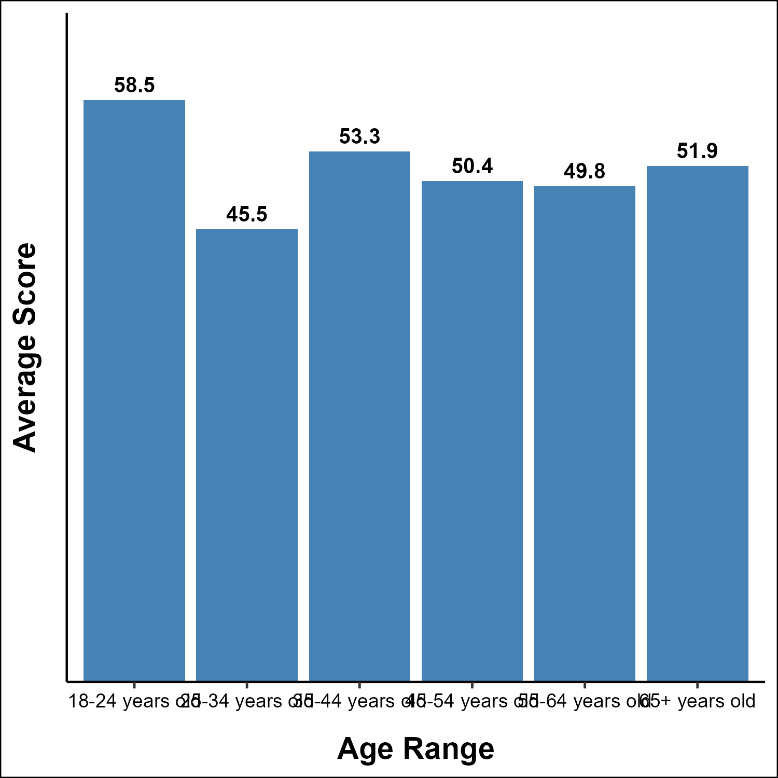
Figure 17: Average Fraboni Scores by Age Range

Discrimination Average Fraboni Scores
Discrimination Average Scores by Age Group
#| out-width: "100%"
average_disc_scores_by_age <- average_disc_scores_by_age |>
mutate(score_label = as.character(round(Average_Score, 1)))
graph_bar_chart(average_disc_scores_by_age,
"Age",
"Age Range",
"Average Score",
y_category = "Average_Score",
label_col = "score_label",
horizontal = FALSE)
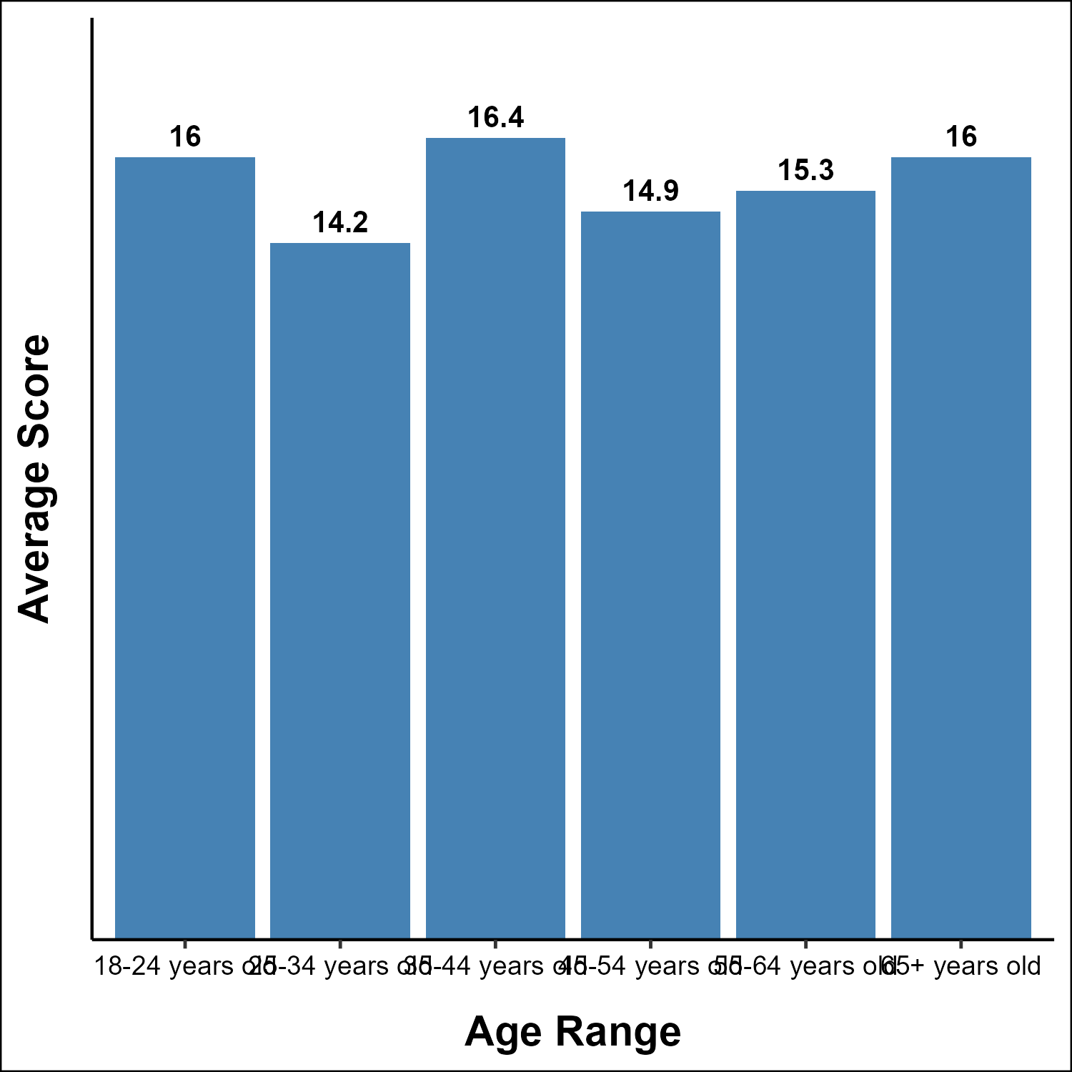
Figure 18: Discrimination Fraboni Scores by Age Range

Avoidance Average Fraboni Scores
Avoidance Average Scores by Age Group
average_avoid_scores_by_age <- average_avoid_scores_by_age |>
mutate(score_label = as.character(round(Average_Score, 1)))
graph_bar_chart(average_avoid_scores_by_age,
"Age",
"Age Range",
"Average Score",
y_category = "Average_Score",
label_col = "score_label",
horizontal = FALSE)
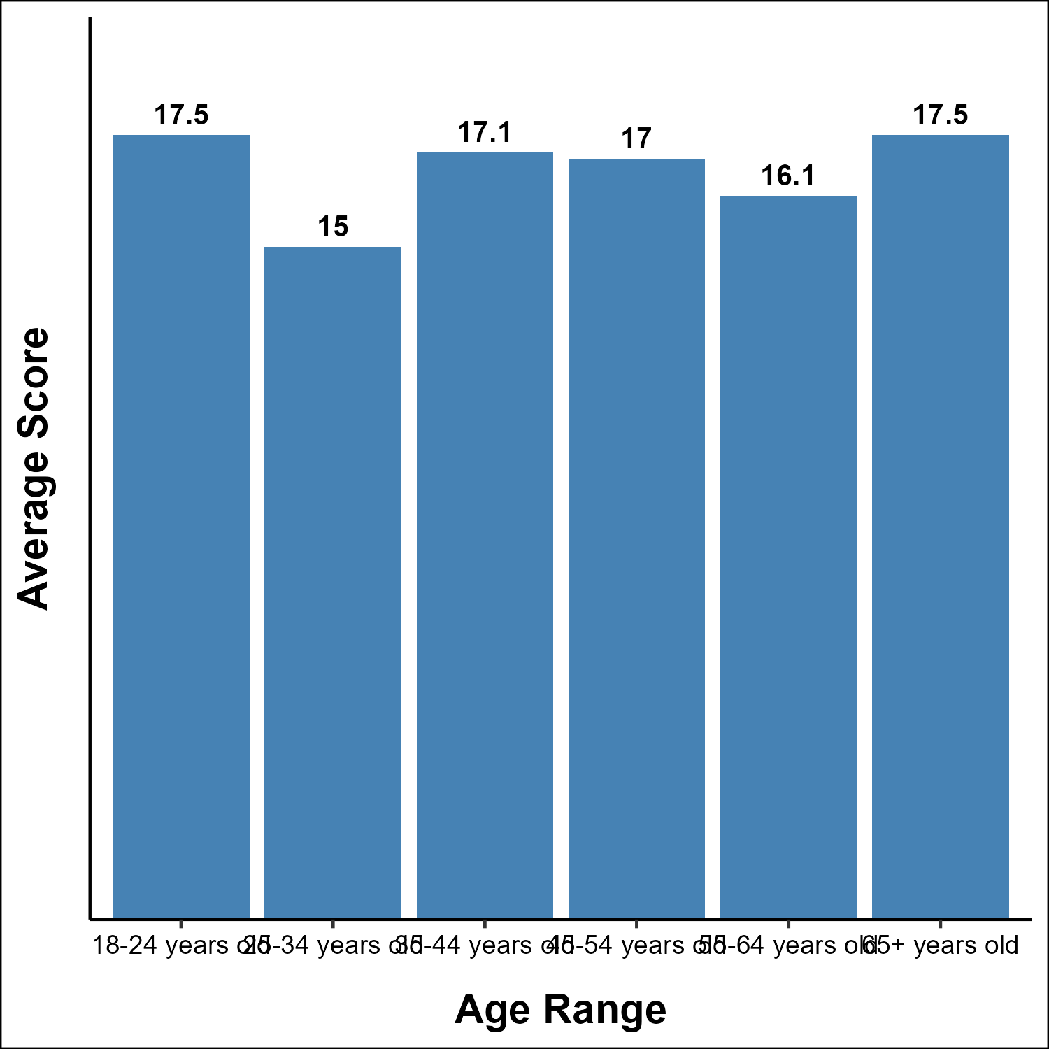
Figure 19: Avoidance Fraboni Scores by Age Range

Antilocution Average Fraboni Scores
Antilocution Average Scores by Age Group
average_antiloc_scores_by_age <- average_antiloc_scores_by_age |>
mutate(score_label = as.character(round(Average_Score, 1)))
graph_bar_chart(average_antiloc_scores_by_age,
"Age",
"Age Range",
"Average Score",
y_category = "Average_Score",
label_col = "score_label",
horizontal = FALSE)
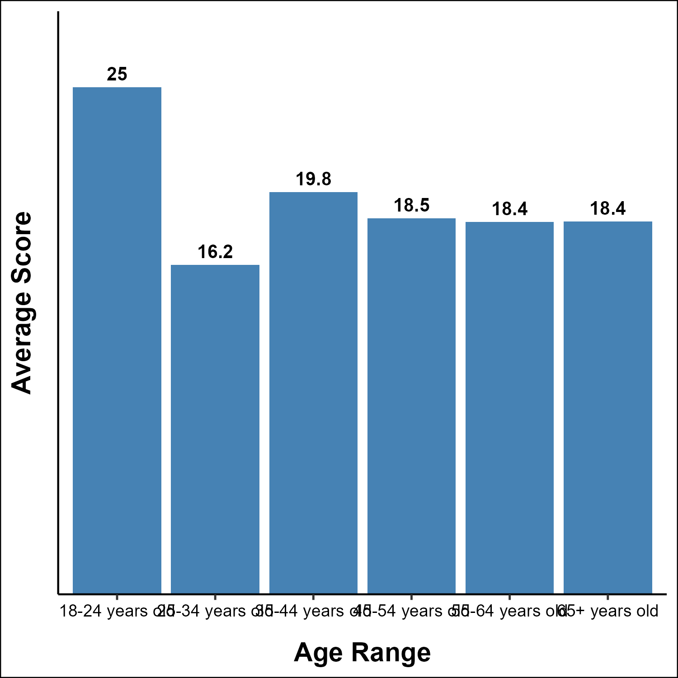
Figure 20: Antilocution Fraboni Scores by Age Range

Summary
Based on the data, we find no evidence that IT professional’s age impacts their level of ageism based on the Fraboni Scale of Ageism. Further, when looking at the summary statistics, we understand that IT workers with a mean score of 50.81 and a standard deviation of 9.12 are similar or higher than other industries where we have access to Fraboni Data.
MOVE THIS DISCUSSION TO PAPER.
Lebanese Healthcare Workers: 58.9 SD 10.2 (Healthcare) Turkish Study: 59.66 SD 9.40 (Gen Pop) Nusring/Brazil Study: 36.74 Nursing/Japan Study: 29.80 (J_FSA Different)
https://journals-sagepub-com.akin.css.edu/doi/10.1177/30495334251325606 https://onlinelibrary.wiley.com/doi/10.1111/j.1442-2018.2012.00717.x https://academic.oup.com/innovateage/article/9/Supplement_2/igaf122.1921/8411040 https://pmc.ncbi.nlm.nih.gov/articles/PMC11625483/ https://pmc.ncbi.nlm.nih.gov/articles/PMC7792127/

Ageism and Employment
This section takes the Fraboni Scale on Ageism and attempts to make it more applicable to an employment scenario. The questions are divided into two sections. First, we ask people about their own views of older co-workers to assess a level of ageism, and then we ask about their feelings towards continuing education - both in terms of their own skilling up, as well as their views of older co-workers value with continuing education.
I will run a Spearman’s analysis on the two averages to determine if there is any correlation between the two to help answer Research Question 2.

Questions Scale
All questions in this section use a 5 Point Likert Scale with the following point values:
- 1 = Strongly Disagree
- 2 = Somewhat Disagree
- 3 = Neither Agree nor Disagree
- 4 = Somewhat Agree
- 5 = Strongly Agree

Vector Definitions
# Map to convert Ageism_Employment Likert scale answers to numbers. Includes
# both normal and reverse mappings.
ageism_employment_map <- list(
normal = c(
"Strongly Disagree" = 1,
"Somewhat Disagree" = 2,
"Neither Agree nor Disagree" = 3,
"Somewhat Agree" = 4,
"Strongly Agree" = 5
),
reverse = c(
"Strongly Agree" = 1,
"Somewhat Agree" = 2,
"Neither Agree nor Disagree" = 3,
"Somewhat Disagree" = 4,
"Strongly Disagree" = 5
)
)
# Like the original Fraboni Scale of Ageism, I wanted to create reverse
# scaled questions to help add validity to the the questions. This is a
# character vector of those reverse scaled questions.
reverse_scale_variables <- c("Ageism_Employment_2",
"Ageism_Employment_5",
"Ageism_Employment_19")
# This is a character vector with the questions associated with Continuing
# Education questions.
ce_variables <- c("Ageism_Employment_12",
"Ageism_Employment_13",
"Ageism_Employment_14",
"Ageism_Employment_15",
"Ageism_Employment_16",
"Ageism_Employment_17",
"Ageism_Employment_18",
"Ageism_Employment_19")
# Short Label Vectors with Question Wording for graphing purposes. Ageist
# are the ageist questions and ce are the Continuing Education questions. The
# [R] indicates Reverse Scaled.
short_labels_ageist <- c(
"Ageism_Employment_1" = "Q1: Forced retirement after a certain age",
"Ageism_Employment_2" = "Q2: Prefer same-age coworkers [R]",
"Ageism_Employment_3" = "Q3: Skills no longer applicable",
"Ageism_Employment_4" = "Q4: Don't understand today's tech",
"Ageism_Employment_5" = "Q5: Enjoy diverse age groups [R]",
"Ageism_Employment_6" = "Q6: Less to offer than younger workers",
"Ageism_Employment_7" = "Q7: Harder to work with",
"Ageism_Employment_8" = "Q8: Prefer same-age socializing",
"Ageism_Employment_9" = "Q9: Older workers didn't save enough",
"Ageism_Employment_10" = "Q10: Less technologically savvy",
"Ageism_Employment_11" = "Q11: Don't stay current with trends"
)
short_labels_ce <- c(
"Ageism_Employment_12" = "Q12: Important to earn certifications",
"Ageism_Employment_13" = "Q13: Older workers w/ CE easier to work with",
"Ageism_Employment_14" = "Q14: Staying current is critical to success",
"Ageism_Employment_15" = "Q15: Not staying current is biggest issue",
"Ageism_Employment_16" = "Q16: CE makes older workers more competent",
"Ageism_Employment_17" = "Q17: Higher respect for those who pursue CE",
"Ageism_Employment_18" = "Q18: CE important for IT career success",
"Ageism_Employment_19" = "Q19: Don't need CE to stay competent [R]"
)

Create a data frame specific to Ageism & Employment
Create an Ageism Employment DataFrame with ID and answers to the Ageism Employment questions.
ageism_employment_df <- main_df |>
select(ID, starts_with("Ageism_Employment_"))

Recode the DataFrame
Re-code the data frame with the associated numbers including those that need to be reverse scored.
ageism_employment_df <- recode_likert(ageism_employment_df,
"Ageism_Employment_",
ageism_employment_map$normal,
ageism_employment_map$reverse,
reverse_scale_variables)

Cleaning up NA Values.
Investigate the number of NA Values across the data frame.
ageism_employment_df |>
mutate(na_count = rowSums(is.na(across(everything())))) |>
filter(na_count > 0) |>
select(ID, na_count) |>
knitr::kable(col.names = c("ID", "Num Missing"))
Table 13: Number of Missing Values from Ageism & Employment Section
ID | Num Missing
31 | 1
55 | 2
65 | 1
79 | 1
95 | 1
114 | 19
117 | 19
133 | 1
135 | 19
140 | 19
149 | 1
154 | 19
157 | 19

This section has 19 questions and the dataframe has 20 variables. Since the ID represents one of those variables, I am just going to drop every row that has more than 18 NAs since these are clearly unusable in this analysis. Here I build the dataframe with only the results that have less than or equal to 18 responses and verify the results.
ageism_employment_df <- ageism_employment_df |>
filter(rowSums(is.na(across(everything()))) <= 18)
ageism_employment_df |>
mutate(na_count = rowSums(is.na(across(everything())))) |>
filter(na_count > 0) |>
select(ID, na_count) |>
knitr::kable(col.names = c("ID", "Num Missing"))
Table 14: Missing Values after Dropping Significant Entries
ID | Num Missing
31 | 1
55 | 2
65 | 1
79 | 1
95 | 1
133 | 1
149 | 1

Further cleanup
The most NAs is 2 with only 7 rows having them at all. Since this section had a neutral answer of ‘3’, we can simply replace these with that value.
ageism_employment_df <- ageism_employment_df |>
mutate(across(everything(), ~ replace(., is.na(.), 3)))

Post Dataframe Manipulation Information:
Any NAs in data frame: FALSE
Number of Research Participants for Ageism & Employment Analysis is: 129

Save Out Ageism Employment Data Frame
We will be using this cleaned data frame in our Correlation Analysis.
saveRDS(ageism_employment_df,
"ageism_employment_df.rds")

Feelings toward Continuing Education
To answer one of my research questions, I need to address participants feelings toward continuing education. These are questions 12 - 19.
ce_df <- ageism_employment_df |>
select(ID, all_of(ce_variables))
summary(ce_df)
ID Ageism_Employment_12 Ageism_Employment_13
Min. : 1.00 1:18 1: 3
1st Qu.: 33.00 2:28 2: 8
Median : 65.00 3:24 3:58
Mean : 69.66 4:41 4:41
3rd Qu.: 97.00 5:18 5:19
Max. :166.00
Ageism_Employment_14 Ageism_Employment_15 Ageism_Employment_16
1: 2 1:11 1: 4
2: 1 2:36 2: 8
3: 8 3:45 3:35
4:51 4:29 4:56
5:67 5: 8 5:26
Ageism_Employment_17 Ageism_Employment_18 Ageism_Employment_19
1: 4 1: 7 1:11
2: 8 2: 7 2:14
3:25 3:13 3:16
4:55 4:52 4:45
5:37 5:50 5:43

Response Distributions

General Ageist Beliefs (Q1–11)
These questions measure general ageist attitudes toward older workers in the IT workplace. All items are scored 1–5 where higher scores indicate stronger agreement with the statement. Reverse-scored items (Q2, Q5) have been recoded so that higher scores remain consistent in direction with the rest of the scale.
# Calculate the Ageism & Employment averages on the entire question set.
ae_means <- ageism_employment_df |>
select(-ID) |>
mutate(across(everything(), ~as.numeric(as.character(.)))) |>
summarise(across(everything(), ~mean(., na.rm = TRUE))) |>
pivot_longer(everything(), names_to = "question", values_to = "mean") |>
mutate(mean_label = as.character(round(mean, 2)))
# Calculate the averages for just the first set of questions.
# Regular Ageist Type Questions
ageist_means <- ae_means |>
filter(question %in% names(short_labels_ageist)) |>
mutate(
label = short_labels_ageist[question],
# Order levels lowest-to-highest so highest appears at top of horizontal
# chart
label = factor(label, levels = label[order(mean)])
)
# Calculate the averages for just the last set of questions
# Continuing Education Based
ce_means <- ae_means |>
filter(question %in% names(short_labels_ce)) |>
mutate(
label = short_labels_ce[question],
label = factor(label, levels = label[order(mean)])
)
There is a strong feeling towards a preference of working with like-aged coworkers. Not nearly as strong, but still significant is the preference of socializing with like-aged co-workers. The rest of the questions ordered by their strength don’t show strong ageist views.
graph_bar_chart(
df = ageist_means,
x_category = "label",
y_category = "mean",
label_col = "mean_label",
x_label = "Survey Question",
y_label = "Mean Score (1–5)",
horizontal = TRUE
)
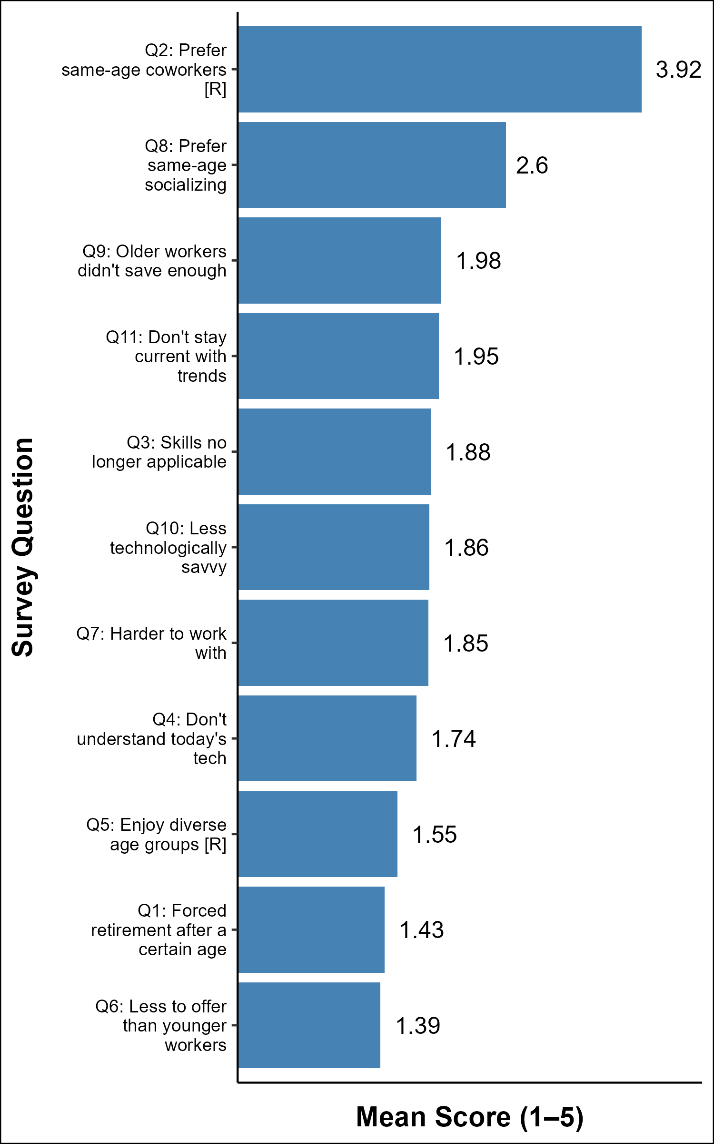
Figure 21: General Ageist Beliefs Toward Older IT Workers Mean response per question (1 = Strongly Disagree 5 = Strongly Agree)
Graphing the same data using a Violin Chart gives us a better idea how responses varied to the questions.
Kernel Density Estimate is used here and causes some values outside the scale range not to be displayed. This does not impact the data being displayed.
The wider the graph, the more the responses cluster together. The Box Plot inside the clusters indicates the Interquartile Range (IQR) with the darker vertical line indicating the median.
ageism_employment_df |>
select(-ID) |>
mutate(across(everything(), ~as.numeric(as.character(.)))) |>
pivot_longer(everything(), names_to = "question", values_to = "score") |>
filter(question %in% names(short_labels_ageist)) |>
mutate(
label = short_labels_ageist[question],
label = factor(label, levels = names(sort(tapply(score, label, median))))
) |>
ggplot(aes(x = label, y = score)) +
geom_violin(fill = "#4472C4", alpha = 0.6, trim = FALSE) +
geom_boxplot(width = 0.1, fill = "white", outlier.shape = NA) +
coord_flip() +
scale_y_continuous(breaks = 1:5, limits = c(0.5, 5.5)) +
labs(
x = "Survey Question",
y = "Score (1–5)"
) +
theme_minimal()
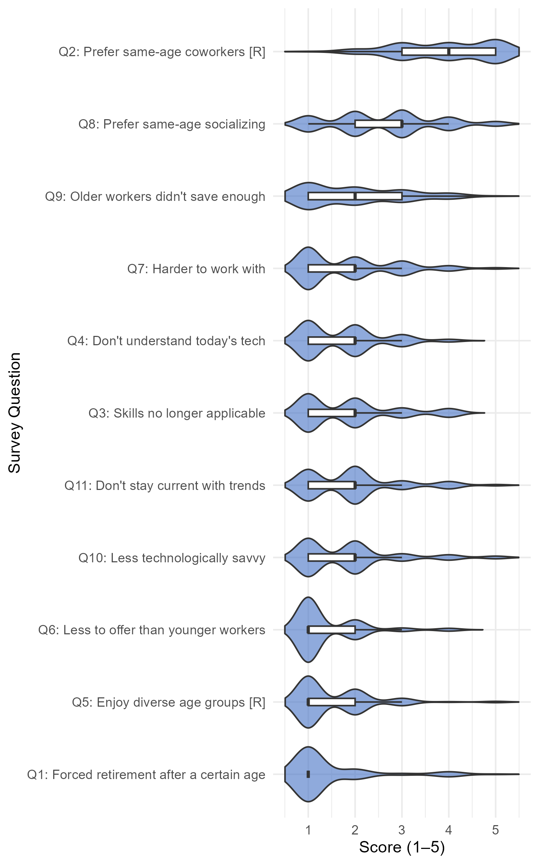
Figure 22: General Ageist Beliefs Toward Older IT Workers Response distribution per question (1 = Strongly Disagree 5 = Strongly Agree)

Continuing Education Attitudes (Q12–19)
These questions measure attitudes toward continuing education and its relationship to perceptions of older IT workers. Higher scores indicate stronger agreement that CE is valuable and that older workers who pursue it are viewed more favorably.
graph_bar_chart(
df = ce_means,
x_category = "label",
y_category = "mean",
label_col = "mean_label",
x_label = "Survey Question",
y_label = "Mean Score (1–5)",
horizontal = TRUE
)
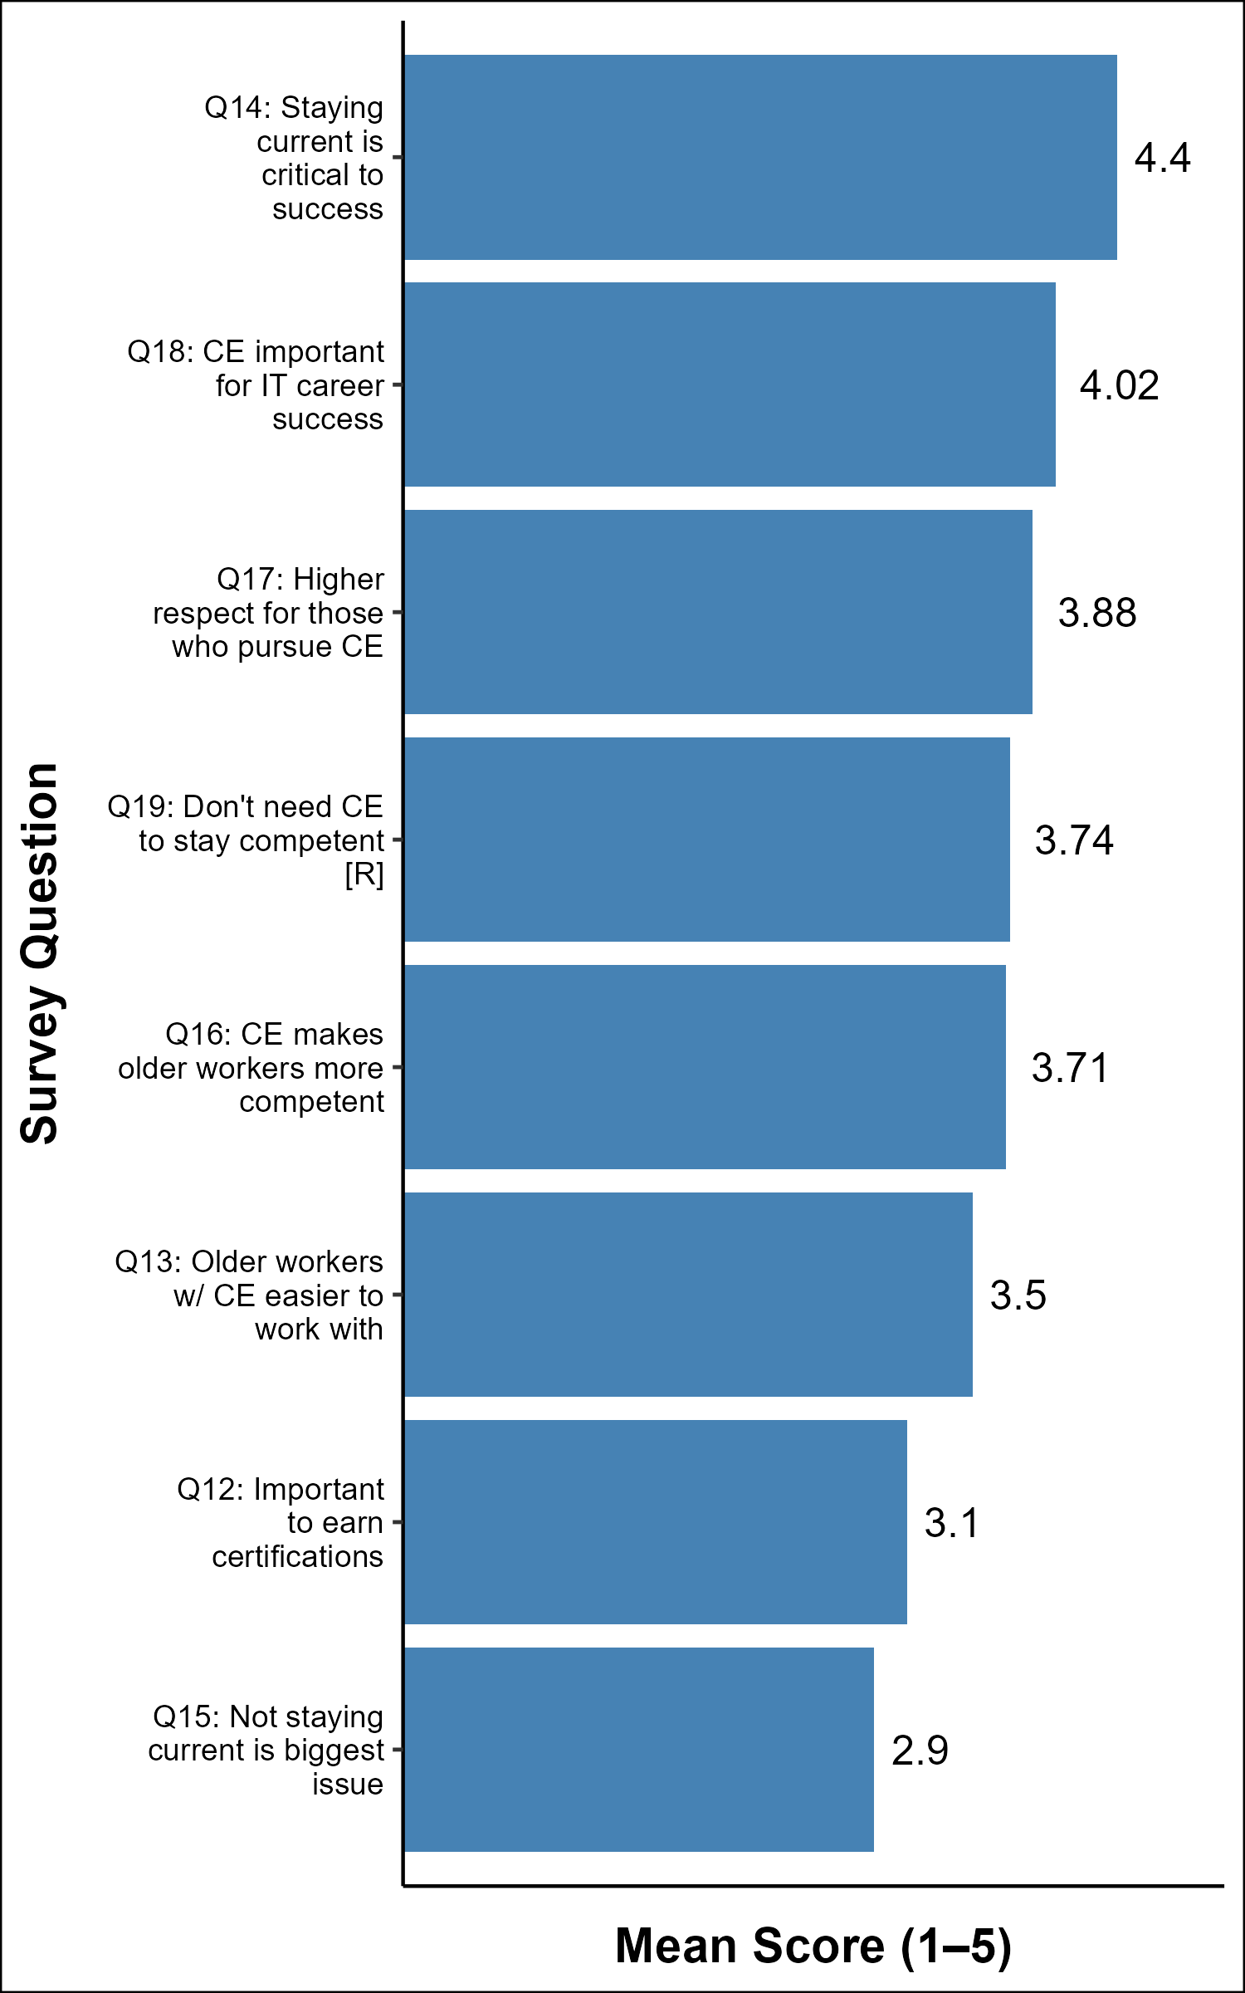
Figure 23: Attitudes Toward Continuing Education Mean response per question (1 = Strongly Disagree “5 = Strongly Agree

Research Question 2 Analysis
To directly address Research Question 2, a composite score is computed for each respondent in both question areas:
- General Ageist Beliefs (Q1–11)
- Continuing Education Attitudes (Q12-19)
A Spearman rank correlation is run between them. A negative correlation would support the hypothesis that valuing Continuing Education is associated with holding fewer ageist beliefs toward older IT workers.
Spearman’s ρ is used because both composites are means of ordinal Likert responses. No normality assumption is required.

Composite Scores
composites <- ageism_employment_df |>
mutate(across(-ID, ~as.numeric(as.character(.)))) |>
mutate(
ageist_composite = rowMeans(across(
Ageism_Employment_1:Ageism_Employment_11),
na.rm = TRUE),
ce_composite = rowMeans(
across(Ageism_Employment_12:Ageism_Employment_19),
na.rm = TRUE)
) |>
select(ID, ageist_composite, ce_composite)
composites |>
summarise(
across(c(ageist_composite, ce_composite),
list(N = ~sum(!is.na(.)),
Mean = ~round(mean(., na.rm = TRUE), 2),
SD = ~round(sd(., na.rm = TRUE), 2),
Min = ~round(min(., na.rm = TRUE), 2),
Max = ~round(max(., na.rm = TRUE), 2)))
) |>
pivot_longer(everything(),
names_to = c("Scale", "Stat"),
names_sep = "_(?=[^_]+$)") |>
pivot_wider(names_from = Stat, values_from = value) |>
mutate(Scale = case_when(
Scale == "ageist_composite" ~ "Ageist Beliefs (Q1–11)",
Scale == "ce_composite" ~ "CE Attitudes (Q12–19)",
TRUE ~ Scale
)) |>
knitr::kable(align = c("l", "r", "r", "r", "r", "r"))
Scale | N | Mean | SD | Min | Max
Ageist Beliefs (Q1–11) | 129 | 2.01 | 0.46 | 1.09 | 3.36
CE Attitudes (Q12–19) | 129 | 3.66 | 0.71 | 1.50 | 5.00
The ageist beliefs composite (mean = 2.01, SD = 0.46) sits well below the scale midpoint of 3.0, confirming the sample generally does not hold strong ageist beliefs. The CE composite (mean = 3.66, SD = 0.71) sits above the midpoint, reflecting broad agreement that continuing education is important for ones career.

Spearman Correlation
I perform the Spearman Correlation against the composite scores of the two question sections.
cor_result <- cor.test(composites$ageist_composite,
composites$ce_composite,
method = "spearman",
exact = FALSE)
cor_result
Spearman's rank correlation rho
data: composites$ageist_composite and composites$ce_composite
S = 302457, p-value = 0.08027
alternative hypothesis: true rho is not equal to 0
sample estimates:
rho
0.1545807

Research Question 2 Interpretation
The Spearman correlation between CE attitudes and ageist beliefs is ρ = 0.155 (p = 0.08). This is not statistically significant at α being 0.05, and the effect size is negligible.

Conclusion
Generally people value continuing education in IT.
Generally, people do not have strong ageist views towards their older co-workers.
For Research Question 2 We fail to reject the null hypothesis. The data does not support a significant relationship between how strongly a respondent values continuing education and how ageist their general beliefs about older IT workers are.
This is a noteworthy finding. While individual continuing education questions (Q13, Q16) show that respondents believe older workers who pursue continuing education are viewed more favorably, this aggregate analysis suggests that holding positive continuing education attitudes does not translate into measurably lower ageist beliefs at the individual level. The relationship between continuing education and ageism in the IT workforce may be more nuanced than a direct correlation captures, and warrants further investigation.

Personal Experience
This section is focused around the personal experience of ageism of survey participants. The answers to this question will help in our evaluation of how ageist the IT industry is along with the Fraboni analysis.

Vector Definitions
# These vectors are used to be able to see the question being asked of the
# participant.
pe_question_labels <- c(
"Personal_Experience_1" = "Age prevented a promotion",
"Personal_Experience_2" = "Age prevented receiving training",
"Personal_Experience_3" = "Age prevented getting a job",
"Personal_Experience_4" = "Excluded from groups or events due to age",
"Personal_Experience_5" = "Age used against me at work",
"Personal_Experience_6" = "Company wants me to retire soon",
"Personal_Experience_7" = "Harassed at work due to age",
"Personal_Experience_8" = "Uncomfortable at work due to age",
"Personal_Experience_9" = "Let go or fired due to age",
"Personal_Experience_10" = "Challenging work given to younger employees"
)

Create Personal Experience Data Frame
Create a Personal Experience data frame with ID, Age, and answers to the 10 Personal Experience questions. Rows where more than 30% of values are missing are dropped — these represent respondents who skipped the section entirely. Remaining isolated NA values are replaced with “Neither true nor false” as a conservative neutral response.
personal_experience_df <- main_df |>
select(ID, Age, starts_with("Personal_Experience_")) |>
filter(rowMeans(is.na(across(everything()))) <= 0.3)
personal_experience_df |>
mutate(na_count = rowSums(is.na(across(everything())))) |>
filter(na_count > 0) |>
select(ID, na_count) |>
knitr::kable(col.names = c("ID", "Num Missing"))
Table 15: Number of Missing Values from the Personal Experience Section
ID | Num Missing
6 | 2

Based on this, I only have one row with NAs in them. I will update these responses with a a neutral response.
personal_experience_df <- personal_experience_df |>
mutate(across(starts_with("Personal_Experience_"),
~replace(., is.na(.), "Neither true nor false")))

Post Dataframe Manipulation Information:
Any NAs in Dataframe: FALSE
Number of Research Participants for Personal Experience Analysis is: 115

Save Out Personal Experience Data Frame
We will be using this cleaned data frame in our Correlation Analysis.
saveRDS(personal_experience_df,
"personal_experience_df.rds")

Summary of Reported Experiences
The following table shows the percentage of respondents who reported each experience as True, Neutral, or False, sorted by the percentage reporting True.
pe_summary <- personal_experience_df |>
select(starts_with("Personal_Experience_")) |>
summarise(across(everything(), list(
True = ~round(mean(. == "True") * 100, 1),
Neutral = ~round(mean(. == "Neither true nor false") * 100, 1),
False = ~round(mean(. == "False") * 100, 1)
))) |>
pivot_longer(everything(),
names_to = c("question", "response"),
names_sep = "_(?=True|Neutral|False)") |>
pivot_wider(names_from = response, values_from = value) |>
mutate(label = pe_question_labels[question]) |>
arrange(desc(True)) |>
select(label, True, Neutral, False)
pe_summary |>
knitr::kable(
col.names = c("Experience", "True (%)", "Neutral (%)", "False (%)"),
align = c("l", "r", "r", "r")
)
Table 16: Response Distribution To Personal Experience Questions
Experience | True (%) | Neutral (%) | False (%)
Age prevented getting a job | 23.5 | 20.9 | 55.7
Age prevented a promotion | 15.7 | 23.5 | 60.9
Age used against me at work | 13.9 | 20.9 | 65.2
Challenging work given to younger employees | 13.0 | 17.4 | 69.6
Uncomfortable at work due to age | 8.7 | 13.0 | 78.3
Age prevented receiving training | 6.1 | 17.4 | 76.5
Let go or fired due to age | 6.1 | 8.7 | 85.2
Excluded from groups or events due to age | 5.2 | 20.9 | 73.9
Company wants me to retire soon | 5.2 | 25.2 | 69.6
Harassed at work due to age | 4.3 | 10.4 | 85.2

Percentage Reporting True for Each Experience
pct_true_df <- pe_summary |>
mutate(
pct_label = paste0(True, "%"),
label = factor(label, levels = label[order(True)])
)
graph_bar_chart(
df = pct_true_df,
x_category = "label",
y_category = "True",
label_col = "pct_label",
x_label = "Experience",
y_label = "% Reporting True",
horizontal = TRUE,
y_limits = c(0, 100)
)
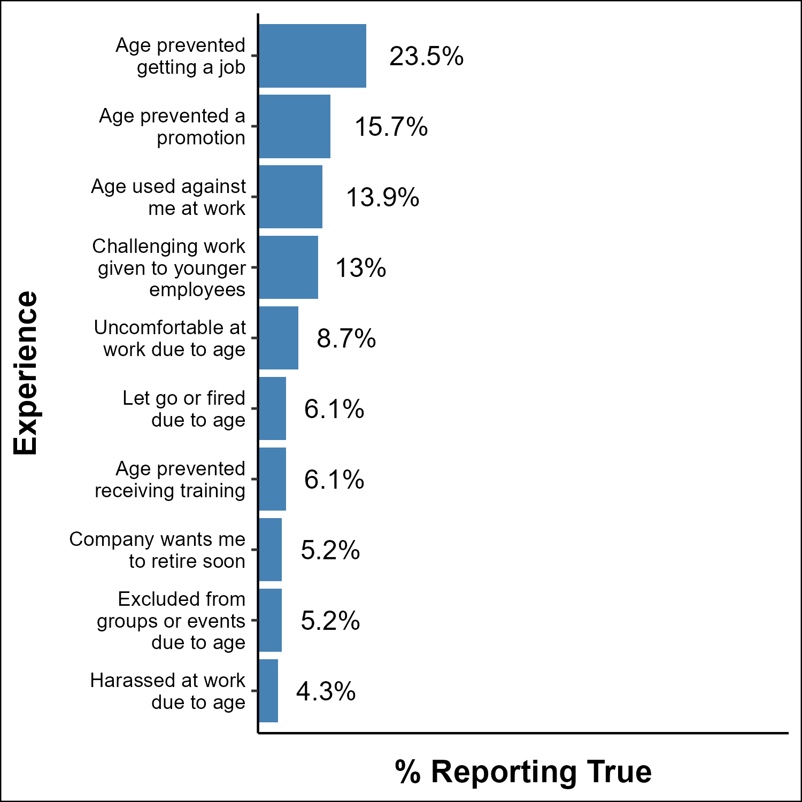
Figure 24: Percentage Reporting Each Ageist Experience Sorted by prevalence; scale 0–100%
The most commonly reported experience is being denied a job due to age (22.8%), followed by promotion barriers (14.9%) and age being used against the respondent (13.2%). Overt experiences such as harassment and termination are least common (under 5%). This pattern suggests ageism in this sample manifests primarily through employment barriers rather than direct social mistreatment.

Personal Experience by Age Group
To understand whether older IT workers experience ageism at higher rates, a composite experience score is computed per respondent — the count of questions marked “True.” A higher score indicates more reported ageist experiences.
pe_score_df <- personal_experience_df |>
mutate(across(starts_with("Personal_Experience_"),
~case_when(. == "True" ~ 1L, TRUE ~ 0L))) |>
mutate(exp_score = rowSums(across(starts_with("Personal_Experience_")))) |>
select(ID, Age, exp_score)
pe_age_summary <- pe_score_df |>
group_by(Age) |>
summarise(
n = n(),
mean_score = round(mean(exp_score), 2),
pct_any = round(mean(exp_score > 0) * 100, 1),
.groups = "drop"
) |>
mutate(
score_label = as.character(mean_score),
age_label = str_remove(as.character(Age), " years old")
)
graph_bar_chart(
df = pe_age_summary,
x_category = "age_label",
y_category = "mean_score",
label_col = "score_label",
x_label = "Respondent Age Group",
y_label = "Mean Experiences Reported",
horizontal = FALSE
)
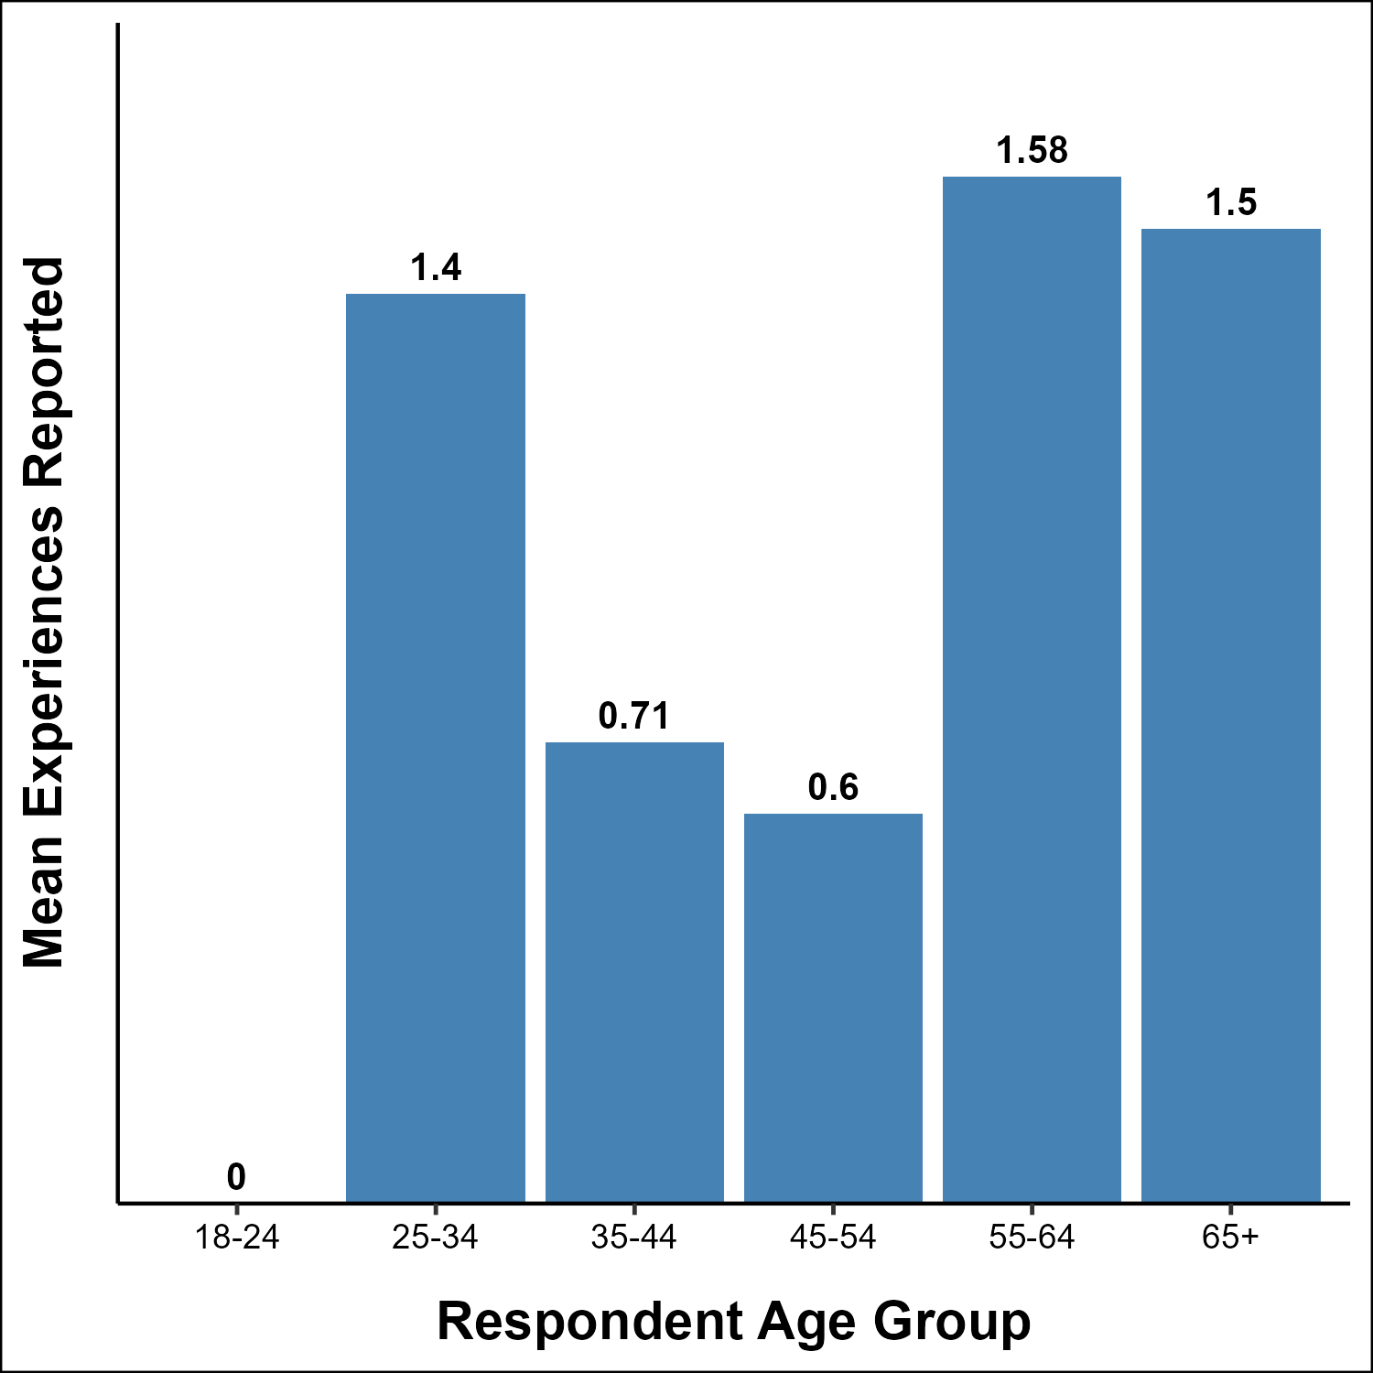
Figure 25: Mean Number of Ageist Experiences by Age Group Count of ‘True’ responses out of 10 possible experiences
pe_age_summary |>
select(Age, n, mean_score, pct_any) |>
knitr::kable(
col.names = c("Age Group", "N", "Mean Score", "% Reporting Any Experience"),
align = c("l", "r", "r", "r")
)
Table 17: Age Groups and Ageist Experience
Age Group | N | Mean Score | % Reporting Any Experience
18-24 years old | 2 | 0.00 | 0.0
25-34 years old | 5 | 1.40 | 60.0
35-44 years old | 21 | 0.71 | 28.6
45-54 years old | 43 | 0.60 | 32.6
55-64 years old | 36 | 1.58 | 44.4
65+ years old | 8 | 1.50 | 37.5

Conclusion
Respondents aged 55–64 and 65+ report the highest mean experience scores (1.23 and 1.50 respectively) and the highest rates of reporting at least one ageist experience (38.5% and 37.5%). Middle-aged respondents (35–54) report substantially fewer experiences (mean 0.47–0.58, 23–26% reporting any). The youngest groups (18–34) have very small sample sizes (n=2 and n=8) and should be interpreted with caution.
While the focus of this paper is the impact of ageism on older IT workers, as previously mentioned, ageism can be experienced by all age groups with higher levels being experienced by both older and younger workers. While caution is advised with the low sample size in the younger groups, the data is consistent with overall expectations.
The trend among the age groups with the larger sample sizes groups (ages 35+) is consistent with what would be expected if age-based discrimination increases with age in the IT workforce. Formal statistical testing of this relationship will be further analyzed in the Correlations analysis Section.

Correlation Analysis
In this section I perform some further in-depth analysis looking for further correlations between the different metrics we have obtained and calculated.

Data Preparation
The data frames previously saved out are loaded here performing some data manipulation as appropriate. All modifications are documented in their respective data frame load.
# For Fraboni Scores, I load the data frame from the file and only keep the
# following columns: ID, Total_Score, Disc_Score, Avoid_Score and AntiLoc_Score
fraboni_scores <- readRDS("fraboni_df.rds") |>
select(ID, Total_Score, Disc_Score, Avoid_Score, AntiLoc_Score)
# For Personal Experience, we load the data frame from the file and do the
# following:
# - Drop Age
# - Change 'True' to 1, 'Neither true nor false' to 0, and 'False' to -1.
# - Average the numbers and put them in a pe_composite column.
# - Default to 'No Opinion' if blank
# - Return only the ID and Composite Score.
pe_scores <- readRDS("personal_experience_df.rds") |>
select(-Age) |>
mutate(across(-ID, ~case_when(
. == "True" ~ 1,
. == "Neither true nor false" ~ 0,
. == "False" ~ -1,
TRUE ~ 0
))) |>
mutate(
pe_composite = rowMeans(across(starts_with("Personal_Experience_")))
) |>
select(ID, pe_composite)
# For Ageism in Employment, we load the data frame from the file and do the
# following:
# - Convert everything to Numeric (Ignoring 'ID')
# - Create Averages for Ageist Questions
# - Create Averages for Continuing Education Questions
# - Only save the ID and the two averages above.
ae_scores <- readRDS("ageism_employment_df.rds") |>
mutate(across(-ID, ~as.numeric(.))) |>
mutate(
ageist_composite = rowMeans(
across(Ageism_Employment_1:Ageism_Employment_11)
),
ce_composite = rowMeans(
across(Ageism_Employment_12:Ageism_Employment_19)
)
) |>
select(ID, ageist_composite, ce_composite)
# For Age Perception, we load the data frame from the file and create an
# average composite score column and save only the ID and composite score.
ap_scores <- readRDS("age_perception_df.rds") |>
mutate(ap_composite = rowMeans(across(starts_with("Age_Perception_")))) |>
select(ID, ap_composite)

Build Master Analysis Data Frame
I combine the unique data frames into one master data frame for analysis. One important note is I add age_num and educ_num as the associated integer based on the ordered values we previously defined during our Load and Clean.
master_df <- main_df |>
select(ID, Age, Education, Gender, IT_Field, IT_Industry) |>
mutate(
age_num = as.integer(Age),
educ_num = as.integer(Education)
) |>
inner_join(fraboni_scores, by = "ID") |>
left_join(ae_scores, by = "ID") |>
left_join(pe_scores, by = "ID") |>
left_join(ap_scores, by = "ID")
master_df |>
mutate(na_count = rowSums(is.na(across(everything())))) |>
filter(na_count > 0) |>
select(ID, na_count) |>
apa_table(col.names = c("ID", "Num Missing"), caption="TESTTTTT")
Table 18: Number of Missing Values from the Correlation Analysis Section
(#tab:tbl-ca-NACheck) TESTTTTT
ID | Num Missing
18.00 | 1.00
70.00 | 1.00
90.00 | 1.00
127.00 | 1.00

colSums(is.na(master_df))[colSums(is.na(master_df)) > 0] |>
knitr::kable(col.names = c("Column Name", "Num Missing"))
Table 19: Column Names with number of NAs in them
Column Name | Num Missing
pe_composite | 1
ap_composite | 3

Update NAs
The only NA is from Participant 126 with their Personal Experience Score being previously dropped due to insufficient data. I will set their score to a neutral score of 0.
Note: This is the composite score ranging from -1 to 1 with zero being neutral.
master_df <- master_df |>
mutate(pe_composite = replace_na(pe_composite, 0))

Post Data Frame Manipulation Information:
Any NAs in the Master data frame: TRUE
Number of Research Participants for Master analysis is: 110

Overview
This analysis tests for correlations between all major variables collected in the survey and the Fraboni Ageism Score of the participant. I also look at cross-scale relationships relevant to each research question.
Two statistical methods are used:
- Spearman’s ρ (rho) This method is used for ordinal and continuous variables — no normality assumption required. Items addressed by Spearman’s have a natural order and it doesn’t require the data to have a perfect bell curve. I use this method to see if ageism increases or decreases as the variable changes.
- ie: As education level goes up, does the ageism score rise, fall or stay the same.
- Spearman’s will give a +1 to -1 result where the strength and direction of the relationship is addressed. A result near +1 shows ageism increases as the variable increases. A result near -1 shows ageism decreases as the variable increases. Anything near 0 shows no clear relationship exists.
- Kruskal-Wallis for nominal grouping variables (Gender, IT Field, IT Industry). I use this when there is no natural order to the variables. I use this method to see if any groups score differently from each other.
- ie: Do people in different IT Fields have different Ageism Scores?
- Kruskal-Wallis will provide an H Statistic and a p value. If we find a p value of less that 0.05, I will investigate further to find out which group was identified as different.

Research Question 1
Does a Respondent’s Age Predict Their Perception of “Old”?
Research Question 1 asks whether a person’s own age is associated with the age at which they consider someone “old.” The Age Perception composite score represents the mean rating a respondent assigned across all 14 age brackets (1 = Very Young, 5 = Very Old). A lower composite means the respondent rates people as younger overall — i.e., they have a higher threshold for “old.”
Spearman will be used as the participant’s age is ordered data.
rq1_result <- cor.test(master_df$age_num,
master_df$ap_composite,
method = "spearman",
exact = FALSE)
rq1_result
Spearman's rank correlation rho
data: master_df$age_num and master_df$ap_composite
S = 244173, p-value = 0.04303
alternative hypothesis: true rho is not equal to 0
sample estimates:
rho
-0.1960107
# Used to label the graph in the next code chunk.
rq1_cap <- paste0(
"Respondent Age vs. Perception of Age<br>",
"Spearman ρ = ", round(rq1_result$estimate, 3),
", p = ", round(rq1_result$p.value, 4))
graph_scatter(
df = master_df |> filter(!is.na(ap_composite)),
x_category = "age_num",
y_category = "ap_composite",
x_label = "Respondent Age Group (1 = 18–24, 6 = 65+)",
y_label = "Mean Age Perception Score (1–5)",
trend_line = TRUE,
trend_method = "lm",
x_breaks = 1:6,
x_limits = c(1, 6)
)
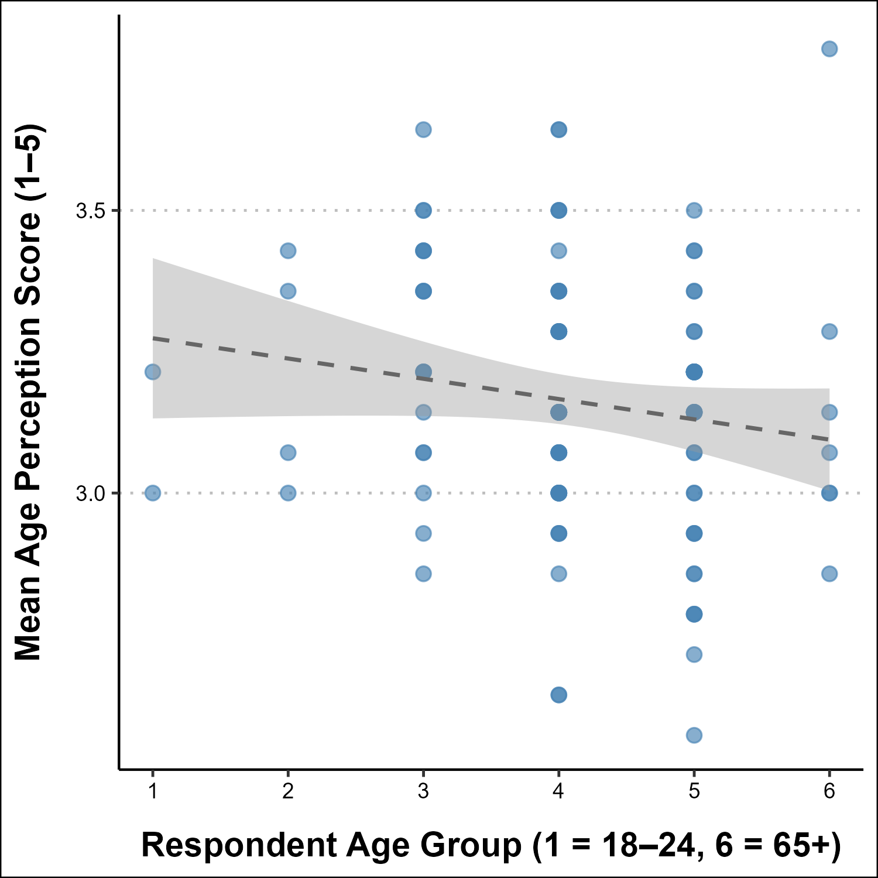
Figure 26: Respondent Age vs. Perception of AgeSpearman ρ = -0.196, p = 0.043
Research Question 1 Finding: There is a statistically significant negative correlation between respondent age and mean age perception score (ρ = -0.196, p = 0.043). Older respondents consistently rate age brackets as younger. In other words they require someone to be older before considering them “old.” This supports Research Question 1: a person’s own age does influence their perception of what constitutes oldness. The effect is moderate and consistent with the threshold analysis reported in Section 3, where respondents aged 35–44 placed the “old” threshold at 56–60 while older groups converged on 61–65.

Demographic Predictors of Fraboni Score

Age vs Fraboni Score
Spearman will be used as the participant’s age is ordered data. I am comparing the respondent’s age to their Fraboni Total Score.
age_cor <- cor.test(master_df$age_num,
master_df$Total_Score,
method = "spearman",
exact = FALSE)
age_cor |>
tidy() |>
select(estimate, statistic, p.value) |>
mutate(across(everything(), ~round(., 4))) |>
knitr::kable(col.names = c("ρ", "S", "p-value"))
Table 20: Age vs Fraboni Correlation Test
ρ | S | p-value
-0.0503 | 232968.7 | 0.6019

Conclusion: Age is not significantly correlated with Fraboni Total Score (ρ = -0.05, p = 0.6019), consistent with the ANOVA result reported in Section 4. The direction is slightly negative, but the effect is negligible.

Education vs Fraboni Score
Spearman will be used as the participant’s education is ordered data. I am comparing the respondent’s education to their Fraboni Total Score.
educ_cor <- cor.test(master_df$educ_num,
master_df$Total_Score,
method = "spearman",
exact = FALSE)
educ_cor |>
tidy() |>
select(estimate, statistic, p.value) |>
mutate(across(everything(), ~round(., 4))) |>
knitr::kable(col.names = c("ρ", "S", "p-value"))
Table 21: Education vs Fraboni Correlation Test
ρ | S | p-value
0.0802 | 204024.3 | 0.4049

Conclusion: Education level is not significantly associated with Fraboni score (ρ = 0.08, p = 0.4049). Higher levels of formal education do not appear to reduce ageist attitudes in this sample.

Gender vs Fraboni Score
Kruskal-Wallis is used because gender is not ordered. We limit this analysis to only those who reported Male and Female due to the limited sample size for the other options.
# Limit to Male/Female (n too small for other categories)
gender_df <- master_df |>
filter(Gender %in% c("Male", "Female")) |>
mutate(Gender = droplevels(Gender))
# Run the Kruskal-Wallis Test against Fraboni Score vs Gender
gender_kw <- kruskal.test(Total_Score ~ Gender,
data = gender_df)
# Show the result of the Kruskal-Wallis Test
# Degrees of Freedom, H Statistic and p-value.
# Note: This needs to be piped through Broom::Tidy because the data is in
# htest format, not a data frame. Tidy will convert it for me.
gender_kw |>
tidy() |>
select(parameter, statistic, p.value) |>
mutate(across(everything(), ~round(., 4))) |>
knitr::kable(col.names = c("Degrees of Freedom",
"H Statistic (χ²)",
"p-value"))
Table 22: Gender vs Fraboni Correlation Test
Degrees of Freedom | H Statistic (χ²) | p-value
1 | 1.2144 | 0.2705

# For each gender group, calculate number of respondents, their Average Fraboni
# Total Score rounded to one decimal, A Label for the chart, and clean up the
# grouping.
gender_means <- gender_df |>
group_by(Gender) |>
summarise(n = n(),
mean_score = round(mean(Total_Score), 1),
score_label = as.character(round(mean(Total_Score), 1)),
.groups = "drop")
gender_means |>
select(Gender, n, mean_score) |>
mutate(mean_score = round(mean_score, 4)) |>
knitr::kable(col.names = c("Gender", "Count", "Mean Score"))
Table 23: Gender vs Fraboni by Gender Mean Scores
Gender | Count | Mean Score
Female | 26 | 52.5
Male | 84 | 50.2

graph_bar_chart(
df = gender_means,
x_category = "Gender",
y_category = "mean_score",
label_col = "score_label",
x_label = "Gender",
y_label = "Mean Fraboni Score",
horizontal = FALSE
)
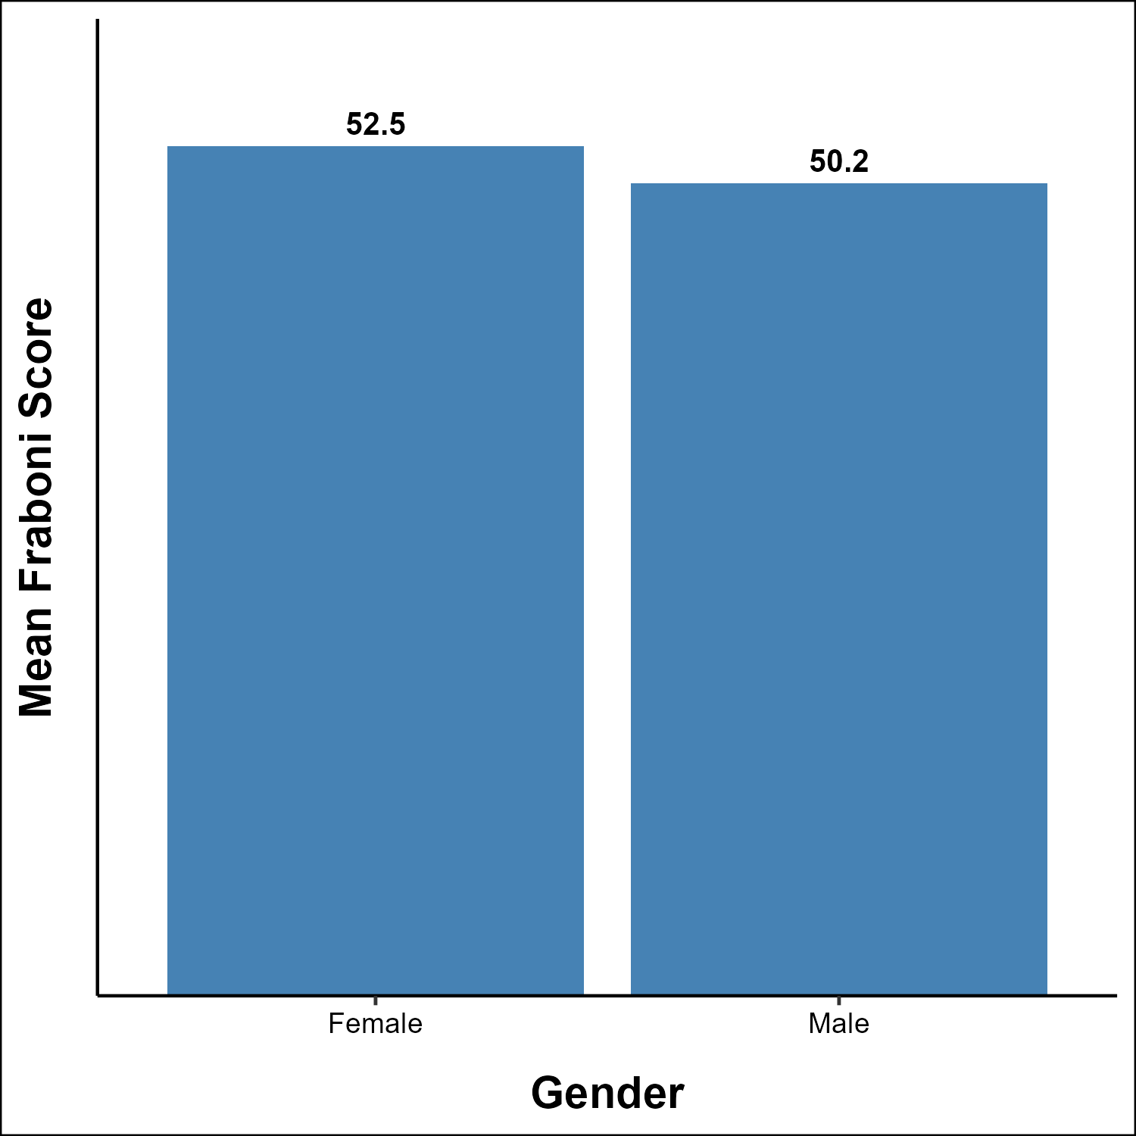
Figure 27: Mean Fraboni Score by Gender
Conclusion: Gender is not a significant predictor of Fraboni score (χ² = 1.214, p = 0.2705). Female respondents have a slightly higher mean score (52.5) than male respondents (50.2), but the difference is not statistically significant.

IT Field and IT Industry
Again Kruskal-Wallis is used because neither IT Field or IT Industry are ordered.
# Run the Kruskal-Wallis Test against IT Field and Total Fraboni Score
field_kw <- kruskal.test(Total_Score ~ IT_Field,
data = master_df)
# Run the Kruskal-Wallis Test against IT Industry and Total Fraboni Score
industry_kw <- kruskal.test(Total_Score ~ IT_Industry,
data = master_df)
bind_rows(
field_kw |> tidy() |> mutate(Group = "IT Field"),
industry_kw |> tidy() |> mutate(Group = "IT Industry")
) |>
select(Group, parameter, statistic, p.value) |>
mutate(
statistic = round(statistic, 3),
p.value = round(p.value, 4)
) |>
knitr::kable(col.names = c("Group",
"Degrees of Freedom",
"H Statistic (χ²)",
"p-value"))
Table 24: Fraboni Score vs IT Industry
Group | Degrees of Freedom | H Statistic (χ²) | p-value
IT Field | 12 | 8.998 | 0.7031
IT Industry | 13 | 11.794 | 0.5446

Conclusion: Neither IT Field (χ² = 8.998, p = 0.7031) nor IT Industry (χ² = 11.794, p = 0.5446) is significantly associated with ageism level. Note that several groups contain very few respondents (n < 5), which limits the power of these tests to detect real differences.

Scale Predictors of Fraboni Score

Ageism Employment Beliefs (Q1–11) vs Fraboni
I compare the first questions in the Ageism Employment survey associated with Ageism Employment Beliefs with the Fraboni Total Score. Spearman is used since the Ageist Score is ordered data.
ae_cor <- cor.test(master_df$ageist_composite,
master_df$Total_Score,
method = "spearman",
exact = FALSE)
ae_cor
Spearman's rank correlation rho
data: master_df$ageist_composite and master_df$Total_Score
S = 107945, p-value = 9.765e-09
alternative hypothesis: true rho is not equal to 0
sample estimates:
rho
0.5133549
# Used to label the graph in the next code chunk.
ae_cap <- paste0(
"Workplace Ageist Beliefs vs. Fraboni Ageism Score<br>",
"Spearman ρ = ", round(ae_cor$estimate, 3),
", p = ", round(ae_cor$p.value, 4))
graph_scatter(
df = master_df |> filter(!is.na(ageist_composite)),
x_category = "ageist_composite",
y_category = "Total_Score",
x_label = "Ageist Beliefs Composite (AE Q1–11)",
y_label = "Fraboni Total Score",
trend_line = TRUE
)
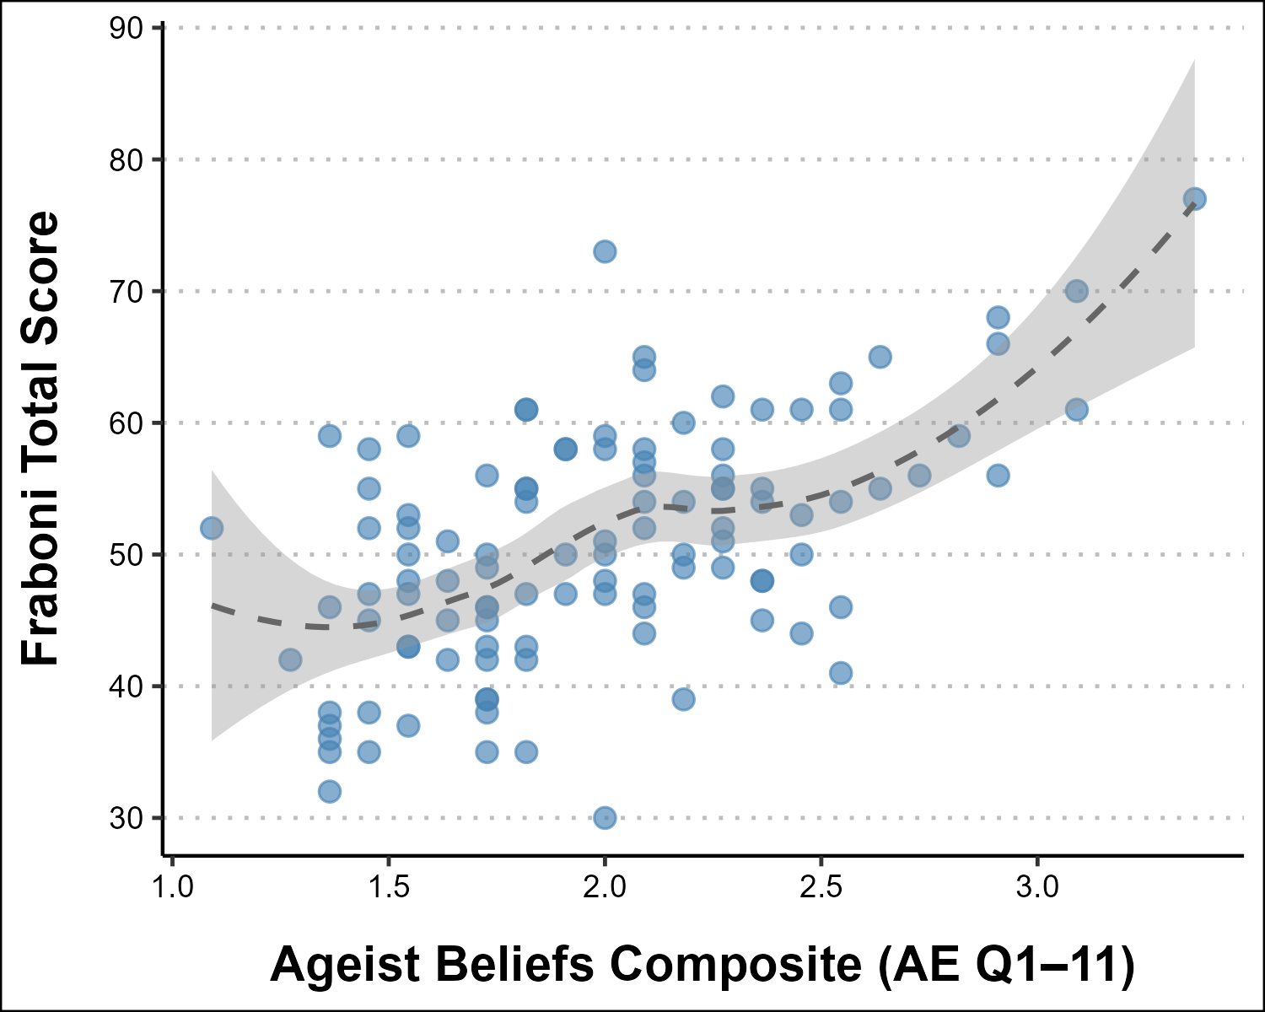
Workplace Ageist Beliefs vs. Fraboni Ageism ScoreSpearman ρ = 0.513, p = 0
Conclusion: This is the strongest finding in the analysis. Workplace ageist beliefs (AE composite Q1–11) are strongly and significantly correlated with Fraboni ageism score (ρ = 0.513, p < 0.001). Respondents who agree with ageist statements about older IT workers — that their skills are outdated, that they are harder to work with, or that they contribute less — also score substantially higher on the Fraboni general ageism scale.
This finding has two important implications: it validates both instruments as measuring related constructs, and it identifies workplace ageist beliefs as the single strongest predictor of overall ageism level in this sample.

Continuing Education Attitudes (Q12–19) vs Fraboni
I do the same analysis as previously done except with the last set of questions in the Ageism Employment section. Again, Spearman is used due to the ordered nature of the scale.
ce_cor <- cor.test(master_df$ce_composite,
master_df$Total_Score,
method = "spearman",
exact = FALSE)
ce_cor |>
tidy() |>
select(estimate, statistic, p.value) |>
mutate(across(everything(), ~round(., 4))) |>
knitr::kable(col.names = c("ρ", "S", "p-value"))
Table 25: Fraboni Score vs Continuing Education
ρ | S | p-value
0.1373 | 191357.3 | 0.1526

Conclusion: Continuing Education attitudes are not significantly correlated with Total Fraboni score (ρ = 0.137, p = 0.1526). Combined with the non-significant result from Section 5 (Continuing Education attitudes vs. Ageist Beliefs), this consistently indicates that valuing continuing education does not translate into measurably lower ageism in this sample.

Personal Experience of Ageism vs. Fraboni
I want to see if a person’s own experience with Ageism might impact their own ageist views.
pe_cor <- cor.test(master_df$pe_composite,
master_df$Total_Score,
method = "spearman",
exact = FALSE)
pe_cor |>
tidy() |>
select(estimate, statistic, p.value) |>
mutate(across(everything(), ~round(., 4))) |>
knitr::kable(col.names = c("ρ", "S", "p-value"))
Table 26: Fraboni Score vs Personal Experience
ρ | S | p-value
0.0665 | 207054 | 0.4897

Conclusion: Personal experience of workplace ageism is not significantly correlated with Total Fraboni score (ρ = 0.067, p = 0.4897). Respondents who have personally experienced ageist treatment do not score consistently higher or lower on general ageism than those who have not.

Age Perception Composite vs. Fraboni
I want to look at whether the perception of age influences ageist views or not.
ap_cor <- cor.test(master_df$ap_composite,
master_df$Total_Score,
method = "spearman",
exact = FALSE)
ap_cor |>
tidy() |>
select(estimate, statistic, p.value) |>
mutate(across(everything(), ~round(., 4))) |>
knitr::kable(col.names = c("ρ", "S", "p-value"))
Table 27: Fraboni Score vs Age Perception
ρ | S | p-value
-0.1015 | 224878.1 | 0.2982

Conclusion: Mean age perception score (how respondents rate general age brackets) is not significantly correlated with Fraboni score (ρ = -0.102, p = 0.2982). Rating people as “older” does not correspond to higher general ageism.

Summary of All Correlations
summary_table <- tribble(
~Variable, ~Method, ~Statistic, ~p_value, ~Significant,
"Age (ordinal)", "Spearman ρ", round(age_cor$estimate, 3),
round(age_cor$p.value, 4), "No",
"Education (ordinal)", "Spearman ρ", round(educ_cor$estimate, 3),
round(educ_cor$p.value, 4), "No",
"Gender", "Kruskal-Wallis", round(gender_kw$statistic, 3),
round(gender_kw$p.value,4), "No",
"IT Field", "Kruskal-Wallis", round(field_kw$statistic, 3),
round(field_kw$p.value, 4), "No",
"IT Industry", "Kruskal-Wallis", round(industry_kw$statistic, 3),
round(industry_kw$p.value, 4), "No",
"Ageist Beliefs (AE Q1–11)", "Spearman ρ", round(ae_cor$estimate, 3),
round(ae_cor$p.value, 4), "Yes",
"CE Attitudes (AE Q12–19)", "Spearman ρ", round(ce_cor$estimate, 3),
round(ce_cor$p.value, 4), "No",
"Personal Experience", "Spearman ρ", round(pe_cor$estimate, 3),
round(pe_cor$p.value, 4), "No",
"Age Perception (mean score)", "Spearman ρ", round(ap_cor$estimate, 3),
round(ap_cor$p.value, 4), "No",
"RQ1: Age → Age Perception", "Spearman ρ", round(rq1_result$estimate, 3),
round(rq1_result$p.value, 4), "Yes"
)
summary_table |>
knitr::kable(
col.names = c("Variable",
"Method",
"Statistic (ρ or H)",
"p-value",
"Significant"),
align = c("l",
"l",
"r",
"r",
"c")
)
Table 28: Summary Table
Variable | Method | Statistic (ρ or H) | p-value | Significant
Age (ordinal) | Spearman ρ | -0.050 | 0.6019 | No
Education (ordinal) | Spearman ρ | 0.080 | 0.4049 | No
Gender | Kruskal-Wallis | 1.214 | 0.2705 | No
IT Field | Kruskal-Wallis | 8.998 | 0.7031 | No
IT Industry | Kruskal-Wallis | 11.794 | 0.5446 | No
Ageist Beliefs (AE Q1–11) | Spearman ρ | 0.513 | 0.0000 | Yes
CE Attitudes (AE Q12–19) | Spearman ρ | 0.137 | 0.1526 | No
Personal Experience | Spearman ρ | 0.067 | 0.4897 | No
Age Perception (mean score) | Spearman ρ | -0.102 | 0.2982 | No
RQ1: Age → Age Perception | Spearman ρ | -0.196 | 0.0430 | Yes

Overall Conclusions

Research Question 1
Does a person’s own age influence their perception of what constitutes “old”?
Supported, with a moderate effect. Respondent age is negatively correlated with mean age perception score (ρ = -0.196, p = 0.043), meaning older respondents consistently rate age brackets as younger — they require someone to be older before labeling them “old.” This is corroborated by the threshold analysis in Section 3, where respondents aged 35–44 set the “old” threshold at 56–60 while all older age groups converged on 61–65. The sample sizes for the youngest age groups are very small, so this finding should be interpreted cautiously. It is consistent across both analyses and warrants replication with a larger, more evenly distributed sample.

Research Question 2
Does continuing education impact perceptions of older IT workers?
Not supported. Two separate tests address this question. First, Continuing Education attitudes (Ageism Emloyment Q12–19 composite) are not significantly correlated with ageist workplace beliefs (Ageism Employment Q1–11 composite) (ρ = 0.134, p = 0.128; reported in Section 5). Second, Continuing Education attitudes are not significantly correlated with overall Fraboni ageism score (ρ = 0.137, p = 0.1526). Neither test approaches significance, and the effect sizes are negligible.
This is a notable null result. Respondents in this sample hold strong pro-Continuing Education attitudes (mean Continuing Education composite = 3.65/5) and low ageist beliefs (mean ageist composite = 2.02/5), yet these two attitudes do not significantly co-vary at the individual level. The relationship between valuing continuing education and holding less ageist views may be more complex than a direct correlation captures — for instance, it may be moderated by years of experience, management responsibility, or whether the respondent has actively worked alongside older colleagues who have pursued Continuing Education.

Research Question 3
How ageist is the IT workforce?
The low ageism level is consistent across all four Fraboni subscales (Discrimination, Avoidance, Antilocution), none of which shows a significant relationship with respondent age (ANOVA p = 0.563). No demographic subgroup — by age, gender, education, IT field, or industry — scores meaningfully higher than any other.
It is worth noting that the sample is heavily concentrated in Healthcare & Life Science (51%) and skewed male (77%). Both factors may limit the general ability to the broader IT workforce. Future research drawing from a more diverse industry cross-section would strengthen claims about the IT workforce as a whole.

Emergent Finding
Workplace Ageist Beliefs Cross-Validate General Ageism
Beyond the three research questions, the strongest statistical signal in the entire dataset is the correlation between workplace ageist beliefs (AE Q1–11 composite) and Fraboni Total Score (ρ = 0.513, p < 0.001). This relationship confirms that the two instruments are measuring related constructs — respondents who express ageist views about older IT coworkers in a workplace context also score higher on a general measure of ageism. This convergent validity strengthens confidence in both scales as meaningful tools for studying ageism in the IT workforce.

##

