Use git to clone AquaCrop from github.
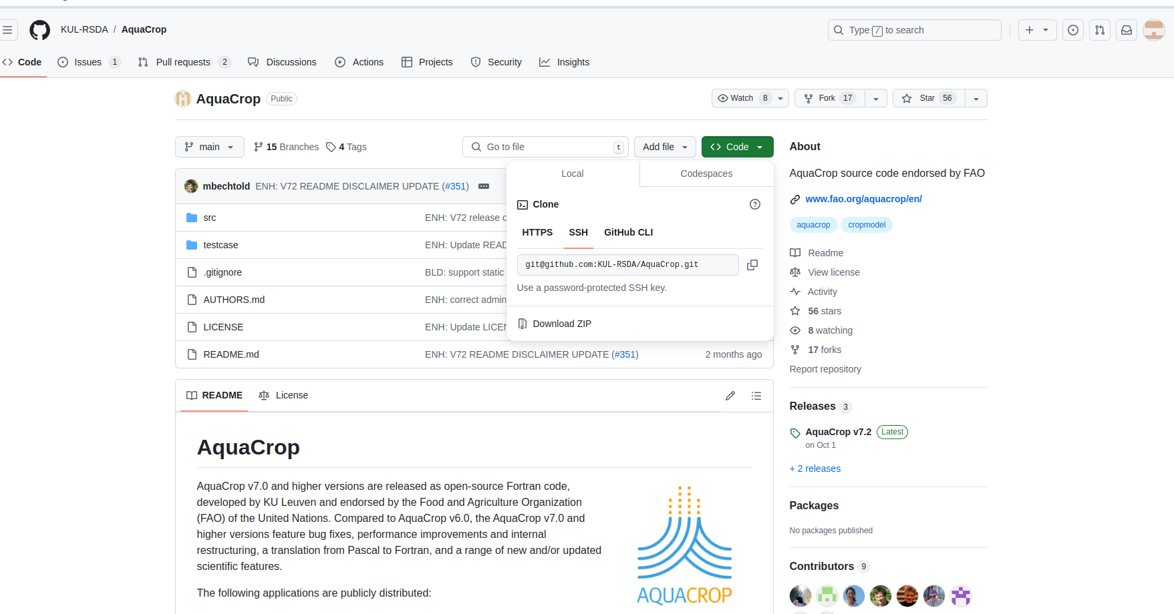

Make a new directory for Aquacrop
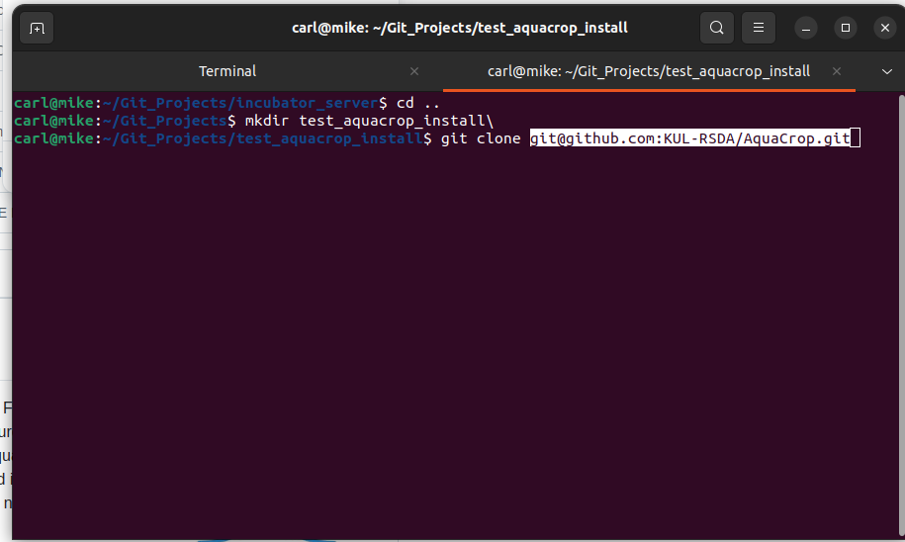
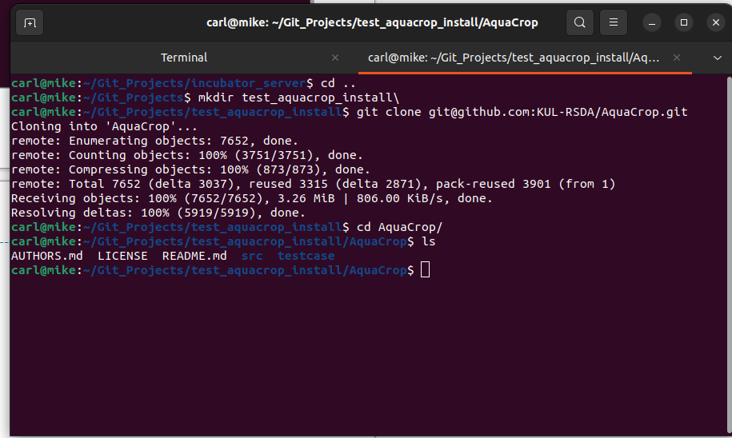
Go to the src directory.
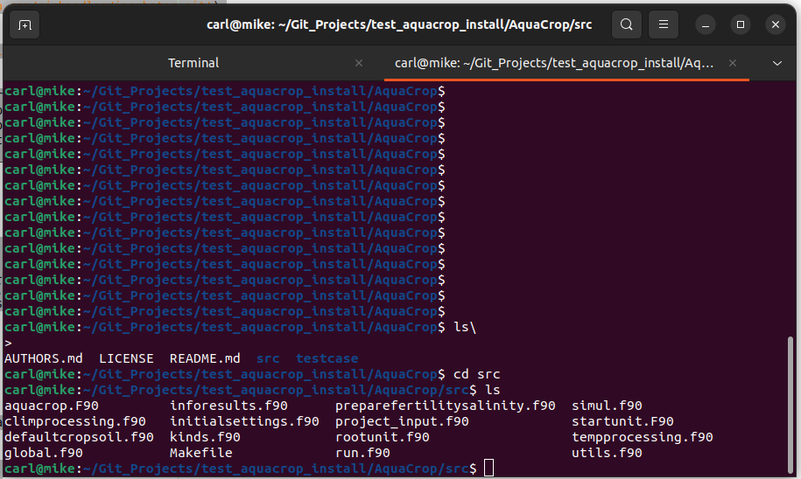

Use make to compile the fortran code. You may need to get a fortran90 compiler, I used on ubuntu:
sudo apt-get install gfortran
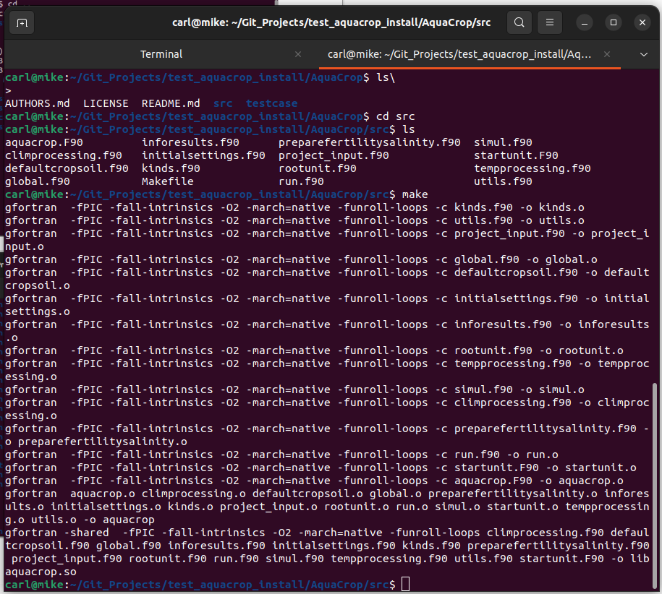

Copy the executable aquacrop file that you just compiled into the testcase directory.
Now you run the test case: (note that there is no output in the terminal, it’s all in the OUTP directory)
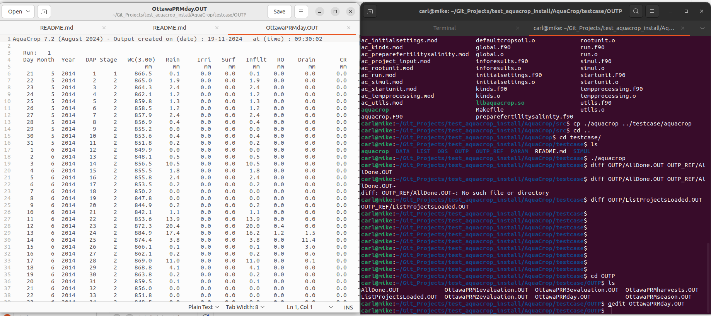

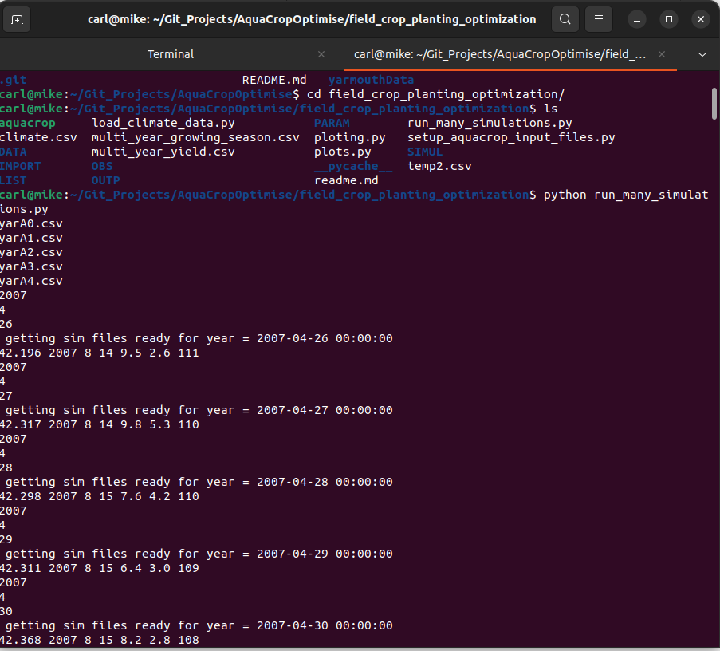
Copy the aquacrop executable into the AquaCropOptimise/field_crop_planting_optimization directory
Test with:
python run_many_simulations.py

