Error with CubicSDR 12-18-21
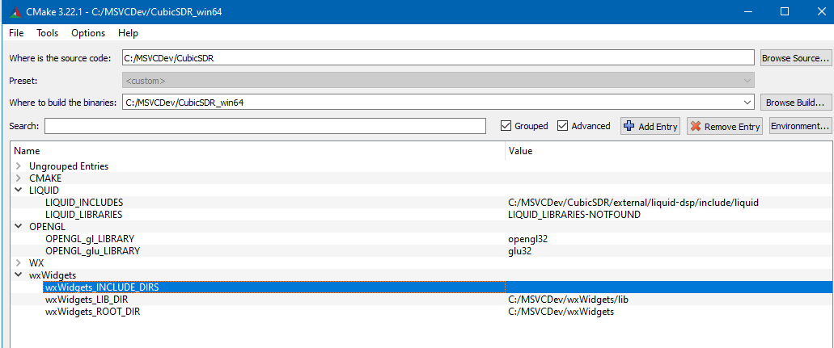
Configure Output
CMake Deprecation Warning at CMakeLists.txt:1 (cmake_minimum_required):
Compatibility with CMake < 2.8.12 will be removed from a future version of
CMake.
Update the VERSION argument <min> value or use a ...<max> suffix to tell
CMake that the project does not need compatibility with older versions.
64 bit compiler detected
CMake Warning (dev) at C:/Program Files/CMake/share/cmake-3.22/Modules/FindPackageHandleStandardArgs.cmake:438 (message):
The package name passed to `find_package_handle_standard_args` (LIQUID)
does not match the name of the calling package (Liquid). This can lead to
problems in calling code that expects `find_package` result variables
(e.g., `_FOUND`) to follow a certain pattern.
Call Stack (most recent call first):
cmake/Modules/FindLiquid.cmake:20 (find_package_handle_standard_args)
CMakeLists.txt:171 (find_package)
This warning is for project developers. Use -Wno-dev to suppress it.
CMake Error at C:/Program Files/CMake/share/cmake-3.22/Modules/FindPackageHandleStandardArgs.cmake:230 (message):
Could NOT find wxWidgets (missing: wxWidgets_LIBRARIES
wxWidgets_INCLUDE_DIRS gl core propgrid adv base)
Call Stack (most recent call first):
C:/Program Files/CMake/share/cmake-3.22/Modules/FindPackageHandleStandardArgs.cmake:594 (_FPHSA_FAILURE_MESSAGE)
C:/Program Files/CMake/share/cmake-3.22/Modules/FindwxWidgets.cmake:1025 (find_package_handle_standard_args)
CMakeLists.txt:175 (find_package)
Configuring incomplete, errors occurred!
See also "C:/MSVCDev/CubicSDR_win64/CMakeFiles/CMakeOutput.log".

