Error with CubicSDR 12-18-21 1017hr
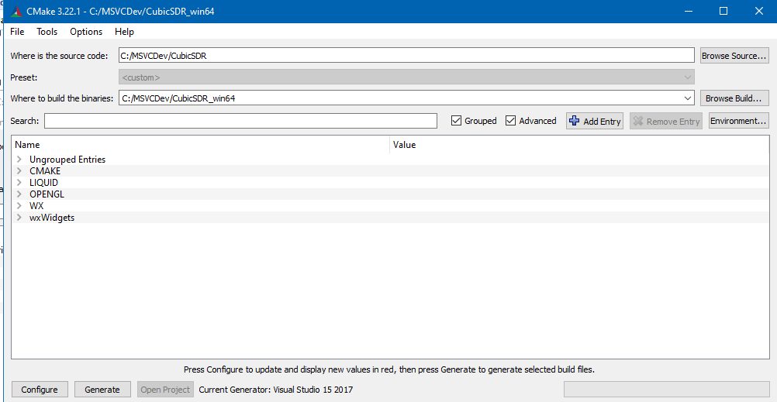
Configure Output
CMake Deprecation Warning at CMakeLists.txt:1 (cmake_minimum_required):
Compatibility with CMake < 2.8.12 will be removed from a future version of
CMake.
Update the VERSION argument <min> value or use a ...<max> suffix to tell
CMake that the project does not need compatibility with older versions.
Selecting Windows SDK version 10.0.19041.0 to target Windows 10.0.19043.
64 bit compiler detected
CMake Warning (dev) at C:/Program Files/CMake/share/cmake-3.22/Modules/FindPackageHandleStandardArgs.cmake:438 (message):
The package name passed to `find_package_handle_standard_args` (LIQUID)
does not match the name of the calling package (Liquid). This can lead to
problems in calling code that expects `find_package` result variables
(e.g., `_FOUND`) to follow a certain pattern.
Call Stack (most recent call first):
cmake/Modules/FindLiquid.cmake:20 (find_package_handle_standard_args)
CMakeLists.txt:171 (find_package)
This warning is for project developers. Use -Wno-dev to suppress it.
CMake Error at CMakeLists.txt:179 (find_package):
Could not find a package configuration file provided by "SoapySDR"
(requested version 0.4.0) with any of the following names:
SoapySDRConfig.cmake
soapysdr-config.cmake
Add the installation prefix of "SoapySDR" to CMAKE_PREFIX_PATH or set
"SoapySDR_DIR" to a directory containing one of the above files. If
"SoapySDR" provides a separate development package or SDK, be sure it has
been installed.
Configuring incomplete, errors occurred!
See also "C:/MSVCDev/CubicSDR_win64/CMakeFiles/CMakeOutput.log".

