Secret Hitler

# Disclaimer

Our project is based on a board game called Secret Hitler created by Max Temkin, Mike Boxleiter, and Tommy Maranges. It is a hidden role game set in 1930’s Germany. We have simplified and relaxed some of the original rules to increase project feasibility and aid in the simulation of the game. The rules which we relaxed were special events. We judged that some of these events would clutter and confuse the crux of the project. A complete set of the rules can be found at secretHitler.com. The only other relaxation to the game made, is that players do not share information with each other. In an actual game of Secret Hitler, the sharing of information and discussion is encouraged, however, the information shared is not always correct, and is sometimes misinformation seeded by the members of the Fascist party. We decided that creating an AI that could believably lie was beyond the scope of the project, and the sharing of perfectly remembered and analyzed information in a balanced and realistic manner would be exceedingly difficult. Keeping this in mind, we came to the decision that our players would keep record of their own information, but not share it. The remaining rules, setup, and spirit of the game remain unchanged.

# Set-Up

The game can be played with 5-10 players, and the rules are altered depending on how many players there are. With 5-6 players one player is given the role of Hitler, and another player is assigned to be a Fascist. All the remaining players are Liberals. The Fascist and Hitler know who each other are, and the Liberals only know their own role. With 7-8 players there is a second Fascist (for a total of 2 facists and 1 Hitler), and the remaining players are Liberals. In 7-8 player mode the Fascists still know who each other are, and who Hitler is, but Hitler doesn't have any information about other player's roles. With 9-10 players the rules are the same as 7-8 but there is an additional Fascist.

The deck contains all of the policy cards, 6 of which are Liberal policies, and 11 of which are Fascist policies. The board has 6 spots for Fascist policies, and 5 spots for Liberal policies, all of these spots begin empty.

# Rules

## Win Conditions

Each party has two win conditions. These conditions are in two groups, one that is through the passing of policies, and another which pertains to the status of Hitler. Liberals’ policy victory is attained by passing 5 Liberal policies. Liberals’ alternate win condition is that Hitler is shot and killed. The Fascists’ policy victory is achieved when 6 Fascist policies are passed. The Fascist’s alternate win condition is that Hitler is elected to the officer of Chancellor after 3 Fascist policies have been played. These are the only win conditions in the game.

## The Government

The Government of a round consists of a President and a Chancellor. The Presidency starts with player 0 and proceeds in increasing order to the last player. The Presidency cycles around in this manner until the end of the game. The President chooses the player whom they want to be Chancellor. A player is only eligible to be Chancellor if they were not Chancellor or President in the previous round. After a Chancellor is selected, all the players vote in an election to either accept or reject the players in the Government.

## The Election

Players vote on whether or not they accept the Government for the round. A ‘Ja’ vote is an affirmative, meaning that player accepts the Government. A ‘Nein’ vote is a negative, meaning that the player rejects the Government. If a majority of the votes cast are ‘Ja’, then the Government passes, and the President and Chancellor are the President and Chancellor of the round. If a majority of the votes cast are ‘Nein’, then the Government fails, and the next player becomes President and the process starts again. If the election of the Government fails three times in a row, then the top policy on the deck is enacted.

## Special Conditions Based on Progression of Fascist Policies

There are some special actions and circumstances that arise when specific numbers of Fascist policies. As mentioned previously, once three Fascist policies have been played, if Hitler is elected to Chancellor, then the Fascists win. On the 4th and 5th Fascist policies played, the current President chooses one person the shoot. The person who is shot is removed from the game. If that person was Hitler, then the Liberals automatically win the game.

# Gameplay Loop

## Determining the Government

The round starts with the assigning of the President. The President then chooses a Chancellor. Players at this point vote on the Government. Both the President and Chancellor may vote in the election. If the election fails, this step is repeated with the next President. If the election passes, the round proceeds to the next step, unless Hitler was elected to Chancellor and there are three Fascists policies enacted. If that is the case, the game is over and the Fascists have won.

## Policy Selection

The President draws three policies from the deck. The possible combinations are three Fascist policies, two Fascist policies and one Liberal policy, two Liberal policies and one Fascist policy, and three Liberal policies. If there are not three policies remaining in the deck, then the discard pile is shuffled and placed beneath the remaining policies. The President selects one policy to discard and discards it. The President then gives the remaining two policies to the Chancellor.

The Chancellor can receive three different combinations of policies. The Chancellor can get two Fascist policies, one Fascist and one Liberal policy, and two Liberal policies. The Chancellor then discards one of the two policies. The solitary remaining policy is then enacted. It is placed on a board in an open space. It is placed on the Liberal board if it is a Liberal policy. It is placed on the Fascist board if it is a Fascist policy.

After the policy is played, all players update the probabilities of other players being Fascist or Hitler. If this was the 4th or 5th Fascist policy played, the President chooses a person to shoot at this time. Play then proceeds to the final step.

## Determine the Winners

At this time, each player’s win condition is checked. If any of the win conditions are met, the game is over and those players win. Otherwise the gameplay loop repeats with the next President.

# Strategies

As a note, there may be multiple strategies that a player may be able to use for each scenario. The strategy which the player would choose is determined at the beginning of the game.

## Choosing a Chancellor

### Liberal President choosing a Chancellor

A Liberal President will always choose the player who is least likely to be Fascist according to the player’s analysis. If multiple players are tied with the smallest probability, one of those players is chosen at random. The rationale behind this strategy is that if the President is correct and the Chancellor is indeed Liberal, then the chance of a Liberal policy being enacted increases dramatically.

### Fascist President choosing a Chancellor

Fascists have three strategies that may be used to choose a Chancellor. The first is that a Fascist President will always choose a Fascist Chancellor. The President will choose one of the Fascists at random to be Chancellor. If there are no other Fascists in the game, then a Liberal will be chosen. The rationale behind this strategy is that a Fascist Chancellor significantly increases the chances that a Fascist policy will be enacted.

The second possible strategy is that the Fascist President will choose a Liberal Chancellor. As the Fascists know the identities of the other Fascists and Hitler, by deduction they can figure out which players are Liberals. The rationale behind this strategy is that the Liberal Chancellor will either play a Fascist policy, if they are given two Fascist policies, or a Liberal policy in any other situation. Either result is in the Fascist’s favor as a Fascist policy advances the Fascists’ march to their win condition, and a Liberal policy decreases the likelihood that the President will be labelled as Fascist by the Liberals, so that this particular Fascist player may be a part of more Governments.

The third possible strategy is that the Fascist President will choose any player that is not Hitler to be Chancellor. This strategy chooses at random any player, which is not Hitler. This strategy’s rationale is to hide Hitler, to make it easier to win by the election of Hitler. It also accomplishes the best of both worlds from the previous two strategies. When a Liberal Chancellor is selected, the suspicion on the Fascist President is reduced. When a Fascist Chancellor is selected, a Fascist policy is played. This has been found to be the optimal Fascist President Strategy.

## Presidents Discarding a Policy

### Liberal President Discarding a Policy

There are two strategies that may be implemented by a Liberal President when discarding a policy. The first strategy is to discard a Fascist policy. This increases the chance of a Liberal policy being enacted, unless the original three policies drawn were all Fascist. If all three policies are Liberal, a Liberal policy is discarded.

The other strategy is to impose a choice on the Chancellor. If the President is able, they will discard one policy, regardless of whether it is Fascist or Liberal, so that they give the Chancellor a choice between a Fascist or Liberal policy. The rationale behind this strategy, is that the President can determine if the Chancellor is a Liberal or a Fascist based on the policy the Chancellor played. This strategy focuses on gaining information rather than short term success.

### Fascist President Discarding a Policy

A Fascist President will always discard a Liberal policy, unless the three policies drawn are Fascist, in which case, the Fascist President will discard a Fascist Policy. The Fascist President will try to pass the Chancellor two Fascist Policies, as often as able. As Fascists know every player's’ party affiliation, giving a choice to determine a player’s role is unnecessary.

## Chancellors Discarding a Policy

### Liberal Chancellor Discarding a Policy

A Liberal Chancellor will always discard a Fascist policy of able. If a Liberal Chancellor is given two Fascist Policies, the Chancellor will infer an increased likelihood of the President being a Fascist.

### Fascist Chancellor Discarding a Policy

A Fascist Chancellor will always discard a Liberal policy if able.

# Extraneous Strategies

## Electing a Government

A Liberal will accept a Government if the probabilities computed by the Liberal indicate that the probability of this Government having a Fascist is not significantly more than random chance. A Fascist will accept a Government if there is at least one Fascist in the government.

## Shooting

A Liberal will shoot the player whom they believe to be the player that is most likely Fascist. A Fascist will shoot a random Liberal. Hitler will shoot the player least likely to be Fascist.

# Methodology

## Probabilistic Analysis

The players in this game analyze the actions taken by other players, and assign probabilities. Each player can assign the probabilities that a player is Fascist or Hitler. Currently the probability that someone is Hitler is not taken into account or adjusted anywhere, but the ability to set the probability was included for easy use in the future. There are three points when the probabilities are adjusted.

* Players not in the government adjust their attitudes towards the players who were part of the government when a policy from a government is revealed.
* The President adjusts their view of the chancellor when the chancellor reveals a Fascist policy when the chancellor was given a choice by the president.
* The chancellor adjusts their view of the president when they are given two fascist policies from the president.

To help shorten the proofs of some short hand notation is used, A list of the event short hand is given below.

|  |  |
| --- | --- |
| **Short Hand** | **Event** |
| F | A Fascist policy was played |
| L | A Liberal policy was played |
| FF | The chancellor was given two Fascist policies |
| FL | The chancellor was given two different policies |
| FF | The chancellor was given two Liberal policies |
| FFF | The president drew three Fascist policies |
| FFL | The president drew two Fascist policies and one Liberal Policy |
| FLL | The president drew two Liberal policies and one Fascist Policy |
| LLL | The president drew three Liberal policies |
| P=F | The President is Fascist |
| P=L | The president is Liberal |
| C=F | The chancellor is Fascist |
| C=L | The president is Liberal |

## Assumptions

To simplify these calculations we make several assumptions:

1. A Liberal player will ALWAYS discard a Fascist Policy
2. A Fascist player will ALWAYS discard a Liberal Policy

$P\left(P=X∩C=Y\right)=P\left(P=X\right)+P\left(C=Y\right)- P\left(P=X\right)*P\left(C=Y\right)$

$P\left(P=X∪C=Y\right)=P\left(P=X\right)+P(X=Y)$

These assumptions do not necessarily hold true, but these assumptions simplify the calculations.

## Non-Government Adjustments

To calculate the probability that the president is Fascist given that a Fascist Policy has been played:

$$P\left(P=F | F\right)=\frac{P\left(F∩P=F\right)}{P\left(F\right)}$$

$$P(F)=P\left(FFF∪\left(FFL∩\left(P=F∪C=F\right)\right)∪\left(FLL∩P=F∩C=F\right) \right)$$

$$P(F∩P=F)=P\left(\left(FFF∩P=F\right)∪\left(FFL∩\left(P=F∪C=F\right)∩P=F\right)∪\left(FLL∩P=F∩C=F\right) \right)$$

$$P(F∩P=F)=P\left(\left(FFF∩P=F\right)∪\left(FFL∩\left(P=F\right)\right)∪\left(FLL∩P=F∩C=F\right) \right)$$

$$P\left(F∩P=F\right)=P\left(\left(FFF∪FFL∪\left(FLL∩C=F\right) \right)∩P=F\right)$$

$$∴P\left(P=F | F\right)=\frac{P\left(\left(FFF∪FFL∪\left(FLL∩C=F\right) \right)∩P=F\right)}{P\left(FFF∪\left(FFL∩\left(P=F∪C=F\right)\right)∪\left(FLL∩P=F∩C=F\right) \right)}$$

A similar calculation can be done to calculate the probability that the chancellor is Fascist given that a Fascist Policy has been played is: $$P\left(C=F | F\right)=\frac{P\left(\left(FFF∪FFL∪\left(FLL∩P=F\right) \right)∩C=F\right)}{P\left(FFF∪\left(FFL∩\left(P=F∪C=F\right)\right)∪\left(FLL∩P=F∩C=F\right) \right)}$$

Similarly, if a Liberal card was played:

$$P\left(P=L | L\right)=\frac{P\left(\left(LLL∪FLL∪\left(FFL∩C=L\right) \right)∩P=L\right)}{P\left(LLL∪\left(FLL∩\left(P=L∪C=L\right)\right)∪\left(FFL∩P=L∩C=L\right) \right)}$$

$$P\left(C=L | L\right)=\frac{P\left(\left(LLL∪FLL∪\left(FFL∩P=L\right) \right)∩C=L\right)}{P\left(LLL∪\left(FLL∩\left(P=L∪C=L\right)\right)∪\left(FFL∩P=L∩C=L\right) \right)}$$

## President Adjustments

If the chancellor plays a Fascist policy when the president gives them a choice of a Fascist policy and a Liberal policy, the president will assume that they are Fascist.

## Chancellor Adjustments

Similar to the Non-Government adjustments, the Chancellor will adjust their thoughts on the president if the chancellor is given two Fascist cards.

$$P\left(P=F | FF\right)=\frac{P\left(F∩P=FF\right)}{P\left(FF\right)}$$

$$P\left(FF\right)=P(FFF∪(FFL∩P=F)$$

$$P\left(F∩P=FF\right)=P\left(\left(FFF∪FFL\right)∩P=F\right)$$

$$∴ P\left(P=F | FF\right)=\frac{P(FFF∪(FFL∩P=F)}{P\left(\left(FFF∪FFL\right)∩P=F\right)}$$

## Card Probabilities

In the previous calculations, the probability of certain cards being drawn is used. This is how those probabilities are calculated.

Note X is the number of Liberal Policies not played, Y is the number of Fascist policies not played, and N is the total number of cards not played.

$$P\left(FFF\right)=\frac{X*\left(X-1\right)*\left(X-2\right)}{N*\left(N-1\right)*(N-2)}$$

$$P\left(FFL\right)=3*\frac{X*\left(X-1\right)*Y}{N*\left(N-1\right)*(N-2)}$$

$$P\left(FLL\right)=3*\frac{X*Y*\left(Y-1\right)}{N*\left(N-1\right)*(N-2)}$$

$$P\left(LLL\right)=\frac{Y*\left(Y-1\right)*\left(Y-2\right)}{N*\left(N-1\right)*(N-2)}$$

## Influences of Minimax on Some of the Strategies

It is important to note that our AI does not perform a Minimax search of the decision space. That being said, we found it helpful to look through a Minimax ‘lens’ when assessing and designing some of the strategies employed by the players. The decisions available in this game do not provide for a perfect decision space to run a Minimax search, but the principles behind a Minimax search are in use.

Each President will assume that the Chancellor will enact a policy along their party lines. A Fascist Chancellor when given the choice would enact a Fascist policy, and a Liberal Chancellor would enact a Liberal one. There are edge cases where a Fascist would choose to enact a Liberal policy, but there are no cases where a Liberal Chancellor would choose to play a Fascist policy, as that would be detrimental to the Chancellor’s win condition. Therefore, when looking at the decision space of a round, the President may follow strategies which will be aimed at ‘maximizing’ the outcome. By selecting Chancellors of the same party as the President, it increases the odds of a favorable policy being enacted by 33%. The meaningful decision space for a President is outlined below.

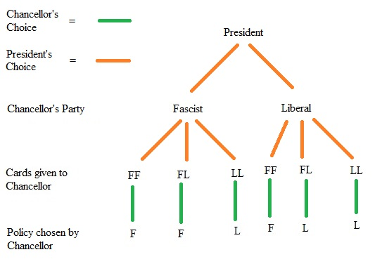

# Results and Analysis

There are six sets of strategies that we wanted determine the best strategies. These strategy sets are Fascists choosing a chancellor (FCC), Hitler choosing a chancellor, (HCC), Hitler choosing president cards (HCPC), Liberals choosing a president char (LCPC), Hitler choosing a chancellor chard (HCCC), and Hitler Voting. Each of these sets have 2 or 3 strategies that can be assigned at the beginning of the game. To simplify the representations, the individual strategy are referred to by number. To determine the best strategy of each set, we ran 1000 games with an adjust factor of 1.0 and each strategy combination and player count. The results are summarized below, but the full results can be found in the results folder. The “strategy_results_raw.csv” contains the raw data in a csv format while the “strategy_results.xlsx” contains the data along with some calculations.

## Strategies

### FCC

Fascists presidents choosing a ‘not Hitler’ player as chancellor won 64% of the time, Fascists choosing a Liberal chancellor won 51% of the time, and Fascists choosing a Fascist chancellor won 51% of the time.

### HCC

The strategies for the ‘Hitler’ player choosing a chancellor were to play aggressive and pick a Fascist chancellor (an aggressive strategy) or to pick a Liberal chancellor (to masquerade as a Liberal). The aggressive strategy had a 50% win rate, while the masquerading strategy had a 60% winrate.

### LCPC

For a Liberal president there are two strategies for picking which card to discard (assuming the player has a choice). The first strategy gives the chancellor one of each (generally this strategy is employed to get more information about other players), and the second strategy tries to give as many Liberal cards as possible. The information strategy had a 52% Fascist win rate while the aggressive Liberal strategy had a 58% Fascist winrate.

### HCPC

For the ‘Hitler’ player there are also two options when giving the chancellor cards, to prioritize giving Fascist cards, or to give Liberal cards. Again the distinction between these two strategies is whether or not the Hitler player want to play aggressive or to pretend to be a Liberal. Giving Fascist cards had a 60% Hitler win rate, whereas the Liberal card strategy had a 50% winrate.

### HCCC

Similarly when the “Hitler” player was chancellor they had the choice of whether they wanted to play a Fascist or Liberal policy, Playing aggressive was a better strategy with a 61% win rate while playing Liberal policies had a 50% win rate.

### HV

Finally the ‘Hitler’ player has two strategies for voting on whether to elect a chancellor. Hitler can either vote as a Fascist, or as a Liberal. Voting as a Fascist has a 56% win rate, and voting as a Liberal has a 54% win rate.

### Summary

A summary of this information can be seen in the table below. Clearly the best strategies are [].

|  |  |  |  |  |  |  |
| --- | --- | --- | --- | --- | --- | --- |
| Strategy Num | FCC | HCC | HCPC | LCPC | HCCC | HV |
| 0 | 51.1401 | 50.43368 | 61.14688 | 52.31806 | 60.41736 | 56.04931 |
| 1 | 51.11927 | 60.34861 | 49.63542 | 58.46424 | 50.36493 | 54.73299 |
| 2 | 63.91406 |  |  |  |  |  |

We also decided to look at how “fair” or how close to 50% the win rates where for different player counts. This can be seen in the graph below:

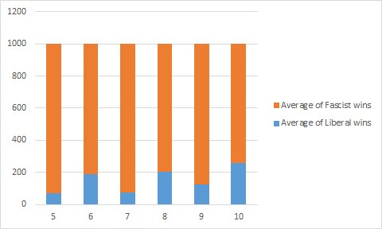

This is filtered to have only ‘best’ strategies. The unfiltered data can be seen in the figure below. It is easy to see that the

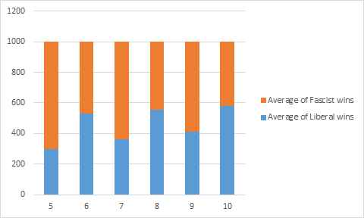

## Adjust Factor

After determining the optimal strategy, we wanted to determine the most optimal adjust factor, which is the adjust factor that results in the highest win rate for the Liberal players. We ran sets of 1000 games with the strategy determined above and an adjust factor ranging from 0 to 2 incrementing with steps of .05. We found that an adjust factor or .3 allowed for the Liberals to perform better.

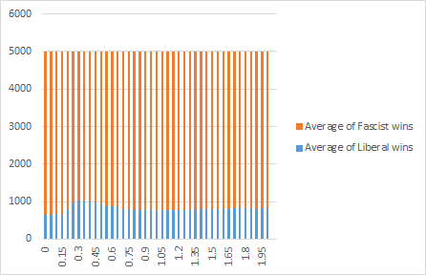

## Random Strategies

We also ran one final test with an adjust factor of 1 and every player playing randomly. Using random strategies yields a Fascist winrate of around 70%-75%. This shows that with the optimal strategies Fascists can greatly improve their chances of winning.

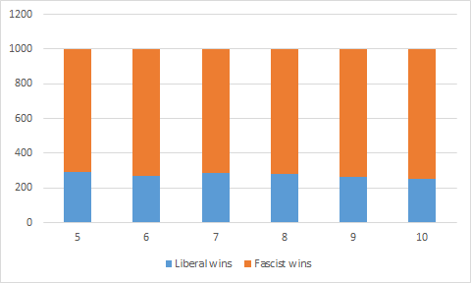

# Conclusion

When we play Secret Hitler with humans, we find that the Fascists do not have an overwhelming advantage like the results of our testing showed. There are two possibilities for this: the lack of communications and the several special events that were left out.

Barring a large disparity between Liberal and Fascist players, the ability to communicate helps the Liberal players more as the Fascist players start with having all of the hidden information. Adding in the communications aspects helps put some of the information back into the Liberal player’s hands.

Several of the events help Liberal players more than Fascist players, this is shown with this the execution event. If the shooting player is Liberal, the Liberal players have a chance to outright win the game if they shoot Hitler. The special election power has a similar effect, after this event is triggered, the current president can skip the turn order and force one player to be president for one turn. After that election, the turn order resumes as normal. This allows a higher chance at producing a Liberal government if the first president was Liberal as there should be more information about which players to trust.

With more time it would be interesting to try and train an ‘optimal’ AI that could also take in shared information and potentially play against humans. In addition to allowing the AI players to communicate another interesting project would be to expand some of the events that happen throughout the game that require more analysis than simply shooting a player. Some of these events are Investigate Loyalty and Calling Special Elections.