1. 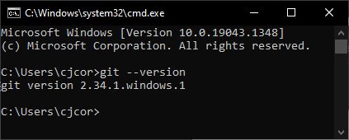
2. 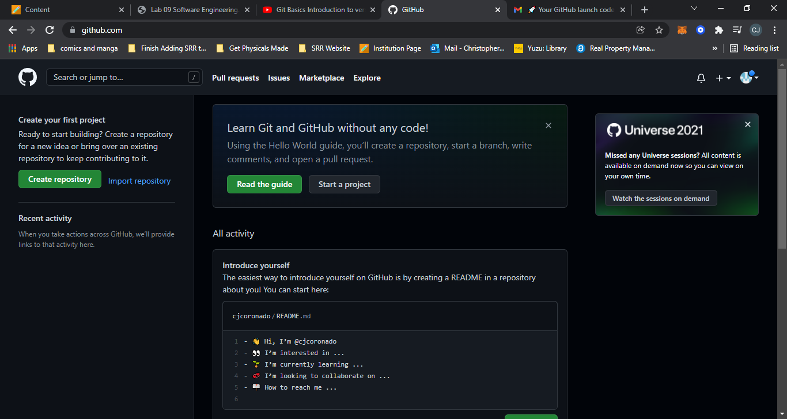
3. <https://github.com/cjcoronado/CSC_120_Tic_Tac_Toe.git>
4. 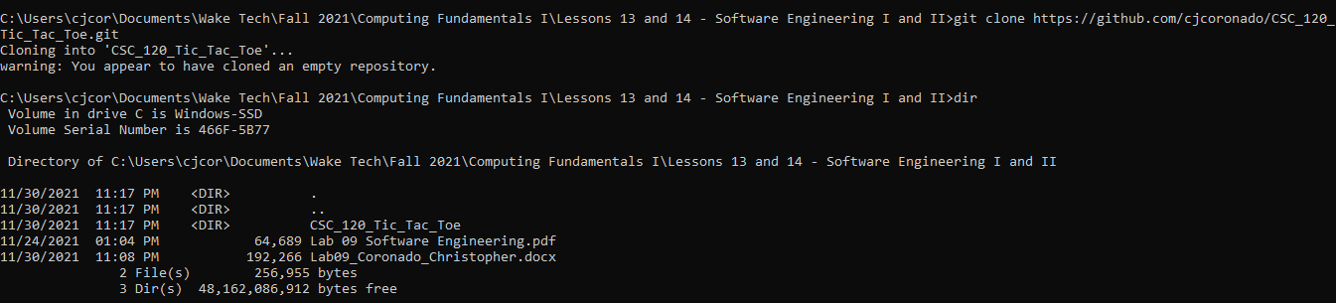

5 - 7.

https://github.com/cjcoronado/CSC_120_Tic_Tac_Toe

Extra Credit #2: Instead of an SQLite database, I added a .sql file representing the databases created for my own website, shirleyroadrecords.com. My website is an online marketplace to buy items I sell through my record label.