App Name: Ezraslist

App Tagline: A buy and sell marketplace app tailored to Cornell University students

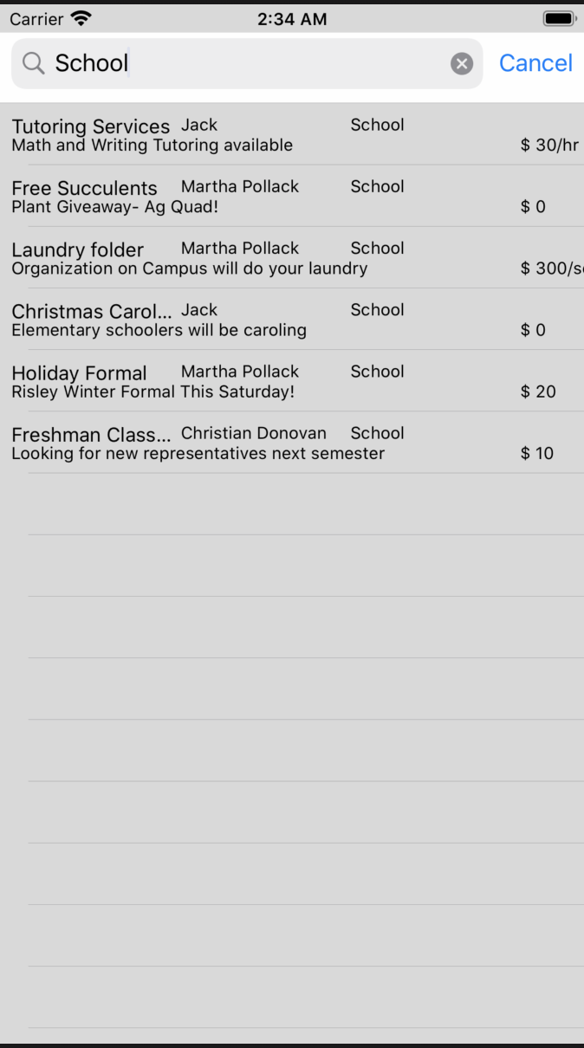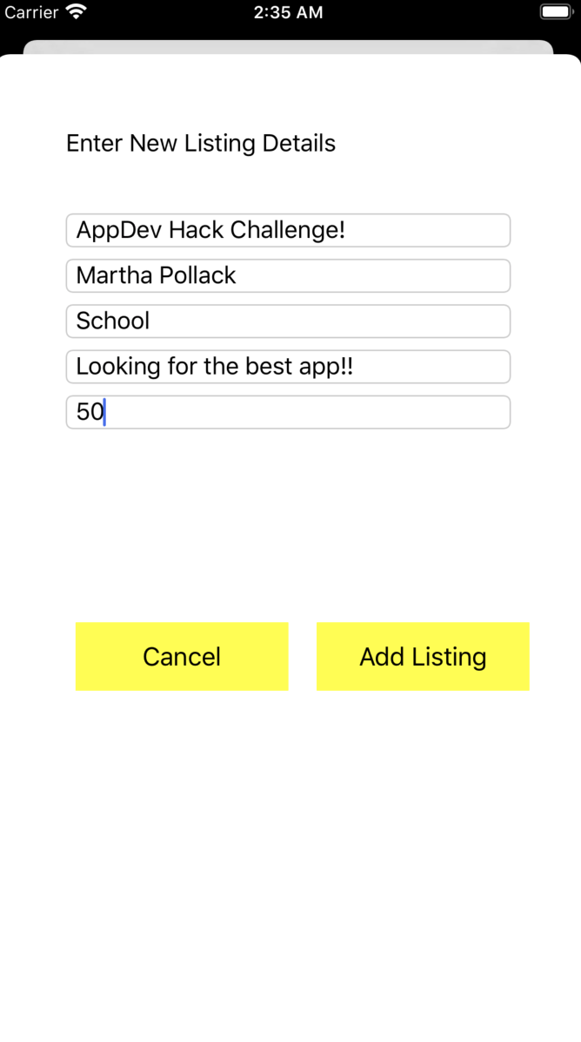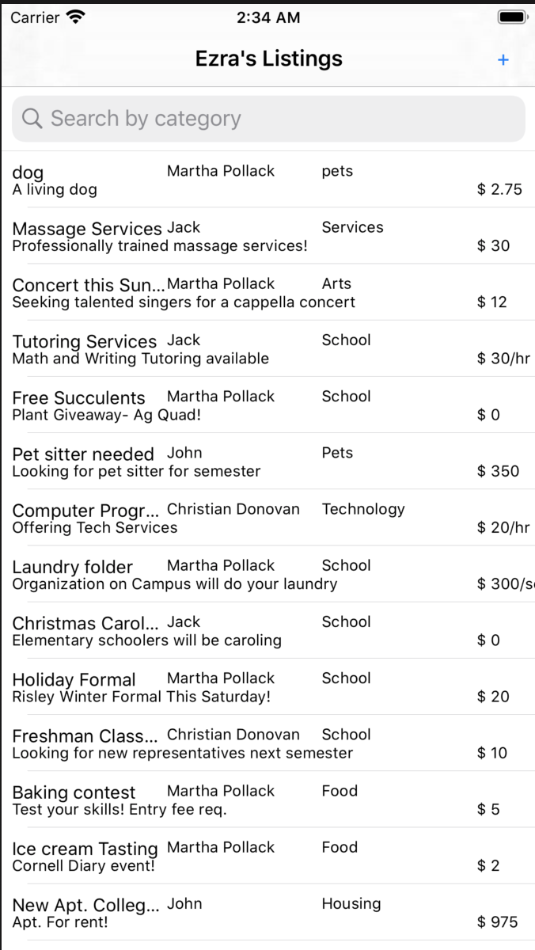

<https://github.com/cjd100/Ezras-List-Fina->

(both iOS and Backend repos are in this one in different branches. Master is backend, iOS is iOS)

The purpose of Ezraslist is to create a space where Cornell students are able to find what they need and sell to others in need –– from textbooks to clothing and more. As a buyer, Ezraslist allows for users to search for products by category. As a seller, users can create new listings, tag the product in a category and edit them later on.

Link to initial design: <https://www.figma.com/file/lWdu8oUBZnGMiynWiMUTeX/ezraslist?node-id=0%3A1>

The app has a main UIViewController which provides access to a main SearchController and the UITableView of all the listings on Ezraslist. Each TableViewCell contains information on the listing’s user, title, category, description, and price. There is the ability to add new listings by using requests to the backend API on a separate modally presented ViewController. There is the ability to delete apps from the database by swiping on a row. Users can also filter the listings by searching for specific categories, like School, Food, etc.

The backend for this application relies on two tables currently. A users table stores a list of users, along with associated info such as usernames, passwords, and the items they have made for sale. An items table contains all the items of the database, along with associated info like an asking price, item description, a category string that describes the general category the item could be (similar to a tag), and the id of the user entry that owns the object. Users can be created. Items can be created and deleted simply. The code for the app also would support a third offers table that is meant to represent a user’s bid on an item, but it was decided that this was ultimately unnecessary for this implementation of the app.