

Vehicle Rental Management System

A PROJECT PROPOSAL FOR IT 13/L -
PROFESSIONAL TRACK FOR IT 4

SUBMITTED TO:
KATE STEFUNNY BRUNO

SUBMITTED BY:

Chris John Dagongdong
Zedric Mulod
Reykrix Nidoy

December 2025

Project Description
The Vehicle Rental Management System is a Windows-based application developed using C# programming language integrated in .NET Winforms and back up with SQL Server for the database to automate rental operations, including the fleet management, reservation, rentals, returns, billings, and reporting. The system applies Object-Oriented Programming (OOP) principles and SOLID design patterns to ensure the scalibility, maintainability, and reliability. It integrates role-based user management (administrators and rental agents), customer verification, vehicle lifecycle tracker, rate configuration, and analytics dashboards. The database schema is normalized to third normal for form (3NF), enforcing referential integrity and transaction safety across critical operations such as reservations, billings, and damage assessments.
This project addresses inefficiencies in manual rental processes by providing a centralized platform that ensures accurate billing, and enhances customer satisfaction through efficient workflows. The reporting module supports decision-making by offering insights into fleet utilization, revenue per vehicle, customer retention, and damage incident rates. Researches demonstrates that automated rental systems significantly improve the operational efficiency and user experience by integrating modular architectrure and secure data handling (Mahindrakar et al., 2025; Gupta et al., 2023).

UML Diagrams

- UML Class Diagram

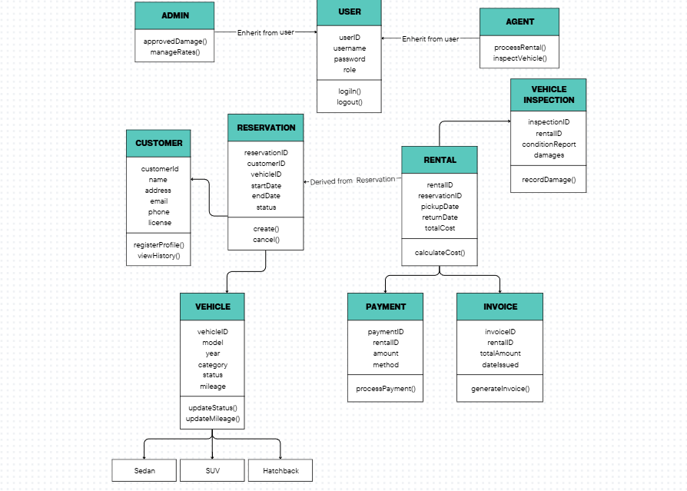

Figure 1. Vehicle Rental Management UML Class Diagram

The UML class diagram for the Vehicle Rental Management System illustrates the structural design of the application by defining its core classes, attributes, methods, and relationships. It begins with a base User class, from which Admin and Rental/Agent inherit specialized responsibilities such as managing rates, approving damages, processing rentals, and conducting inspections. The Customer class captures essential client information and links directly to Reservation, which connects customers to vehicles. The Vehicle class serves as a parent for specific types like Hatchback, Sedan, and SUV, while maintaining attributes such as make, model, year, and status. Supporting classes like Rental, Vehicle Inspection, Payment, and Invoice ensure that the system handles transactions, inspections, and billing accurately. Overall, the diagram demonstrates how inheritance, associations, and encapsulation are applied to create a modular, maintainable, and academically rigorous system design.

- Use Case Diagram 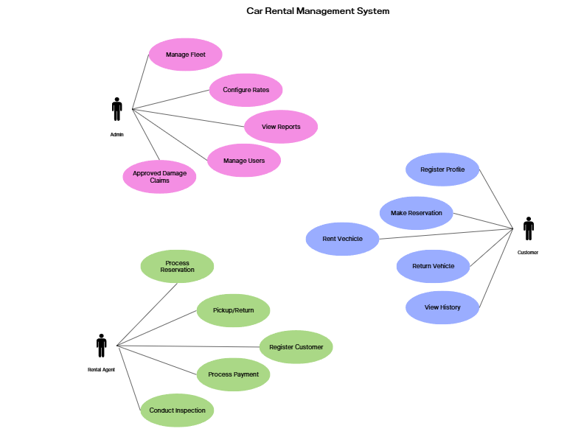
Figure 2. Vehicle Rental Management Use Case Diagram

Admin, Agent, Customer Use Cases
- Admin
Manage Users
- The administrator creates, updates, and removes system user accounts. They assign roles (admin, rental agent) and enforce access control to ensure secure and role-based operations.
Manage Fleet
- The administrator oversees the vehicle fleet, including adding new vehicles, updating details (mileage, category, features), retiring vehicles, and monitoring maintenance status. This ensures accurate availability and lifecycle tracking.
Configure Rates
- The administrator defines and updates rental pricing strategies for different vehicle categories. Rates may be daily, weekly, monthly, or hourly, ensuring flexible billing aligned with business policies.
Approve Damage Claims
- The administrator reviews inspection reports and authorizes repair costs for damages incurred during rentals. This ensures accountability and financial accuracy in damage handling.
View Reports
- The administrator generates and reviews analytical reports, including fleet utilization, revenue per vehicle, customer retention, and damage incident rates. These reports support strategic decision-making and operational efficiency
- Rental Agent
Process Reservations
- The rental agent creates, modifies, or cancels reservations based on customer requests. They check vehicle availability, assign vehicles, and confirm booking details to prevent double-booking.
Handle Vehicle Pickup/Return
- The rental agent manages the vehicle handover process. At pickup, they verify customer credentials and record vehicle condition. At return, they conduct inspections, document damages, calculate billing, and update vehicle status.
Register Customers
- The rental agent registers new customers by capturing personal details, verifying driver’s licenses, and classifying them (individual, corporate, frequent renter, or blacklisted). This ensures compliance and accurate customer records.
Process Payments
- The rental agent processes payments for rentals, including deposits, penalties, and refunds. Payment methods may include cash, card, or online transactions, ensuring financial accuracy and transparency.
Conduct Inspections
- The rental agent performs vehicle inspections during pickup and return. They document mileage, fuel level, cleanliness, and damages, ensuring accountability and supporting accurate billing.
- Customer
Register Profile
- The customer creates a profile with personal information, driver’s license details, and optional photo. This enables eligibility verification and supports loyalty programs.
Make Reservation
- The customer requests a vehicle reservation by selecting category, rental duration, and pickup/return dates. The system validates availability and confirms the booking.
Rent Vehicle
- The customer completes the rental process by signing agreements, paying deposits, and receiving the vehicle. This use case ensures compliance with rental policies and initiates the rental contract.
Return Vehicle
- The customer returns the vehicle at the end of the rental period. The system records inspection results, calculates final charges, and processes refunds or penalties.
View Rental History
- The customer can access their rental history, including past reservations, payments, damages, and loyalty points. This feature enhances transparency and customer engagement.

Entity Relationship Diagram (ERD)

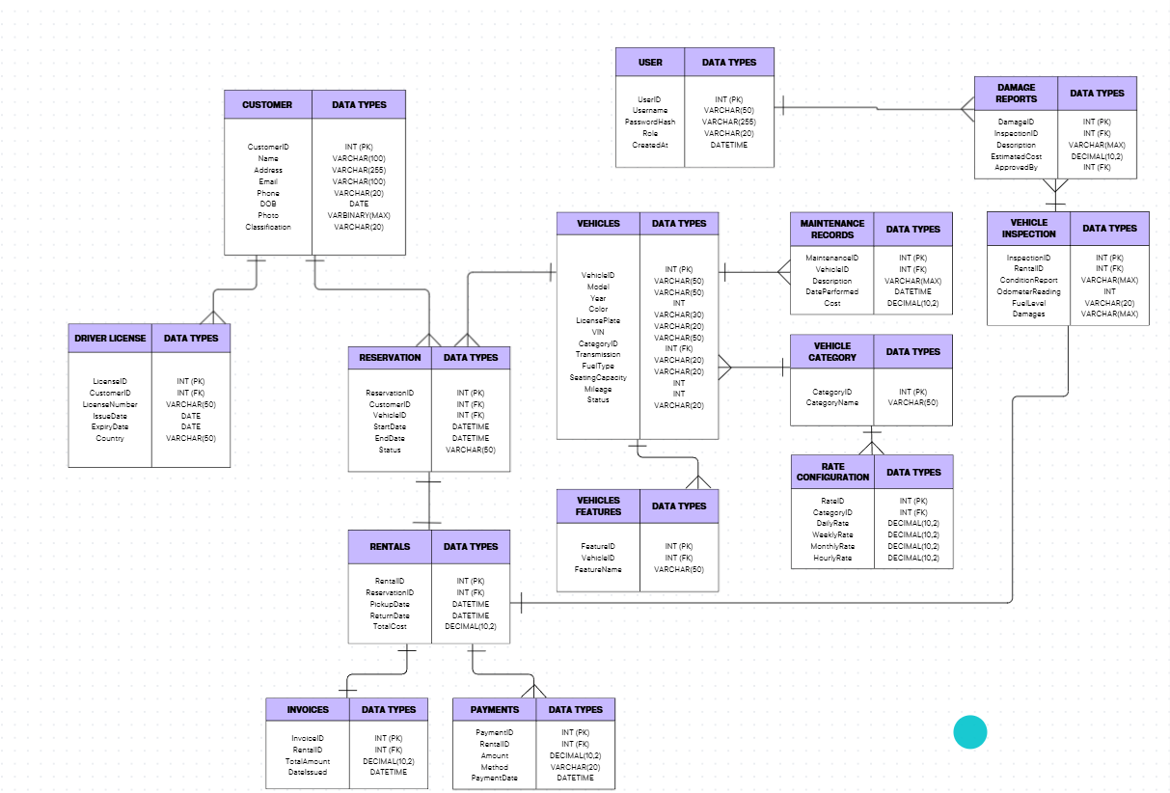

Figure 3. Vehicle Rental Management ERD

The Entity-Relationship Diagram (ERD) presents the core data structure of the Vehicle Rental Management System and illustrates how information flows between its major components. The User entity represents administrators and rental agents who interact with the system through role-based access. Each user manages multiple Customers, creating a one-to-many relationship that supports customer registration and classification. Customers may place one or more Reservations, each linked to a specific Vehicle, establishing a many-to-one relationship that ensures accurate fleet allocation.
Every reservation generates a corresponding Rental, which records pickup and return details, forming a one-to-one relationship. Rentals are further associated with Vehicle Inspections, where damages, mileage, and fuel levels are documented. To ensure financial accountability, each rental produces Payments and Invoices, creating one-to-many relationships that capture transaction details and billing accuracy. Additionally, vehicles may have multiple Maintenance Records over time, supporting lifecycle management and operational reliability.
This ERD defines how users, customers, vehicles, reservations, rentals, inspections, payments, invoices, and maintenance records work together to support efficient, accurate

References

- Shreya Mahindrakar, Shradha Sutare, Kalyani Satpute. Smart Vehicle Rental Management System: A Secure and Scalable Approach Using PHP. International Research Journal of Modernization in Engineering Technology and Science, Vol. 07, Issue 04, April 2025. Available at: IRJMETS
- Gupta Nayan, Patel Drashti, Patel Vidhi, Mistry Devam, et al. Car Rental System. IJIRT Research Journal, 2023. Available at: IJIRT

