NFL Report R

Chloe Drummond

2024-04-28

## Introduction

American football is a sport loved by many. It is a sport that is played by two teams of eleven players on a rectangular field with goalposts at each end. The object of the game is to score points by carrying the ball across the opponent’s goal line or by kicking the ball through the opponent’s goalposts. The team with the most points at the end of the game wins. Many of the players in the National Football League (NFL) are considered to be some of the best athletes in the world. They are strong, fast, and agile, and they have to be in order to compete at the highest level. In this project, we will analyze data of NFL players to see if we can identify some of the key factors that contribute to a player’s success in the league. The data was obtained from Kaggle and was collected by Trevor Youngquist. The link to the dataset can be found [here](https://www.kaggle.com/trevoryoungquist/nfl-players-career-data). The dataset contains basic and career statistics for players from the 1960s to 2020. The data initial is separated into twenty different csv files, each containing data for a different position. For this project we will ignore the special teams positions and their data which lowers the csv files from twenty to twelve.

This data needed heavy cleaning and merging to able to analyze it. Of the twelve csv files there are six for active players and six for retired players. For the retired players the csv files are Defensive Stats, Fumbles Stats, Passing Stats, Receiving Stats, Rushing Stats, and Basic Stats. For the active players the csv files are Defensive Stats, Fumbles Stats, Passing Stats, Receiving Stats, Rushing Stats, and Basic Stats.

The csv files all had the same columns except for the active and retired basic stats csv files. The column names for the defensive csv files are “Player_Id”, “Year”, “Team”, “Games_Played”, “Tackles”, “Solo_Tackles”, “Assisted_Tackles”, “Sacks”, “Sack_Yards”, “Safties”, “Passes_Deflected”, “INTs”, “TDs”, “INT_Yards”, “Average”, “Long”. The Fumbles data has columns “Player_Id”, “Year”, “Team”, “Games_Played”, “Fumbles”, “Fumbles_Lost”, “Forced_Fumbles”, “Own_Recovery”, “Opposing_Recovery”, “TDs” The Passing data has columns, “Player_Id”, “Year”, “Team”, “Games_Played”, “Attempts” “Completions”, “Completion_Percentage”, “Yards”, “Average”,“Long”, “TDs”, “INTs”, “First_Downs”, “First_Down_Percentage”, “Passes_Over_Twenty_Yards”, “Passes_Over_Forty_Yards”, “Sacks”, “Sack_Yards”, “Passer_Rating” The Receiving data has columns,“Player_Id”, “Year”, “Team”, “Games_Played”, “Receptions”, “Yard”, “Average”, “Long”, “TDs”, “First_Downs”, “First_Down_Percentage”, “Receptions_Over_Twenty_Yards”, “Receptions_Over_Forty_Yards” The Rushing data has columns, “Player_Id”, “Year”, “Team”, “Games_Played”, “Attempts” “Yards”, “Average”, “Long”, “TDs”, “First_Downs”, “First_Down_Percentage”, “Rushes_Over_Twenty_Yards”, “Rushes_Over_Forty_Yards”, “Fumbles” The retired basic stats data has columns, “Player_Id”, “Full_Name”, “Position”, “Height”, “Weight”, “College”, “Hall_Of_Fame” The active basic stats data has columns, “Player_Id”, “Full_Name”, “Position”, “Number”, “Current_Team”, “Height”, “Weight”, “Experience”, “Age”, “College”

Since the data was conviently separated into active players and retired players I chose to go clean the data by positional data for both active and retired then merge those into large postional dataframes then merge those all together to create one massive dataframe. However to accomplish this, the data needed to heavy cleaning which is described below.

### Data Cleaning

The libraries needed for data cleaning are dplyr, purrr, tidyr, and tibble packages. The first step was to load the data. When I looked at the each of the dataframes there seemed to be a lot of issues. All of the dataframes had different columns except for one column that allowed for merging, Player_Id and varied in the number of rows in each dataframe indicating that some Player_Id’s were missing in some dataframes. While some dataframes had matching column names like INTs and Fumbles, it was inconistent on if these values were implying the same thing. Upon investigating further I also found that alot of the issues came from players before 1980. Some data collection methods were different back then and some of the performance metrics were not even collected until after 1960. I decided to only use data from the players who played from 1980 and beyond. The years the players played are not shown in the basic stats dataframes so I focused on the other dataframes for this. I also wanted to focus on players total career data instead of their individual year data. Because of this, I also needed to remove players that only had a career row which means that they played less than 1 year. Since I wanted to apply this process to multiple dataframes I created a function called allstatsfilter that takes a dataframe and does the following; Replaces TOTAL in the Year column to be 9999 and then converts Year to an integer class since all of them are whole numbers. Then it finds and removes any Player_Ids who have any year less than 1980. It then finds the Player_Ids who have atleast 2 rows of data meaning they have a year and total career of data, and removes those who only have one row of data. Then it subsets the dataframe to be only the rows where Year == 9999 and then changes 9999 back to “Total Career”. The function then returns this new filtered dataframe. The function allstatsfilter is called within another function I created which will be mentioned shortly. When I was looking at the filtered dataframes more closely I saw that there were some errors when the data was scraped initially that I needed to address. To fix these issues and also help with renaming the columns to help with merging my data later on I created functions for each of the positional grouping dataframes. I will not describe each function in detail but essentially each of the functions takes in a dataframe and then calls the allstatsfilter function to create the filtered dataframe. Then creates an empty dataframe that has the correct dimesions and column names. It then fills in that new dataframe with the values from the filtered dataframe. This way it also assigns the correct class to the new columns as well. The function then returns the new fixed dataframe. This is done for all of the dataframes including the basic stats dataframes.

Then the dataframes are then merged using Player_Id and then are written to a csv file to preserve these changes for the analysis. This was a very brief explanation of this data cleaning and processing as that was not the main purpose of this project. The full detailed process for the data cleaning and processing can be found on my Github in the NFL Player Data Cleaning script.

One important thing to note about this data is the large amount of missing values for some of the players. This makes analysis much more difficult however it also makes sense for the data. The positions of the players determines a lot of what data is going to be collected on them. For example a quarterback is not going to have any data for Sacks due to the definition of what a Sack is. Many of these performance metrics that I will be analyzing are grouped by offensive and defensive positions. Since all of my variables except for a select few have some amount of missing data, a regression model is not beneficial with my available data. Instead I plan to use factorial ANOVA and ANCOVA to see the effect of a player’s College geographical region, hall of fame status and height and weight (combined into BMI) has on their performance metrics. For both the factorial ANOVA and ANCOVA I analyzed 3 times. Once for the offense using the mainly offensive metrics. Another for the defense using the mainly defensive metrics, and a final one using the full ungrouped data with all of the performance metrics.

The goal of this project was to two-fold. The first was to see if there was a difference in the performance metrics based on a player’s hall of fame status and the region where they attended college. The second was to again see if there was a difference in player’s performance metrics based on their college region and hall of fame status but also control for a player’s BMI.

## Literature Reviews

There are few articles that really discuss the NFL hall of fame and how it ties into a player’s success on the field. There are many more that talk about predicting a player’s success in the NFL, or the region of the players. Those are discussed here. Of a study conducted in 1998, the results found that height, speed, athletic ability and Trait L on a 16 personality factor questionnaire were significant between players who made it to the NFL and didn’t. Just getting into the NFL also doesn’t guarantee success. “After two years only half of those [Rookies] are still in the league.” What is interesting is that height and weight aren’t necesarrily a significant factor to this. However is it because it is already expected. All of the players in the NFL that I analyzed are above 65 inches and are atleast 142 lbs. This is also dependent on the positions they play as well. An article from 2001 talks about the morphological evolution of athletes over the 20th century. “Athletes in many sports have been getting taller and more massive over time; the rates of rise outstripping those of the secular trend.” This article also includes a quote from the NFL team the Indianapolis Colts General Manager in 1994, Bill Tobin where he says “Twenty years ago we never felt we’d have this many big people who could run this fast. It wasn’t much further back that 250 lbs was big for a lineman. Now it’s not big enough to play. With advances in nutrition, weights, anesthesiology, and development techniques at an early age, we could see the day when 300lb may be the minimum and 350 lb may be the standard.” When heights and weights of retired players are regressed against their career lengths the relationships are significant and positive. “In the NFL, an increment of 51kg in mass or 17cm in height is associated with an additional playing year. The average NFL playing career is 4.7 years give or take 3.4 years. This study took Z-scores for mass and height of 300 all-time greatest players in their respective positions. The results were as follows.”Inside linemen selected as all-time greats across the years had an average z-score of 0.78 for mass and 0.80 for height. Quarterbacks averaged z-scores of 0.20 and 0.69, wide receivers 0.03 and 0.33, and running backs 1.18 and –0.63 for mass and height, respectively. With the exception of height for the running backs, there was a clear pattern of career success and above average size. The all-time great running backs had an average BMI z-score of 0.56. Starting linemen in the NFL are significantly more massive compared with secondstring players. The pattern is clear, larger players have an advantage.”

Another interesting article I found was a geographical analysis of the origin of NFL players and draftees. This article focuses mainly on where these players are from and not their college but it does add some interesting insight. The conclusions that the author Robert Murray found was that “the three big states of Texas, Florida, and California are the top regions for NFL talent.” If a team is looking for a specific position to fill it is best to look at a region where the percentage of their NFL Draft picks is above the United States percentage for that position and one that has produced at least 50 NFL players. “Lastly, with regard to players growing up in the Southeast geographic region, higher obesity levels, income levels and educational ratings may factor into one’s having a better chance of getting into the NFL as well. These results could be persuasive in an NFL or college recruiting room in choosing the next great NFL football player.”

The next articles I discuss and draw insight from are very much position based. Many of these performance metrics that I am analyzing are heavily grouped by the position of the player. However I do not group by that in this analysis, it is still important to note and view the literature on it. This next article is focused primarily on the wide receiver position but the methodology can be expanded to other positions. Its goal is to provide a new way of quantifying a players’ value for the use of decision making in signing free agents to a team. This analysis creates a value component chart with the variables fumbles/reception, touchdowns/reception, yards/reception, receptions/target, targets/snap, total snap counts. Each of these values add together to create a total value for each player.

The next article “Evaluating the Performance of Offensive Linemen in the NFL” aims to “develop a framework to objectively analyze the overall performance of an individual offensive lineman and determine specific linemen who are overvalued or undervalued relative to their salary.” This paper uses statistics from Pro-football-reference.com to evaluate linemen. When looking at the results of this regression in the appendix it is shown that experience, draft-round and pro-bowl selections among other factors are significant in evaluating a lineman’s overall success.

## Method

To start my analysis I chose to focus on players who had played at least 2 games played. I then looked at the correlation between height and weight for each of the players since I had a suspicion that these variables would be correlated. Height and weight had a correlation of 0.7081832 which confirmed my suspicions so I chose to add a new variable, BMI to combine height and weight for analysis. Then with that I went and viewed a full correlation breakdown. I used a function I created that outputs a upper correlation plot as well as prints out pairs that have a high correlation. The correlation plot is written to a specific file and is displayed in the Appendix.

## Solo_Tackles and Assisted_Tackles have a correlation of 0.8831814   
## Solo_Tackles and Passes_Defended have a correlation of 0.7689866   
## Interceptions and INT_Yards have a correlation of 0.9099564   
## def_TDs and INT_Yards have a correlation of 0.7631004   
## Interceptions and Tot_CareerHighINTReturn have a correlation of 0.8904848   
## def_TDs and Tot_CareerHighINTReturn have a correlation of 0.7422354   
## INT_Yards and Tot_CareerHighINTReturn have a correlation of 0.9641279   
## Fumbles and Fumbles_Lost have a correlation of 0.9645013   
## Fumbles and Own_Recovery have a correlation of 0.9191412   
## Fumbles_Lost and Own_Recovery have a correlation of 0.848438   
## def_TDs and Passing_Attempts have a correlation of 0.9312661   
## Fumbles and Passing_Attempts have a correlation of 0.868412   
## Fumbles_Lost and Passing_Attempts have a correlation of 0.8073945   
## Own_Recovery and Passing_Attempts have a correlation of 0.8005756   
## Fumbles and Passing_Completions have a correlation of 0.8715021   
## Fumbles_Lost and Passing_Completions have a correlation of 0.82009   
## Own_Recovery and Passing_Completions have a correlation of 0.8069362   
## Passing_Attempts and Passing_Completions have a correlation of 0.9978167   
## Fumbles and Passing_Yards_Gained have a correlation of 0.8684514   
## Fumbles_Lost and Passing_Yards_Gained have a correlation of 0.8167976   
## Own_Recovery and Passing_Yards_Gained have a correlation of 0.8022151   
## Passing_Attempts and Passing_Yards_Gained have a correlation of 0.9979062   
## Passing_Completions and Passing_Yards_Gained have a correlation of 0.9988973   
## Fumbles and Sum_cr_long_passes have a correlation of 0.8384727   
## Fumbles_Lost and Sum_cr_long_passes have a correlation of 0.77684   
## Own_Recovery and Sum_cr_long_passes have a correlation of 0.7691093   
## Passing_Attempts and Sum_cr_long_passes have a correlation of 0.947112   
## Passing_Completions and Sum_cr_long_passes have a correlation of 0.9354452   
## Passing_Yards_Gained and Sum_cr_long_passes have a correlation of 0.9378553   
## Interceptions and Passing_TDs have a correlation of -1   
## Fumbles and Passing_TDs have a correlation of 0.8467077   
## Fumbles_Lost and Passing_TDs have a correlation of 0.7993516   
## Own_Recovery and Passing_TDs have a correlation of 0.789834   
## Passing_Attempts and Passing_TDs have a correlation of 0.9828258   
## Passing_Completions and Passing_TDs have a correlation of 0.9892758   
## Passing_Yards_Gained and Passing_TDs have a correlation of 0.9910151   
## Sum_cr_long_passes and Passing_TDs have a correlation of 0.9065698   
## Fumbles and Interceptions_thrown have a correlation of 0.8679618   
## Fumbles_Lost and Interceptions_thrown have a correlation of 0.8211938   
## Own_Recovery and Interceptions_thrown have a correlation of 0.7939956   
## Passing_Attempts and Interceptions_thrown have a correlation of 0.9651149   
## Passing_Completions and Interceptions_thrown have a correlation of 0.9489339   
## Passing_Yards_Gained and Interceptions_thrown have a correlation of 0.9540301   
## Sum_cr_long_passes and Interceptions_thrown have a correlation of 0.9421799   
## Passing_TDs and Interceptions_thrown have a correlation of 0.9224274   
## Fumbles and First_downs_thrown have a correlation of 0.8864984   
## Fumbles_Lost and First_downs_thrown have a correlation of 0.8475305   
## Own_Recovery and First_downs_thrown have a correlation of 0.8279248   
## Passing_Attempts and First_downs_thrown have a correlation of 0.9643779   
## Passing_Completions and First_downs_thrown have a correlation of 0.9737488   
## Passing_Yards_Gained and First_downs_thrown have a correlation of 0.9679485   
## Sum_cr_long_passes and First_downs_thrown have a correlation of 0.8878438   
## Passing_TDs and First_downs_thrown have a correlation of 0.962451   
## Interceptions_thrown and First_downs_thrown have a correlation of 0.8864291   
## Completion_Percentage and First_downs_per_attempt_percentage have a correlation of 0.833172   
## Yrds_gained_per_Attempt and First_downs_per_attempt_percentage have a correlation of 0.7218182   
## Fumbles and Been_Sacked have a correlation of 0.8780714   
## Fumbles_Lost and Been_Sacked have a correlation of 0.8319553   
## Own_Recovery and Been_Sacked have a correlation of 0.8100796   
## Passing_Attempts and Been_Sacked have a correlation of 0.9461408   
## Passing_Completions and Been_Sacked have a correlation of 0.9342282   
## Passing_Yards_Gained and Been_Sacked have a correlation of 0.9373409   
## Sum_cr_long_passes and Been_Sacked have a correlation of 0.9365159   
## Passing_TDs and Been_Sacked have a correlation of 0.9022453   
## Interceptions_thrown and Been_Sacked have a correlation of 0.9203122   
## First_downs_thrown and Been_Sacked have a correlation of 0.8819686   
## Passes_Defended and Sack_Yards have a correlation of 0.9191582   
## AverageYrdperINT and Sack_Yards have a correlation of -1   
## Fumbles and Sack_Yards have a correlation of 0.8611133   
## Fumbles_Lost and Sack_Yards have a correlation of 0.818269   
## Own_Recovery and Sack_Yards have a correlation of 0.7859039   
## Passing_Attempts and Sack_Yards have a correlation of 0.9405773   
## Passing_Completions and Sack_Yards have a correlation of 0.9270709   
## Passing_Yards_Gained and Sack_Yards have a correlation of 0.9321255   
## Sum_cr_long_passes and Sack_Yards have a correlation of 0.9297615   
## Passing_TDs and Sack_Yards have a correlation of 0.8975301   
## Interceptions_thrown and Sack_Yards have a correlation of 0.9226076   
## First_downs_thrown and Sack_Yards have a correlation of 0.8637313   
## Been_Sacked and Sack_Yards have a correlation of 0.9934898   
## Interceptions and Sacked_per_game have a correlation of -1   
## INT_Yards and Sacked_per_game have a correlation of -1   
## Tot_CareerHighINTReturn and Sacked_per_game have a correlation of -1   
## First_downs_per_attempt_percentage and Passer_Rating have a correlation of 0.779224   
## Receptions and Receiving_Yards have a correlation of 0.9763763   
## Receptions and Sum_cr_long_receptions have a correlation of 0.9232466   
## Receiving_Yards and Sum_cr_long_receptions have a correlation of 0.927574   
## Receptions and Receiving_TDs have a correlation of 0.9072474   
## Receiving_Yards and Receiving_TDs have a correlation of 0.9498617   
## Sum_cr_long_receptions and Receiving_TDs have a correlation of 0.8641397   
## Sacked_per_game and Receptions_per_Game have a correlation of -0.7062682   
## Receptions and Receptions_per_Game have a correlation of 0.7856012   
## Receiving_Yards and Receptions_per_Game have a correlation of 0.7659396   
## Sum_cr_long_receptions and Receptions_per_Game have a correlation of 0.7309987   
## Receptions and Receiving_Yards_per_Game have a correlation of 0.7619192   
## Receiving_Yards and Receiving_Yards_per_Game have a correlation of 0.7951733   
## Sum_cr_long_receptions and Receiving_Yards_per_Game have a correlation of 0.754185   
## Receiving_TDs and Receiving_Yards_per_Game have a correlation of 0.7305   
## Receptions_per_Game and Receiving_Yards_per_Game have a correlation of 0.9495188   
## Receptions and First_down_receptions have a correlation of 0.944204   
## Receiving_Yards and First_down_receptions have a correlation of 0.9567219   
## Sum_cr_long_receptions and First_down_receptions have a correlation of 0.8677464   
## Receiving_TDs and First_down_receptions have a correlation of 0.9135949   
## Receptions_per_Game and First_down_receptions have a correlation of 0.7701865   
## Receiving_Yards_per_Game and First_down_receptions have a correlation of 0.7960868   
## Forced_Fumbles and TDs_per_Reception have a correlation of 0.741522   
## Sacked_per_game and TDs_per_Reception have a correlation of 0.7653447   
## Rushing_Attempts and Rushing_Yards have a correlation of 0.9941193   
## Rushing_Attempts and Sum_cr_long_rush_yds have a correlation of 0.8796913   
## Rushing_Yards and Sum_cr_long_rush_yds have a correlation of 0.8892801   
## Rushing_Attempts and Rushing_TDs have a correlation of 0.9420781   
## Rushing_Yards and Rushing_TDs have a correlation of 0.9450549   
## Sum_cr_long_rush_yds and Rushing_TDs have a correlation of 0.8370862   
## Rushing_Attempts and Rushing_Yards_per_Game have a correlation of 0.7886155   
## Rushing_Yards and Rushing_Yards_per_Game have a correlation of 0.7938822   
## Sum_cr_long_rush_yds and Rushing_Yards_per_Game have a correlation of 0.7001313   
## Rushing_TDs and Rushing_Yards_per_Game have a correlation of 0.7222067   
## Rushing_Attempts and Rushing_Attempts_per_Game have a correlation of 0.7847854   
## Rushing_Yards and Rushing_Attempts_per_Game have a correlation of 0.777076   
## Rushing_TDs and Rushing_Attempts_per_Game have a correlation of 0.7084183   
## Rushing_Yards_per_Game and Rushing_Attempts_per_Game have a correlation of 0.9841729   
## Rushing_Attempts and First_down_rushes have a correlation of 0.9394355   
## Rushing_Yards and First_down_rushes have a correlation of 0.9423879   
## Sum_cr_long_rush_yds and First_down_rushes have a correlation of 0.8529021   
## Rushing_TDs and First_down_rushes have a correlation of 0.9059212   
## Rushing_Yards_per_Game and First_down_rushes have a correlation of 0.7785345   
## Rushing_Attempts_per_Game and First_down_rushes have a correlation of 0.7683133   
## First_down_rushes_percentage and TDs_per_Rush_Attempt have a correlation of 0.7378462   
## def_TDs and Rush_TD_per_Game have a correlation of -0.9405623   
## Rushing_Yards_per_Game and Rush_TD_per_Game have a correlation of 0.8390271   
## Rushing_Attempts_per_Game and Rush_TD_per_Game have a correlation of 0.8365489

Clearly there were quite a few pairs of variables with a high correlation that needed to be addressed before any models can be built. Many of these high correlation pairs however do make conceptual sense such as the attempts_per_game and total_yards_per_game as you need to attempt passes in order to get yards. Instead of removing these variables I opted for creating new dataframes to preserve the data for possible future analysis purposes. Another thing to note is that alot of the correlations and issues seen with the question marks in my plot come from the data that is able to be collected by position. As mentioned in the introduction, a QB wont have any data for Sacks as they are the players being sacked. However, some of the correlation pairs don’t quite make sense like the correlation between passing_yards_gained and Interceptions_thrown. If a pass is completed thus yards are gained then an interception was not thrown. To possibly address this issue I will split the data into offensive and defensive positions and see if the correlations are still present I will also further manipulate the variables to include as few of variables as possible while keeping as much of the information from my data as I can. I also wanted to add something to the College variable as there were too many levels to really make use of it in analysis. I created a new csv file with all of the colleges in my data and added what region of the US they were located in effectively creating a new factor variable with 7 levels, “No College”, “West”, “Midwest”, “Northeast”, “Southwest”, “Southeast” and “International”. In my function New_Variable_and_DF_creation I create 3 new variables. 4 technically since I removed Total_Tackles earlier in the analysis but seeing the correlation with solo and assisted tackles I chose to add it back in and then remove the separated tackles. I created a variable “Fumble_recovery_kept_pct” to combine the highly correlated Fumbles and Fumbles_Lost variables. Since Fumbles describes how many fumbles that player themselves has recovered and then Fumbles_Lost tells us how many of those Fumbles that player has proceeded to lose again. Combining the two into what percentage of the recovered fumbled balls a player manages to keep is an interesting performance metric. The next variable I created was “Passing_TD_per_Game”. I saw that Passing_TDs was heavily correlated with quite a few variables and I also recognized that the more games a player has played the more touchdowns that player is likely to throw. To essentially normalize this variable I made it a ratio of how many touchdowns a player has thrown over the number of games they have played. The last variable was the number of interceptions thrown per passing attempt helped to see how many of a quarterback’s throws resulted in an interception. With these new variables I also added the college regions here from the csv file I created with the regions for each college as well as reordered my columns for readablility and to prepare for future analysis.

new_df_all <- New_Variable_and_DF_Creation(player_data_filtered)  
new_df_retired <- New_Variable_and_DF_Creation(player_retired_filtered)  
  
new_df_all_regions <- merge(new_df_all, college_df, by = "College", all.x = TRUE)  
# Reorder the columns  
new_df_all_regions <- new_df_all_regions %>%  
 dplyr::select(Player_Id, Hall_Of_Fame, College, Region, Position, is_offense, BMI, Games_Played, everything())  
  
new_df_all_regions$Region <- as.factor(new_df_all_regions$Region)  
#colnames(new_df_all_regions)  
#dim(new_df_all_regions)  
  
new_df_retired_regions <- merge(new_df_retired, college_df, by = "College", all.x = TRUE)  
# Reorder the columns   
new_df_retired_regions <- new_df_retired_regions %>%  
 dplyr::select(Player_Id, Hall_Of_Fame, College, Region, Position, is_offense, BMI, Games_Played, everything())  
new_df_retired_regions$Region <- as.factor(new_df_retired_regions$Region)

I then also re-ran the correlation plot with these new variables. The new correlation plot is shown in the Appendix.

cols_for_corr_new <- c("BMI", "Total_Tackles", "Sacks", "Safeties", "Passes_Defended", "def_TDs", "AverageYrdperINT", "Fumble_recovery_kept_pct", "Forced_Fumbles", "Completion_Percentage", "Yrds_gained_per_Attempt", "Passing_TD_per_Game", "Interceptions_Thrown_per_passing_attempt", "First_downs_per_attempt_percentage", "Been_Sacked", "Passer_Rating", "Yards_per_Reception", "First_down_receptions_percentage", "Receiving_TDs", "Rushing_Yards_per_Attempt", "First_down_rushes", "TDs_per_Rush_Attempt")  
  
# Compute the correlation matrix  
Correlation_Matrix_and_Plot(new_df_all_regions, cols_for_corr_new, filename = "new_all_correlation_plot.png")

## Sacks and Passing_TD_per_Game have a correlation of -1   
## Completion_Percentage and First_downs_per_attempt_percentage have a correlation of 0.833172   
## Yrds_gained_per_Attempt and First_downs_per_attempt_percentage have a correlation of 0.7218182   
## Interceptions_Thrown_per_passing_attempt and Passer_Rating have a correlation of -0.9613184   
## First_downs_per_attempt_percentage and Passer_Rating have a correlation of 0.779224

Some correlations are still present but there are much fewer and those that are present make at least some conceptual sense.

Then I viewed histograms of the variables and performed transformations on the variables that needed it for analysis. At the end of this process, 16 transformations were conducted. Functions were created perform log, inverse, square root, and cube root transformations which also are designed to view the histogram before the transformation as well as after. The variables that did not need any transformations are the following, BMI, Fumble_recovery_kept_pct, Completion_percentage, First_downs_per_attempt_percentage, and First_down_receptions_percentage. The other variables needed some transformation, with the exception of Safeties which was removed from analysis all together. The histograms for the transformed variables is displayed in the Appendix.

After the transformations were conducted the new values were added to the existing dataframe with the same name but with _trans added on the end for easier readability. Then I compared the correlation of the new transformed variables. Again as with the other correlation plots, it will be shown in the Appendix.

col_for_correl <- c("BMI", "Total_Tackles_trans", "Sacks_trans", "Passes_Defended_trans", "def_TDs_trans", "AverageYrdperINT_trans", "Fumble_recovery_kept_pct", "Forced_Fumbles_trans", "Completion_Percentage", "Yrds_gained_per_Attempt_trans", "Passing_TD_per_Game_trans", "Interceptions_Thrown_per_passing_attempt_trans", "First_downs_per_attempt_percentage", "Been_Sacked_trans", "Passer_Rating_trans", "Yards_per_Reception_trans", "First_down_receptions_percentage", "Receiving_TDs_trans", "Rushing_Yards_per_Attempt_trans", "First_down_rushes_trans", "TDs_per_Rush_Attempt_trans")  
  
Correlation_Matrix_and_Plot(new_df_all_regions_16t, col_for_correl, filename = "correlation_all_players_transformed.png")

## Total_Tackles_trans and Passes_Defended_trans have a correlation of 0.7886907   
## Completion_Percentage and First_downs_per_attempt_percentage have a correlation of 0.833172   
## Passing_TD_per_Game_trans and Been_Sacked_trans have a correlation of 0.7446276   
## def_TDs_trans and Passer_Rating_trans have a correlation of -0.8261342   
## First_downs_per_attempt_percentage and Passer_Rating_trans have a correlation of 0.7781993

I still have some correlation pairs but they are not as extreme as before. I next split my data into offensive and defensive positions to see if correlations are still present within the groups. Plots for the offense and defense correlations for both all and retired players are shown in the appendix.

offensive_players_all <- new_df_all_regions_16t[new_df_all_regions_16t$is_offense == "True", ]  
  
offensive_players_retired <- new_df_retired_regions_16t[new_df_retired_regions_16t$is_offense == "True", ]  
  
cols_for_corr_off <- c("BMI", "Total_Tackles_trans", "Fumble_recovery_kept_pct", "Completion_Percentage", "Yrds_gained_per_Attempt_trans", "Passing_TD_per_Game_trans", "Interceptions_Thrown_per_passing_attempt_trans", "First_downs_per_attempt_percentage", "Been_Sacked_trans", "Passer_Rating_trans", "Yards_per_Reception_trans", "First_down_receptions_percentage", "Receiving_TDs_trans", "Rushing_Yards_per_Attempt_trans", "First_down_rushes_trans", "TDs_per_Rush_Attempt_trans")  
  
Correlation_Matrix_and_Plot(offensive_players_all, cols_for_corr_off, filename = "correlation_offensive_players_transformed.png")

## Completion_Percentage and First_downs_per_attempt_percentage have a correlation of 0.8254415   
## Passing_TD_per_Game_trans and Been_Sacked_trans have a correlation of 0.7446276   
## First_downs_per_attempt_percentage and Passer_Rating_trans have a correlation of 0.7755709

cat("\n-------------------------------------------\n")

##   
## -------------------------------------------

Correlation_Matrix_and_Plot(offensive_players_retired, cols_for_corr_off, filename = "correlation_offensive_players_retired_transformed.png")

## Completion_Percentage and First_downs_per_attempt_percentage have a correlation of 0.8219005   
## Passing_TD_per_Game_trans and Been_Sacked_trans have a correlation of 0.7216929   
## First_downs_per_attempt_percentage and Passer_Rating_trans have a correlation of 0.7895758

Offense still has 3 extreme correlations

defensive_players_all <- new_df_all_regions_16t[new_df_all_regions_16t$is_offense == "False", ]  
defensive_players_retired <- new_df_retired_regions_16t[new_df_retired_regions_16t$is_offense == "False", ]  
  
cols_for_corr_def <- c("BMI", "Total_Tackles_trans", "Sacks_trans", "Passes_Defended_trans", "def_TDs_trans", "AverageYrdperINT_trans", "Fumble_recovery_kept_pct", "Forced_Fumbles_trans")  
  
Correlation_Matrix_and_Plot(defensive_players_all, cols_for_corr_def, filename = "correlation_defensive_players_transformed.png")

## Total_Tackles_trans and Passes_Defended_trans have a correlation of 0.7859634

cat("\n-------------------------------------------\n")

##   
## -------------------------------------------

Correlation_Matrix_and_Plot(defensive_players_retired, cols_for_corr_def, filename = "correlation_defensive_players_retired_transformed.png")

## Total_Tackles_trans and Passes_Defended_trans have a correlation of 0.7910287

Defense has one correlation pair.

Next, I perform factorial ANOVA for each metric based on Region and hall of fame status for retired players. Two functions were created, one to test the offense and defense and then another to test all together. The function tests every performance metric and also tests all of the assumptions for each of them. The output is written to a text file since it is to large for the terminal. The output for each of the functions will be included in the appendix.

Then after the factorial ANOVA models, I chose to also look at ANCOVA models for each of the performance metrics based again on region and hall of fame status but control for BMI of the retired players. Similar to the factorial ANOVA functions I have the output written to a text file as it is too large for the terminal to output. I also run this ANCOVA model for the offense and defense groups and all together. This function also checks all assumptions.

cols_for_ancova_all <- c("Total_Tackles_trans", "Sacks_trans", "Passes_Defended_trans", "def_TDs_trans", "AverageYrdperINT_trans", "Fumble_recovery_kept_pct", "Forced_Fumbles_trans", "Completion_Percentage", "Yrds_gained_per_Attempt_trans", "Passing_TD_per_Game_trans", "Interceptions_Thrown_per_passing_attempt_trans", "First_downs_per_attempt_percentage", "Been_Sacked_trans", "Passer_Rating_trans", "Yards_per_Reception_trans", "First_down_receptions_percentage", "Receiving_TDs_trans", "Rushing_Yards_per_Attempt_trans", "First_down_rushes_trans", "TDs_per_Rush_Attempt_trans")  
  
cols_for_ancova_off <- c("Total_Tackles_trans", "Fumble_recovery_kept_pct", "Completion_Percentage", "Yrds_gained_per_Attempt_trans", "Passing_TD_per_Game_trans", "Interceptions_Thrown_per_passing_attempt_trans", "First_downs_per_attempt_percentage", "Been_Sacked_trans", "Passer_Rating_trans", "Yards_per_Reception_trans", "First_down_receptions_percentage", "Receiving_TDs_trans", "Rushing_Yards_per_Attempt_trans", "First_down_rushes_trans", "TDs_per_Rush_Attempt_trans")  
  
cols_for_ancova_def <- c("Total_Tackles_trans", "Sacks_trans", "Passes_Defended_trans", "def_TDs_trans", "AverageYrdperINT_trans", "Fumble_recovery_kept_pct", "Forced_Fumbles_trans")  
  
## perform ANCOVA for each performance metric by position grouped into offense and defense  
ANCOVA_Region_HOF_BMI(offensive_players_retired, cols_for_ancova_off, filename = "ANCOVA_offensive_players_trans.txt")  
ANCOVA_Region_HOF_BMI(defensive_players_retired, cols_for_ancova_def, filename = "ANCOVA_defensive_players_trans.txt")  
ANCOVA_Region_HOF_BMI(new_df_retired_regions_16t, cols_for_ancova_all, filename = "ANCOVA_all_players_retired_trans.txt")

## Results

The factorial ANOVA models for the retired players showed that there were significant differences in the performance metrics based on the region of the college the player attended. However this result must be taken with some precautions as the assumption of normally distributed residuals was not met for all of the performance metrics. The assumption of homogeneity of variances was also not met for some but not all of the metrics.

The ANCOVA models for the retired players showed that there were significant differences in the performance metrics based on the region of the college the player attended while controlling for BMI. The ANCOVA models for the retired players also showed that there were significant differences in the performance metrics based on the hall of fame status of the player while controlling for BMI. The ANCOVA models for the retired players also showed that there were significant differences in the performance metrics based on the hall of fame status of the player while controlling for BMI and region of the college the player attended.

The output of the factorial ANOVA models including the interaction plots as well as the ANCOVA models is shown in the Appendix. A summary of the results for each of the performance metrics is shown here for both the factorial ANOVA and ANCOVA. For the scope of this report I will only be discussing the full retired player models and not discussing the offense and defense models. However, the output for the offense and defense models is still included in the Appendix.

### All Retired Players Performance Metrics

#### BMI (factorial ANOVA only)

There was a significant difference in BMI based on the region of the college the player attended. The Tukey HSD test showed that the BMI of players was significantly different between all of the regions. There were also significant differences in BMI based on the interaction of region and hall of fame status. The Tukey HSD test showed that the BMI of players was significantly different between all of the regions for both hall of fame status groups. For this metric the assumption of homogeneity of variance was met but the assumption of normality of residuals was not met. Looking at the eta squared values, the effect size of region, hall of fame status, and the interaction of region and hall of fame status were all very small.

#### Total Tackles

##### Factorial ANOVA

There was a slight significant difference in total tackles based on the region of the college the player attended as well as the players hall of fame status, however the interaction of region and hall of fame status was not significant. The Tukey HSD test showed that there was a small significant difference in total tackles between hall of fame status groups. There was also a small significant difference in total tackles between the southeast and northeast regions but no other significant differences were found. The assumption of homogeneity of variance was not met nor was the assumption of normality of residuals. The eta squared values for this metric were very small. With 2 assumptions not met and a very small effect size, this metric is highly questionable to be trustworthy for any analysis.

##### ANCOVA

There was a significant difference in total tackles based on the player’s hall of fame status, Region and BMI. The assumption of no interaction between factors and covariates was met for this metric. The assumption of homogeneity of variance was met for all of the independent variables. The Tukey post-hoc test showed that there were not any significant linear combinations of the factors. With this model I would say that hall of fame status and region have significant effects on total tackles when controlling for BMI.

#### Sacks

##### Factorial ANOVA

There was a significant difference in sacks based on the player’s hall of fame status, however the region and interaction of region and hall of fame status was not significant. The Tukey HSD test showed that there was a significant difference in sacks between hall of fame status groups. There were some significant differences in sacks between the interaction between some of the interactions of hall of fame and region against sacks however they are very small and since they are not significant in the model, we ignore these results. Also to add to the questionable credibility of this model, the assumption of homogeneity of variance was not met nor was the assumption of normality of residuals. The eta squared values for this metric were also very small. With 2 assumptions again not met, this model is not credible for this metric.

##### ANCOVA

There was a significant effect on sacks from hall of fame status and BMI when controlling for BMI. There are no significant interactions between the factors and covariates. The assumption of homogeneity of variance was not met for any of the independent variables. The Tukey post-hoc test showed that there were not any significant linear combinations of the factors. With this model I would say that hall of fame status has significant effects on sacks when controlling for BMI.

#### Passes Defended

##### Factorial ANOVA

There was a small significance in region for passes defended and a strong significance for hall of fame status for passes defended. The interaction of region and hall of fame status was not significant. The Tukey HSD test showed that there was a significant difference in passes defended between the two hall of fame status groups. There was also a small significant difference in passes defended between the west and southeast regions. The Levene’s test of homogeneiy of variance was only slightly violated and while the asssumption of norality of residuals was not met, it was still better than the most of the other metrics. The eta squared values for this metric were very small. With 1 assumption not met and a very small effect size, I would still trust is model and say that hall of fame status is a significant factor in passes defended.

##### ANCOVA

There was a significant effect on passes defended from hall of fame status, Region and BMI when controlling for BMI. There are no significant interactions between the factors and covariates. The assumption of homogeneity of variance was met for all but the interaction term of region and hall of fame status but even then was only slightly violated. The Tukey post-hoc test showed that there were only two significant differences within the factors. With this model I would say that hall of fame status has significant effects on passes defended when controlling for BMI and BMI is significant when controlling for the other factors.

#### Def TDs

##### Factorial ANOVA

There was a significant difference in defensive touchdowns based on the player’s hall of fame status, and a small significance in the interaction between region and hall of fame status, however the region alone was not significant. The Tukey HSD test showed that there was a significant difference in defensive touchdowns between hall of fame status groups. There were some significant differences in defensive touchdowns between the interaction between some of the interactions of hall of fame and region against defensive touchdowns. The assumption of homogeneity of variance was met however the assumption of normality of residuals was not. The eta squared values for this metric were small but larger than the previous metrics. This metric also had quite a few observations removed due to missing data so I would take this significance with a grain of salt.

##### ANCOVA

There was a significant effect on defensive touchdowns from hall of fame status and BMI when controlling for BMI. There is one significant interaction between the hall of fame and BMI. The assumption of homogeneity of variance was met for all but one of the independent variables. The Tukey post-hoc test showed that there was a significant difference between the different hall of fame groups. With this model I would be hesitant to make any solid conclusions about the significance of hall of fame status on defensive touchdowns since there was a significant interaction between hall of fame status and BMI and a significant difference between hall of fame status groups.

#### Average Yards per Interception

##### Factorial ANOVA

There was no significant differences in average yards per interception based on the region of the college the player attended, the player’s hall of fame status, or the interaction of region and hall of fame status. The assumption of homogeneity of variance was met however the assumption of normality of residuals was not. The eta squared values for this metric were very small. This shows that hall of fame status and region are not significant factors in average yards per interception.

##### ANCOVA

There was a significant effect on average yards per interception from BMI when controlling the other factors. There are two interactions between hall of fame and BMI as well as region and BMI which violates the first assumption. The assumption of homogeneity of variance was met for all of the variables. The Tukey post-hoc test showed that there were not any significant differences within any of the factors. With this model I would hesitate to make any solid conclusions since the assumption of interactions was violated and the interactions did not show in the F tests.

#### Fumble Recovery Kept Percentage

##### Factorial ANOVA

There was no significant differences in fumble recovery kept percentage based on the region of the college the player attended, the player’s hall of fame status, or the interaction of region and hall of fame status. The assumption of homogeneity of variance was not met nor was the assumption of normality of residuals. The eta squared values for this metric were very small. Even though two of the assumptions were not met I would still say that this model does show that hall of fame status and region are not significant factors in fumble recovery kept percentage, since the distribution of fumble recovery kept percentage was normal and the p-values for the F-tests are so large.

##### ANCOVA

There was a significant effect on fumble recovery kept percentage from hall of fame status when controlling for BMI and BMI was significant when controlling for the other factors. There are no significant interactions between the factors and covariates. The assumption of homogeneity of variance was met for only one of the independent variables. The Tukey post-hoc test showed that there were not any significant linear combinations of the factors. With this model I would say that hall of fame status has significant effects on fumble recovery kept percentage when controlling for BMI. Even with the assumption of homogeneity of variance not met, I would still say that this model is credible.

#### Forced Fumbles

##### Factorial ANOVA

There was a significant difference in forced fumbles based on the player’s hall of fame status, however the region and interaction of region and hall of fame status was not significant. The Tukey HSD test showed that there was a significant difference in forced fumbles between the two hall of fame status groups. There were some significant differences in forced fumbles between some of the interactions of hall of fame and region against forced fumbles. The assumption of homogeneity of variance was met however the assumption of normality of residuals was not. The eta squared values for this metric were very small. I would say that this model is credible and that hall of fame status is a significant factor in forced fumbles.

##### ANCOVA

There was a significant effect on forced fumbles from hall of fame status when controlling for BMI. There are no significant interactions between the factors and covariates. The assumption of homogeneity of variance was met for all of the independent variables. The Tukey post-hoc test showed that there were not any significant differences within the factors. With this model I would say that hall of fame status has significant effects on forced fumbles when controlling for BMI.

#### Completion Percentage

##### Factorial ANOVA

There was a significant difference in completion percentage based on hall of fame status and in the interaction of region and hall of fame status, however the region alone was only slightly significant. The Tukey HSD test showed that there was a significant difference in completion percentage between hall of fame status groups. There were no significant pairs for region but there were quite a few significant differences between the different interactions. The eta squared value was small as well. With this model the assumption of homogeneity of variance and normality of residuals were both heavily violated. Given the literature about finding successful positions based on draft percentage in a region and number of draft picks in a region, I would say that this model is not credible given that region is not nearly as significant as is implied in the literature and since there is such a strong interaction between region and hall of fame status.

##### ANCOVA

There were no significant effects on completion percentage from any of the factors when controlling for BMI. There are no significant interactions between the factors and covariates. The assumption of homogeneity of variance was met for all of the independent variables. The Tukey post-hoc test showed that there were not any significant differences within the factors. With this model I would say that hall of fame status and region are not significant factors when controlling for BMI in completion percentage.

#### Yards Gained per Attempt

##### Factorial ANOVA

There was a significant difference in yards gained per attempt based on the player’s hall of fame status, however the region and interaction of region and hall of fame status was not significant. The Tukey HSD test showed that there was a significant difference in yards gained per attempt between the two hall of fame status groups. However there were no significant differences in region or interaction which is confirmed by the F tests. The assumption of homogeneity of variance was met however the assumption of normality of residuals was not. The eta squared values for this metric were small. I would say that this model is credible and that hall of fame status is a significant factor in yards gained per attempt.

##### ANCOVA

There was a significant effect on yards gained per attempt from hall of fame status when controlling for BMI. There are no significant interactions between the factors and covariates. The assumption of homogeneity of variance was met for all of the independent variables. The Tukey post-hoc test showed that there were not any significant differences within the factors. With this model I would say that hall of fame status has significant effects on yards gained per attempt when controlling for BMI.

#### Passing TD per Game

##### Factorial ANOVA

There was a significant difference in passing touchdowns per game based on the player’s hall of fame status as well as the interaction between region and hall of fame. The region alone was also significant but not to the same degree as the others. The Tukey HSD test showed that there was a significant difference in passing touchdowns per game between hall of fame status groups. There were some significant differences in passing touchdowns per game between the west region and the midwest, southeast and southwest regions. There were also some significant differences in passing touchdowns per game between the different combinations of interactions of hall of fame and region. The assumption of homogeneity of variance was not met nor was the assumption of normality of residuals. The eta squared values for this metric were small. There appears to be a lot of significance around the west region which is interesting and could be affecting the homogeneity of variance assumption. I would say that this model is not super credible and that more research is needed into the west region for this metric.

##### ANCOVA

There was a significant effect on passing touchdowns per game from BMI when controlling for the other factors. The interaction between region and hall of fame was also slightly significant. There was no significant interaction between the factors and covariates but there was a significant interaction between hall of fame and Region. The assumption of homogeneity of variance was met for only one of the independent variables and was violated for hall of fame and the interaction between hall of fame and region. The Tukey post-hoc test showed that there were not any significant differences within the factors. With this model I would hesitate to make any solid conclusions about the significance of hall of fame status on passing touchdowns per game since there was a significant interaction between hall of fame status and region and since there were some homegeneity of variance violations.

#### Interceptions Thrown per Passing Attempt

##### Factorial ANOVA

There were no significant factors in interceptions thrown per passing attempt. The assumption of homogeneity of variance was met however the assumption of normality of residuals was not. The eta squared values for this metric were very small. This shows that hall of fame status and region are not significant factors in interceptions thrown per passing attempt.

##### ANCOVA

There was a significant effect on interceptions thrown per passing attempt from BMI after controlling for the other factors. There was a significant interaction between Region and BMI. The assumption of homogeneity of variance was met for all of the independent variables. The Tukey post-hoc test showed that there were not any significant differences within the factors. With this model I would say that hall of fame status has significant effects on interceptions thrown per passing attempt when controlling for BMI, however I would still hold some hesitance since there was a small interaction between the Region and the covariate BMI.

#### First Downs per Attempt Percentage

##### Factorial ANOVA

There was a significant difference in first downs per attempt percentage based on the player’s hall of fame status and the interaction between hall of fame and region. However the region alone was not significant. The Tukey HSD test showed that there was a significant difference in first downs per attempt percentage between the two hall of fame status groups. There were no significant differences in region but there are significant differences between some of the different combinations of interactions which is confirmed by the F tests. The assumption of homogeneity of variance was not met nor was the assumption of normality of residuals. The eta squared values for this metric were small. Given that two of the assumptions is violated and that the interaction term but not one of the main effects is significant, I would hesitate to say that this model is credible.

##### ANCOVA

There was a significant effect on first downs per attempt percentage from BMI after controlling the other factors. There are no significant interactions between the factors and covariates. The assumption of homogeneity of variance was met for all of the independent variables. The Tukey post-hoc test showed that there were not any significant differences within the factors. With this model I would say that the BMI has significant effects on first downs per attempt percentage when controlling for the other factors.

#### Been Sacked

##### Factorial ANOVA

There are very few observations for this metric, however the F tests show that Region and the interaction of hall of fame and region are significant factors in being sacked. The Tukey HSD test showed that there was a significant difference in being sacked between the west and southeast regions. The interactions were also different across the west and southeast regions with the different hall of fame groups. This tells me that the significance is mainly from the main region rather than the interaction. The assumption of homogeneity of variance was not met nor was the assumption of normality of residuals. However the normality assumption was the best for this metric than all the other metrics. The eta squared values for this metric were small. Given that two of the assumptions is violated and that the interaction term but not one of the main effects is significant, I would hesitate to say that this model is credible. ALso since so many observations were removed, I would say that this model is not credible.

##### ANCOVA

There was a significant effect on being sacked from region and the interaction from region and hall of fame status when controlling for BMI. There are no significant interactions between the factors and covariates however there is an interaction between the two factors. The assumption of homogeneity of variance was violated for all of the independent variables. The Tukey post-hoc test showed that there was one significant differences within the region levels. With this model I would hesitate to make any solid conclusions since the homogeneity f variance was violated for all of the variables and since there was an interaction between the two factors.

#### Passer Rating

##### Factorial ANOVA

There were no significant factors in passer rating. The Tukey HSD test confirms this. The Levene’s test passes but the assumption of normality of residuals does not pass. The eta squared values for this metric were small. This shows that hall of fame status and region are not significant factors in passer rating.

##### ANCOVA

There was a significant effect on passer rating from BMI when controlling for the other factors. There was a significant interactions between the hall of fame factors and BMI covariate. The assumption of homogeneity of variance was met for all of the independent variables. The Tukey post-hoc test showed that there were not any significant differences within the factors. With this model I would say that BMI has significant effects on passer rating when controlling for the other factors.

#### Yards per Reception

##### Factorial ANOVA

There was a significant difference in yards per reception based on the player’s region and interaction of region and hall of fame status. The Tukey HSD test showed that there was a significant difference in yards per reception between the interaction of different hall of fame status groups and the west, international and southeast regions. The assumption of homogeneity of variance was not met nor was the assumption of normality of residuals. The eta squared values for this metric were small. Since the homegeneity of variance assumption was not met by only a small amount and that there are only a few significant interaction differences, I would still say that is model is credible but would still take it hesitantly.

##### ANCOVA

There was a significant effect on yards per reception from Region and the interaction of hall of fame and Region when controlling for BMI. BMI was also significant when controlling for the other factors. There are no significant interactions between the factors and covariates. The assumption of homogeneity of variance was met for only one of the independent variables. The Tukey post-hoc test showed that there were not any significant differences within the factors except for one for the hall of fame status. With this model I would say that Region and the interaction of Region and hall of fame has significant effects on yards per reception when controlling for BMI. I would also say that BMI is a significant factor in yards per reception when controlling for the other factors. Even though the assumption of homogeneity of variance was not met for all of the variables, I would still say that this model is credible since the Tukey post-hoc test showed that there were no significant differences within the factors and there are no interactions between the factors and covariates.

#### First Down Receptions Percentage

##### Factorial ANOVA

There is a significant difference in first down receptions percentage based on the player’s hall of fame status and the region. The Tukey HSD test showed that there was a significant difference in first down receptions percentage between the two hall of fame status groups. There was also significant differences between 2 region pairs, but none for the different interactions. The assumption of homogeneity of variance was not met nor was the assumption of normality of residuals. The eta squared values for this metric were small. Even though two of the assumptions are violated, the Levene’s test was not violated by much and the Tukey HSD test showed that there were significant differences between the hall of fame status groups. I would say that this model is credible and that hall of fame status is a significant factor in first down receptions percentage, and the region is somewhat significant.

##### ANCOVA

There was a significant effect on first down receptions percentage from region when controlling for BMI, and BMI is significant when controlling for the other factors. There are significant interactions between the hall of fame factor and BMI covariate. The assumption of homogeneity of variance was met for all of the independent variables. The Tukey post-hoc test showed that there was one significant difference within the region factor. With this model I would say that Region and the interaction of Region and hall of fame has significant effects on first down receptions percentage when controlling for BMI. Also BMI is a significant factor in first down receptions percentage when controlling for the other factors. Even though there are some factor, covariate interactions, I would still say that this model is credible. since the assumption of homogeneity of variance was met for all of the variables, and there was only one significant difference within the factors.

#### Receiving TDs

##### Factorial ANOVA

There was a significant effect on receiving touchdowns based on the player’s hall of fame status, region and a small effect from the interaction term. The Tukey HSD test showed that there was a significant difference in receiving touchdowns between the two hall of fame status groups. There were also significant differences in receiving touchdowns between the Southwest and Midwest regions as well as the Southwest and Southeast regions. There were quite a few differences between the different combinations of the hall of fame and regions. The assumption of homogeneity of variance was not met nor was the assumption of normality of residuals but the Levene’s test was not heavily violated. The eta squared values for this metric were small. Since the Levene’s test was not heavily violated and the Tukey test confirms what is seen in the F test, I would still say that this model is credible and that hall of fame status and region are significant factors in receiving touchdowns, however I might ignore the interaction term as the effect seems to mainly be from the main effects and differences within those.

##### ANCOVA

There was a significant effect on receiving touchdowns from hall of fame status and Region when controlling for BMI. BMI was also significant when controlling for the other factors. There is a significant interaction between the hall of fame status and BMI. The assumption of homogeneity of variance was not met for any of the independent variables. The Tukey post-hoc test showed that there were some significant differences within the factors. With this model I would hesitate to make any solid conclusions about the effect on receiving touchdowns. Since the assumption of homogeneity of variance was not met for any of the variables, there were some significant differences within the factors, and there was an interaction between a factor and covariate, I would say that this model is not credible.

#### Rushing Yards per Attempt

##### Factorial ANOVA

There were no significant effects on rushing yards per attempt. The Tukey HSD tests confirm this. The assumption of homogeneity of variance was met however the assumption of normality of residuals was not. The eta squared values for this metric were small. This shows that hall of fame status and region are not significant factors in rushing yards per attempt.

##### ANCOVA

There was a significant effect on rushing yards per attempt for BMI when controlling for the other factors. There are no significant interactions between the factors and covariates. The assumption of homogeneity of variance was met for all of the independent variables. The Tukey post-hoc test showed that there were not any significant differences within the factors. With this model I would say that BMI has significant effects on rushing yards per attempt when controlling for the other factors.

#### First Down Rushes

##### Factorial ANOVA

There was a significant effect on first down rushes based on the player’s hall of fame status and a small effect from the interaction term. The Tukey HSD test showed that there was a significant difference in first down rushes between the two hall of fame status groups. There were quite a few differences between the different combinations of the hall of fame and regions. The assumption of homogeneity of variance was not met nor was the assumption of normality of residuals but the Levene’s test was not heavily violated in fact it was barely violated and the normality p-value was not as heavily violated as some of the other metrics. The eta squared values for this metric were small. Since the Levene’s test was not heavily violated and the Tukey test confirms what is seen in the F test, I would still say that this model is credible and that hall of fame status is a significant factor in first down rushes, there is also a small effect from the interaction between the hall of fame status and region, which also implies that region is also a significant factor.

##### ANCOVA

There was a significant effect on first down rushes from hall of fame status and the interaction between the factors when controlling for BMI. BMI is significant when controlling for the other factors. There is a significant interaction between the hall of fame status and BMI. The assumption of homogeneity of variance was met for all but one of the independent variables. The Tukey post-hoc test showed that there was one significant differences within the hall of fame factor. With this model I would hesitate to make any solid conclusions about the effect on first down rushes. Since the assumption of homogeneity of variance was met for all but one of the variables, there were some significant differences within the factors, and there was an interaction between a factor and covariate, I would say that this model is not credible.

#### TDs per Rush Attempt

##### Factorial ANOVA

No significant effects were found for TDs per rush attempt. The assumption of homogeneity of variance was not technically met but only by a small amount. The assumption of normality of residuals was not met either. The eta squared values for this metric were very small. Given that Levene’s test was only slightly violated and that the Tukey HSD test confirmed that there were no significant differences, I would say that this model is credible and that hall of fame status and region are not significant factors in TDs per rush attempt.

##### ANCOVA

There were nos significant effects on TDs per rush attempt from any of the factors when controlling for BMI. There are no interactions between the factors and covariate. The assumption of homogeneity of variance was barely met for two of the three of the independent variables. The Tukey post-hoc test showed that there were not any significant differences within the factors. With this model I would say that hall of fame status and region are not significant factors in TDs per rush attempt when controlling for BMI.

## Discussion and Conclusion

Overall the results of the ANOVA and ANCOVA models show that there are significant differences in the performance metrics based on the region of the college the player attended and the hall of fame status of the player. The ANOVA models showed that there were significant differences in the performance metrics based on the region of the college the player attended. However, the ANCOVA models showed that there were significant differences in the performance metrics based on the region of the college the player attended while controlling for BMI, and that BMI is significant when controlling for the other factors. However many of these models had assumptions that were not met and the effect sizes were very small, which brings into question the validity of the results of these models. Some of the ANCOVA models had no violations of assumptions and had significant effects, but the matching factorial ANOVA had a normality violation. Overall this brings insight that the region of the college the player attended and the hall of fame status of the player may be significant factors in the performance metrics of retired NFL players, however if they are their effect is small. More research needs to be done to find variables that can better evaluate these performance metrics.

Some future analysis plans is to combine these players career data with their combine data to see if combine data can better predict performance metrics. Also look at the individual positions and their data to see if there are any significant differences in the performance metrics based on the position of the player beyond just offense and defense positions.

## References

Gross, D. J. (1998). *Predictors of NFL football player success: Implications for student-athletes*. University of Southern California.

Norton, K., & Olds, T. (2001). Morphological evolution of athletes over the 20th century: causes and consequences. *Sports medicine*, *31*, 763-783.

Murray, Robert, "A Geographical Analysis of the Origin of National Football League Players and Draftees" (2014). *Honors Capstone Projects - All*. 792.  
<https://surface.syr.edu/honors_capstone/792>

Porter, L. (2021). Decision Making within an NFL Context Using Multiple Objective Decision Analysis. Industrial Engineering Undergraduate Honors Theses Retrieved from <https://scholarworks.uark.edu/ineguht/77>

Byanna, N., Ebrahimi, A., & Klabjan, D. (2021). Evaluating the Performance of Offensive Lineman in the NFL. *International Journal of Sport and Health Sciences*, *15*(12), 1004-1015.

## Appendix

### Full Correlation Plot

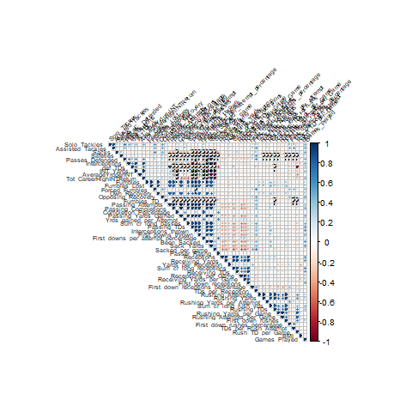

Original Correlation Plot

### New Variable Correlation Plot

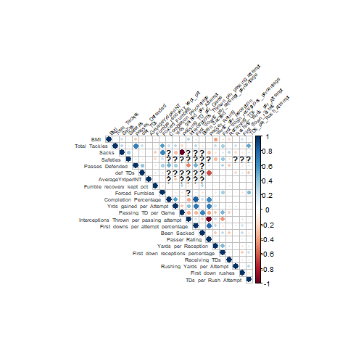

New Variable Correlation Plot

### Metric Histograms before and after Transformations

#### Total Tackles

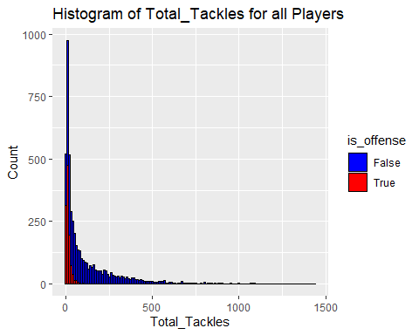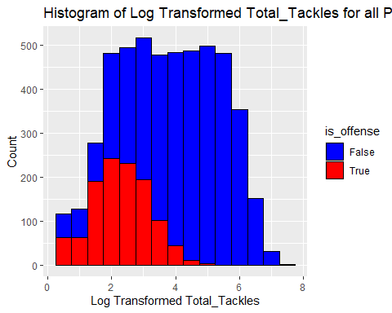

#### Sacks

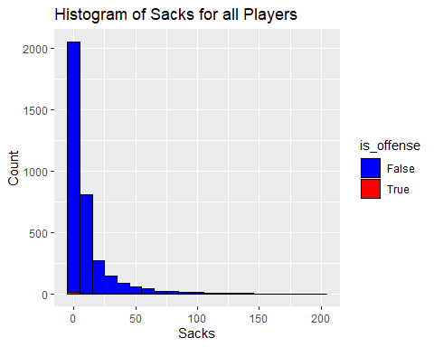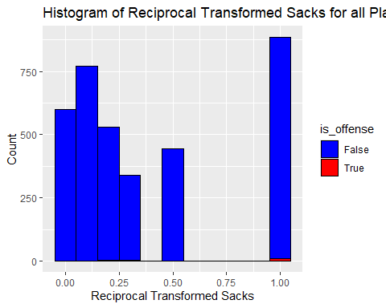

#### Passes Defended

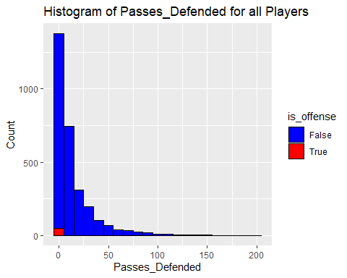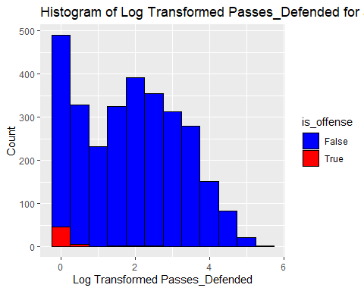

#### Defensive Touchdowns

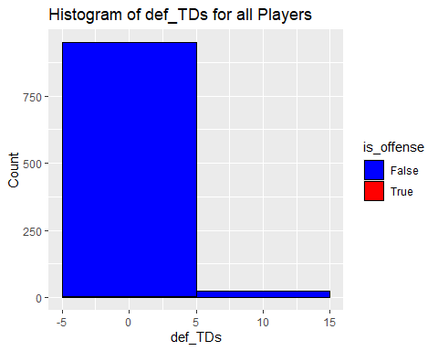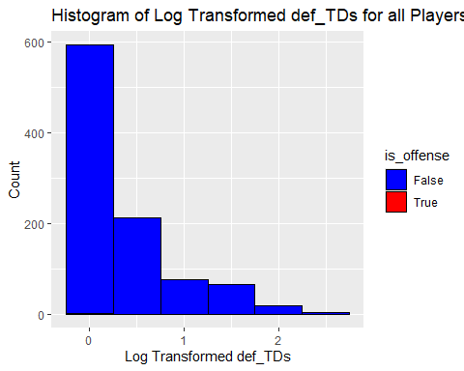

#### Average Yards per Interception

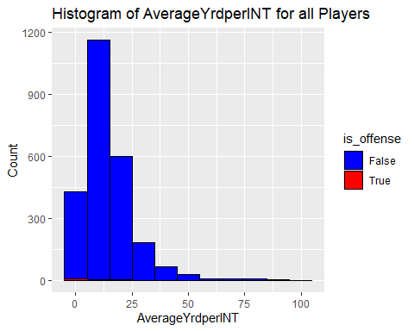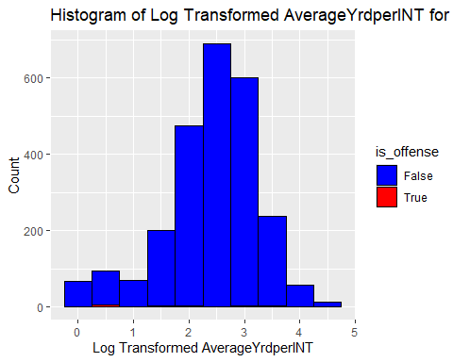

#### Forced Fumbles

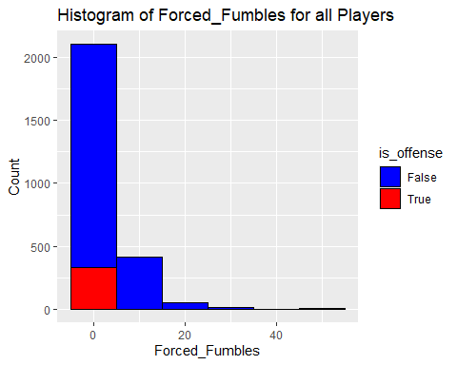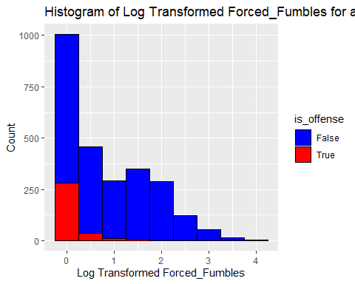

#### Yards gained per Attempt

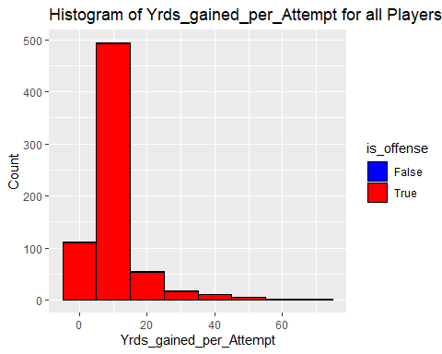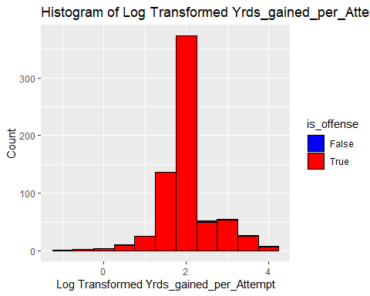

#### Passing TD per Game

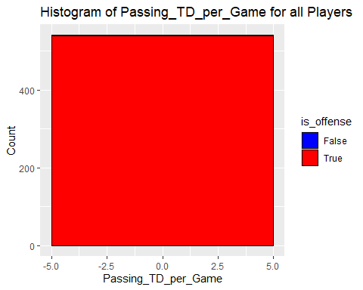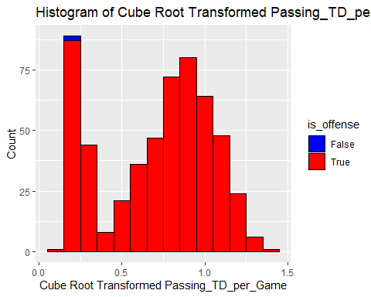

#### Interceptions Thrown per Passing Attempt

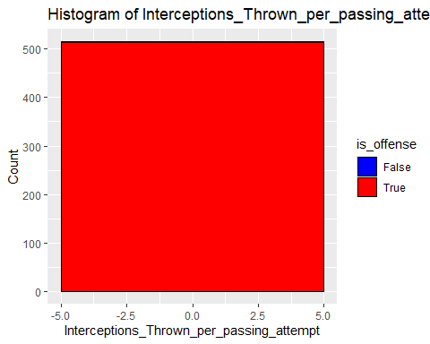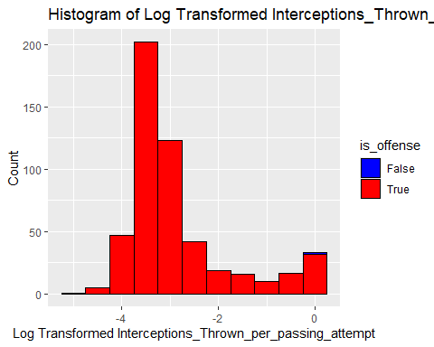

#### Been Sacked

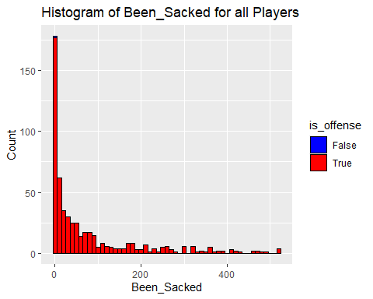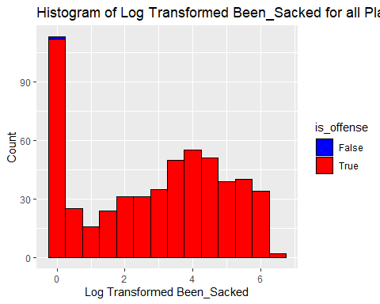

#### Passer Rating

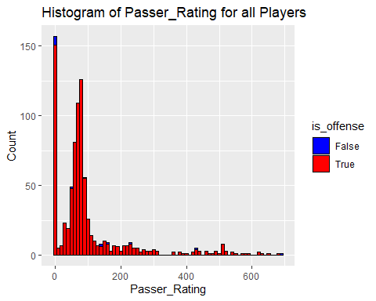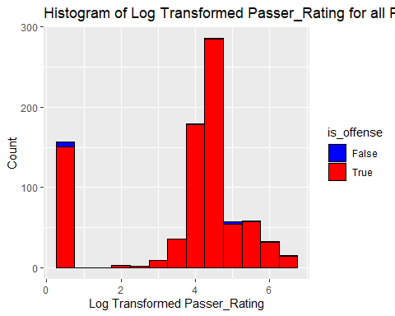

#### Yards per Reception

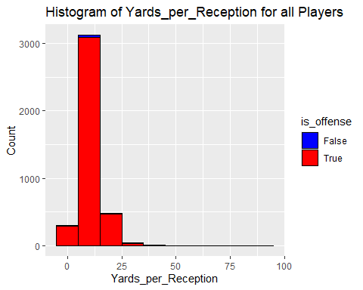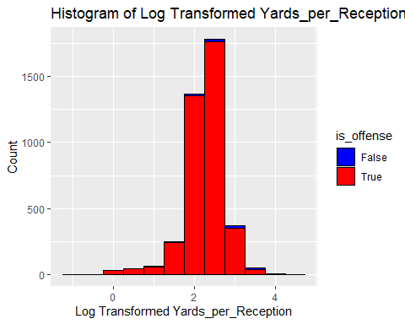

#### Receiving TDs

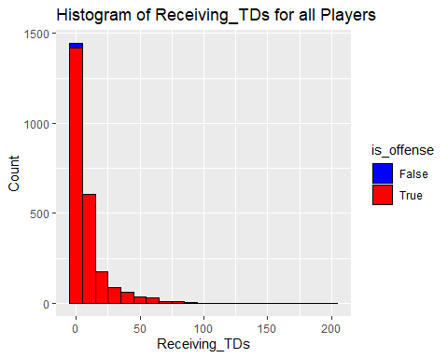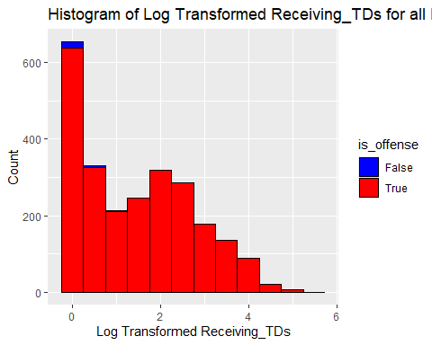

#### Rushing Yards per Attempt

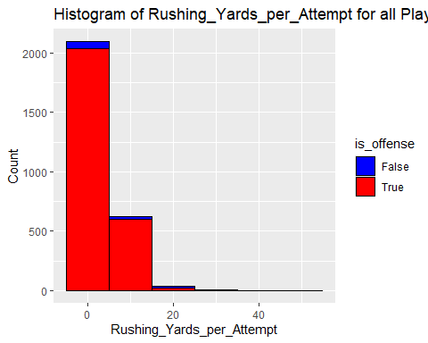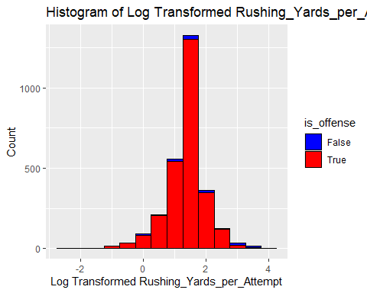

#### First Down Rushes

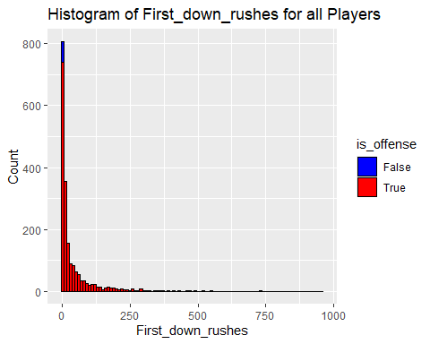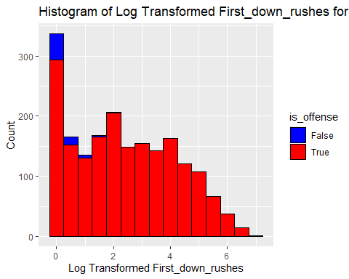

#### TDs per Rush Attempt

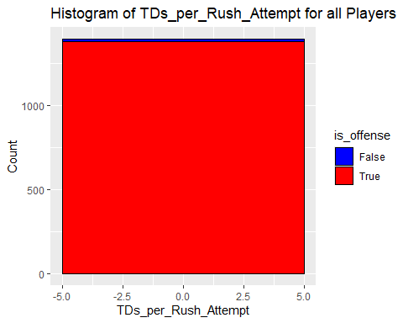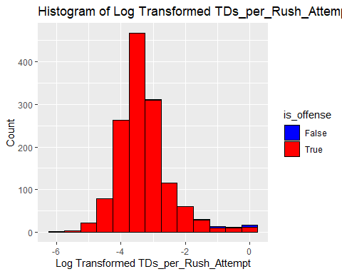

## [1] "\n"

### Full Correlation Plot with transformed Variables

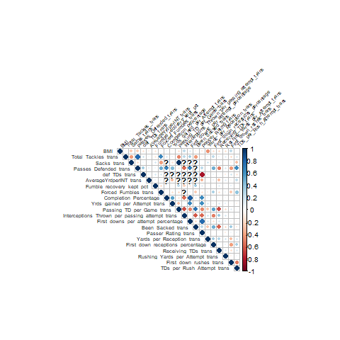

Correlation of all players with transformations

### Correlation Plot of all offensive players

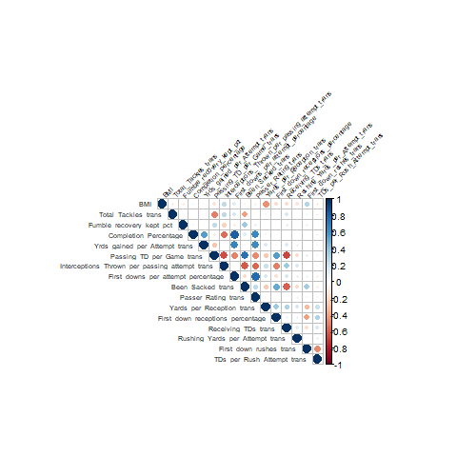

All offense Correlation Plot

### Correlation Plot of retired offensive players

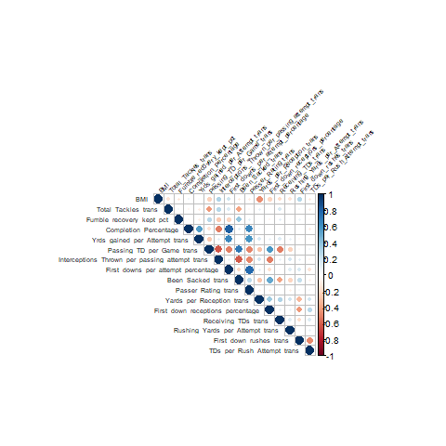

Retired offense Correlation Plot

### Correlation Plot of all defensive players

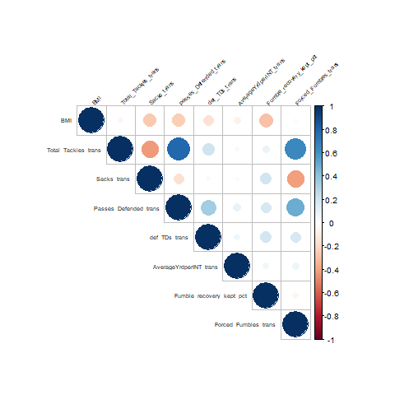

All defense Correlation Plot

### Correlation Plot of retired defensive players

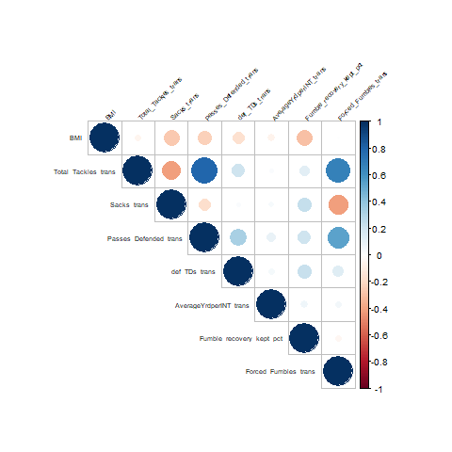

Retired defense Correlation Plot

### BMI interaction plot

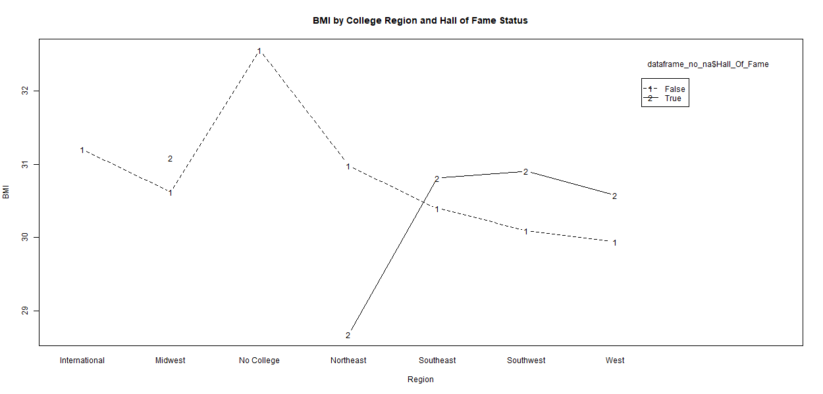

BMI interaction plot

### Total Tackles before transformation interaction plot

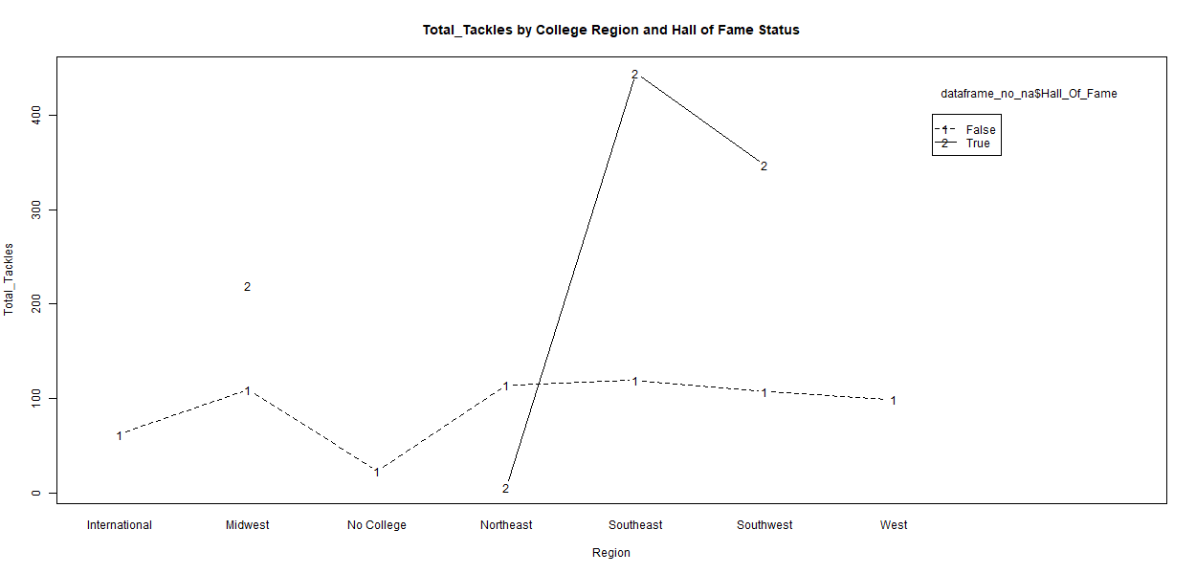

Total Tackles interaction plot

### Total Tackles after transformation interaction plot

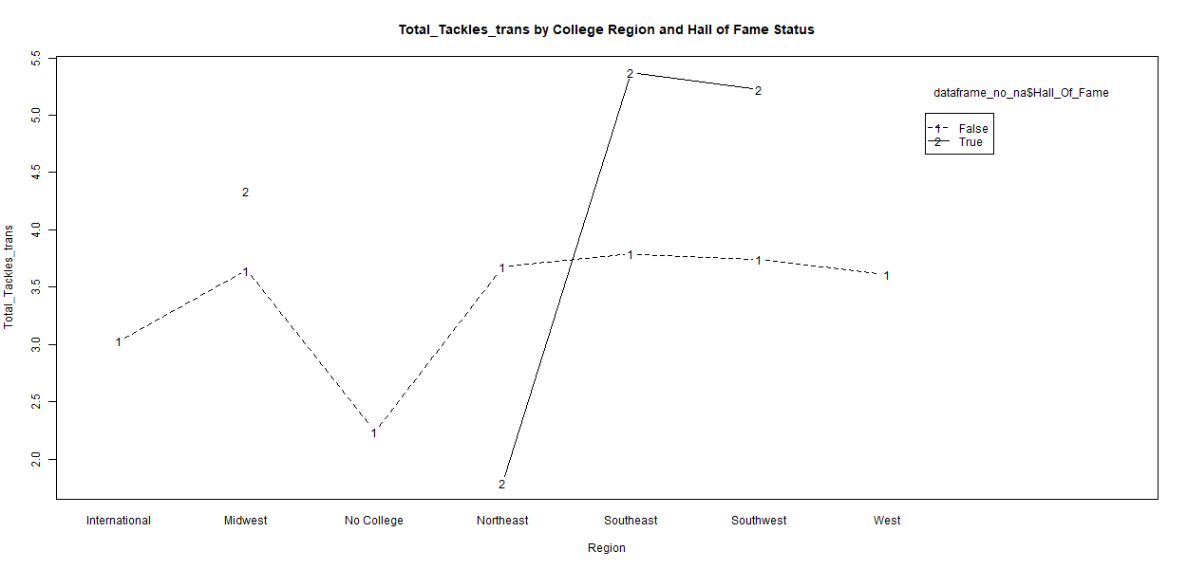

Total Tackles trans interaction plot

### Sacks before transformation interaction plot

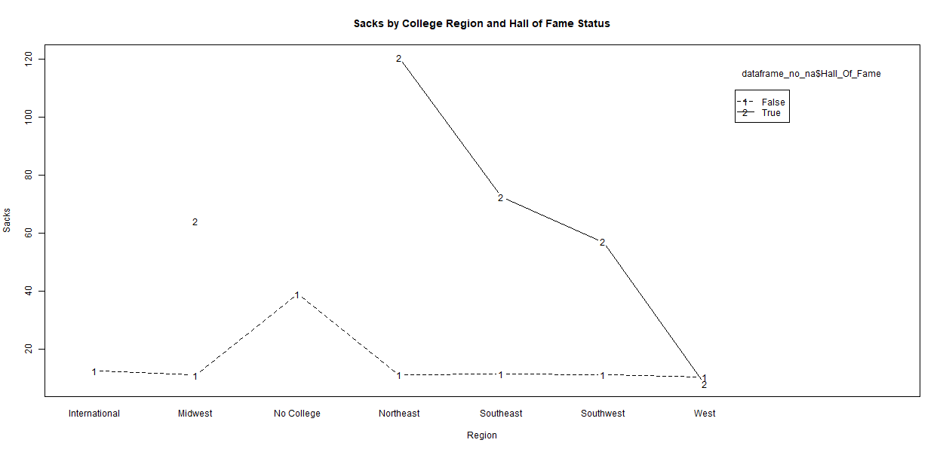

Sacks interaction plot

### Sacks after transformation interaction plot

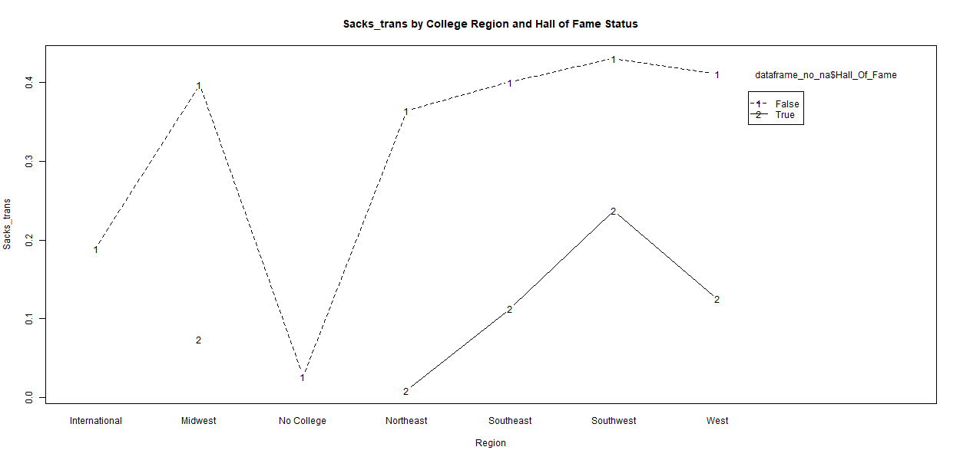

Sacks trans interaction plot

### Passes Defended before transformation interaction plot

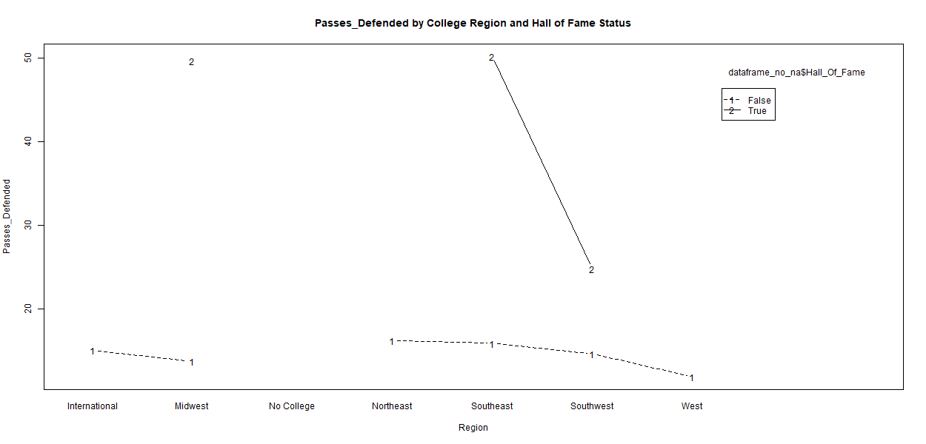

Passes Defended interaction plot

### Passes Defended after transformation interaction plot

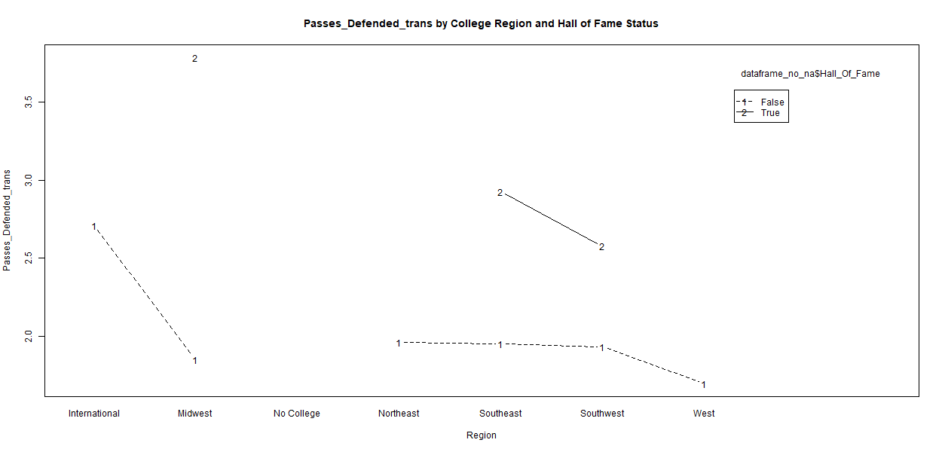

Passes Defended trans interaction plot

### Defensive Touchdowns before transformation interaction plot

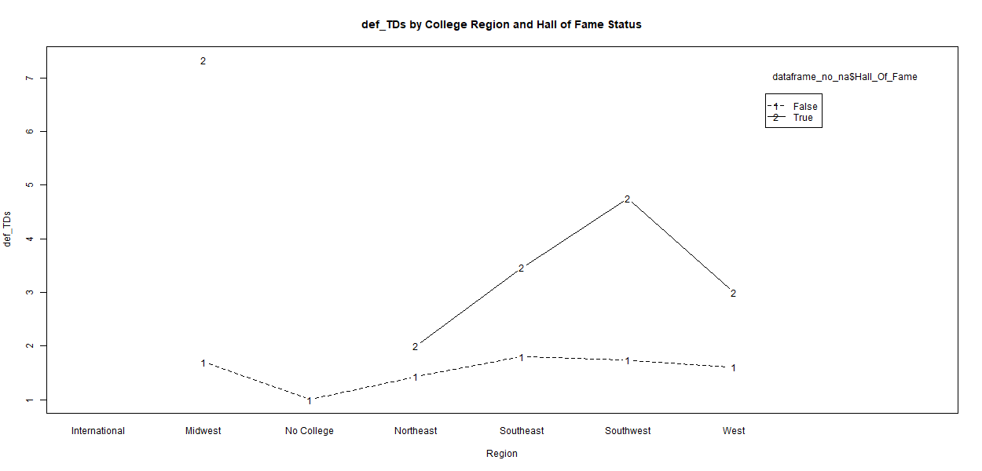

Defensive Touchdowns interaction plot

### Defensive Touchdowns after transformation interaction plot

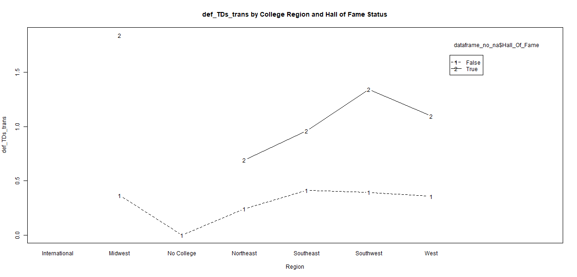

Defensive Touchdowns trans interaction plot

### Average Yards per Interception before transformation interaction plot

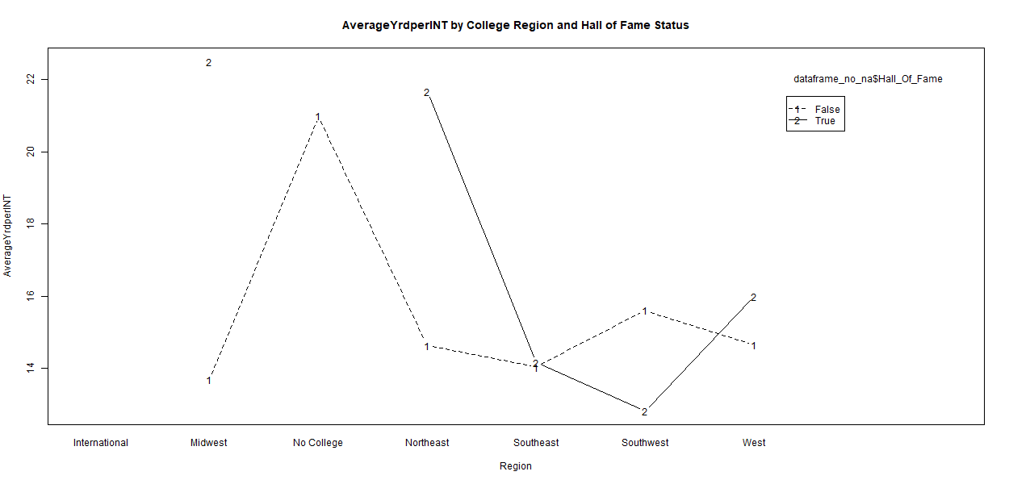

Average Yards per Interception interaction plot

### Average Yards per Interception after transformation interaction plot

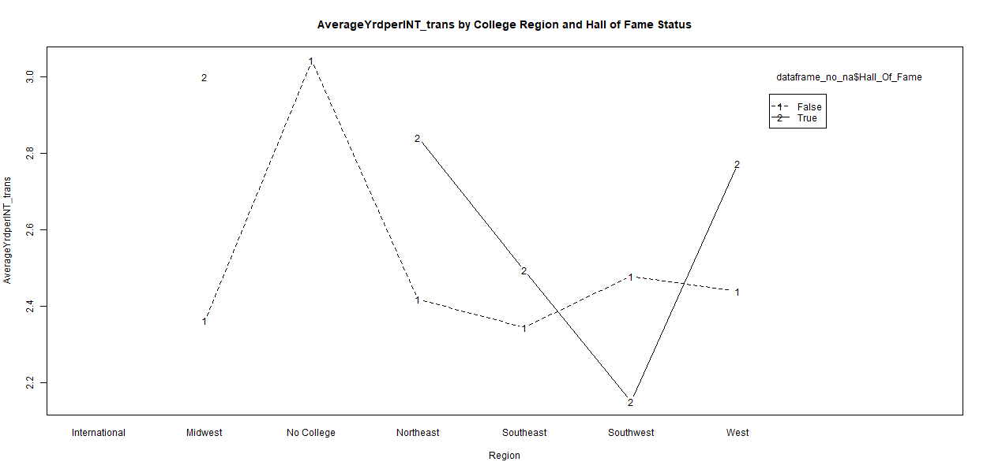

Average Yards per Interception trans interaction plot

### Fumble Recovery Kept Percentage interaction plot

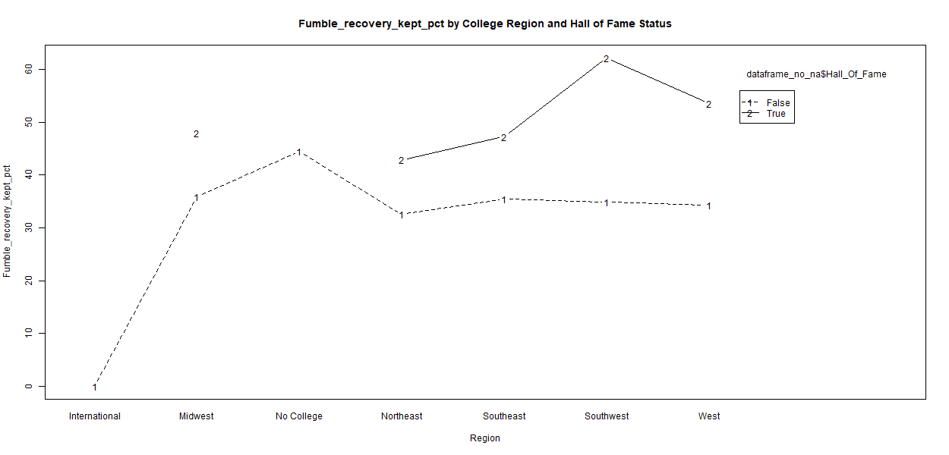

Fumble Recovery Kept Percentage interaction plot

### Forced Fumbles before transformation interaction plot

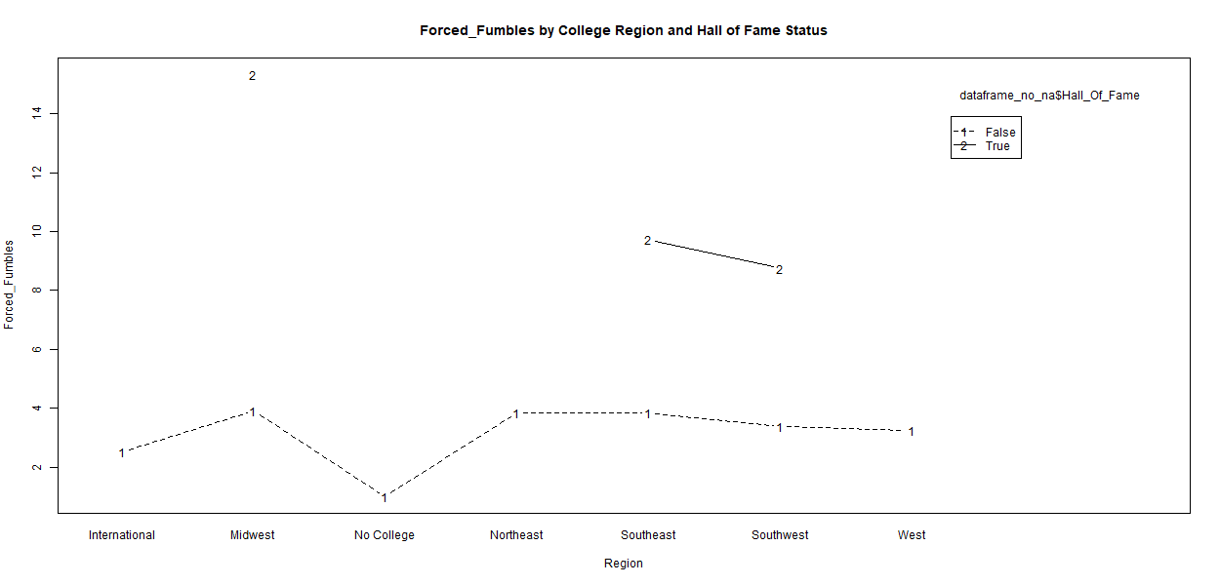

Forced Fumbles interaction plot

### Forced Fumbles after transformation interaction plot

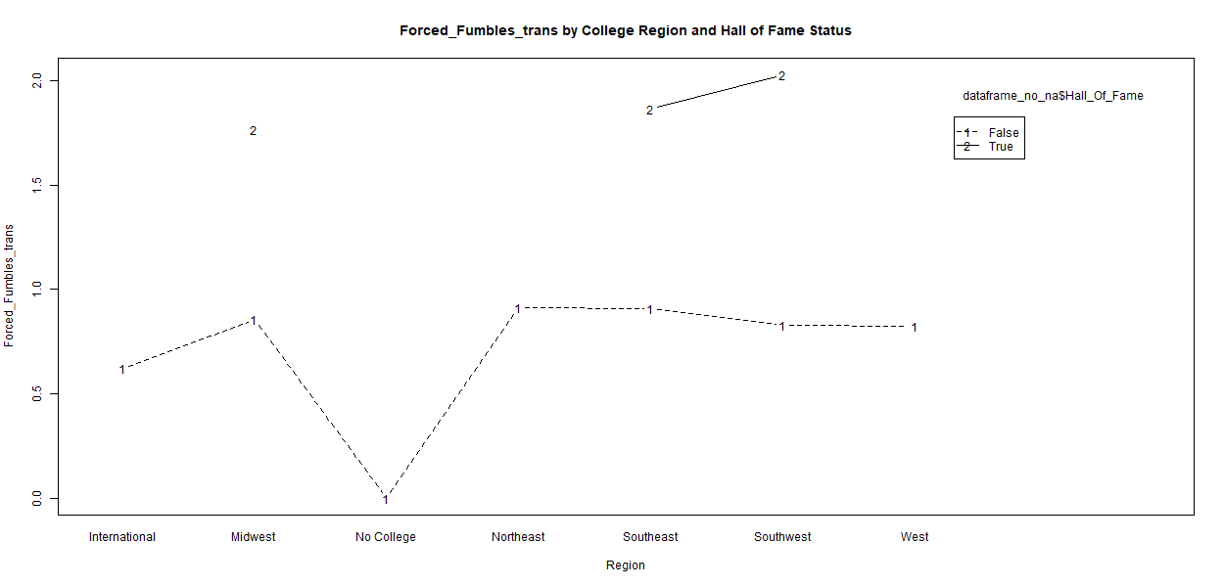

Forced Fumbles trans interaction plot

### Completion Percentage interaction plot

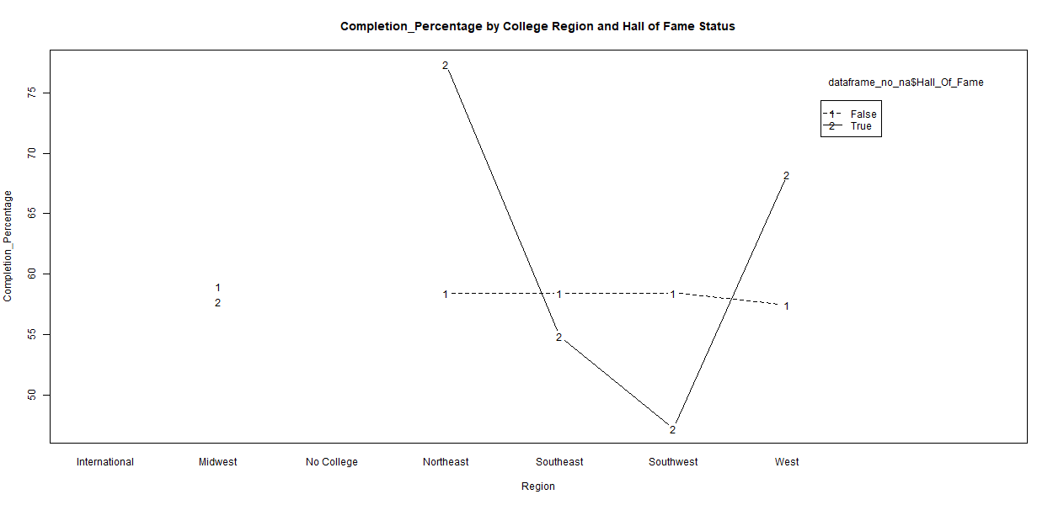

Completion Percentage interaction plot

### Yards Gained per Attempt before transformation interaction plot

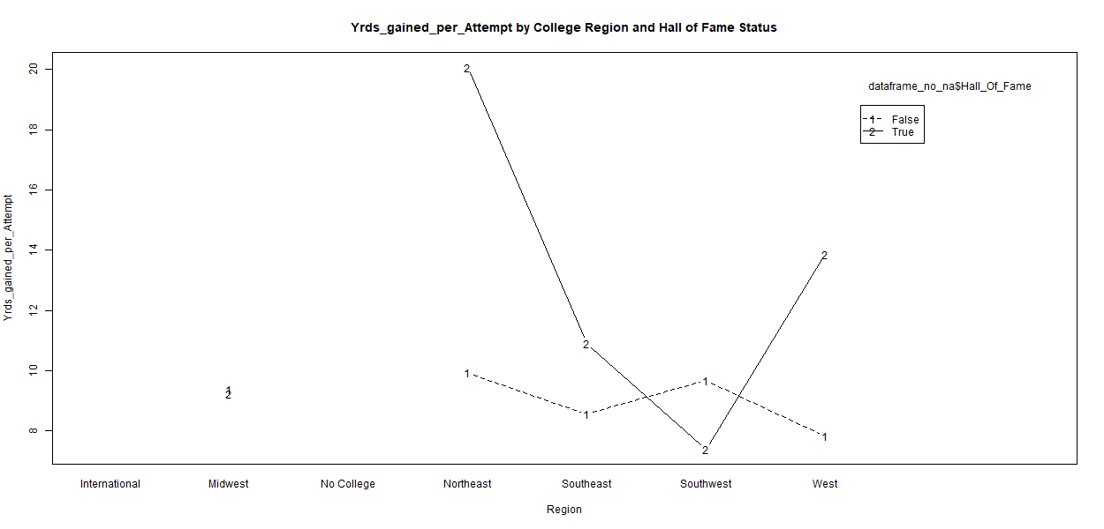

Yards Gained per Attempt interaction plot

### Yards Gained per Attempt after transformation interaction plot

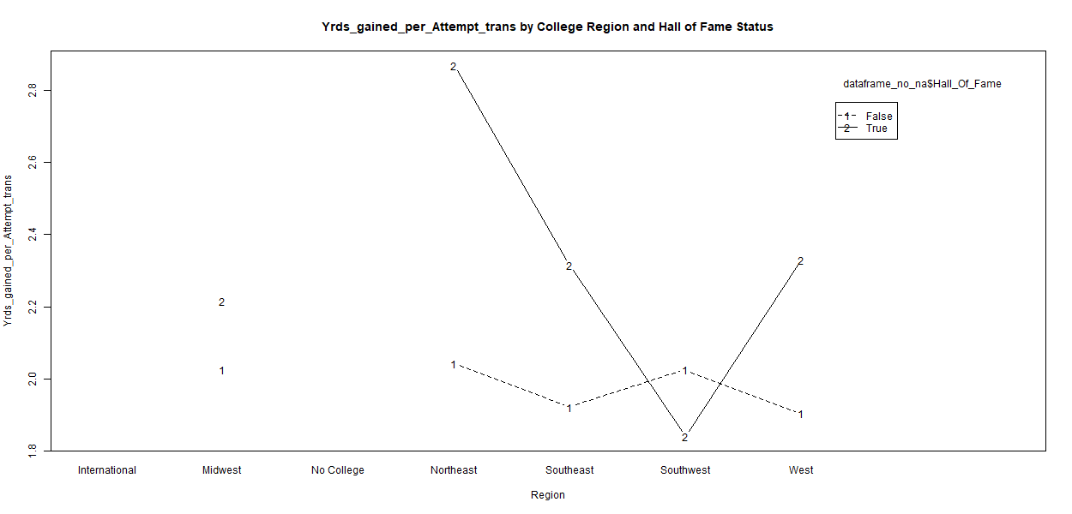

Yards Gained per Attempt trans interaction plot

### Passing TD per Game before transformation interaction plot

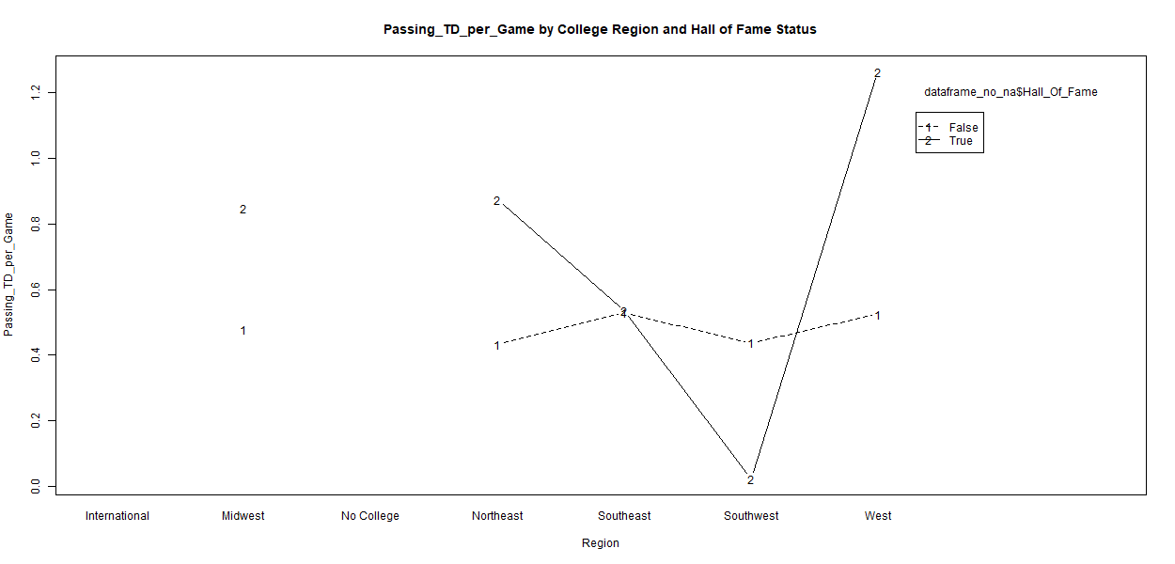

Passing TD per Game interaction plot

### Passing TD per Game after transformation interaction plot

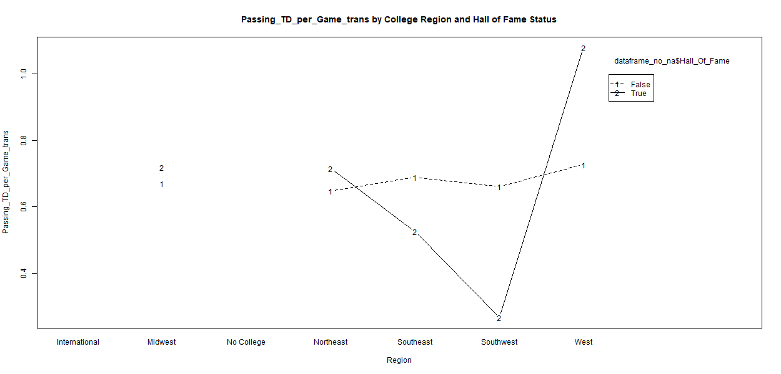

Passing TD per Game trans interaction plot

### Interceptions Thrown per Passing Attempt before transformation interaction plot

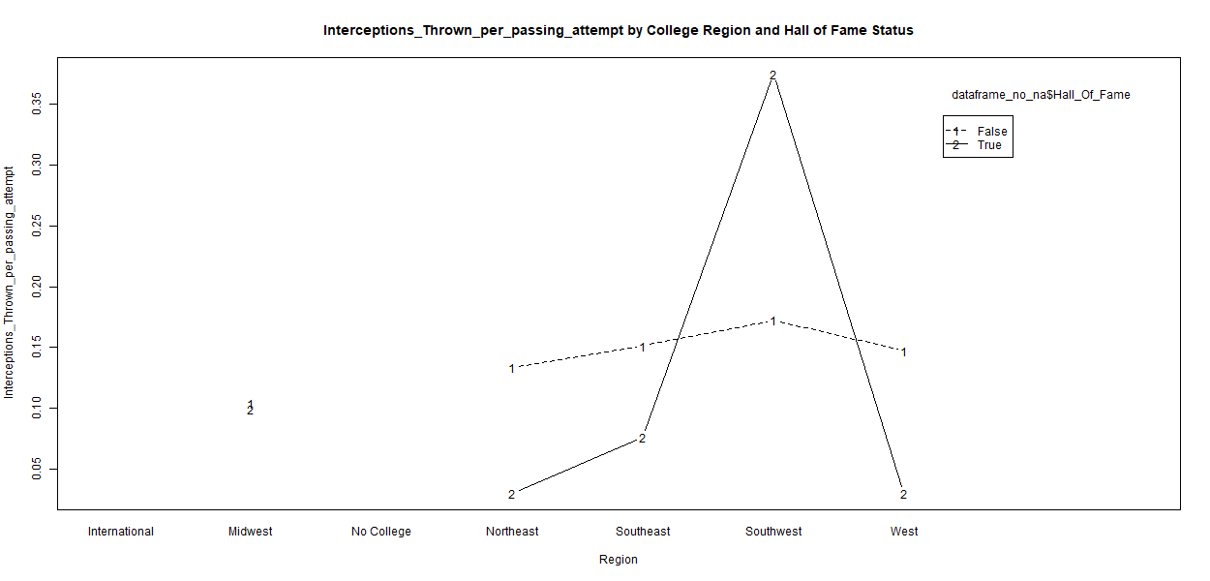

Interceptions Thrown per Passing Attempt interaction plot

### Interceptions Thrown per Passing Attempt after transformation interaction plot

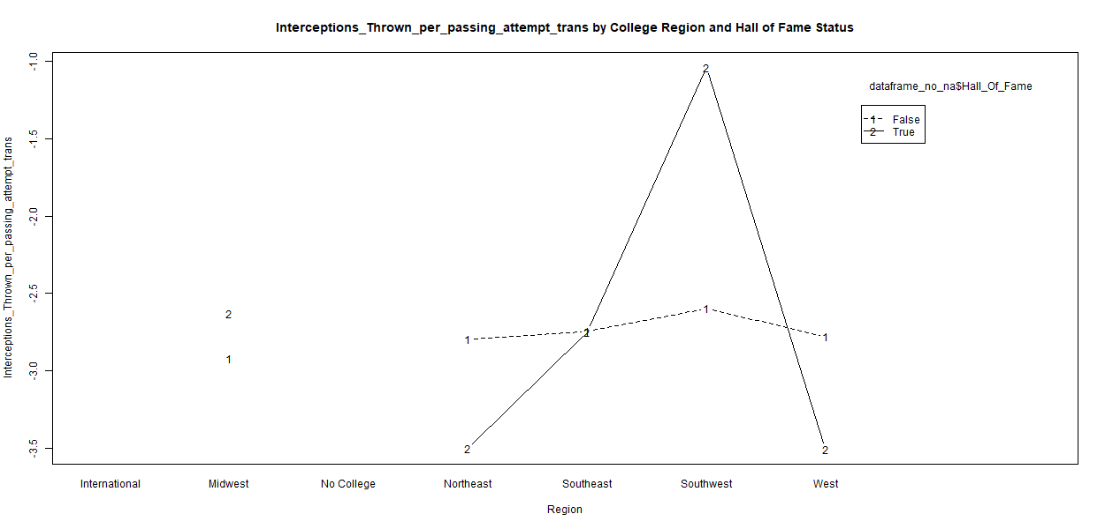

Interceptions Thrown per Passing Attempt trans interaction plot

### First Downs per Attempt Percentage interaction plot

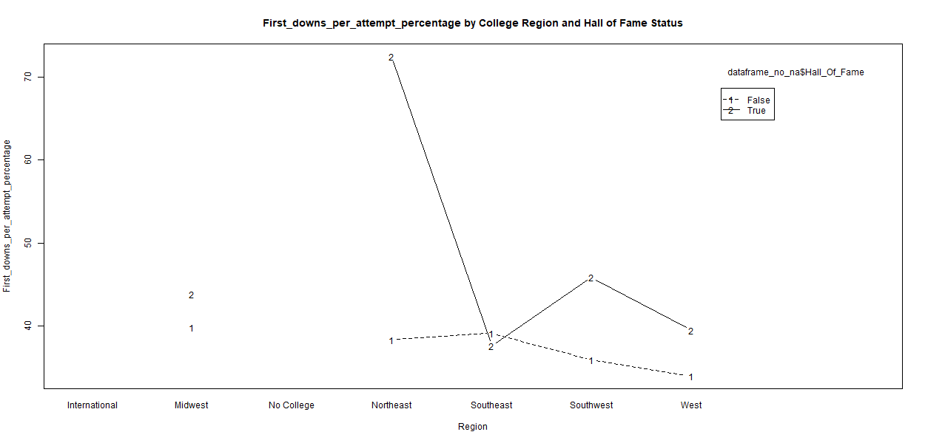

First Downs per Attempt Percentage interaction plot

### Been Sacked before transformation interaction plot

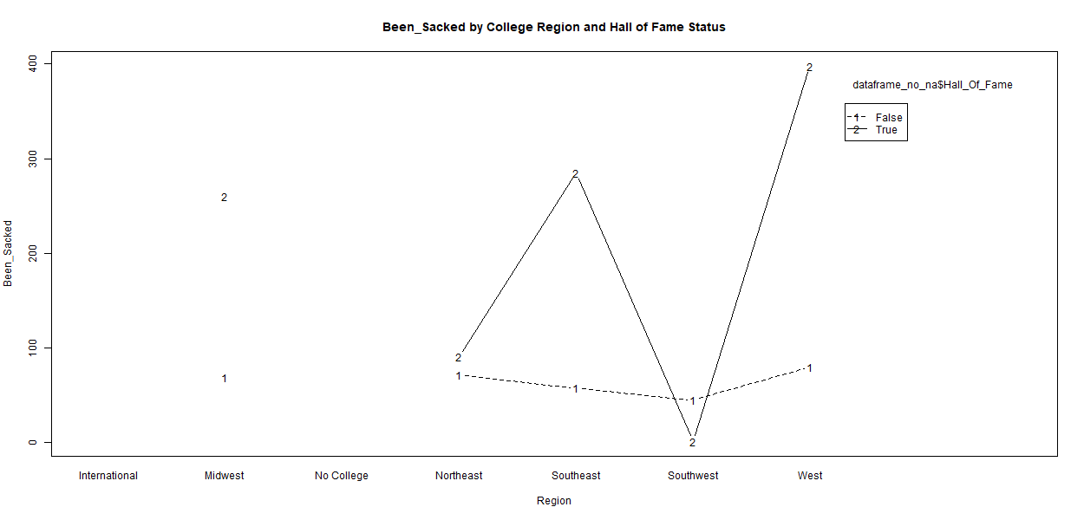

Been Sacked interaction plot

### Been Sacked after transformation interaction plot

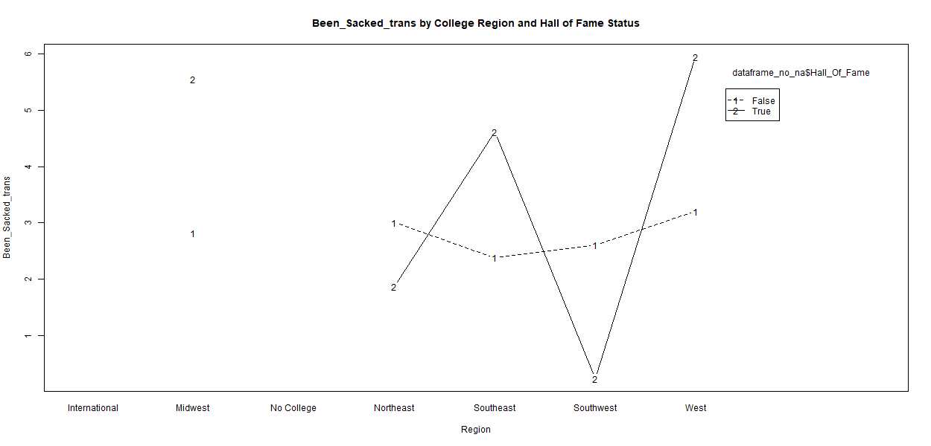

Been Sacked trans interaction plot

### Passer Rating before transformation interaction plot

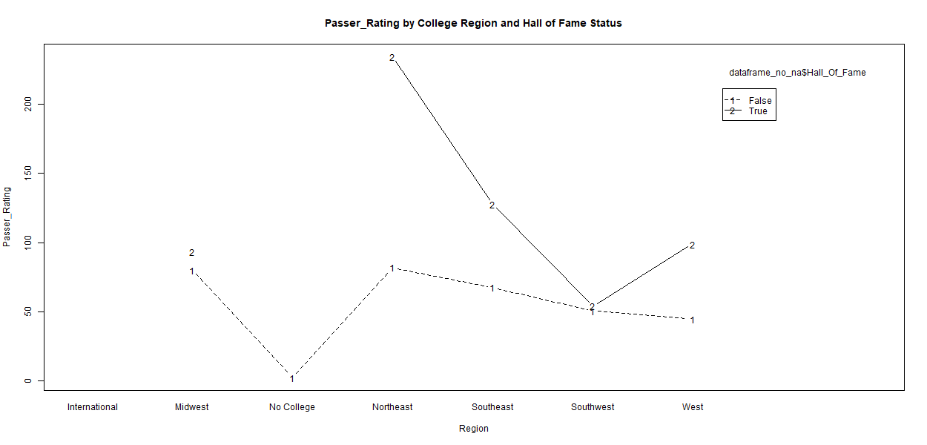

Passer Rating interaction plot

### Passer Rating after transformation interaction plot

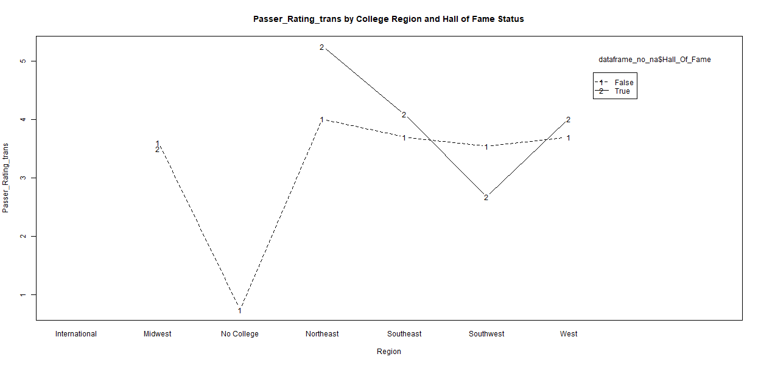

Passer Rating trans interaction plot

### Yards per Reception before transformation interaction plot

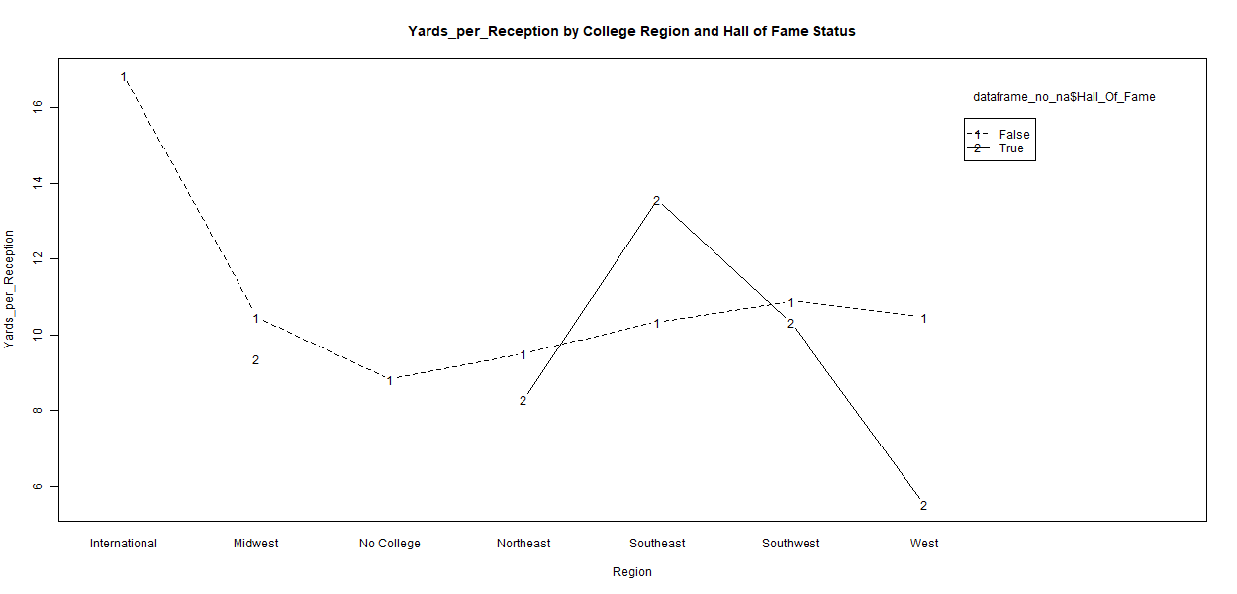

Yards per Reception interaction plot

### Yards per Reception after transformation interaction plot

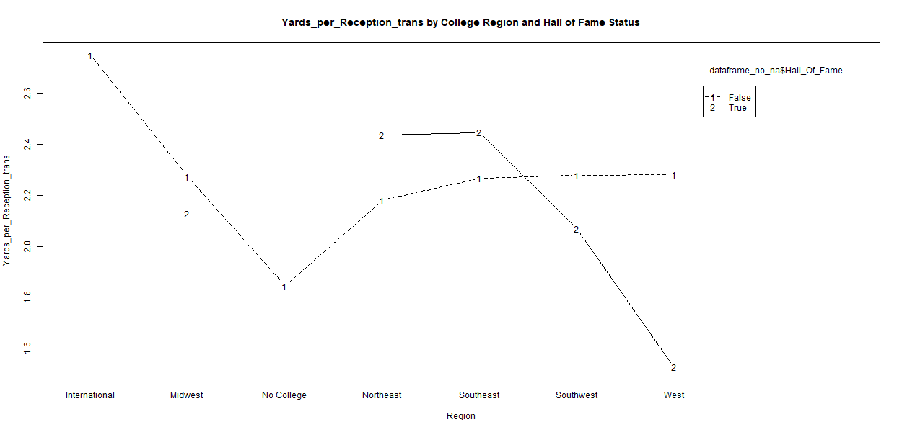

Yards per Reception trans interaction plot

### First Down Receptions Percentage interaction plot

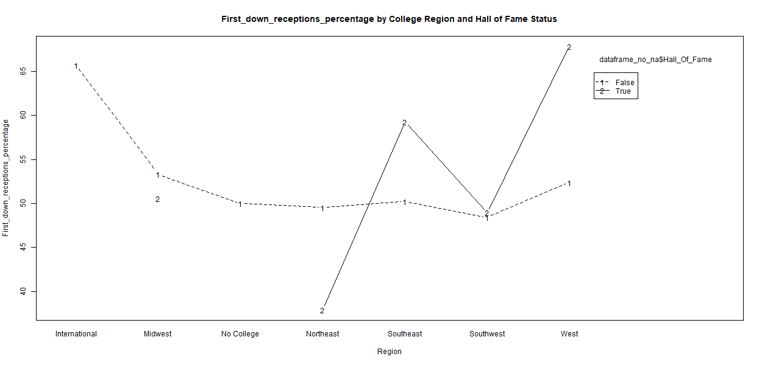

First Down Receptions Percentage interaction plot

### Receiving TDs before transformation interaction plot

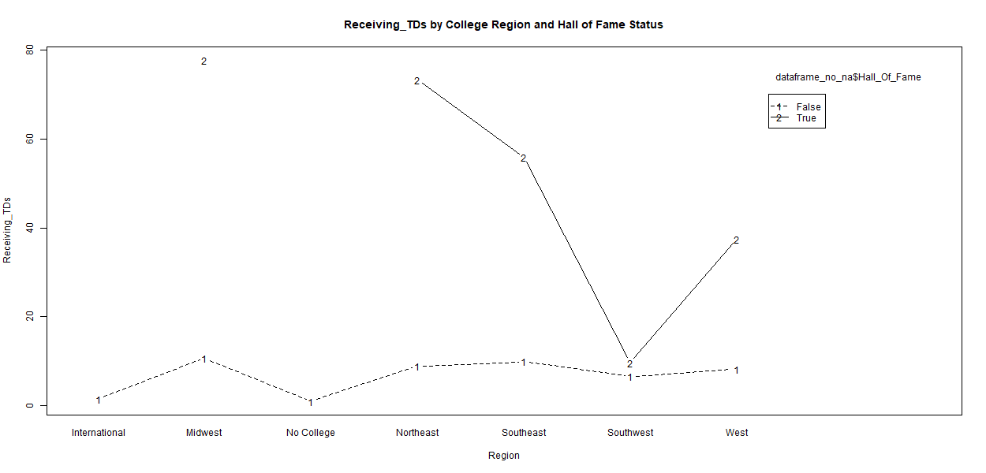

Receiving TDs interaction plot

### Receiving TDs after transformation interaction plot

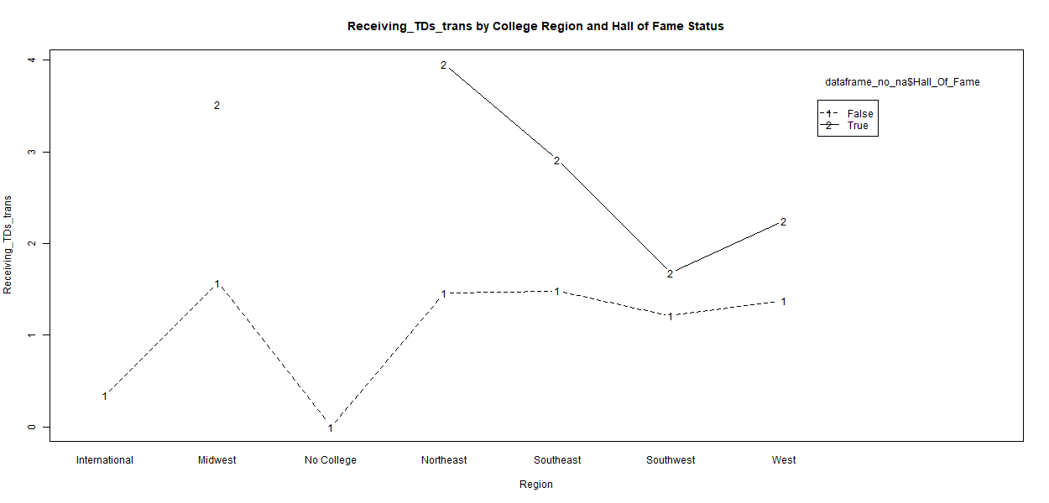

Receiving TDs trans interaction plot

### Rushing Yards per Attempt before transformation interaction plot

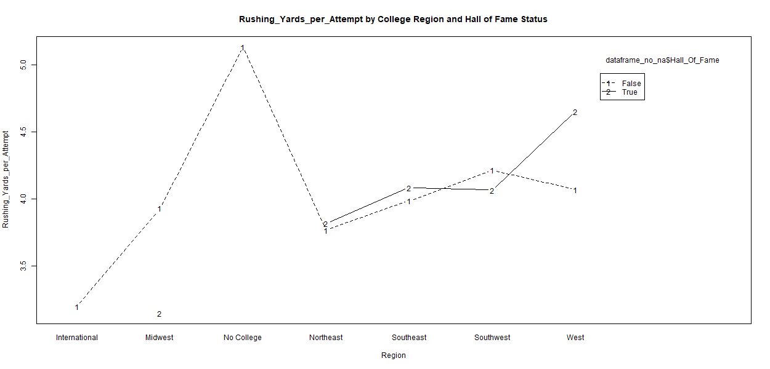

Rushing Yards per Attempt interaction plot

### Rushing Yards per Attempt after transformation interaction plot

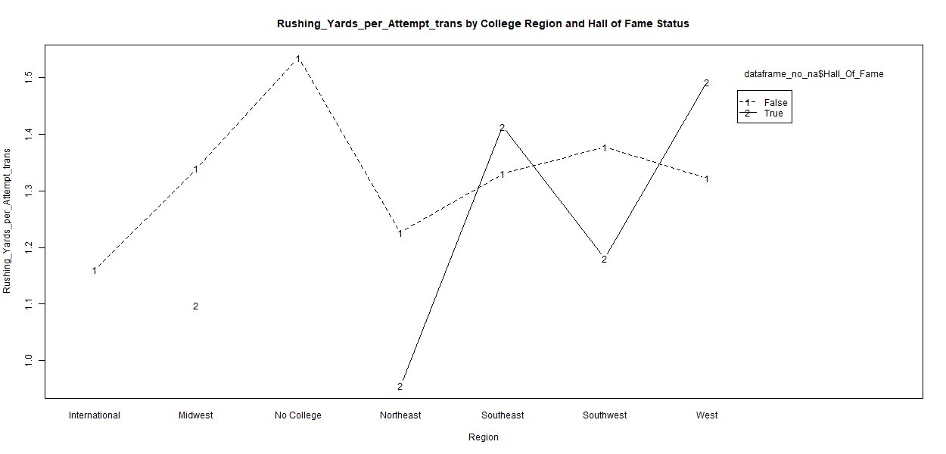

Rushing Yards per Attempt trans interaction plot

### First Down Rushes before transformation interaction plot

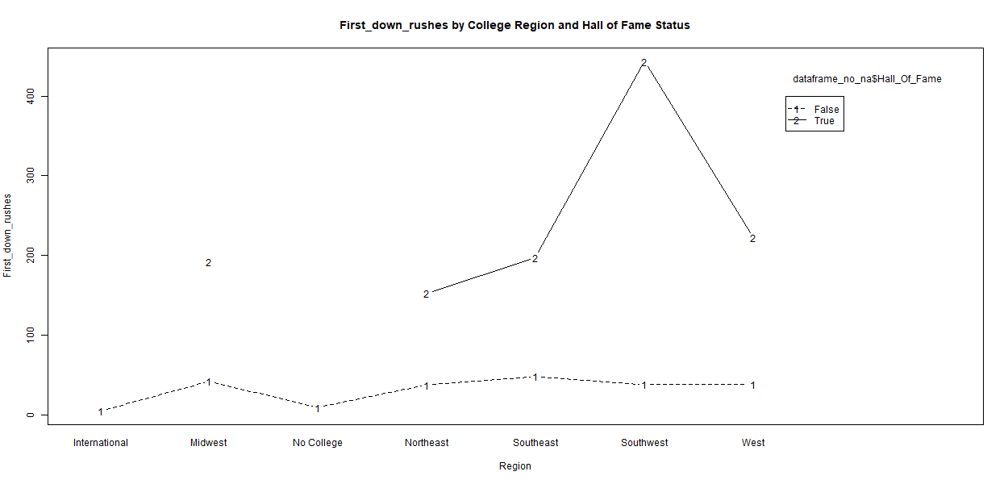

First Down Rushes interaction plot

### First Down Rushes after transformation interaction plot

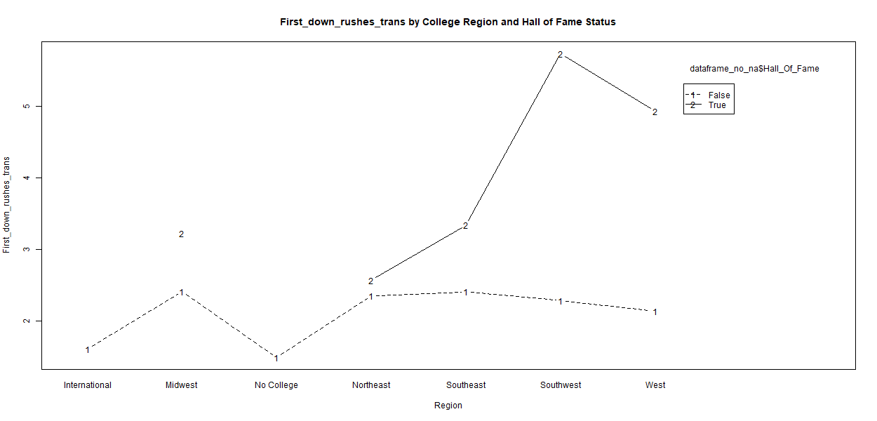

First Down Rushes trans interaction plot

### TDs per Rush Attempt before transformation interaction plot

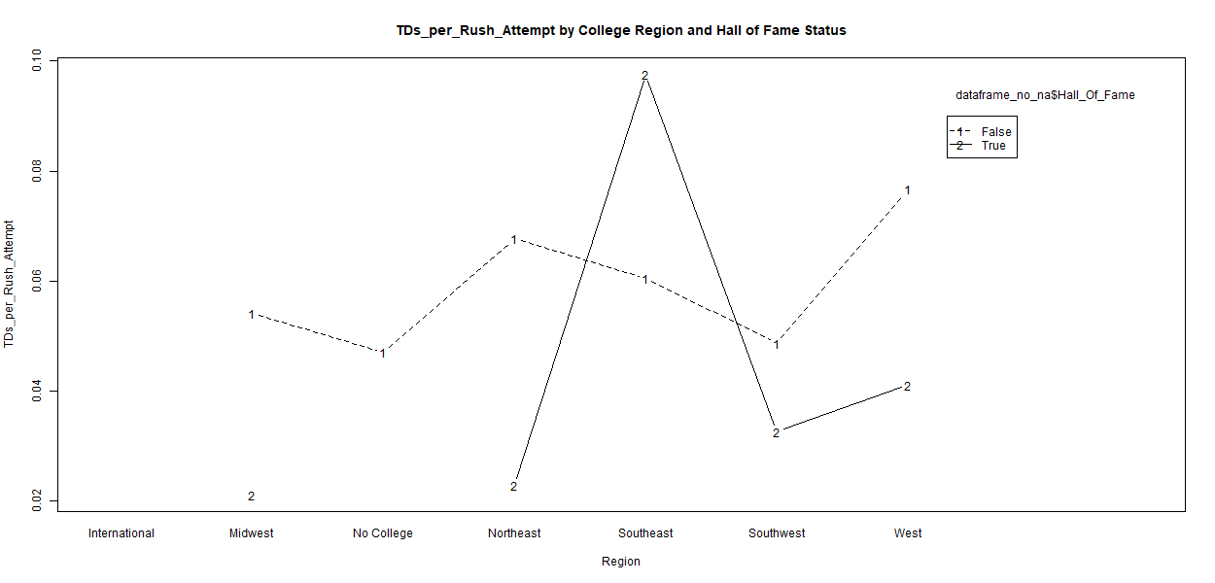

TDs per Rush Attempt interaction plot

### TDs per Rush Attempt after transformation interaction plot

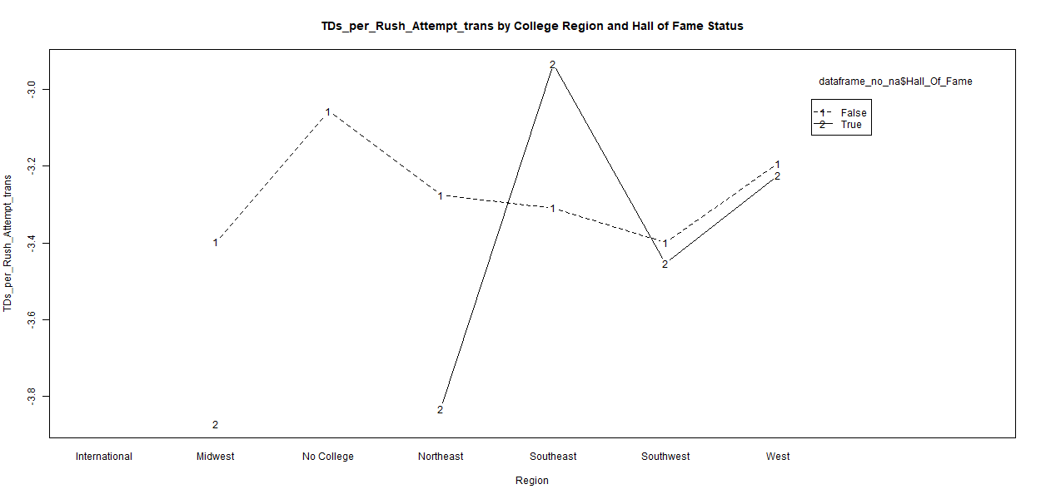

TDs per Rush Attempt trans interaction plot

### Factorial ANOVA output all retired players

##   
## Factorial ANOVA for BMI accounting for interactions between HOF status and College Region:  
## Df Sum Sq Mean Sq F value Pr(>F)   
## Hall_Of_Fame 1 4 3.96 0.227 0.634   
## Region 6 850 141.64 8.133 8.64e-09 ***  
## Hall_Of_Fame:Region 4 58 14.52 0.834 0.504   
## Residuals 9212 160434 17.42   
## ---  
## Signif. codes: 0 '***' 0.001 '**' 0.01 '*' 0.05 '.' 0.1 ' ' 1  
##   
## Significant Tukey's HSD results for Hall_Of_Fame against BMI :  
## [1] diff lwr upr p.adj  
## <0 rows> (or 0-length row.names)  
##   
## Significant Tukey's HSD results for Region against BMI :  
## diff lwr upr p.adj  
## Southwest-Midwest -0.5297050 -0.9793031 -0.08010699 9.287300e-03  
## West-Midwest -0.6863804 -1.1077340 -0.26502689 3.254905e-05  
## Southeast-Northeast -0.5579589 -1.0214927 -0.09442510 7.101354e-03  
## Southwest-Northeast -0.8633892 -1.4065629 -0.32021544 5.751020e-05  
## West-Northeast -1.0200646 -1.5401012 -0.50002793 1.571983e-07  
## West-Southeast -0.4621057 -0.8345610 -0.08965035 4.758135e-03  
##   
## Significant Tukey's HSD results for Hall_Of_Fame:Region against BMI :  
## diff lwr upr p.adj  
## False:Southwest-False:Midwest -0.5335043 -1.046900 -0.02010886 3.271335e-02  
## False:West-False:Midwest -0.6876368 -1.168418 -0.20685598 1.417324e-04  
## False:Southeast-False:Northeast -0.5829932 -1.112755 -0.05323119 1.604683e-02  
## False:Southwest-False:Northeast -0.8917432 -1.512423 -0.27106361 1.273917e-04  
## False:West-False:Northeast -1.0458757 -1.639861 -0.45189045 3.272237e-07  
## False:West-False:Southeast -0.4628825 -0.888165 -0.03759998 1.854580e-02  
##   
## Levene's test for BMI :  
## Levene's Test for Homogeneity of Variance (center = median)  
## Df F value Pr(>F)  
## group 11 1.0871 0.3669  
## 9212   
##   
## Eta squared for BMI :  
## eta.sq eta.sq.part  
## Hall_Of_Fame 2.356569e-05 2.369907e-05  
## Region 5.267209e-03 5.269234e-03  
## Hall_Of_Fame:Region 3.598922e-04 3.618068e-04  
##   
## Asymptotic one-sample Kolmogorov-Smirnov test  
##   
## data: factorial_anova$residuals  
## D = 0.070851, p-value < 2.2e-16  
## alternative hypothesis: two-sided  
##   
##   
## --------------------------------------------------  
##   
## Factorial ANOVA for Total_Tackles_trans accounting for interactions between HOF status and College Region:  
## Df Sum Sq Mean Sq F value Pr(>F)   
## Hall_Of_Fame 1 36 35.67 15.191 9.9e-05 ***  
## Region 6 28 4.60 1.958 0.0682 .   
## Hall_Of_Fame:Region 3 13 4.32 1.838 0.1380   
## Residuals 3497 8212 2.35   
## ---  
## Signif. codes: 0 '***' 0.001 '**' 0.01 '*' 0.05 '.' 0.1 ' ' 1  
## 5716 observations deleted due to missingness  
##   
## Significant Tukey's HSD results for Hall_Of_Fame against Total_Tackles_trans :  
## diff lwr upr p.adj  
## True-False 1.249501 0.6209555 1.878047 9.897086e-05  
##   
## Significant Tukey's HSD results for Region against Total_Tackles_trans :  
## [1] diff lwr upr p.adj  
## <0 rows> (or 0-length row.names)  
##   
## Significant Tukey's HSD results for Hall_Of_Fame:Region against Total_Tackles_trans :  
## diff lwr upr p.adj  
## True:Southeast-False:Midwest 1.727795 0.23140812 3.2241823 0.008188206  
## True:Southeast-False:Northeast 1.694612 0.18269742 3.2065272 0.012537377  
## True:Southeast-False:Southeast 1.584786 0.09411274 3.0754593 0.024959220  
## False:Southwest-True:Southeast -1.634484 -3.14221094 -0.1267575 0.019553751  
## False:West-True:Southeast -1.765192 -3.26565961 -0.2647251 0.006169368  
##   
## Levene's test for Total_Tackles_trans :  
## Levene's Test for Homogeneity of Variance (center = median)  
## Df F value Pr(>F)  
## group 10 1.0937 0.3628  
## 3497   
##   
## Eta squared for Total_Tackles_trans :  
## eta.sq eta.sq.part  
## Hall_Of_Fame 0.004076198 0.004097169  
## Region 0.003328078 0.003347718  
## Hall_Of_Fame:Region 0.001562356 0.001574372  
##   
## Asymptotic one-sample Kolmogorov-Smirnov test  
##   
## data: factorial_anova$residuals  
## D = 0.052292, p-value = 9.315e-09  
## alternative hypothesis: two-sided  
##   
##   
## --------------------------------------------------  
##   
## Factorial ANOVA for Sacks_trans accounting for interactions between HOF status and College Region:  
## Df Sum Sq Mean Sq F value Pr(>F)   
## Hall_Of_Fame 1 2.6 2.5647 18.315 1.93e-05 ***  
## Region 6 1.2 0.1971 1.407 0.208   
## Hall_Of_Fame:Region 4 0.1 0.0176 0.126 0.973   
## Residuals 2847 398.7 0.1400   
## ---  
## Signif. codes: 0 '***' 0.001 '**' 0.01 '*' 0.05 '.' 0.1 ' ' 1  
## 6365 observations deleted due to missingness  
##   
## Significant Tukey's HSD results for Hall_Of_Fame against Sacks_trans :  
## diff lwr upr p.adj  
## True-False -0.2804006 -0.4088735 -0.1519277 1.934209e-05  
##   
## Significant Tukey's HSD results for Region against Sacks_trans :  
## [1] diff lwr upr p.adj  
## <0 rows> (or 0-length row.names)  
##   
## Significant Tukey's HSD results for Hall_Of_Fame:Region against Sacks_trans :  
## diff lwr upr p.adj  
## False:Southwest-True:Southeast 0.3178713 0.022669979 0.6130726 0.02131088  
## False:West-True:Southeast 0.2978185 0.003214238 0.5924227 0.04454688  
##   
## Levene's test for Sacks_trans :  
## Levene's Test for Homogeneity of Variance (center = median)  
## Df F value Pr(>F)   
## group 11 2.7373 0.001585 **  
## 2847   
## ---  
## Signif. codes: 0 '***' 0.001 '**' 0.01 '*' 0.05 '.' 0.1 ' ' 1  
##   
## Eta squared for Sacks_trans :  
## eta.sq eta.sq.part  
## Hall_Of_Fame 0.0063985728 0.0064183831  
## Region 0.0029378810 0.0029572426  
## Hall_Of_Fame:Region 0.0001752128 0.0001768593  
##   
## Asymptotic one-sample Kolmogorov-Smirnov test  
##   
## data: factorial_anova$residuals  
## D = 0.18674, p-value < 2.2e-16  
## alternative hypothesis: two-sided  
##   
##   
## --------------------------------------------------  
##   
## Factorial ANOVA for Passes_Defended_trans accounting for interactions between HOF status and College Region:  
## Df Sum Sq Mean Sq F value Pr(>F)   
## Hall_Of_Fame 1 23 23.071 13.676 0.000223 ***  
## Region 5 17 3.478 2.062 0.067425 .   
## Hall_Of_Fame:Region 2 3 1.607 0.953 0.385792   
## Residuals 2032 3428 1.687   
## ---  
## Signif. codes: 0 '***' 0.001 '**' 0.01 '*' 0.05 '.' 0.1 ' ' 1  
## 7183 observations deleted due to missingness  
##   
## Significant Tukey's HSD results for Hall_Of_Fame against Passes_Defended_trans :  
## diff lwr upr p.adj  
## True-False 1.079331 0.5069609 1.651701 0.000222938  
##   
## Significant Tukey's HSD results for Region against Passes_Defended_trans :  
## diff lwr upr p.adj  
## West-Southeast -0.2552947 -0.4985698 -0.01201971 0.03324416  
##   
## Significant Tukey's HSD results for Hall_Of_Fame:Region against Passes_Defended_trans :  
## [1] diff lwr upr p.adj  
## <0 rows> (or 0-length row.names)  
##   
## Levene's test for Passes_Defended_trans :  
## Levene's Test for Homogeneity of Variance (center = median)  
## Df F value Pr(>F)   
## group 8 1.8213 0.06874 .  
## 2032   
## ---  
## Signif. codes: 0 '***' 0.001 '**' 0.01 '*' 0.05 '.' 0.1 ' ' 1  
##   
## Eta squared for Passes_Defended_trans :  
## eta.sq eta.sq.part  
## Hall_Of_Fame 0.0061345060 0.0061743093  
## Region 0.0050092055 0.0050474241  
## Hall_Of_Fame:Region 0.0009260964 0.0009370173  
##   
## Asymptotic one-sample Kolmogorov-Smirnov test  
##   
## data: factorial_anova$residuals  
## D = 0.069168, p-value = 6.6e-09  
## alternative hypothesis: two-sided  
##   
##   
## --------------------------------------------------  
##   
## Factorial ANOVA for def_TDs_trans accounting for interactions between HOF status and College Region:  
## Df Sum Sq Mean Sq F value Pr(>F)   
## Hall_Of_Fame 1 12.64 12.642 45.227 3.34e-11 ***  
## Region 5 1.99 0.398 1.423 0.214   
## Hall_Of_Fame:Region 4 2.30 0.574 2.054 0.085 .   
## Residuals 799 223.35 0.280   
## ---  
## Signif. codes: 0 '***' 0.001 '**' 0.01 '*' 0.05 '.' 0.1 ' ' 1  
## 8414 observations deleted due to missingness  
##   
## Significant Tukey's HSD results for Hall_Of_Fame against def_TDs_trans :  
## diff lwr upr p.adj  
## True-False 0.768567 0.5442351 0.9928988 0  
##   
## Significant Tukey's HSD results for Region against def_TDs_trans :  
## [1] diff lwr upr p.adj  
## <0 rows> (or 0-length row.names)  
##   
## Significant Tukey's HSD results for Hall_Of_Fame:Region against def_TDs_trans :  
## diff lwr upr p.adj  
## True:Midwest-False:Midwest 1.4777213 0.46701648 2.48842620 1.241523e-04  
## True:Southeast-False:Midwest 0.5972049 0.09575484 1.09865491 5.764117e-03  
## True:Southwest-False:Midwest 0.9783979 0.10018902 1.85660680 1.458857e-02  
## False:No College-True:Midwest -1.8431430 -3.42514637 -0.26113969 7.947078e-03  
## False:Northeast-True:Midwest -1.6016811 -2.62438285 -0.57897929 2.300867e-05  
## False:Southeast-True:Midwest -1.4311028 -2.43608000 -0.42612550 2.235616e-04  
## False:Southwest-True:Midwest -1.4494228 -2.46181076 -0.43703483 1.988103e-04  
## False:West-True:Midwest -1.4857891 -2.50013714 -0.47144101 1.190041e-04  
## True:Southeast-False:Northeast 0.7211646 0.19595346 1.24637576 4.792954e-04  
## True:Southwest-False:Northeast 1.1023576 0.21036803 1.99434725 3.238495e-03  
## True:Southeast-False:Southeast 0.5505863 0.06078317 1.04038942 1.298261e-02  
## True:Southwest-False:Southeast 0.9317793 0.06016828 1.80339037 2.424765e-02  
## False:Southwest-True:Southeast -0.5689063 -1.07374019 -0.06407248 1.256003e-02  
## False:West-True:Southeast -0.6052726 -1.11402581 -0.09651942 5.854473e-03  
## True:Southwest-False:Southwest 0.9500994 0.06995396 1.83024478 2.160526e-02  
## False:West-True:Southwest -0.9864656 -1.86886495 -0.10406634 1.395069e-02  
##   
## Levene's test for def_TDs_trans :  
## Levene's Test for Homogeneity of Variance (center = median)  
## Df F value Pr(>F)  
## group 10 1.365 0.1919  
## 799   
##   
## Eta squared for def_TDs_trans :  
## eta.sq eta.sq.part  
## Hall_Of_Fame 0.050620655 0.051644866  
## Region 0.008275882 0.008824563  
## Hall_Of_Fame:Region 0.009560408 0.010180308  
##   
## Asymptotic one-sample Kolmogorov-Smirnov test  
##   
## data: factorial_anova$residuals  
## D = 0.28882, p-value < 2.2e-16  
## alternative hypothesis: two-sided  
##   
##   
## --------------------------------------------------  
##   
## Factorial ANOVA for AverageYrdperINT_trans accounting for interactions between HOF status and College Region:  
## Df Sum Sq Mean Sq F value Pr(>F)  
## Hall_Of_Fame 1 0.7 0.6670 0.982 0.322  
## Region 5 5.4 1.0741 1.581 0.162  
## Hall_Of_Fame:Region 4 2.5 0.6367 0.937 0.441  
## Residuals 2048 1391.0 0.6792   
## 7165 observations deleted due to missingness  
##   
## Significant Tukey's HSD results for Hall_Of_Fame against AverageYrdperINT_trans :  
## [1] diff lwr upr p.adj  
## <0 rows> (or 0-length row.names)  
##   
## Significant Tukey's HSD results for Region against AverageYrdperINT_trans :  
## [1] diff lwr upr p.adj  
## <0 rows> (or 0-length row.names)  
##   
## Significant Tukey's HSD results for Hall_Of_Fame:Region against AverageYrdperINT_trans :  
## [1] diff lwr upr p.adj  
## <0 rows> (or 0-length row.names)  
##   
## Levene's test for AverageYrdperINT_trans :  
## Levene's Test for Homogeneity of Variance (center = median)  
## Df F value Pr(>F)  
## group 10 0.9863 0.453  
## 2048   
##   
## Eta squared for AverageYrdperINT_trans :  
## eta.sq eta.sq.part  
## Hall_Of_Fame 0.0005316238 0.0005346185  
## Region 0.0038369941 0.0038458252  
## Hall_Of_Fame:Region 0.0018197331 0.0018276165  
##   
## Asymptotic one-sample Kolmogorov-Smirnov test  
##   
## data: factorial_anova$residuals  
## D = 0.089179, p-value = 1.199e-14  
## alternative hypothesis: two-sided  
##   
##   
## --------------------------------------------------  
##   
## Factorial ANOVA for Fumble_recovery_kept_pct accounting for interactions between HOF status and College Region:  
## Df Sum Sq Mean Sq F value Pr(>F)   
## Hall_Of_Fame 1 7946 7946 11.281 0.000799 ***  
## Region 6 3151 525 0.745 0.613027   
## Hall_Of_Fame:Region 4 1023 256 0.363 0.834879   
## Residuals 1854 1305866 704   
## ---  
## Signif. codes: 0 '***' 0.001 '**' 0.01 '*' 0.05 '.' 0.1 ' ' 1  
## 7358 observations deleted due to missingness  
##   
## Significant Tukey's HSD results for Hall_Of_Fame against Fumble_recovery_kept_pct :  
## diff lwr upr p.adj  
## True-False 14.42503 6.00177 22.8483 0.0007990253  
##   
## Significant Tukey's HSD results for Region against Fumble_recovery_kept_pct :  
## [1] diff lwr upr p.adj  
## <0 rows> (or 0-length row.names)  
##   
## Significant Tukey's HSD results for Hall_Of_Fame:Region against Fumble_recovery_kept_pct :  
## [1] diff lwr upr p.adj  
## <0 rows> (or 0-length row.names)  
##   
## Levene's test for Fumble_recovery_kept_pct :  
## Levene's Test for Homogeneity of Variance (center = median)  
## Df F value Pr(>F)   
## group 11 2.7022 0.001857 **  
## 1854   
## ---  
## Signif. codes: 0 '***' 0.001 '**' 0.01 '*' 0.05 '.' 0.1 ' ' 1  
##   
## Eta squared for Fumble_recovery_kept_pct :  
## eta.sq eta.sq.part  
## Hall_Of_Fame 0.0060386119 0.0060577358  
## Region 0.0023904077 0.0024067862  
## Hall_Of_Fame:Region 0.0007765542 0.0007831475  
##   
## Asymptotic one-sample Kolmogorov-Smirnov test  
##   
## data: factorial_anova$residuals  
## D = 0.18528, p-value < 2.2e-16  
## alternative hypothesis: two-sided  
##   
##   
## --------------------------------------------------  
##   
## Factorial ANOVA for Forced_Fumbles_trans accounting for interactions between HOF status and College Region:  
## Df Sum Sq Mean Sq F value Pr(>F)   
## Hall_Of_Fame 1 18.2 18.198 23.980 1.06e-06 ***  
## Region 6 3.3 0.545 0.719 0.635   
## Hall_Of_Fame:Region 2 0.2 0.101 0.133 0.875   
## Residuals 1836 1393.3 0.759   
## ---  
## Signif. codes: 0 '***' 0.001 '**' 0.01 '*' 0.05 '.' 0.1 ' ' 1  
## 7378 observations deleted due to missingness  
##   
## Significant Tukey's HSD results for Hall_Of_Fame against Forced_Fumbles_trans :  
## diff lwr upr p.adj  
## True-False 1.010426 0.6057467 1.415105 1.05854e-06  
##   
## Significant Tukey's HSD results for Region against Forced_Fumbles_trans :  
## [1] diff lwr upr p.adj  
## <0 rows> (or 0-length row.names)  
##   
## Significant Tukey's HSD results for Hall_Of_Fame:Region against Forced_Fumbles_trans :  
## diff lwr upr p.adj  
## True:Southeast-False:Midwest 1.0083759 0.11381783 1.9029340 0.011621059  
## True:Southeast-False:Northeast 0.9539211 0.04242072 1.8654215 0.030173867  
## True:Southeast-False:Southeast 0.9583721 0.07038613 1.8463580 0.020732689  
## False:Southwest-True:Southeast -1.0367786 -1.94466916 -0.1288881 0.009663572  
## False:West-True:Southeast -1.0423729 -1.94176212 -0.1429837 0.007779532  
##   
## Levene's test for Forced_Fumbles_trans :  
## Levene's Test for Homogeneity of Variance (center = median)  
## Df F value Pr(>F)  
## group 9 1.6006 0.1095  
## 1836   
##   
## Eta squared for Forced_Fumbles_trans :  
## eta.sq eta.sq.part  
## Hall_Of_Fame 0.0126373767 0.0126713222  
## Region 0.0023122886 0.0023427538  
## Hall_Of_Fame:Region 0.0001428564 0.0001450574  
##   
## Asymptotic one-sample Kolmogorov-Smirnov test  
##   
## data: factorial_anova$residuals  
## D = 0.21056, p-value < 2.2e-16  
## alternative hypothesis: two-sided  
##   
##   
## --------------------------------------------------  
##   
## Factorial ANOVA for Completion_Percentage accounting for interactions between HOF status and College Region:  
## Df Sum Sq Mean Sq F value Pr(>F)  
## Hall_Of_Fame 1 205 204.7 0.555 0.456  
## Region 4 165 41.2 0.112 0.978  
## Hall_Of_Fame:Region 4 2149 537.4 1.458 0.214  
## Residuals 534 196775 368.5   
## 8680 observations deleted due to missingness  
##   
## Significant Tukey's HSD results for Hall_Of_Fame against Completion_Percentage :  
## [1] diff lwr upr p.adj  
## <0 rows> (or 0-length row.names)  
##   
## Significant Tukey's HSD results for Region against Completion_Percentage :  
## [1] diff lwr upr p.adj  
## <0 rows> (or 0-length row.names)  
##   
## Significant Tukey's HSD results for Hall_Of_Fame:Region against Completion_Percentage :  
## [1] diff lwr upr p.adj  
## <0 rows> (or 0-length row.names)  
##   
## Levene's test for Completion_Percentage :  
## Levene's Test for Homogeneity of Variance (center = median)  
## Df F value Pr(>F)  
## group 9 0.63 0.7717  
## 534   
##   
## Eta squared for Completion_Percentage :  
## eta.sq eta.sq.part  
## Hall_Of_Fame 0.0010207719 0.0010327701  
## Region 0.0008261372 0.0008360123  
## Hall_Of_Fame:Region 0.0107851973 0.0108052198  
##   
## Asymptotic one-sample Kolmogorov-Smirnov test  
##   
## data: factorial_anova$residuals  
## D = 0.21111, p-value < 2.2e-16  
## alternative hypothesis: two-sided  
##   
##   
## --------------------------------------------------  
##   
## Factorial ANOVA for Yrds_gained_per_Attempt_trans accounting for interactions between HOF status and College Region:  
## Df Sum Sq Mean Sq F value Pr(>F)   
## Hall_Of_Fame 1 2.97 2.9716 7.344 0.00695 **  
## Region 4 1.85 0.4634 1.145 0.33432   
## Hall_Of_Fame:Region 4 1.74 0.4361 1.078 0.36667   
## Residuals 530 214.46 0.4046   
## ---  
## Signif. codes: 0 '***' 0.001 '**' 0.01 '*' 0.05 '.' 0.1 ' ' 1  
## 8684 observations deleted due to missingness  
##   
## Significant Tukey's HSD results for Hall_Of_Fame against Yrds_gained_per_Attempt_trans :  
## diff lwr upr p.adj  
## True-False 0.3837091 0.1055608 0.6618573 0.0069466  
##   
## Significant Tukey's HSD results for Region against Yrds_gained_per_Attempt_trans :  
## [1] diff lwr upr p.adj  
## <0 rows> (or 0-length row.names)  
##   
## Significant Tukey's HSD results for Hall_Of_Fame:Region against Yrds_gained_per_Attempt_trans :  
## [1] diff lwr upr p.adj  
## <0 rows> (or 0-length row.names)  
##   
## Levene's test for Yrds_gained_per_Attempt_trans :  
## Levene's Test for Homogeneity of Variance (center = median)  
## Df F value Pr(>F)  
## group 9 0.6988 0.7102  
## 530   
##   
## Eta squared for Yrds_gained_per_Attempt_trans :  
## eta.sq eta.sq.part  
## Hall_Of_Fame 0.013153169 0.013374806  
## Region 0.008386746 0.008569601  
## Hall_Of_Fame:Region 0.007892882 0.008069041  
##   
## Asymptotic one-sample Kolmogorov-Smirnov test  
##   
## data: factorial_anova$residuals  
## D = 0.19981, p-value < 2.2e-16  
## alternative hypothesis: two-sided  
##   
##   
## --------------------------------------------------  
##   
## Factorial ANOVA for Passing_TD_per_Game_trans accounting for interactions between HOF status and College Region:  
## Df Sum Sq Mean Sq F value Pr(>F)   
## Hall_Of_Fame 1 0.00 0.00056 0.006 0.9383   
## Region 4 0.46 0.11465 1.225 0.2994   
## Hall_Of_Fame:Region 4 0.94 0.23483 2.509 0.0414 *  
## Residuals 413 38.65 0.09358   
## ---  
## Signif. codes: 0 '***' 0.001 '**' 0.01 '*' 0.05 '.' 0.1 ' ' 1  
## 8801 observations deleted due to missingness  
##   
## Significant Tukey's HSD results for Hall_Of_Fame against Passing_TD_per_Game_trans :  
## [1] diff lwr upr p.adj  
## <0 rows> (or 0-length row.names)  
##   
## Significant Tukey's HSD results for Region against Passing_TD_per_Game_trans :  
## [1] diff lwr upr p.adj  
## <0 rows> (or 0-length row.names)  
##   
## Significant Tukey's HSD results for Hall_Of_Fame:Region against Passing_TD_per_Game_trans :  
## [1] diff lwr upr p.adj  
## <0 rows> (or 0-length row.names)  
##   
## Levene's test for Passing_TD_per_Game_trans :  
## Levene's Test for Homogeneity of Variance (center = median)  
## Df F value Pr(>F)   
## group 9 2.1678 0.02335 *  
## 413   
## ---  
## Signif. codes: 0 '***' 0.001 '**' 0.01 '*' 0.05 '.' 0.1 ' ' 1  
##   
## Eta squared for Passing_TD_per_Game_trans :  
## eta.sq eta.sq.part  
## Hall_Of_Fame 2.549662e-05 2.641853e-05  
## Region 1.145226e-02 1.172750e-02  
## Hall_Of_Fame:Region 2.345576e-02 2.372783e-02  
##   
## Asymptotic one-sample Kolmogorov-Smirnov test  
##   
## data: factorial_anova$residuals  
## D = 0.12164, p-value = 7.317e-06  
## alternative hypothesis: two-sided  
##   
##   
## --------------------------------------------------  
##   
## Factorial ANOVA for Interceptions_Thrown_per_passing_attempt_trans accounting for interactions between HOF status and College Region:  
## Df Sum Sq Mean Sq F value Pr(>F)  
## Hall_Of_Fame 1 0.0 0.0033 0.003 0.956  
## Region 4 4.6 1.1618 1.036 0.388  
## Hall_Of_Fame:Region 4 7.3 1.8337 1.635 0.165  
## Residuals 402 450.9 1.1215   
## 8812 observations deleted due to missingness  
##   
## Significant Tukey's HSD results for Hall_Of_Fame against Interceptions_Thrown_per_passing_attempt_trans :  
## [1] diff lwr upr p.adj  
## <0 rows> (or 0-length row.names)  
##   
## Significant Tukey's HSD results for Region against Interceptions_Thrown_per_passing_attempt_trans :  
## [1] diff lwr upr p.adj  
## <0 rows> (or 0-length row.names)  
##   
## Significant Tukey's HSD results for Hall_Of_Fame:Region against Interceptions_Thrown_per_passing_attempt_trans :  
## [1] diff lwr upr p.adj  
## <0 rows> (or 0-length row.names)  
##   
## Levene's test for Interceptions_Thrown_per_passing_attempt_trans :  
## Levene's Test for Homogeneity of Variance (center = median)  
## Df F value Pr(>F)  
## group 9 0.6028 0.7948  
## 402   
##   
## Eta squared for Interceptions_Thrown_per_passing_attempt_trans :  
## eta.sq eta.sq.part  
## Hall_Of_Fame 7.284297e-07 7.477935e-07  
## Region 1.004035e-02 1.020210e-02  
## Hall_Of_Fame:Region 1.584775e-02 1.600860e-02  
##   
## Asymptotic one-sample Kolmogorov-Smirnov test  
##   
## data: factorial_anova$residuals  
## D = 0.20107, p-value = 6.772e-15  
## alternative hypothesis: two-sided  
##   
##   
## --------------------------------------------------  
##   
## Factorial ANOVA for First_downs_per_attempt_percentage accounting for interactions between HOF status and College Region:  
## Df Sum Sq Mean Sq F value Pr(>F)  
## Hall_Of_Fame 1 1005 1004.8 1.606 0.206  
## Region 4 2093 523.3 0.837 0.502  
## Hall_Of_Fame:Region 4 2595 648.8 1.037 0.388  
## Residuals 399 249572 625.5   
## 8815 observations deleted due to missingness  
##   
## Significant Tukey's HSD results for Hall_Of_Fame against First_downs_per_attempt_percentage :  
## [1] diff lwr upr p.adj  
## <0 rows> (or 0-length row.names)  
##   
## Significant Tukey's HSD results for Region against First_downs_per_attempt_percentage :  
## [1] diff lwr upr p.adj  
## <0 rows> (or 0-length row.names)  
##   
## Significant Tukey's HSD results for Hall_Of_Fame:Region against First_downs_per_attempt_percentage :  
## [1] diff lwr upr p.adj  
## <0 rows> (or 0-length row.names)  
##   
## Levene's test for First_downs_per_attempt_percentage :  
## Levene's Test for Homogeneity of Variance (center = median)  
## Df F value Pr(>F)  
## group 9 0.3423 0.9604  
## 399   
##   
## Eta squared for First_downs_per_attempt_percentage :  
## eta.sq eta.sq.part  
## Hall_Of_Fame 0.004193197 0.004270537  
## Region 0.008199933 0.008317234  
## Hall_Of_Fame:Region 0.010166945 0.010291851  
##   
## Asymptotic one-sample Kolmogorov-Smirnov test  
##   
## data: factorial_anova$residuals  
## D = 0.26729, p-value < 2.2e-16  
## alternative hypothesis: two-sided  
##   
##   
## --------------------------------------------------  
##   
## Factorial ANOVA for Been_Sacked_trans accounting for interactions between HOF status and College Region:  
## Df Sum Sq Mean Sq F value Pr(>F)   
## Hall_Of_Fame 1 8.9 8.852 2.307 0.12954   
## Region 4 53.7 13.423 3.498 0.00796 **  
## Hall_Of_Fame:Region 4 63.3 15.819 4.123 0.00274 **  
## Residuals 429 1646.1 3.837   
## ---  
## Signif. codes: 0 '***' 0.001 '**' 0.01 '*' 0.05 '.' 0.1 ' ' 1  
## 8785 observations deleted due to missingness  
##   
## Significant Tukey's HSD results for Hall_Of_Fame against Been_Sacked_trans :  
## [1] diff lwr upr p.adj  
## <0 rows> (or 0-length row.names)  
##   
## Significant Tukey's HSD results for Region against Been_Sacked_trans :  
## diff lwr upr p.adj  
## West-Southeast 0.8755705 0.1882732 1.562868 0.004822753  
##   
## Significant Tukey's HSD results for Hall_Of_Fame:Region against Been_Sacked_trans :  
## diff lwr upr p.adj  
## False:West-False:Southeast 0.8201481 0.008627284 1.631669 0.045211893  
## True:West-False:Southeast 3.5712919 0.418478709 6.724105 0.012854378  
## True:West-False:Southwest 3.3458130 0.106108357 6.585518 0.036496743  
## True:West-True:Southwest 5.7215352 0.963212214 10.479858 0.005793635  
##   
## Levene's test for Been_Sacked_trans :  
## Levene's Test for Homogeneity of Variance (center = median)  
## Df F value Pr(>F)   
## group 9 3.9042 8.768e-05 ***  
## 429   
## ---  
## Signif. codes: 0 '***' 0.001 '**' 0.01 '*' 0.05 '.' 0.1 ' ' 1  
##   
## Eta squared for Been_Sacked_trans :  
## eta.sq eta.sq.part  
## Hall_Of_Fame 0.00414789 0.004445086  
## Region 0.03030181 0.031587594  
## Hall_Of_Fame:Region 0.03570995 0.037016537  
##   
## Asymptotic one-sample Kolmogorov-Smirnov test  
##   
## data: factorial_anova$residuals  
## D = 0.11778, p-value = 1.027e-05  
## alternative hypothesis: two-sided  
##   
##   
## --------------------------------------------------  
##   
## Factorial ANOVA for Passer_Rating_trans accounting for interactions between HOF status and College Region:  
## Df Sum Sq Mean Sq F value Pr(>F)  
## Hall_Of_Fame 1 1.8 1.776 0.657 0.418  
## Region 5 23.0 4.603 1.704 0.131  
## Hall_Of_Fame:Region 4 9.0 2.244 0.831 0.506  
## Residuals 653 1763.8 2.701   
## 8560 observations deleted due to missingness  
##   
## Significant Tukey's HSD results for Hall_Of_Fame against Passer_Rating_trans :  
## [1] diff lwr upr p.adj  
## <0 rows> (or 0-length row.names)  
##   
## Significant Tukey's HSD results for Region against Passer_Rating_trans :  
## [1] diff lwr upr p.adj  
## <0 rows> (or 0-length row.names)  
##   
## Significant Tukey's HSD results for Hall_Of_Fame:Region against Passer_Rating_trans :  
## [1] diff lwr upr p.adj  
## <0 rows> (or 0-length row.names)  
##   
## Levene's test for Passer_Rating_trans :  
## Levene's Test for Homogeneity of Variance (center = median)  
## Df F value Pr(>F)  
## group 10 0.8856 0.5464  
## 653   
##   
## Eta squared for Passer_Rating_trans :  
## eta.sq eta.sq.part  
## Hall_Of_Fame 0.000808244 0.0008230385  
## Region 0.012802889 0.0128799207  
## Hall_Of_Fame:Region 0.004992861 0.0050626798  
##   
## Asymptotic one-sample Kolmogorov-Smirnov test  
##   
## data: factorial_anova$residuals  
## D = 0.238, p-value < 2.2e-16  
## alternative hypothesis: two-sided  
##   
##   
## --------------------------------------------------  
##   
## Factorial ANOVA for Yards_per_Reception_trans accounting for interactions between HOF status and College Region:  
## Df Sum Sq Mean Sq F value Pr(>F)   
## Hall_Of_Fame 1 0.1 0.0684 0.266 0.60631   
## Region 6 3.9 0.6538 2.539 0.01870 *   
## Hall_Of_Fame:Region 4 3.9 0.9718 3.774 0.00457 **  
## Residuals 3257 838.8 0.2575   
## ---  
## Signif. codes: 0 '***' 0.001 '**' 0.01 '*' 0.05 '.' 0.1 ' ' 1  
## 5955 observations deleted due to missingness  
##   
## Significant Tukey's HSD results for Hall_Of_Fame against Yards_per_Reception_trans :  
## [1] diff lwr upr p.adj  
## <0 rows> (or 0-length row.names)  
##   
## Significant Tukey's HSD results for Region against Yards_per_Reception_trans :  
## [1] diff lwr upr p.adj  
## <0 rows> (or 0-length row.names)  
##   
## Significant Tukey's HSD results for Hall_Of_Fame:Region against Yards_per_Reception_trans :  
## diff lwr upr p.adj  
## True:West-False:International -1.2218329 -2.364359 -0.07930700 0.02321678  
## True:West-True:Southeast -0.9185318 -1.785018 -0.05204557 0.02585685  
##   
## Levene's test for Yards_per_Reception_trans :  
## Levene's Test for Homogeneity of Variance (center = median)  
## Df F value Pr(>F)   
## group 11 2.9475 0.0006809 ***  
## 3257   
## ---  
## Signif. codes: 0 '***' 0.001 '**' 0.01 '*' 0.05 '.' 0.1 ' ' 1  
##   
## Eta squared for Yards_per_Reception_trans :  
## eta.sq eta.sq.part  
## Hall_Of_Fame 7.551584e-05 7.621936e-05  
## Region 4.633635e-03 4.655386e-03  
## Hall_Of_Fame:Region 4.591261e-03 4.613008e-03  
##   
## Asymptotic one-sample Kolmogorov-Smirnov test  
##   
## data: factorial_anova$residuals  
## D = 0.086008, p-value < 2.2e-16  
## alternative hypothesis: two-sided  
##   
##   
## --------------------------------------------------  
##   
## Factorial ANOVA for First_down_receptions_percentage accounting for interactions between HOF status and College Region:  
## Df Sum Sq Mean Sq F value Pr(>F)   
## Hall_Of_Fame 1 437 436.9 0.815 0.3669   
## Region 6 7485 1247.4 2.326 0.0305 *  
## Hall_Of_Fame:Region 4 2032 507.9 0.947 0.4356   
## Residuals 2336 1252739 536.3   
## ---  
## Signif. codes: 0 '***' 0.001 '**' 0.01 '*' 0.05 '.' 0.1 ' ' 1  
## 6876 observations deleted due to missingness  
##   
## Significant Tukey's HSD results for Hall_Of_Fame against First_down_receptions_percentage :  
## [1] diff lwr upr p.adj  
## <0 rows> (or 0-length row.names)  
##   
## Significant Tukey's HSD results for Region against First_down_receptions_percentage :  
## [1] diff lwr upr p.adj  
## <0 rows> (or 0-length row.names)  
##   
## Significant Tukey's HSD results for Hall_Of_Fame:Region against First_down_receptions_percentage :  
## [1] diff lwr upr p.adj  
## <0 rows> (or 0-length row.names)  
##   
## Levene's test for First_down_receptions_percentage :  
## Levene's Test for Homogeneity of Variance (center = median)  
## Df F value Pr(>F)  
## group 11 0.5767 0.8492  
## 2336   
##   
## Eta squared for First_down_receptions_percentage :  
## eta.sq eta.sq.part  
## Hall_Of_Fame 0.0004749155 0.0004784597  
## Region 0.0059274785 0.0059390889  
## Hall_Of_Fame:Region 0.0016089390 0.0016190963  
##   
## Asymptotic one-sample Kolmogorov-Smirnov test  
##   
## data: factorial_anova$residuals  
## D = 0.057135, p-value = 4.401e-07  
## alternative hypothesis: two-sided  
##   
##   
## --------------------------------------------------  
##   
## Factorial ANOVA for Receiving_TDs_trans accounting for interactions between HOF status and College Region:  
## Df Sum Sq Mean Sq F value Pr(>F)   
## Hall_Of_Fame 1 54.8 54.75 36.349 1.96e-09 ***  
## Region 6 31.4 5.23 3.471 0.00204 **   
## Hall_Of_Fame:Region 4 11.9 2.97 1.972 0.09623 .   
## Residuals 1970 2967.4 1.51   
## ---  
## Signif. codes: 0 '***' 0.001 '**' 0.01 '*' 0.05 '.' 0.1 ' ' 1  
## 7242 observations deleted due to missingness  
##   
## Significant Tukey's HSD results for Hall_Of_Fame against Receiving_TDs_trans :  
## diff lwr upr p.adj  
## True-False 1.339502 0.9037768 1.775228 2.004024e-09  
##   
## Significant Tukey's HSD results for Region against Receiving_TDs_trans :  
## diff lwr upr p.adj  
## Southwest-Midwest -0.3858746 -0.6764606 -0.09528857 0.001776077  
## Southwest-Southeast -0.2939399 -0.5528385 -0.03504117 0.014399174  
##   
## Significant Tukey's HSD results for Hall_Of_Fame:Region against Receiving_TDs_trans :  
## diff lwr upr  
## True:Northeast-False:International 3.6134342 0.04441416 7.18245425  
## True:Northeast-False:Midwest 2.3859218 0.31455869 4.45728491  
## True:Southeast-False:Midwest 1.3404628 0.21898576 2.46193990  
## False:Southwest-False:Midwest -0.3609827 -0.69442010 -0.02754527  
## True:Northeast-False:Northeast 2.5025341 0.41980203 4.58526611  
## True:Southeast-False:Northeast 1.4570751 0.31473608 2.59941412  
## False:Southeast-True:Northeast -2.4746939 -4.54062072 -0.40876705  
## False:Southwest-True:Northeast -2.7469045 -4.82357766 -0.67023132  
## False:West-True:Northeast -2.5797994 -4.65185368 -0.50774508  
## True:Southeast-False:Southeast 1.4292349 0.31783067 2.54063915  
## False:Southwest-True:Southeast -1.7014455 -2.83270019 -0.57019084  
## False:West-True:Southeast -1.5343404 -2.65709359 -0.41158723  
## p.adj  
## True:Northeast-False:International 4.382945e-02  
## True:Northeast-False:Midwest 8.517294e-03  
## True:Southeast-False:Midwest 4.829254e-03  
## False:Southwest-False:Midwest 1.992855e-02  
## True:Northeast-False:Northeast 4.438082e-03  
## True:Southeast-False:Northeast 1.582266e-03  
## False:Southeast-True:Northeast 4.664307e-03  
## False:Southwest-True:Northeast 7.893065e-04  
## False:West-True:Northeast 2.441324e-03  
## True:Southeast-False:Southeast 1.359813e-03  
## False:Southwest-True:Southeast 4.250498e-05  
## False:West-True:Southeast 4.036738e-04  
##   
## Levene's test for Receiving_TDs_trans :  
## Levene's Test for Homogeneity of Variance (center = median)  
## Df F value Pr(>F)   
## group 11 2.8138 0.001193 **  
## 1970   
## ---  
## Signif. codes: 0 '***' 0.001 '**' 0.01 '*' 0.05 '.' 0.1 ' ' 1  
##   
## Eta squared for Receiving_TDs_trans :  
## eta.sq eta.sq.part  
## Hall_Of_Fame 0.018357031 0.01861042  
## Region 0.010235015 0.01046244  
## Hall_Of_Fame:Region 0.003875942 0.00398799  
##   
## Asymptotic one-sample Kolmogorov-Smirnov test  
##   
## data: factorial_anova$residuals  
## D = 0.1056, p-value < 2.2e-16  
## alternative hypothesis: two-sided  
##   
##   
## --------------------------------------------------  
##   
## Factorial ANOVA for Rushing_Yards_per_Attempt_trans accounting for interactions between HOF status and College Region:  
## Df Sum Sq Mean Sq F value Pr(>F)  
## Hall_Of_Fame 1 0.1 0.0677 0.173 0.678  
## Region 6 3.4 0.5655 1.444 0.194  
## Hall_Of_Fame:Region 4 1.0 0.2555 0.652 0.625  
## Residuals 2241 877.7 0.3916   
## 6971 observations deleted due to missingness  
##   
## Significant Tukey's HSD results for Hall_Of_Fame against Rushing_Yards_per_Attempt_trans :  
## [1] diff lwr upr p.adj  
## <0 rows> (or 0-length row.names)  
##   
## Significant Tukey's HSD results for Region against Rushing_Yards_per_Attempt_trans :  
## [1] diff lwr upr p.adj  
## <0 rows> (or 0-length row.names)  
##   
## Significant Tukey's HSD results for Hall_Of_Fame:Region against Rushing_Yards_per_Attempt_trans :  
## [1] diff lwr upr p.adj  
## <0 rows> (or 0-length row.names)  
##   
## Levene's test for Rushing_Yards_per_Attempt_trans :  
## Levene's Test for Homogeneity of Variance (center = median)  
## Df F value Pr(>F)  
## group 11 0.8929 0.5466  
## 2241   
##   
## Eta squared for Rushing_Yards_per_Attempt_trans :  
## eta.sq eta.sq.part  
## Hall_Of_Fame 6.207196e-05 6.238509e-05  
## Region 3.846145e-03 3.850901e-03  
## Hall_Of_Fame:Region 1.158456e-03 1.163018e-03  
##   
## Asymptotic one-sample Kolmogorov-Smirnov test  
##   
## data: factorial_anova$residuals  
## D = 0.12266, p-value < 2.2e-16  
## alternative hypothesis: two-sided  
##   
##   
## --------------------------------------------------  
##   
## Factorial ANOVA for First_down_rushes_trans accounting for interactions between HOF status and College Region:  
## Df Sum Sq Mean Sq F value Pr(>F)   
## Hall_Of_Fame 1 62 61.92 20.287 7.18e-06 ***  
## Region 6 14 2.37 0.776 0.5891   
## Hall_Of_Fame:Region 4 37 9.24 3.027 0.0168 *   
## Residuals 1510 4609 3.05   
## ---  
## Signif. codes: 0 '***' 0.001 '**' 0.01 '*' 0.05 '.' 0.1 ' ' 1  
## 7702 observations deleted due to missingness  
##   
## Significant Tukey's HSD results for Hall_Of_Fame against First_down_rushes_trans :  
## diff lwr upr p.adj  
## True-False 1.427962 0.8060921 2.049832 7.176177e-06  
##   
## Significant Tukey's HSD results for Region against First_down_rushes_trans :  
## [1] diff lwr upr p.adj  
## <0 rows> (or 0-length row.names)  
##   
## Significant Tukey's HSD results for Hall_Of_Fame:Region against First_down_rushes_trans :  
## diff lwr upr p.adj  
## True:Southwest-False:Midwest 3.324579 0.3705783 6.2785788 0.011899255  
## True:Southwest-False:Northeast 3.386300 0.4108861 6.3617146 0.010164077  
## True:Southwest-False:Southeast 3.329553 0.3854648 6.2736420 0.011116817  
## True:Southwest-False:Southwest 3.451528 0.4865887 6.4164673 0.007296644  
## False:West-True:Southwest -3.600602 -6.5580793 -0.6431238 0.003592638  
## True:West-False:West 2.797916 0.1475258 5.4483056 0.027237280  
##   
## Levene's test for First_down_rushes_trans :  
## Levene's Test for Homogeneity of Variance (center = median)  
## Df F value Pr(>F)   
## group 11 1.6685 0.07493 .  
## 1510   
## ---  
## Signif. codes: 0 '***' 0.001 '**' 0.01 '*' 0.05 '.' 0.1 ' ' 1  
##   
## Eta squared for First_down_rushes_trans :  
## eta.sq eta.sq.part  
## Hall_Of_Fame 0.013131704 0.013275299  
## Region 0.003007758 0.003072090  
## Hall_Of_Fame:Region 0.007827007 0.007955257  
##   
## Asymptotic one-sample Kolmogorov-Smirnov test  
##   
## data: factorial_anova$residuals  
## D = 0.079488, p-value = 8.876e-09  
## alternative hypothesis: two-sided  
##   
##   
## --------------------------------------------------  
##   
## Factorial ANOVA for TDs_per_Rush_Attempt_trans accounting for interactions between HOF status and College Region:  
## Df Sum Sq Mean Sq F value Pr(>F)  
## Hall_Of_Fame 1 0.0 0.0008 0.001 0.973  
## Region 5 5.7 1.1455 1.655 0.143  
## Hall_Of_Fame:Region 4 2.8 0.7070 1.021 0.395  
## Residuals 1124 778.1 0.6923   
## 8089 observations deleted due to missingness  
##   
## Significant Tukey's HSD results for Hall_Of_Fame against TDs_per_Rush_Attempt_trans :  
## [1] diff lwr upr p.adj  
## <0 rows> (or 0-length row.names)  
##   
## Significant Tukey's HSD results for Region against TDs_per_Rush_Attempt_trans :  
## [1] diff lwr upr p.adj  
## <0 rows> (or 0-length row.names)  
##   
## Significant Tukey's HSD results for Hall_Of_Fame:Region against TDs_per_Rush_Attempt_trans :  
## [1] diff lwr upr p.adj  
## <0 rows> (or 0-length row.names)  
##   
## Levene's test for TDs_per_Rush_Attempt_trans :  
## Levene's Test for Homogeneity of Variance (center = median)  
## Df F value Pr(>F)   
## group 10 1.962 0.03413 *  
## 1124   
## ---  
## Signif. codes: 0 '***' 0.001 '**' 0.01 '*' 0.05 '.' 0.1 ' ' 1  
##   
## Eta squared for TDs_per_Rush_Attempt_trans :  
## eta.sq eta.sq.part  
## Hall_Of_Fame 2.856715e-07 2.888127e-07  
## Region 7.280603e-03 7.306876e-03  
## Hall_Of_Fame:Region 3.594714e-03 3.621082e-03  
##   
## Asymptotic one-sample Kolmogorov-Smirnov test  
##   
## data: factorial_anova$residuals  
## D = 0.10194, p-value = 1.138e-10  
## alternative hypothesis: two-sided  
##   
##   
## --------------------------------------------------

### ANCOVA output all retired players

##   
## ANCOVA for Total_Tackles_trans accounting for BMI across different College Regions:  
## Df Sum Sq Mean Sq F value Pr(>F)   
## Hall_Of_Fame 1 36 35.67 15.206 9.82e-05 ***  
## Region 6 28 4.60 1.960 0.0679 .   
## BMI 1 10 10.05 4.282 0.0386 *   
## Hall_Of_Fame:Region 3 13 4.32 1.842 0.1374   
## Residuals 3496 8202 2.35   
## ---  
## Signif. codes: 0 '***' 0.001 '**' 0.01 '*' 0.05 '.' 0.1 ' ' 1  
## 5716 observations deleted due to missingness  
##   
## Assumptions Check of no interaction between factors and covariate  
## Df Sum Sq Mean Sq F value Pr(>F)   
## Hall_Of_Fame 1 36 35.67 15.203 9.84e-05 ***  
## Region 6 28 4.60 1.959 0.0680 .   
## BMI 1 10 10.05 4.281 0.0386 *   
## Hall_Of_Fame:Region 3 13 4.32 1.841 0.1374   
## Hall_Of_Fame:BMI 1 3 2.84 1.209 0.2717   
## Region:BMI 6 12 2.03 0.863 0.5211   
## Residuals 3489 8187 2.35   
## ---  
## Signif. codes: 0 '***' 0.001 '**' 0.01 '*' 0.05 '.' 0.1 ' ' 1  
##   
## Assumptions Check for Homogeneity of Variance  
##   
## Levene's test for Total_Tackles_trans ~ Region:  
## Levene's Test for Homogeneity of Variance (center = median)  
## Df F value Pr(>F)  
## group 6 1.1914 0.3076  
## 3501   
##   
## Levene's test for Total_Tackles_trans ~ Hall_Of_Fame:  
## Levene's Test for Homogeneity of Variance (center = median)  
## Df F value Pr(>F)  
## group 1 0.5077 0.4762  
## 3506   
##   
## Levene's test for Total_Tackles_trans ~ Hall_Of_Fame:Region:  
## Levene's Test for Homogeneity of Variance (center = median)  
## Df F value Pr(>F)  
## group 10 1.0937 0.3628  
## 3497   
##   
## Tukey's HSD post-hoc test for Total_Tackles_trans compared with Region and Hall of Fame:  
##   
## Simultaneous Tests for General Linear Hypotheses  
##   
## Multiple Comparisons of Means: Tukey Contrasts  
##   
##   
## Fit: aov(formula = formula, data = dataframe)  
##   
## Linear Hypotheses:  
## Estimate Std. Error t value Pr(>|t|)  
## Region: Midwest - International == 0 0.59443 0.58172 1.022 0.952  
## Region: No College - International == 0 -0.86512 1.22863 -0.704 0.994  
## Region: Northeast - International == 0 0.62937 0.58526 1.075 0.938  
## Region: Southeast - International == 0 0.73423 0.58045 1.265 0.864  
## Region: Southwest - International == 0 0.68220 0.58437 1.167 0.906  
## Region: West - International == 0 0.54967 0.58273 0.943 0.969  
## Region: No College - Midwest == 0 -1.45955 1.08480 -1.345 0.822  
## Region: Northeast - Midwest == 0 0.03495 0.10190 0.343 1.000  
## Region: Southeast - Midwest == 0 0.13980 0.06876 2.033 0.353  
## Region: Southwest - Midwest == 0 0.08777 0.09627 0.912 0.974  
## Region: West - Midwest == 0 -0.04475 0.08566 -0.522 0.999  
## Region: Northeast - No College == 0 1.49449 1.08673 1.375 0.806  
## Region: Southeast - No College == 0 1.59934 1.08407 1.475 0.744  
## Region: Southwest - No College == 0 1.54731 1.08614 1.425 0.776  
## Region: West - No College == 0 1.41479 1.08523 1.304 0.845  
## Region: Southeast - Northeast == 0 0.10485 0.09421 1.113 0.926  
## Region: Southwest - Northeast == 0 0.05282 0.11583 0.456 1.000  
## Region: West - Northeast == 0 -0.07970 0.10718 -0.744 0.992  
## Region: Southwest - Southeast == 0 -0.05203 0.08803 -0.591 0.998  
## Region: West - Southeast == 0 -0.18455 0.07625 -2.420 0.159  
## Region: West - Southwest == 0 -0.13252 0.10172 -1.303 0.845  
## Hall_Of_Fame: True - False == 0 1.48685 0.68946 2.157 0.280  
## (Adjusted p values reported -- single-step method)  
##   
##   
## --------------------------------------------------  
##   
## ANCOVA for Sacks_trans accounting for BMI across different College Regions:  
## Df Sum Sq Mean Sq F value Pr(>F)   
## Hall_Of_Fame 1 2.6 2.565 19.672 9.54e-06 ***  
## Region 6 1.2 0.197 1.512 0.170   
## BMI 1 27.6 27.590 211.630 < 2e-16 ***  
## Hall_Of_Fame:Region 4 0.1 0.031 0.234 0.919   
## Residuals 2846 371.0 0.130   
## ---  
## Signif. codes: 0 '***' 0.001 '**' 0.01 '*' 0.05 '.' 0.1 ' ' 1  
## 6365 observations deleted due to missingness  
##   
## Assumptions Check of no interaction between factors and covariate  
## Df Sum Sq Mean Sq F value Pr(>F)   
## Hall_Of_Fame 1 2.6 2.565 19.650 9.65e-06 ***  
## Region 6 1.2 0.197 1.510 0.171   
## BMI 1 27.6 27.590 211.392 < 2e-16 ***  
## Hall_Of_Fame:Region 4 0.1 0.031 0.234 0.919   
## Hall_Of_Fame:BMI 1 0.1 0.095 0.726 0.394   
## Region:BMI 6 0.4 0.067 0.512 0.800   
## Residuals 2839 370.5 0.131   
## ---  
## Signif. codes: 0 '***' 0.001 '**' 0.01 '*' 0.05 '.' 0.1 ' ' 1  
##   
## Assumptions Check for Homogeneity of Variance  
##   
## Levene's test for Sacks_trans ~ Region:  
## Levene's Test for Homogeneity of Variance (center = median)  
## Df F value Pr(>F)   
## group 6 1.8448 0.08668 .  
## 2852   
## ---  
## Signif. codes: 0 '***' 0.001 '**' 0.01 '*' 0.05 '.' 0.1 ' ' 1  
##   
## Levene's test for Sacks_trans ~ Hall_Of_Fame:  
## Levene's Test for Homogeneity of Variance (center = median)  
## Df F value Pr(>F)   
## group 1 16.316 5.502e-05 ***  
## 2857   
## ---  
## Signif. codes: 0 '***' 0.001 '**' 0.01 '*' 0.05 '.' 0.1 ' ' 1  
##   
## Levene's test for Sacks_trans ~ Hall_Of_Fame:Region:  
## Levene's Test for Homogeneity of Variance (center = median)  
## Df F value Pr(>F)   
## group 11 2.7373 0.001585 **  
## 2847   
## ---  
## Signif. codes: 0 '***' 0.001 '**' 0.01 '*' 0.05 '.' 0.1 ' ' 1  
##   
## Tukey's HSD post-hoc test for Sacks_trans compared with Region and Hall of Fame:  
##   
## Simultaneous Tests for General Linear Hypotheses  
##   
## Multiple Comparisons of Means: Tukey Contrasts  
##   
##   
## Fit: aov(formula = formula, data = dataframe)  
##   
## Linear Hypotheses:  
## Estimate Std. Error t value Pr(>|t|)  
## Region: Midwest - International == 0 0.129606 0.209077 0.620 0.997  
## Region: No College - International == 0 -0.084776 0.329651 -0.257 1.000  
## Region: Northeast - International == 0 0.110232 0.209762 0.526 0.999  
## Region: Southeast - International == 0 0.136079 0.208788 0.652 0.996  
## Region: Southwest - International == 0 0.157013 0.209355 0.750 0.992  
## Region: West - International == 0 0.132194 0.209295 0.632 0.997  
## Region: No College - Midwest == 0 -0.214382 0.255985 -0.837 0.984  
## Region: Northeast - Midwest == 0 -0.019374 0.027422 -0.706 0.994  
## Region: Southeast - Midwest == 0 0.006474 0.018349 0.353 1.000  
## Region: Southwest - Midwest == 0 0.027407 0.023815 1.151 0.913  
## Region: West - Midwest == 0 0.002589 0.023204 0.112 1.000  
## Region: Northeast - No College == 0 0.195009 0.256525 0.760 0.991  
## Region: Southeast - No College == 0 0.220856 0.255744 0.864 0.981  
## Region: Southwest - No College == 0 0.241789 0.256220 0.944 0.969  
## Region: West - No College == 0 0.216971 0.256177 0.847 0.983  
## Region: Southeast - Northeast == 0 0.025847 0.025163 1.027 0.951  
## Region: Southwest - Northeast == 0 0.046781 0.029408 1.591 0.665  
## Region: West - Northeast == 0 0.021962 0.028926 0.759 0.991  
## Region: Southwest - Southeast == 0 0.020933 0.021189 0.988 0.960  
## Region: West - Southeast == 0 -0.003885 0.020503 -0.189 1.000  
## Region: West - Southwest == 0 -0.024818 0.025495 -0.973 0.963  
## Hall_Of_Fame: True - False == 0 -0.413639 0.361604 -1.144 0.915  
## (Adjusted p values reported -- single-step method)  
##   
##   
## --------------------------------------------------  
##   
## ANCOVA for Passes_Defended_trans accounting for BMI across different College Regions:  
## Df Sum Sq Mean Sq F value Pr(>F)   
## Hall_Of_Fame 1 23 23.07 14.413 0.000151 ***  
## Region 5 17 3.48 2.173 0.054591 .   
## BMI 1 178 177.83 111.093 < 2e-16 ***  
## Hall_Of_Fame:Region 2 2 1.08 0.678 0.507978   
## Residuals 2031 3251 1.60   
## ---  
## Signif. codes: 0 '***' 0.001 '**' 0.01 '*' 0.05 '.' 0.1 ' ' 1  
## 7183 observations deleted due to missingness  
##   
## Assumptions Check of no interaction between factors and covariate  
## Df Sum Sq Mean Sq F value Pr(>F)   
## Hall_Of_Fame 1 23 23.07 14.429 0.00015 ***  
## Region 5 17 3.48 2.175 0.05434 .   
## BMI 1 178 177.83 111.215 < 2e-16 ***  
## Hall_Of_Fame:Region 2 2 1.08 0.678 0.50760   
## Hall_Of_Fame:BMI 1 0 0.07 0.041 0.83963   
## Region:BMI 4 11 2.87 1.796 0.12695   
## Residuals 2026 3239 1.60   
## ---  
## Signif. codes: 0 '***' 0.001 '**' 0.01 '*' 0.05 '.' 0.1 ' ' 1  
##   
## Assumptions Check for Homogeneity of Variance  
##   
## Levene's test for Passes_Defended_trans ~ Region:  
## Levene's Test for Homogeneity of Variance (center = median)  
## Df F value Pr(>F)  
## group 5 1.4128 0.2164  
## 2035   
##   
## Levene's test for Passes_Defended_trans ~ Hall_Of_Fame:  
## Levene's Test for Homogeneity of Variance (center = median)  
## Df F value Pr(>F)  
## group 1 1.372 0.2416  
## 2039   
##   
## Levene's test for Passes_Defended_trans ~ Hall_Of_Fame:Region:  
## Levene's Test for Homogeneity of Variance (center = median)  
## Df F value Pr(>F)   
## group 8 1.8213 0.06874 .  
## 2032   
## ---  
## Signif. codes: 0 '***' 0.001 '**' 0.01 '*' 0.05 '.' 0.1 ' ' 1  
##   
## Tukey's HSD post-hoc test for Passes_Defended_trans compared with Region and Hall of Fame:  
##   
## Simultaneous Tests for General Linear Hypotheses  
##   
## Multiple Comparisons of Means: Tukey Contrasts  
##   
##   
## Fit: aov(formula = formula, data = dataframe)  
##   
## Linear Hypotheses:  
## Estimate Std. Error t value Pr(>|t|)   
## Region: Midwest - International == 0 -0.89768 1.26671 -0.709 0.98729   
## Region: Northeast - International == 0 -0.77919 1.26904 -0.614 0.99408   
## Region: Southeast - International == 0 -0.80599 1.26590 -0.637 0.99280   
## Region: Southwest - International == 0 -0.85875 1.26800 -0.677 0.98999   
## Region: West - International == 0 -1.10247 1.26725 -0.870 0.96419   
## Region: Northeast - Midwest == 0 0.11848 0.11658 1.016 0.92583   
## Region: Southeast - Midwest == 0 0.09169 0.07490 1.224 0.83747   
## Region: Southwest - Midwest == 0 0.03892 0.10440 0.373 0.99964   
## Region: West - Midwest == 0 -0.20479 0.09488 -2.158 0.24111   
## Region: Southeast - Northeast == 0 -0.02679 0.10744 -0.249 0.99997   
## Region: Southwest - Northeast == 0 -0.07956 0.12976 -0.613 0.99412   
## Region: West - Northeast == 0 -0.32327 0.12223 -2.645 0.07666 .   
## Region: Southwest - Southeast == 0 -0.05277 0.09402 -0.561 0.99637   
## Region: West - Southeast == 0 -0.29648 0.08331 -3.559 0.00419 **  
## Region: West - Southwest == 0 -0.24371 0.11045 -2.207 0.21871   
## Hall_Of_Fame: True - False == 0 0.66816 0.57201 1.168 0.86527   
## ---  
## Signif. codes: 0 '***' 0.001 '**' 0.01 '*' 0.05 '.' 0.1 ' ' 1  
## (Adjusted p values reported -- single-step method)  
##   
##   
## --------------------------------------------------  
##   
## ANCOVA for def_TDs_trans accounting for BMI across different College Regions:  
## Df Sum Sq Mean Sq F value Pr(>F)   
## Hall_Of_Fame 1 12.64 12.642 46.462 1.84e-11 ***  
## Region 5 1.99 0.398 1.462 0.200   
## BMI 1 6.50 6.501 23.891 1.23e-06 ***  
## Hall_Of_Fame:Region 4 2.01 0.501 1.842 0.119   
## Residuals 798 217.14 0.272   
## ---  
## Signif. codes: 0 '***' 0.001 '**' 0.01 '*' 0.05 '.' 0.1 ' ' 1  
## 8414 observations deleted due to missingness  
##   
## Assumptions Check of no interaction between factors and covariate  
## Df Sum Sq Mean Sq F value Pr(>F)   
## Hall_Of_Fame 1 12.64 12.642 46.602 1.73e-11 ***  
## Region 5 1.99 0.398 1.466 0.1986   
## BMI 1 6.50 6.501 23.964 1.19e-06 ***  
## Hall_Of_Fame:Region 4 2.01 0.501 1.848 0.1177   
## Hall_Of_Fame:BMI 1 1.78 1.783 6.571 0.0105 *   
## Region:BMI 5 0.50 0.100 0.368 0.8708   
## Residuals 792 214.86 0.271   
## ---  
## Signif. codes: 0 '***' 0.001 '**' 0.01 '*' 0.05 '.' 0.1 ' ' 1  
##   
## Assumptions Check for Homogeneity of Variance  
##   
## Levene's test for def_TDs_trans ~ Region:  
## Levene's Test for Homogeneity of Variance (center = median)  
## Df F value Pr(>F)  
## group 5 1.6688 0.1396  
## 804   
##   
## Levene's test for def_TDs_trans ~ Hall_Of_Fame:  
## Levene's Test for Homogeneity of Variance (center = median)  
## Df F value Pr(>F)   
## group 1 5.0864 0.02438 *  
## 808   
## ---  
## Signif. codes: 0 '***' 0.001 '**' 0.01 '*' 0.05 '.' 0.1 ' ' 1  
##   
## Levene's test for def_TDs_trans ~ Hall_Of_Fame:Region:  
## Levene's Test for Homogeneity of Variance (center = median)  
## Df F value Pr(>F)  
## group 10 1.365 0.1919  
## 799   
##   
## Tukey's HSD post-hoc test for def_TDs_trans compared with Region and Hall of Fame:  
##   
## Simultaneous Tests for General Linear Hypotheses  
##   
## Multiple Comparisons of Means: Tukey Contrasts  
##   
##   
## Fit: aov(formula = formula, data = dataframe)  
##   
## Linear Hypotheses:  
## Estimate Std. Error t value Pr(>|t|)   
## Region: No College - Midwest == 0 -0.1010773 0.3754523 -0.269 1.000   
## Region: Northeast - Midwest == 0 -0.1019240 0.0770295 -1.323 0.787   
## Region: Southeast - Midwest == 0 0.0491351 0.0515398 0.953 0.946   
## Region: Southwest - Midwest == 0 0.0471169 0.0634515 0.743 0.984   
## Region: West - Midwest == 0 -0.0071222 0.0661101 -0.108 1.000   
## Region: Northeast - No College == 0 -0.0008467 0.3777372 -0.002 1.000   
## Region: Southeast - No College == 0 0.1502123 0.3739792 0.402 0.999   
## Region: Southwest - No College == 0 0.1481942 0.3753032 0.395 1.000   
## Region: West - No College == 0 0.0939551 0.3763124 0.250 1.000   
## Region: Southeast - Northeast == 0 0.1510590 0.0698782 2.162 0.246   
## Region: Southwest - Northeast == 0 0.1490409 0.0788747 1.890 0.403   
## Region: West - Northeast == 0 0.0948018 0.0812415 1.167 0.869   
## Region: Southwest - Southeast == 0 -0.0020181 0.0545548 -0.037 1.000   
## Region: West - Southeast == 0 -0.0562572 0.0576594 -0.976 0.940   
## Region: West - Southwest == 0 -0.0542391 0.0685055 -0.792 0.978   
## Hall_Of_Fame: True - False == 0 1.4649153 0.3042351 4.815 <0.001 ***  
## ---  
## Signif. codes: 0 '***' 0.001 '**' 0.01 '*' 0.05 '.' 0.1 ' ' 1  
## (Adjusted p values reported -- single-step method)  
##   
##   
## --------------------------------------------------  
##   
## ANCOVA for AverageYrdperINT_trans accounting for BMI across different College Regions:  
## Df Sum Sq Mean Sq F value Pr(>F)   
## Hall_Of_Fame 1 0.7 0.667 0.986 0.32086   
## Region 5 5.4 1.074 1.588 0.16019   
## BMI 1 6.5 6.451 9.537 0.00204 **  
## Hall_Of_Fame:Region 4 2.4 0.589 0.871 0.48043   
## Residuals 2047 1384.8 0.676   
## ---  
## Signif. codes: 0 '***' 0.001 '**' 0.01 '*' 0.05 '.' 0.1 ' ' 1  
## 7165 observations deleted due to missingness  
##   
## Assumptions Check of no interaction between factors and covariate  
## Df Sum Sq Mean Sq F value Pr(>F)   
## Hall_Of_Fame 1 0.7 0.667 0.991 0.31963   
## Region 5 5.4 1.074 1.596 0.15794   
## BMI 1 6.5 6.451 9.585 0.00199 **  
## Hall_Of_Fame:Region 4 2.4 0.589 0.876 0.47773   
## Hall_Of_Fame:BMI 1 2.7 2.698 4.009 0.04539 *   
## Region:BMI 4 7.7 1.922 2.856 0.02245 *   
## Residuals 2042 1374.4 0.673   
## ---  
## Signif. codes: 0 '***' 0.001 '**' 0.01 '*' 0.05 '.' 0.1 ' ' 1  
##   
## Assumptions Check for Homogeneity of Variance  
##   
## Levene's test for AverageYrdperINT_trans ~ Region:  
## Levene's Test for Homogeneity of Variance (center = median)  
## Df F value Pr(>F)  
## group 5 1.0461 0.3887  
## 2053   
##   
## Levene's test for AverageYrdperINT_trans ~ Hall_Of_Fame:  
## Levene's Test for Homogeneity of Variance (center = median)  
## Df F value Pr(>F)  
## group 1 1.2876 0.2566  
## 2057   
##   
## Levene's test for AverageYrdperINT_trans ~ Hall_Of_Fame:Region:  
## Levene's Test for Homogeneity of Variance (center = median)  
## Df F value Pr(>F)  
## group 10 0.9863 0.453  
## 2048   
##   
## Tukey's HSD post-hoc test for AverageYrdperINT_trans compared with Region and Hall of Fame:  
##   
## Simultaneous Tests for General Linear Hypotheses  
##   
## Multiple Comparisons of Means: Tukey Contrasts  
##   
##   
## Fit: aov(formula = formula, data = dataframe)  
##   
## Linear Hypotheses:  
## Estimate Std. Error t value Pr(>|t|)  
## Region: No College - Midwest == 0 0.823885 0.824833 0.999 0.932  
## Region: Northeast - Midwest == 0 0.064144 0.076209 0.842 0.970  
## Region: Southeast - Midwest == 0 -0.018303 0.050041 -0.366 1.000  
## Region: Southwest - Midwest == 0 0.112947 0.062600 1.804 0.454  
## Region: West - Midwest == 0 0.070517 0.061954 1.138 0.880  
## Region: Northeast - No College == 0 -0.759741 0.826131 -0.920 0.954  
## Region: Southeast - No College == 0 -0.842188 0.824290 -1.022 0.925  
## Region: Southwest - No College == 0 -0.710938 0.825204 -0.862 0.966  
## Region: West - No College == 0 -0.753368 0.825219 -0.913 0.955  
## Region: Southeast - Northeast == 0 -0.082448 0.070089 -1.176 0.862  
## Region: Southwest - Northeast == 0 0.048802 0.079579 0.613 0.994  
## Region: West - Northeast == 0 0.006373 0.079113 0.081 1.000  
## Region: Southwest - Southeast == 0 0.131250 0.054986 2.387 0.147  
## Region: West - Southeast == 0 0.088820 0.054249 1.637 0.572  
## Region: West - Southwest == 0 -0.042430 0.065980 -0.643 0.992  
## Hall_Of_Fame: True - False == 0 0.626335 0.413329 1.515 0.658  
## (Adjusted p values reported -- single-step method)  
##   
##   
## --------------------------------------------------  
##   
## ANCOVA for Fumble_recovery_kept_pct accounting for BMI across different College Regions:  
## Df Sum Sq Mean Sq F value Pr(>F)   
## Hall_Of_Fame 1 7946 7946 11.488 0.000715 ***  
## Region 6 3151 525 0.759 0.602110   
## BMI 1 24095 24095 34.836 4.26e-09 ***  
## Hall_Of_Fame:Region 4 1132 283 0.409 0.802090   
## Residuals 1853 1281662 692   
## ---  
## Signif. codes: 0 '***' 0.001 '**' 0.01 '*' 0.05 '.' 0.1 ' ' 1  
## 7358 observations deleted due to missingness  
##   
## Assumptions Check of no interaction between factors and covariate  
## Df Sum Sq Mean Sq F value Pr(>F)   
## Hall_Of_Fame 1 7946 7946 11.476 0.00072 ***  
## Region 6 3151 525 0.758 0.60270   
## BMI 1 24095 24095 34.802 4.33e-09 ***  
## Hall_Of_Fame:Region 4 1132 283 0.409 0.80238   
## Hall_Of_Fame:BMI 1 15 15 0.022 0.88118   
## Region:BMI 5 2882 576 0.832 0.52653   
## Residuals 1847 1278765 692   
## ---  
## Signif. codes: 0 '***' 0.001 '**' 0.01 '*' 0.05 '.' 0.1 ' ' 1  
##   
## Assumptions Check for Homogeneity of Variance  
##   
## Levene's test for Fumble_recovery_kept_pct ~ Region:  
## Levene's Test for Homogeneity of Variance (center = median)  
## Df F value Pr(>F)  
## group 6 1.3267 0.2416  
## 1859   
##   
## Levene's test for Fumble_recovery_kept_pct ~ Hall_Of_Fame:  
## Levene's Test for Homogeneity of Variance (center = median)  
## Df F value Pr(>F)   
## group 1 18.523 1.766e-05 ***  
## 1864   
## ---  
## Signif. codes: 0 '***' 0.001 '**' 0.01 '*' 0.05 '.' 0.1 ' ' 1  
##   
## Levene's test for Fumble_recovery_kept_pct ~ Hall_Of_Fame:Region:  
## Levene's Test for Homogeneity of Variance (center = median)  
## Df F value Pr(>F)   
## group 11 2.7022 0.001857 **  
## 1854   
## ---  
## Signif. codes: 0 '***' 0.001 '**' 0.01 '*' 0.05 '.' 0.1 ' ' 1  
##   
## Tukey's HSD post-hoc test for Fumble_recovery_kept_pct compared with Region and Hall of Fame:  
##   
## Simultaneous Tests for General Linear Hypotheses  
##   
## Multiple Comparisons of Means: Tukey Contrasts  
##   
##   
## Fit: aov(formula = formula, data = dataframe)  
##   
## Linear Hypotheses:  
## Estimate Std. Error t value Pr(>|t|)  
## Region: Midwest - International == 0 33.4488 26.3380 1.270 0.861  
## Region: No College - International == 0 43.4649 30.3686 1.431 0.771  
## Region: Northeast - International == 0 30.3300 26.3843 1.150 0.913  
## Region: Southeast - International == 0 32.5022 26.3220 1.235 0.878  
## Region: Southwest - International == 0 32.1616 26.3690 1.220 0.884  
## Region: West - International == 0 31.3268 26.3432 1.189 0.897  
## Region: No College - Midwest == 0 10.0161 15.2469 0.657 0.996  
## Region: Northeast - Midwest == 0 -3.1187 2.4848 -1.255 0.868  
## Region: Southeast - Midwest == 0 -0.9466 1.6674 -0.568 0.999  
## Region: Southwest - Midwest == 0 -1.2871 2.3006 -0.559 0.999  
## Region: West - Midwest == 0 -2.1220 1.9755 -1.074 0.938  
## Region: Northeast - No College == 0 -13.1348 15.3272 -0.857 0.982  
## Region: Southeast - No College == 0 -10.9627 15.2183 -0.720 0.993  
## Region: Southwest - No College == 0 -11.3033 15.2998 -0.739 0.992  
## Region: West - No College == 0 -12.1381 15.2549 -0.796 0.988  
## Region: Southeast - Northeast == 0 2.1721 2.2943 0.947 0.968  
## Region: Southwest - Northeast == 0 1.8316 2.7878 0.657 0.996  
## Region: West - Northeast == 0 0.9968 2.5269 0.394 1.000  
## Region: Southwest - Southeast == 0 -0.3406 2.0894 -0.163 1.000  
## Region: West - Southeast == 0 -1.1754 1.7230 -0.682 0.995  
## Region: West - Southwest == 0 -0.8348 2.3428 -0.356 1.000  
## Hall_Of_Fame: True - False == 0 18.2736 10.8331 1.687 0.596  
## (Adjusted p values reported -- single-step method)  
##   
##   
## --------------------------------------------------  
##   
## ANCOVA for Forced_Fumbles_trans accounting for BMI across different College Regions:  
## Df Sum Sq Mean Sq F value Pr(>F)   
## Hall_Of_Fame 1 18.2 18.198 23.996 1.05e-06 ***  
## Region 6 3.3 0.545 0.719 0.634   
## BMI 1 1.7 1.704 2.246 0.134   
## Hall_Of_Fame:Region 2 0.2 0.090 0.119 0.888   
## Residuals 1835 1391.6 0.758   
## ---  
## Signif. codes: 0 '***' 0.001 '**' 0.01 '*' 0.05 '.' 0.1 ' ' 1  
## 7378 observations deleted due to missingness  
##   
## Assumptions Check of no interaction between factors and covariate  
## Df Sum Sq Mean Sq F value Pr(>F)   
## Hall_Of_Fame 1 18.2 18.198 23.990 1.05e-06 ***  
## Region 6 3.3 0.545 0.719 0.634   
## BMI 1 1.7 1.704 2.246 0.134   
## Hall_Of_Fame:Region 2 0.2 0.090 0.119 0.888   
## Hall_Of_Fame:BMI 1 0.3 0.340 0.449 0.503   
## Region:BMI 5 3.8 0.768 1.012 0.409   
## Residuals 1829 1387.4 0.759   
## ---  
## Signif. codes: 0 '***' 0.001 '**' 0.01 '*' 0.05 '.' 0.1 ' ' 1  
##   
## Assumptions Check for Homogeneity of Variance  
##   
## Levene's test for Forced_Fumbles_trans ~ Region:  
## Levene's Test for Homogeneity of Variance (center = median)  
## Df F value Pr(>F)   
## group 6 1.8884 0.07931 .  
## 1839   
## ---  
## Signif. codes: 0 '***' 0.001 '**' 0.01 '*' 0.05 '.' 0.1 ' ' 1  
##   
## Levene's test for Forced_Fumbles_trans ~ Hall_Of_Fame:  
## Levene's Test for Homogeneity of Variance (center = median)  
## Df F value Pr(>F)  
## group 1 0.9237 0.3366  
## 1844   
##   
## Levene's test for Forced_Fumbles_trans ~ Hall_Of_Fame:Region:  
## Levene's Test for Homogeneity of Variance (center = median)  
## Df F value Pr(>F)  
## group 9 1.6006 0.1095  
## 1836   
##   
## Tukey's HSD post-hoc test for Forced_Fumbles_trans compared with Region and Hall of Fame:  
##   
## Simultaneous Tests for General Linear Hypotheses  
##   
## Multiple Comparisons of Means: Tukey Contrasts  
##   
##   
## Fit: aov(formula = formula, data = dataframe)  
##   
## Linear Hypotheses:  
## Estimate Std. Error t value Pr(>|t|)  
## Region: Midwest - International == 0 0.2533134 0.4378425 0.579 0.9983  
## Region: No College - International == 0 -0.5671699 0.9743114 -0.582 0.9983  
## Region: Northeast - International == 0 0.3074528 0.4409224 0.697 0.9946  
## Region: Southeast - International == 0 0.3043760 0.4366755 0.697 0.9946  
## Region: Southwest - International == 0 0.2220566 0.4402197 0.504 0.9993  
## Region: West - International == 0 0.2225712 0.4387838 0.507 0.9993  
## Region: No College - Midwest == 0 -0.8204834 0.8723151 -0.941 0.9690  
## Region: Northeast - Midwest == 0 0.0541393 0.0815546 0.664 0.9960  
## Region: Southeast - Midwest == 0 0.0510625 0.0538699 0.948 0.9676  
## Region: Southwest - Midwest == 0 -0.0312568 0.0779280 -0.401 0.9998  
## Region: West - Midwest == 0 -0.0307423 0.0686468 -0.448 0.9997  
## Region: Northeast - No College == 0 0.8746227 0.8738739 1.001 0.9566  
## Region: Southeast - No College == 0 0.8715459 0.8717003 1.000 0.9569  
## Region: Southwest - No College == 0 0.7892265 0.8735904 0.903 0.9752  
## Region: West - No College == 0 0.7897411 0.8726970 0.905 0.9749  
## Region: Southeast - Northeast == 0 -0.0030768 0.0749254 -0.041 1.0000  
## Region: Southwest - Northeast == 0 -0.0853962 0.0937204 -0.911 0.9739  
## Region: West - Northeast == 0 -0.0848816 0.0861676 -0.985 0.9602  
## Region: Southwest - Southeast == 0 -0.0823193 0.0709780 -1.160 0.9084  
## Region: West - Southeast == 0 -0.0818048 0.0605941 -1.350 0.8190  
## Region: West - Southwest == 0 0.0005145 0.0827885 0.006 1.0000  
## Hall_Of_Fame: True - False == 0 1.1994340 0.4401073 2.725 0.0728  
##   
## Region: Midwest - International == 0   
## Region: No College - International == 0   
## Region: Northeast - International == 0   
## Region: Southeast - International == 0   
## Region: Southwest - International == 0   
## Region: West - International == 0   
## Region: No College - Midwest == 0   
## Region: Northeast - Midwest == 0   
## Region: Southeast - Midwest == 0   
## Region: Southwest - Midwest == 0   
## Region: West - Midwest == 0   
## Region: Northeast - No College == 0   
## Region: Southeast - No College == 0   
## Region: Southwest - No College == 0   
## Region: West - No College == 0   
## Region: Southeast - Northeast == 0   
## Region: Southwest - Northeast == 0   
## Region: West - Northeast == 0   
## Region: Southwest - Southeast == 0   
## Region: West - Southeast == 0   
## Region: West - Southwest == 0   
## Hall_Of_Fame: True - False == 0 .  
## ---  
## Signif. codes: 0 '***' 0.001 '**' 0.01 '*' 0.05 '.' 0.1 ' ' 1  
## (Adjusted p values reported -- single-step method)  
##   
##   
## --------------------------------------------------  
##   
## ANCOVA for Completion_Percentage accounting for BMI across different College Regions:  
## Df Sum Sq Mean Sq F value Pr(>F)  
## Hall_Of_Fame 1 205 204.7 0.556 0.456  
## Region 4 165 41.2 0.112 0.978  
## BMI 1 359 359.3 0.976 0.324  
## Hall_Of_Fame:Region 4 2298 574.5 1.560 0.184  
## Residuals 533 196267 368.2   
## 8680 observations deleted due to missingness  
##   
## Assumptions Check of no interaction between factors and covariate  
## Df Sum Sq Mean Sq F value Pr(>F)  
## Hall_Of_Fame 1 205 204.7 0.554 0.457  
## Region 4 165 41.2 0.111 0.978  
## BMI 1 359 359.3 0.973 0.324  
## Hall_Of_Fame:Region 4 2298 574.5 1.556 0.185  
## Hall_Of_Fame:BMI 1 829 829.1 2.246 0.135  
## Region:BMI 4 519 129.8 0.352 0.843  
## Residuals 528 194918 369.2   
##   
## Assumptions Check for Homogeneity of Variance  
##   
## Levene's test for Completion_Percentage ~ Region:  
## Levene's Test for Homogeneity of Variance (center = median)  
## Df F value Pr(>F)  
## group 4 0.7528 0.5564  
## 539   
##   
## Levene's test for Completion_Percentage ~ Hall_Of_Fame:  
## Levene's Test for Homogeneity of Variance (center = median)  
## Df F value Pr(>F)  
## group 1 0.9468 0.331  
## 542   
##   
## Levene's test for Completion_Percentage ~ Hall_Of_Fame:Region:  
## Levene's Test for Homogeneity of Variance (center = median)  
## Df F value Pr(>F)  
## group 9 0.63 0.7717  
## 534   
##   
## Tukey's HSD post-hoc test for Completion_Percentage compared with Region and Hall of Fame:  
##   
## Simultaneous Tests for General Linear Hypotheses  
##   
## Multiple Comparisons of Means: Tukey Contrasts  
##   
##   
## Fit: aov(formula = formula, data = dataframe)  
##   
## Linear Hypotheses:  
## Estimate Std. Error t value Pr(>|t|)  
## Region: Northeast - Midwest == 0 -0.8279 3.1625 -0.262 1.000  
## Region: Southeast - Midwest == 0 -0.7191 2.3725 -0.303 1.000  
## Region: Southwest - Midwest == 0 -0.5007 3.1081 -0.161 1.000  
## Region: West - Midwest == 0 -1.3907 2.6741 -0.520 0.994  
## Region: Southeast - Northeast == 0 0.1088 2.8518 0.038 1.000  
## Region: Southwest - Northeast == 0 0.3273 3.4984 0.094 1.000  
## Region: West - Northeast == 0 -0.5628 3.1261 -0.180 1.000  
## Region: Southwest - Southeast == 0 0.2184 2.8039 0.078 1.000  
## Region: West - Southeast == 0 -0.6716 2.3203 -0.289 1.000  
## Region: West - Southwest == 0 -0.8900 3.0594 -0.291 1.000  
## Hall_Of_Fame: True - False == 0 -3.2336 13.8106 -0.234 1.000  
## (Adjusted p values reported -- single-step method)  
##   
##   
## --------------------------------------------------  
##   
## ANCOVA for Yrds_gained_per_Attempt_trans accounting for BMI across different College Regions:  
## Df Sum Sq Mean Sq F value Pr(>F)   
## Hall_Of_Fame 1 2.97 2.9716 7.334 0.00699 **  
## Region 4 1.85 0.4634 1.144 0.33506   
## BMI 1 0.03 0.0313 0.077 0.78130   
## Hall_Of_Fame:Region 4 1.82 0.4551 1.123 0.34471   
## Residuals 529 214.35 0.4052   
## ---  
## Signif. codes: 0 '***' 0.001 '**' 0.01 '*' 0.05 '.' 0.1 ' ' 1  
## 8684 observations deleted due to missingness  
##   
## Assumptions Check of no interaction between factors and covariate  
## Df Sum Sq Mean Sq F value Pr(>F)   
## Hall_Of_Fame 1 2.97 2.9716 7.282 0.00719 **  
## Region 4 1.85 0.4634 1.136 0.33880   
## BMI 1 0.03 0.0313 0.077 0.78205   
## Hall_Of_Fame:Region 4 1.82 0.4551 1.115 0.34847   
## Hall_Of_Fame:BMI 1 0.14 0.1407 0.345 0.55735   
## Region:BMI 4 0.38 0.0960 0.235 0.91839   
## Residuals 524 213.82 0.4081   
## ---  
## Signif. codes: 0 '***' 0.001 '**' 0.01 '*' 0.05 '.' 0.1 ' ' 1  
##   
## Assumptions Check for Homogeneity of Variance  
##   
## Levene's test for Yrds_gained_per_Attempt_trans ~ Region:  
## Levene's Test for Homogeneity of Variance (center = median)  
## Df F value Pr(>F)  
## group 4 1.6331 0.1645  
## 535   
##   
## Levene's test for Yrds_gained_per_Attempt_trans ~ Hall_Of_Fame:  
## Levene's Test for Homogeneity of Variance (center = median)  
## Df F value Pr(>F)  
## group 1 0.2776 0.5985  
## 538   
##   
## Levene's test for Yrds_gained_per_Attempt_trans ~ Hall_Of_Fame:Region:  
## Levene's Test for Homogeneity of Variance (center = median)  
## Df F value Pr(>F)  
## group 9 0.6988 0.7102  
## 530   
##   
## Tukey's HSD post-hoc test for Yrds_gained_per_Attempt_trans compared with Region and Hall of Fame:  
##   
## Simultaneous Tests for General Linear Hypotheses  
##   
## Multiple Comparisons of Means: Tukey Contrasts  
##   
##   
## Fit: aov(formula = formula, data = dataframe)  
##   
## Linear Hypotheses:  
## Estimate Std. Error t value Pr(>|t|)  
## Region: Northeast - Midwest == 0 0.0137455 0.1051058 0.131 1.000  
## Region: Southeast - Midwest == 0 -0.1056220 0.0790873 -1.336 0.724  
## Region: Southwest - Midwest == 0 0.0005441 0.1033052 0.005 1.000  
## Region: West - Midwest == 0 -0.1189800 0.0891384 -1.335 0.724  
## Region: Southeast - Northeast == 0 -0.1193674 0.0947198 -1.260 0.770  
## Region: Southwest - Northeast == 0 -0.0132013 0.1160518 -0.114 1.000  
## Region: West - Northeast == 0 -0.1327255 0.1038713 -1.278 0.759  
## Region: Southwest - Southeast == 0 0.1061661 0.0931116 1.140 0.836  
## Region: West - Southeast == 0 -0.0133580 0.0773029 -0.173 1.000  
## Region: West - Southwest == 0 -0.1195241 0.1016609 -1.176 0.817  
## Hall_Of_Fame: True - False == 0 0.1614733 0.4581852 0.352 0.999  
## (Adjusted p values reported -- single-step method)  
##   
##   
## --------------------------------------------------  
##   
## ANCOVA for Passing_TD_per_Game_trans accounting for BMI across different College Regions:  
## Df Sum Sq Mean Sq F value Pr(>F)   
## Hall_Of_Fame 1 0.00 0.0006 0.006 0.9369   
## Region 4 0.46 0.1147 1.283 0.2758   
## BMI 1 1.85 1.8519 20.730 6.97e-06 ***  
## Hall_Of_Fame:Region 4 0.93 0.2324 2.601 0.0357 *   
## Residuals 412 36.81 0.0893   
## ---  
## Signif. codes: 0 '***' 0.001 '**' 0.01 '*' 0.05 '.' 0.1 ' ' 1  
## 8801 observations deleted due to missingness  
##   
## Assumptions Check of no interaction between factors and covariate  
## Df Sum Sq Mean Sq F value Pr(>F)   
## Hall_Of_Fame 1 0.00 0.0006 0.006 0.9369   
## Region 4 0.46 0.1147 1.282 0.2763   
## BMI 1 1.85 1.8519 20.708 7.07e-06 ***  
## Hall_Of_Fame:Region 4 0.93 0.2324 2.598 0.0358 *   
## Hall_Of_Fame:BMI 1 0.01 0.0105 0.118 0.7319   
## Region:BMI 4 0.40 0.0994 1.112 0.3505   
## Residuals 407 36.40 0.0894   
## ---  
## Signif. codes: 0 '***' 0.001 '**' 0.01 '*' 0.05 '.' 0.1 ' ' 1  
##   
## Assumptions Check for Homogeneity of Variance  
##   
## Levene's test for Passing_TD_per_Game_trans ~ Region:  
## Levene's Test for Homogeneity of Variance (center = median)  
## Df F value Pr(>F)  
## group 4 1.867 0.1153  
## 418   
##   
## Levene's test for Passing_TD_per_Game_trans ~ Hall_Of_Fame:  
## Levene's Test for Homogeneity of Variance (center = median)  
## Df F value Pr(>F)   
## group 1 18.366 2.261e-05 ***  
## 421   
## ---  
## Signif. codes: 0 '***' 0.001 '**' 0.01 '*' 0.05 '.' 0.1 ' ' 1  
##   
## Levene's test for Passing_TD_per_Game_trans ~ Hall_Of_Fame:Region:  
## Levene's Test for Homogeneity of Variance (center = median)  
## Df F value Pr(>F)   
## group 9 2.1678 0.02335 *  
## 413   
## ---  
## Signif. codes: 0 '***' 0.001 '**' 0.01 '*' 0.05 '.' 0.1 ' ' 1  
##   
## Tukey's HSD post-hoc test for Passing_TD_per_Game_trans compared with Region and Hall of Fame:  
##   
## Simultaneous Tests for General Linear Hypotheses  
##   
## Multiple Comparisons of Means: Tukey Contrasts  
##   
##   
## Fit: aov(formula = formula, data = dataframe)  
##   
## Linear Hypotheses:  
## Estimate Std. Error t value Pr(>|t|)  
## Region: Northeast - Midwest == 0 -0.006477 0.055083 -0.118 1.000  
## Region: Southeast - Midwest == 0 0.029378 0.042207 0.696 0.977  
## Region: Southwest - Midwest == 0 -0.008423 0.054966 -0.153 1.000  
## Region: West - Midwest == 0 0.044342 0.046602 0.952 0.916  
## Region: Southeast - Northeast == 0 0.035855 0.049789 0.720 0.974  
## Region: Southwest - Northeast == 0 -0.001946 0.061115 -0.032 1.000  
## Region: West - Northeast == 0 0.050820 0.053903 0.943 0.919  
## Region: Southwest - Southeast == 0 -0.037801 0.049823 -0.759 0.967  
## Region: West - Southeast == 0 0.014965 0.040565 0.369 0.999  
## Region: West - Southwest == 0 0.052766 0.053597 0.984 0.904  
## Hall_Of_Fame: True - False == 0 0.194522 0.216450 0.899 0.933  
## (Adjusted p values reported -- single-step method)  
##   
##   
## --------------------------------------------------  
##   
## ANCOVA for Interceptions_Thrown_per_passing_attempt_trans accounting for BMI across different College Regions:  
## Df Sum Sq Mean Sq F value Pr(>F)   
## Hall_Of_Fame 1 0.0 0.00 0.003 0.954   
## Region 4 4.6 1.16 1.143 0.336   
## BMI 1 44.3 44.34 43.606 1.28e-10 ***  
## Hall_Of_Fame:Region 4 6.1 1.52 1.498 0.202   
## Residuals 401 407.8 1.02   
## ---  
## Signif. codes: 0 '***' 0.001 '**' 0.01 '*' 0.05 '.' 0.1 ' ' 1  
## 8812 observations deleted due to missingness  
##   
## Assumptions Check of no interaction between factors and covariate  
## Df Sum Sq Mean Sq F value Pr(>F)   
## Hall_Of_Fame 1 0.0 0.00 0.003 0.9539   
## Region 4 4.6 1.16 1.160 0.3279   
## BMI 1 44.3 44.34 44.279 9.5e-11 ***  
## Hall_Of_Fame:Region 4 6.1 1.52 1.522 0.1951   
## Hall_Of_Fame:BMI 1 0.9 0.91 0.910 0.3407   
## Region:BMI 4 10.3 2.57 2.571 0.0375 *   
## Residuals 396 396.5 1.00   
## ---  
## Signif. codes: 0 '***' 0.001 '**' 0.01 '*' 0.05 '.' 0.1 ' ' 1  
##   
## Assumptions Check for Homogeneity of Variance  
##   
## Levene's test for Interceptions_Thrown_per_passing_attempt_trans ~ Region:  
## Levene's Test for Homogeneity of Variance (center = median)  
## Df F value Pr(>F)  
## group 4 0.6717 0.6119  
## 407   
##   
## Levene's test for Interceptions_Thrown_per_passing_attempt_trans ~ Hall_Of_Fame:  
## Levene's Test for Homogeneity of Variance (center = median)  
## Df F value Pr(>F)  
## group 1 0.0039 0.9505  
## 410   
##   
## Levene's test for Interceptions_Thrown_per_passing_attempt_trans ~ Hall_Of_Fame:Region:  
## Levene's Test for Homogeneity of Variance (center = median)  
## Df F value Pr(>F)  
## group 9 0.6028 0.7948  
## 402   
##   
## Tukey's HSD post-hoc test for Interceptions_Thrown_per_passing_attempt_trans compared with Region and Hall of Fame:  
##   
## Simultaneous Tests for General Linear Hypotheses  
##   
## Multiple Comparisons of Means: Tukey Contrasts  
##   
##   
## Fit: aov(formula = formula, data = dataframe)  
##   
## Linear Hypotheses:  
## Estimate Std. Error t value Pr(>|t|)  
## Region: Northeast - Midwest == 0 0.01628 0.19701 0.083 1.000  
## Region: Southeast - Midwest == 0 0.11631 0.14758 0.788 0.961  
## Region: Southwest - Midwest == 0 0.28383 0.18628 1.524 0.598  
## Region: West - Midwest == 0 0.12995 0.15785 0.823 0.953  
## Region: Southeast - Northeast == 0 0.10004 0.17785 0.562 0.991  
## Region: Southwest - Northeast == 0 0.26755 0.21132 1.266 0.766  
## Region: West - Northeast == 0 0.11368 0.18713 0.607 0.988  
## Region: Southwest - Southeast == 0 0.16751 0.16648 1.006 0.896  
## Region: West - Southeast == 0 0.01364 0.13422 0.102 1.000  
## Region: West - Southwest == 0 -0.15387 0.17592 -0.875 0.940  
## Hall_Of_Fame: True - False == 0 -0.41582 0.73121 -0.569 0.991  
## (Adjusted p values reported -- single-step method)  
##   
##   
## --------------------------------------------------  
##   
## ANCOVA for First_downs_per_attempt_percentage accounting for BMI across different College Regions:  
## Df Sum Sq Mean Sq F value Pr(>F)   
## Hall_Of_Fame 1 1005 1005 1.673 0.197   
## Region 4 2093 523 0.871 0.481   
## BMI 1 9907 9907 16.495 5.88e-05 ***  
## Hall_Of_Fame:Region 4 3234 809 1.346 0.252   
## Residuals 398 239027 601   
## ---  
## Signif. codes: 0 '***' 0.001 '**' 0.01 '*' 0.05 '.' 0.1 ' ' 1  
## 8815 observations deleted due to missingness  
##   
## Assumptions Check of no interaction between factors and covariate  
## Df Sum Sq Mean Sq F value Pr(>F)   
## Hall_Of_Fame 1 1005 1005 1.664 0.198   
## Region 4 2093 523 0.867 0.484   
## BMI 1 9907 9907 16.409 6.15e-05 ***  
## Hall_Of_Fame:Region 4 3234 809 1.339 0.255   
## Hall_Of_Fame:BMI 1 574 574 0.950 0.330   
## Region:BMI 4 1188 297 0.492 0.742   
## Residuals 393 237265 604   
## ---  
## Signif. codes: 0 '***' 0.001 '**' 0.01 '*' 0.05 '.' 0.1 ' ' 1  
##   
## Assumptions Check for Homogeneity of Variance  
##   
## Levene's test for First_downs_per_attempt_percentage ~ Region:  
## Levene's Test for Homogeneity of Variance (center = median)  
## Df F value Pr(>F)  
## group 4 0.2009 0.9378  
## 404   
##   
## Levene's test for First_downs_per_attempt_percentage ~ Hall_Of_Fame:  
## Levene's Test for Homogeneity of Variance (center = median)  
## Df F value Pr(>F)   
## group 1 3.8063 0.05175 .  
## 407   
## ---  
## Signif. codes: 0 '***' 0.001 '**' 0.01 '*' 0.05 '.' 0.1 ' ' 1  
##   
## Levene's test for First_downs_per_attempt_percentage ~ Hall_Of_Fame:Region:  
## Levene's Test for Homogeneity of Variance (center = median)  
## Df F value Pr(>F)  
## group 9 0.3423 0.9604  
## 399   
##   
## Tukey's HSD post-hoc test for First_downs_per_attempt_percentage compared with Region and Hall of Fame:  
##   
## Simultaneous Tests for General Linear Hypotheses  
##   
## Multiple Comparisons of Means: Tukey Contrasts  
##   
##   
## Fit: aov(formula = formula, data = dataframe)  
##   
## Linear Hypotheses:  
## Estimate Std. Error t value Pr(>|t|)  
## Region: Northeast - Midwest == 0 -2.9687 4.6482 -0.639 0.984  
## Region: Southeast - Midwest == 0 -2.1462 3.6006 -0.596 0.989  
## Region: Southwest - Midwest == 0 -3.7627 4.6061 -0.817 0.955  
## Region: West - Midwest == 0 -5.2883 4.0169 -1.317 0.735  
## Region: Southeast - Northeast == 0 0.8225 4.1134 0.200 1.000  
## Region: Southwest - Northeast == 0 -0.7941 5.0430 -0.157 1.000  
## Region: West - Northeast == 0 -2.3196 4.5197 -0.513 0.994  
## Region: Southwest - Southeast == 0 -1.6165 4.0975 -0.395 0.998  
## Region: West - Southeast == 0 -3.1421 3.4327 -0.915 0.928  
## Region: West - Southwest == 0 -1.5256 4.4652 -0.342 0.999  
## Hall_Of_Fame: True - False == 0 -6.4984 17.7562 -0.366 0.999  
## (Adjusted p values reported -- single-step method)  
##   
##   
## --------------------------------------------------  
##   
## ANCOVA for Been_Sacked_trans accounting for BMI across different College Regions:  
## Df Sum Sq Mean Sq F value Pr(>F)   
## Hall_Of_Fame 1 8.9 8.852 2.315 0.12888   
## Region 4 53.7 13.423 3.510 0.00779 **  
## BMI 1 11.5 11.467 2.999 0.08404 .   
## Hall_Of_Fame:Region 4 61.4 15.339 4.012 0.00332 **  
## Residuals 428 1636.6 3.824   
## ---  
## Signif. codes: 0 '***' 0.001 '**' 0.01 '*' 0.05 '.' 0.1 ' ' 1  
## 8785 observations deleted due to missingness  
##   
## Assumptions Check of no interaction between factors and covariate  
## Df Sum Sq Mean Sq F value Pr(>F)   
## Hall_Of_Fame 1 8.9 8.852 2.332 0.12752   
## Region 4 53.7 13.423 3.536 0.00747 **  
## BMI 1 11.5 11.467 3.021 0.08294 .   
## Hall_Of_Fame:Region 4 61.4 15.339 4.040 0.00316 **  
## Hall_Of_Fame:BMI 1 5.4 5.418 1.427 0.23291   
## Region:BMI 4 25.3 6.314 1.663 0.15762   
## Residuals 423 1605.9 3.796   
## ---  
## Signif. codes: 0 '***' 0.001 '**' 0.01 '*' 0.05 '.' 0.1 ' ' 1  
##   
## Assumptions Check for Homogeneity of Variance  
##   
## Levene's test for Been_Sacked_trans ~ Region:  
## Levene's Test for Homogeneity of Variance (center = median)  
## Df F value Pr(>F)   
## group 4 3.5782 0.006939 **  
## 434   
## ---  
## Signif. codes: 0 '***' 0.001 '**' 0.01 '*' 0.05 '.' 0.1 ' ' 1  
##   
## Levene's test for Been_Sacked_trans ~ Hall_Of_Fame:  
## Levene's Test for Homogeneity of Variance (center = median)  
## Df F value Pr(>F)   
## group 1 4.9979 0.02588 *  
## 437   
## ---  
## Signif. codes: 0 '***' 0.001 '**' 0.01 '*' 0.05 '.' 0.1 ' ' 1  
##   
## Levene's test for Been_Sacked_trans ~ Hall_Of_Fame:Region:  
## Levene's Test for Homogeneity of Variance (center = median)  
## Df F value Pr(>F)   
## group 9 3.9042 8.768e-05 ***  
## 429   
## ---  
## Signif. codes: 0 '***' 0.001 '**' 0.01 '*' 0.05 '.' 0.1 ' ' 1  
##   
## Tukey's HSD post-hoc test for Been_Sacked_trans compared with Region and Hall of Fame:  
##   
## Simultaneous Tests for General Linear Hypotheses  
##   
## Multiple Comparisons of Means: Tukey Contrasts  
##   
##   
## Fit: aov(formula = formula, data = dataframe)  
##   
## Linear Hypotheses:  
## Estimate Std. Error t value Pr(>|t|)   
## Region: Northeast - Midwest == 0 0.1959 0.3744 0.523 0.9937   
## Region: Southeast - Midwest == 0 -0.4171 0.2694 -1.548 0.5810   
## Region: Southwest - Midwest == 0 -0.2130 0.3565 -0.597 0.9885   
## Region: West - Midwest == 0 0.3408 0.3019 1.129 0.8407   
## Region: Southeast - Northeast == 0 -0.6130 0.3382 -1.812 0.4045   
## Region: Southwest - Northeast == 0 -0.4088 0.4113 -0.994 0.9003   
## Region: West - Northeast == 0 0.1449 0.3658 0.396 0.9983   
## Region: Southwest - Southeast == 0 0.2041 0.3186 0.641 0.9842   
## Region: West - Southeast == 0 0.7579 0.2577 2.941 0.0308 *  
## Region: West - Southwest == 0 0.5538 0.3468 1.597 0.5476   
## Hall_Of_Fame: True - False == 0 2.7466 1.9680 1.396 0.6840   
## ---  
## Signif. codes: 0 '***' 0.001 '**' 0.01 '*' 0.05 '.' 0.1 ' ' 1  
## (Adjusted p values reported -- single-step method)  
##   
##   
## --------------------------------------------------  
##   
## ANCOVA for Passer_Rating_trans accounting for BMI across different College Regions:  
## Df Sum Sq Mean Sq F value Pr(>F)   
## Hall_Of_Fame 1 1.8 1.776 0.663 0.41582   
## Region 5 23.0 4.603 1.718 0.12820   
## BMI 1 19.7 19.662 7.340 0.00692 **  
## Hall_Of_Fame:Region 4 6.6 1.639 0.612 0.65415   
## Residuals 652 1746.6 2.679   
## ---  
## Signif. codes: 0 '***' 0.001 '**' 0.01 '*' 0.05 '.' 0.1 ' ' 1  
## 8560 observations deleted due to missingness  
##   
## Assumptions Check of no interaction between factors and covariate  
## Df Sum Sq Mean Sq F value Pr(>F)   
## Hall_Of_Fame 1 1.8 1.776 0.668 0.41420   
## Region 5 23.0 4.603 1.730 0.12549   
## BMI 1 19.7 19.662 7.391 0.00673 **  
## Hall_Of_Fame:Region 4 6.6 1.639 0.616 0.65108   
## Hall_Of_Fame:BMI 1 11.0 11.041 4.151 0.04203 *   
## Region:BMI 4 14.4 3.601 1.354 0.24868   
## Residuals 647 1721.1 2.660   
## ---  
## Signif. codes: 0 '***' 0.001 '**' 0.01 '*' 0.05 '.' 0.1 ' ' 1  
##   
## Assumptions Check for Homogeneity of Variance  
##   
## Levene's test for Passer_Rating_trans ~ Region:  
## Levene's Test for Homogeneity of Variance (center = median)  
## Df F value Pr(>F)  
## group 5 1.4165 0.2162  
## 658   
##   
## Levene's test for Passer_Rating_trans ~ Hall_Of_Fame:  
## Levene's Test for Homogeneity of Variance (center = median)  
## Df F value Pr(>F)  
## group 1 0.2012 0.6539  
## 662   
##   
## Levene's test for Passer_Rating_trans ~ Hall_Of_Fame:Region:  
## Levene's Test for Homogeneity of Variance (center = median)  
## Df F value Pr(>F)  
## group 10 0.8856 0.5464  
## 653   
##   
## Tukey's HSD post-hoc test for Passer_Rating_trans compared with Region and Hall of Fame:  
##   
## Simultaneous Tests for General Linear Hypotheses  
##   
## Multiple Comparisons of Means: Tukey Contrasts  
##   
##   
## Fit: aov(formula = formula, data = dataframe)  
##   
## Linear Hypotheses:  
## Estimate Std. Error t value Pr(>|t|)  
## Region: No College - Midwest == 0 -2.35333 1.65534 -1.422 0.726  
## Region: Northeast - Midwest == 0 0.42725 0.24861 1.719 0.520  
## Region: Southeast - Midwest == 0 0.13044 0.18035 0.723 0.986  
## Region: Southwest - Midwest == 0 -0.08170 0.23368 -0.350 1.000  
## Region: West - Midwest == 0 0.07248 0.20593 0.352 1.000  
## Region: Northeast - No College == 0 2.78059 1.65989 1.675 0.550  
## Region: Southeast - No College == 0 2.48377 1.65059 1.505 0.670  
## Region: Southwest - No College == 0 2.27163 1.65973 1.369 0.759  
## Region: West - No College == 0 2.42581 1.65631 1.465 0.697  
## Region: Southeast - Northeast == 0 -0.29681 0.22762 -1.304 0.798  
## Region: Southwest - Northeast == 0 -0.50895 0.27267 -1.867 0.418  
## Region: West - Northeast == 0 -0.35477 0.24940 -1.423 0.725  
## Region: Southwest - Southeast == 0 -0.21214 0.21239 -0.999 0.933  
## Region: West - Southeast == 0 -0.05796 0.18159 -0.319 1.000  
## Region: West - Southwest == 0 0.15418 0.23399 0.659 0.992  
## Hall_Of_Fame: True - False == 0 0.05622 0.95813 0.059 1.000  
## (Adjusted p values reported -- single-step method)  
##   
##   
## --------------------------------------------------  
##   
## ANCOVA for Yards_per_Reception_trans accounting for BMI across different College Regions:  
## Df Sum Sq Mean Sq F value Pr(>F)   
## Hall_Of_Fame 1 0.1 0.07 0.335 0.56292   
## Region 6 3.9 0.65 3.199 0.00391 **   
## BMI 1 174.7 174.72 854.976 < 2e-16 ***  
## Hall_Of_Fame:Region 4 2.5 0.64 3.110 0.01449 *   
## Residuals 3256 665.4 0.20   
## ---  
## Signif. codes: 0 '***' 0.001 '**' 0.01 '*' 0.05 '.' 0.1 ' ' 1  
## 5955 observations deleted due to missingness  
##   
## Assumptions Check of no interaction between factors and covariate  
## Df Sum Sq Mean Sq F value Pr(>F)   
## Hall_Of_Fame 1 0.1 0.07 0.335 0.56267   
## Region 6 3.9 0.65 3.203 0.00388 **   
## BMI 1 174.7 174.72 856.046 < 2e-16 ***  
## Hall_Of_Fame:Region 4 2.5 0.64 3.114 0.01439 *   
## Hall_Of_Fame:BMI 1 0.6 0.60 2.936 0.08671 .   
## Region:BMI 6 1.7 0.28 1.357 0.22828   
## Residuals 3249 663.1 0.20   
## ---  
## Signif. codes: 0 '***' 0.001 '**' 0.01 '*' 0.05 '.' 0.1 ' ' 1  
##   
## Assumptions Check for Homogeneity of Variance  
##   
## Levene's test for Yards_per_Reception_trans ~ Region:  
## Levene's Test for Homogeneity of Variance (center = median)  
## Df F value Pr(>F)  
## group 6 1.1503 0.3303  
## 3262   
##   
## Levene's test for Yards_per_Reception_trans ~ Hall_Of_Fame:  
## Levene's Test for Homogeneity of Variance (center = median)  
## Df F value Pr(>F)   
## group 1 14.311 0.0001578 ***  
## 3267   
## ---  
## Signif. codes: 0 '***' 0.001 '**' 0.01 '*' 0.05 '.' 0.1 ' ' 1  
##   
## Levene's test for Yards_per_Reception_trans ~ Hall_Of_Fame:Region:  
## Levene's Test for Homogeneity of Variance (center = median)  
## Df F value Pr(>F)   
## group 11 2.9475 0.0006809 ***  
## 3257   
## ---  
## Signif. codes: 0 '***' 0.001 '**' 0.01 '*' 0.05 '.' 0.1 ' ' 1  
##   
## Tukey's HSD post-hoc test for Yards_per_Reception_trans compared with Region and Hall of Fame:  
##   
## Simultaneous Tests for General Linear Hypotheses  
##   
## Multiple Comparisons of Means: Tukey Contrasts  
##   
##   
## Fit: aov(formula = formula, data = dataframe)  
##   
## Linear Hypotheses:  
## Estimate Std. Error t value Pr(>|t|)  
## Region: Midwest - International == 0 -0.3661689 0.2267510 -1.615 0.6514  
## Region: No College - International == 0 -0.7258195 0.3197157 -2.270 0.2252  
## Region: Northeast - International == 0 -0.4201185 0.2275065 -1.847 0.4831  
## Region: Southeast - International == 0 -0.3871499 0.2264201 -1.710 0.5823  
## Region: Southwest - International == 0 -0.3922077 0.2271039 -1.727 0.5696  
## Region: West - International == 0 -0.3867842 0.2268207 -1.705 0.5858  
## Region: No College - Midwest == 0 -0.3596505 0.2267316 -1.586 0.6714  
## Region: Northeast - Midwest == 0 -0.0539495 0.0309190 -1.745 0.5571  
## Region: Southeast - Midwest == 0 -0.0209810 0.0218333 -0.961 0.9659  
## Region: Southwest - Midwest == 0 -0.0260387 0.0281292 -0.926 0.9722  
## Region: West - Midwest == 0 -0.0206152 0.0257242 -0.801 0.9878  
## Region: Northeast - No College == 0 0.3057010 0.2274506 1.344 0.8252  
## Region: Southeast - No College == 0 0.3386695 0.2264137 1.496 0.7329  
## Region: Southwest - No College == 0 0.3336118 0.2271133 1.469 0.7504  
## Region: West - No College == 0 0.3390353 0.2268267 1.495 0.7336  
## Region: Southeast - Northeast == 0 0.0329685 0.0284767 1.158 0.9111  
## Region: Southwest - Northeast == 0 0.0279108 0.0335718 0.831 0.9850  
## Region: West - Northeast == 0 0.0333343 0.0315785 1.056 0.9439  
## Region: Southwest - Southeast == 0 -0.0050577 0.0253748 -0.199 1.0000  
## Region: West - Southeast == 0 0.0003658 0.0226822 0.016 1.0000  
## Region: West - Southwest == 0 0.0054235 0.0287741 0.188 1.0000  
## Hall_Of_Fame: True - False == 0 -0.6311006 0.2030730 -3.108 0.0242  
##   
## Region: Midwest - International == 0   
## Region: No College - International == 0   
## Region: Northeast - International == 0   
## Region: Southeast - International == 0   
## Region: Southwest - International == 0   
## Region: West - International == 0   
## Region: No College - Midwest == 0   
## Region: Northeast - Midwest == 0   
## Region: Southeast - Midwest == 0   
## Region: Southwest - Midwest == 0   
## Region: West - Midwest == 0   
## Region: Northeast - No College == 0   
## Region: Southeast - No College == 0   
## Region: Southwest - No College == 0   
## Region: West - No College == 0   
## Region: Southeast - Northeast == 0   
## Region: Southwest - Northeast == 0   
## Region: West - Northeast == 0   
## Region: Southwest - Southeast == 0   
## Region: West - Southeast == 0   
## Region: West - Southwest == 0   
## Hall_Of_Fame: True - False == 0 *  
## ---  
## Signif. codes: 0 '***' 0.001 '**' 0.01 '*' 0.05 '.' 0.1 ' ' 1  
## (Adjusted p values reported -- single-step method)  
##   
##   
## --------------------------------------------------  
##   
## ANCOVA for First_down_receptions_percentage accounting for BMI across different College Regions:  
## Df Sum Sq Mean Sq F value Pr(>F)   
## Hall_Of_Fame 1 437 437 0.847 0.3574   
## Region 6 7485 1247 2.419 0.0247 *   
## BMI 1 47945 47945 92.991 <2e-16 ***  
## Hall_Of_Fame:Region 4 2917 729 1.415 0.2266   
## Residuals 2335 1203907 516   
## ---  
## Signif. codes: 0 '***' 0.001 '**' 0.01 '*' 0.05 '.' 0.1 ' ' 1  
## 6876 observations deleted due to missingness  
##   
## Assumptions Check of no interaction between factors and covariate  
## Df Sum Sq Mean Sq F value Pr(>F)   
## Hall_Of_Fame 1 437 437 0.852 0.35622   
## Region 6 7485 1247 2.431 0.02401 *   
## BMI 1 47945 47945 93.455 < 2e-16 ***  
## Hall_Of_Fame:Region 4 2917 729 1.422 0.22421   
## Hall_Of_Fame:BMI 1 3976 3976 7.750 0.00541 **   
## Region:BMI 6 5592 932 1.817 0.09204 .   
## Residuals 2328 1194339 513   
## ---  
## Signif. codes: 0 '***' 0.001 '**' 0.01 '*' 0.05 '.' 0.1 ' ' 1  
##   
## Assumptions Check for Homogeneity of Variance  
##   
## Levene's test for First_down_receptions_percentage ~ Region:  
## Levene's Test for Homogeneity of Variance (center = median)  
## Df F value Pr(>F)  
## group 6 0.3293 0.9219  
## 2341   
##   
## Levene's test for First_down_receptions_percentage ~ Hall_Of_Fame:  
## Levene's Test for Homogeneity of Variance (center = median)  
## Df F value Pr(>F)   
## group 1 3.6849 0.05503 .  
## 2346   
## ---  
## Signif. codes: 0 '***' 0.001 '**' 0.01 '*' 0.05 '.' 0.1 ' ' 1  
##   
## Levene's test for First_down_receptions_percentage ~ Hall_Of_Fame:Region:  
## Levene's Test for Homogeneity of Variance (center = median)  
## Df F value Pr(>F)  
## group 11 0.5767 0.8492  
## 2336   
##   
## Tukey's HSD post-hoc test for First_down_receptions_percentage compared with Region and Hall of Fame:  
##   
## Simultaneous Tests for General Linear Hypotheses  
##   
## Multiple Comparisons of Means: Tukey Contrasts  
##   
##   
## Fit: aov(formula = formula, data = dataframe)  
##   
## Linear Hypotheses:  
## Estimate Std. Error t value Pr(>|t|)   
## Region: Midwest - International == 0 -9.7654 11.4027 -0.856 0.9822   
## Region: No College - International == 0 -12.5295 17.3455 -0.722 0.9935   
## Region: Northeast - International == 0 -12.7573 11.4595 -1.113 0.9269   
## Region: Southeast - International == 0 -13.1676 11.3809 -1.157 0.9116   
## Region: Southwest - International == 0 -14.9131 11.4367 -1.304 0.8470   
## Region: West - International == 0 -11.2036 11.4099 -0.982 0.9618   
## Region: No College - Midwest == 0 -2.7641 13.1499 -0.210 1.0000   
## Region: Northeast - Midwest == 0 -2.9919 1.8331 -1.632 0.6390   
## Region: Southeast - Midwest == 0 -3.4021 1.2749 -2.668 0.0865 .  
## Region: Southwest - Midwest == 0 -5.1477 1.7013 -3.026 0.0307 *  
## Region: West - Midwest == 0 -1.4382 1.5157 -0.949 0.9683   
## Region: Northeast - No College == 0 -0.2278 13.1972 -0.017 1.0000   
## Region: Southeast - No College == 0 -0.6381 13.1318 -0.049 1.0000   
## Region: Southwest - No College == 0 -2.3836 13.1800 -0.181 1.0000   
## Region: West - No College == 0 1.3258 13.1574 0.101 1.0000   
## Region: Southeast - Northeast == 0 -0.4103 1.6989 -0.241 1.0000   
## Region: Southwest - Northeast == 0 -2.1558 2.0382 -1.058 0.9436   
## Region: West - Northeast == 0 1.5536 1.8872 0.823 0.9858   
## Region: Southwest - Southeast == 0 -1.7455 1.5536 -1.124 0.9234   
## Region: West - Southeast == 0 1.9639 1.3472 1.458 0.7584   
## Region: West - Southwest == 0 3.7094 1.7563 2.112 0.3098   
## Hall_Of_Fame: True - False == 0 18.5004 11.4122 1.621 0.6471   
## ---  
## Signif. codes: 0 '***' 0.001 '**' 0.01 '*' 0.05 '.' 0.1 ' ' 1  
## (Adjusted p values reported -- single-step method)  
##   
##   
## --------------------------------------------------  
##   
## ANCOVA for Receiving_TDs_trans accounting for BMI across different College Regions:  
## Df Sum Sq Mean Sq F value Pr(>F)   
## Hall_Of_Fame 1 54.8 54.75 37.771 9.6e-10 ***  
## Region 6 31.4 5.23 3.607 0.00146 **   
## BMI 1 117.5 117.51 81.062 < 2e-16 ***  
## Hall_Of_Fame:Region 4 7.6 1.89 1.304 0.26637   
## Residuals 1969 2854.2 1.45   
## ---  
## Signif. codes: 0 '***' 0.001 '**' 0.01 '*' 0.05 '.' 0.1 ' ' 1  
## 7242 observations deleted due to missingness  
##   
## Assumptions Check of no interaction between factors and covariate  
## Df Sum Sq Mean Sq F value Pr(>F)   
## Hall_Of_Fame 1 54.8 54.75 37.859 9.19e-10 ***  
## Region 6 31.4 5.23 3.616 0.00143 **   
## BMI 1 117.5 117.51 81.252 < 2e-16 ***  
## Hall_Of_Fame:Region 4 7.6 1.89 1.307 0.26521   
## Hall_Of_Fame:BMI 1 14.0 14.01 9.689 0.00188 **   
## Region:BMI 5 1.3 0.26 0.183 0.96900   
## Residuals 1963 2838.9 1.45   
## ---  
## Signif. codes: 0 '***' 0.001 '**' 0.01 '*' 0.05 '.' 0.1 ' ' 1  
##   
## Assumptions Check for Homogeneity of Variance  
##   
## Levene's test for Receiving_TDs_trans ~ Region:  
## Levene's Test for Homogeneity of Variance (center = median)  
## Df F value Pr(>F)   
## group 6 2.4865 0.02123 *  
## 1975   
## ---  
## Signif. codes: 0 '***' 0.001 '**' 0.01 '*' 0.05 '.' 0.1 ' ' 1  
##   
## Levene's test for Receiving_TDs_trans ~ Hall_Of_Fame:  
## Levene's Test for Homogeneity of Variance (center = median)  
## Df F value Pr(>F)   
## group 1 18.485 1.796e-05 ***  
## 1980   
## ---  
## Signif. codes: 0 '***' 0.001 '**' 0.01 '*' 0.05 '.' 0.1 ' ' 1  
##   
## Levene's test for Receiving_TDs_trans ~ Hall_Of_Fame:Region:  
## Levene's Test for Homogeneity of Variance (center = median)  
## Df F value Pr(>F)   
## group 11 2.8138 0.001193 **  
## 1970   
## ---  
## Signif. codes: 0 '***' 0.001 '**' 0.01 '*' 0.05 '.' 0.1 ' ' 1  
##   
## Tukey's HSD post-hoc test for Receiving_TDs_trans compared with Region and Hall of Fame:  
##   
## Simultaneous Tests for General Linear Hypotheses  
##   
## Multiple Comparisons of Means: Tukey Contrasts  
##   
##   
## Fit: aov(formula = formula, data = dataframe)  
##   
## Linear Hypotheses:  
## Estimate Std. Error t value Pr(>|t|)   
## Region: Midwest - International == 0 1.37371 0.85374 1.609 0.65215   
## Region: No College - International == 0 -0.40551 1.47459 -0.275 0.99999   
## Region: Northeast - International == 0 1.30324 0.85621 1.522 0.71277   
## Region: Southeast - International == 0 1.27149 0.85259 1.491 0.73318   
## Region: Southwest - International == 0 0.98772 0.85479 1.156 0.91062   
## Region: West - International == 0 1.16105 0.85384 1.360 0.81433   
## Region: No College - Midwest == 0 -1.77922 1.20579 -1.476 0.74381   
## Region: Northeast - Midwest == 0 -0.07047 0.10802 -0.652 0.99645   
## Region: Southeast - Midwest == 0 -0.10222 0.07545 -1.355 0.81702   
## Region: Southwest - Midwest == 0 -0.38600 0.09745 -3.961 0.00107 **  
## Region: West - Midwest == 0 -0.21266 0.08865 -2.399 0.16701   
## Region: Northeast - No College == 0 1.70875 1.20757 1.415 0.78182   
## Region: Southeast - No College == 0 1.67700 1.20496 1.392 0.79581   
## Region: Southwest - No College == 0 1.39322 1.20652 1.155 0.91091   
## Region: West - No College == 0 1.56656 1.20585 1.299 0.84706   
## Region: Southeast - Northeast == 0 -0.03175 0.09882 -0.321 0.99997   
## Region: Southwest - Northeast == 0 -0.31553 0.11655 -2.707 0.07718 .   
## Region: West - Northeast == 0 -0.14219 0.10926 -1.301 0.84604   
## Region: Southwest - Southeast == 0 -0.28378 0.08701 -3.261 0.01440 *   
## Region: West - Southeast == 0 -0.11044 0.07704 -1.434 0.77012   
## Region: West - Southwest == 0 0.17333 0.09866 1.757 0.54504   
## Hall_Of_Fame: True - False == 0 1.04746 0.60569 1.729 0.56464   
## ---  
## Signif. codes: 0 '***' 0.001 '**' 0.01 '*' 0.05 '.' 0.1 ' ' 1  
## (Adjusted p values reported -- single-step method)  
##   
##   
## --------------------------------------------------  
##   
## ANCOVA for Rushing_Yards_per_Attempt_trans accounting for BMI across different College Regions:  
## Df Sum Sq Mean Sq F value Pr(>F)   
## Hall_Of_Fame 1 0.1 0.068 0.177 0.674   
## Region 6 3.4 0.565 1.475 0.183   
## BMI 1 19.1 19.112 49.865 2.19e-12 ***  
## Hall_Of_Fame:Region 4 1.0 0.260 0.678 0.607   
## Residuals 2240 858.5 0.383   
## ---  
## Signif. codes: 0 '***' 0.001 '**' 0.01 '*' 0.05 '.' 0.1 ' ' 1  
## 6971 observations deleted due to missingness  
##   
## Assumptions Check of no interaction between factors and covariate  
## Df Sum Sq Mean Sq F value Pr(>F)   
## Hall_Of_Fame 1 0.1 0.068 0.177 0.674   
## Region 6 3.4 0.565 1.476 0.183   
## BMI 1 19.1 19.112 49.875 2.18e-12 ***  
## Hall_Of_Fame:Region 4 1.0 0.260 0.678 0.607   
## Hall_Of_Fame:BMI 1 0.6 0.573 1.494 0.222   
## Region:BMI 6 2.3 0.381 0.995 0.427   
## Residuals 2233 855.7 0.383   
## ---  
## Signif. codes: 0 '***' 0.001 '**' 0.01 '*' 0.05 '.' 0.1 ' ' 1  
##   
## Assumptions Check for Homogeneity of Variance  
##   
## Levene's test for Rushing_Yards_per_Attempt_trans ~ Region:  
## Levene's Test for Homogeneity of Variance (center = median)  
## Df F value Pr(>F)  
## group 6 0.9775 0.4388  
## 2246   
##   
## Levene's test for Rushing_Yards_per_Attempt_trans ~ Hall_Of_Fame:  
## Levene's Test for Homogeneity of Variance (center = median)  
## Df F value Pr(>F)  
## group 1 0.0053 0.942  
## 2251   
##   
## Levene's test for Rushing_Yards_per_Attempt_trans ~ Hall_Of_Fame:Region:  
## Levene's Test for Homogeneity of Variance (center = median)  
## Df F value Pr(>F)  
## group 11 0.8929 0.5466  
## 2241   
##   
## Tukey's HSD post-hoc test for Rushing_Yards_per_Attempt_trans compared with Region and Hall of Fame:  
##   
## Simultaneous Tests for General Linear Hypotheses  
##   
## Multiple Comparisons of Means: Tukey Contrasts  
##   
##   
## Fit: aov(formula = formula, data = dataframe)  
##   
## Linear Hypotheses:  
## Estimate Std. Error t value Pr(>|t|)  
## Region: Midwest - International == 0 0.121719 0.438840 0.277 1.000  
## Region: No College - International == 0 0.340937 0.565175 0.603 0.998  
## Region: Northeast - International == 0 0.026250 0.439843 0.060 1.000  
## Region: Southeast - International == 0 0.114439 0.438340 0.261 1.000  
## Region: Southwest - International == 0 0.153556 0.439298 0.350 1.000  
## Region: West - International == 0 0.095580 0.438980 0.218 1.000  
## Region: No College - Midwest == 0 0.219218 0.358675 0.611 0.998  
## Region: Northeast - Midwest == 0 -0.095469 0.051713 -1.846 0.483  
## Region: Southeast - Midwest == 0 -0.007281 0.036314 -0.200 1.000  
## Region: Southwest - Midwest == 0 0.031836 0.046289 0.688 0.995  
## Region: West - Midwest == 0 -0.026139 0.043086 -0.607 0.998  
## Region: Northeast - No College == 0 -0.314687 0.359933 -0.874 0.980  
## Region: Southeast - No College == 0 -0.226498 0.358065 -0.633 0.997  
## Region: Southwest - No College == 0 -0.187381 0.359224 -0.522 0.999  
## Region: West - No College == 0 -0.245357 0.358829 -0.684 0.995  
## Region: Southeast - Northeast == 0 0.088188 0.047303 1.864 0.470  
## Region: Southwest - Northeast == 0 0.127305 0.055379 2.299 0.211  
## Region: West - Northeast == 0 0.069330 0.052751 1.314 0.840  
## Region: Southwest - Southeast == 0 0.039117 0.041324 0.947 0.968  
## Region: West - Southeast == 0 -0.018859 0.037704 -0.500 0.999  
## Region: West - Southwest == 0 -0.057976 0.047359 -1.224 0.884  
## Hall_Of_Fame: True - False == 0 0.150949 0.254687 0.593 0.998  
## (Adjusted p values reported -- single-step method)  
##   
##   
## --------------------------------------------------  
##   
## ANCOVA for First_down_rushes_trans accounting for BMI across different College Regions:  
## Df Sum Sq Mean Sq F value Pr(>F)   
## Hall_Of_Fame 1 62 61.9 21.791 3.31e-06 ***  
## Region 6 14 2.4 0.833 0.5443   
## BMI 1 328 328.2 115.498 < 2e-16 ***  
## Hall_Of_Fame:Region 4 30 7.4 2.604 0.0344 *   
## Residuals 1509 4288 2.8   
## ---  
## Signif. codes: 0 '***' 0.001 '**' 0.01 '*' 0.05 '.' 0.1 ' ' 1  
## 7702 observations deleted due to missingness  
##   
## Assumptions Check of no interaction between factors and covariate  
## Df Sum Sq Mean Sq F value Pr(>F)   
## Hall_Of_Fame 1 62 61.9 21.902 3.13e-06 ***  
## Region 6 14 2.4 0.837 0.541025   
## BMI 1 328 328.2 116.086 < 2e-16 ***  
## Hall_Of_Fame:Region 4 30 7.4 2.617 0.033629 *   
## Hall_Of_Fame:BMI 1 34 34.3 12.125 0.000512 ***  
## Region:BMI 5 4 0.9 0.313 0.905566   
## Residuals 1503 4249 2.8   
## ---  
## Signif. codes: 0 '***' 0.001 '**' 0.01 '*' 0.05 '.' 0.1 ' ' 1  
##   
## Assumptions Check for Homogeneity of Variance  
##   
## Levene's test for First_down_rushes_trans ~ Region:  
## Levene's Test for Homogeneity of Variance (center = median)  
## Df F value Pr(>F)  
## group 6 1.0982 0.3611  
## 1515   
##   
## Levene's test for First_down_rushes_trans ~ Hall_Of_Fame:  
## Levene's Test for Homogeneity of Variance (center = median)  
## Df F value Pr(>F)   
## group 1 8.0846 0.004524 **  
## 1520   
## ---  
## Signif. codes: 0 '***' 0.001 '**' 0.01 '*' 0.05 '.' 0.1 ' ' 1  
##   
## Levene's test for First_down_rushes_trans ~ Hall_Of_Fame:Region:  
## Levene's Test for Homogeneity of Variance (center = median)  
## Df F value Pr(>F)   
## group 11 1.6685 0.07493 .  
## 1510   
## ---  
## Signif. codes: 0 '***' 0.001 '**' 0.01 '*' 0.05 '.' 0.1 ' ' 1  
##   
## Tukey's HSD post-hoc test for First_down_rushes_trans compared with Region and Hall of Fame:  
##   
## Simultaneous Tests for General Linear Hypotheses  
##   
## Multiple Comparisons of Means: Tukey Contrasts  
##   
##   
## Fit: aov(formula = formula, data = dataframe)  
##   
## Linear Hypotheses:  
## Estimate Std. Error t value Pr(>|t|)   
## Region: Midwest - International == 0 1.18173 1.68894 0.700 0.99455   
## Region: No College - International == 0 0.22741 1.94680 0.117 1.00000   
## Region: Northeast - International == 0 1.05374 1.69192 0.623 0.99736   
## Region: Southeast - International == 0 1.19122 1.68754 0.706 0.99425   
## Region: Southwest - International == 0 1.07456 1.69056 0.636 0.99699   
## Region: West - International == 0 0.95590 1.68955 0.566 0.99856   
## Region: No College - Midwest == 0 -0.95432 0.97815 -0.976 0.96250   
## Region: Northeast - Midwest == 0 -0.12798 0.17201 -0.744 0.99209   
## Region: Southeast - Midwest == 0 0.00949 0.11937 0.080 1.00000   
## Region: Southwest - Midwest == 0 -0.10716 0.15626 -0.686 0.99518   
## Region: West - Midwest == 0 -0.22583 0.14419 -1.566 0.68363   
## Region: Northeast - No College == 0 0.82633 0.98350 0.840 0.98380   
## Region: Southeast - No College == 0 0.96381 0.97569 0.988 0.95991   
## Region: Southwest - No College == 0 0.84715 0.98089 0.864 0.98101   
## Region: West - No College == 0 0.72849 0.97905 0.744 0.99207   
## Region: Southeast - Northeast == 0 0.13748 0.15743 0.873 0.97978   
## Region: Southwest - Northeast == 0 0.02082 0.18696 0.111 1.00000   
## Region: West - Northeast == 0 -0.09784 0.17710 -0.552 0.99877   
## Region: Southwest - Southeast == 0 -0.11666 0.13997 -0.833 0.98455   
## Region: West - Southeast == 0 -0.23532 0.12632 -1.863 0.46979   
## Region: West - Southwest == 0 -0.11866 0.16161 -0.734 0.99268   
## Hall_Of_Fame: True - False == 0 3.01671 0.76158 3.961 0.00109 **  
## ---  
## Signif. codes: 0 '***' 0.001 '**' 0.01 '*' 0.05 '.' 0.1 ' ' 1  
## (Adjusted p values reported -- single-step method)  
##   
##   
## --------------------------------------------------  
##   
## ANCOVA for TDs_per_Rush_Attempt_trans accounting for BMI across different College Regions:  
## Df Sum Sq Mean Sq F value Pr(>F)  
## Hall_Of_Fame 1 0.0 0.0008 0.001 0.973  
## Region 5 5.7 1.1455 1.656 0.142  
## BMI 1 1.3 1.3438 1.943 0.164  
## Hall_Of_Fame:Region 4 2.8 0.7068 1.022 0.395  
## Residuals 1123 776.8 0.6917   
## 8089 observations deleted due to missingness  
##   
## Assumptions Check of no interaction between factors and covariate  
## Df Sum Sq Mean Sq F value Pr(>F)  
## Hall_Of_Fame 1 0.0 0.0008 0.001 0.973  
## Region 5 5.7 1.1455 1.660 0.141  
## BMI 1 1.3 1.3438 1.948 0.163  
## Hall_Of_Fame:Region 4 2.8 0.7068 1.025 0.393  
## Hall_Of_Fame:BMI 1 0.1 0.1426 0.207 0.649  
## Region:BMI 4 5.3 1.3364 1.937 0.102  
## Residuals 1118 771.3 0.6899   
##   
## Assumptions Check for Homogeneity of Variance  
##   
## Levene's test for TDs_per_Rush_Attempt_trans ~ Region:  
## Levene's Test for Homogeneity of Variance (center = median)  
## Df F value Pr(>F)   
## group 5 2.5248 0.02775 *  
## 1129   
## ---  
## Signif. codes: 0 '***' 0.001 '**' 0.01 '*' 0.05 '.' 0.1 ' ' 1  
##   
## Levene's test for TDs_per_Rush_Attempt_trans ~ Hall_Of_Fame:  
## Levene's Test for Homogeneity of Variance (center = median)  
## Df F value Pr(>F)  
## group 1 1.1917 0.2752  
## 1133   
##   
## Levene's test for TDs_per_Rush_Attempt_trans ~ Hall_Of_Fame:Region:  
## Levene's Test for Homogeneity of Variance (center = median)  
## Df F value Pr(>F)   
## group 10 1.962 0.03413 *  
## 1124   
## ---  
## Signif. codes: 0 '***' 0.001 '**' 0.01 '*' 0.05 '.' 0.1 ' ' 1  
##   
## Tukey's HSD post-hoc test for TDs_per_Rush_Attempt_trans compared with Region and Hall of Fame:  
##   
## Simultaneous Tests for General Linear Hypotheses  
##   
## Multiple Comparisons of Means: Tukey Contrasts  
##   
##   
## Fit: aov(formula = formula, data = dataframe)  
##   
## Linear Hypotheses:  
## Estimate Std. Error t value Pr(>|t|)  
## Region: No College - Midwest == 0 0.40415 0.83488 0.484 0.998  
## Region: Northeast - Midwest == 0 0.13091 0.09698 1.350 0.769  
## Region: Southeast - Midwest == 0 0.09063 0.06909 1.312 0.792  
## Region: Southwest - Midwest == 0 -0.00256 0.08849 -0.029 1.000  
## Region: West - Midwest == 0 0.20008 0.08438 2.371 0.155  
## Region: Northeast - No College == 0 -0.27324 0.83629 -0.327 1.000  
## Region: Southeast - No College == 0 -0.31352 0.83376 -0.376 1.000  
## Region: Southwest - No College == 0 -0.40671 0.83574 -0.487 0.998  
## Region: West - No College == 0 -0.20407 0.83540 -0.244 1.000  
## Region: Southeast - Northeast == 0 -0.04028 0.08755 -0.460 0.999  
## Region: Southwest - Northeast == 0 -0.13347 0.10370 -1.287 0.806  
## Region: West - Northeast == 0 0.06917 0.10031 0.690 0.989  
## Region: Southwest - Southeast == 0 -0.09319 0.07818 -1.192 0.856  
## Region: West - Southeast == 0 0.10944 0.07353 1.488 0.679  
## Region: West - Southwest == 0 0.20264 0.09191 2.205 0.223  
## Hall_Of_Fame: True - False == 0 -0.46814 0.48356 -0.968 0.942  
## (Adjusted p values reported -- single-step method)  
##   
##   
## --------------------------------------------------

### Factorial ANOVA output offensive players

##   
## Factorial ANOVA for BMI accounting for interactions between HOF status and College Region:  
## Df Sum Sq Mean Sq F value Pr(>F)   
## Hall_Of_Fame 1 10 9.60 0.537 0.4638   
## Region 6 512 85.40 4.777 7.3e-05 ***  
## Hall_Of_Fame:Region 4 143 35.74 1.999 0.0919 .   
## Residuals 4558 81496 17.88   
## ---  
## Signif. codes: 0 '***' 0.001 '**' 0.01 '*' 0.05 '.' 0.1 ' ' 1  
##   
## Significant Tukey's HSD results for Hall_Of_Fame against BMI :  
## [1] diff lwr upr p.adj  
## <0 rows> (or 0-length row.names)  
##   
## Significant Tukey's HSD results for Region against BMI :  
## diff lwr upr p.adj  
## West-Midwest -0.7922153 -1.385587 -0.198843355 0.0016170320  
## Southeast-Northeast -0.7563534 -1.406533 -0.106174002 0.0108387289  
## Southwest-Northeast -0.7771938 -1.547806 -0.006581567 0.0464880744  
## West-Northeast -1.0761674 -1.797309 -0.355025899 0.0002218199  
##   
## Significant Tukey's HSD results for Hall_Of_Fame:Region against BMI :  
## diff lwr upr p.adj  
## False:West-False:Midwest -0.7890893 -1.467239 -0.11093968 0.0072862990  
## False:Southeast-False:Northeast -0.8092627 -1.552858 -0.06566772 0.0185855023  
## False:West-False:Northeast -1.1371573 -1.961956 -0.31235811 0.0003279259  
##   
## Levene's test for BMI :  
## Levene's Test for Homogeneity of Variance (center = median)  
## Df F value Pr(>F)  
## group 11 0.8304 0.6095  
## 4558   
##   
## Eta squared for BMI :  
## eta.sq eta.sq.part  
## Hall_Of_Fame 0.0001268696 0.0001278885  
## Region 0.0062368875 0.0062484897  
## Hall_Of_Fame:Region 0.0017399846 0.0017511106  
##   
## Shapiro-Wilk normality test  
##   
## data: aov_residuals  
## W = 0.95083, p-value < 2.2e-16  
##   
##   
## --------------------------------------------------  
##   
## Factorial ANOVA for Total_Tackles_trans accounting for interactions between HOF status and College Region:  
## Df Sum Sq Mean Sq F value Pr(>F)  
## Hall_Of_Fame 1 0.1 0.0769 0.101 0.751  
## Region 6 1.4 0.2252 0.296 0.939  
## Hall_Of_Fame:Region 2 0.5 0.2466 0.324 0.723  
## Residuals 812 618.1 0.7612   
## 3748 observations deleted due to missingness  
##   
## Significant Tukey's HSD results for Hall_Of_Fame against Total_Tackles_trans :  
## [1] diff lwr upr p.adj  
## <0 rows> (or 0-length row.names)  
##   
## Significant Tukey's HSD results for Region against Total_Tackles_trans :  
## [1] diff lwr upr p.adj  
## <0 rows> (or 0-length row.names)  
##   
## Significant Tukey's HSD results for Hall_Of_Fame:Region against Total_Tackles_trans :  
## [1] diff lwr upr p.adj  
## <0 rows> (or 0-length row.names)  
##   
## Levene's test for Total_Tackles_trans :  
## Levene's Test for Homogeneity of Variance (center = median)  
## Df F value Pr(>F)   
## group 9 3.5714 0.0002281 ***  
## 812   
## ---  
## Signif. codes: 0 '***' 0.001 '**' 0.01 '*' 0.05 '.' 0.1 ' ' 1  
##   
## Eta squared for Total_Tackles_trans :  
## eta.sq eta.sq.part  
## Hall_Of_Fame 0.0001442845 0.0001447121  
## Region 0.0021794784 0.0021814840  
## Hall_Of_Fame:Region 0.0007953735 0.0007972099  
##   
## Shapiro-Wilk normality test  
##   
## data: aov_residuals  
## W = 0.99063, p-value = 4.316e-05  
##   
##   
## --------------------------------------------------  
##   
## Factorial ANOVA for Fumble_recovery_kept_pct accounting for interactions between HOF status and College Region:  
## Df Sum Sq Mean Sq F value Pr(>F)   
## Hall_Of_Fame 1 5084 5084 7.909 0.00498 **  
## Region 6 5869 978 1.522 0.16719   
## Hall_Of_Fame:Region 4 1696 424 0.660 0.62009   
## Residuals 1573 1011204 643   
## ---  
## Signif. codes: 0 '***' 0.001 '**' 0.01 '*' 0.05 '.' 0.1 ' ' 1  
## 2985 observations deleted due to missingness  
##   
## Significant Tukey's HSD results for Hall_Of_Fame against Fumble_recovery_kept_pct :  
## diff lwr upr p.adj  
## True-False 12.54371 3.794895 21.29253 0.00498019  
##   
## Significant Tukey's HSD results for Region against Fumble_recovery_kept_pct :  
## [1] diff lwr upr p.adj  
## <0 rows> (or 0-length row.names)  
##   
## Significant Tukey's HSD results for Hall_Of_Fame:Region against Fumble_recovery_kept_pct :  
## [1] diff lwr upr p.adj  
## <0 rows> (or 0-length row.names)  
##   
## Levene's test for Fumble_recovery_kept_pct :  
## Levene's Test for Homogeneity of Variance (center = median)  
## Df F value Pr(>F)   
## group 11 2.3395 0.007443 **  
## 1573   
## ---  
## Signif. codes: 0 '***' 0.001 '**' 0.01 '*' 0.05 '.' 0.1 ' ' 1  
##   
## Eta squared for Fumble_recovery_kept_pct :  
## eta.sq eta.sq.part  
## Hall_Of_Fame 0.005051321 0.005088487  
## Region 0.005732587 0.005770804  
## Hall_Of_Fame:Region 0.001656736 0.001674652  
##   
## Shapiro-Wilk normality test  
##   
## data: aov_residuals  
## W = 0.91649, p-value < 2.2e-16  
##   
##   
## --------------------------------------------------  
##   
## Factorial ANOVA for Completion_Percentage accounting for interactions between HOF status and College Region:  
## Df Sum Sq Mean Sq F value Pr(>F)  
## Hall_Of_Fame 1 248 248.0 0.693 0.406  
## Region 4 239 59.9 0.167 0.955  
## Hall_Of_Fame:Region 4 2096 523.9 1.463 0.212  
## Residuals 530 189753 358.0   
## 4030 observations deleted due to missingness  
##   
## Significant Tukey's HSD results for Hall_Of_Fame against Completion_Percentage :  
## [1] diff lwr upr p.adj  
## <0 rows> (or 0-length row.names)  
##   
## Significant Tukey's HSD results for Region against Completion_Percentage :  
## [1] diff lwr upr p.adj  
## <0 rows> (or 0-length row.names)  
##   
## Significant Tukey's HSD results for Hall_Of_Fame:Region against Completion_Percentage :  
## [1] diff lwr upr p.adj  
## <0 rows> (or 0-length row.names)  
##   
## Levene's test for Completion_Percentage :  
## Levene's Test for Homogeneity of Variance (center = median)  
## Df F value Pr(>F)  
## group 9 0.6991 0.71  
## 530   
##   
## Eta squared for Completion_Percentage :  
## eta.sq eta.sq.part  
## Hall_Of_Fame 0.001270354 0.001285991  
## Region 0.001244947 0.001260304  
## Hall_Of_Fame:Region 0.010896027 0.010923710  
##   
## Shapiro-Wilk normality test  
##   
## data: aov_residuals  
## W = 0.85211, p-value < 2.2e-16  
##   
##   
## --------------------------------------------------  
##   
## Factorial ANOVA for Yrds_gained_per_Attempt_trans accounting for interactions between HOF status and College Region:  
## Df Sum Sq Mean Sq F value Pr(>F)   
## Hall_Of_Fame 1 3.00 2.9983 7.513 0.00633 **  
## Region 4 1.62 0.4051 1.015 0.39892   
## Hall_Of_Fame:Region 4 1.66 0.4151 1.040 0.38584   
## Residuals 527 210.31 0.3991   
## ---  
## Signif. codes: 0 '***' 0.001 '**' 0.01 '*' 0.05 '.' 0.1 ' ' 1  
## 4033 observations deleted due to missingness  
##   
## Significant Tukey's HSD results for Hall_Of_Fame against Yrds_gained_per_Attempt_trans :  
## diff lwr upr p.adj  
## True-False 0.3854708 0.109208 0.6617335 0.006332395  
##   
## Significant Tukey's HSD results for Region against Yrds_gained_per_Attempt_trans :  
## [1] diff lwr upr p.adj  
## <0 rows> (or 0-length row.names)  
##   
## Significant Tukey's HSD results for Hall_Of_Fame:Region against Yrds_gained_per_Attempt_trans :  
## [1] diff lwr upr p.adj  
## <0 rows> (or 0-length row.names)  
##   
## Levene's test for Yrds_gained_per_Attempt_trans :  
## Levene's Test for Homogeneity of Variance (center = median)  
## Df F value Pr(>F)  
## group 9 0.7093 0.7006  
## 527   
##   
## Eta squared for Yrds_gained_per_Attempt_trans :  
## eta.sq eta.sq.part  
## Hall_Of_Fame 0.013561257 0.013773780  
## Region 0.007481740 0.007646202  
## Hall_Of_Fame:Region 0.007665607 0.007832640  
##   
## Shapiro-Wilk normality test  
##   
## data: aov_residuals  
## W = 0.8721, p-value < 2.2e-16  
##   
##   
## --------------------------------------------------  
##   
## Factorial ANOVA for Passing_TD_per_Game_trans accounting for interactions between HOF status and College Region:  
## Df Sum Sq Mean Sq F value Pr(>F)   
## Hall_Of_Fame 1 0.00 0.00056 0.006 0.9383   
## Region 4 0.46 0.11465 1.225 0.2994   
## Hall_Of_Fame:Region 4 0.94 0.23483 2.509 0.0414 *  
## Residuals 413 38.65 0.09358   
## ---  
## Signif. codes: 0 '***' 0.001 '**' 0.01 '*' 0.05 '.' 0.1 ' ' 1  
## 4147 observations deleted due to missingness  
##   
## Significant Tukey's HSD results for Hall_Of_Fame against Passing_TD_per_Game_trans :  
## [1] diff lwr upr p.adj  
## <0 rows> (or 0-length row.names)  
##   
## Significant Tukey's HSD results for Region against Passing_TD_per_Game_trans :  
## [1] diff lwr upr p.adj  
## <0 rows> (or 0-length row.names)  
##   
## Significant Tukey's HSD results for Hall_Of_Fame:Region against Passing_TD_per_Game_trans :  
## [1] diff lwr upr p.adj  
## <0 rows> (or 0-length row.names)  
##   
## Levene's test for Passing_TD_per_Game_trans :  
## Levene's Test for Homogeneity of Variance (center = median)  
## Df F value Pr(>F)   
## group 9 2.1678 0.02335 *  
## 413   
## ---  
## Signif. codes: 0 '***' 0.001 '**' 0.01 '*' 0.05 '.' 0.1 ' ' 1  
##   
## Eta squared for Passing_TD_per_Game_trans :  
## eta.sq eta.sq.part  
## Hall_Of_Fame 2.549662e-05 2.641853e-05  
## Region 1.145226e-02 1.172750e-02  
## Hall_Of_Fame:Region 2.345576e-02 2.372783e-02  
##   
## Shapiro-Wilk normality test  
##   
## data: aov_residuals  
## W = 0.93268, p-value = 6.981e-13  
##   
##   
## --------------------------------------------------  
##   
## Factorial ANOVA for Interceptions_Thrown_per_passing_attempt_trans accounting for interactions between HOF status and College Region:  
## Df Sum Sq Mean Sq F value Pr(>F)  
## Hall_Of_Fame 1 0.0 0.0071 0.006 0.936  
## Region 4 4.5 1.1330 1.025 0.394  
## Hall_Of_Fame:Region 4 7.3 1.8336 1.659 0.159  
## Residuals 401 443.3 1.1054   
## 4159 observations deleted due to missingness  
##   
## Significant Tukey's HSD results for Hall_Of_Fame against Interceptions_Thrown_per_passing_attempt_trans :  
## [1] diff lwr upr p.adj  
## <0 rows> (or 0-length row.names)  
##   
## Significant Tukey's HSD results for Region against Interceptions_Thrown_per_passing_attempt_trans :  
## [1] diff lwr upr p.adj  
## <0 rows> (or 0-length row.names)  
##   
## Significant Tukey's HSD results for Hall_Of_Fame:Region against Interceptions_Thrown_per_passing_attempt_trans :  
## [1] diff lwr upr p.adj  
## <0 rows> (or 0-length row.names)  
##   
## Levene's test for Interceptions_Thrown_per_passing_attempt_trans :  
## Levene's Test for Homogeneity of Variance (center = median)  
## Df F value Pr(>F)  
## group 9 0.5654 0.8255  
## 401   
##   
## Eta squared for Interceptions_Thrown_per_passing_attempt_trans :  
## eta.sq eta.sq.part  
## Hall_Of_Fame 5.200575e-06 5.339851e-06  
## Region 9.957469e-03 1.012072e-02  
## Hall_Of_Fame:Region 1.611436e-02 1.627669e-02  
##   
## Shapiro-Wilk normality test  
##   
## data: aov_residuals  
## W = 0.80457, p-value < 2.2e-16  
##   
##   
## --------------------------------------------------  
##   
## Factorial ANOVA for First_downs_per_attempt_percentage accounting for interactions between HOF status and College Region:  
## Df Sum Sq Mean Sq F value Pr(>F)  
## Hall_Of_Fame 1 1048 1048.4 1.700 0.193  
## Region 4 2375 593.7 0.963 0.428  
## Hall_Of_Fame:Region 4 2610 652.5 1.058 0.377  
## Residuals 398 245384 616.5   
## 4162 observations deleted due to missingness  
##   
## Significant Tukey's HSD results for Hall_Of_Fame against First_downs_per_attempt_percentage :  
## [1] diff lwr upr p.adj  
## <0 rows> (or 0-length row.names)  
##   
## Significant Tukey's HSD results for Region against First_downs_per_attempt_percentage :  
## [1] diff lwr upr p.adj  
## <0 rows> (or 0-length row.names)  
##   
## Significant Tukey's HSD results for Hall_Of_Fame:Region against First_downs_per_attempt_percentage :  
## [1] diff lwr upr p.adj  
## <0 rows> (or 0-length row.names)  
##   
## Levene's test for First_downs_per_attempt_percentage :  
## Levene's Test for Homogeneity of Variance (center = median)  
## Df F value Pr(>F)  
## group 9 0.377 0.9459  
## 398   
##   
## Eta squared for First_downs_per_attempt_percentage :  
## eta.sq eta.sq.part  
## Hall_Of_Fame 0.004418325 0.004506557  
## Region 0.009446398 0.009585878  
## Hall_Of_Fame:Region 0.010380591 0.010523888  
##   
## Shapiro-Wilk normality test  
##   
## data: aov_residuals  
## W = 0.7663, p-value < 2.2e-16  
##   
##   
## --------------------------------------------------  
##   
## Factorial ANOVA for Been_Sacked_trans accounting for interactions between HOF status and College Region:  
## Df Sum Sq Mean Sq F value Pr(>F)   
## Hall_Of_Fame 1 8.7 8.711 2.273 0.13241   
## Region 4 52.1 13.018 3.396 0.00945 **  
## Hall_Of_Fame:Region 4 63.1 15.787 4.119 0.00276 **  
## Residuals 428 1640.4 3.833   
## ---  
## Signif. codes: 0 '***' 0.001 '**' 0.01 '*' 0.05 '.' 0.1 ' ' 1  
## 4132 observations deleted due to missingness  
##   
## Significant Tukey's HSD results for Hall_Of_Fame against Been_Sacked_trans :  
## [1] diff lwr upr p.adj  
## <0 rows> (or 0-length row.names)  
##   
## Significant Tukey's HSD results for Region against Been_Sacked_trans :  
## diff lwr upr p.adj  
## West-Southeast 0.8612233 0.1735553 1.548891 0.005922738  
##   
## Significant Tukey's HSD results for Hall_Of_Fame:Region against Been_Sacked_trans :  
## diff lwr upr p.adj  
## True:West-False:Southeast 3.556683 0.4053942 6.707971 0.013447019  
## True:West-False:Southwest 3.345813 0.1079115 6.583714 0.036291510  
## True:West-True:Southwest 5.721535 0.9658606 10.477210 0.005748512  
##   
## Levene's test for Been_Sacked_trans :  
## Levene's Test for Homogeneity of Variance (center = median)  
## Df F value Pr(>F)   
## group 9 3.8482 0.0001061 ***  
## 428   
## ---  
## Signif. codes: 0 '***' 0.001 '**' 0.01 '*' 0.05 '.' 0.1 ' ' 1  
##   
## Eta squared for Been_Sacked_trans :  
## eta.sq eta.sq.part  
## Hall_Of_Fame 0.004129185 0.004421499  
## Region 0.029513143 0.030766189  
## Hall_Of_Fame:Region 0.035790937 0.037067937  
##   
## Shapiro-Wilk normality test  
##   
## data: aov_residuals  
## W = 0.94379, p-value = 7.942e-12  
##   
##   
## --------------------------------------------------  
##   
## Factorial ANOVA for Passer_Rating_trans accounting for interactions between HOF status and College Region:  
## Df Sum Sq Mean Sq F value Pr(>F)  
## Hall_Of_Fame 1 6.4 6.450 2.431 0.119  
## Region 5 21.7 4.347 1.639 0.148  
## Hall_Of_Fame:Region 4 5.7 1.435 0.541 0.706  
## Residuals 643 1705.7 2.653   
## 3916 observations deleted due to missingness  
##   
## Significant Tukey's HSD results for Hall_Of_Fame against Passer_Rating_trans :  
## [1] diff lwr upr p.adj  
## <0 rows> (or 0-length row.names)  
##   
## Significant Tukey's HSD results for Region against Passer_Rating_trans :  
## [1] diff lwr upr p.adj  
## <0 rows> (or 0-length row.names)  
##   
## Significant Tukey's HSD results for Hall_Of_Fame:Region against Passer_Rating_trans :  
## [1] diff lwr upr p.adj  
## <0 rows> (or 0-length row.names)  
##   
## Levene's test for Passer_Rating_trans :  
## Levene's Test for Homogeneity of Variance (center = median)  
## Df F value Pr(>F)  
## group 10 0.859 0.5718  
## 643   
##   
## Eta squared for Passer_Rating_trans :  
## eta.sq eta.sq.part  
## Hall_Of_Fame 0.003240020 0.003293580  
## Region 0.012493550 0.012581726  
## Hall_Of_Fame:Region 0.003300706 0.003355061  
##   
## Shapiro-Wilk normality test  
##   
## data: aov_residuals  
## W = 0.82581, p-value < 2.2e-16  
##   
##   
## --------------------------------------------------  
##   
## Factorial ANOVA for Yards_per_Reception_trans accounting for interactions between HOF status and College Region:  
## Df Sum Sq Mean Sq F value Pr(>F)   
## Hall_Of_Fame 1 0.7 0.6997 2.923 0.08742 .   
## Region 6 4.2 0.7001 2.925 0.00758 **  
## Hall_Of_Fame:Region 4 3.6 0.9006 3.762 0.00466 **  
## Residuals 3179 761.0 0.2394   
## ---  
## Signif. codes: 0 '***' 0.001 '**' 0.01 '*' 0.05 '.' 0.1 ' ' 1  
## 1379 observations deleted due to missingness  
##   
## Significant Tukey's HSD results for Hall_Of_Fame against Yards_per_Reception_trans :  
## [1] diff lwr upr p.adj  
## <0 rows> (or 0-length row.names)  
##   
## Significant Tukey's HSD results for Region against Yards_per_Reception_trans :  
## diff lwr upr p.adj  
## West-Northeast 0.1064853 0.005469098 0.2075015 0.03109429  
##   
## Significant Tukey's HSD results for Hall_Of_Fame:Region against Yards_per_Reception_trans :  
## diff lwr upr p.adj  
## True:West-False:International -1.2218329 -2.32338006 -0.120285694 0.01446759  
## True:West-False:Midwest -0.7387106 -1.47598378 -0.001437428 0.04898542  
## False:West-False:Northeast 0.1170325 0.00146178 0.232603139 0.04372552  
## True:West-False:Southeast -0.7370819 -1.47294872 -0.001214989 0.04913964  
## True:West-False:West -0.7624460 -1.50001347 -0.024878590 0.03476914  
##   
## Levene's test for Yards_per_Reception_trans :  
## Levene's Test for Homogeneity of Variance (center = median)  
## Df F value Pr(>F)   
## group 11 3.0872 0.0003861 ***  
## 3179   
## ---  
## Signif. codes: 0 '***' 0.001 '**' 0.01 '*' 0.05 '.' 0.1 ' ' 1  
##   
## Eta squared for Yards_per_Reception_trans :  
## eta.sq eta.sq.part  
## Hall_Of_Fame 0.000866214 0.0008751264  
## Region 0.005459121 0.0054898155  
## Hall_Of_Fame:Region 0.004681766 0.0047117723  
##   
## Shapiro-Wilk normality test  
##   
## data: aov_residuals  
## W = 0.91911, p-value < 2.2e-16  
##   
##   
## --------------------------------------------------  
##   
## Factorial ANOVA for First_down_receptions_percentage accounting for interactions between HOF status and College Region:  
## Df Sum Sq Mean Sq F value Pr(>F)   
## Hall_Of_Fame 1 62 61.5 0.122 0.7267   
## Region 6 5790 965.0 1.916 0.0746 .  
## Hall_Of_Fame:Region 4 1903 475.8 0.945 0.4369   
## Residuals 2280 1148087 503.5   
## ---  
## Signif. codes: 0 '***' 0.001 '**' 0.01 '*' 0.05 '.' 0.1 ' ' 1  
## 2278 observations deleted due to missingness  
##   
## Significant Tukey's HSD results for Hall_Of_Fame against First_down_receptions_percentage :  
## [1] diff lwr upr p.adj  
## <0 rows> (or 0-length row.names)  
##   
## Significant Tukey's HSD results for Region against First_down_receptions_percentage :  
## [1] diff lwr upr p.adj  
## <0 rows> (or 0-length row.names)  
##   
## Significant Tukey's HSD results for Hall_Of_Fame:Region against First_down_receptions_percentage :  
## [1] diff lwr upr p.adj  
## <0 rows> (or 0-length row.names)  
##   
## Levene's test for First_down_receptions_percentage :  
## Levene's Test for Homogeneity of Variance (center = median)  
## Df F value Pr(>F)  
## group 11 0.3103 0.984  
## 2280   
##   
## Eta squared for First_down_receptions_percentage :  
## eta.sq eta.sq.part  
## Hall_Of_Fame 2.533997e-05 2.551048e-05  
## Region 5.009571e-03 5.018100e-03  
## Hall_Of_Fame:Region 1.646541e-03 1.654920e-03  
##   
## Shapiro-Wilk normality test  
##   
## data: aov_residuals  
## W = 0.98139, p-value < 2.2e-16  
##   
##   
## --------------------------------------------------  
##   
## Factorial ANOVA for Receiving_TDs_trans accounting for interactions between HOF status and College Region:  
## Df Sum Sq Mean Sq F value Pr(>F)   
## Hall_Of_Fame 1 74.8 74.81 49.984 2.15e-12 ***  
## Region 6 31.2 5.20 3.476 0.00202 **   
## Hall_Of_Fame:Region 4 10.9 2.72 1.815 0.12322   
## Residuals 1949 2916.9 1.50   
## ---  
## Signif. codes: 0 '***' 0.001 '**' 0.01 '*' 0.05 '.' 0.1 ' ' 1  
## 2609 observations deleted due to missingness  
##   
## Significant Tukey's HSD results for Hall_Of_Fame against Receiving_TDs_trans :  
## diff lwr upr p.adj  
## True-False 1.676112 1.211165 2.141058 3.86271e-11  
##   
## Significant Tukey's HSD results for Region against Receiving_TDs_trans :  
## diff lwr upr p.adj  
## Southwest-Midwest -0.3866405 -0.6778868 -0.09539423 0.001784354  
## Southwest-Southeast -0.2975650 -0.5566700 -0.03845997 0.012637355  
##   
## Significant Tukey's HSD results for Hall_Of_Fame:Region against Receiving_TDs_trans :  
## diff lwr upr  
## True:Northeast-False:International 3.6134342 0.05584536 7.17102305  
## True:Southeast-False:International 3.1999650 0.04215886 6.35777106  
## True:Northeast-False:Midwest 2.3745843 0.30968396 4.43948466  
## True:Southeast-False:Midwest 1.9611151 0.70448687 3.21774326  
## False:Southwest-False:Midwest -0.3675442 -0.70136849 -0.03371987  
## True:Northeast-False:Northeast 2.4946130 0.41843236 4.57079367  
## True:Southeast-False:Northeast 2.0811438 0.80606453 3.35622301  
## False:Southeast-True:Northeast -2.4669275 -4.52626528 -0.40758979  
## False:Southwest-True:Northeast -2.7421285 -4.81221322 -0.67204376  
## False:West-True:Northeast -2.5641769 -4.62975622 -0.49859752  
## True:Southeast-False:Southeast 2.0534583 0.80599170 3.30092489  
## False:Southwest-True:Southeast -2.3286592 -3.59378839 -1.06353011  
## False:West-True:Southeast -2.1507076 -3.40845124 -0.89296401  
## p.adj  
## True:Northeast-False:International 4.232889e-02  
## True:Southeast-False:International 4.340703e-02  
## True:Northeast-False:Midwest 8.725442e-03  
## True:Southeast-False:Midwest 1.580506e-05  
## False:Southwest-False:Midwest 1.600885e-02  
## True:Northeast-False:Northeast 4.440092e-03  
## True:Southeast-False:Northeast 4.294975e-06  
## False:Southeast-True:Northeast 4.661078e-03  
## False:Southwest-True:Northeast 7.672550e-04  
## False:West-True:Northeast 2.570225e-03  
## True:Southeast-False:Southeast 3.310682e-06  
## False:Southwest-True:Southeast 7.030482e-08  
## False:West-True:Southeast 9.773607e-07  
##   
## Levene's test for Receiving_TDs_trans :  
## Levene's Test for Homogeneity of Variance (center = median)  
## Df F value Pr(>F)   
## group 11 2.2153 0.01163 *  
## 1949   
## ---  
## Signif. codes: 0 '***' 0.001 '**' 0.01 '*' 0.05 '.' 0.1 ' ' 1  
##   
## Eta squared for Receiving_TDs_trans :  
## eta.sq eta.sq.part  
## Hall_Of_Fame 0.025171037 0.025511822  
## Region 0.010289153 0.010588161  
## Hall_Of_Fame:Region 0.003581703 0.003711406  
##   
## Shapiro-Wilk normality test  
##   
## data: aov_residuals  
## W = 0.94303, p-value < 2.2e-16  
##   
##   
## --------------------------------------------------  
##   
## Factorial ANOVA for Rushing_Yards_per_Attempt_trans accounting for interactions between HOF status and College Region:  
## Df Sum Sq Mean Sq F value Pr(>F)  
## Hall_Of_Fame 1 0.1 0.1248 0.348 0.555  
## Region 6 3.7 0.6221 1.734 0.109  
## Hall_Of_Fame:Region 4 1.1 0.2869 0.800 0.525  
## Residuals 2165 776.7 0.3588   
## 2393 observations deleted due to missingness  
##   
## Significant Tukey's HSD results for Hall_Of_Fame against Rushing_Yards_per_Attempt_trans :  
## [1] diff lwr upr p.adj  
## <0 rows> (or 0-length row.names)  
##   
## Significant Tukey's HSD results for Region against Rushing_Yards_per_Attempt_trans :  
## [1] diff lwr upr p.adj  
## <0 rows> (or 0-length row.names)  
##   
## Significant Tukey's HSD results for Hall_Of_Fame:Region against Rushing_Yards_per_Attempt_trans :  
## [1] diff lwr upr p.adj  
## <0 rows> (or 0-length row.names)  
##   
## Levene's test for Rushing_Yards_per_Attempt_trans :  
## Levene's Test for Homogeneity of Variance (center = median)  
## Df F value Pr(>F)  
## group 11 0.9532 0.4877  
## 2165   
##   
## Eta squared for Rushing_Yards_per_Attempt_trans :  
## eta.sq eta.sq.part  
## Hall_Of_Fame 0.0001216839 0.000122453  
## Region 0.0047746778 0.004782462  
## Hall_Of_Fame:Region 0.0014681349 0.001475415  
##   
## Shapiro-Wilk normality test  
##   
## data: aov_residuals  
## W = 0.92254, p-value < 2.2e-16  
##   
##   
## --------------------------------------------------  
##   
## Factorial ANOVA for First_down_rushes_trans accounting for interactions between HOF status and College Region:  
## Df Sum Sq Mean Sq F value Pr(>F)   
## Hall_Of_Fame 1 75 75.11 25.086 6.15e-07 ***  
## Region 6 14 2.28 0.762 0.6001   
## Hall_Of_Fame:Region 4 31 7.86 2.624 0.0333 *   
## Residuals 1464 4384 2.99   
## ---  
## Signif. codes: 0 '***' 0.001 '**' 0.01 '*' 0.05 '.' 0.1 ' ' 1  
## 3094 observations deleted due to missingness  
##   
## Significant Tukey's HSD results for Hall_Of_Fame against First_down_rushes_trans :  
## diff lwr upr p.adj  
## True-False 1.625417 0.98883 2.262004 6.149273e-07  
##   
## Significant Tukey's HSD results for Region against First_down_rushes_trans :  
## [1] diff lwr upr p.adj  
## <0 rows> (or 0-length row.names)  
##   
## Significant Tukey's HSD results for Hall_Of_Fame:Region against First_down_rushes_trans :  
## diff lwr upr p.adj  
## True:Southwest-False:Midwest 3.271339 0.34491428 6.1977635 0.013068634  
## True:Southwest-False:Northeast 3.340522 0.39255034 6.2884935 0.010814961  
## True:Southwest-False:Southeast 3.267150 0.35079805 6.1835011 0.012685216  
## True:Southwest-False:Southwest 3.384852 0.44715031 6.3225539 0.008504187  
## False:West-True:Southwest -3.522101 -6.45237370 -0.5918287 0.004432886  
## True:West-False:West 2.719415 0.09319983 5.3456309 0.034137741  
##   
## Levene's test for First_down_rushes_trans :  
## Levene's Test for Homogeneity of Variance (center = median)  
## Df F value Pr(>F)  
## group 11 1.4193 0.1576  
## 1464   
##   
## Eta squared for First_down_rushes_trans :  
## eta.sq eta.sq.part  
## Hall_Of_Fame 0.016807230 0.016975064  
## Region 0.003038355 0.003111971  
## Hall_Of_Fame:Region 0.006978246 0.007118597  
##   
## Shapiro-Wilk normality test  
##   
## data: aov_residuals  
## W = 0.95957, p-value < 2.2e-16  
##   
##   
## --------------------------------------------------  
##   
## Factorial ANOVA for TDs_per_Rush_Attempt_trans accounting for interactions between HOF status and College Region:  
## Df Sum Sq Mean Sq F value Pr(>F)  
## Hall_Of_Fame 1 0.2 0.1662 0.262 0.609  
## Region 5 5.7 1.1391 1.797 0.111  
## Hall_Of_Fame:Region 4 1.3 0.3336 0.526 0.717  
## Residuals 1113 705.6 0.6339   
## 3446 observations deleted due to missingness  
##   
## Significant Tukey's HSD results for Hall_Of_Fame against TDs_per_Rush_Attempt_trans :  
## [1] diff lwr upr p.adj  
## <0 rows> (or 0-length row.names)  
##   
## Significant Tukey's HSD results for Region against TDs_per_Rush_Attempt_trans :  
## [1] diff lwr upr p.adj  
## <0 rows> (or 0-length row.names)  
##   
## Significant Tukey's HSD results for Hall_Of_Fame:Region against TDs_per_Rush_Attempt_trans :  
## [1] diff lwr upr p.adj  
## <0 rows> (or 0-length row.names)  
##   
## Levene's test for TDs_per_Rush_Attempt_trans :  
## Levene's Test for Homogeneity of Variance (center = median)  
## Df F value Pr(>F)   
## group 10 2.1329 0.01972 *  
## 1113   
## ---  
## Signif. codes: 0 '***' 0.001 '**' 0.01 '*' 0.05 '.' 0.1 ' ' 1  
##   
## Eta squared for TDs_per_Rush_Attempt_trans :  
## eta.sq eta.sq.part  
## Hall_Of_Fame 0.0002960169 0.0002989464  
## Region 0.0079904218 0.0080072771  
## Hall_Of_Fame:Region 0.0018718896 0.0018874107  
##   
## Shapiro-Wilk normality test  
##   
## data: aov_residuals  
## W = 0.93926, p-value < 2.2e-16  
##   
##   
## --------------------------------------------------

### ANCOVA output retired offensive players

##   
## ANCOVA for Total_Tackles_trans accounting for BMI across different College Regions:  
## Df Sum Sq Mean Sq F value Pr(>F)   
## Hall_Of_Fame 1 0.1 0.077 0.103 0.748   
## Region 6 1.4 0.225 0.302 0.936   
## BMI 1 14.2 14.178 19.041 1.44e-05 ***  
## Hall_Of_Fame:Region 2 0.5 0.259 0.348 0.706   
## Residuals 811 603.9 0.745   
## ---  
## Signif. codes: 0 '***' 0.001 '**' 0.01 '*' 0.05 '.' 0.1 ' ' 1  
## 3748 observations deleted due to missingness  
##   
## Assumptions Check of no interaction between factors and covariate  
## Df Sum Sq Mean Sq F value Pr(>F)   
## Hall_Of_Fame 1 0.1 0.077 0.105 0.74591   
## Region 6 1.4 0.225 0.308 0.93304   
## BMI 1 14.2 14.178 19.375 1.22e-05 ***  
## Hall_Of_Fame:Region 2 0.5 0.259 0.354 0.70219   
## Hall_Of_Fame:BMI 1 0.0 0.002 0.002 0.96251   
## Region:BMI 5 14.8 2.963 4.049 0.00123 **   
## Residuals 805 589.1 0.732   
## ---  
## Signif. codes: 0 '***' 0.001 '**' 0.01 '*' 0.05 '.' 0.1 ' ' 1  
##   
## Assumptions Check for Homogeneity of Variance  
##   
## Levene's test for Total_Tackles_trans ~ Region:  
## Levene's Test for Homogeneity of Variance (center = median)  
## Df F value Pr(>F)   
## group 6 4.3323 0.0002586 ***  
## 815   
## ---  
## Signif. codes: 0 '***' 0.001 '**' 0.01 '*' 0.05 '.' 0.1 ' ' 1  
##   
## Levene's test for Total_Tackles_trans ~ Hall_Of_Fame:  
## Levene's Test for Homogeneity of Variance (center = median)  
## Df F value Pr(>F)   
## group 1 2.8775 0.0902 .  
## 820   
## ---  
## Signif. codes: 0 '***' 0.001 '**' 0.01 '*' 0.05 '.' 0.1 ' ' 1  
##   
## Levene's test for Total_Tackles_trans ~ Hall_Of_Fame:Region:  
## Levene's Test for Homogeneity of Variance (center = median)  
## Df F value Pr(>F)   
## group 9 3.5714 0.0002281 ***  
## 812   
## ---  
## Signif. codes: 0 '***' 0.001 '**' 0.01 '*' 0.05 '.' 0.1 ' ' 1  
##   
## Tukey's HSD post-hoc test for Total_Tackles_trans compared with Region and Hall of Fame:  
##   
## Simultaneous Tests for General Linear Hypotheses  
##   
## Multiple Comparisons of Means: Tukey Contrasts  
##   
##   
## Fit: aov(formula = formula, data = dataframe)  
##   
## Linear Hypotheses:  
## Estimate Std. Error t value Pr(>|t|)  
## Region: Midwest - International == 0 0.854731 0.865589 0.987 0.961  
## Region: No College - International == 0 0.604083 1.056867 0.572 0.998  
## Region: Northeast - International == 0 0.955283 0.868330 1.100 0.931  
## Region: Southeast - International == 0 0.847442 0.864557 0.980 0.962  
## Region: Southwest - International == 0 0.891565 0.869167 1.026 0.952  
## Region: West - International == 0 0.806847 0.865997 0.932 0.971  
## Region: No College - Midwest == 0 -0.250648 0.614220 -0.408 1.000  
## Region: Northeast - Midwest == 0 0.100552 0.111824 0.899 0.976  
## Region: Southeast - Midwest == 0 -0.007288 0.079631 -0.092 1.000  
## Region: Southwest - Midwest == 0 0.036834 0.118917 0.310 1.000  
## Region: West - Midwest == 0 -0.047884 0.094169 -0.508 0.999  
## Region: Northeast - No College == 0 0.351199 0.618100 0.568 0.999  
## Region: Southeast - No College == 0 0.243359 0.612721 0.397 1.000  
## Region: Southwest - No College == 0 0.287482 0.619242 0.464 1.000  
## Region: West - No College == 0 0.202764 0.614744 0.330 1.000  
## Region: Southeast - Northeast == 0 -0.107840 0.104830 -1.029 0.951  
## Region: Southwest - Northeast == 0 -0.063718 0.137009 -0.465 1.000  
## Region: West - Northeast == 0 -0.148436 0.116272 -1.277 0.860  
## Region: Southwest - Southeast == 0 0.044122 0.112218 0.393 1.000  
## Region: West - Southeast == 0 -0.040596 0.085313 -0.476 1.000  
## Region: West - Southwest == 0 -0.084718 0.122956 -0.689 0.995  
## Hall_Of_Fame: True - False == 0 0.114780 0.612420 0.187 1.000  
## (Adjusted p values reported -- single-step method)  
##   
##   
## --------------------------------------------------  
##   
## ANCOVA for Fumble_recovery_kept_pct accounting for BMI across different College Regions:  
## Df Sum Sq Mean Sq F value Pr(>F)   
## Hall_Of_Fame 1 5084 5084 8.025 0.00467 **   
## Region 6 5869 978 1.544 0.16006   
## BMI 1 15310 15310 24.166 9.76e-07 ***  
## Hall_Of_Fame:Region 4 1656 414 0.654 0.62433   
## Residuals 1572 995934 634   
## ---  
## Signif. codes: 0 '***' 0.001 '**' 0.01 '*' 0.05 '.' 0.1 ' ' 1  
## 2985 observations deleted due to missingness  
##   
## Assumptions Check of no interaction between factors and covariate  
## Df Sum Sq Mean Sq F value Pr(>F)   
## Hall_Of_Fame 1 5084 5084 8.002 0.00473 **   
## Region 6 5869 978 1.540 0.16147   
## BMI 1 15310 15310 24.096 1.01e-06 ***  
## Hall_Of_Fame:Region 4 1656 414 0.652 0.62567   
## Hall_Of_Fame:BMI 1 307 307 0.483 0.48713   
## Region:BMI 5 606 121 0.191 0.96619   
## Residuals 1566 995021 635   
## ---  
## Signif. codes: 0 '***' 0.001 '**' 0.01 '*' 0.05 '.' 0.1 ' ' 1  
##   
## Assumptions Check for Homogeneity of Variance  
##   
## Levene's test for Fumble_recovery_kept_pct ~ Region:  
## Levene's Test for Homogeneity of Variance (center = median)  
## Df F value Pr(>F)  
## group 6 1.3742 0.2214  
## 1578   
##   
## Levene's test for Fumble_recovery_kept_pct ~ Hall_Of_Fame:  
## Levene's Test for Homogeneity of Variance (center = median)  
## Df F value Pr(>F)   
## group 1 14.626 0.0001362 ***  
## 1583   
## ---  
## Signif. codes: 0 '***' 0.001 '**' 0.01 '*' 0.05 '.' 0.1 ' ' 1  
##   
## Levene's test for Fumble_recovery_kept_pct ~ Hall_Of_Fame:Region:  
## Levene's Test for Homogeneity of Variance (center = median)  
## Df F value Pr(>F)   
## group 11 2.3395 0.007443 **  
## 1573   
## ---  
## Signif. codes: 0 '***' 0.001 '**' 0.01 '*' 0.05 '.' 0.1 ' ' 1  
##   
## Tukey's HSD post-hoc test for Fumble_recovery_kept_pct compared with Region and Hall of Fame:  
##   
## Simultaneous Tests for General Linear Hypotheses  
##   
## Multiple Comparisons of Means: Tukey Contrasts  
##   
##   
## Fit: aov(formula = formula, data = dataframe)  
##   
## Linear Hypotheses:  
## Estimate Std. Error t value Pr(>|t|)  
## Region: Midwest - International == 0 35.73669 25.21359 1.417 0.780  
## Region: No College - International == 0 62.43125 30.83930 2.024 0.360  
## Region: Northeast - International == 0 32.17203 25.26145 1.274 0.860  
## Region: Southeast - International == 0 35.77884 25.19541 1.420 0.779  
## Region: Southwest - International == 0 34.16930 25.24813 1.353 0.818  
## Region: West - International == 0 33.65213 25.21762 1.334 0.828  
## Region: No College - Midwest == 0 26.69456 17.85952 1.495 0.731  
## Region: Northeast - Midwest == 0 -3.56466 2.54239 -1.402 0.789  
## Region: Southeast - Midwest == 0 0.04215 1.73716 0.024 1.000  
## Region: Southwest - Midwest == 0 -1.56739 2.39282 -0.655 0.996  
## Region: West - Midwest == 0 -2.08456 2.03709 -1.023 0.951  
## Region: Northeast - No College == 0 -30.25922 17.92991 -1.688 0.595  
## Region: Southeast - No College == 0 -26.65241 17.83026 -1.495 0.731  
## Region: Southwest - No College == 0 -28.26195 17.90743 -1.578 0.674  
## Region: West - No College == 0 -28.77912 17.86233 -1.611 0.651  
## Region: Southeast - Northeast == 0 3.60681 2.34377 1.539 0.701  
## Region: Southwest - Northeast == 0 1.99727 2.86256 0.698 0.995  
## Region: West - Northeast == 0 1.48009 2.57363 0.575 0.998  
## Region: Southwest - Southeast == 0 -1.60954 2.17800 -0.739 0.992  
## Region: West - Southeast == 0 -2.12671 1.77806 -1.196 0.895  
## Region: West - Southwest == 0 -0.51717 2.42408 -0.213 1.000  
## Hall_Of_Fame: True - False == 0 16.51264 10.38198 1.591 0.665  
## (Adjusted p values reported -- single-step method)  
##   
##   
## --------------------------------------------------  
##   
## ANCOVA for Completion_Percentage accounting for BMI across different College Regions:  
## Df Sum Sq Mean Sq F value Pr(>F)  
## Hall_Of_Fame 1 248 248.0 0.694 0.405  
## Region 4 239 59.9 0.168 0.955  
## BMI 1 640 639.9 1.792 0.181  
## Hall_Of_Fame:Region 4 2288 572.0 1.602 0.172  
## Residuals 529 188921 357.1   
## 4030 observations deleted due to missingness  
##   
## Assumptions Check of no interaction between factors and covariate  
## Df Sum Sq Mean Sq F value Pr(>F)  
## Hall_Of_Fame 1 248 248.0 0.693 0.406  
## Region 4 239 59.9 0.167 0.955  
## BMI 1 640 639.9 1.788 0.182  
## Hall_Of_Fame:Region 4 2288 572.0 1.599 0.173  
## Hall_Of_Fame:BMI 1 752 751.7 2.101 0.148  
## Region:BMI 4 691 172.7 0.483 0.749  
## Residuals 524 187478 357.8   
##   
## Assumptions Check for Homogeneity of Variance  
##   
## Levene's test for Completion_Percentage ~ Region:  
## Levene's Test for Homogeneity of Variance (center = median)  
## Df F value Pr(>F)  
## group 4 0.8816 0.4746  
## 535   
##   
## Levene's test for Completion_Percentage ~ Hall_Of_Fame:  
## Levene's Test for Homogeneity of Variance (center = median)  
## Df F value Pr(>F)  
## group 1 1.1303 0.2882  
## 538   
##   
## Levene's test for Completion_Percentage ~ Hall_Of_Fame:Region:  
## Levene's Test for Homogeneity of Variance (center = median)  
## Df F value Pr(>F)  
## group 9 0.6991 0.71  
## 530   
##   
## Tukey's HSD post-hoc test for Completion_Percentage compared with Region and Hall of Fame:  
##   
## Simultaneous Tests for General Linear Hypotheses  
##   
## Multiple Comparisons of Means: Tukey Contrasts  
##   
##   
## Fit: aov(formula = formula, data = dataframe)  
##   
## Linear Hypotheses:  
## Estimate Std. Error t value Pr(>|t|)  
## Region: Northeast - Midwest == 0 -0.4623 3.1198 -0.148 1.000  
## Region: Southeast - Midwest == 0 -0.5650 2.3465 -0.241 1.000  
## Region: Southwest - Midwest == 0 -0.7258 3.0825 -0.235 1.000  
## Region: West - Midwest == 0 -1.3043 2.6470 -0.493 0.995  
## Region: Southeast - Northeast == 0 -0.1027 2.8100 -0.037 1.000  
## Region: Southwest - Northeast == 0 -0.2635 3.4595 -0.076 1.000  
## Region: West - Northeast == 0 -0.8420 3.0839 -0.273 1.000  
## Region: Southwest - Southeast == 0 -0.1608 2.7813 -0.058 1.000  
## Region: West - Southeast == 0 -0.7393 2.2955 -0.322 0.999  
## Region: West - Southwest == 0 -0.5785 3.0335 -0.191 1.000  
## Hall_Of_Fame: True - False == 0 -3.3790 13.6025 -0.248 1.000  
## (Adjusted p values reported -- single-step method)  
##   
##   
## --------------------------------------------------  
##   
## ANCOVA for Yrds_gained_per_Attempt_trans accounting for BMI across different College Regions:  
## Df Sum Sq Mean Sq F value Pr(>F)   
## Hall_Of_Fame 1 3.00 2.9983 7.500 0.00638 **  
## Region 4 1.62 0.4051 1.013 0.39985   
## BMI 1 0.00 0.0025 0.006 0.93706   
## Hall_Of_Fame:Region 4 1.70 0.4240 1.061 0.37527   
## Residuals 526 210.27 0.3998   
## ---  
## Signif. codes: 0 '***' 0.001 '**' 0.01 '*' 0.05 '.' 0.1 ' ' 1  
## 4033 observations deleted due to missingness  
##   
## Assumptions Check of no interaction between factors and covariate  
## Df Sum Sq Mean Sq F value Pr(>F)   
## Hall_Of_Fame 1 3.00 2.9983 7.453 0.00655 **  
## Region 4 1.62 0.4051 1.007 0.40330   
## BMI 1 0.00 0.0025 0.006 0.93726   
## Hall_Of_Fame:Region 4 1.70 0.4240 1.054 0.37871   
## Hall_Of_Fame:BMI 1 0.16 0.1623 0.403 0.52565   
## Region:BMI 4 0.50 0.1259 0.313 0.86937   
## Residuals 521 209.60 0.4023   
## ---  
## Signif. codes: 0 '***' 0.001 '**' 0.01 '*' 0.05 '.' 0.1 ' ' 1  
##   
## Assumptions Check for Homogeneity of Variance  
##   
## Levene's test for Yrds_gained_per_Attempt_trans ~ Region:  
## Levene's Test for Homogeneity of Variance (center = median)  
## Df F value Pr(>F)  
## group 4 1.6714 0.1552  
## 532   
##   
## Levene's test for Yrds_gained_per_Attempt_trans ~ Hall_Of_Fame:  
## Levene's Test for Homogeneity of Variance (center = median)  
## Df F value Pr(>F)  
## group 1 0.3252 0.5687  
## 535   
##   
## Levene's test for Yrds_gained_per_Attempt_trans ~ Hall_Of_Fame:Region:  
## Levene's Test for Homogeneity of Variance (center = median)  
## Df F value Pr(>F)  
## group 9 0.7093 0.7006  
## 527   
##   
## Tukey's HSD post-hoc test for Yrds_gained_per_Attempt_trans compared with Region and Hall of Fame:  
##   
## Simultaneous Tests for General Linear Hypotheses  
##   
## Multiple Comparisons of Means: Tukey Contrasts  
##   
##   
## Fit: aov(formula = formula, data = dataframe)  
##   
## Linear Hypotheses:  
## Estimate Std. Error t value Pr(>|t|)  
## Region: Northeast - Midwest == 0 0.02079 0.10458 0.199 1.000  
## Region: Southeast - Midwest == 0 -0.09273 0.07889 -1.175 0.817  
## Region: Southwest - Midwest == 0 -0.01886 0.10333 -0.182 1.000  
## Region: West - Midwest == 0 -0.11430 0.08880 -1.287 0.753  
## Region: Southeast - Northeast == 0 -0.11352 0.09413 -1.206 0.801  
## Region: Southwest - Northeast == 0 -0.03964 0.11574 -0.343 0.999  
## Region: West - Northeast == 0 -0.13509 0.10318 -1.309 0.740  
## Region: Southwest - Southeast == 0 0.07388 0.09315 0.793 0.960  
## Region: West - Southeast == 0 -0.02157 0.07691 -0.280 1.000  
## Region: West - Southwest == 0 -0.09545 0.10149 -0.940 0.920  
## Hall_Of_Fame: True - False == 0 0.17868 0.45515 0.393 0.998  
## (Adjusted p values reported -- single-step method)  
##   
##   
## --------------------------------------------------  
##   
## ANCOVA for Passing_TD_per_Game_trans accounting for BMI across different College Regions:  
## Df Sum Sq Mean Sq F value Pr(>F)   
## Hall_Of_Fame 1 0.00 0.0006 0.006 0.9369   
## Region 4 0.46 0.1147 1.283 0.2758   
## BMI 1 1.85 1.8519 20.730 6.97e-06 ***  
## Hall_Of_Fame:Region 4 0.93 0.2324 2.601 0.0357 *   
## Residuals 412 36.81 0.0893   
## ---  
## Signif. codes: 0 '***' 0.001 '**' 0.01 '*' 0.05 '.' 0.1 ' ' 1  
## 4147 observations deleted due to missingness  
##   
## Assumptions Check of no interaction between factors and covariate  
## Df Sum Sq Mean Sq F value Pr(>F)   
## Hall_Of_Fame 1 0.00 0.0006 0.006 0.9369   
## Region 4 0.46 0.1147 1.282 0.2763   
## BMI 1 1.85 1.8519 20.708 7.07e-06 ***  
## Hall_Of_Fame:Region 4 0.93 0.2324 2.598 0.0358 *   
## Hall_Of_Fame:BMI 1 0.01 0.0105 0.118 0.7319   
## Region:BMI 4 0.40 0.0994 1.112 0.3505   
## Residuals 407 36.40 0.0894   
## ---  
## Signif. codes: 0 '***' 0.001 '**' 0.01 '*' 0.05 '.' 0.1 ' ' 1  
##   
## Assumptions Check for Homogeneity of Variance  
##   
## Levene's test for Passing_TD_per_Game_trans ~ Region:  
## Levene's Test for Homogeneity of Variance (center = median)  
## Df F value Pr(>F)  
## group 4 1.867 0.1153  
## 418   
##   
## Levene's test for Passing_TD_per_Game_trans ~ Hall_Of_Fame:  
## Levene's Test for Homogeneity of Variance (center = median)  
## Df F value Pr(>F)   
## group 1 18.366 2.261e-05 ***  
## 421   
## ---  
## Signif. codes: 0 '***' 0.001 '**' 0.01 '*' 0.05 '.' 0.1 ' ' 1  
##   
## Levene's test for Passing_TD_per_Game_trans ~ Hall_Of_Fame:Region:  
## Levene's Test for Homogeneity of Variance (center = median)  
## Df F value Pr(>F)   
## group 9 2.1678 0.02335 *  
## 413   
## ---  
## Signif. codes: 0 '***' 0.001 '**' 0.01 '*' 0.05 '.' 0.1 ' ' 1  
##   
## Tukey's HSD post-hoc test for Passing_TD_per_Game_trans compared with Region and Hall of Fame:  
##   
## Simultaneous Tests for General Linear Hypotheses  
##   
## Multiple Comparisons of Means: Tukey Contrasts  
##   
##   
## Fit: aov(formula = formula, data = dataframe)  
##   
## Linear Hypotheses:  
## Estimate Std. Error t value Pr(>|t|)  
## Region: Northeast - Midwest == 0 -0.006477 0.055083 -0.118 1.000  
## Region: Southeast - Midwest == 0 0.029378 0.042207 0.696 0.977  
## Region: Southwest - Midwest == 0 -0.008423 0.054966 -0.153 1.000  
## Region: West - Midwest == 0 0.044342 0.046602 0.952 0.916  
## Region: Southeast - Northeast == 0 0.035855 0.049789 0.720 0.974  
## Region: Southwest - Northeast == 0 -0.001946 0.061115 -0.032 1.000  
## Region: West - Northeast == 0 0.050820 0.053903 0.943 0.919  
## Region: Southwest - Southeast == 0 -0.037801 0.049823 -0.759 0.967  
## Region: West - Southeast == 0 0.014965 0.040565 0.369 0.999  
## Region: West - Southwest == 0 0.052766 0.053597 0.984 0.904  
## Hall_Of_Fame: True - False == 0 0.194522 0.216450 0.899 0.933  
## (Adjusted p values reported -- single-step method)  
##   
##   
## --------------------------------------------------  
##   
## ANCOVA for Interceptions_Thrown_per_passing_attempt_trans accounting for BMI across different College Regions:  
## Df Sum Sq Mean Sq F value Pr(>F)   
## Hall_Of_Fame 1 0.0 0.01 0.007 0.933   
## Region 4 4.5 1.13 1.130 0.342   
## BMI 1 43.2 43.22 43.090 1.63e-10 ***  
## Hall_Of_Fame:Region 4 6.1 1.53 1.530 0.193   
## Residuals 400 401.2 1.00   
## ---  
## Signif. codes: 0 '***' 0.001 '**' 0.01 '*' 0.05 '.' 0.1 ' ' 1  
## 4159 observations deleted due to missingness  
##   
## Assumptions Check of no interaction between factors and covariate  
## Df Sum Sq Mean Sq F value Pr(>F)   
## Hall_Of_Fame 1 0.0 0.01 0.007 0.9323   
## Region 4 4.5 1.13 1.149 0.3330   
## BMI 1 43.2 43.22 43.838 1.17e-10 ***  
## Hall_Of_Fame:Region 4 6.1 1.53 1.557 0.1851   
## Hall_Of_Fame:BMI 1 0.9 0.88 0.897 0.3442   
## Region:BMI 4 10.9 2.72 2.763 0.0274 *   
## Residuals 395 389.5 0.99   
## ---  
## Signif. codes: 0 '***' 0.001 '**' 0.01 '*' 0.05 '.' 0.1 ' ' 1  
##   
## Assumptions Check for Homogeneity of Variance  
##   
## Levene's test for Interceptions_Thrown_per_passing_attempt_trans ~ Region:  
## Levene's Test for Homogeneity of Variance (center = median)  
## Df F value Pr(>F)  
## group 4 0.6052 0.6591  
## 406   
##   
## Levene's test for Interceptions_Thrown_per_passing_attempt_trans ~ Hall_Of_Fame:  
## Levene's Test for Homogeneity of Variance (center = median)  
## Df F value Pr(>F)  
## group 1 0.008 0.9289  
## 409   
##   
## Levene's test for Interceptions_Thrown_per_passing_attempt_trans ~ Hall_Of_Fame:Region:  
## Levene's Test for Homogeneity of Variance (center = median)  
## Df F value Pr(>F)  
## group 9 0.5654 0.8255  
## 401   
##   
## Tukey's HSD post-hoc test for Interceptions_Thrown_per_passing_attempt_trans compared with Region and Hall of Fame:  
##   
## Simultaneous Tests for General Linear Hypotheses  
##   
## Multiple Comparisons of Means: Tukey Contrasts  
##   
##   
## Fit: aov(formula = formula, data = dataframe)  
##   
## Linear Hypotheses:  
## Estimate Std. Error t value Pr(>|t|)  
## Region: Northeast - Midwest == 0 0.01759 0.19567 0.090 1.000  
## Region: Southeast - Midwest == 0 0.09850 0.14675 0.671 0.981  
## Region: Southwest - Midwest == 0 0.28432 0.18501 1.537 0.589  
## Region: West - Midwest == 0 0.13012 0.15679 0.830 0.952  
## Region: Southeast - Northeast == 0 0.08091 0.17681 0.458 0.997  
## Region: Southwest - Northeast == 0 0.26674 0.20989 1.271 0.763  
## Region: West - Northeast == 0 0.11253 0.18586 0.605 0.988  
## Region: Southwest - Southeast == 0 0.18582 0.16551 1.123 0.844  
## Region: West - Southeast == 0 0.03162 0.13350 0.237 1.000  
## Region: West - Southwest == 0 -0.15421 0.17473 -0.883 0.938  
## Hall_Of_Fame: True - False == 0 -0.40727 0.72626 -0.561 0.991  
## (Adjusted p values reported -- single-step method)  
##   
##   
## --------------------------------------------------  
##   
## ANCOVA for First_downs_per_attempt_percentage accounting for BMI across different College Regions:  
## Df Sum Sq Mean Sq F value Pr(>F)   
## Hall_Of_Fame 1 1048 1048 1.771 0.184   
## Region 4 2375 594 1.003 0.406   
## BMI 1 9764 9764 16.493 5.89e-05 ***  
## Hall_Of_Fame:Region 4 3204 801 1.353 0.250   
## Residuals 397 235025 592   
## ---  
## Signif. codes: 0 '***' 0.001 '**' 0.01 '*' 0.05 '.' 0.1 ' ' 1  
## 4162 observations deleted due to missingness  
##   
## Assumptions Check of no interaction between factors and covariate  
## Df Sum Sq Mean Sq F value Pr(>F)   
## Hall_Of_Fame 1 1048 1048 1.761 0.185   
## Region 4 2375 594 0.998 0.409   
## BMI 1 9764 9764 16.404 6.17e-05 ***  
## Hall_Of_Fame:Region 4 3204 801 1.346 0.252   
## Hall_Of_Fame:BMI 1 584 584 0.982 0.322   
## Region:BMI 4 1111 278 0.467 0.760   
## Residuals 392 233329 595   
## ---  
## Signif. codes: 0 '***' 0.001 '**' 0.01 '*' 0.05 '.' 0.1 ' ' 1  
##   
## Assumptions Check for Homogeneity of Variance  
##   
## Levene's test for First_downs_per_attempt_percentage ~ Region:  
## Levene's Test for Homogeneity of Variance (center = median)  
## Df F value Pr(>F)  
## group 4 0.2654 0.9001  
## 403   
##   
## Levene's test for First_downs_per_attempt_percentage ~ Hall_Of_Fame:  
## Levene's Test for Homogeneity of Variance (center = median)  
## Df F value Pr(>F)   
## group 1 3.9719 0.04694 *  
## 406   
## ---  
## Signif. codes: 0 '***' 0.001 '**' 0.01 '*' 0.05 '.' 0.1 ' ' 1  
##   
## Levene's test for First_downs_per_attempt_percentage ~ Hall_Of_Fame:Region:  
## Levene's Test for Homogeneity of Variance (center = median)  
## Df F value Pr(>F)  
## group 9 0.377 0.9459  
## 398   
##   
## Tukey's HSD post-hoc test for First_downs_per_attempt_percentage compared with Region and Hall of Fame:  
##   
## Simultaneous Tests for General Linear Hypotheses  
##   
## Multiple Comparisons of Means: Tukey Contrasts  
##   
##   
## Fit: aov(formula = formula, data = dataframe)  
##   
## Linear Hypotheses:  
## Estimate Std. Error t value Pr(>|t|)  
## Region: Northeast - Midwest == 0 -2.9557 4.6150 -0.640 0.984  
## Region: Southeast - Midwest == 0 -2.1335 3.5748 -0.597 0.989  
## Region: Southwest - Midwest == 0 -5.0956 4.6018 -1.107 0.852  
## Region: West - Midwest == 0 -5.2932 3.9882 -1.327 0.729  
## Region: Southeast - Northeast == 0 0.8222 4.0840 0.201 1.000  
## Region: Southwest - Northeast == 0 -2.1399 5.0336 -0.425 0.998  
## Region: West - Northeast == 0 -2.3375 4.4873 -0.521 0.994  
## Region: Southwest - Southeast == 0 -2.9621 4.1010 -0.722 0.973  
## Region: West - Southeast == 0 -3.1597 3.4081 -0.927 0.924  
## Region: West - Southwest == 0 -0.1976 4.4626 -0.044 1.000  
## Hall_Of_Fame: True - False == 0 -6.4058 17.6291 -0.363 0.999  
## (Adjusted p values reported -- single-step method)  
##   
##   
## --------------------------------------------------  
##   
## ANCOVA for Been_Sacked_trans accounting for BMI across different College Regions:  
## Df Sum Sq Mean Sq F value Pr(>F)   
## Hall_Of_Fame 1 8.7 8.711 2.281 0.13168   
## Region 4 52.1 13.018 3.409 0.00925 **  
## BMI 1 12.0 11.993 3.141 0.07707 .   
## Hall_Of_Fame:Region 4 61.2 15.295 4.006 0.00335 **  
## Residuals 427 1630.4 3.818   
## ---  
## Signif. codes: 0 '***' 0.001 '**' 0.01 '*' 0.05 '.' 0.1 ' ' 1  
## 4132 observations deleted due to missingness  
##   
## Assumptions Check of no interaction between factors and covariate  
## Df Sum Sq Mean Sq F value Pr(>F)   
## Hall_Of_Fame 1 8.7 8.711 2.297 0.13035   
## Region 4 52.1 13.018 3.433 0.00889 **  
## BMI 1 12.0 11.993 3.163 0.07606 .   
## Hall_Of_Fame:Region 4 61.2 15.295 4.034 0.00320 **  
## Hall_Of_Fame:BMI 1 5.5 5.464 1.441 0.23065   
## Region:BMI 4 24.8 6.197 1.634 0.16462   
## Residuals 422 1600.1 3.792   
## ---  
## Signif. codes: 0 '***' 0.001 '**' 0.01 '*' 0.05 '.' 0.1 ' ' 1  
##   
## Assumptions Check for Homogeneity of Variance  
##   
## Levene's test for Been_Sacked_trans ~ Region:  
## Levene's Test for Homogeneity of Variance (center = median)  
## Df F value Pr(>F)   
## group 4 3.5004 0.007921 **  
## 433   
## ---  
## Signif. codes: 0 '***' 0.001 '**' 0.01 '*' 0.05 '.' 0.1 ' ' 1  
##   
## Levene's test for Been_Sacked_trans ~ Hall_Of_Fame:  
## Levene's Test for Homogeneity of Variance (center = median)  
## Df F value Pr(>F)   
## group 1 5.05 0.02512 *  
## 436   
## ---  
## Signif. codes: 0 '***' 0.001 '**' 0.01 '*' 0.05 '.' 0.1 ' ' 1  
##   
## Levene's test for Been_Sacked_trans ~ Hall_Of_Fame:Region:  
## Levene's Test for Homogeneity of Variance (center = median)  
## Df F value Pr(>F)   
## group 9 3.8482 0.0001061 ***  
## 428   
## ---  
## Signif. codes: 0 '***' 0.001 '**' 0.01 '*' 0.05 '.' 0.1 ' ' 1  
##   
## Tukey's HSD post-hoc test for Been_Sacked_trans compared with Region and Hall of Fame:  
##   
## Simultaneous Tests for General Linear Hypotheses  
##   
## Multiple Comparisons of Means: Tukey Contrasts  
##   
##   
## Fit: aov(formula = formula, data = dataframe)  
##   
## Linear Hypotheses:  
## Estimate Std. Error t value Pr(>|t|)   
## Region: Northeast - Midwest == 0 0.1963 0.3741 0.525 0.9937   
## Region: Southeast - Midwest == 0 -0.4012 0.2695 -1.489 0.6216   
## Region: Southwest - Midwest == 0 -0.2129 0.3562 -0.598 0.9885   
## Region: West - Midwest == 0 0.3399 0.3017 1.127 0.8419   
## Region: Southeast - Northeast == 0 -0.5975 0.3382 -1.767 0.4336   
## Region: Southwest - Northeast == 0 -0.4092 0.4110 -0.996 0.8997   
## Region: West - Northeast == 0 0.1436 0.3655 0.393 0.9984   
## Region: Southwest - Southeast == 0 0.1884 0.3187 0.591 0.9890   
## Region: West - Southeast == 0 0.7411 0.2579 2.874 0.0374 *  
## Region: West - Southwest == 0 0.5527 0.3465 1.595 0.5489   
## Hall_Of_Fame: True - False == 0 2.7469 1.9665 1.397 0.6833   
## ---  
## Signif. codes: 0 '***' 0.001 '**' 0.01 '*' 0.05 '.' 0.1 ' ' 1  
## (Adjusted p values reported -- single-step method)  
##   
##   
## --------------------------------------------------  
##   
## ANCOVA for Passer_Rating_trans accounting for BMI across different College Regions:  
## Df Sum Sq Mean Sq F value Pr(>F)   
## Hall_Of_Fame 1 6.4 6.450 2.447 0.1183   
## Region 5 21.7 4.347 1.649 0.1450   
## BMI 1 15.0 14.965 5.677 0.0175 *  
## Hall_Of_Fame:Region 4 4.1 1.014 0.385 0.8198   
## Residuals 642 1692.4 2.636   
## ---  
## Signif. codes: 0 '***' 0.001 '**' 0.01 '*' 0.05 '.' 0.1 ' ' 1  
## 3916 observations deleted due to missingness  
##   
## Assumptions Check of no interaction between factors and covariate  
## Df Sum Sq Mean Sq F value Pr(>F)   
## Hall_Of_Fame 1 6.4 6.450 2.468 0.117   
## Region 5 21.7 4.347 1.663 0.141   
## BMI 1 15.0 14.965 5.726 0.017 *  
## Hall_Of_Fame:Region 4 4.1 1.014 0.388 0.817   
## Hall_Of_Fame:BMI 1 10.3 10.348 3.960 0.047 *  
## Region:BMI 4 17.3 4.324 1.654 0.159   
## Residuals 637 1664.8 2.613   
## ---  
## Signif. codes: 0 '***' 0.001 '**' 0.01 '*' 0.05 '.' 0.1 ' ' 1  
##   
## Assumptions Check for Homogeneity of Variance  
##   
## Levene's test for Passer_Rating_trans ~ Region:  
## Levene's Test for Homogeneity of Variance (center = median)  
## Df F value Pr(>F)  
## group 5 1.3377 0.2464  
## 648   
##   
## Levene's test for Passer_Rating_trans ~ Hall_Of_Fame:  
## Levene's Test for Homogeneity of Variance (center = median)  
## Df F value Pr(>F)  
## group 1 0.0863 0.769  
## 652   
##   
## Levene's test for Passer_Rating_trans ~ Hall_Of_Fame:Region:  
## Levene's Test for Homogeneity of Variance (center = median)  
## Df F value Pr(>F)  
## group 10 0.859 0.5718  
## 643   
##   
## Tukey's HSD post-hoc test for Passer_Rating_trans compared with Region and Hall of Fame:  
##   
## Simultaneous Tests for General Linear Hypotheses  
##   
## Multiple Comparisons of Means: Tukey Contrasts  
##   
##   
## Fit: aov(formula = formula, data = dataframe)  
##   
## Linear Hypotheses:  
## Estimate Std. Error t value Pr(>|t|)  
## Region: No College - Midwest == 0 -2.40079 1.64239 -1.462 0.699  
## Region: Northeast - Midwest == 0 0.43328 0.24694 1.755 0.494  
## Region: Southeast - Midwest == 0 0.15719 0.17974 0.875 0.964  
## Region: Southwest - Midwest == 0 -0.06387 0.23406 -0.273 1.000  
## Region: West - Midwest == 0 0.10578 0.20554 0.515 0.998  
## Region: Northeast - No College == 0 2.83407 1.64690 1.721 0.518  
## Region: Southeast - No College == 0 2.55797 1.63770 1.562 0.630  
## Region: Southwest - No College == 0 2.33692 1.64730 1.419 0.727  
## Region: West - No College == 0 2.50657 1.64350 1.525 0.656  
## Region: Southeast - Northeast == 0 -0.27610 0.22611 -1.221 0.843  
## Region: Southwest - Northeast == 0 -0.49715 0.27219 -1.826 0.445  
## Region: West - Northeast == 0 -0.32750 0.24810 -1.320 0.789  
## Region: Southwest - Southeast == 0 -0.22106 0.21325 -1.037 0.921  
## Region: West - Southeast == 0 -0.05141 0.18150 -0.283 1.000  
## Region: West - Southwest == 0 0.16965 0.23464 0.723 0.986  
## Hall_Of_Fame: True - False == 0 0.04760 0.95057 0.050 1.000  
## (Adjusted p values reported -- single-step method)  
##   
##   
## --------------------------------------------------  
##   
## ANCOVA for Yards_per_Reception_trans accounting for BMI across different College Regions:  
## Df Sum Sq Mean Sq F value Pr(>F)   
## Hall_Of_Fame 1 0.7 0.70 3.718 0.05392 .   
## Region 6 4.2 0.70 3.720 0.00109 **   
## BMI 1 164.4 164.43 873.663 < 2e-16 ***  
## Hall_Of_Fame:Region 4 2.0 0.50 2.681 0.03005 *   
## Residuals 3178 598.1 0.19   
## ---  
## Signif. codes: 0 '***' 0.001 '**' 0.01 '*' 0.05 '.' 0.1 ' ' 1  
## 1379 observations deleted due to missingness  
##   
## Assumptions Check of no interaction between factors and covariate  
## Df Sum Sq Mean Sq F value Pr(>F)   
## Hall_Of_Fame 1 0.7 0.70 3.727 0.05364 .   
## Region 6 4.2 0.70 3.729 0.00106 **   
## BMI 1 164.4 164.43 875.749 < 2e-16 ***  
## Hall_Of_Fame:Region 4 2.0 0.50 2.687 0.02973 *   
## Hall_Of_Fame:BMI 1 1.3 1.26 6.713 0.00961 **   
## Region:BMI 6 1.5 0.25 1.313 0.24759   
## Residuals 3171 595.4 0.19   
## ---  
## Signif. codes: 0 '***' 0.001 '**' 0.01 '*' 0.05 '.' 0.1 ' ' 1  
##   
## Assumptions Check for Homogeneity of Variance  
##   
## Levene's test for Yards_per_Reception_trans ~ Region:  
## Levene's Test for Homogeneity of Variance (center = median)  
## Df F value Pr(>F)  
## group 6 1.3828 0.2175  
## 3184   
##   
## Levene's test for Yards_per_Reception_trans ~ Hall_Of_Fame:  
## Levene's Test for Homogeneity of Variance (center = median)  
## Df F value Pr(>F)   
## group 1 9.3005 0.00231 **  
## 3189   
## ---  
## Signif. codes: 0 '***' 0.001 '**' 0.01 '*' 0.05 '.' 0.1 ' ' 1  
##   
## Levene's test for Yards_per_Reception_trans ~ Hall_Of_Fame:Region:  
## Levene's Test for Homogeneity of Variance (center = median)  
## Df F value Pr(>F)   
## group 11 3.0872 0.0003861 ***  
## 3179   
## ---  
## Signif. codes: 0 '***' 0.001 '**' 0.01 '*' 0.05 '.' 0.1 ' ' 1  
##   
## Tukey's HSD post-hoc test for Yards_per_Reception_trans compared with Region and Hall of Fame:  
##   
## Simultaneous Tests for General Linear Hypotheses  
##   
## Multiple Comparisons of Means: Tukey Contrasts  
##   
##   
## Fit: aov(formula = formula, data = dataframe)  
##   
## Linear Hypotheses:  
## Estimate Std. Error t value Pr(>|t|)   
## Region: Midwest - International == 0 -0.375880 0.217635 -1.727 0.5702   
## Region: No College - International == 0 -0.727210 0.306826 -2.370 0.1799   
## Region: Northeast - International == 0 -0.426191 0.218363 -1.952 0.4101   
## Region: Southeast - International == 0 -0.389844 0.217296 -1.794 0.5212   
## Region: Southwest - International == 0 -0.405443 0.217970 -1.860 0.4739   
## Region: West - International == 0 -0.379228 0.217691 -1.742 0.5588   
## Region: No College - Midwest == 0 -0.351329 0.217618 -1.614 0.6515   
## Region: Northeast - Midwest == 0 -0.050311 0.030069 -1.673 0.6093   
## Region: Southeast - Midwest == 0 -0.013964 0.021285 -0.656 0.9964   
## Region: Southwest - Midwest == 0 -0.029562 0.027382 -1.080 0.9373   
## Region: West - Midwest == 0 -0.003348 0.025073 -0.134 1.0000   
## Region: Northeast - No College == 0 0.301019 0.218305 1.379 0.8060   
## Region: Southeast - No College == 0 0.337366 0.217290 1.553 0.6951   
## Region: Southwest - No College == 0 0.321767 0.217977 1.476 0.7461   
## Region: West - No College == 0 0.347982 0.217699 1.598 0.6629   
## Region: Southeast - Northeast == 0 0.036347 0.027585 1.318 0.8393   
## Region: Southwest - Northeast == 0 0.020748 0.032541 0.638 0.9970   
## Region: West - Northeast == 0 0.046963 0.030626 1.533 0.7080   
## Region: Southwest - Southeast == 0 -0.015599 0.024589 -0.634 0.9971   
## Region: West - Southeast == 0 0.010616 0.021987 0.483 0.9995   
## Region: West - Southwest == 0 0.026215 0.027916 0.939 0.9700   
## Hall_Of_Fame: True - False == 0 -0.640239 0.194907 -3.285 0.0137 *  
## ---  
## Signif. codes: 0 '***' 0.001 '**' 0.01 '*' 0.05 '.' 0.1 ' ' 1  
## (Adjusted p values reported -- single-step method)  
##   
##   
## --------------------------------------------------  
##   
## ANCOVA for First_down_receptions_percentage accounting for BMI across different College Regions:  
## Df Sum Sq Mean Sq F value Pr(>F)   
## Hall_Of_Fame 1 62 62 0.128 0.7205   
## Region 6 5790 965 2.008 0.0614 .   
## BMI 1 51824 51824 107.825 <2e-16 ***  
## Hall_Of_Fame:Region 4 2812 703 1.463 0.2110   
## Residuals 2279 1095354 481   
## ---  
## Signif. codes: 0 '***' 0.001 '**' 0.01 '*' 0.05 '.' 0.1 ' ' 1  
## 2278 observations deleted due to missingness  
##   
## Assumptions Check of no interaction between factors and covariate  
## Df Sum Sq Mean Sq F value Pr(>F)   
## Hall_Of_Fame 1 62 62 0.128 0.7201   
## Region 6 5790 965 2.014 0.0606 .   
## BMI 1 51824 51824 108.130 <2e-16 ***  
## Hall_Of_Fame:Region 4 2812 703 1.467 0.2097   
## Hall_Of_Fame:BMI 1 1248 1248 2.603 0.1068   
## Region:BMI 6 5197 866 1.807 0.0938 .   
## Residuals 2272 1088909 479   
## ---  
## Signif. codes: 0 '***' 0.001 '**' 0.01 '*' 0.05 '.' 0.1 ' ' 1  
##   
## Assumptions Check for Homogeneity of Variance  
##   
## Levene's test for First_down_receptions_percentage ~ Region:  
## Levene's Test for Homogeneity of Variance (center = median)  
## Df F value Pr(>F)  
## group 6 0.3922 0.8844  
## 2285   
##   
## Levene's test for First_down_receptions_percentage ~ Hall_Of_Fame:  
## Levene's Test for Homogeneity of Variance (center = median)  
## Df F value Pr(>F)  
## group 1 1.794 0.1806  
## 2290   
##   
## Levene's test for First_down_receptions_percentage ~ Hall_Of_Fame:Region:  
## Levene's Test for Homogeneity of Variance (center = median)  
## Df F value Pr(>F)  
## group 11 0.3103 0.984  
## 2280   
##   
## Tukey's HSD post-hoc test for First_down_receptions_percentage compared with Region and Hall of Fame:  
##   
## Simultaneous Tests for General Linear Hypotheses  
##   
## Multiple Comparisons of Means: Tukey Contrasts  
##   
##   
## Fit: aov(formula = formula, data = dataframe)  
##   
## Linear Hypotheses:  
## Estimate Std. Error t value Pr(>|t|)   
## Region: Midwest - International == 0 -11.2617 11.0113 -1.023 0.9525   
## Region: No College - International == 0 -12.3292 16.7472 -0.736 0.9927   
## Region: Northeast - International == 0 -12.9165 11.0662 -1.167 0.9078   
## Region: Southeast - International == 0 -13.4951 10.9888 -1.228 0.8829   
## Region: Southwest - International == 0 -15.6774 11.0444 -1.419 0.7818   
## Region: West - International == 0 -12.0840 11.0173 -1.097 0.9321   
## Region: No College - Midwest == 0 -1.0675 12.6980 -0.084 1.0000   
## Region: Northeast - Midwest == 0 -1.6549 1.7936 -0.923 0.9728   
## Region: Southeast - Midwest == 0 -2.2334 1.2511 -1.785 0.5283   
## Region: Southwest - Midwest == 0 -4.4157 1.6690 -2.646 0.0922 .  
## Region: West - Midwest == 0 -0.8223 1.4861 -0.553 0.9988   
## Region: Northeast - No College == 0 -0.5873 12.7434 -0.046 1.0000   
## Region: Southeast - No College == 0 -1.1659 12.6790 -0.092 1.0000   
## Region: Southwest - No College == 0 -3.3482 12.7270 -0.263 1.0000   
## Region: West - No College == 0 0.2452 12.7045 0.019 1.0000   
## Region: Southeast - Northeast == 0 -0.5786 1.6542 -0.350 0.9999   
## Region: Southwest - Northeast == 0 -2.7608 1.9885 -1.388 0.8007   
## Region: West - Northeast == 0 0.8325 1.8398 0.453 0.9997   
## Region: Southwest - Southeast == 0 -2.1823 1.5168 -1.439 0.7702   
## Region: West - Southeast == 0 1.4111 1.3122 1.075 0.9387   
## Region: West - Southwest == 0 3.5934 1.7156 2.094 0.3198   
## Hall_Of_Fame: True - False == 0 19.7069 11.0199 1.788 0.5256   
## ---  
## Signif. codes: 0 '***' 0.001 '**' 0.01 '*' 0.05 '.' 0.1 ' ' 1  
## (Adjusted p values reported -- single-step method)  
##   
##   
## --------------------------------------------------  
##   
## ANCOVA for Receiving_TDs_trans accounting for BMI across different College Regions:  
## Df Sum Sq Mean Sq F value Pr(>F)   
## Hall_Of_Fame 1 74.8 74.81 51.866 8.45e-13 ***  
## Region 6 31.2 5.20 3.607 0.00146 **   
## BMI 1 111.4 111.38 77.219 < 2e-16 ***  
## Hall_Of_Fame:Region 4 6.8 1.69 1.172 0.32124   
## Residuals 1948 2809.7 1.44   
## ---  
## Signif. codes: 0 '***' 0.001 '**' 0.01 '*' 0.05 '.' 0.1 ' ' 1  
## 2609 observations deleted due to missingness  
##   
## Assumptions Check of no interaction between factors and covariate  
## Df Sum Sq Mean Sq F value Pr(>F)   
## Hall_Of_Fame 1 74.8 74.81 51.988 7.96e-13 ***  
## Region 6 31.2 5.20 3.616 0.00143 **   
## BMI 1 111.4 111.38 77.400 < 2e-16 ***  
## Hall_Of_Fame:Region 4 6.8 1.69 1.175 0.32001   
## Hall_Of_Fame:BMI 1 13.8 13.83 9.609 0.00196 **   
## Region:BMI 5 1.4 0.27 0.191 0.96626   
## Residuals 1942 2794.5 1.44   
## ---  
## Signif. codes: 0 '***' 0.001 '**' 0.01 '*' 0.05 '.' 0.1 ' ' 1  
##   
## Assumptions Check for Homogeneity of Variance  
##   
## Levene's test for Receiving_TDs_trans ~ Region:  
## Levene's Test for Homogeneity of Variance (center = median)  
## Df F value Pr(>F)   
## group 6 2.5281 0.0193 *  
## 1954   
## ---  
## Signif. codes: 0 '***' 0.001 '**' 0.01 '*' 0.05 '.' 0.1 ' ' 1  
##   
## Levene's test for Receiving_TDs_trans ~ Hall_Of_Fame:  
## Levene's Test for Homogeneity of Variance (center = median)  
## Df F value Pr(>F)   
## group 1 7.915 0.004952 **  
## 1959   
## ---  
## Signif. codes: 0 '***' 0.001 '**' 0.01 '*' 0.05 '.' 0.1 ' ' 1  
##   
## Levene's test for Receiving_TDs_trans ~ Hall_Of_Fame:Region:  
## Levene's Test for Homogeneity of Variance (center = median)  
## Df F value Pr(>F)   
## group 11 2.2153 0.01163 *  
## 1949   
## ---  
## Signif. codes: 0 '***' 0.001 '**' 0.01 '*' 0.05 '.' 0.1 ' ' 1  
##   
## Tukey's HSD post-hoc test for Receiving_TDs_trans compared with Region and Hall of Fame:  
##   
## Simultaneous Tests for General Linear Hypotheses  
##   
## Multiple Comparisons of Means: Tukey Contrasts  
##   
##   
## Fit: aov(formula = formula, data = dataframe)  
##   
## Linear Hypotheses:  
## Estimate Std. Error t value Pr(>|t|)   
## Region: Midwest - International == 0 1.37865 0.85163 1.619 0.64511   
## Region: No College - International == 0 -0.40496 1.47090 -0.275 0.99999   
## Region: Northeast - International == 0 1.31034 0.85411 1.534 0.70428   
## Region: Southeast - International == 0 1.27717 0.85046 1.502 0.72624   
## Region: Southwest - International == 0 0.99190 0.85267 1.163 0.90771   
## Region: West - International == 0 1.17178 0.85173 1.376 0.80520   
## Region: No College - Midwest == 0 -1.78361 1.20279 -1.483 0.73896   
## Region: Northeast - Midwest == 0 -0.06831 0.10826 -0.631 0.99712   
## Region: Southeast - Midwest == 0 -0.10147 0.07571 -1.340 0.82525   
## Region: Southwest - Midwest == 0 -0.38675 0.09762 -3.962 0.00107 **  
## Region: West - Midwest == 0 -0.20687 0.08908 -2.322 0.19895   
## Region: Northeast - No College == 0 1.71529 1.20458 1.424 0.77629   
## Region: Southeast - No College == 0 1.68213 1.20195 1.399 0.79136   
## Region: Southwest - No College == 0 1.39686 1.20351 1.161 0.90880   
## Region: West - No College == 0 1.57674 1.20285 1.311 0.84104   
## Region: Southeast - Northeast == 0 -0.03316 0.09886 -0.335 0.99996   
## Region: Southwest - Northeast == 0 -0.31844 0.11655 -2.732 0.07162 .   
## Region: West - Northeast == 0 -0.13856 0.10949 -1.265 0.86363   
## Region: Southwest - Southeast == 0 -0.28527 0.08698 -3.280 0.01351 *   
## Region: West - Southeast == 0 -0.10540 0.07728 -1.364 0.81203   
## Region: West - Southwest == 0 0.17988 0.09882 1.820 0.49921   
## Hall_Of_Fame: True - False == 0 1.03385 0.60425 1.711 0.57832   
## ---  
## Signif. codes: 0 '***' 0.001 '**' 0.01 '*' 0.05 '.' 0.1 ' ' 1  
## (Adjusted p values reported -- single-step method)  
##   
##   
## --------------------------------------------------  
##   
## ANCOVA for Rushing_Yards_per_Attempt_trans accounting for BMI across different College Regions:  
## Df Sum Sq Mean Sq F value Pr(>F)   
## Hall_Of_Fame 1 0.1 0.125 0.354 0.552   
## Region 6 3.7 0.622 1.765 0.103   
## BMI 1 13.9 13.885 39.385 4.19e-10 ***  
## Hall_Of_Fame:Region 4 1.1 0.269 0.764 0.549   
## Residuals 2164 762.9 0.353   
## ---  
## Signif. codes: 0 '***' 0.001 '**' 0.01 '*' 0.05 '.' 0.1 ' ' 1  
## 2393 observations deleted due to missingness  
##   
## Assumptions Check of no interaction between factors and covariate  
## Df Sum Sq Mean Sq F value Pr(>F)   
## Hall_Of_Fame 1 0.1 0.125 0.354 0.552   
## Region 6 3.7 0.622 1.766 0.102   
## BMI 1 13.9 13.885 39.414 4.13e-10 ***  
## Hall_Of_Fame:Region 4 1.1 0.269 0.765 0.548   
## Hall_Of_Fame:BMI 1 0.4 0.439 1.246 0.264   
## Region:BMI 6 2.6 0.430 1.220 0.293   
## Residuals 2157 759.9 0.352   
## ---  
## Signif. codes: 0 '***' 0.001 '**' 0.01 '*' 0.05 '.' 0.1 ' ' 1  
##   
## Assumptions Check for Homogeneity of Variance  
##   
## Levene's test for Rushing_Yards_per_Attempt_trans ~ Region:  
## Levene's Test for Homogeneity of Variance (center = median)  
## Df F value Pr(>F)  
## group 6 1.0038 0.4209  
## 2170   
##   
## Levene's test for Rushing_Yards_per_Attempt_trans ~ Hall_Of_Fame:  
## Levene's Test for Homogeneity of Variance (center = median)  
## Df F value Pr(>F)  
## group 1 0.0417 0.8382  
## 2175   
##   
## Levene's test for Rushing_Yards_per_Attempt_trans ~ Hall_Of_Fame:Region:  
## Levene's Test for Homogeneity of Variance (center = median)  
## Df F value Pr(>F)  
## group 11 0.9532 0.4877  
## 2165   
##   
## Tukey's HSD post-hoc test for Rushing_Yards_per_Attempt_trans compared with Region and Hall of Fame:  
##   
## Simultaneous Tests for General Linear Hypotheses  
##   
## Multiple Comparisons of Means: Tukey Contrasts  
##   
##   
## Fit: aov(formula = formula, data = dataframe)  
##   
## Linear Hypotheses:  
## Estimate Std. Error t value Pr(>|t|)  
## Region: Midwest - International == 0 0.128190 0.420920 0.305 1.000  
## Region: No College - International == 0 0.344827 0.542043 0.636 0.997  
## Region: Northeast - International == 0 0.008116 0.421893 0.019 1.000  
## Region: Southeast - International == 0 0.110850 0.420426 0.264 1.000  
## Region: Southwest - International == 0 0.142091 0.421353 0.337 1.000  
## Region: West - International == 0 0.085119 0.421060 0.202 1.000  
## Region: No College - Midwest == 0 0.216637 0.344040 0.630 0.997  
## Region: Northeast - Midwest == 0 -0.120074 0.050287 -2.388 0.174  
## Region: Southeast - Midwest == 0 -0.017340 0.035491 -0.489 0.999  
## Region: Southwest - Midwest == 0 0.013901 0.045003 0.309 1.000  
## Region: West - Midwest == 0 -0.043070 0.042092 -1.023 0.952  
## Region: Northeast - No College == 0 -0.336711 0.345259 -0.975 0.963  
## Region: Southeast - No College == 0 -0.233977 0.343436 -0.681 0.995  
## Region: Southwest - No College == 0 -0.202736 0.344557 -0.588 0.998  
## Region: West - No College == 0 -0.259708 0.344193 -0.755 0.991  
## Region: Southeast - Northeast == 0 0.102734 0.045974 2.235 0.243  
## Region: Southwest - Northeast == 0 0.133975 0.053695 2.495 0.134  
## Region: West - Northeast == 0 0.077003 0.051296 1.501 0.729  
## Region: Southwest - Southeast == 0 0.031241 0.040126 0.779 0.990  
## Region: West - Southeast == 0 -0.025731 0.036832 -0.699 0.995  
## Region: West - Southwest == 0 -0.056972 0.046042 -1.237 0.878  
## Hall_Of_Fame: True - False == 0 0.171309 0.244332 0.701 0.995  
## (Adjusted p values reported -- single-step method)  
##   
##   
## --------------------------------------------------  
##   
## ANCOVA for First_down_rushes_trans accounting for BMI across different College Regions:  
## Df Sum Sq Mean Sq F value Pr(>F)   
## Hall_Of_Fame 1 75 75.1 27.483 1.82e-07 ***  
## Region 6 14 2.3 0.834 0.5431   
## BMI 1 392 392.4 143.577 < 2e-16 ***  
## Hall_Of_Fame:Region 4 24 6.0 2.209 0.0658 .   
## Residuals 1463 3998 2.7   
## ---  
## Signif. codes: 0 '***' 0.001 '**' 0.01 '*' 0.05 '.' 0.1 ' ' 1  
## 3094 observations deleted due to missingness  
##   
## Assumptions Check of no interaction between factors and covariate  
## Df Sum Sq Mean Sq F value Pr(>F)   
## Hall_Of_Fame 1 75 75.1 27.575 1.74e-07 ***  
## Region 6 14 2.3 0.837 0.54102   
## BMI 1 392 392.4 144.054 < 2e-16 ***  
## Hall_Of_Fame:Region 4 24 6.0 2.217 0.06507 .   
## Hall_Of_Fame:BMI 1 22 21.8 8.000 0.00474 **   
## Region:BMI 5 8 1.6 0.573 0.72068   
## Residuals 1457 3969 2.7   
## ---  
## Signif. codes: 0 '***' 0.001 '**' 0.01 '*' 0.05 '.' 0.1 ' ' 1  
##   
## Assumptions Check for Homogeneity of Variance  
##   
## Levene's test for First_down_rushes_trans ~ Region:  
## Levene's Test for Homogeneity of Variance (center = median)  
## Df F value Pr(>F)  
## group 6 1.1167 0.3501  
## 1469   
##   
## Levene's test for First_down_rushes_trans ~ Hall_Of_Fame:  
## Levene's Test for Homogeneity of Variance (center = median)  
## Df F value Pr(>F)   
## group 1 4.4687 0.03469 *  
## 1474   
## ---  
## Signif. codes: 0 '***' 0.001 '**' 0.01 '*' 0.05 '.' 0.1 ' ' 1  
##   
## Levene's test for First_down_rushes_trans ~ Hall_Of_Fame:Region:  
## Levene's Test for Homogeneity of Variance (center = median)  
## Df F value Pr(>F)  
## group 11 1.4193 0.1576  
## 1464   
##   
## Tukey's HSD post-hoc test for First_down_rushes_trans compared with Region and Hall of Fame:  
##   
## Simultaneous Tests for General Linear Hypotheses  
##   
## Multiple Comparisons of Means: Tukey Contrasts  
##   
##   
## Fit: aov(formula = formula, data = dataframe)  
##   
## Linear Hypotheses:  
## Estimate Std. Error t value Pr(>|t|)   
## Region: Midwest - International == 0 1.29331 1.65644 0.781 0.98944   
## Region: No College - International == 0 0.27485 1.90921 0.144 1.00000   
## Region: Northeast - International == 0 1.15444 1.65940 0.696 0.99474   
## Region: Southeast - International == 0 1.31599 1.65503 0.795 0.98824   
## Region: Southwest - International == 0 1.19672 1.65808 0.722 0.99342   
## Region: West - International == 0 1.09273 1.65708 0.659 0.99621   
## Region: No College - Midwest == 0 -1.01845 0.95940 -1.062 0.94168   
## Region: Northeast - Midwest == 0 -0.13887 0.17065 -0.814 0.98654   
## Region: Southeast - Midwest == 0 0.02268 0.11870 0.191 1.00000   
## Region: Southwest - Midwest == 0 -0.09659 0.15556 -0.621 0.99741   
## Region: West - Midwest == 0 -0.20058 0.14384 -1.394 0.79509   
## Region: Northeast - No College == 0 0.87958 0.96471 0.912 0.97423   
## Region: Southeast - No College == 0 1.04113 0.95692 1.088 0.93386   
## Region: Southwest - No College == 0 0.92186 0.96219 0.958 0.96616   
## Region: West - No College == 0 0.81788 0.96037 0.852 0.98248   
## Region: Southeast - Northeast == 0 0.16155 0.15614 1.035 0.94898   
## Region: Southwest - Northeast == 0 0.04228 0.18571 0.228 1.00000   
## Region: West - Northeast == 0 -0.06171 0.17610 -0.350 0.99994   
## Region: Southwest - Southeast == 0 -0.11927 0.13942 -0.855 0.98201   
## Region: West - Southeast == 0 -0.22326 0.12617 -1.770 0.53685   
## Region: West - Southwest == 0 -0.10399 0.16133 -0.645 0.99672   
## Hall_Of_Fame: True - False == 0 2.96891 0.74719 3.973 0.00112 **  
## ---  
## Signif. codes: 0 '***' 0.001 '**' 0.01 '*' 0.05 '.' 0.1 ' ' 1  
## (Adjusted p values reported -- single-step method)  
##   
##   
## --------------------------------------------------  
##   
## ANCOVA for TDs_per_Rush_Attempt_trans accounting for BMI across different College Regions:  
## Df Sum Sq Mean Sq F value Pr(>F)   
## Hall_Of_Fame 1 0.2 0.166 0.265 0.606700   
## Region 5 5.7 1.139 1.818 0.106523   
## BMI 1 8.7 8.695 13.877 0.000205 ***  
## Hall_Of_Fame:Region 4 1.4 0.356 0.569 0.685334   
## Residuals 1112 696.8 0.627   
## ---  
## Signif. codes: 0 '***' 0.001 '**' 0.01 '*' 0.05 '.' 0.1 ' ' 1  
## 3446 observations deleted due to missingness  
##   
## Assumptions Check of no interaction between factors and covariate  
## Df Sum Sq Mean Sq F value Pr(>F)   
## Hall_Of_Fame 1 0.2 0.166 0.264 0.60729   
## Region 5 5.7 1.139 1.812 0.10769   
## BMI 1 8.7 8.695 13.831 0.00021 ***  
## Hall_Of_Fame:Region 4 1.4 0.356 0.567 0.68669   
## Hall_Of_Fame:BMI 1 0.2 0.156 0.248 0.61832   
## Region:BMI 4 0.7 0.175 0.278 0.89211   
## Residuals 1107 695.9 0.629   
## ---  
## Signif. codes: 0 '***' 0.001 '**' 0.01 '*' 0.05 '.' 0.1 ' ' 1  
##   
## Assumptions Check for Homogeneity of Variance  
##   
## Levene's test for TDs_per_Rush_Attempt_trans ~ Region:  
## Levene's Test for Homogeneity of Variance (center = median)  
## Df F value Pr(>F)   
## group 5 2.6783 0.02048 *  
## 1118   
## ---  
## Signif. codes: 0 '***' 0.001 '**' 0.01 '*' 0.05 '.' 0.1 ' ' 1  
##   
## Levene's test for TDs_per_Rush_Attempt_trans ~ Hall_Of_Fame:  
## Levene's Test for Homogeneity of Variance (center = median)  
## Df F value Pr(>F)   
## group 1 3.4092 0.0651 .  
## 1122   
## ---  
## Signif. codes: 0 '***' 0.001 '**' 0.01 '*' 0.05 '.' 0.1 ' ' 1  
##   
## Levene's test for TDs_per_Rush_Attempt_trans ~ Hall_Of_Fame:Region:  
## Levene's Test for Homogeneity of Variance (center = median)  
## Df F value Pr(>F)   
## group 10 2.1329 0.01972 *  
## 1113   
## ---  
## Signif. codes: 0 '***' 0.001 '**' 0.01 '*' 0.05 '.' 0.1 ' ' 1  
##   
## Tukey's HSD post-hoc test for TDs_per_Rush_Attempt_trans compared with Region and Hall of Fame:  
##   
## Simultaneous Tests for General Linear Hypotheses  
##   
## Multiple Comparisons of Means: Tukey Contrasts  
##   
##   
## Fit: aov(formula = formula, data = dataframe)  
##   
## Linear Hypotheses:  
## Estimate Std. Error t value Pr(>|t|)   
## Region: No College - Midwest == 0 0.53724 0.79480 0.676 0.9903   
## Region: Northeast - Midwest == 0 0.13758 0.09277 1.483 0.6829   
## Region: Southeast - Midwest == 0 0.08715 0.06619 1.317 0.7891   
## Region: Southwest - Midwest == 0 0.02054 0.08447 0.243 1.0000   
## Region: West - Midwest == 0 0.20729 0.08069 2.569 0.0955 .  
## Region: Northeast - No College == 0 -0.39966 0.79615 -0.502 0.9981   
## Region: Southeast - No College == 0 -0.45008 0.79373 -0.567 0.9963   
## Region: Southwest - No College == 0 -0.51670 0.79558 -0.649 0.9922   
## Region: West - No College == 0 -0.32995 0.79529 -0.415 0.9994   
## Region: Southeast - Northeast == 0 -0.05042 0.08370 -0.602 0.9948   
## Region: Southwest - Northeast == 0 -0.11704 0.09890 -1.183 0.8604   
## Region: West - Northeast == 0 0.06971 0.09579 0.728 0.9857   
## Region: Southwest - Southeast == 0 -0.06662 0.07450 -0.894 0.9600   
## Region: West - Southeast == 0 0.12013 0.07022 1.711 0.5227   
## Region: West - Southwest == 0 0.18675 0.08760 2.132 0.2582   
## Hall_Of_Fame: True - False == 0 -0.43415 0.46029 -0.943 0.9484   
## ---  
## Signif. codes: 0 '***' 0.001 '**' 0.01 '*' 0.05 '.' 0.1 ' ' 1  
## (Adjusted p values reported -- single-step method)  
##   
##   
## --------------------------------------------------

### Factorial ANOVA output defensive players

##   
## Factorial ANOVA for BMI accounting for interactions between HOF status and College Region:  
## Df Sum Sq Mean Sq F value Pr(>F)   
## Hall_Of_Fame 1 0 0.02 0.001 0.973   
## Region 6 567 94.42 5.604 8.34e-06 ***  
## Hall_Of_Fame:Region 4 53 13.35 0.792 0.530   
## Residuals 4642 78216 16.85   
## ---  
## Signif. codes: 0 '***' 0.001 '**' 0.01 '*' 0.05 '.' 0.1 ' ' 1  
##   
## Significant Tukey's HSD results for Hall_Of_Fame against BMI :  
## [1] diff lwr upr p.adj  
## <0 rows> (or 0-length row.names)  
##   
## Significant Tukey's HSD results for Region against BMI :  
## diff lwr upr p.adj  
## Southwest-Northeast -0.9718380 -1.737965 -0.20571142 0.003498274  
## West-Northeast -0.9601195 -1.709710 -0.21052848 0.003041582  
## Southwest-Southeast -0.5593766 -1.109095 -0.00965833 0.043005277  
## West-Southeast -0.5476581 -1.074087 -0.02122962 0.035200501  
##   
## Significant Tukey's HSD results for Hall_Of_Fame:Region against BMI :  
## diff lwr upr p.adj  
## False:Southwest-False:Northeast -0.9713091 -1.84639 -0.09622798 0.01431714  
## False:West-False:Northeast -0.9456866 -1.80065 -0.09072343 0.01500467  
##   
## Levene's test for BMI :  
## Levene's Test for Homogeneity of Variance (center = median)  
## Df F value Pr(>F)   
## group 11 2.4306 0.005125 **  
## 4642   
## ---  
## Signif. codes: 0 '***' 0.001 '**' 0.01 '*' 0.05 '.' 0.1 ' ' 1  
##   
## Eta squared for BMI :  
## eta.sq eta.sq.part  
## Hall_Of_Fame 1.708829e-06 1.722371e-06  
## Region 7.186471e-03 7.191345e-03  
## Hall_Of_Fame:Region 6.775169e-04 6.824213e-04  
##   
## Shapiro-Wilk normality test  
##   
## data: aov_residuals  
## W = 0.95229, p-value < 2.2e-16  
##   
##   
## --------------------------------------------------  
##   
## Factorial ANOVA for Total_Tackles_trans accounting for interactions between HOF status and College Region:  
## Df Sum Sq Mean Sq F value Pr(>F)   
## Hall_Of_Fame 1 45 45.36 21.553 3.61e-06 ***  
## Region 5 11 2.23 1.062 0.380   
## Hall_Of_Fame:Region 2 1 0.60 0.286 0.751   
## Residuals 2677 5634 2.10   
## ---  
## Signif. codes: 0 '***' 0.001 '**' 0.01 '*' 0.05 '.' 0.1 ' ' 1  
## 1968 observations deleted due to missingness  
##   
## Significant Tukey's HSD results for Hall_Of_Fame against Total_Tackles_trans :  
## diff lwr upr p.adj  
## True-False 1.592798 0.9200474 2.265548 3.607523e-06  
##   
## Significant Tukey's HSD results for Region against Total_Tackles_trans :  
## [1] diff lwr upr p.adj  
## <0 rows> (or 0-length row.names)  
##   
## Significant Tukey's HSD results for Hall_Of_Fame:Region against Total_Tackles_trans :  
## diff lwr upr p.adj  
## True:Southeast-False:International 2.671462 0.2210434 5.121880 0.019033037  
## True:Southeast-False:Midwest 1.855218 0.3413818 3.369055 0.003623794  
## True:Southeast-False:Northeast 1.800262 0.2682315 3.332293 0.006915696  
## True:Southeast-False:Southeast 1.758529 0.2514385 3.265619 0.007662599  
## False:Southwest-True:Southeast -1.878473 -3.4031299 -0.353817 0.003323869  
## False:West-True:Southeast -1.847413 -3.3663494 -0.328477 0.004089976  
##   
## Levene's test for Total_Tackles_trans :  
## Levene's Test for Homogeneity of Variance (center = median)  
## Df F value Pr(>F)  
## group 8 1.376 0.2018  
## 2677   
##   
## Eta squared for Total_Tackles_trans :  
## eta.sq eta.sq.part  
## Hall_Of_Fame 0.0079102304 0.0079279393  
## Region 0.0019628137 0.0019790042  
## Hall_Of_Fame:Region 0.0002117375 0.0002138616  
##   
## Shapiro-Wilk normality test  
##   
## data: aov_residuals  
## W = 0.97659, p-value < 2.2e-16  
##   
##   
## --------------------------------------------------  
##   
## Factorial ANOVA for Sacks_trans accounting for interactions between HOF status and College Region:  
## Df Sum Sq Mean Sq F value Pr(>F)   
## Hall_Of_Fame 1 2.5 2.5470 18.219 2.03e-05 ***  
## Region 6 1.2 0.2028 1.450 0.191   
## Hall_Of_Fame:Region 4 0.1 0.0172 0.123 0.974   
## Residuals 2835 396.3 0.1398   
## ---  
## Signif. codes: 0 '***' 0.001 '**' 0.01 '*' 0.05 '.' 0.1 ' ' 1  
## 1807 observations deleted due to missingness  
##   
## Significant Tukey's HSD results for Hall_Of_Fame against Sacks_trans :  
## diff lwr upr p.adj  
## True-False -0.2794378 -0.4078063 -0.1510693 2.033702e-05  
##   
## Significant Tukey's HSD results for Region against Sacks_trans :  
## [1] diff lwr upr p.adj  
## <0 rows> (or 0-length row.names)  
##   
## Significant Tukey's HSD results for Hall_Of_Fame:Region against Sacks_trans :  
## diff lwr upr p.adj  
## False:Southwest-True:Southeast 0.3185606 0.0235876557 0.6135335 0.02053359  
## False:West-True:Southeast 0.2949984 0.0006097254 0.5893870 0.04892308  
##   
## Levene's test for Sacks_trans :  
## Levene's Test for Homogeneity of Variance (center = median)  
## Df F value Pr(>F)   
## group 11 2.7429 0.001551 **  
## 2835   
## ---  
## Signif. codes: 0 '***' 0.001 '**' 0.01 '*' 0.05 '.' 0.1 ' ' 1  
##   
## Eta squared for Sacks_trans :  
## eta.sq eta.sq.part  
## Hall_Of_Fame 0.0063962918 0.006416701  
## Region 0.0030402646 0.003060269  
## Hall_Of_Fame:Region 0.0001718553 0.000173487  
##   
## Shapiro-Wilk normality test  
##   
## data: aov_residuals  
## W = 0.80896, p-value < 2.2e-16  
##   
##   
## --------------------------------------------------  
##   
## Factorial ANOVA for Passes_Defended_trans accounting for interactions between HOF status and College Region:  
## Df Sum Sq Mean Sq F value Pr(>F)   
## Hall_Of_Fame 1 32 31.98 19.352 1.14e-05 ***  
## Region 5 17 3.31 2.005 0.075 .   
## Hall_Of_Fame:Region 2 4 1.79 1.086 0.338   
## Residuals 1993 3294 1.65   
## ---  
## Signif. codes: 0 '***' 0.001 '**' 0.01 '*' 0.05 '.' 0.1 ' ' 1  
## 2652 observations deleted due to missingness  
##   
## Significant Tukey's HSD results for Hall_Of_Fame against Passes_Defended_trans :  
## diff lwr upr p.adj  
## True-False 1.33904 0.7420895 1.93599 1.144182e-05  
##   
## Significant Tukey's HSD results for Region against Passes_Defended_trans :  
## diff lwr upr p.adj  
## West-Southeast -0.2492165 -0.4930218 -0.005411185 0.04174925  
##   
## Significant Tukey's HSD results for Hall_Of_Fame:Region against Passes_Defended_trans :  
## diff lwr upr p.adj  
## True:Southeast-False:Midwest 1.577446 0.23119851 2.9236926 0.007226737  
## True:Southeast-False:Northeast 1.453593 0.08274404 2.8244428 0.026558070  
## True:Southeast-False:Southeast 1.456106 0.11843278 2.7937790 0.019415714  
## False:Southwest-True:Southeast -1.496211 -2.85561078 -0.1368106 0.016913637  
## False:West-True:Southeast -1.704011 -3.05594542 -0.3520775 0.002282559  
##   
## Levene's test for Passes_Defended_trans :  
## Levene's Test for Homogeneity of Variance (center = median)  
## Df F value Pr(>F)  
## group 8 1.1954 0.2977  
## 1993   
##   
## Eta squared for Passes_Defended_trans :  
## eta.sq eta.sq.part  
## Hall_Of_Fame 0.009049664 0.009109186  
## Region 0.004952403 0.005005620  
## Hall_Of_Fame:Region 0.001072607 0.001088401  
##   
## Shapiro-Wilk normality test  
##   
## data: aov_residuals  
## W = 0.96865, p-value < 2.2e-16  
##   
##   
## --------------------------------------------------  
##   
## Factorial ANOVA for def_TDs_trans accounting for interactions between HOF status and College Region:  
## Df Sum Sq Mean Sq F value Pr(>F)   
## Hall_Of_Fame 1 12.59 12.594 44.969 3.79e-11 ***  
## Region 5 2.01 0.403 1.438 0.2083   
## Hall_Of_Fame:Region 4 2.27 0.568 2.027 0.0888 .   
## Residuals 796 222.92 0.280   
## ---  
## Signif. codes: 0 '***' 0.001 '**' 0.01 '*' 0.05 '.' 0.1 ' ' 1  
## 3847 observations deleted due to missingness  
##   
## Significant Tukey's HSD results for Hall_Of_Fame against def_TDs_trans :  
## diff lwr upr p.adj  
## True-False 0.7671248 0.5425726 0.991677 0  
##   
## Significant Tukey's HSD results for Region against def_TDs_trans :  
## [1] diff lwr upr p.adj  
## <0 rows> (or 0-length row.names)  
##   
## Significant Tukey's HSD results for Hall_Of_Fame:Region against def_TDs_trans :  
## diff lwr upr p.adj  
## True:Midwest-False:Midwest 1.4726810 0.46089089 2.48447119 1.375795e-04  
## True:Southeast-False:Midwest 0.5921646 0.08996414 1.09436501 6.681707e-03  
## True:Southwest-False:Midwest 0.9733576 0.09416636 1.85254886 1.581192e-02  
## False:No College-True:Midwest -1.8431430 -3.42662672 -0.25965934 8.054318e-03  
## False:Northeast-True:Midwest -1.6016811 -2.62533984 -0.57802231 2.359162e-05  
## False:Southeast-True:Midwest -1.4311028 -2.43702040 -0.42518510 2.282181e-04  
## False:Southwest-True:Midwest -1.4462730 -2.45970260 -0.43284347 2.133193e-04  
## False:West-True:Midwest -1.4857891 -2.50108631 -0.47049184 1.216322e-04  
## True:Southeast-False:Northeast 0.7211646 0.19546200 1.24686722 4.885461e-04  
## True:Southwest-False:Northeast 1.1023576 0.20953336 1.99518193 3.288343e-03  
## True:Southeast-False:Southeast 0.5505863 0.06032484 1.04084775 1.314400e-02  
## True:Southwest-False:Southeast 0.9317793 0.05935267 1.80420598 2.451544e-02  
## False:Southwest-True:Southeast -0.5657566 -1.07125182 -0.06026132 1.374559e-02  
## False:West-True:Southeast -0.6052726 -1.11450187 -0.09604336 5.937293e-03  
## True:Southwest-False:Southwest 0.9469496 0.06587219 1.82802703 2.276529e-02  
## False:West-True:Southwest -0.9864656 -1.86969065 -0.10324064 1.412191e-02  
##   
## Levene's test for def_TDs_trans :  
## Levene's Test for Homogeneity of Variance (center = median)  
## Df F value Pr(>F)  
## group 10 1.3574 0.1957  
## 796   
##   
## Eta squared for def_TDs_trans :  
## eta.sq eta.sq.part  
## Hall_Of_Fame 0.050542293 0.051565330  
## Region 0.008395297 0.008950082  
## Hall_Of_Fame:Region 0.009468794 0.010082980  
##   
## Shapiro-Wilk normality test  
##   
## data: aov_residuals  
## W = 0.80127, p-value < 2.2e-16  
##   
##   
## --------------------------------------------------  
##   
## Factorial ANOVA for AverageYrdperINT_trans accounting for interactions between HOF status and College Region:  
## Df Sum Sq Mean Sq F value Pr(>F)  
## Hall_Of_Fame 1 0.6 0.6371 0.945 0.331  
## Region 5 5.4 1.0812 1.603 0.156  
## Hall_Of_Fame:Region 4 2.5 0.6302 0.934 0.443  
## Residuals 2036 1373.3 0.6745   
## 2607 observations deleted due to missingness  
##   
## Significant Tukey's HSD results for Hall_Of_Fame against AverageYrdperINT_trans :  
## [1] diff lwr upr p.adj  
## <0 rows> (or 0-length row.names)  
##   
## Significant Tukey's HSD results for Region against AverageYrdperINT_trans :  
## [1] diff lwr upr p.adj  
## <0 rows> (or 0-length row.names)  
##   
## Significant Tukey's HSD results for Hall_Of_Fame:Region against AverageYrdperINT_trans :  
## [1] diff lwr upr p.adj  
## <0 rows> (or 0-length row.names)  
##   
## Levene's test for AverageYrdperINT_trans :  
## Levene's Test for Homogeneity of Variance (center = median)  
## Df F value Pr(>F)  
## group 10 0.982 0.4568  
## 2036   
##   
## Eta squared for AverageYrdperINT_trans :  
## eta.sq eta.sq.part  
## Hall_Of_Fame 0.0005175451 0.0005205016  
## Region 0.0039123221 0.0039212835  
## Hall_Of_Fame:Region 0.0018242231 0.0018322362  
##   
## Shapiro-Wilk normality test  
##   
## data: aov_residuals  
## W = 0.96153, p-value < 2.2e-16  
##   
##   
## --------------------------------------------------  
##   
## Factorial ANOVA for Fumble_recovery_kept_pct accounting for interactions between HOF status and College Region:  
## Df Sum Sq Mean Sq F value Pr(>F)   
## Hall_Of_Fame 1 3693 3693 4.176 0.042 *  
## Region 5 1903 381 0.430 0.827   
## Hall_Of_Fame:Region 1 1604 1604 1.814 0.179   
## Residuals 273 241393 884   
## ---  
## Signif. codes: 0 '***' 0.001 '**' 0.01 '*' 0.05 '.' 0.1 ' ' 1  
## 4373 observations deleted due to missingness  
##   
## Significant Tukey's HSD results for Hall_Of_Fame against Fumble_recovery_kept_pct :  
## diff lwr upr p.adj  
## True-False 25.07687 0.9183885 49.23535 0.04195967  
##   
## Significant Tukey's HSD results for Region against Fumble_recovery_kept_pct :  
## [1] diff lwr upr p.adj  
## <0 rows> (or 0-length row.names)  
##   
## Significant Tukey's HSD results for Hall_Of_Fame:Region against Fumble_recovery_kept_pct :  
## [1] diff lwr upr p.adj  
## <0 rows> (or 0-length row.names)  
##   
## Levene's test for Fumble_recovery_kept_pct :  
## Levene's Test for Homogeneity of Variance (center = median)  
## Df F value Pr(>F)  
## group 7 0.4032 0.9  
## 273   
##   
## Eta squared for Fumble_recovery_kept_pct :  
## eta.sq eta.sq.part  
## Hall_Of_Fame 0.014751427 0.014964042  
## Region 0.007654385 0.007821014  
## Hall_Of_Fame:Region 0.006451618 0.006600176  
##   
## Shapiro-Wilk normality test  
##   
## data: aov_residuals  
## W = 0.77882, p-value < 2.2e-16  
##   
##   
## --------------------------------------------------  
##   
## Factorial ANOVA for Forced_Fumbles_trans accounting for interactions between HOF status and College Region:  
## Df Sum Sq Mean Sq F value Pr(>F)   
## Hall_Of_Fame 1 20.4 20.364 26.737 2.63e-07 ***  
## Region 5 2.3 0.461 0.605 0.696   
## Hall_Of_Fame:Region 2 0.6 0.283 0.371 0.690   
## Residuals 1588 1209.5 0.762   
## ---  
## Signif. codes: 0 '***' 0.001 '**' 0.01 '*' 0.05 '.' 0.1 ' ' 1  
## 3057 observations deleted due to missingness  
##   
## Significant Tukey's HSD results for Hall_Of_Fame against Forced_Fumbles_trans :  
## diff lwr upr p.adj  
## True-False 1.133854 0.7037402 1.563968 2.627667e-07  
##   
## Significant Tukey's HSD results for Region against Forced_Fumbles_trans :  
## [1] diff lwr upr p.adj  
## <0 rows> (or 0-length row.names)  
##   
## Significant Tukey's HSD results for Hall_Of_Fame:Region against Forced_Fumbles_trans :  
## diff lwr upr p.adj  
## True:Southeast-False:Midwest 1.287323 0.3221871 2.2524592 0.0008223724  
## True:Southeast-False:Northeast 1.243850 0.2611704 2.2265294 0.0021315664  
## True:Southeast-False:Southeast 1.273228 0.3151321 2.2313241 0.0008824914  
## False:Southwest-True:Southeast -1.338897 -2.3172697 -0.3605244 0.0004957823  
## False:West-True:Southeast -1.348879 -2.3189864 -0.3787716 0.0003573202  
##   
## Levene's test for Forced_Fumbles_trans :  
## Levene's Test for Homogeneity of Variance (center = median)  
## Df F value Pr(>F)   
## group 8 1.9598 0.04798 *  
## 1588   
## ---  
## Signif. codes: 0 '***' 0.001 '**' 0.01 '*' 0.05 '.' 0.1 ' ' 1  
##   
## Eta squared for Forced_Fumbles_trans :  
## eta.sq eta.sq.part  
## Hall_Of_Fame 0.0164303454 0.016470159  
## Region 0.0018695352 0.001901825  
## Hall_Of_Fame:Region 0.0004588433 0.000467439  
##   
## Shapiro-Wilk normality test  
##   
## data: aov_residuals  
## W = 0.92003, p-value < 2.2e-16  
##   
##   
## --------------------------------------------------

### ANCOVA output retired defensive players

##   
## ANCOVA for Total_Tackles_trans accounting for BMI across different College Regions:  
## Df Sum Sq Mean Sq F value Pr(>F)   
## Hall_Of_Fame 1 45 45.36 21.596 3.53e-06 ***  
## Region 5 11 2.23 1.064 0.3785   
## BMI 1 14 13.51 6.434 0.0113 *   
## Hall_Of_Fame:Region 2 1 0.56 0.267 0.7657   
## Residuals 2676 5621 2.10   
## ---  
## Signif. codes: 0 '***' 0.001 '**' 0.01 '*' 0.05 '.' 0.1 ' ' 1  
## 1968 observations deleted due to missingness  
##   
## Assumptions Check of no interaction between factors and covariate  
## Df Sum Sq Mean Sq F value Pr(>F)   
## Hall_Of_Fame 1 45 45.36 21.602 3.52e-06 ***  
## Region 5 11 2.23 1.064 0.3783   
## BMI 1 14 13.51 6.436 0.0112 *   
## Hall_Of_Fame:Region 2 1 0.56 0.267 0.7657   
## Hall_Of_Fame:BMI 1 0 0.01 0.005 0.9430   
## Region:BMI 5 14 2.80 1.335 0.2464   
## Residuals 2670 5607 2.10   
## ---  
## Signif. codes: 0 '***' 0.001 '**' 0.01 '*' 0.05 '.' 0.1 ' ' 1  
##   
## Assumptions Check for Homogeneity of Variance  
##   
## Levene's test for Total_Tackles_trans ~ Region:  
## Levene's Test for Homogeneity of Variance (center = median)  
## Df F value Pr(>F)  
## group 5 0.8033 0.5471  
## 2680   
##   
## Levene's test for Total_Tackles_trans ~ Hall_Of_Fame:  
## Levene's Test for Homogeneity of Variance (center = median)  
## Df F value Pr(>F)   
## group 1 3.8348 0.0503 .  
## 2684   
## ---  
## Signif. codes: 0 '***' 0.001 '**' 0.01 '*' 0.05 '.' 0.1 ' ' 1  
##   
## Levene's test for Total_Tackles_trans ~ Hall_Of_Fame:Region:  
## Levene's Test for Homogeneity of Variance (center = median)  
## Df F value Pr(>F)  
## group 8 1.376 0.2018  
## 2677   
##   
## Tukey's HSD post-hoc test for Total_Tackles_trans compared with Region and Hall of Fame:  
##   
## Simultaneous Tests for General Linear Hypotheses  
##   
## Multiple Comparisons of Means: Tukey Contrasts  
##   
##   
## Fit: aov(formula = formula, data = dataframe)  
##   
## Linear Hypotheses:  
## Estimate Std. Error t value Pr(>|t|)  
## Region: Midwest - International == 0 0.7731614 0.5950491 1.299 0.801  
## Region: Northeast - International == 0 0.8295151 0.5993614 1.384 0.750  
## Region: Southeast - International == 0 0.8669832 0.5934831 1.461 0.699  
## Region: Southwest - International == 0 0.7412714 0.5977274 1.240 0.833  
## Region: West - International == 0 0.7722063 0.5963691 1.295 0.803  
## Region: Northeast - Midwest == 0 0.0563537 0.1123872 0.501 0.998  
## Region: Southeast - Midwest == 0 0.0938217 0.0745759 1.258 0.823  
## Region: Southwest - Midwest == 0 -0.0318901 0.1026629 -0.311 1.000  
## Region: West - Midwest == 0 -0.0009552 0.0944247 -0.010 1.000  
## Region: Southeast - Northeast == 0 0.0374680 0.1035970 0.362 1.000  
## Region: Southwest - Northeast == 0 -0.0882437 0.1253514 -0.704 0.988  
## Region: West - Northeast == 0 -0.0573088 0.1186986 -0.483 0.998  
## Region: Southwest - Southeast == 0 -0.1257118 0.0929092 -1.353 0.769  
## Region: West - Southeast == 0 -0.0947769 0.0837160 -1.132 0.885  
## Region: West - Southwest == 0 0.0309349 0.1094105 0.283 1.000  
## Hall_Of_Fame: True - False == 0 1.1687926 0.6533546 1.789 0.469  
## (Adjusted p values reported -- single-step method)  
##   
##   
## --------------------------------------------------  
##   
## ANCOVA for Sacks_trans accounting for BMI across different College Regions:  
## Df Sum Sq Mean Sq F value Pr(>F)   
## Hall_Of_Fame 1 2.5 2.547 19.635 9.73e-06 ***  
## Region 6 1.2 0.203 1.563 0.154   
## BMI 1 28.7 28.655 220.906 < 2e-16 ***  
## Hall_Of_Fame:Region 4 0.1 0.030 0.234 0.919   
## Residuals 2834 367.6 0.130   
## ---  
## Signif. codes: 0 '***' 0.001 '**' 0.01 '*' 0.05 '.' 0.1 ' ' 1  
## 1807 observations deleted due to missingness  
##   
## Assumptions Check of no interaction between factors and covariate  
## Df Sum Sq Mean Sq F value Pr(>F)   
## Hall_Of_Fame 1 2.5 2.547 19.609 9.86e-06 ***  
## Region 6 1.2 0.203 1.561 0.154   
## BMI 1 28.7 28.655 220.623 < 2e-16 ***  
## Hall_Of_Fame:Region 4 0.1 0.030 0.234 0.920   
## Hall_Of_Fame:BMI 1 0.1 0.089 0.686 0.408   
## Region:BMI 6 0.3 0.058 0.446 0.848   
## Residuals 2827 367.2 0.130   
## ---  
## Signif. codes: 0 '***' 0.001 '**' 0.01 '*' 0.05 '.' 0.1 ' ' 1  
##   
## Assumptions Check for Homogeneity of Variance  
##   
## Levene's test for Sacks_trans ~ Region:  
## Levene's Test for Homogeneity of Variance (center = median)  
## Df F value Pr(>F)   
## group 6 1.8596 0.08403 .  
## 2840   
## ---  
## Signif. codes: 0 '***' 0.001 '**' 0.01 '*' 0.05 '.' 0.1 ' ' 1  
##   
## Levene's test for Sacks_trans ~ Hall_Of_Fame:  
## Levene's Test for Homogeneity of Variance (center = median)  
## Df F value Pr(>F)   
## group 1 16.285 5.593e-05 ***  
## 2845   
## ---  
## Signif. codes: 0 '***' 0.001 '**' 0.01 '*' 0.05 '.' 0.1 ' ' 1  
##   
## Levene's test for Sacks_trans ~ Hall_Of_Fame:Region:  
## Levene's Test for Homogeneity of Variance (center = median)  
## Df F value Pr(>F)   
## group 11 2.7429 0.001551 **  
## 2835   
## ---  
## Signif. codes: 0 '***' 0.001 '**' 0.01 '*' 0.05 '.' 0.1 ' ' 1  
##   
## Tukey's HSD post-hoc test for Sacks_trans compared with Region and Hall of Fame:  
##   
## Simultaneous Tests for General Linear Hypotheses  
##   
## Multiple Comparisons of Means: Tukey Contrasts  
##   
##   
## Fit: aov(formula = formula, data = dataframe)  
##   
## Linear Hypotheses:  
## Estimate Std. Error t value Pr(>|t|)  
## Region: Midwest - International == 0 0.128163 0.208555 0.615 0.998  
## Region: No College - International == 0 -0.083028 0.328826 -0.252 1.000  
## Region: Northeast - International == 0 0.105689 0.209249 0.505 0.999  
## Region: Southeast - International == 0 0.132508 0.208268 0.636 0.997  
## Region: Southwest - International == 0 0.156179 0.208833 0.748 0.992  
## Region: West - International == 0 0.127081 0.208775 0.609 0.998  
## Region: No College - Midwest == 0 -0.211191 0.255347 -0.827 0.985  
## Region: Northeast - Midwest == 0 -0.022474 0.027436 -0.819 0.986  
## Region: Southeast - Midwest == 0 0.004345 0.018328 0.237 1.000  
## Region: Southwest - Midwest == 0 0.028016 0.023782 1.178 0.902  
## Region: West - Midwest == 0 -0.001082 0.023187 -0.047 1.000  
## Region: Northeast - No College == 0 0.188717 0.255895 0.737 0.992  
## Region: Southeast - No College == 0 0.215535 0.255107 0.845 0.983  
## Region: Southwest - No College == 0 0.239206 0.255580 0.936 0.970  
## Region: West - No College == 0 0.210109 0.255541 0.822 0.986  
## Region: Southeast - Northeast == 0 0.026818 0.025193 1.064 0.941  
## Region: Southwest - Northeast == 0 0.050489 0.029417 1.716 0.575  
## Region: West - Northeast == 0 0.021392 0.028949 0.739 0.992  
## Region: Southwest - Southeast == 0 0.023671 0.021168 1.118 0.924  
## Region: West - Southeast == 0 -0.005426 0.020501 -0.265 1.000  
## Region: West - Southwest == 0 -0.029097 0.025479 -1.142 0.916  
## Hall_Of_Fame: True - False == 0 -0.413395 0.360700 -1.146 0.914  
## (Adjusted p values reported -- single-step method)  
##   
##   
## --------------------------------------------------  
##   
## ANCOVA for Passes_Defended_trans accounting for BMI across different College Regions:  
## Df Sum Sq Mean Sq F value Pr(>F)   
## Hall_Of_Fame 1 32.0 31.98 20.478 6.39e-06 ***  
## Region 5 16.6 3.31 2.122 0.0602 .   
## BMI 1 183.6 183.63 117.569 < 2e-16 ***  
## Hall_Of_Fame:Region 2 2.6 1.30 0.835 0.4340   
## Residuals 1992 3111.2 1.56   
## ---  
## Signif. codes: 0 '***' 0.001 '**' 0.01 '*' 0.05 '.' 0.1 ' ' 1  
## 2652 observations deleted due to missingness  
##   
## Assumptions Check of no interaction between factors and covariate  
## Df Sum Sq Mean Sq F value Pr(>F)   
## Hall_Of_Fame 1 32.0 31.98 20.520 6.25e-06 ***  
## Region 5 16.6 3.31 2.126 0.0597 .   
## BMI 1 183.6 183.63 117.811 < 2e-16 ***  
## Hall_Of_Fame:Region 2 2.6 1.30 0.837 0.4333   
## Hall_Of_Fame:BMI 1 1.3 1.31 0.838 0.3601   
## Region:BMI 4 12.9 3.22 2.067 0.0826 .   
## Residuals 1987 3097.1 1.56   
## ---  
## Signif. codes: 0 '***' 0.001 '**' 0.01 '*' 0.05 '.' 0.1 ' ' 1  
##   
## Assumptions Check for Homogeneity of Variance  
##   
## Levene's test for Passes_Defended_trans ~ Region:  
## Levene's Test for Homogeneity of Variance (center = median)  
## Df F value Pr(>F)  
## group 5 1.3609 0.2361  
## 1996   
##   
## Levene's test for Passes_Defended_trans ~ Hall_Of_Fame:  
## Levene's Test for Homogeneity of Variance (center = median)  
## Df F value Pr(>F)  
## group 1 0.0557 0.8135  
## 2000   
##   
## Levene's test for Passes_Defended_trans ~ Hall_Of_Fame:Region:  
## Levene's Test for Homogeneity of Variance (center = median)  
## Df F value Pr(>F)  
## group 8 1.1954 0.2977  
## 1993   
##   
## Tukey's HSD post-hoc test for Passes_Defended_trans compared with Region and Hall of Fame:  
##   
## Simultaneous Tests for General Linear Hypotheses  
##   
## Multiple Comparisons of Means: Tukey Contrasts  
##   
##   
## Fit: aov(formula = formula, data = dataframe)  
##   
## Linear Hypotheses:  
## Estimate Std. Error t value Pr(>|t|)   
## Region: Midwest - International == 0 -0.87625 1.25127 -0.700 0.98807   
## Region: Northeast - International == 0 -0.74369 1.25363 -0.593 0.99509   
## Region: Southeast - International == 0 -0.77170 1.25047 -0.617 0.99391   
## Region: Southwest - International == 0 -0.84048 1.25254 -0.671 0.99047   
## Region: West - International == 0 -1.06641 1.25184 -0.852 0.96770   
## Region: Northeast - Midwest == 0 0.13255 0.11620 1.141 0.87781   
## Region: Southeast - Midwest == 0 0.10455 0.07464 1.401 0.73384   
## Region: Southwest - Midwest == 0 0.03576 0.10373 0.345 0.99977   
## Region: West - Midwest == 0 -0.19016 0.09481 -2.006 0.32389   
## Region: Southeast - Northeast == 0 -0.02801 0.10712 -0.261 0.99995   
## Region: Southwest - Northeast == 0 -0.09679 0.12910 -0.750 0.98300   
## Region: West - Northeast == 0 -0.32271 0.12207 -2.644 0.07678 .   
## Region: Southwest - Southeast == 0 -0.06878 0.09337 -0.737 0.98447   
## Region: West - Southeast == 0 -0.29471 0.08332 -3.537 0.00451 **  
## Region: West - Southwest == 0 -0.22592 0.11000 -2.054 0.29617   
## Hall_Of_Fame: True - False == 0 0.64837 0.56508 1.147 0.87484   
## ---  
## Signif. codes: 0 '***' 0.001 '**' 0.01 '*' 0.05 '.' 0.1 ' ' 1  
## (Adjusted p values reported -- single-step method)  
##   
##   
## --------------------------------------------------  
##   
## ANCOVA for def_TDs_trans accounting for BMI across different College Regions:  
## Df Sum Sq Mean Sq F value Pr(>F)   
## Hall_Of_Fame 1 12.59 12.594 46.213 2.08e-11 ***  
## Region 5 2.01 0.403 1.477 0.195   
## BMI 1 6.56 6.562 24.078 1.12e-06 ***  
## Hall_Of_Fame:Region 4 1.98 0.495 1.816 0.124   
## Residuals 795 216.65 0.273   
## ---  
## Signif. codes: 0 '***' 0.001 '**' 0.01 '*' 0.05 '.' 0.1 ' ' 1  
## 3847 observations deleted due to missingness  
##   
## Assumptions Check of no interaction between factors and covariate  
## Df Sum Sq Mean Sq F value Pr(>F)   
## Hall_Of_Fame 1 12.59 12.594 46.343 1.97e-11 ***  
## Region 5 2.01 0.403 1.482 0.1934   
## BMI 1 6.56 6.562 24.146 1.09e-06 ***  
## Hall_Of_Fame:Region 4 1.98 0.495 1.821 0.1228   
## Hall_Of_Fame:BMI 1 1.78 1.776 6.536 0.0108 *   
## Region:BMI 5 0.46 0.093 0.341 0.8884   
## Residuals 789 214.41 0.272   
## ---  
## Signif. codes: 0 '***' 0.001 '**' 0.01 '*' 0.05 '.' 0.1 ' ' 1  
##   
## Assumptions Check for Homogeneity of Variance  
##   
## Levene's test for def_TDs_trans ~ Region:  
## Levene's Test for Homogeneity of Variance (center = median)  
## Df F value Pr(>F)  
## group 5 1.6788 0.1372  
## 801   
##   
## Levene's test for def_TDs_trans ~ Hall_Of_Fame:  
## Levene's Test for Homogeneity of Variance (center = median)  
## Df F value Pr(>F)   
## group 1 5.0194 0.02534 *  
## 805   
## ---  
## Signif. codes: 0 '***' 0.001 '**' 0.01 '*' 0.05 '.' 0.1 ' ' 1  
##   
## Levene's test for def_TDs_trans ~ Hall_Of_Fame:Region:  
## Levene's Test for Homogeneity of Variance (center = median)  
## Df F value Pr(>F)  
## group 10 1.3574 0.1957  
## 796   
##   
## Tukey's HSD post-hoc test for def_TDs_trans compared with Region and Hall of Fame:  
##   
## Simultaneous Tests for General Linear Hypotheses  
##   
## Multiple Comparisons of Means: Tukey Contrasts  
##   
##   
## Fit: aov(formula = formula, data = dataframe)  
##   
## Linear Hypotheses:  
## Estimate Std. Error t value Pr(>|t|)   
## Region: No College - Midwest == 0 -0.103654 0.375807 -0.276 1.000   
## Region: Northeast - Midwest == 0 -0.106329 0.077260 -1.376 0.755   
## Region: Southeast - Midwest == 0 0.044583 0.051827 0.860 0.967   
## Region: Southwest - Midwest == 0 0.046636 0.063854 0.730 0.986   
## Region: West - Midwest == 0 -0.011686 0.066354 -0.176 1.000   
## Region: Northeast - No College == 0 -0.002675 0.378041 -0.007 1.000   
## Region: Southeast - No College == 0 0.148237 0.374284 0.396 1.000   
## Region: Southwest - No College == 0 0.150290 0.375606 0.400 0.999   
## Region: West - No College == 0 0.091967 0.376619 0.244 1.000   
## Region: Southeast - Northeast == 0 0.150912 0.069932 2.158 0.248   
## Region: Southwest - Northeast == 0 0.152965 0.079043 1.935 0.374   
## Region: West - Northeast == 0 0.094643 0.081304 1.164 0.871   
## Region: Southwest - Southeast == 0 0.002054 0.054766 0.037 1.000   
## Region: West - Southeast == 0 -0.056269 0.057703 -0.975 0.940   
## Region: West - Southwest == 0 -0.058323 0.068693 -0.849 0.969   
## Hall_Of_Fame: True - False == 0 1.460247 0.304507 4.795 <0.001 ***  
## ---  
## Signif. codes: 0 '***' 0.001 '**' 0.01 '*' 0.05 '.' 0.1 ' ' 1  
## (Adjusted p values reported -- single-step method)  
##   
##   
## --------------------------------------------------  
##   
## ANCOVA for AverageYrdperINT_trans accounting for BMI across different College Regions:  
## Df Sum Sq Mean Sq F value Pr(>F)   
## Hall_Of_Fame 1 0.6 0.637 0.949 0.33015   
## Region 5 5.4 1.081 1.610 0.15404   
## BMI 1 6.8 6.815 10.149 0.00147 **  
## Hall_Of_Fame:Region 4 2.3 0.582 0.866 0.48363   
## Residuals 2035 1366.6 0.672   
## ---  
## Signif. codes: 0 '***' 0.001 '**' 0.01 '*' 0.05 '.' 0.1 ' ' 1  
## 2607 observations deleted due to missingness  
##   
## Assumptions Check of no interaction between factors and covariate  
## Df Sum Sq Mean Sq F value Pr(>F)   
## Hall_Of_Fame 1 0.6 0.637 0.954 0.32888   
## Region 5 5.4 1.081 1.619 0.15175   
## BMI 1 6.8 6.815 10.202 0.00142 **  
## Hall_Of_Fame:Region 4 2.3 0.582 0.870 0.48083   
## Hall_Of_Fame:BMI 1 2.7 2.670 3.997 0.04572 *   
## Region:BMI 4 7.9 1.965 2.942 0.01940 *   
## Residuals 2030 1356.1 0.668   
## ---  
## Signif. codes: 0 '***' 0.001 '**' 0.01 '*' 0.05 '.' 0.1 ' ' 1  
##   
## Assumptions Check for Homogeneity of Variance  
##   
## Levene's test for AverageYrdperINT_trans ~ Region:  
## Levene's Test for Homogeneity of Variance (center = median)  
## Df F value Pr(>F)  
## group 5 1.0482 0.3875  
## 2041   
##   
## Levene's test for AverageYrdperINT_trans ~ Hall_Of_Fame:  
## Levene's Test for Homogeneity of Variance (center = median)  
## Df F value Pr(>F)  
## group 1 1.239 0.2658  
## 2045   
##   
## Levene's test for AverageYrdperINT_trans ~ Hall_Of_Fame:Region:  
## Levene's Test for Homogeneity of Variance (center = median)  
## Df F value Pr(>F)  
## group 10 0.982 0.4568  
## 2036   
##   
## Tukey's HSD post-hoc test for AverageYrdperINT_trans compared with Region and Hall of Fame:  
##   
## Simultaneous Tests for General Linear Hypotheses  
##   
## Multiple Comparisons of Means: Tukey Contrasts  
##   
##   
## Fit: aov(formula = formula, data = dataframe)  
##   
## Linear Hypotheses:  
## Estimate Std. Error t value Pr(>|t|)  
## Region: No College - Midwest == 0 0.8251412 0.8218436 1.004 0.930  
## Region: Northeast - Midwest == 0 0.0720061 0.0762360 0.945 0.947  
## Region: Southeast - Midwest == 0 -0.0187281 0.0501021 -0.374 1.000  
## Region: Southwest - Midwest == 0 0.1105665 0.0626010 1.766 0.480  
## Region: West - Midwest == 0 0.0714494 0.0620151 1.152 0.874  
## Region: Northeast - No College == 0 -0.7531351 0.8231379 -0.915 0.955  
## Region: Southeast - No College == 0 -0.8438693 0.8212906 -1.027 0.923  
## Region: Southwest - No College == 0 -0.7145747 0.8222037 -0.869 0.965  
## Region: West - No College == 0 -0.7536918 0.8222314 -0.917 0.954  
## Region: Southeast - Northeast == 0 -0.0907343 0.0700315 -1.296 0.800  
## Region: Southwest - Northeast == 0 0.0385604 0.0794906 0.485 0.998  
## Region: West - Northeast == 0 -0.0005568 0.0790763 -0.007 1.000  
## Region: Southwest - Southeast == 0 0.1292946 0.0548769 2.356 0.158  
## Region: West - Southeast == 0 0.0901775 0.0542080 1.664 0.553  
## Region: West - Southwest == 0 -0.0391171 0.0658992 -0.594 0.995  
## Hall_Of_Fame: True - False == 0 0.6228862 0.4118492 1.512 0.660  
## (Adjusted p values reported -- single-step method)  
##   
##   
## --------------------------------------------------  
##   
## ANCOVA for Fumble_recovery_kept_pct accounting for BMI across different College Regions:  
## Df Sum Sq Mean Sq F value Pr(>F)   
## Hall_Of_Fame 1 3693 3693 4.596 0.0329 *   
## Region 5 1903 381 0.474 0.7958   
## BMI 1 23584 23584 29.355 1.33e-07 ***  
## Hall_Of_Fame:Region 1 887 887 1.104 0.2943   
## Residuals 272 218526 803   
## ---  
## Signif. codes: 0 '***' 0.001 '**' 0.01 '*' 0.05 '.' 0.1 ' ' 1  
## 4373 observations deleted due to missingness  
##   
## Assumptions Check of no interaction between factors and covariate  
## Df Sum Sq Mean Sq F value Pr(>F)   
## Hall_Of_Fame 1 3693 3693 4.542 0.034 *   
## Region 5 1903 381 0.468 0.800   
## BMI 1 23584 23584 29.007 1.58e-07 ***  
## Hall_Of_Fame:Region 1 887 887 1.091 0.297   
## Hall_Of_Fame:BMI 1 52 52 0.064 0.801   
## Region:BMI 4 1391 348 0.428 0.789   
## Residuals 267 217083 813   
## ---  
## Signif. codes: 0 '***' 0.001 '**' 0.01 '*' 0.05 '.' 0.1 ' ' 1  
##   
## Assumptions Check for Homogeneity of Variance  
##   
## Levene's test for Fumble_recovery_kept_pct ~ Region:  
## Levene's Test for Homogeneity of Variance (center = median)  
## Df F value Pr(>F)  
## group 5 0.43 0.8276  
## 275   
##   
## Levene's test for Fumble_recovery_kept_pct ~ Hall_Of_Fame:  
## Levene's Test for Homogeneity of Variance (center = median)  
## Df F value Pr(>F)  
## group 1 0.014 0.906  
## 279   
##   
## Levene's test for Fumble_recovery_kept_pct ~ Hall_Of_Fame:Region:  
## Levene's Test for Homogeneity of Variance (center = median)  
## Df F value Pr(>F)  
## group 7 0.4032 0.9  
## 273   
##   
## Tukey's HSD post-hoc test for Fumble_recovery_kept_pct compared with Region and Hall of Fame:  
##   
## Simultaneous Tests for General Linear Hypotheses  
##   
## Multiple Comparisons of Means: Tukey Contrasts  
##   
##   
## Fit: aov(formula = formula, data = dataframe)  
##   
## Linear Hypotheses:  
## Estimate Std. Error t value Pr(>|t|)  
## Region: No College - Midwest == 0 0.1784 28.9850 0.006 1.000  
## Region: Northeast - Midwest == 0 -5.3697 7.6678 -0.700 0.988  
## Region: Southeast - Midwest == 0 -6.4667 4.5683 -1.416 0.729  
## Region: Southwest - Midwest == 0 -1.5800 6.3553 -0.249 1.000  
## Region: West - Midwest == 0 -7.2010 5.7789 -1.246 0.829  
## Region: Northeast - No College == 0 -5.5481 29.5497 -0.188 1.000  
## Region: Southeast - No College == 0 -6.6451 28.9554 -0.229 1.000  
## Region: Southwest - No College == 0 -1.7584 29.2948 -0.060 1.000  
## Region: West - No College == 0 -7.3794 29.2030 -0.253 1.000  
## Region: Southeast - Northeast == 0 -1.0970 7.1534 -0.153 1.000  
## Region: Southwest - Northeast == 0 3.7897 8.4070 0.451 0.999  
## Region: West - Northeast == 0 -1.8312 7.9748 -0.230 1.000  
## Region: Southwest - Southeast == 0 4.8867 5.6872 0.859 0.967  
## Region: West - Southeast == 0 -0.7343 5.0150 -0.146 1.000  
## Region: West - Southwest == 0 -5.6210 6.6805 -0.841 0.970  
## Hall_Of_Fame: True - False == 0 44.1289 20.4088 2.162 0.248  
## (Adjusted p values reported -- single-step method)  
##   
##   
## --------------------------------------------------  
##   
## ANCOVA for Forced_Fumbles_trans accounting for BMI across different College Regions:  
## Df Sum Sq Mean Sq F value Pr(>F)   
## Hall_Of_Fame 1 20.4 20.364 26.723 2.65e-07 ***  
## Region 5 2.3 0.461 0.605 0.696   
## BMI 1 0.2 0.154 0.202 0.654   
## Hall_Of_Fame:Region 2 0.6 0.275 0.361 0.697   
## Residuals 1587 1209.4 0.762   
## ---  
## Signif. codes: 0 '***' 0.001 '**' 0.01 '*' 0.05 '.' 0.1 ' ' 1  
## 3057 observations deleted due to missingness  
##   
## Assumptions Check of no interaction between factors and covariate  
## Df Sum Sq Mean Sq F value Pr(>F)   
## Hall_Of_Fame 1 20.4 20.364 26.696 2.68e-07 ***  
## Region 5 2.3 0.461 0.604 0.697   
## BMI 1 0.2 0.154 0.201 0.654   
## Hall_Of_Fame:Region 2 0.6 0.275 0.361 0.697   
## Hall_Of_Fame:BMI 1 0.3 0.294 0.386 0.535   
## Region:BMI 5 3.1 0.617 0.809 0.543   
## Residuals 1581 1206.0 0.763   
## ---  
## Signif. codes: 0 '***' 0.001 '**' 0.01 '*' 0.05 '.' 0.1 ' ' 1  
##   
## Assumptions Check for Homogeneity of Variance  
##   
## Levene's test for Forced_Fumbles_trans ~ Region:  
## Levene's Test for Homogeneity of Variance (center = median)  
## Df F value Pr(>F)   
## group 5 2.0652 0.06711 .  
## 1591   
## ---  
## Signif. codes: 0 '***' 0.001 '**' 0.01 '*' 0.05 '.' 0.1 ' ' 1  
##   
## Levene's test for Forced_Fumbles_trans ~ Hall_Of_Fame:  
## Levene's Test for Homogeneity of Variance (center = median)  
## Df F value Pr(>F)  
## group 1 0.1995 0.6552  
## 1595   
##   
## Levene's test for Forced_Fumbles_trans ~ Hall_Of_Fame:Region:  
## Levene's Test for Homogeneity of Variance (center = median)  
## Df F value Pr(>F)   
## group 8 1.9598 0.04798 *  
## 1588   
## ---  
## Signif. codes: 0 '***' 0.001 '**' 0.01 '*' 0.05 '.' 0.1 ' ' 1  
##   
## Tukey's HSD post-hoc test for Forced_Fumbles_trans compared with Region and Hall of Fame:  
##   
## Simultaneous Tests for General Linear Hypotheses  
##   
## Multiple Comparisons of Means: Tukey Contrasts  
##   
##   
## Fit: aov(formula = formula, data = dataframe)  
##   
## Linear Hypotheses:  
## Estimate Std. Error t value Pr(>|t|)  
## Region: Midwest - International == 0 0.375943 0.439290 0.856 0.968  
## Region: Northeast - International == 0 0.419616 0.442920 0.947 0.948  
## Region: Southeast - International == 0 0.390552 0.437882 0.892 0.961  
## Region: Southwest - International == 0 0.323499 0.441967 0.732 0.985  
## Region: West - International == 0 0.315623 0.440398 0.717 0.987  
## Region: Northeast - Midwest == 0 0.043672 0.088615 0.493 0.998  
## Region: Southeast - Midwest == 0 0.014609 0.058289 0.251 1.000  
## Region: Southwest - Midwest == 0 -0.052444 0.084070 -0.624 0.994  
## Region: West - Midwest == 0 -0.060320 0.074618 -0.808 0.976  
## Region: Southeast - Northeast == 0 -0.029063 0.081169 -0.358 1.000  
## Region: Southwest - Northeast == 0 -0.096117 0.101299 -0.949 0.947  
## Region: West - Northeast == 0 -0.103992 0.093579 -1.111 0.893  
## Region: Southwest - Southeast == 0 -0.067053 0.076220 -0.880 0.963  
## Region: West - Southeast == 0 -0.074929 0.065557 -1.143 0.880  
## Region: West - Southwest == 0 -0.007876 0.089368 -0.088 1.000  
## Hall_Of_Fame: True - False == 0 1.089076 0.441864 2.465 0.125  
## (Adjusted p values reported -- single-step method)  
##   
##   
## --------------------------------------------------