

Philippine Christian University
Sampaloc I, Dasmariñas, Cavite
https://dasma.pcu.edu.ph
Configuring SSH Remote Access on Ubuntu Server
Objective
Set up an Ubuntu Server with SSH (Secure Shell) remote access and connect to it from a host desktop machine using Bridged Network mode.
Operating System Installation
Install Ubuntu Server
1. Start the VM and boot from the Ubuntu Server ISO
2. Follow the installation wizard:
o Profile setup: Create a user account (e.g., server / server123)
o Install OpenSSH server: Check this option (Important!)
o Selected software: None (Standard Ubuntu Server)
3. Wait for installation to complete and reboot
Network Configuration
Configure Network Mode
For VirtualBox:
1. Power off the VM (if running)
2. Go to Settings → Network
3. Adapter 1: Enable Network Adapter
4. Attached to: Select Bridged Adapter
5. Name: Select your host's physical network adapter (Wi-Fi/Ethernet)
6. Click OK
For VMware:
1. Power off the VM
2. Go to VM Settings → Network Adapter
3. Select Bridged mode
4. Click OK
Install/Verify SSH Server
Server: Install SSH on the server (if not already installed):
• sudo systemctl status ssh – for checking the SSH status.
• sudo apt update – updating the your server.
• sudo apt install openssh-server -y –installing the SHH.
• sudo systemctl enable ssh – enabling the SSH to your unit. (SERVER/DESKTOP)
• sudo systemctlstartssh – starting the SHH to your unit. (SERVER/DESKTOP)
Bridged makes the server behave like a separate PC in your LAN.
1. Find the Server’s IP
Inside the VM, run:
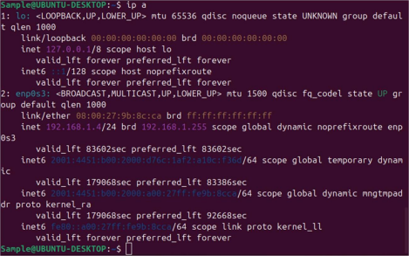From the desktop, connect to the server: ssh username@192.168.1.120
2. Connect from Desktop
From your host desktop:
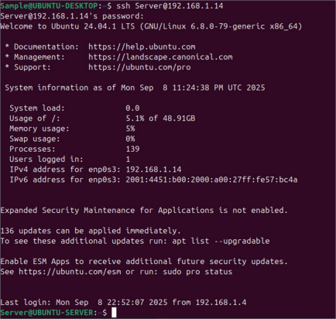
Submission Requirements
1. Screenshots (labeled clearly):
• VM network settings showing Bridged Adapter
• Server IP address (output of ip a or hostname -I)
• SSH service status (sudo systemctl status ssh)
• Successful SSH connection from host
• Verification commands executed inside VM
2. Submission Format:
• Single PDF file
• Include name, student ID, and date
• All screenshots with brief explanation
• Upload to your portfolio website.
UBUNTU SERVER SSH REMOTE ACCESS LAB
Name: Aranas, Carl Jerald E.
Student ID: 2025301449
Course/Year/Section: BSIT3B
Date Submitted: 02/09/2026
Instructor: Johneros P. Puyo
1 OBJECTIVES (5 POINTS)
Check all that apply:
- Create and configure a Virtual Machine with Ubuntu Server
- Configure Bridged Network Adapter for network access
- Determine and verify the server's IP address
- Install OpenSSH Server and enable the service
- Establish successful SSH connection from host machine
- Execute verification commands to confirm remote access
2 HARDWARE & SOFTWARE REQUIREMENTS (5 POINTS)
Item | Specification
Host Operating System | Linux
Virtualization Software  (VirtualBox/VMware) | Oracle Virtual Box
Ubuntu Server Version | ubuntu-26.04-live-server-amd64
VM Name | cja-server
RAM Allocated | 8000MB
Storage Allocated | 100GB
Network Mode | NatNetwork
SSH Client Used | Secure shell client

3 VM CONFIGURATION
Setting | Value
VM Name | UBUNTU-SERVER
OS Type | Ubuntu (64-bit)
Memory | 8000 MB
Hard Disk | 100 GB
Network Adapter | NatNetwork

4. NETWORK CONFIGURATION
Commands Executed:
Server IP Address: 10.0.2.4
Network Interface: enp0s3
6. REMOTE CONNECTION
Connection Details:
Parameter | Value
Server IP | 10.0.2.4
Username | aranas
SSH Port | 22

Creating Vm server
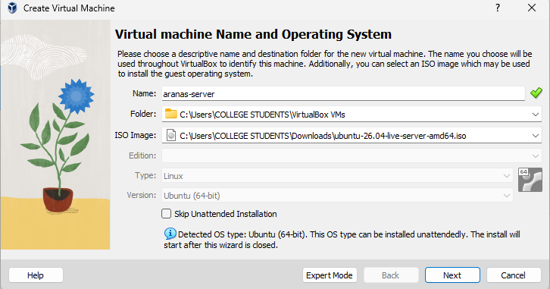
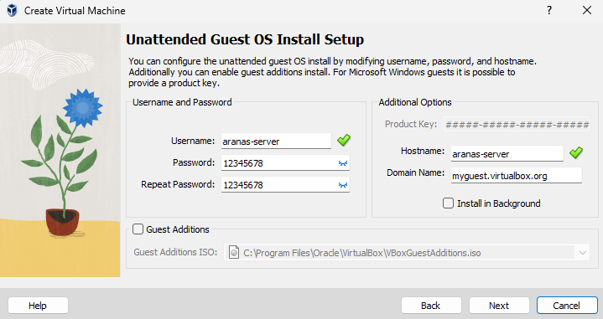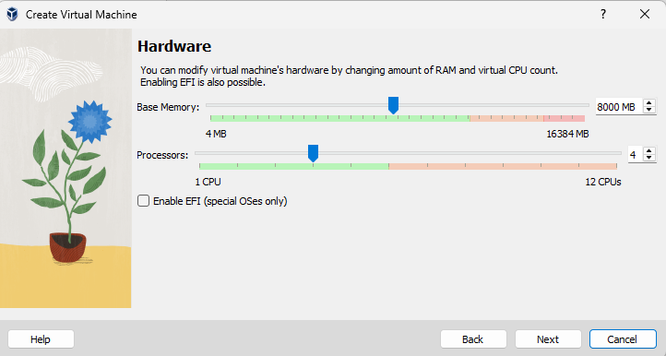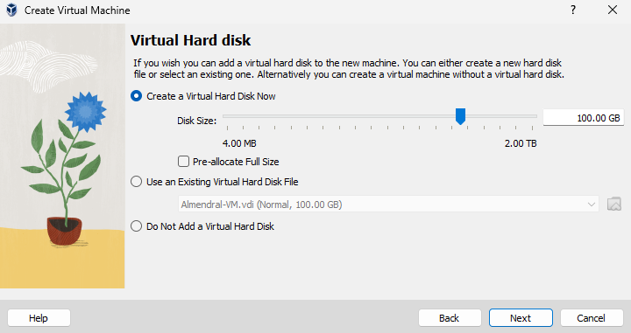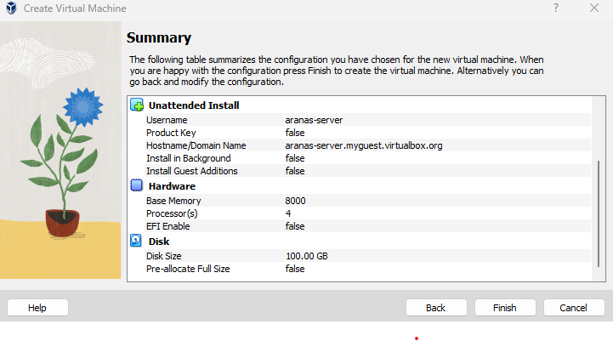
INSTALLATION PROCESS
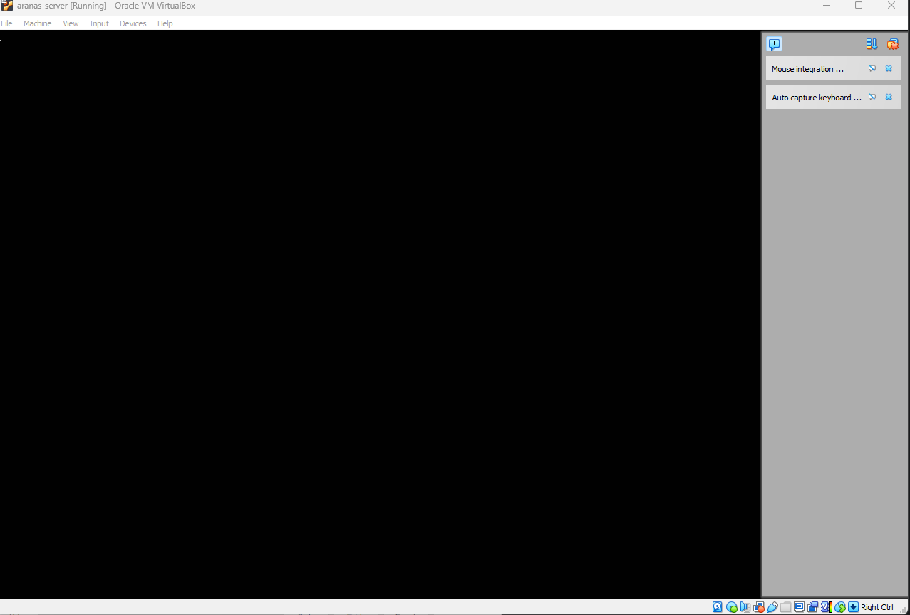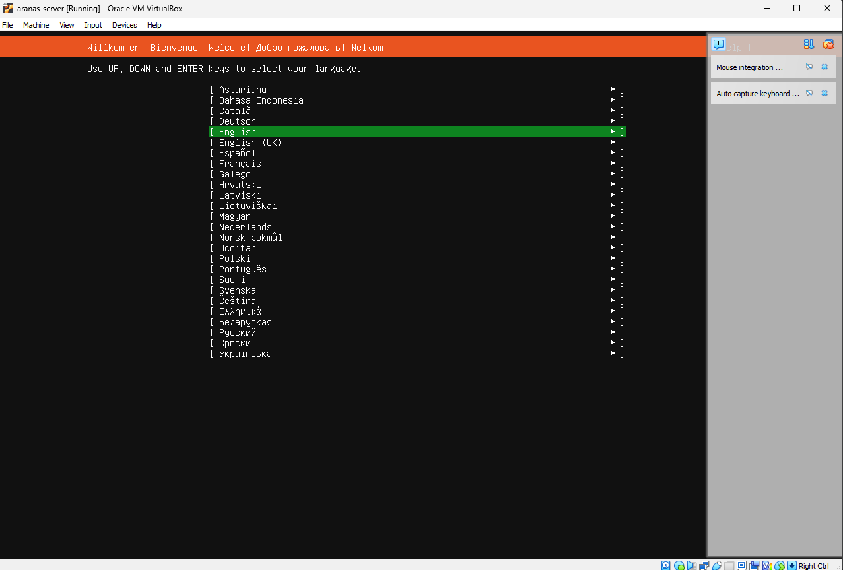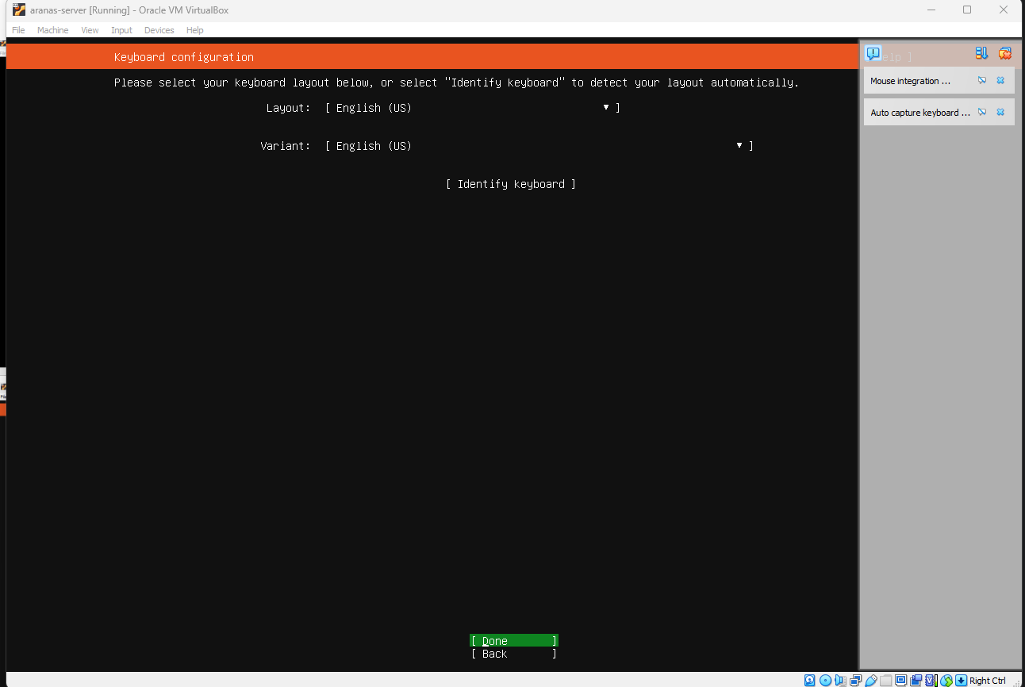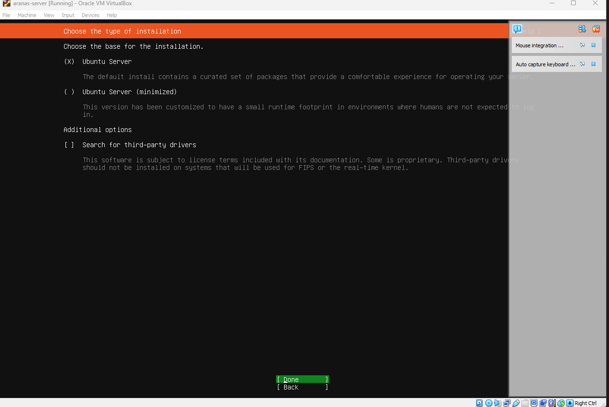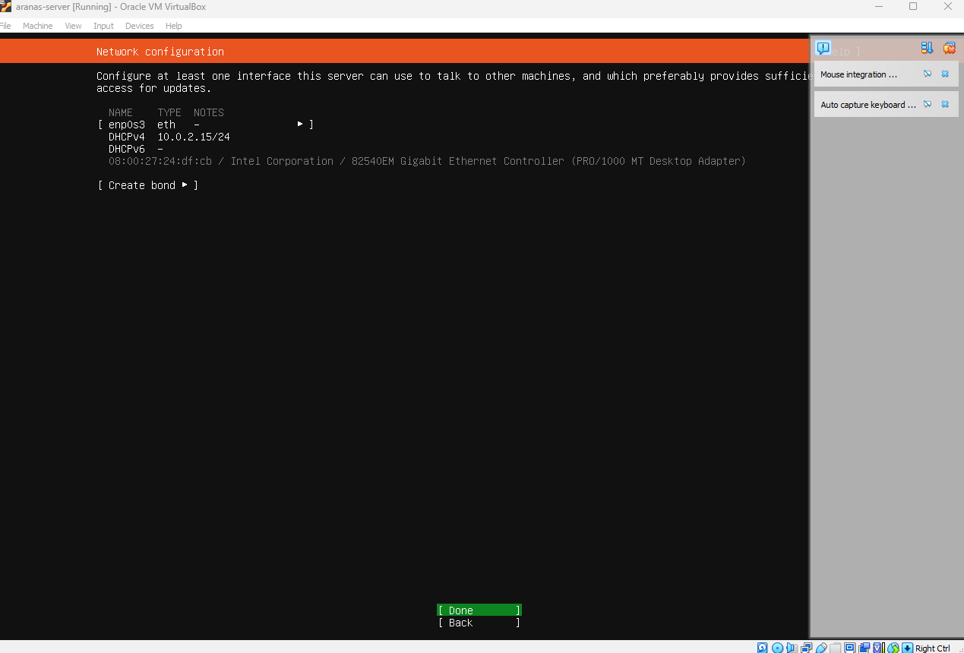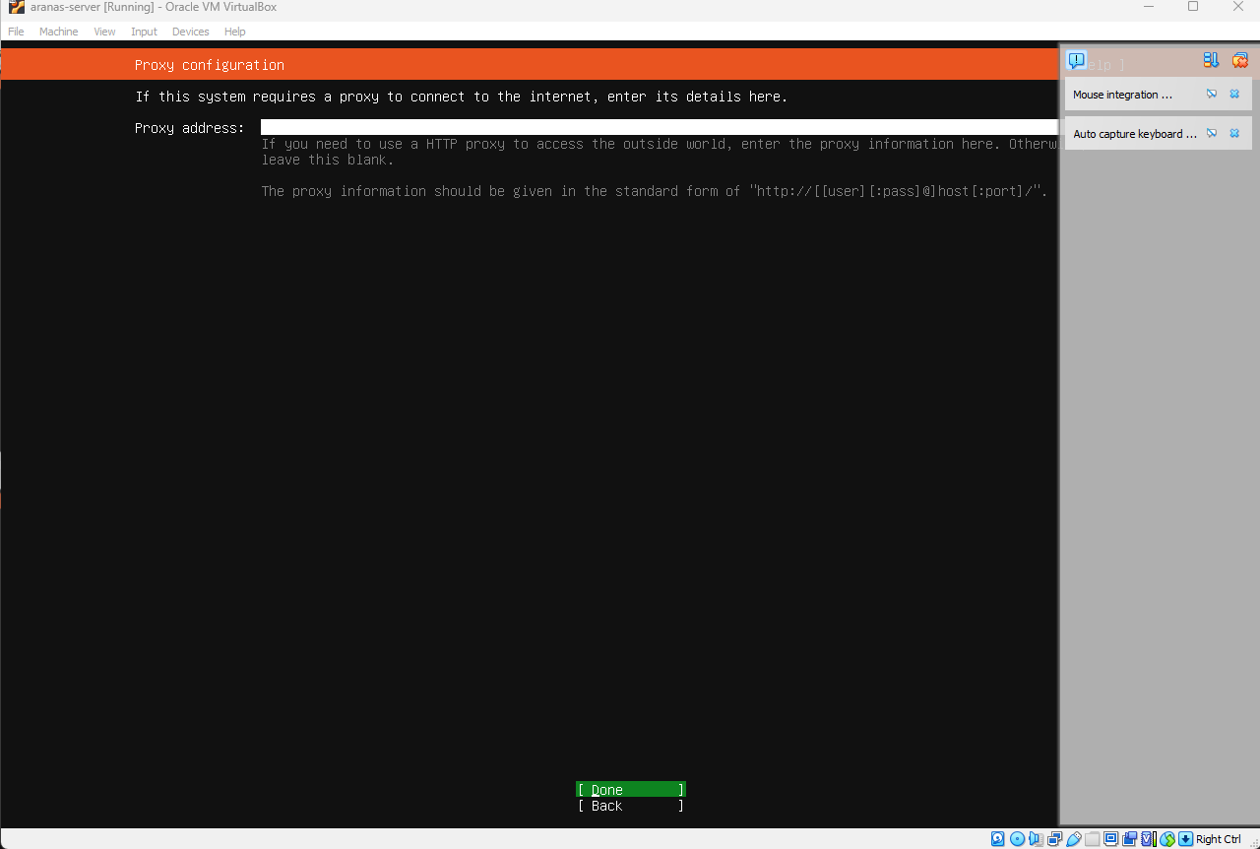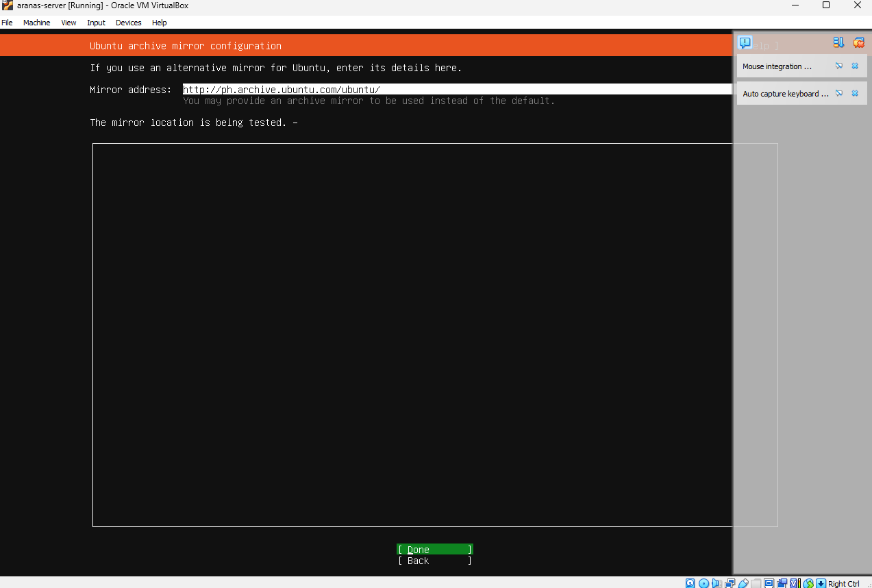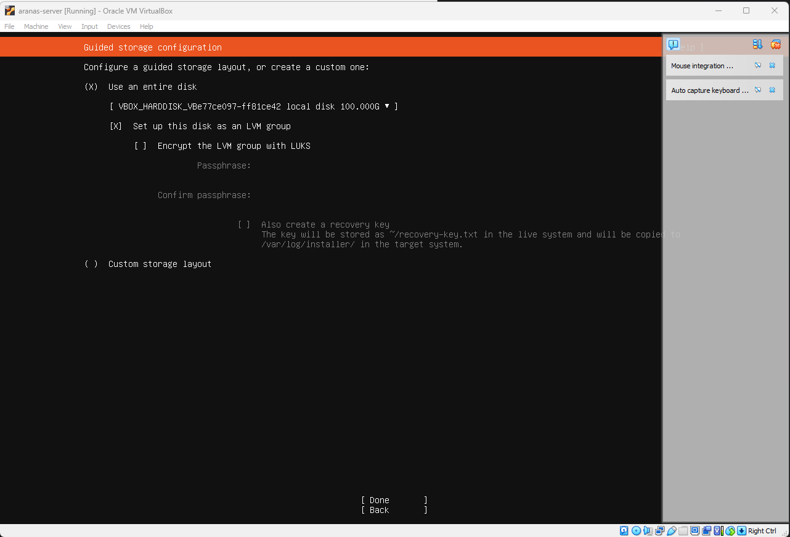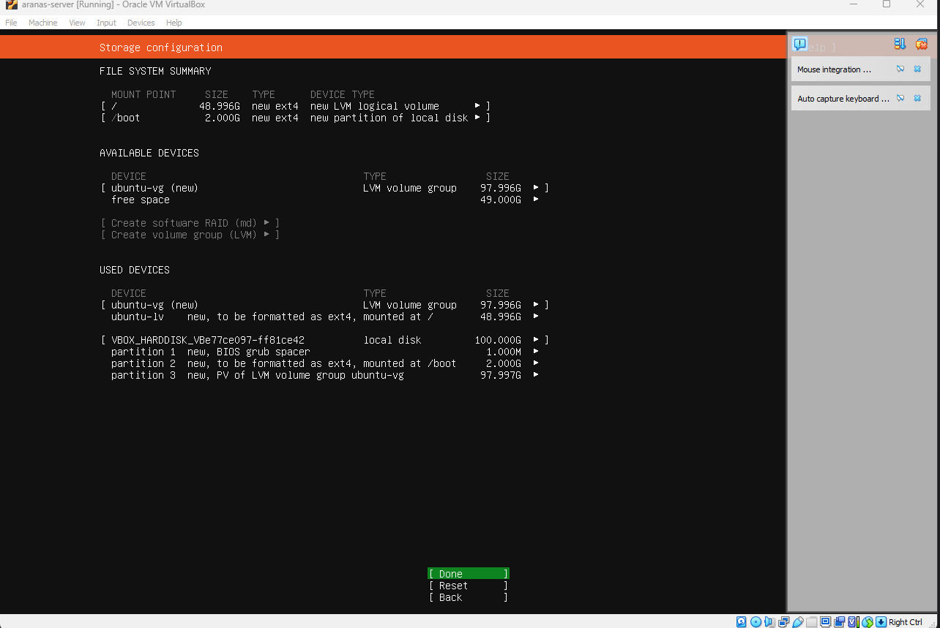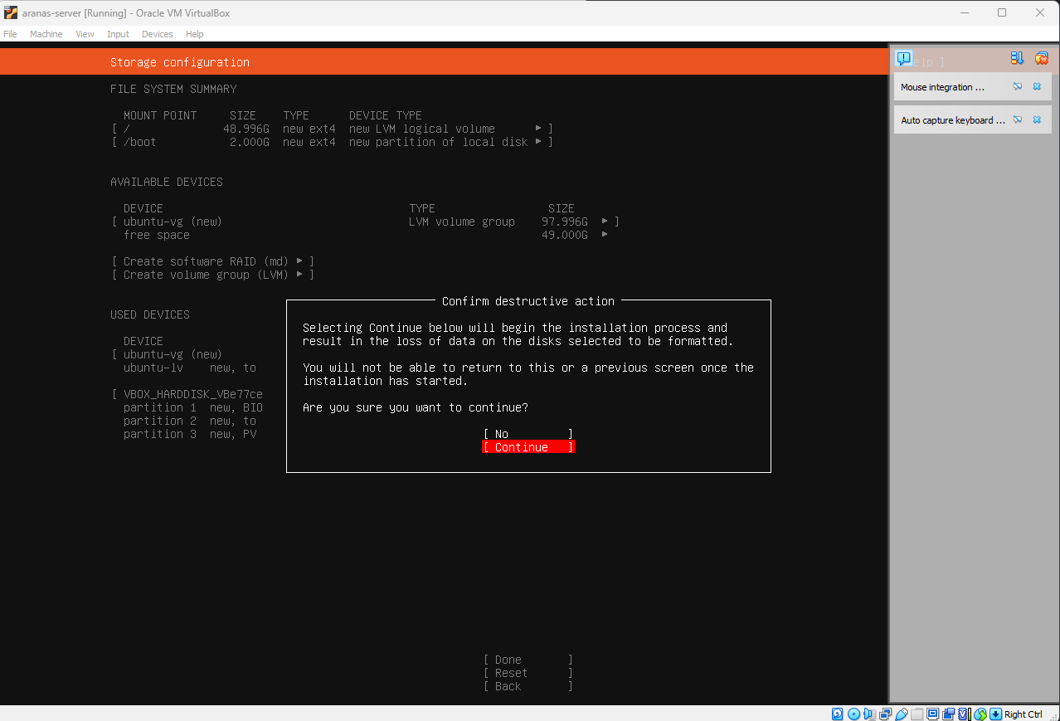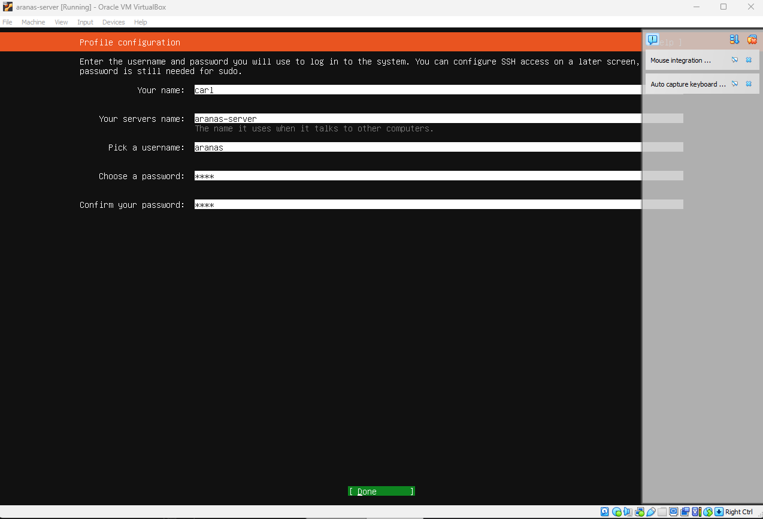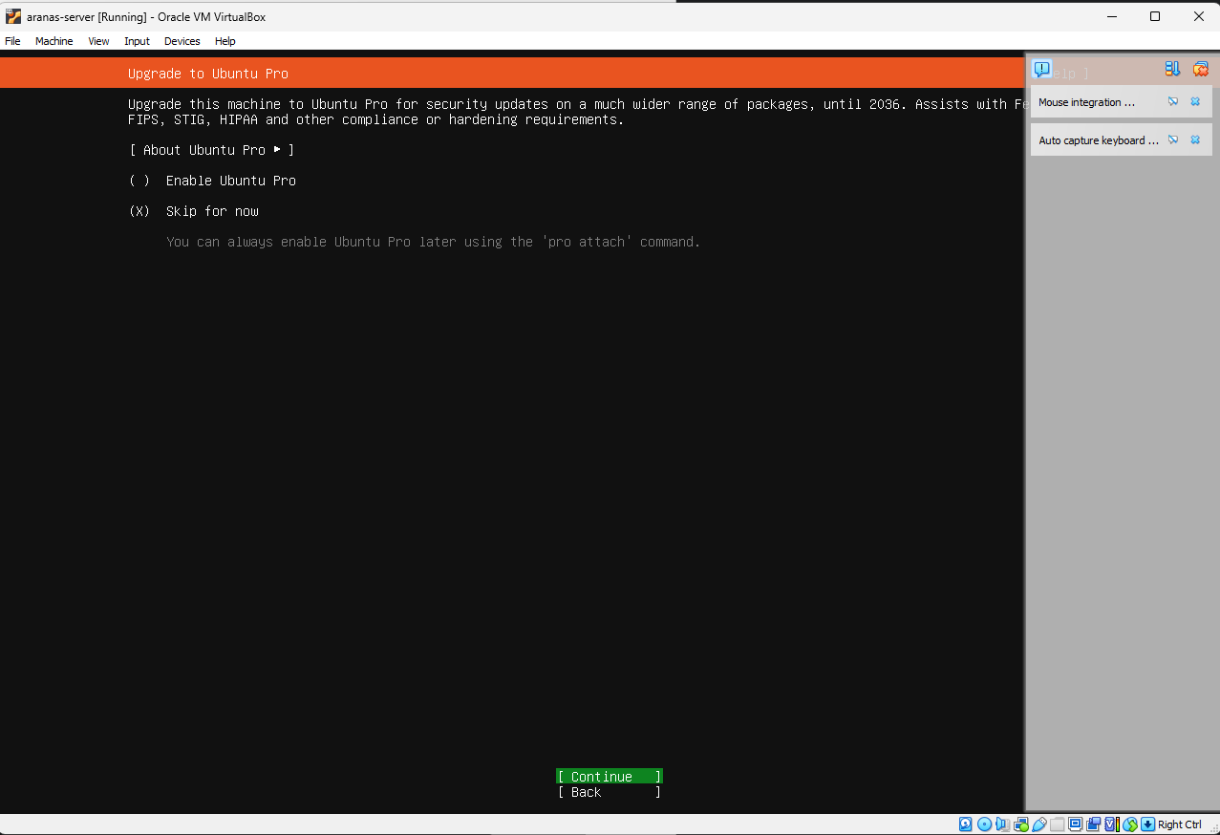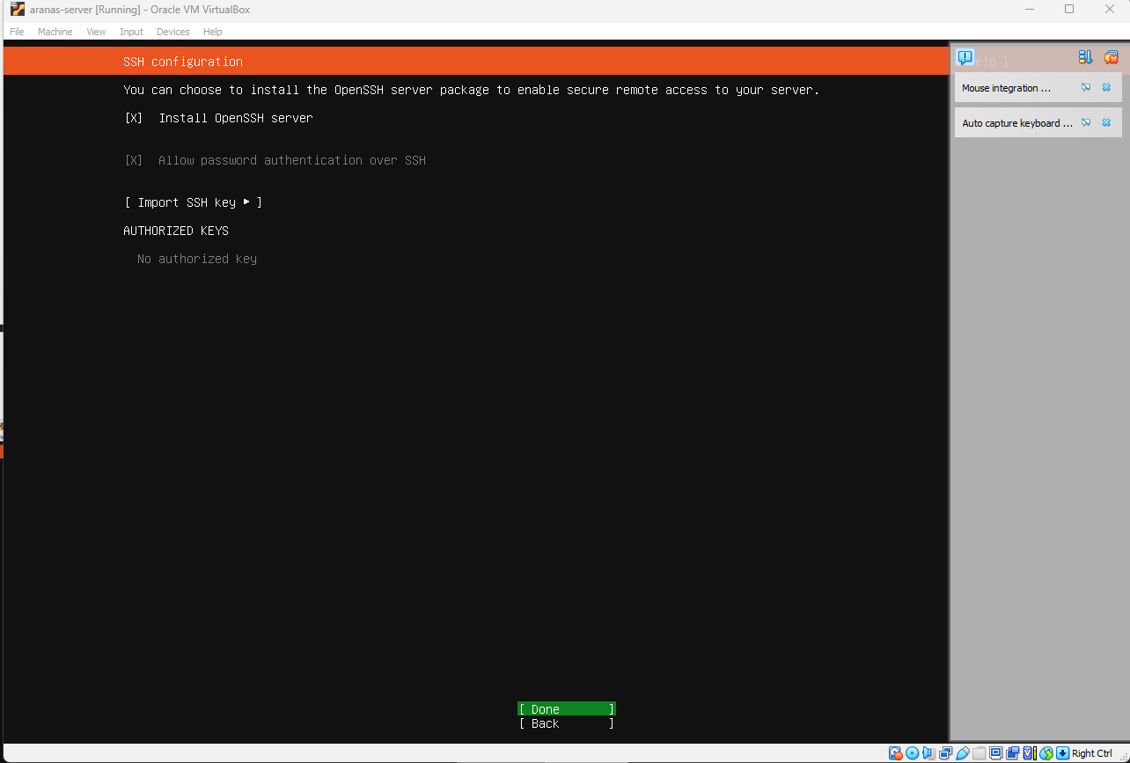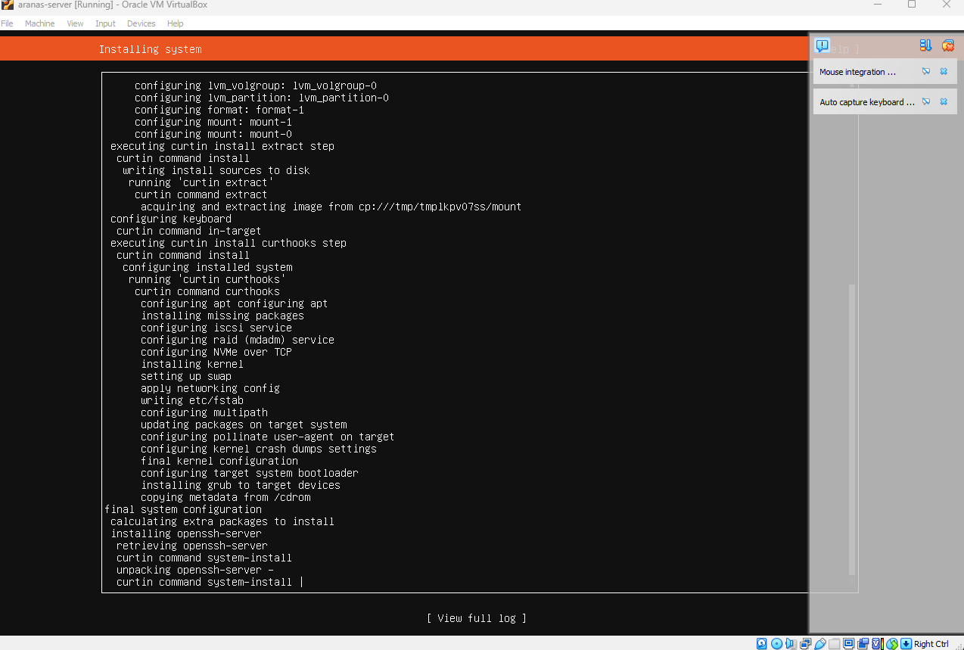
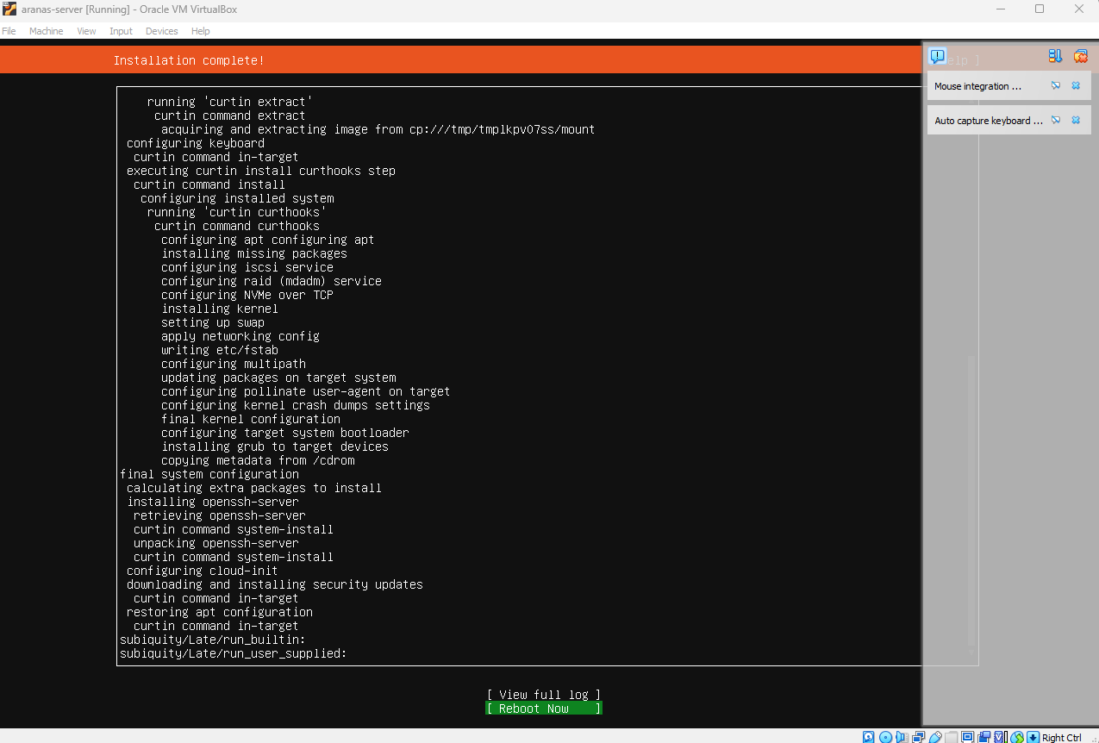

Connecting server to desktop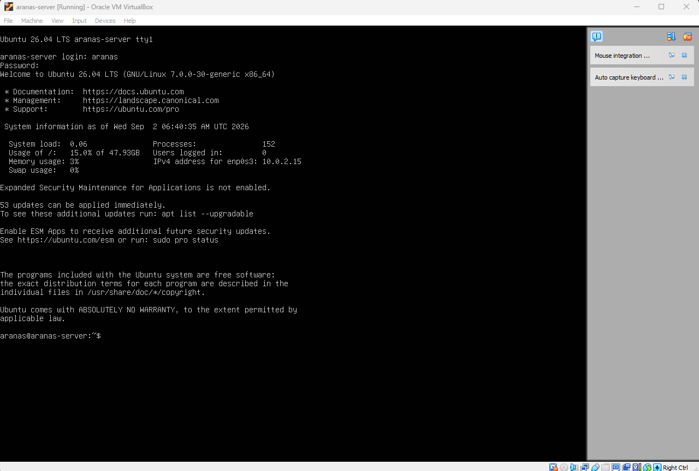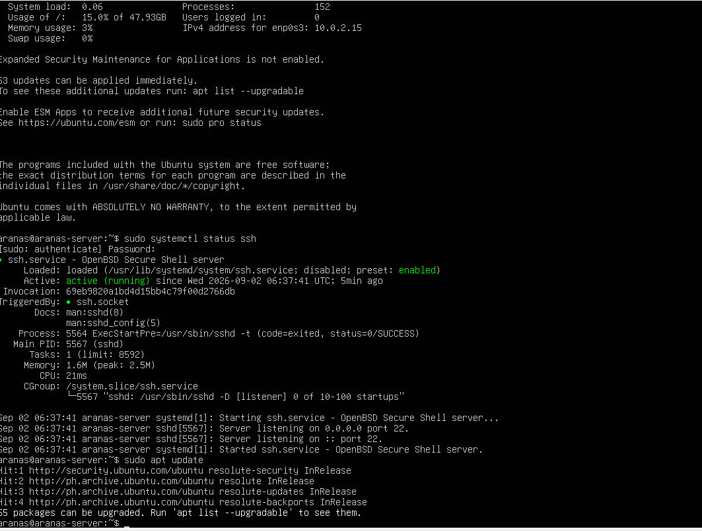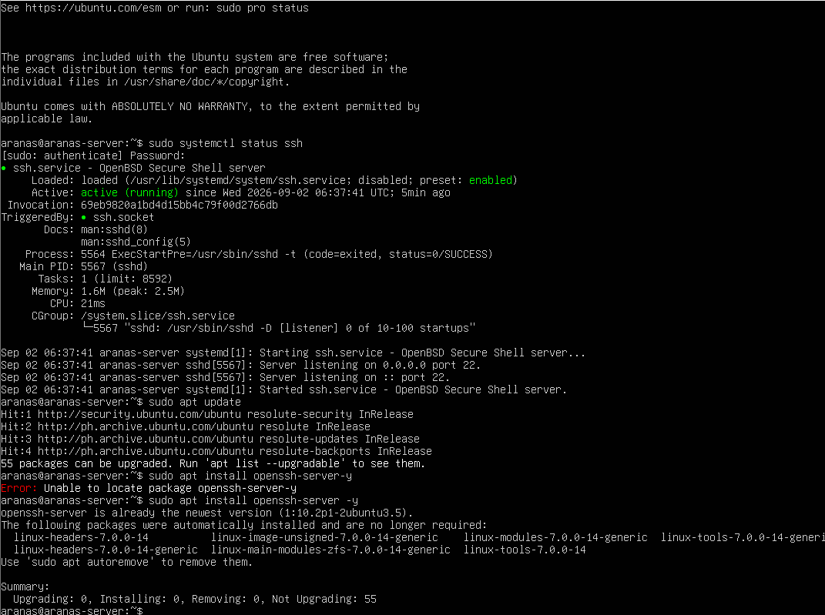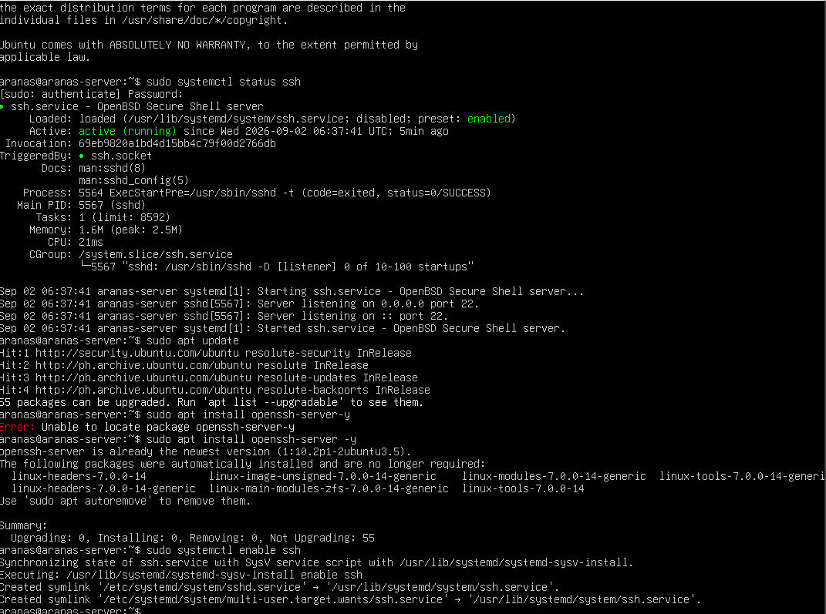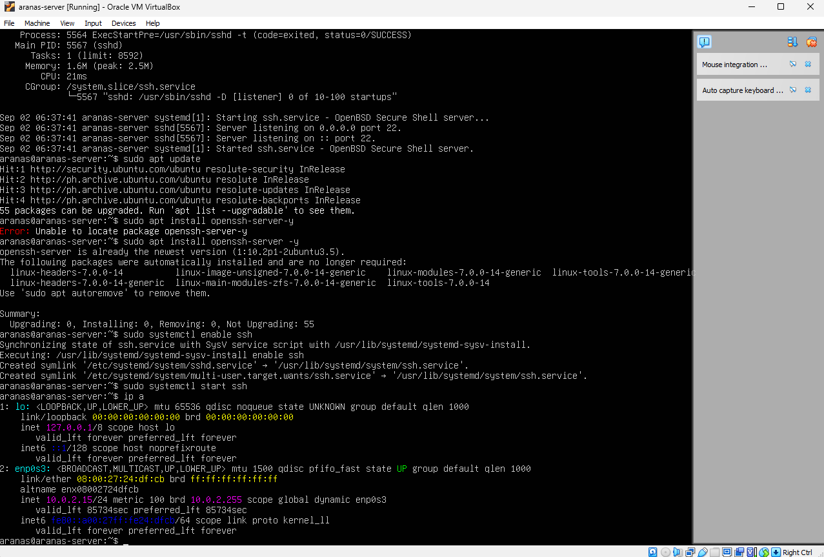

Desktop connected to server.