<Graphic Information System Mapping of the Active Cases of COVID-19 in the United States of America and Wyoming>

Software Engineering

ITSC-3155

Final Project Report

<5/5/20>

<Christopher Jeffcoat

David Stokes

Thomas Curry>

**Table of Contents**

**1. INTRODUCTION 1**

1.1 Purpose 1

1.2 Scope 1

1.3 Definitions, Acronyms, and Abbreviations 1

1.4 References 1

1.5 Overview 1

**2. GENERAL PROJECT DESCRIPTION 2**

2.1 project Perspective 2

2.2 project components 2

2.3 specific goals 2

2.4 overview of programs related to specific goals 2

2.5 Assumptions and Dependencies 2

**3. EFFORT 2**

2.1 EFFORT 2

**4. PROGRAMS DEVELOPED 2**

4.1 User Interfaces *3*

4.2 Comparison

4

**5. DISCUSSIONS AND CONCLUSION 4**

5.1 What can be concluded 5

5.2 5

5.4 5

**A. APPENDICES 5**

A.1 Appendix 1:Use Case 1 5

A.2 Appendix 2 Use Case 2 5

# **1. Introduction**

*The general concept of the project is to provide an easy to understand visualization of the spread*

*of COVID-19 in the United States of America. The massive scale of the pandemic further demonstrates the need for clear and concise mechanisms to convey the state of infection in the United States. There is a similar application on the CDC’s site but it is only updated once daily, thus developing this application would allow for the visualization to be updated as soon as new data is available. Our application also presents the user with projection maps of the possible spread for the next day.*

## **1.1 Purpose**

*The purpose of our project is to better educate the public on the spread of Covid-19. We believe that the public deserves access to a source of information that is easy to use, read, and understand.*

## **1.2 Scope**

*This subsection should:*

*(1) Identify the software product(s) to be produced by name; for example, Host DBMS, Report Generator, etc*

*(2) Explain what the software product(s) will, and, if necessary, will not do*

*(3) Describe the application of the software being specified. As a portion of this, it should:*

*(a) Describe all relevant benefits, objectives, and goals as precisely as possible. For example, to say that one goal is to provide effective reporting capabilities is not as good as saying parameter-driven, user-definable reports with a 2 h turnaround and on-line entry of user parameters.*

*(b) Be consistent with similar statements in higher-level specifications (for example, the System Requirement Specification) , if they exist.What is the scope of this software product.*

*This application is being written in python and makes use of many python based libraries. The application will pull state by state statistics from web based APIs and integrate this data into an easy to read format. The data is shown to the user in the form of a map and allows them to switch what data type is shown. The application also creates an infection projection for the next day, next 14 days, and next 30 days.*

## **1.3 Definitions, Acronyms, and Abbreviations**

*: Graphic Information System Mapping of the Active Cases of COVID-19 in the United States of America and Wyoming*

## **1.**4 **Overview**

*This subsection should:*

*(1) Describe what the program(s) contain and do*

*(2) Explain what is being studied..*

*Our project is a self contained web application that is designed to provide an end user with easy to read data regarding Covid-19. It is programmed in python and makes use of multiple libraries. These libraries are: plotly, pandas, json and Dash. We also use the requests API. Our program also gives projected values for certain statistics associated with COVID-19 (1 day, 14 days, and 30 days in the future).*

# **2. General Description**

*Our project (The GISMACCOVID-XIXUSAW) is a web based dashboard designed with ease of use and readability in mind. Our dashboard takes in raw data and presents it in a way that anyone can read. We present this data in multiple forms such as, infections per state, deaths per state, new infections per state, new deaths per state, tests per state, and tests per one million people. Our project also produces multiple projections. These projects are done per state and are as follows, infected in 1 day, infected in 14 days and infected in 30 days. These projections are done on a per state basis and are presented on seperate maps.*

## **….**

# **3. Effort**

|  |  |  |  |  |
| --- | --- | --- | --- | --- |
| Task | Estimated Time of Research | Actual Time of Research | Estimated Coding Effort | Actual Coding Effort |
| Get JSON | 30 Min | 30 Minutes | Minimal | Minimal |
| Parse JSON | 3 Hours | 3 Hours | Medium | Medium |
| Map Data | 1 Hours | 3 Hours | Medium | Large |
| Assign Gradients | 30 Minutes | 5 Minutes | Minimal | Minimal |
| Label Map with Data | 1 Hours | 1 Hour 30 Minutes | Minimum | Medium |
| Create Projection | 2 Hours | 10 hours | Medium | All of it. |
| Present Data | 1 Hour | 5 Hours | Minimal | Large |

# **4. Programs Developed**

***4.1 User Interfaces:***

*Add screen shots of user interfaces from your project*

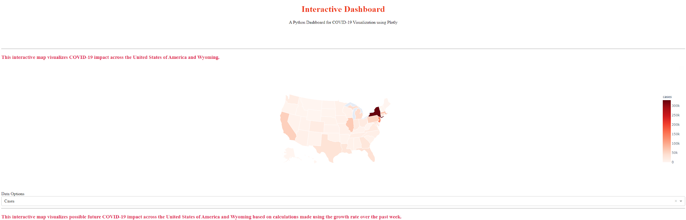

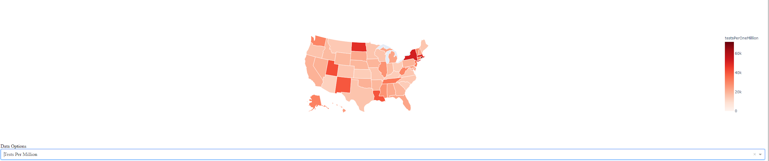

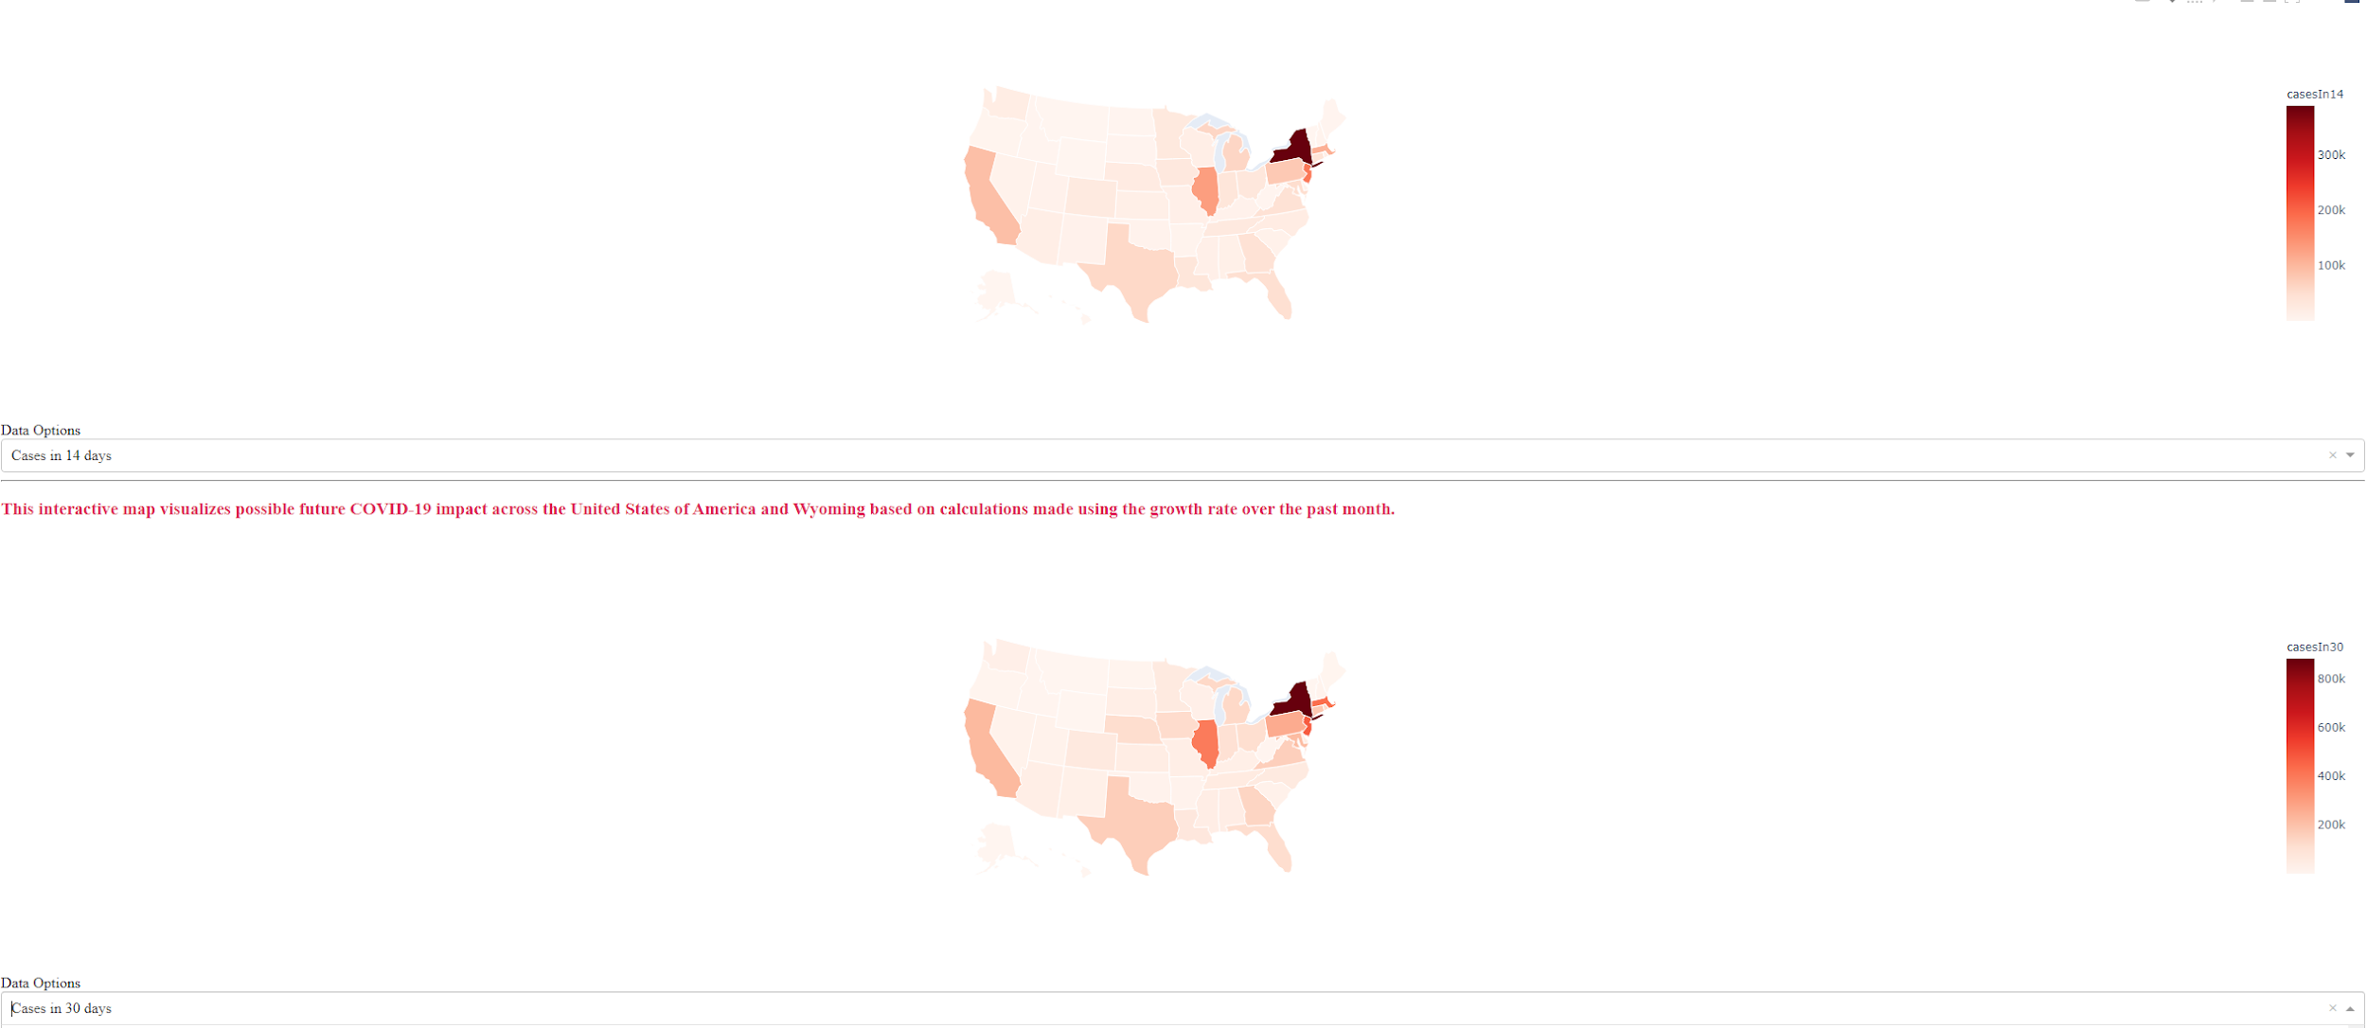

***4.2 Comparison:***

*Do a before and after comparison of the existing application and the enhanced version (include screenshots of before and after the changes)*

*Include screen shots differences between the existing code and the changes you made. (You can use any difference tool from online for showing the differences)*

# 1.**5. Discussions and Conclusions**

*Include description about the challenges and the road blocks you faced while working in the project. Also, your learning experience working in your project.*

Our main issue came from working with the plotly library and having to format our data in a way readably by plotly. Other than that the main roadblock faced by the project was the implementation of the per state infected projection. During our programs calculation the data has to be converted to multiple different formats and this leads to a minor roadblock. Other than these issues the only problem we faced was burnout.