Our “Preparing data” explanations have been added as comments in each respective Python file. These can be found in the group repository at <https://github.com/cjeffcoatjr/ITSC-3155-Group9/tree/master/python-dash/Plots>. Our reflection is at the bottom of this document.

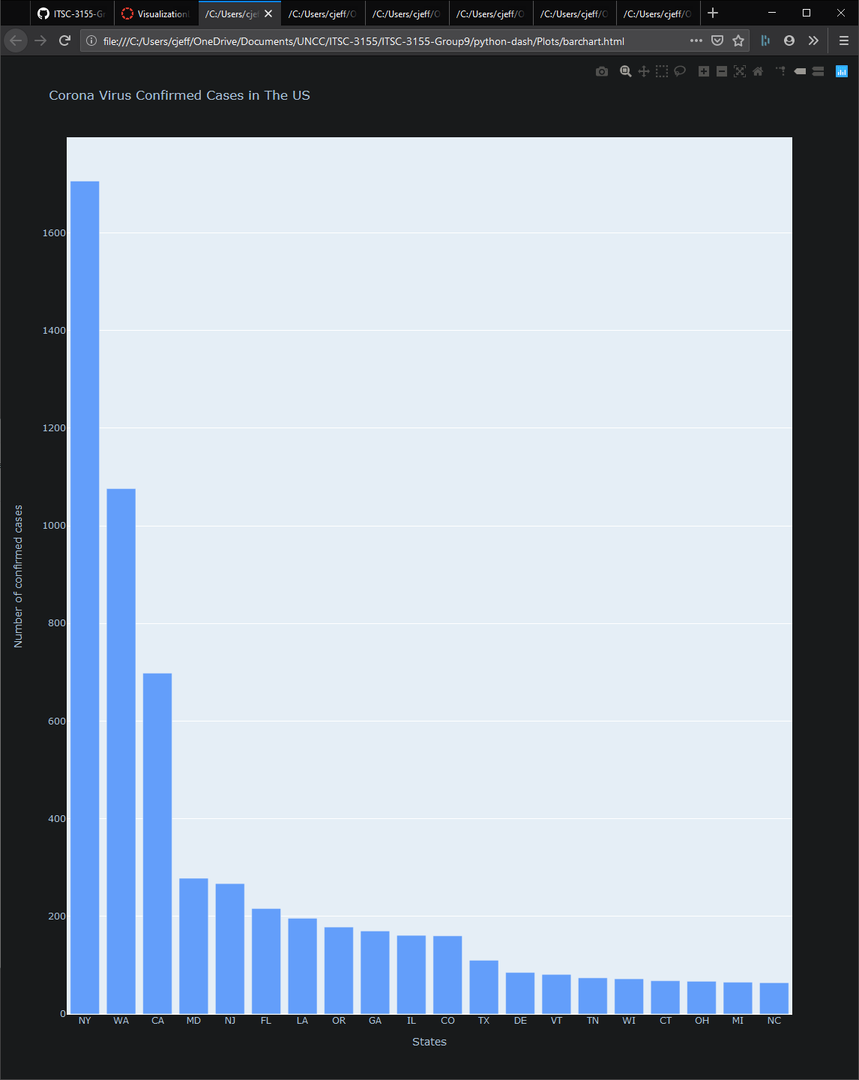

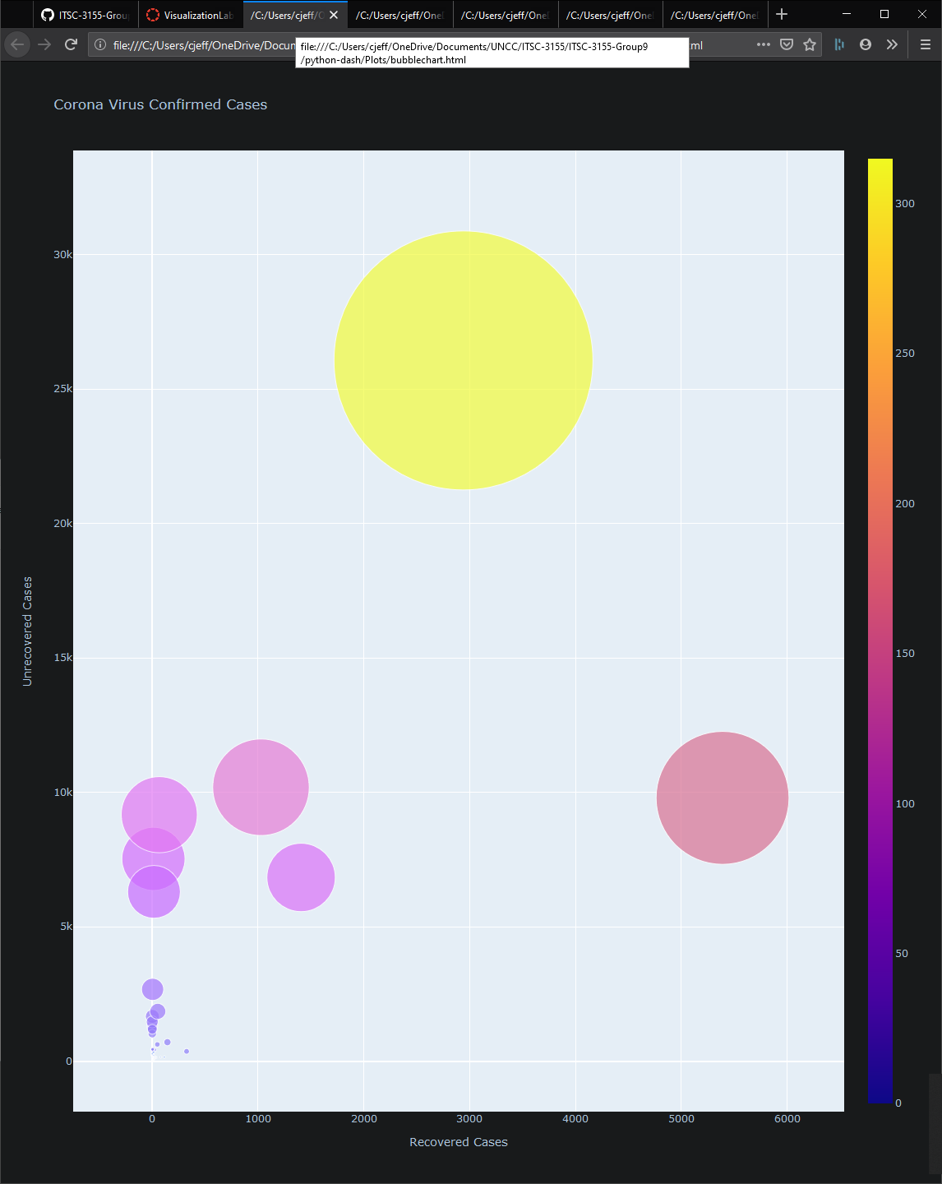

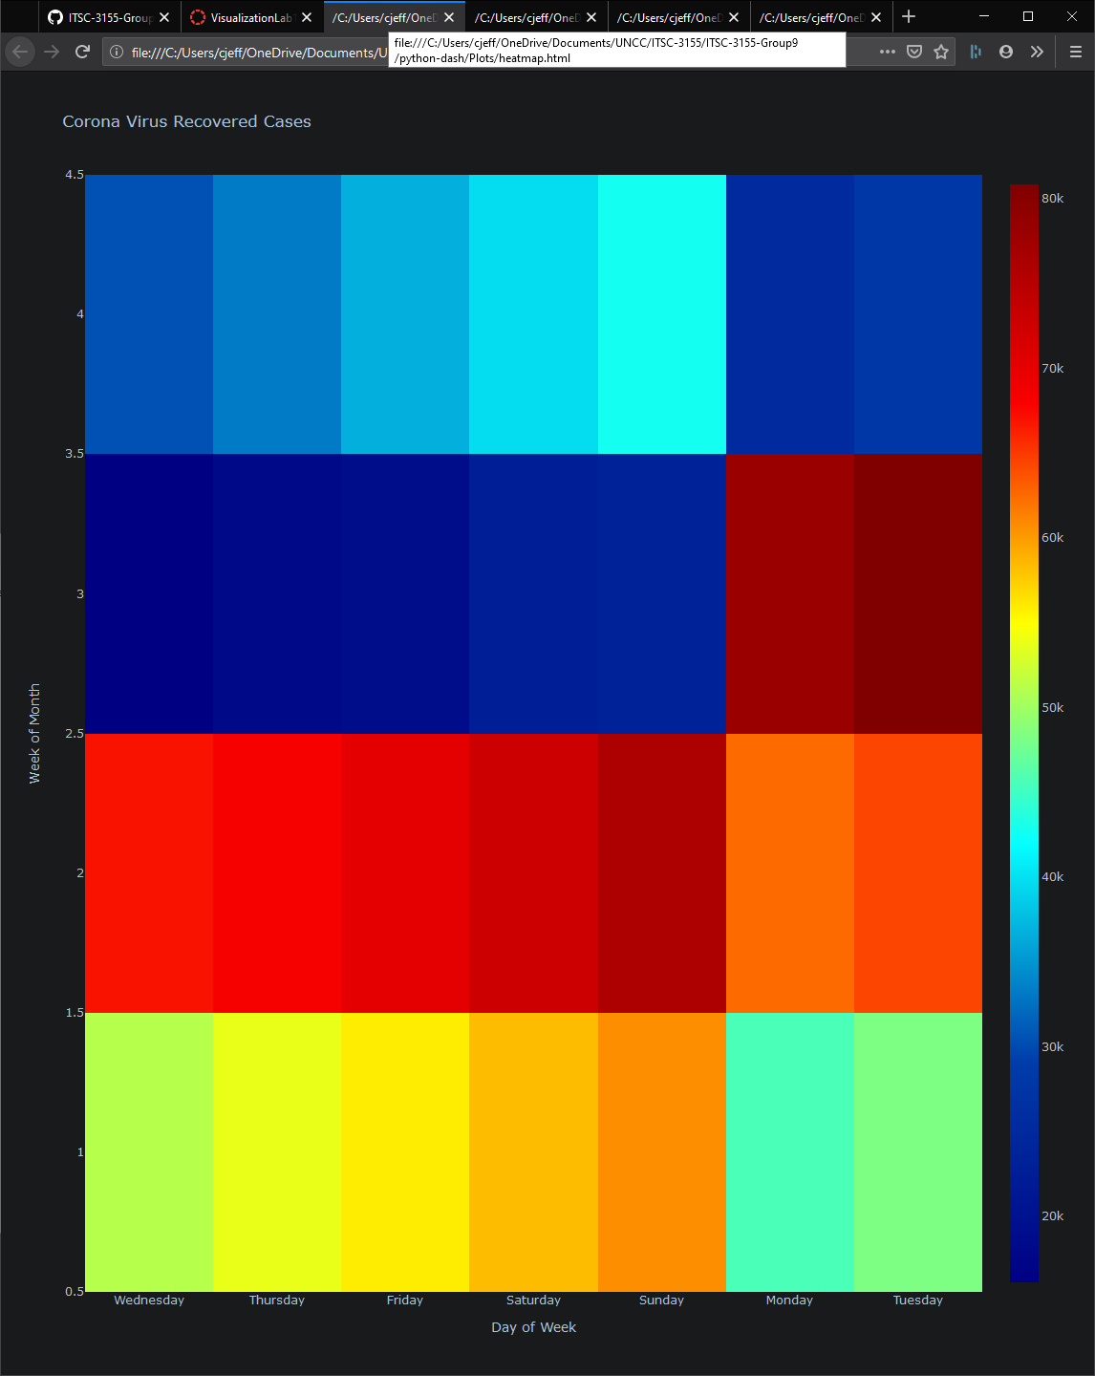

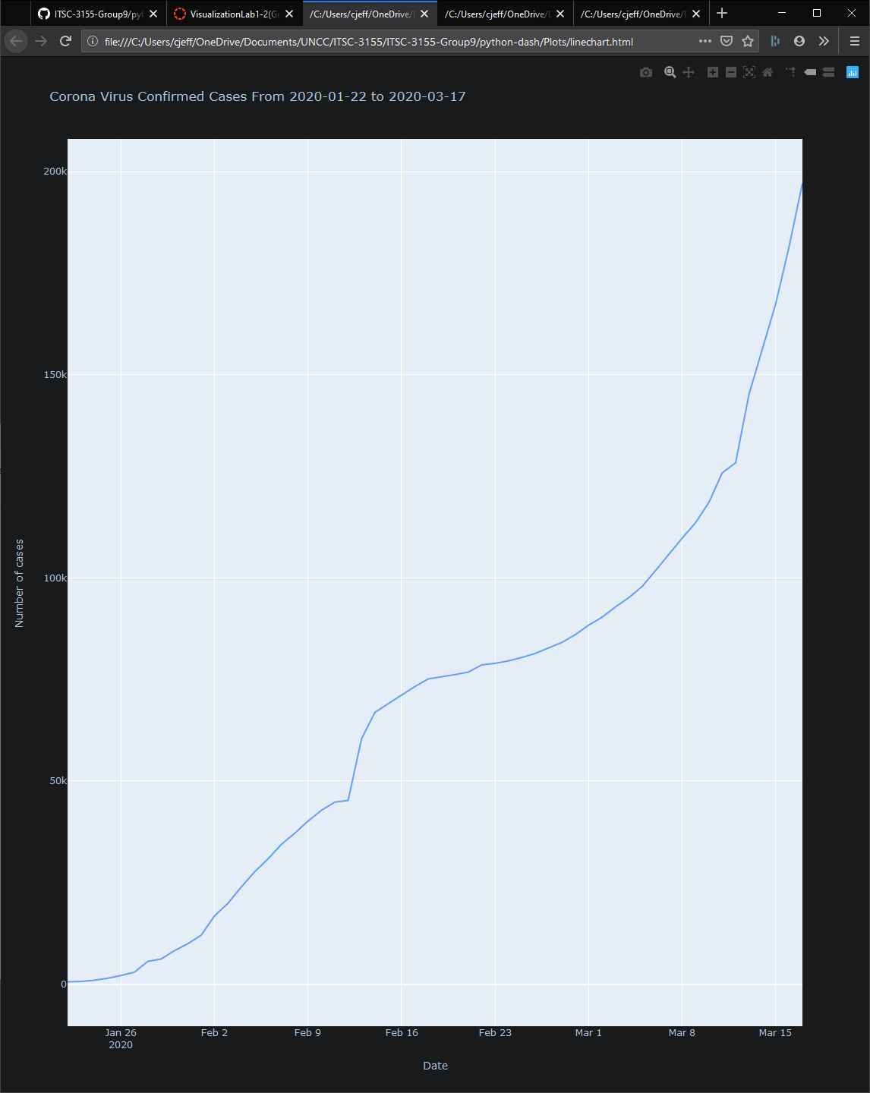

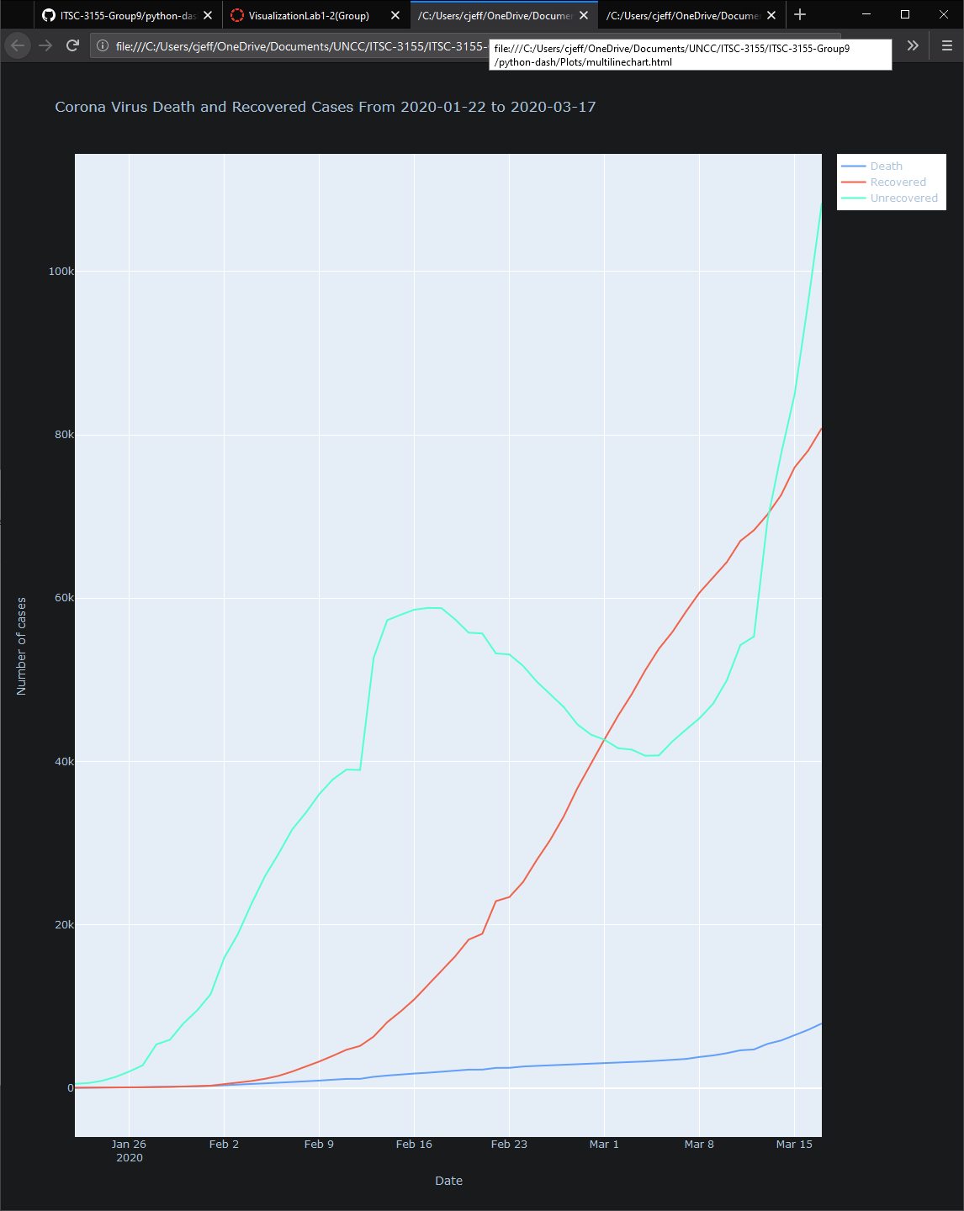

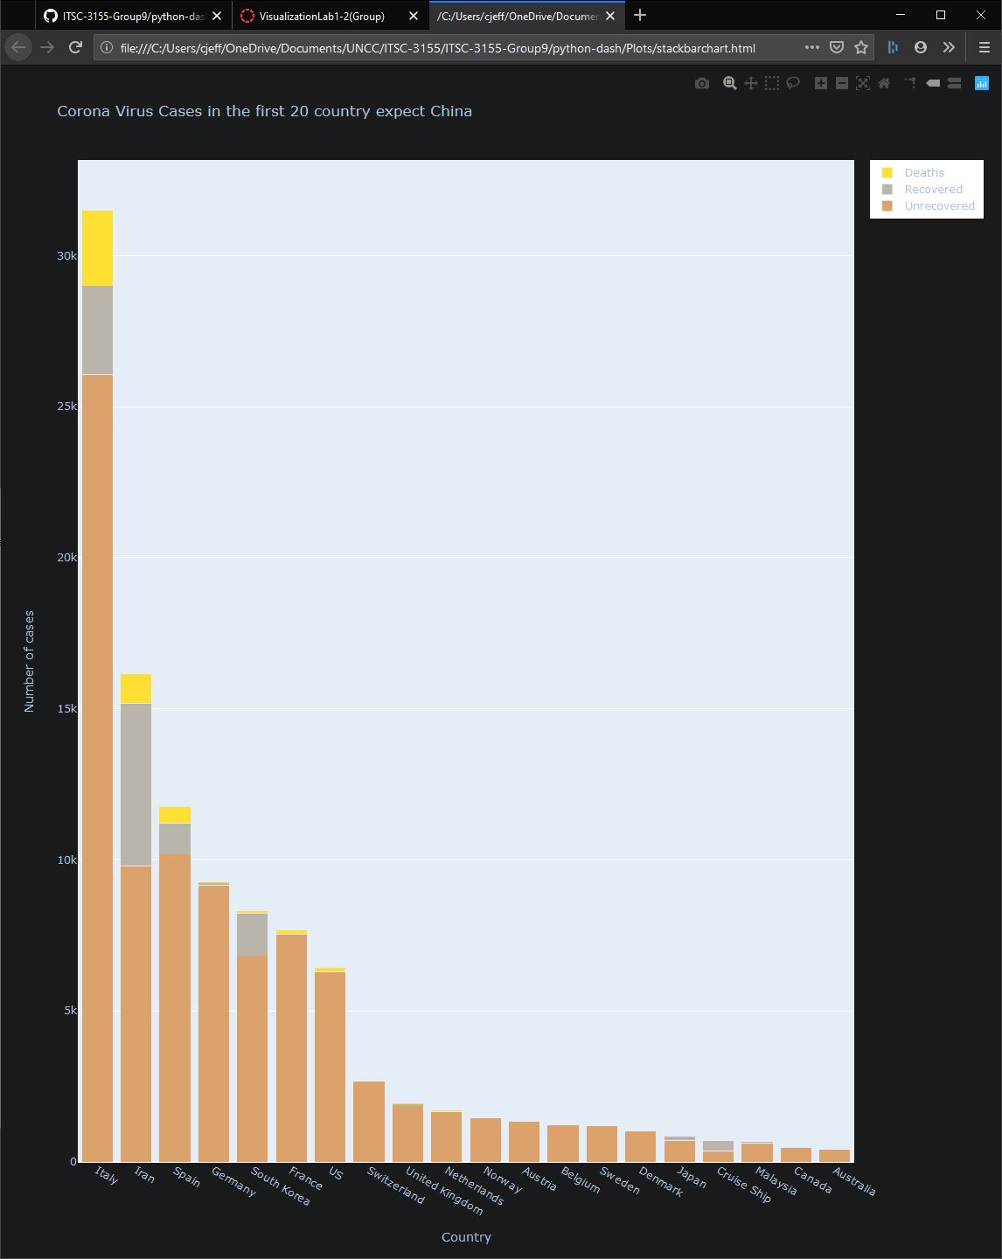

Plotly is very straightforward and works well as a tool for data visualization. The fact that it can parse the data into interactive .html files is very helpful. Specifically, the .html format is a relative and universal format. You can add these results into webpages, for example.