

**Technical Report of DC Motor Design**

**The University of Texas at Tyler**

**Department of Electrical Engineering**

**Assigned: April 24, 2017**

**Due: May 5, 2017**

**Christopher Emery**

**Francis Malalou**

**Diana Ortega**

**Oscar Suram**

**Introduction:**

Project 3 involves the application of a DC motor to turn a 5kg wheel with a radius of 30cm at a velocity of 200 RPM. With the project we will calculate torque requirements and find an appropriate supplier and do a cost analysis of our chosen DC motor. For simulation we will be using Simulink. To test our DC motor we are required to run it at 100 RPM for 1 minute followed immediately by 150 RPM for 1 minute before turning it off.

**Technical Discussion:**

A DC motor is an electric motor that runs on direct current power. In any electric motor, operation is dependent upon simple electromagnetism. A current carrying conductor generates a magnetic field, when is placed in an external magnetic field, it will encounter a force proportional to the current in the conductor and to the strength of the external magnetic field. DC motor is a device which converts electrical energy to mechanical energy. It works on the fact that a current carrying conductor placed in a magnetic field experiences a force which causes it to rotate with respect to its original position

During DC motor design we will have knowledge of velocity, voltage, rotation, speed, torque and time. The idea is that when we model the DC motor and connect it with a battery, the motor load start to spin up. Here we are interested in the virtual simulation, and how it works. Power is the rate of doing work in time. More specific for the DC motor, work can be defined angular velocity, and for that the power is the rotational distance per unit time multiplied by the torque. We did detail calculations to determine the mechanical of the DC motor, also evaluate the torque, and how to determine of the steady state temperature increase of the DC motor. The back EMF generates by the DC motor is directly proportional to the angular velocity. The back EMF is the proportionality constant of the motor. Table 1 holds the values we found.

**V0 = (I x R) + Ve**

**Vo** = Power supply (Volts)  
**I** = Current (A)  
**R** = Terminal Resistance (Ohms)  
**VB** = Back EMF (Volts)

**V**B**= ω x KB**

**ω**= angular velocity of the motor  
**kB** = back EMF constant of the motor

**kT=**torque constant   
  
Therefore, by substitution:

**Vo = (I x R) + (ω x KB)**

**Calculations:**

A DC design relies on accurate calculations the following formulas were used to help with the motor design in Simulink. Figure 1shows a derivation of the two main equations needed for the simulink design.

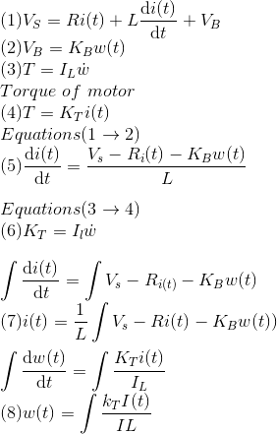

Figure 1 several of the calculations needed

Two differential equations were calculated for implementation in the DC motor. One differential equation (7) represents the electrical component of the system while the other differential equation (8) represents the mechanical component (see figure 1). Once these equations were calculated, they were directly implemented into Simulink using gain blocks and negative feedback control see figure 2.

**Results:**

To implement the timing aspect of the design transport delay blocks were used in Simulink, allowing for precise control of the motor. Next, research was conducted in order to find a DC motor that was capable of producing the required performance for the given load provided by the specifications of the assignment.

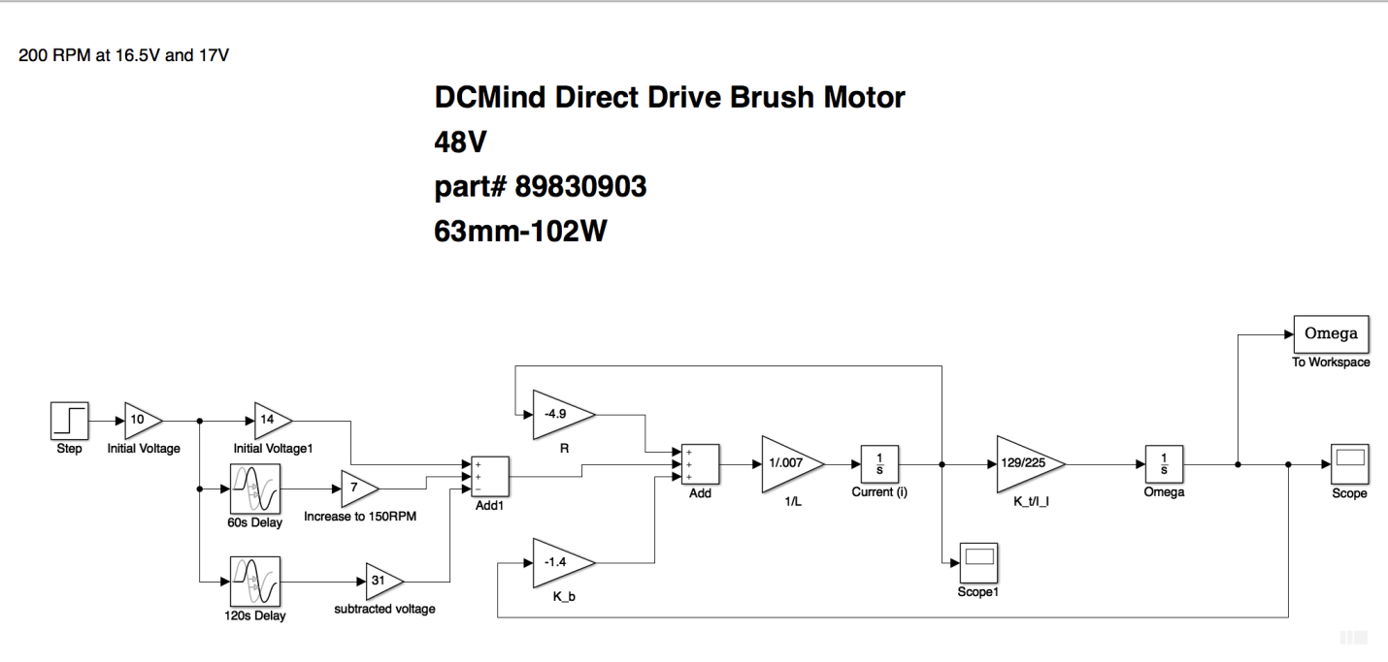

Figure Schematic for Simulink design implementing load and dc motor specifications

Once the DC motor was obtained, we gathered the necessary values to implement to the Simulink see table 1:

Table

|  |  |  |  |  |  |
| --- | --- | --- | --- | --- | --- |
| Back EMF constant Kb | Torque Constant Kt | Resistance R | Inductance L | Voltage | Total Inertia |
| 1.4 ms | 129 mNm/A | 4.9 Ω | 7 mH | 48V | .005kgm^2 |

While testing out the values above for different DC motors, it was realized that the higher Torque constant and back EMF constants produced better results for the motor. Once the values above were obtained, they were implemented in the DC motor design and produced the below results:

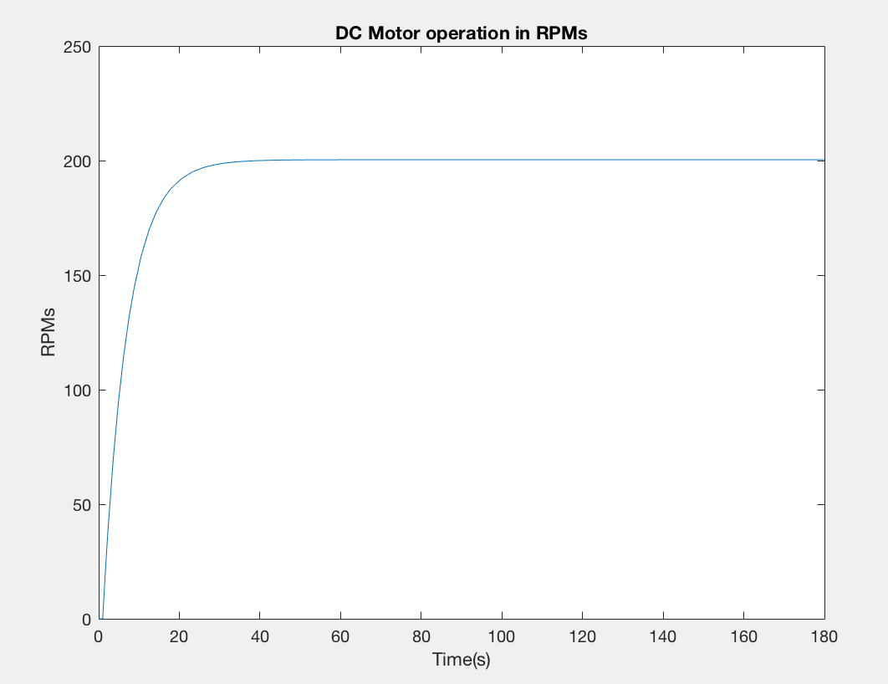

Figure Figure 3 The graph above shows that our motor is capable of running at 200RPMS

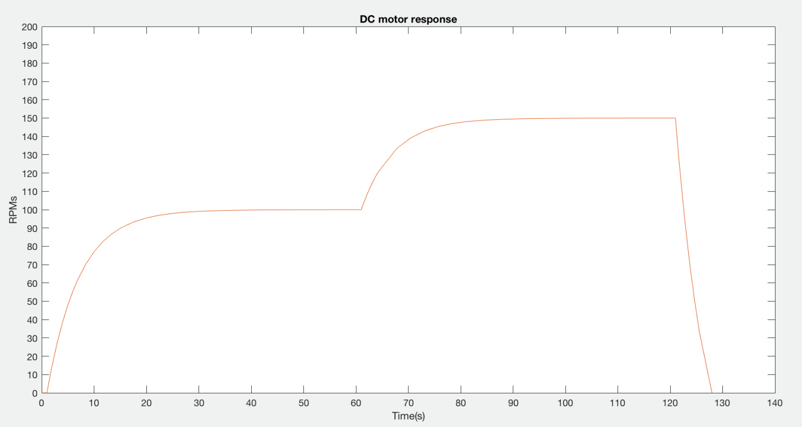

Figure The DC motor response that ran from 100 RPMs for 60 seconds then we increased it to 150 for the remainder 60 seconds. Using the transport block delay blocks we were able to control the motor.

As seen from the above graphs it is clear that the DC motor operates per the required specs. The motor runs at 100 RPMs for one minute increasing to 150 RPMs for another minute before shutting off. Specific data points over time can be seen in the table 2 in the appendix

**Discussion**

The motor we selected from the three is the DC Mind Direct Brush Motor, part #89830903. It met the specs when using Simulink, ran the maximum velocity of 200 rpm and turned the 5kg wheel with a radius of 30cm. The figure above shows how the motor performed when we ran it at 100 rpm for a minute and then increased it to 150 rpm before it was shut off this motor met the specs and was a success

**Appendix**

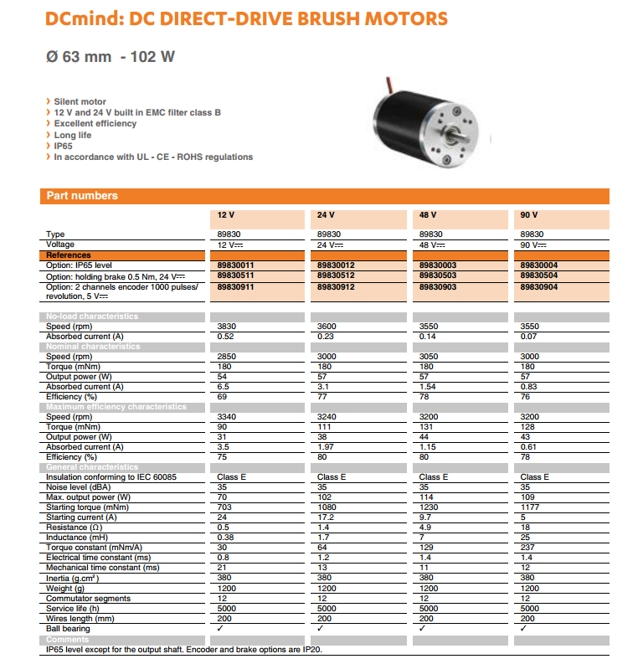

Figure data sheet for motor used. We focused on the 48V motor

Table Data points for Figure 5

|  |  |  |  |  |
| --- | --- | --- | --- | --- |
| **Time (0-60s)** | **ω (RPM)** |  | **Time (60s-120s)** | **ω (RPM)** |
| **1** | 0.9804 |  | 61 | 149.377 |
| **2** | 1.6007 |  | 62 | 149.651 |
| **3** | 2.2172 |  | 63 | 149.8081 |
| **4** | 2.8298 |  | 64 | 149.895 |
| **5** | 3.4385 |  | 65 | 149.9419 |
| **6** | 4.0435 |  | 66 | 149.9673 |
| **7** | 6.8079 |  | 67 | 149.9816 |
| **8** | 9.4928 |  | 68 | 149.9898 |
| **9** | 12.1003 |  | 69 | 149.9945 |
| **10** | 14.6326 |  | 70 | 149.997 |
| **11** | 27.1376 |  | 71 | 149.9971 |
| **12** | 37.8073 |  | 72 | 149.9971 |
| **13** | 46.9143 |  | 73 | 149.9971 |
| **14** | 54.6887 |  | 74 | 149.9972 |
| **15** | 61.3251 |  | 75 | 149.9972 |
| **16** | 70.4533 |  | 76 | 149.9972 |
| **17** | 77.422 |  | 77 | 149.9972 |
| **18** | 82.7498 |  | 78 | 149.9972 |
| **19** | 86.8235 |  | 79 | 149.9972 |
| **20** | 89.9361 |  | 80 | 149.9972 |
| **21** | 93.2111 |  | 81 | 149.9972 |
| **22** | 95.4156 |  | 82 | 149.9972 |
| **23** | 96.9078 |  | 83 | 149.9972 |
| **24** | 97.9177 |  | 84 | 149.9972 |
| **25** | 98.5988 |  | 85 | 149.9972 |
| **26** | 99.7482 |  | 86 | 149.9972 |
| **27** | 99.861 |  | 87 | 149.9972 |
| **28** | 99.9239 |  | 88 | 149.9972 |
| **29** | 99.958 |  | 89 | 149.9972 |
| **30** | 99.9764 |  | 90 | 149.9972 |
| **31** | 99.9867 |  | 91 | 149.9971 |
| **32** | 99.9926 |  | 92 | 149.9971 |
| **33** | 99.9935 |  | 93 | 149.9967 |
| **34** | 99.9936 |  | 94 | 149.9961 |
| **35** | 99.9938 |  | 95 | 149.9953 |
| **36** | 99.9939 |  | 96 | 149.9943 |
| **37** | 99.9941 |  | 97 | 149.9912 |
| **38** | 99.9941 |  | 98 | 149.9873 |
| **39** | 99.9942 |  | 99 | 149.9826 |
| **40** | 99.9942 |  | 100 | 149.9773 |
| **41** | 99.9942 |  | 101 | 149.9715 |
| **42** | 99.9942 |  | 102 | 149.9604 |
| **43** | 99.9942 |  | 103 | 149.9483 |
| **44** | 99.9942 |  | 104 | 149.9355 |
| **45** | 99.9942 |  | 105 | 149.922 |
| **46** | 99.9942 |  | 106 | 149.9082 |
| **47** | 99.9942 |  | 107 | 149.8871 |
| **48** | 99.9942 |  | 108 | 149.8656 |
| **49** | 99.9942 |  | 109 | 149.8438 |
| **50** | 99.9942 |  | 110 | 149.8218 |
| **51** | 99.9942 |  | 111 | 149.7997 |
| **52** | 99.9942 |  | 112 | 149.7635 |
| **53** | 99.9942 |  | 113 | 149.7272 |
| **54** | 99.9943 |  | 114 | 149.6909 |
| **55** | 99.9945 |  | 115 | 149.6545 |
| **56** | 99.9947 |  | 116 | 149.6181 |
| **57** | 99.9953 |  | 117 | 149.5324 |
| **58** | 99.9962 |  | 118 | 149.4468 |
| **59** | 99.9972 |  | 119 | 149.3611 |
| **60** | 99.9985 |  | 120 | 149.2755 |