Project/Product/Department |  | Date (file version)
Issue, date | Signature | Name and role
Review, date | Signature | Name and role
Approval, date | Signature | Name and role
Content Page

1 Overview 2
2 Setting up a linux slave node 2
3 Setting up a windows slave node 4
4 Deploying the Jenkins service on RedHat Enterprise Linux 6 5
5 Upgrading jenkins 6
6 Setting up secure access to jenkins 6
7 Backup and ClonE a Jenkins instance 6
8 Using variables in repository URL’s 7
9 Adding functionality 8
9.1 Adding a plugin to Jenkins 8
9.2 Adding unit test report 8
9.3 Adding coverage report 8
9.4 Adding Flexlint report 8
9.5 Adding GCC warnings report 9
9.6 Adding DoxyGen generation 9
9.7 Adding CCCC 9

Overview
A continuous build service is a vital part in detecting defects early in the development cycle. The service has the role of immediately giving feedback on build errors and unit test when code is commited to the version control system.
By also applying reports on metrics like, code coverage, warnings, cyclomatic complexity (http://en.wikipedia.org/wiki/Cyclomatic_complexity) code quality can be measured and trends can be derived by keeping records of previous builds.
Jenkins (formarly known as Hudson) is an open source service that manages tasks to be performed continuously. The service is highly plugable and supports integration with a huge number of tools and services.

Setting up a linux slave node
The Jenkins service can be associated with a number of slave nodes for distributed builds (not to be confused with distributed compilation) . A Jenkins distributed build is executed entirely on one host.
The purpose of distributed builds initiated by Jenkins is to distribute the build load but also to manage all builds from one web service instance, even though they must be executed on different architectures and operating systems.
The following steps will add a host to the available slave nodes ready to execute build requests. These instructions requires that the Jenkins service has been deployed according to the instructions below. The steps 1 through 7 can be accomplished by running the script
http://sth016ux/svn/platform/support/jenkins/add-slave-host.sh
The instructions below uses the following names
jenkins_host : Machine hosting Jenkins service
slave_host : Machine to be added as a slave node to the Jenkins service
jenkins : for the user executing all commands
- Start a terminal session on the machine aimed to be a slave node or login remotely over ssh with root privileges.
- Allow sudo commands to be run remotely on slave_host
Check current configuration
$ grep requiretty /etc/sudoers
If this returns the line “Defaults requiretty” change this setting by running the commands
$sed -r 's/Defaults[ \t]+requiretty/#Defaults:jenkins\t!requiretty/g' /etc/sudoers > /tmp/sudoers.modified
$mv /tmp/sudoers.modified /etc/sudoers
or simply go in and edit the file /etc/sudoers and change the line
Defaults requiretty
to
Defaults:jenkins !requiretty
- Allow then jenkins user to run sudo commands
Make sure that the group wheel can run sudo commands without having to specify a password. This line in the /etc/sudoers file should enable that.
%wheel ALL=(ALL) NOPASSWD: ALL
Then add jenkins to the group wheel
usermod –a –G wheel Jenkins
- If the user doesn't already exist, create the user jenkins on this machine and set the home directory to /var/jenkins
$useradd -m -d /var/jenkins jenkins
- Change user to jenkins
$su – jenkins
If the user already existed, it might not have a login shell. Check if you succeded in logging in as the user jenkins
$id -un
If this command does not return jenkins, check the login shell of the user. The command
$grep jenkins /etc/passwd
should return a line ending with “:/bin/bash”. If not, run
$usermod -s /bin/bash jenkins
again, try running
$su – jenkins
$id -un
- Download the jenkins public key
$wget http://sth016ux:8080/job/jenkins_support/ws/id_rsa.pub
Check that the file id_rsa.pub has been downloaded
$ls id_rsa.pub
- Add the downloaded public key to the file ~jenkins/.ssh/authorized_keys.
$mkdir .ssh
$chmod 700 .ssh/
$cat id_rsa.pub >> ~jenkins/.ssh/authorized_keys
- Make sure the authorized_keys file has the correct permissions
chmod 600 ~jenkins/.ssh/authorized_keys
- From the Jenkins web GUI (http://sth016ux:8080/), click “Manage Jenkins”, then “Manage Nodes” and “New Node”.Type in a name on the format “HOSTNAME-OS-ARCH-ADDRESS” where

- HOSTNAME is the name of the host without domain name
- OS is the operating system (e.g. rhel6 or winxp)
- ARCH is the architecture (e.g. 686)
- ADDRESS is the memory address size (currently 32 or 64)

in the field “Node Name”, for the new slave host. Choose the radio button “Copy Existing Node”, fill in the field “Copy from” with slave_host_template and click OK
- Make the following changes
Set the “Host” field to the fully qualified host name of your slave node (host name + domain name).
The field “Remote FS Location” be set to the home directory of the jenkins user on the slave node. Check home directory by logging in as user jenkins and by running the command
echo $HOME
- Leave the remaining fields unchanged and click Save.
- Make sure that Jenkins can connect to the slave host. If the connection fails the GUI will indicate this as in the case below for the slave node errornous_node
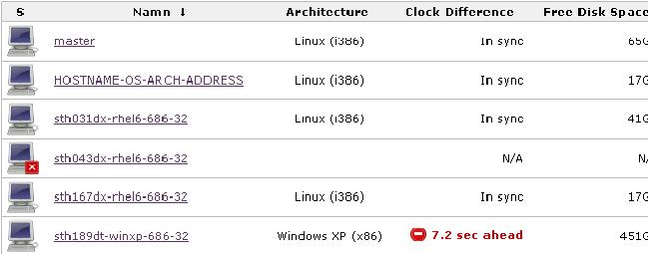
Now the slave node is available for building. What build jobs that will be executed on a specific slave node is configurable per job. See the section “Creating a job” for more information.

Setting up a windows slave node
Make sure the WMI service is running on the Windows machine. Start
c:\>services.msc
from the commander and verify that the service “Windows Management Instrumentation” is started. From the Jenkins web GUI, click “Manage Jenkins”, then “Manage Nodes” and then “New Node”
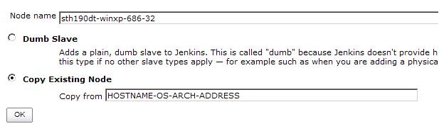
This will bring up the form above. Fill in the node name and click the radio button “Copy Existing Node”, fill in the field “Copy from” with the value HOSTNAME-OS-ARCH-ADDRESS. Click OK.
Now, fill in the fields as follows, exchanging the Launch method as in the picture below and the Host field with the actual name of the host.Click Save.
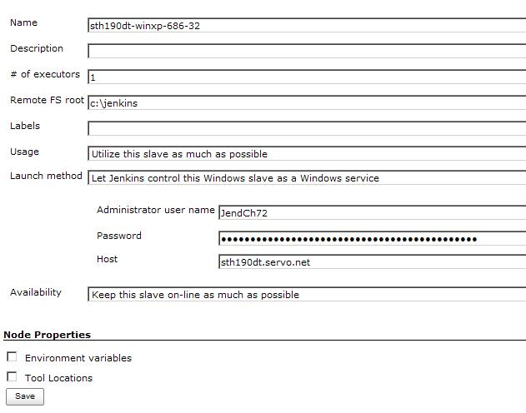
Jenkins will now connect with the new Windows slave node and download any required software onto the host (among other the Java SDK) under c:\jenkins. This concludes the slave node setup of a Windows machine.

Deploying the Jenkins service on RedHat Enterprise Linux 6
- Download the latest package from http://pkg.jenkins-ci.org/redhat/
- Install the downloaded RPM package (need to have root privileges)
rpm -ivh <RPM PACKAGE>
- Start service by running the command
/etc/init.d/jenkins start # (Need to have root privileges)
- The Jenkins web GUI should now be available from the URL http://<HOST_NAME>:8080/manage
- Change to the user jenkins
su - -s /bin/bash jenkins
- Make sure there are no existing RSA key pairs in the directory ~/.ssh
- Generate ssh keys with the command (rsa keys)
ssh-keygen -q -t rsa -N "" -f ~/.ssh/id_rsa
The following keys are generated
~/.ssh/id_rsa
~/.ssh/id_rsa.pub
- Store the public key in Subversion under
http://sth016ux/svn/platform/support/jenkins/id_rsa.pub

Upgrading jenkins
When a new Jenkins version is available the Jenkins web GUI will notify the user about this. From the web GUI, click the link “Manage Jenkins”. If there is a warning symbol at the top of the screen there is a new version available. To install this new version,
- Download the latest package from http://pkg.jenkins-ci.org/redhat/
- Inform the users of Jenkins that the service will be stopped by clicking the “Manage Jenkins” link and then clicking the “Prepare for shutdown” link.
- Stop the Jenkins service
/etc/init.d/jenkins stop
- Install the downloaded RPM package (need to have root privileges)
rpm -Uvh <RPM PACKAGE>
- Start the service again

Setting up secure access to jenkins
There are several ways to configure secure access to the Jenkins web GUI. The method chosen here is authentication and access control over LDAP against ActiveDirectory.
In the web GUI
- Click “Manage Jenkins”, then “Configure System”
- Click the checkbox “Enable security”
- Under the topic Security Realm choose the radio button LDAP
Set these values in the following fields

- Server: dc01.servo.net:3268
- root DN: DC=servo,DC=net
- User search filter : sAMAccountName={0}
- Manager DN: CN=Read LDAP,OU=Service,OU=Users,OU=ServoCare,DC=servo,DC=net
- Manager Password: <Need to acquire this password from internal IT>

Leave the rest of the fields untouched.
- Under the topic Authorization click the radio button “Logged-in users can do anything”

Backup and ClonE a Jenkins instance
To clone an existing Jenkins instance follow these steps
- Login on the machine hosting the Jenkins service.
- Fetch the backup script http://sth016ux/svn/platform/support/jenkins/backup-all.sh
- Run this script
bash backup-all.sh
to back up the current configuration of Jenkins
To clone a Jenkins installation (can only performed with root access)"
- Create new directory
mkdir /var/lib/new-jenkins
- Extract the backup
tar zxvf ${TAR_FILE} -C /var/lib/new-jenkins
- Make jenkins the owner of the new directory structure
chown -R jenkins.jenkins new-jenkins
- Set the new jenkins home (JENKINS_HOME=/var/lib/new-jenkins) in the file /etc/sysconfig/Jenkins
- Restart the Jenkins service
/etc/init.d/jenkins restart

Using variables in repository URL’s
When configuring a job in Jenkins, repository URL’s can be set to use variables, to avoid having to reconfigure multiple locations.
- Set an environment variable by clicking Manage Jenkins from the Jenkins main page
- Click Configure System
- Go down to the section called Global properties and add a new environment variable
- Fill in the name and the value, like in the example below
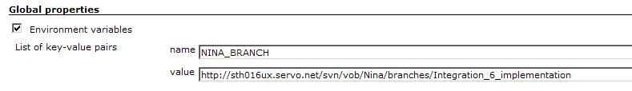
- Go to the configuration of a job and use the environment variable like this
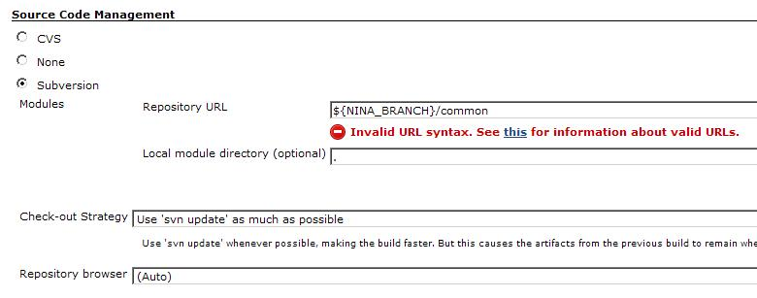

Adding functionality

Adding a plugin to Jenkins
The Jenkins installation contains basic features to initiate builds and interpret build results. If more functionality is required, Jenkins can be extended by adding plugins to the installation. To install a plugin the following steps must be followed
- From the main Jenkins web GUI, click “Manage Jenkins”
- Click the link “Manage Plugins”
- Click the “Available” tab to view available plugins
- Click the checkbox next to the plugins that are required
- Click “Install” and the plugin installation will begin

Observe!, plugins need a certain version of the Jenkins and might require an update.

Adding unit test report
There is built-in support for unit test results in JUnit XML format. If your test result files meet this condition it should be easy to specify the generated result file and view the results from Jenkins.
- Open the job you want to view unit test information on
- Click on the “Configure” link
- Click the checkbox “Publish JUnit test result report”
- Fill in the location of the generated XML file, relative to the top level directory of the workspace of the job

For the unit test graph to appear, more than 1 build needs to be performed

Adding coverage report
To enable Jenkins to interpret coverage results in Cobertura XML format, the “Jenkins Cobertura Plugin” must be installed. To generate files on the correct file format the gcovr tool is used. This tool uses the generated .gcov files from the unit test run and creates a summary of coverage information that the Jenkins Cobertura plugin can interpret.
Enable Cobertura support by
- Open the job you want to view coverage information on
- Click on the “Configure” link
- Click the checkbox “Publish Cobertura Coverage Report”
- Fill in the location of the generated XML file, relative to the top level directory of the workspace of the job.

For the coverage graph to appear, more than 1 build needs to be performed

Adding Flexlint report
To enable Jenkins to interpret Flexlint results, the “Warnings Plugin” must be installed.
Enable Flexlint (PC-Lint) support by following these steps
- Open the job you want to view Flexlint information on
- Click on the “Configure” link
- Click the checkbox “Scan for compiler warnings”
- Under the section “Scan console log”, add the parser “PC-Lint”

When Lint is applied on the code, the tool will output warnings on a certain format. This format is important, for the plugin to be able to parse the console output. A description for how to configure Flexlint to output the correct format can be found here
https://wiki.jenkins-ci.org/display/JENKINS/PcLint+options

Adding GCC warnings report
To activate parsing of GCC warnings, the same procedure as with Flexlint is performed. The only difference is that instead of adding the parser “PC-Lint” the parser “GNU compiler (gcc)” is added.

Adding DoxyGen generation
To enable Jenkins to interpret Doxygen results, the “Jenkins Doxygen Plug-in” must be installed.
This must be done to enable Doxygen support
- Open the job you want to view Doxygen generated files in
- Click on the “Configure” link
- Click the checkbox “Publish Doxygen”
- Specify the Doxygen configuration file in the “Doxyfile path” field.

Adding CCCC
To enable Jenkins to interpret CCCC results, the “Jenkins CCCC Plug-in” must be installed.
This must be done to enable CCCC support
- Open the job you want to view CCCC generated files in
- Click on the “Configure” link
- Click the checkbox “Publish CCCC report”
- Specify the CCC output file in the “Main XML CCCC report file path” field.

The CCCC output is generated by running the following command
find ${MODULE} -name "*.cpp" -o -name "*.cc" -o -name "*.c" -o -name "*.hpp" -o -name "*.h" | xargs /var/jenkins/tools/cccc/bin/cccc
This will produce a result XML file in the current directory, that will be parsed by Jenkins.
Edition | Date (file version) | Description | Issuer | Change no..

