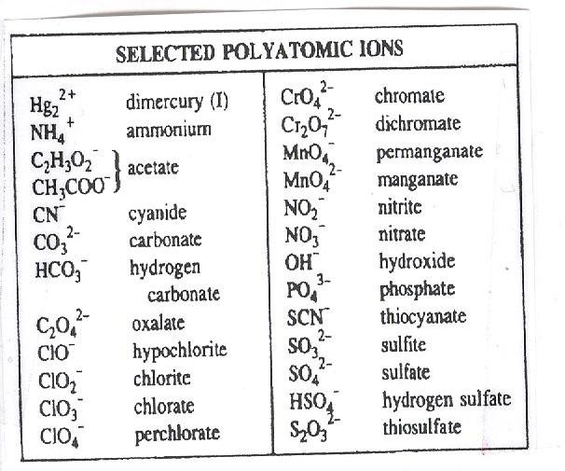
Constants

N_{A} = 6.022 x 10²³ mol⁻¹
h = 6.626 x 10⁻³⁴ Js
c = 2.9979 x 10⁸m/s
B = 2.18 x 10⁻¹⁸J
R = 1.097 x 10⁻²nm⁻¹
J = kgm²/s²

Mass of:
Electron m_{e} = 9.1094 x 10⁻³¹ kg
Proton m_{p} = 1.6726 x 10⁻²⁷ kg
Neutron m_{n} = 1.67493 x 10⁻²⁷ kg
