Elections Commission
City and County of San Francisco

Budget and Oversight of Public
Elections Committee (BOPEC)

Chris Jerdonek, Chairperson John Arntz, Director of Elections
Jill Rowe

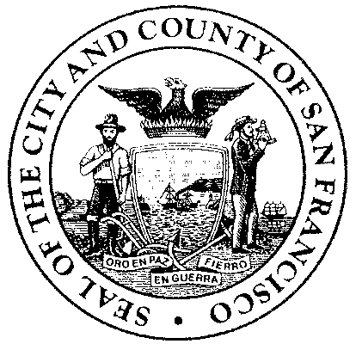
MEETING NOTICE

Budget and Oversight of Public Elections Committee (BOPEC)
Wednesday, October 1, 2014
6:00 p.m.
City Hall, Room 421
1 Dr. Carlton B. Goodlett Place

San Francisco, California 94102

CANCELED

The October 2014 regular meeting of the Budget and Oversight of Public Elections Committee (BOPEC) of the San Francisco Elections Committee will not be held.

KNOW YOUR RIGHTS UNDER THE SUNSHINE ORDINANCE (Chapter 67 of the San Francisco Administrative Code): Government's duty is to serve the public, reaching its decisions in full view of the public. Commissions, boards, councils, and other agencies of the City and County exist to conduct the people's business. This ordinance assures that deliberations are conducted before the people and that City operations are open to the people's review. For more information on your rights under the Sunshine Ordinance or to report a violation of the ordinance, contact the Sunshine Ordinance Task Force, CITY HALL, ROOM 244, 1 DR. CARLTON B. GOODLETT PLACE, SAN FRANCISCO CA 94102-4689; PHONE: (415) 554-7724; FAX: (415) 554-7854; E-MAIL: SOTF@SFGOV.ORG.
Copies of the Sunshine Ordinance can be obtained from the Clerk of the Sunshine Task Force, at the San Francisco Public Library, and on the City's website at http://www.sfgov.org.
Lobbyist Registration and Reporting Requirements: Individuals that influence or attempt to influence local policy or administrative action may be required by the San Francisco Lobbyist Ordinance (San Francisco Campaign and Governmental Conduct Code sections 2.100 – 2.160) to register and report lobbying activity. For more information about the Lobbyist Ordinance, please contact the Ethics Commission at 25 Van Ness Avenue, Suite 220, San Francisco, CA 94102; telephone (415) 252-3100, fax (415) 252-3112; and website: www.sfgov.org/ethics.

