Applied Predictive Modeling Ex4

Chathura J Gunasekara

Monday, September 29, 2014

4.1 (a) In this situation, since the sample size is large it is possible to set aside a testing data set and training data set. simple random spliting , Stratified random sampling or maximum dissimilarity sampling should be used because the dispropotionality of the classes.

## Loading required package: lattice  
## Loading required package: ggplot2

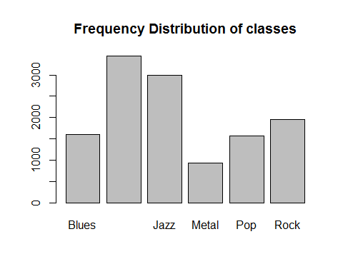

##   
## Attaching package: 'proxy'  
##   
## The following objects are masked from 'package:stats':  
##   
## as.dist, dist

(b)Code for implementing : stratified sampling

Using "createDataPartition" function in Caret package.

## Resample1  
## [1,] 2  
## [2,] 7  
## [3,] 14  
## [4,] 20  
## [5,] 22  
## [6,] 47

implementting maximum dissimilarity sampling in caret package. The data will be split on the basis of the predictor values.

## A random sample of 5 data points  
startSet <- sample(1:dim(train_music)[1], 5)  
samplePool <- train_music[-startSet, ]  
start <- train_music[startSet, ]  
newSamp <- maxDissim(start, samplePool, n = 4)

4.2. (a) This data set is small and can not find a frequency distribution because there is no classes in this data set.So it not possible to do stratified sampling or random sampling.Bootstrapping, k - fold cross validation , Repeated cross validation is used.

## num [1:165, 1:1108] 12.52 1.12 19.41 1.73 1.68 ...  
## - attr(*, "dimnames")=List of 2  
## ..$ : chr [1:165] "1" "2" "3" "4" ...  
## ..$ : chr [1:1108] "permeability" "X1" "X2" "X3" ...

(b)

Code for implementation :Repeated stratified sampling

library(caret)  
set.seed(1)  
repeatSplits <-createDataPartition(permeability,p=0.8,times=3)  
str(repeatSplits)

## List of 3  
## $ Resample1: int [1:133] 2 6 8 13 17 25 29 48 77 87 ...  
## $ Resample2: int [1:133] 2 6 8 11 13 17 29 45 48 49 ...  
## $ Resample3: int [1:133] 2 6 8 11 13 17 25 29 45 48 ...

Code for implementation :10 fold cross validation.

set.seed(1)  
cvSplits <-createFolds(permeability,k=10,returnTrain=TRUE)  
  
str(cvSplits)

## List of 10  
## $ Fold01: int [1:149] 1 2 3 4 5 6 7 8 10 11 ...  
## $ Fold02: int [1:148] 1 2 3 4 5 6 8 9 10 11 ...  
## $ Fold03: int [1:148] 1 2 4 6 7 9 10 11 12 13 ...  
## $ Fold04: int [1:149] 1 2 3 4 5 6 7 8 9 10 ...  
## $ Fold05: int [1:149] 1 2 3 4 5 7 8 9 10 11 ...  
## $ Fold06: int [1:148] 1 2 3 5 6 7 8 9 11 12 ...  
## $ Fold07: int [1:149] 1 2 3 4 5 6 7 8 9 10 ...  
## $ Fold08: int [1:147] 1 2 3 4 5 6 7 8 9 10 ...  
## $ Fold09: int [1:149] 2 3 4 5 6 7 8 9 10 11 ...  
## $ Fold10: int [1:149] 1 3 4 5 6 7 8 9 10 11 ...

4.3. This data set contains information about a chemical manufacturing process, in which the goal is to understand the relationship between the process and the resulting final product yield. Raw material in this process is put through a sequence of 27 steps to make the final pharmaceutical product. The starting material is generated from a biological unit and has a range of quality and characteristics. The objective in this project was to develop a model to predict percent yield of the manufacturing process. The data set consisted of 177 samples of biological material for which 57 characteristics were measured.

(a)A parsimonious model is a model that accomplishes a desired level of explanation or prediction with as few predictor variables as possible.

Follwing plot shows the R-squared and number of PLS components in the model.

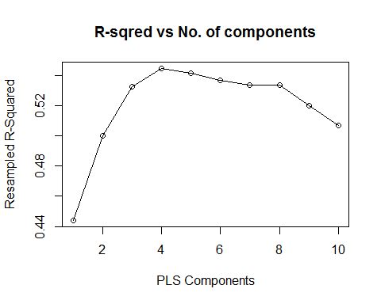 Models with components 1 to 4 increase R squared. then after 4 it decreases becasue over fitting. Numercically optimal value is 0.545 its SD is 0.0308 onestandar_error = 0.545-0.0308

0.545-0.0308

## [1] 0.5142

0.533 > 0.5142 , which is within one standard deviation so Number of PLS Components is enough to model is 3.

b)Computing the toerance values.

Optimal number of PLS components if 10% loss in R-squared acceptable is 2

c) SVM : R Squared is higher in SVM and Random Forests Not much defferece in them, but predictin time is way high for Random forests.so in concering R squared SVM is better. d)

consider using the simplest model that reasonably approximates the performance of more complex methods with a acceptable prediction time. So in that perspective KNN is better.

4.4

## Factor w/ 7 levels "A","B","C","D",..: 1 1 1 1 1 1 1 1 1 1 ...

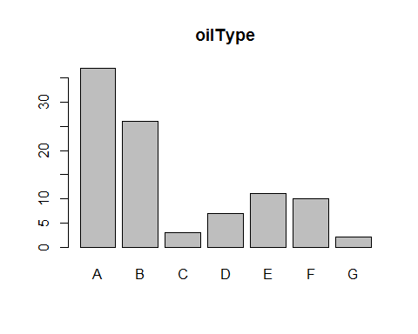 (a)Using Sample function to create a random sample of 60 oils.

barplot(table(oilType[sample((1:96),60,replace=TRUE,prob=NULL )]),main="oilType in random60 using sample function -01")

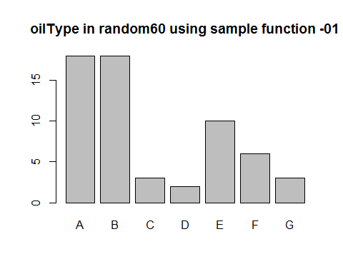

barplot(table(oilType[sample((1:96),60,replace=TRUE,prob=NULL )]),main="oilType in random60 using sample function -02")

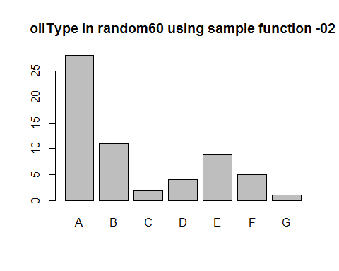

barplot(table(oilType[sample((1:96),60,replace=TRUE,prob=NULL )]),main="oilType in random60 using sample function -03")

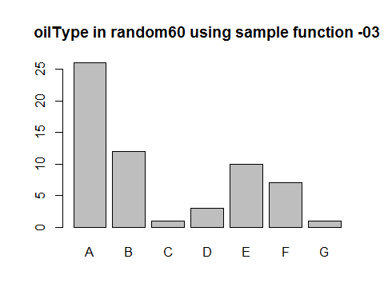 Base on the above figures it is observable that the variation in the random sampling. Sometimes very few obeservations of a class can be selected and sometimes an entire class may be not selected.When one class has a disproportionately small frequency compared to the others, there is a chance that the distribution of the outcomes may be substantially different between the training and test sets. (b)  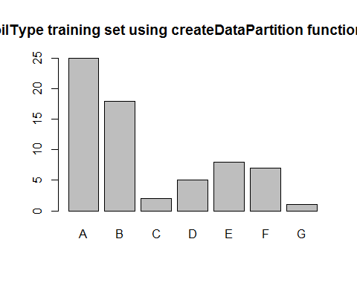  This graph does not change as random sample and it preserve the frequency distribution of the original sample In this way, there is a higher likelihood that the outcome distributions will match.

(c) A test set should be avoided because the sample size is small , random test set may not be enough give sufficient power or precision to make a judgement. So validation using a single test set can be a poor choise. Best to use resampling methods such as Cross validation which evaluates many alternate versions of the data. k-Fold Cross-Validation Repeated Training/Test Splits The Bootstrap

(d) Different sample sizes 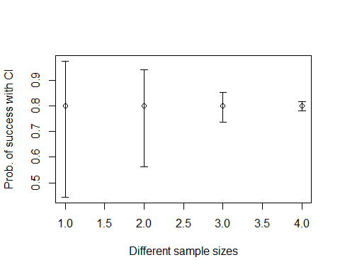 When test set size increase uncertainity decrease.

Different accuracy rates 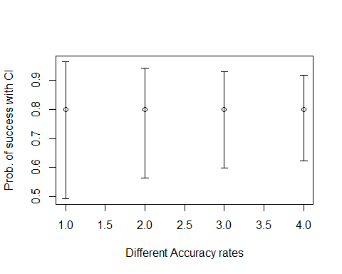 when accuracy rate is decreases is doesn't make a huge difference in uncertainity.