Loans html

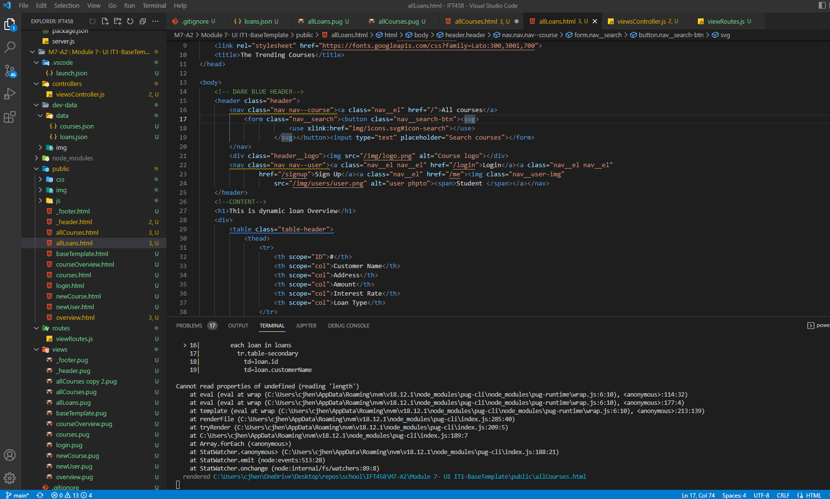

Courses HTML

Loans view

Loans modular pug file

