**Standard Operating Procedures (SOP) for running python version of Jump -m in St. Jude HPC**

In order to run the python version of Jump -m in HPC, “conda” (package and environment management system) for python should be installed first. In HPC, it can be installed in individual user’s home directory by loading a module as follows,

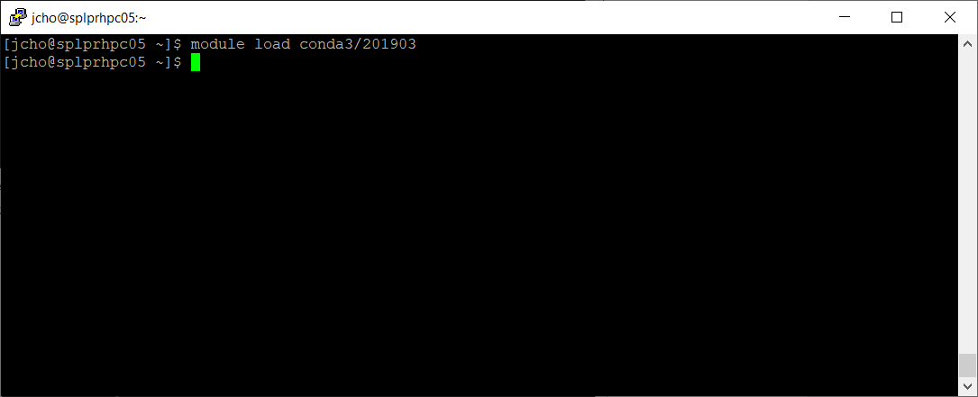

After loading the module called “conda3/201903”, you should run the command of “conda init bash” as follows. It will modify your .bashrc file and enable you to use conda from your next login.

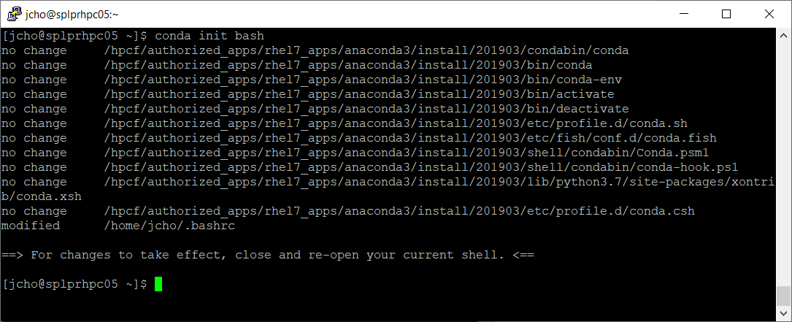

As shown in the above message, you should **close** and **re-open** your shell (e.g. PuTTY) for the changes to take effect.

If you could see “(base)” in the command prompt when you re-open a shell program, you are ready to use the python version of Jump -m in HPC.

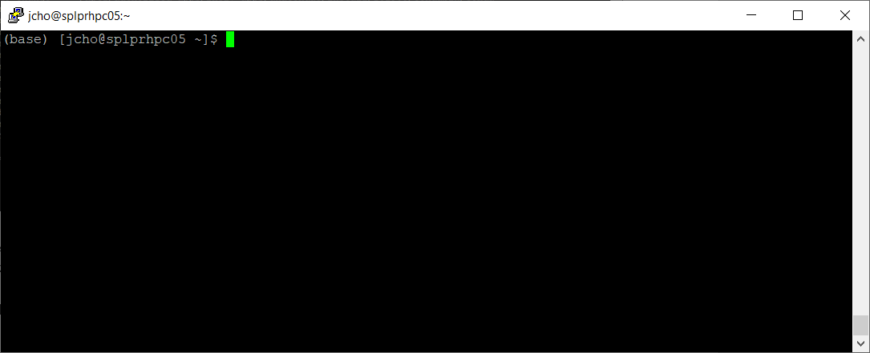

To run Jump -m, a specific conda environment needs to be “activated”. Currently, the environment for Jump -m is located at /hpcf/authorized_apps/proteomics_apps/conda/jumpm and can be activated by the following command,

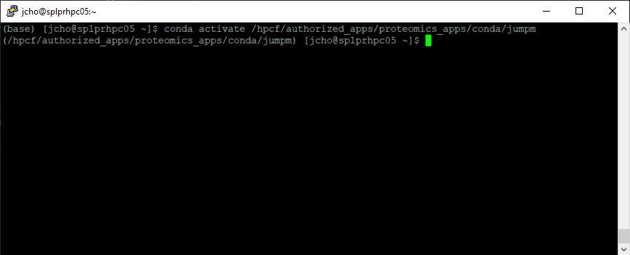

You can see that the command prompt has been changed from “base” to “/hpcf/…/jumpm” once the command is executed. It means that the conda environment specifically designed for Jump -m has been activated and therefore Jump -m is ready to use. When you finish running Jump -m, the prompt will be changed back to “base”.

Note that “(base)” sign will remain even after using Jump -m and in your next login. It does not affect any task in HPC, but just indicates that conda management system is available and stays in “base” (i.e. basic and default python running environment) environment.