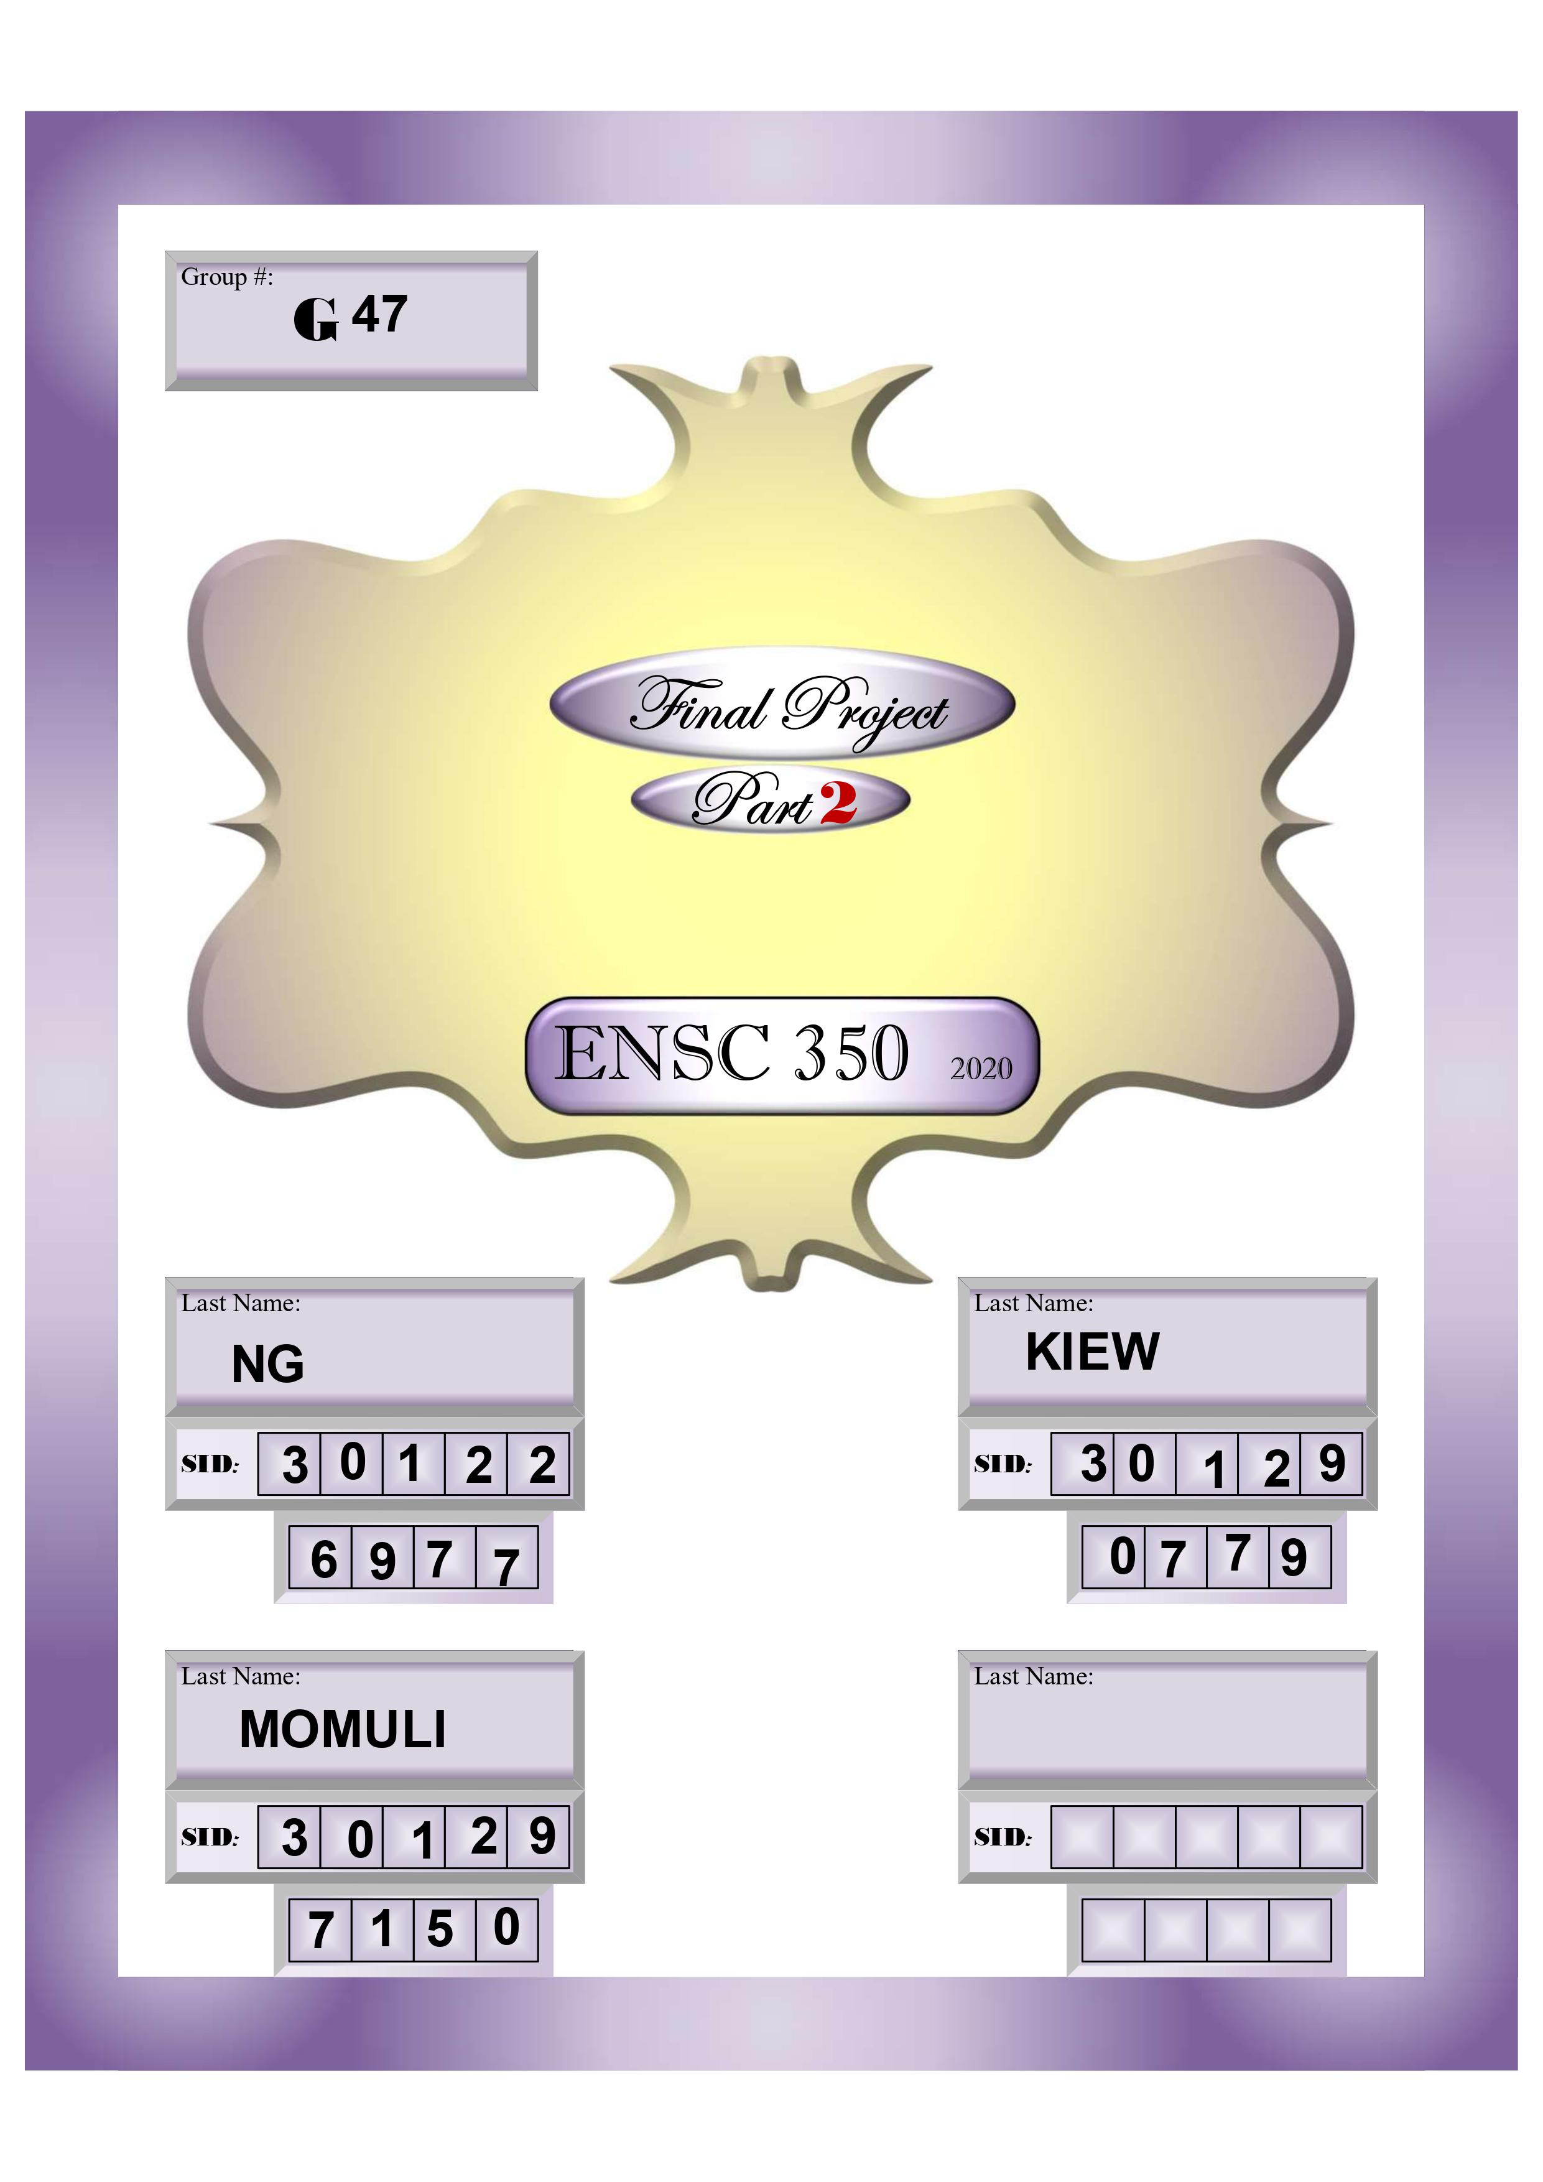

Contents

**No table of contents entries found.**

# Introduction