Game Design Document

Lane Community College

Winter of 2017



A game concept developed by:

Liam Connors, Christopher Isherwood,

Jonathan Tupper, and Nestor Macias

**Table of Contents**

**1 Game Concept 5**

|  |  |
| --- | --- |
| 1.1 Introduction | 5 |
| 1.2 Description | 5 |
| 1.3 Feature Set | 5 |
| 1.4 Genre | 5 |
| 1.5 Game Flow Summary | 5 |
| 1.6 Look and Feel | 6 |

**2 Gameplay and Mechanics 6**

|  |  |
| --- | --- |
| 2.1 Gameplay | 6 |
| 2.1.1 Game Progression | 6 |
| 2.1.2 Puzzle Structure | 6 |
| 2.1.3 Objectives | 6 |
| 2.1.4 Play Flow | 7 |
| 2.2 Mechanics | 7 |
| 2.2.1 Physics | 7 |
| 2.2.2 Movement  2.2.3 Actions  2.2.3.1 Cloning  2.2.3.2 Interactions | 7  8  8  8 |
| 2.2.4 Objects | 8 |
| 2.2.4.1 Activatable Objects | 9 |
| 2.2.4.2 Picking Up Objects  2.2.4.3 Traps | 10  10 |
| 2.2.4.4 Intractables | 12 |
| 2.3 Screenflow | 14 |
| 2.3.1 Screenflow Chart | 14 |
| 2.3.2 Screen Description | 14 |
| 2.3.2.1 Main Menu | 14 |
| 2.3.2.2 Options Screen | 15 |
| 2.3.2.3 In-Game Options  2.3.2.4 End Screen | 15  16 |
| 2.4 Game Options | 16 |
| 2.4.1 Main Menu Screen | 16 |
| 2.4.2 Main Menu Options  2.4.3 In-Game Options | 16  16 |
| 2.5 Replaying and Saving | 16 |

**3 Story, Setting, Characters 16**

|  |  |
| --- | --- |
| 3.1 Story and Narrative | 16 |
| 3.1.1 Back Story | 16 |
| 3.1.2 Plot Elements | 17 |
| 3.1.3 Game Progression | 17 |
| 3.1.4 Cutscenes | 18 |
| 3.2 Game World | 19 |
| 3.2.1 General Look and Feel | 19 |
| 3.2.2 Area #1 Laboratory | 19 |
| 3.2.3 Area #2 Military Base  3.2.4 Area #3 Mr. Chambers Office Building | 20  21 |
| 3.3 Characters | 23 |
| 3.3.1 Aaron Hendricks | 23 |
| 3.3.2 Allison Fletcher | 25 |
| 3.3.3 Dominick Chambers | 27 |

**4 Levels 29**

|  |  |
| --- | --- |
| 4.1 Act 1 | 29 |
| 4.1.1 Synopsis | 29 |
| 4.1.2 Objectives | 29 |
| 4.1.3 Physical Description | 29 |
| 4.1.4 Encounters | 29 |
| 4.2 Act 2 | 29 |
| 4.2.1 Synopsis  4.2.2 Objectives  4.2.3 Physical Description  4.2.4 Encounters  4.3 Act 3  4.3.1 Synopsis  4.3.2 Objectives  4.3.3 Physical Description  4.3.4 Encounters | 29  29  29  30  30  30  30  30  30 |
| 4.4 Act 4 | 30 |
| 4.4.1 Synopsis | 30 |
| 4.4.2 Objectives | 30 |
| 4.4.3 Physical Description | 30 |
| 4.4.4 Encounters | 31 |

**5 Interface 31**

|  |  |
| --- | --- |
| 5.1 Visual System | 31 |
| 5.1.1 HUD | 31 |
| 5.1.2 Menus | 31 |
| 5.1.3 Camera | 31 |
| 5.1.4 Light Models | 31 |
| 5.2 Control Systems | 31 |
| 5.3 Help System | 32 |

**6 Artificial Intelligence 32**

|  |  |
| --- | --- |
| 6.1 Enemy AI | 32 |
| 6.2 Non-Combat Characters | 33 |
| 6.3 Clone Characters | 33 |

**7 Game Art 33**

|  |  |
| --- | --- |
| 7.1 Character Models | 33 |
| 7.2 Environment | 33 |
| 7.3 Other Art Assets | 33 |

**8 Game Audio 33**

|  |  |
| --- | --- |
| 8.1 Music | 33 |
| 8.2 Character Sound Effects | 34 |
| 8.3 Object Sound Effects | 35 |

**9 Market Analysis 36**

|  |  |
| --- | --- |
| 9.1 Target Platform | 36 |
| 9.2 Target Market | 36 |
| 9.3 Target ESRB Rating | 36 |
| 9.4 Target Genre | 37 |
| 9.5 Top Competitors | 37 |

**1 Game Concept**

**1.1 Introduction**

D-Version is a 2D top down puzzle game, where the player uses clones to navigate through puzzles in order to stop a power hungry CEO who is looking for our main character. For he has the one think he can’t obtain. The Prototype D-v1.03 watch which has the ability to rewind time to save the wearer's life, if they are put in any harm.

**1.2 Description**

As a 2D puzzle game about creating clones, D-Version aims to be an experience that rewards the player for carefully thinking out clever solutions to seemingly complex situations. The player will be given as much time as they need to analyze any given puzzle and encouraged to solve it in as few steps as possible. D-Version also has story elements, giving the player an incentive to progress and learn more about the world and characters.

**1.3 Feature Set**

D-Version will include:

* 24-60 Main Story Levels featuring:
  + 9-12 Different Enemy Types
  + 10-15 Different Intractable Puzzle Elements
  + An Introductory/Tutorial level
  + An Ending
* And More!
* 3-6 Bonus Levels(Conditional)
* Achievement/Stat Tracking “Best Time”/”Least Clones”
* New Game+
* Freeplay Mode
* Speedrun Mode

**1.4 Genre**

Top-Down 2D Puzzle Game

**1.5 Game Flow Summary**

The game will be a series of levels, with increasing difficulty, in which the player has to navigate through guards, traps, and puzzles using “cloning” to outmaneuver whatever is thrown your way.

**1.6 Look and Feel**

The look of D-Version is a 2D, top-down, pixel art. Depending on the environment and game progression will determine the ambiance of the levels to match the mood of the current phase of the game. Accompanying our visuals we will have calm, ominous music that will accompany the character through their journey.

**2 Gameplay and Mechanics**

**2.1 Gameplay**

**2.1.1 Game Progression**

D-Version is a game based on increasingly difficult puzzles by understanding and using the core mechanics of the game to progress. There is no character progression, for it is our goal to have the players wit as the main driving force of this game. Abilities will stay the same and it will be a challenge of the mind.

**2.1.2 Puzzle Structure**

D-Version uses a unique mechanic in which the player will record a path and actions. Using these clones the player will navigate using switches, compression buttons, distracting guards, deactivating and avoiding traps in order to achieve the final goal.

The difficulty of the puzzles will steadily increase as the player progresses. Starting with simple levels that walk the player through the basic mechanics and functionality of objects and interactables. Once the player is acquainted with these mechanics they will then on need to strategically use them to complete levels and collect key items.

Some maps will contain extra story building methods that will require extra planning to obtain during the core puzzle. These items will not be required to complete the puzzle but if the player can figure out how to reach them during their navigation to the end of the puzzle then these items and interactables will fill in the history and extra story to engulf the player in this world we have created.

**2.1.3 Objectives**

The main objectives of each level will be to navigate the level to the final ‘door’ which then progresses the player to the next room/floor/level. Unless otherwise stated in the game itself, via dialog cue, then this will be the objective.

Other main objectives that will be present in ‘Title’ will be missions to obtain items. These items will be present in the level and will be referred to somehow through dialog. Lastly a main object can be to get to a character, whether it would be to; talk to them, obtain them, or confront them. This will also be relayed to the player through dialog or a cutscene to make it obvious to the player that this is the main objective of the level.

Side objectives will also be present in some levels. These will be objectives such as folders, computers, recordings, etc. These objects will be off the beaten path from the main objective and would have to be sought after. If obtained the player will learn about the world, history of characters, and more.

**2.1.4 Play Flow**

Player will start by running away from enemy company (I forgot all the names we came up with), player will be unlocking doors and interacting with game objects as a basic tutorial for the player to understand the controls.

The main character has now more knowledge about the watch which allows him make the watch more useful. The puzzles are now in the enemy’s company and each room/floor is more and more difficult until you get to the evil’s CEO office and destroy him/send him into an infinite time loop where he shall no longer escape. This is achieved by allowing the CEO to take the watch from the main character on purpose and then have the main player destroy the watch allowing the CEO to get stuck in time.

**2.2 Mechanics**

**2.2.1 Physics**

Being a top down game the physics of D-Version are very simple. They reflect the physic of the real world. Things stay put on the ground, characters and objects are solid and cannot be moved through, and things such as light and sound can be heard and seen.

**2.2.2 Movement**

Movement will be controlled one of two ways. The arrow keys or ‘wasd’. Up key and ‘W’ key will move the player in the positive direction upon the y-axis. Down key and ‘S’ key will move the player in the negative direction upon the y-axis. Left key and ‘A’ key will move the player in the negative direction upon the x-axis. Right key and the ‘D’ key will move the player in the positive direction upon the x-axis.

Movement will be a fix speed that is immediately reached when the button is pressed. Once released the players speed immediately is reduced to the value of ‘0’.

**2.2.3 Actions**

**2.2.3.1 Cloning**

Clones being one of the main mechanics in this game is a very important feature. Cloning happens when the players life is in danger. Once this happens the world is sent back into the past and the player is spawned at the beginning of the puzzle.

The clones in D-Version are controlled by a prerecorded path and button input. This recording takes place the playthrough the level before. As you move about and interact with objects the game will record the path of the player and the key inputs of the player and replicate them.

Clones can be overwritten, this mechanic is incorporated in case the player makes a mistake and wishes to re-record a clone. This is done by matching the clones number (which will be displayed at the top of the UI) and pressing their number. Once the number is pressed the player will be asked if they are sure they want to overwrite the previous clone. If player selects yes, the next playthrough will overwrite the clones path and input.

Clones will be limited due to the specific level to provide a challenge for the player and avoid infinite clones.

**2.2.3.2 Interactions**

The player will interact with many objects and people in this game. All interactions will be executed with one of two keys. The ‘Enter’ key or the ‘E’ key allows the player to interact with specific objects and people. The player, to interact with an object, will have to approach what they want to interact with. Once in range, a specific area directly in front of the character sprite, the player may press ‘Enter’ or ‘E’ and the following interaction then takes place.

**2.2.4 Objects**

Objects will be discussed focusing on key features that represent the use, how to interact with them, their appearance, and if they are a visual or an audio cue for NPC’s in the game. An example of this format is as follows:

Object Name

Use/Effect- This category will explain the purpose of this object, whether it be an aid to the player or an obstacle they must face.

Interaction- Interaction will explain how the player's character interacts with this object. Such as triggering an object via sight/sound, pressing a button, or entering/leaving an area.

Appearance- Description of how it will appear in game.

Noise: If the object has an audio representation (and it’s range) or if it does not.

Visual- If the object has a visual representation (and it’s range) or if it does not.

**2.2.4.1 Activatable Objects**

**2.2.4.1.1 Cameras**

Use/Effect- Once activated it will alert guard watching the feed.

Interaction- Visual cue

Appearance- Wall mounted black camera

Noise- none

Visual- None

**2.2.4.1.2 Fire Alarm**

Use/Effect- Once activated it will set off an alarm that will attract guard and repel Civilians/Employees

Interaction- ‘E’ - or - fire in room

Appearance- Wall mounted red fire alarm - or - colored button

Noise- High

Visual- None

**2.2.4.1.3 Laser Tripwire**

Use/Effect- Activates alarm or Hidden Trap

Interaction- Player walks through tripwire, it activates connected effect

Appearance- Invisible - or - Colored laser across walkway

Noise- None

Visual- None

**2.2.4.1.4 Motion Sensor**

Use/Effect- Something moves in its line of sight, sets off object

Interaction- Movement in designated area

Appearance- Wall mounted sensor box Green light when clear, red when triggered

Noise- None

Visual- None

**2.2.4.2 Pick-Up Objects**

**2.2.4.2.1 Box**

Use/Effect- This item can be used as cover and/or clock walkways.

Interaction- Moveable and breakable

Appearance- Wooden box

Noise- Break, dropped, and slide sound

Visual- Nose

**2.2.4.2.2 Key Cards**

Use/Effect- Can be used to unlock doors, vaults, and/or computers

Interaction- Swipedor scan

Appearance- Blue little rectangle, credit card-like

Noise- None

Visual- None

**2.2.4.2.3 Extinguisher**

Use/Effect- Can be used to create smoke cover from guards, scare away dogs, mess up mechs

Interaction- Player picks it up and uses it as it is convenient

Appearance- Silver, big cylindrical shape, extinguisher-like

Noise- Extinguisher noise

Visual- None

**2.2.4.2.4 Mirror**

Use/Effect- Can be used to reflect lasers

Interaction- Player can use the mirror to redirect lasers

Appearance- Reflective square

Noise- None

Visual- None

**2.2.4.3 Traps**

**2.2.4.3.1 Alarm**

Use/Effect- Can be triggered to alert enemies

Interaction- Button/Switch/Tripped

Appearance- dark red - off / bright red with sweeping light - on

Noise- Long Range

Visual- Medium Range (walls stop visual alarm)

**2.2.4.3.2 Distortion Serum**

Use/Effect- Switches Controls Around

Interaction- Dispenses from trap pressure plates/switches. Player is then sprayed from a hidden dispenser in the wall.

Appearance- Faulty plates/switches

Noise- None

Visual- None

**2.2.4.3.3 Electrical Trap**

Use/Effect- Acts as a barrier to the player

Interaction- Touch it you die

Appearance- White bright generic

Noise- None

Visual- None

**2.2.4.3.4 Gas Vents**

Use/Effect- Kills player over time

Interaction- Pressure plate/motion sensor/guard activated

Appearance- Normal room vents

Noise- None

Visual- Room progressively turn green

**2.2.4.3.5 Mech Dispenser**

Use/Effect- When activated it releases a number(number depends on the level) of Mech Eliminators

Interaction- Pressure plate/motion sensor/guard activated

Appearance- Metal doors, split in middle, opens horizontally

Noise- None

Visual- Light above the door flashes

**2.2.4.3.7 Trap Doors**

Use/Effect- Trick player into thinking he is heading in the right direction

Interaction- Once player enter through door, he is locked inside room with an alternative path to find

Appearance- Normal door

Noise- Open and close

Visual- Yes

**2.2.4.3.8 Flamethrower**

Use/Effect- Burns player

Interaction- If player is within range, player gets burned

Appearance- Tube coming out of a wall

Noise- Flamethrower

Visual- None

**2.2.4.3.9 Laser**

Use/Effect- Slices player on contact

Interaction- Red lasers are able to slice player into pieces if the player isn’t careful

Appearance- Red lines

Noise- None

Visual- Yes

**2.2.4.3.10 Poison Darts**

Use/Effect- Kills player over time

Interaction- If player activates poison dart trap, he will get shot and die over time.

Appearance- Small needle-like

Noise- None

Visual- Small tubes on walls

**2.2.4.3.11 Shark Tanks**

Use/Effect- When player is caught he will get thrown into a shark tank if one is within a certain range

Interaction- Player will get eaten by sharks after

Appearance- Big glass tank

Noise- None

Visual- Glass tank with sharks inside it

**2.2.4.3.12 Force Field Cages**

Use/Effect- Can be used to protect player from enemy or to lock enemies inside it by damaging controls

Interaction- If player is inside the force field, he will be able to lock himself inside it where the enemy cannot infiltrate. Player can damage controls wit guards inside to make it impossible for the force field to be deactivated

Appearance- Purple but transparent walls around a certain area

Noise- None

Visual- Purple square surrounding certain area

**2.2.4.4 Intractable**

**2.2.4.4.1 Door**

Use/Effect- Move in and out of rooms

Interaction- ‘E’

Appearance- Looks like a door

Noise- Open and close

Visual- Yes

**2.2.4.4.2 Gate/Lock Door**

Use/Effect- Acts as a barrier to player

Appearance- Sliding gate (Either two meeting in the center or one sliding all the way from wall to wall/ceiling to floor)

Noise- Open and close

Visual- None (could make it a visual alert)

**2.2.4.4.3 Level Door**

Use/Effect- Move onto next level

Interaction- ‘E’

Appearance- Elevator Doors

Noise- Unique open

Visual- None

**2.2.4.4.4 Keycard Door**

Use/Effect- Move in and out of rooms

Interaction- Only Guards

Appearance- Looks like a door, with a box to the right, it is lit green

Noise- None

Visual- Yes

**2.2.4.4.5 Pressure Plate**

Use/Effect- When button is compressed it activates an object, once the pressure is released the object to its original state.

Interaction- Stood

Appearance- Large floor pad (Colored), almost the size of full tile, slight edge to show change of depth between button and floor

Noise- None

Visual- None

**2.2.4.4.6 Switch/Lever/Button**

Use/Effect- Activates whatever the switch is attached

Interaction- Interact with ‘E’

Appearance- Located on wall / floor, colored handle

Noise- None

Visual- None

**2.3 Screenflow**

**2.3.1 Screenflow Chart**

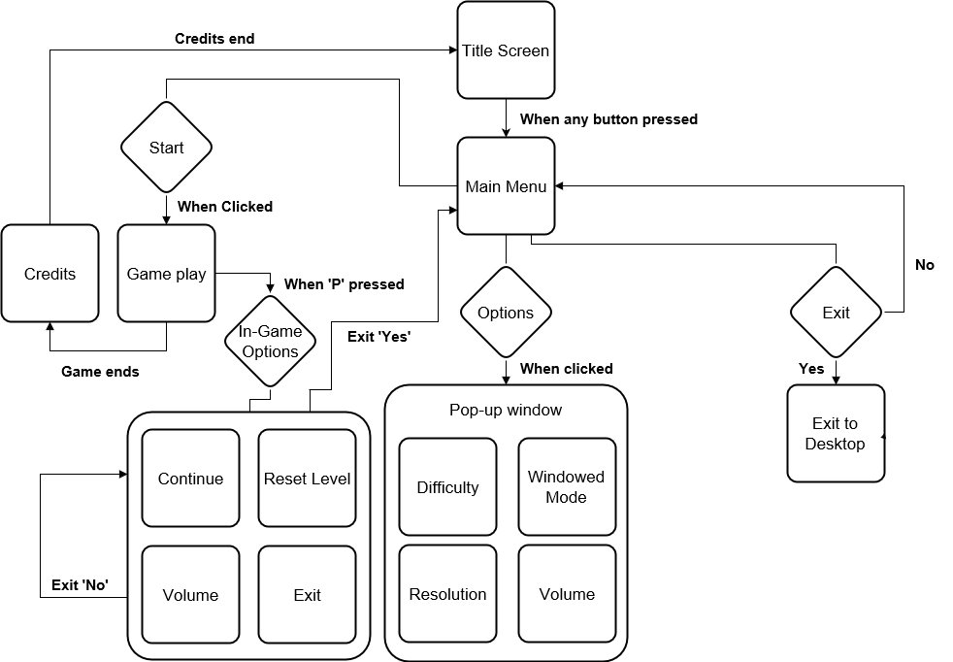

**2.3.2 Screen Description**

**2.3.2.1 Main Menu**

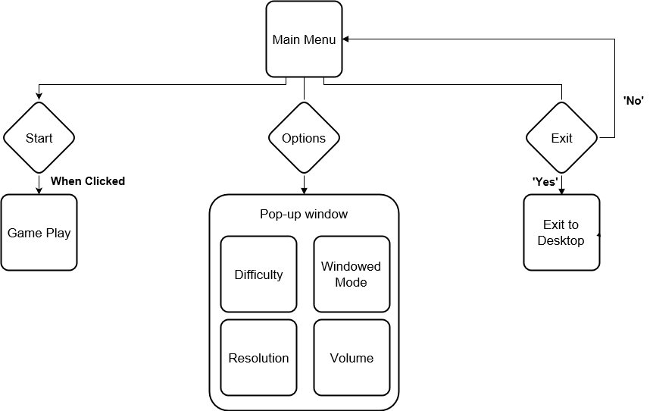

**2.3.2.2 Options Screen**

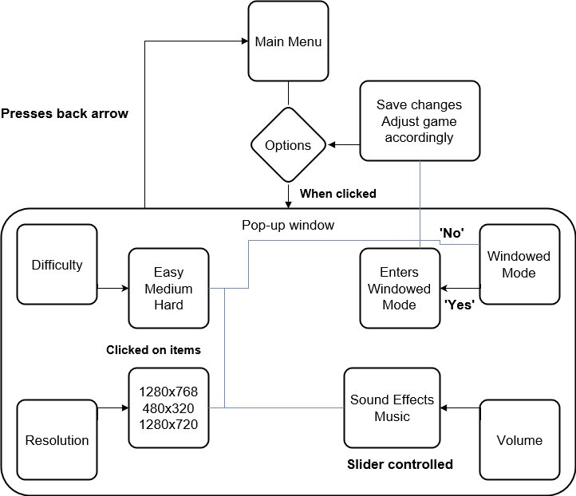

**2.3.2.3 In-Game Options**

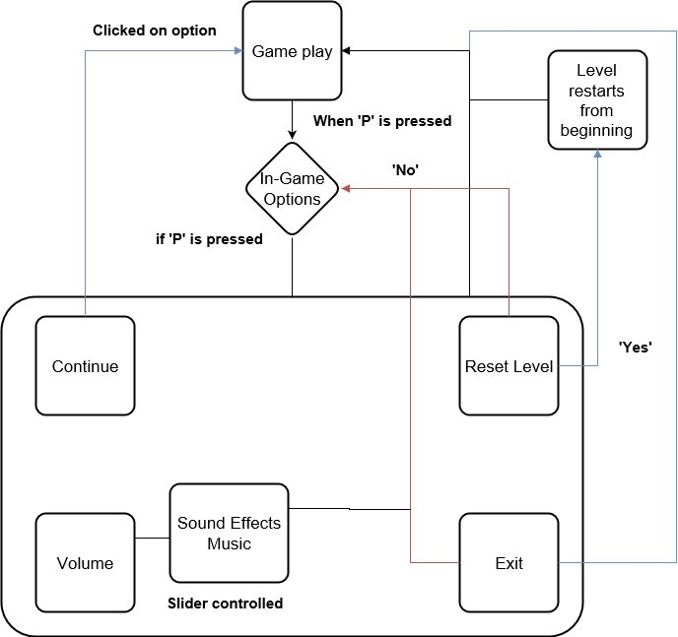

**2.3.2.3 End Screen**

-Display credits, after 5 seconds allow player to skip.

-Display scores,

-At the end of credits, send back to main menu where the player has now unlocked a new feature.

**2.4 Game Options**

**2.4.1 Main Menu Screen**

-Start

-Options

-Exit to Desktop

**2.4.2 Main Menu Options**

-Windowed Mode or Fullscreen Mode

-Volume Slider

-Resolution

-Difficulty

**2.4.3 In-Game Options**

-Continue

-Reset Level

-Volume Slider

-Exit Game

**2.5 Replaying and Saving**

Auto save at the beginning of each level.

Possibly multiple save slots where autosave save to.

**3 Story, Setting, Characters**

**3.1 Story and Narrative**

**3.1.1 Back Story**

Dr. Fletcher is a world renowned scientist/inventor and she has been recently employed by Mr. Chambers to create a wearable device that would have the capability to save the wearer when they are put into harm's way. This concept was intriguing to Dr. Fletcher and she accepted the job.

Dr. Fletcher and her assistant Aaron Hendricks were able to create such an item. They created a watch, Prototype D-v1.03, that had the capability to read the wearers timeline. This allowed the watch to detect harm in the immediate future and return the user to the point in the recent past that would allow the user to avoid the harm.

When it came time to present the invention to Mr. Chambers, Dr. Fletcher tells Aaron that she would not give the watch to Mr. Chambers. Without giving reason, she asked Aaron to trust her and she took the watch off Aarons wrist and switched it with the Prototype D-v1.03.

During the meeting, Dr. Fletcher demonstrated that the watch in fact did not work by creating a small cut on her hand and explained to the watch was designed to detect harm in the future and deliver the wearer back in the past in order to avoid the harm. Mr. Chambers face went from very intrigued to incredibly frustrated. This concept he wanted, he needed. He pulls out a pistol from his jacked. Dr. Fletcher's eyes as Mr Chambers says “Maybe you are just not in enough harm.”

**3.1.2 Plot Elements**

**3.1.2.1 Main**

- Fixing the watch

-Revenge for Allison

-Altering the watch to save Allison

**3.1.2.2 Side**

Side story will be implemented through documents and other collectable items that you can pick up throughout the game that will allow the player to learn more about the history of characters, the watch, etc.

**3.1.2.2.1 Dr. Allison**

-History and backstory of Dr. Allison

-Dr. Allison’s thoughts on Aaron/Mr. Chambers

**3.1.2.2.2 Mr. Chambers**

-Backstory of Mr. Chambers

-Contract between Mr. Chambers and Dr. Fletcher

**3.1.2.2.3 Prototype D-v1.03**

-Functionality

-Log sheet

- Fear of its power/ what good it could bring

**3.1.3 Game Progression**

Game progression will scale with puzzle difficulties. More enemies, new traps, more elaborate floors.

**3.1.4 Cutscenes**

**3.1.4.1 Intro**

**3.1.4.1.1 Actors**

Aaron Hendricks

Alison Fletcher

Dominick Chambers

Grunts

**3.1.4.1.2 Description**

Scene opens up to Aaron and Alison finishing up the last touches on the watch. It is finally finished. In the midst of their excitement Aaron notices Alison’s face go from smiling to stren. Alison is never not smiling, something is wrong. Alison then explains to Aaron that she is not going to hand over the watch. Aaron confused asks why, but Alison told him he needed to trust her for now and she’d explain everything later. She takes the watch off Aarons arm and replaces it with the Prototype D-v1.03. Time goes by and hen Alison has to leave for her meeting with Mr. Chambers. After pleasantries she expressed her apologies that she was unable to make the watch she wanted to and she would not be able to complete his request. She demonstrated its failure by taking out a knife and cutting a small cut on her hand. She then explained that ideally the watch would have rewound time and placed her in a time and place in which she would prevent the harm. Mr. Chambers had been getting more and more frustrated as she talked. After she stopped talking Mr. Chambers sighed and stood up. Pulled out a gun and with a single statement: “Maybe you’re not in enough harm” fires the gun and Dr. Fletcher falls to the ground. Mr. Chambers then orders his men to search the lab for her research.

Back in the lab Aaron is tinkering with some equipment, all of the sudden he hears doors being slammed open. He knew something was wrong. Peaking out the door, player is given control.

**3.1.4.2 Prototype D-v1.03**

**3.1.4.2.1 Actors**

Aaron Hendricks

Alison Fletcher

Dominick Chambers

Grunts

**3.1.4.2.2 Description**

Aaron enters the conference room, shocked he finds Alison on the ground. Aaron finds himself unable to move. The woman who had taught him, who had taken care of him, his mentor, his best friend. His body finally moves, he runs and collapses to her side. Crying the door slams open. “Hand over that watch!” ”If he tries to move shoot him.” Mr. Chambers and two guards stand in the opening of the door. Aaron raises goes to turn around and shot is fired. “You idiot if you break the watch ill you’ll be laying next to the doctor. The bullet had skimmed the watch. Aaron, filled with rage and sorrow. Yelled and turned to the group. One more shot was fired.

Aaron is standing at the front of the room, the body of his mentor laying on the other side. “What just happened” he thought. Suddenly he looked down. The watch had saved him. He heard footsteps coming in, he knew what was next and stood behind the door. The doors swung open. “Where the hell did he go, find him.” The group exits the room. Aaron walks back to Allison after the coast was clear. “Ill kill him for this… he has to pay!” Aaron exits the room. Player resumes control.

**3.2 Game World**

**3.2.1 General Look and Feel**

The visuals of the world depend greatly on the environment that the player is in.

**3.2.2 Area #1: Laboratory**

**3.2.2.1 Description**

Professor Fletcher’s company is known as a lab for hire. This is a large building, many (wings/Floors) that contain his many labs. He uses this business to fund his personal research. During the week the building is buzzing with scientists, students, custodial staff, and white collar staff. On the weekend the building is baron, with the Professor and his mentee. The weekend is the time in which they are able to conduct the Professor's own research.

**3.2.2.2 Physical Characteristics**

Very clean and bright. Professor Fletcher was known to be a very clean and organized man, everywhere except his personal office. So his personal company he ran was spotless. White tiles, with white walls, very well lit, and well kept. Tables are stainless steal, occasionally would be cluttered with a project that is being worked on. Lab rooms contained cabinets, counters, tables, and equipment both near tables and place up against walls. Walkways were always clear for safety. Hallways illuminated by bright lights separated labs.

**3.2.2.3 Levels Using this Area**

This area will be used for the first part of the game. Basic guards, dogs, switches, pick-ups, and alarms. Estimated 8 to 20 Levels.

After the Military base, the player will return to the lab for a few levels. Around 5-10.

**3.2.2.4 Connections to Other Areas**

This area leads up to both the military base and Mr. Chambers Office.

**3.2.3 Area #2: Military Base**

**3.2.3.1 Description**

Military compound, located on home soil. The base is off the beaten path, a person would have to go down a few miles on Highway 26 to get to Arnold Military base. To get into Arnold you must have to get passed posted guards, cameras, alarms, and guard dogs. It is a fairly basic camp. Outside is a chain link fence that follows the boundaries of the facility, just outside the fence is a fairly dense forest populated with ever greens and ferns. The forest is cut away from the immediate fense but 10 feet away the green takes over.

On the inside of this fense few guards are posted and even fewer patrol the outside of the facility. It is mainly guarded by a few dog patrols and they rely on their camera system to keep the area safe. Across the facility are multiple buildings, single story, with few entrances with guards, whom unless are alerted are fairly lax due to the lack of any problems ever occurring besides the random lost civilian and the occasional wild animal tripping a sensor. The halls and rooms are fairly plain, basic concrete floors well polished. Storage rooms are dimly lit with crates, lockers, and larger objects draped with tarps scattered throughout them. Along with these rooms we have offices, bathrooms, and security rooms where guards watch the camera feeds.

**3.2.3.2 Physical Characteristics**

Outside is cement ground, with a parking lot and large military vehicles Scattered throughout. In the center of the compound lie 5 buildings. The buildings have brick walls with white metal roofs. Four lookouts with lights attached are at each corner of the fence that lines the base.

Inside of the buildings is very clean, with cement floors and brown walls. The buildings are lines with rooms with hallways attaching them all. Each building is large and contains many rooms. Each building has 3 entrance all with posted guards.

**3.2.3.3 Levels Using this Area**

Arnold Military base is the setting for the second act of our game. We will be using this setting for the middle of the game. Around the same amount of levels will be taking place in this facility.

**3.2.3.4 Connections to Other Areas**

This area will follow the Laboratory levels and lead into the return to the lab.

**3.2.4 Area #3: Mr. Chambers Office Building**

**3.2.4.1 Description**

The highest skyscraper in the city. This is the building that Mr. Chambers runs his multiple businesses out of. You walk into a vast entrance hallway, marble floors and Marble paneling that rises four feet up the walls. As you follow the cream walls towards the ceiling your sight will be drawn to the many gigantic paintings that cover the top third of the wall up to the high ceilings. In the middle of the hall is a large table, with a large bouquet of flowers that is changed bi-daily that gives off an aroma that fills the hall. To the right there is a large waiting room with seating and a fire mantle. To the left is a display of all the companies that Mr. Chambers has created. In the back of the room there is a receptionist who sits at a large desk, dark wood base with a marble counter that matches the walls. Behind her are four elevators, currently one is out of order. The elevators have gold doors and inside is the same marble finished floors with reflective walls.

The first few floors of this building are meant for the eyes of the public, future clients, and board members. These rooms are very similar to the lobby. Same cream walls (now covered in Mr Chambers business pictures) and marble floors, until you get into conference rooms where the ground is a firm carpet matching the base color of the marble. Conference rooms are long rooms, glass outer wall to the hallways, windows on the opposite wall looking out onto the street and two plain walls, one with a television mounted to it for presentations. Long dark wood tables are placed in the middle of the rooms with black leather chairs 8 on each side, and one at each end. The rest of the floor consists of sitting areas for social meetings and two receptionists to answer any questions.

The upper floors are strictly for authorized personnel only. Accessible only by those who obtain the correct key car. This is where Mr. Chambers holds all his business’s records, serves, his research teams work here, and at the top is his office. These rooms are much more minimalistic than those below. Now the rooms have plain white or grey walls with basic tile or dark carpet. These floors are riddled with guards, employees, cameras, traps, and mechanized personnel.

**3.2.4.2 Physical Characteristics**

First few floors are very rich, with marble and dark woods. Friendly staff, some security, and clients riddle the space.

Upper levels the floors get much darker, much more minimalist, and more personnel. Dark floors and white or grey walls. There is a lot more security devices throughout the floors that can be disabled with the correct key cards. Mr. Chambers had worked his whole life to build his empire and made sure to keep it with these measures.

Mr. Chambers office has deep red walls, dark wood furniture, and marble floors. His back wall is made completely out of glass that looks over the city. In front of the glass is his desk with is always spotless and a large brown leather chair. In front of his desk are two chairs, red material with wood accents.

**3.2.4.3 Levels Using this Area**

This will be used as our concluding act of our game. The last and harder levels will be placed in this setting. This area will have the most levels taking place here. Leaning towards the 20 level mark.

**3.2.4.4 Connections to Other Areas**

The player will come here after going to the lab for the second time.

**3.3 Characters**

**3.3.1 Aaron Hendricks (Protagonist, age 20)**

**3.3.1.1 Back Story**

Aaron Henricks was born and raised in Northern California in a rural town. He had always been interested in the sciences, ever since his Aunt got him a science kit in the first grade. Aaron from then on learned all he could about physics, chemistry, biology, etc. When he was in 7th grade he raised enough money to send him through a summer science program down in southern California. It was taught that year by Alison Fletcher, a renowned inventor/scientist who Aaron had dreamed of meeting one day.

During the camp Aaron showed expreme promise with his enthusiasm and his knowledge as a 13 year old. Alison took note of this and at the end of summer approached Aaron’s parents and told them if they wished, she would love to mentor Aaron during the summers. After thinking it over and a bit of persuasion and seeing how happy their son was talking about Professor Fletcher that they agreed.

Every summer through Jr. High School and High School, Aaron would go down to Professor Fletcher’s company and work directly with her, learning as much as he could. When it came time Aaron applied at a University down in Southern California and was immediately accepted due to a letter of recommendation by Alison. During his freshman year he was put on budget as a paid intern for Fletcher’s company. Between school and work Aaron was surrounded by the thing he loved, science.

One summer between Aarons second and third year of college Alison approached Aaron to let him know some good news. She had decided to work with Aaron as partners on a new contract they were given. She thought it would be good for his resume to have something to this extent on his list of accomplishments when he was done with school. The contract was to a Mr. Dominick Chambers. A wealthy entrepreneur who had countless businesses under his name and he was looking into a device that could “detect harm and prevent it, without user interaction”. So began their work, Aaron’s first big contract, with his name at the top. Right besides Alison Fletcher, “Dreams do come true” he thought to himself.

**3.3.1.2 Personality**

Aaron was a quiet kid growing up, keeping to himself and always had his nose in a book. If Aaron doesn’t know how something works, he has to find out. He is driven by wonder, by knowledge. Both great attributes for a good scientist and he wanted to be the best.

**3.3.1.3 Appearance**

**3.3.1.3.1 Physical Characteristics**

-Brown hair

-Average height

-Caucasian

-Average build

-Green eyes

**3.3.1.3.2 Animations**

-Walking

-Death

-Grabbing

-Interacting with item/door

**3.3.1.3.3 Special Abilities**

Upon death, the watch that Aaron now wears will rewind time and return him to a time in which he has a chance to avoid harm. Due to a malfunction with the watch after being damaged, a clone of his past self now appear and replays the timeline he just returned from.

**3.3.1.3.4 Relevance to Game Story**

Aaron is our main character of this story. He escapes with the Prototype D-v1.03 watch and he decides that he needs to stop Mr. Chambers after he realises he is being hunted for his involvement in the watch’s creation.

**3.3.1.3.5 Relationships**

Alison Fletcher: Aaron and Alison consider each other family. He and she have known each other for 7 years. Even though there is an age discrepancy Alison treats Aaron as a peer and likewise Aaron to Alison, even if Aaron is still learning from Alison. Aaron has always looked up to Alison ever since reading about her when he was younger and her achievements she had under her belt at such a young age.

**3.3.2 Alison Fletcher (Friendly NPC, age 38)**

**3.3.2.1 Back Story**

Alison Fletcher is a prodigy of her time. Graduated college by the age of 15 and had her PhD by 20. Well known in the science community she began her own company inventing and creating the supposedly impossible for those who came to her. She used this company to fund her own research and inventions she did to entertain herself and challenge her intellect. Present day her company employs 150 scientists, engineers, and interns who want work experience for after college.

At the age of 22 Alison falls in love with with a man who she soon married and had a child with. The marriage did not last long after he noticed he was not prioritized by Alisons work and took their child to the east coast. Alison rarely sees her son but talks to him on the weekends and sends him her inventions. He is now top of his class in highschool and wants to be a scientist. She couldn't be more proud and her dream is to have him at her company some day.

Alison was approached by a group who funds the push for science and math education of children and hired her to instruct a group of 13-16 year olds and try to further expand their interest in science. She gladly accepted, she had never taught kids before and she could never pass up a new challenge. During her class a student caught her eye. He was always right up front during demonstrations, asking questions, and volunteering to help with experiments.

After the summer camp was over Alison decided she needed to meet the parents of this boy who showed such promise. After a few conversations with his parents Alison had a new mentee, Aaron Hendricks. They spent every summer together working and researching. She relayed all her knowledge on her student and as he

**3.3.2.2 Personality**

Alison is one of the nicest and bubbliest people you will meet. Always has a warm smile on and never is pessimistic about anything. Even when her and Aaron’s experiments fails, she pulls Aaron out of the slump by explaining how this is just moving them towards the right track. Very few people disliked Alison. She was sociable and was always willing to help. Her success came due to her enjoyment of not knowing. To be able to debunk a theory, or to find something that no one has found. She loved a challenge, rarely turned one down in fact. Her work was her life.

**3.3.2.3 Appearance**

**3.3.2.3.1 Physical Characteristics**

-Red hair

-green eyes

-Taller for a woman ≈ 5’ 10”

-On the slimmer side

-Caucasian

**3.3.2.3.2 Animations**

-Walking

-Handing over object

**3.3.2.3.3 Special Abilities**

-None

**3.3.2.3.4 Relevance to Game Story**

Alison is the scientist/engineer that is contracted to build the watch for Dominick Chambers. She not only ends up successfully develops the watch to perform the task he requested, save the life of the wearer, but in doing so discover the first noticeable advancement in any sort of time travel with her Prototype D-v1.03 watch.

After the completion of the watch and the deadline for the project approaching Alison suddenly seems increasingly more distressed about handing over the watch to Mr. Chambers.

Finally when the meeting is scheduled, Alison decided present Mr. Chambers with a fake watch and tell him she was unsuccessful with her experiment. In frustration Mr. Chambers kills Alison stating: “Maybe you are not in enough harm.”

Aaron finds Alison laying on the ground in the conference room dead. The one he felt closest to on this planet was gone. It was all due to Mr. Chambers. This sequence of events cause Aaron to use the actual watch to try to seek revenge for his mentor, and even if there is only a slight possibility, find out how to control time to save her.

**3.3.2.3.5 Relationships**

Aaron Hendricks: Alison took Aaron in when he was young and took great interest in his progression in the field of science. She subliminally took him under her wing as a coping mechanism for her son. She deeply wishes she could be there for him while he grew up, but her work was always in the way. She taught everything she knew to Aaron and together they discovered and developed new ideas and inventions together. They were an amazing team together, rarely fighting but still conflicting ideas to keep each other on their toes. She truly loves Aaron as a son.

**3.3.3 Dominick Chambers (Antagonist, age 41)**

**3.3.3.1 Back Story**

Dominick Chambers grew up poor. His father was a hard working man but was not able to pull his family from the holds of lower class. Dominick despised his father for that reason. “Why couldn't he work harder, get a better job, why are we always struggling?” At 16 Dominick cut all ties with his family. He left his father, mother, and two sisters without saying a word. He was sure he deserved a better life and if they couldn’t help him reach that goal he would not waste his time with them. This was his outlook on life from then on. If you can’t help him, get out of his way.

He joined a office firm of an entrepreneur who had started from nothing and now was a multimillionaire with three businesses to his name. Dominick started in the mail room and with his incredible work ethic he moved up quickly. Soon he was as high as he could go with the business. He then decided he needed to go higher. He left the company and started his own business. Quickly his company grew, he had taken everything he had learned from his previous company and made it better. It was what he did best. Soon his business was multibillion dollar corporation and spanned across everything from realestate to software. The corporation had a dark side. Dominick wanted more, and he found the best way to get money is war. He built a black market mercenary team. These men were the best and would provide their services to the highest buyer.

**3.3.3.2 Personality**

Dominick is driven by success. He is very polite and warm towards those who will help him gain that success but it will quickly change if the results he is expecting are not met.

Even with his seemingly polite and warm way about him, those who meet him feel his power, his drive. It’s a very unsettling feeling and just from being in the same room as Dominick, you know you don’t want to be on his bad side.

**3.3.3.3 Appearance**

**3.3.3.3.1 Physical Characteristics**

-Black Hair

-Dark eyes

-On the shorter side

-Built man with broad shoulders

-Caucasian

**3.3.3.3.2 Animations**

-Walking

-Sitting/Standing

-Pulling out a gun

**3.3.3.3.3 Special Abilities**

-None

**3.3.3.3.4 Relevance to Game Story**

Dominick is our main antagonist. He is the one who kills Alison Fletcher and sparks the fire in Aaron to come after him. He contracted Dr. Fletcher in order to make a watch in order to save a life if it was ever put in any harm. What he kept from her that he had was going to use the watch to replicate and sell to the highest bidder. Showing it off with his personal mercenary company that has helped overthrow countries, hire them out to war lords, and assassination missions. Alison finds out about this business that Mr. Chambers has in hiding and finds out through her own sources what his plans for the watch would be. This leads to Dr. Fletcher to show Mr. Chambers a fake watch. Mr. Chambers angry with the apparent results that he murders Dr. FLetcher and orders his men to gather all information they can find about Prototype D-v1.03.

**3.3.3.3.5 Relationships**

Alison Fletcher: Mr Chambers has a business relationship no other relationship has been established. He knew about Dr. Fletcher due to her huge fame she accrued over her life with her breakthrough discoveries.

**4 Levels**

**4.1 Act 1**

**4.1.1 Synopsis**

These introductory levels are set in the laboratory, designed to introduce the player to the core mechanics of the game.

**4.1.2 Objectives**

The core objective is point a to b escape.

**4.1.3 Physical Description**

The laboratory will use whites, greys and reds. It will be well-kept, clean, and be filled with research notes and gadgets.

**4.1.4 Encounters**

The player will have several encounters with the main antagonist, as well as his many “grunts”.

**4.2 Act 2**

**4.2.1 Synopsis**

The player has escaped from the lab, and has begun his search for the parts he needs to upgrade the watch. But the player must be wary, he isn’t exactly a welcome guest here either.

**4.2.2 Objectives**

The player will search each level for the needed parts to upgrade his watch.

**4.2.3 Physical Description**

The military base will use many earthy greens, browns and greys. Although dirty and crude, the base is kept organized, and has high security standards.

**4.2.4 Encounters**

The player will encounter new types of guards including posted guards and guard dogs here. Additionally, the player will encounter several officials here that may offer aid.

**4.3 Act 3**

**4.3.1 Synopsis**

Now that the player has the parts, he discovers he needs one more tool, found only in his laboratory, a hand me down given to him presumably by has future self. He must once again enter the laboratory to retrieve it.

**4.3.2 Objectives**

The player must go deep into the laboratory, avoiding detection, retrieving the tool, and making another escape.

**4.3.3 Physical Description**

The laboratory will use whites, greys and reds. Lights will be broken, flickering on and off. It will be torn up, disorganized, completely trashed from being searched and filled with bigger, tougher guards, including robots.

**4.3.4 Encounters**

The player will encounter mech/robot enemy types, as well as tougher guards. There are few encounters with story driven characters in this area.

**4.4 Act 4**

**4.4.1 Synopsis**

After evaluating all of his options, the protagonist decides to go to the antagonist’s office building where he discovers that the watch is not the only time-traveling object. Fighting for his life and for the good of the world, his mission is now to destroy all time-traveling objects and all the research regarding the functionality of the objects.

**4.4.2 Objective**

Aaron is now preparing to get his revenge for his late mentor. He must infiltrate the office building of Mr. Chambers and avoid his countless employees who work in his skyscraper, making his way past the guards, through his testing facility, and all the traps Mr. Chambers has awaiting him.

**4.4.3 Physical Description**

Mr. Chambers’ building and office will use common office colors such as black, white, and grey. Very clean and intimidating long hallways which lead to a secret basement. The basement is very big and while with a glass doors through every lab.

**4.4.4 Encounters**

Player will encounter every kind of enemy with an increasing complexity in levels.

**5 Interface**

**5.1 Visual System**

**5.1.1 HUD**

- Numbers on top representing clones.

- Item being held

**5.1.2 Menus**

-Main

-In-Game

**5.1.3 Camera**

Top down camera which will follow the player, with the player at the center of the screen.

**5.1.4 Light Models**

-Top down skylight

-Occasional separate lighting

**5.2 Control System**

Control schemes will include

|  |  |  |
| --- | --- | --- |
| Control | Main | Alt |
| Move Up | W | Up Arrow |
| Move Down | S | Down Arrow |
| Move Left | A | Left Arrow |
| Move Right | D | Right Arrow |
| Interact/Pickup | E | Enter |
| Clone Recording Select | 1-0 Keys |  |
| Restart Level | R |  |
| Game Menu | Esc |  |
| Pause Game | P |  |

**5.3 Help System**

Will be implemented through tutorials as the game introduces new elements.

**6 Artificial Intelligence**

**6.1 Enemy AI**

**6.1.1 Guards**

Patrols a path in a loop or back and forth. Has a cone/flashlight in front representing the guard’s vision. When the guard spots the player, it will give chase, taking the shortest route to the last location it saw the player. If it has not seen the player for x seconds or the player disappears from time travel, it then returns to its patrol path.

**6.1.2 Post-Guards**

Like a guard, but doesn’t move and guards an objective. Calls for assistance when it spots the player. (Guard appears at predetermined location on the level.)

**6.1.3 Guard Dogs**

Like a guard, but without vision and instead a radius where it can “smell” the player.

**6.1.4 Mech Eliminator**

Released as a trap, a horde of Mech Eliminators swarms the building following a predetermined path, following the player once the player has been found, exploding(?) on contact with player.

**6.1.5 Alarmbot**

Patrols a predetermined path, with a small cone line of sight. Once it finds the player it aggressively chases them and activates its’ alarms, alerting all guards in the level sending them to its’ location.

**6.2 Non-Combat Characters**

**6.2.1 Civilian**

Follows a path. Player may be able to talk to them.

**6.2.2 Employee**

Follow a path. Runs to nearest guard and alerts them.

**6.3 Clone Characters**

Follow the recorded instructions for that particular clone.

**7 Game Art**

**7.1 Character Models**

Character models will be done in the style of 2D pixel art.

**7.2 Environment**

Laboratory uses very simple colors, a lot of white and silver(to represent stainless steel). Rarely will a wing have super colorful assets.

Military base will have earthy tones. Greens/browns/greys. Outside its bounds is a vast green forest.

Corporate building is the most colorful of the three areas. Having reds, golds, deep browns as the main palette of color. As the player gets higher into the building the colors start to fade as the building slowly turns from business to compound in which reds and golds turn to grey and black.

**7.3 Other Art Assets**

Objects will be

**8 Game Audio**

**8.1 Music**

**8.1.1 Main Menu**

-Main Theme

**8.1.2 Lab Music**

-4 tracks that are able to loop.

**8.1.3 Military Base**

- 2 Tracks able loop

**8.1.4 Business**

-1 track for lobby

-2 tracks for upper levels

-1 Track for top floor office

**8.2 Character Sounds Effects**

**8.2.1 Aaron Hendricks**

-Watch Rewind

-Capture/Death

-Out of Charges Warning

**8.2.2 Guards/Soldier**

-Gun Shots

-Baton Hit

-Radio

-Alerted

**8.2.3 Dog**

-Alerted

-Attack

-Apprehended

**8.2.4 Mech**

-Alerted

-Attack

-Alarm

-Explosion

-Activating Self Destruct

-Being Deployed

**8.2.5 Alarmbot**

-High pitched alarm

**8.2.6 Civilian**

-Alerted

-Scream/Panic

**8.2.7 Employee**

-Alerted

-Calls for Guards

**8.2.8 Text**

-Text Written

-’Next’

**8.3 Object Sound Effects**

**8.3.1 Activatable Objects**

**8.3.1.1 Fire Alarm**

-Fire alarm

**8.3.2 Pick-Up Objects**

**8.3.2.1 Box**

-Break

-Drop

-Slide

**8.3.2.2 Extinguisher**

-Extinguisher

**8.3.3 Interactables**

**8.3.3.1 Door**

-Open/Close

**8.3.3.2 Gate/Lock Door**

-Door knob

**8.3.3.3 Level Door**

-Long open/Chimie

**8.3.3.4 Key Card Door**

-Beep open/close

**8.3.3.5 Pressure Plate**

-Air flow

-Short click

**8.3.3.6 Switch/Lever/Button**

-Click

**8.3.4 Traps**

**8.3.4.1 Alarm**

-Alarm

**8.3.4.2 Electrical**

-Electricity

-Short circuit

**8.3.4.3 Gas Vent**

-Gas

**8.3.4.5 Trap Door**

-Open

-Harsh close

**8.3.4.6 Flamethrower**

-Flame thrower

**8.3.4.7 Defence Drones**

-Patrolling drone

-Chasing drone

-Alerting

**8.3.4.8 Laser**

-Laser

-Slicing

**8.3.4.9 Shark Tanks**

-Shark

-Water

-Splash

**8.3.4.10 Force Field Cages**

-Force field

**9 Market Analysis**

**9.1 Target Platform**

PC

**9.2 Target Market**

Any gender, age ranging from teens to young adult (13-35).

**9.3 Target ESRB Rating**

Teen

**9.4 Target Genre**

Puzzle

**9.5 Top Competitors**

Portal

Braid

Fez

Monument Valley