

Version 1.0

**Name: Chandni Jivani**

**Student ID: 801091518**

Table of Contents

1. Introduction 3

1.1 Overview 3

1.2 Goals and Objectives 3

1.3 Scope 3

2. Site Map 4

3. Page Design of every page 4

4. ER Diagram 5

## Introduction

## Overview

The futXchange application is a web-based application available to computer as well as the smart phone users with any platform having the web browser capability, essentially Windows, Linux and MacOS users. The application provides the futXchange account holders to swap their footwears with the other users. They have the capability to add their own items, browser through the items added by other users and initiate and complete the swap request.

## Goals and Objectives

The main objective of this project is to provide the end users a platform to exchange their unused footwears for a new pair of footwear with some other user. The futXchange application is expected to:

## Provide a web-based interface to register for the new users.

* Provide user the capability to add and update the items.
* Function in a simple and intuitive manner

## Scope

The futXchange application will provide only the registered users a capability to add and update the item. The user who has swapped an item can only rate and provide feedback. The other users will however be able to view the comments and the items. The reason for this is to provide a level of accountability to the registered users.

## Site Map

-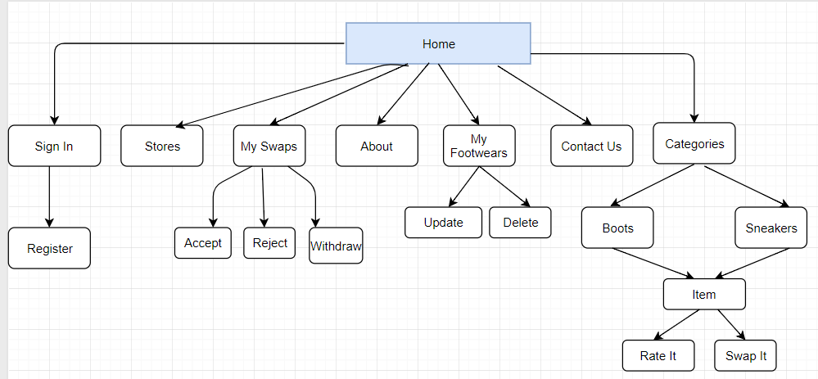

## Page Design of every page

## Home: It is the landing page for the user. It could be both the registered or unregistered users.

* Categories: The items are displayed as per the user selection. In reference to this website, it could be Boots or Sneakers.
* Stores: This page lists the Stores across different locations.
* About Us: This page gives a description about the website.
* Contact Us: This page provides user the capability to get in touch with the website administrators either via email or phone. They can even post a feedback.
* Sign In: This page is designed for the registered user to log in into the website.
* Register: This page is designed for a new user to sign up and add or update the item.
* My Footwears: The user can view his/her items here. They can even view the status of their Items. The user can delete or Update the status of the item.
* My Swaps: This page is designed to view the item that the user intends to swap with his/her item. They can even accept/ reject the offer extended by another user for their item. They can even withdraw the swap offer extended by them.
* Item: This page displays the individual item description.
* Feedback: This page is designed for the registered user to provide feedback for the item they had swapped with theirs.
* Swap: This page is designed to swap the one of the user’s item with some other user item.

## ER Diagram

