

Version 1.0

**Name: Chandni Jivani**

**Student ID: 801091518**

Table of Contents

1. Home 3

2. About Us 3

3. Contact Us 4

4. Categories 4

5. Item Page 5

6. Swap 6

7. Login 6

8. Registration 7

9. Profile 7

10. My Swaps 9

11. Feedback 10

1. 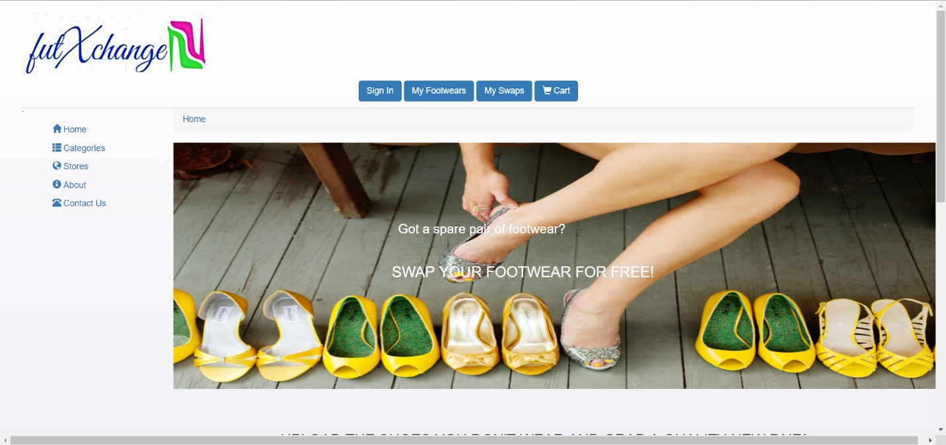Home Page

This is the home page or the landing page which comes up when the user when user enters the URL. The user navigation panel is at the top and left panel has the site navigational panel.

1. 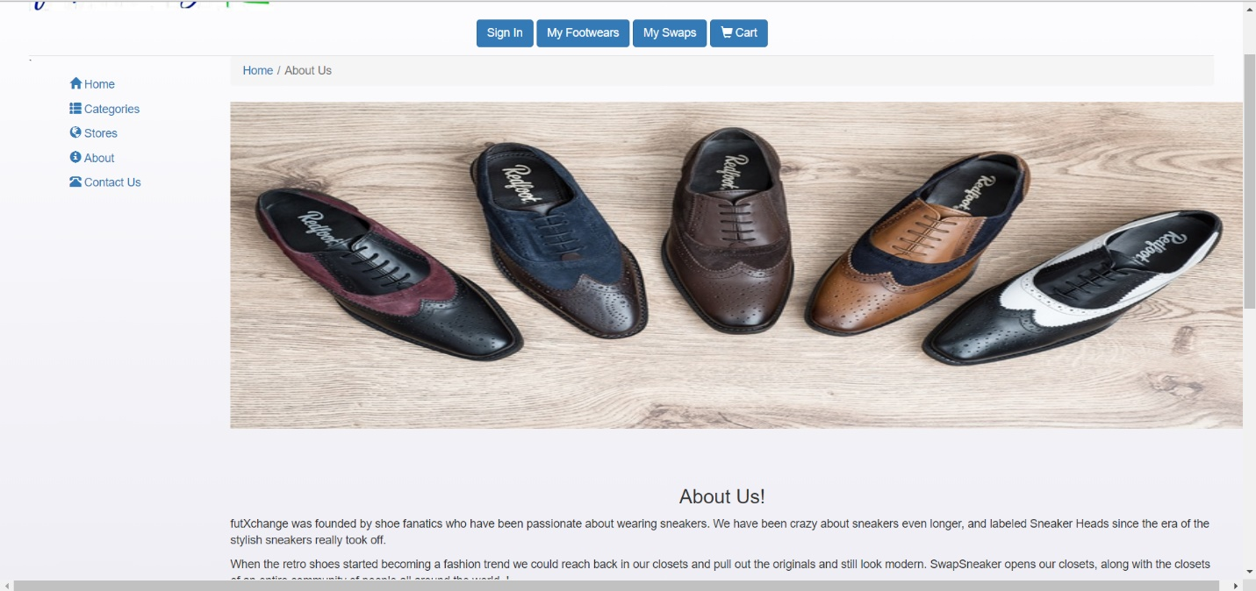About Us

This is the “About Us” page selected from left panel of home page. It is designed to give a description of the website.

1. 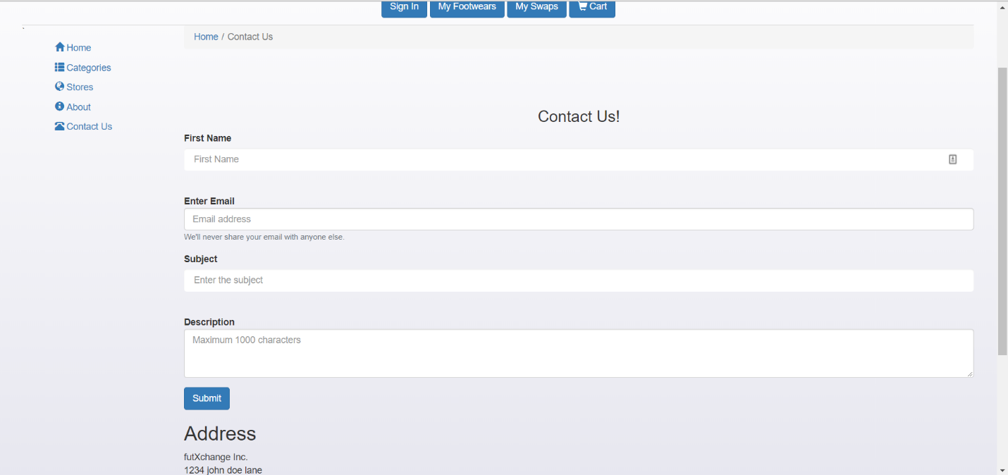Contact Us

This is the “Contact Us” page. It is designed for the users to post any grievances, provide feedbacks or even post queries about any offers. It can be found on the left panel of Home page.

1. 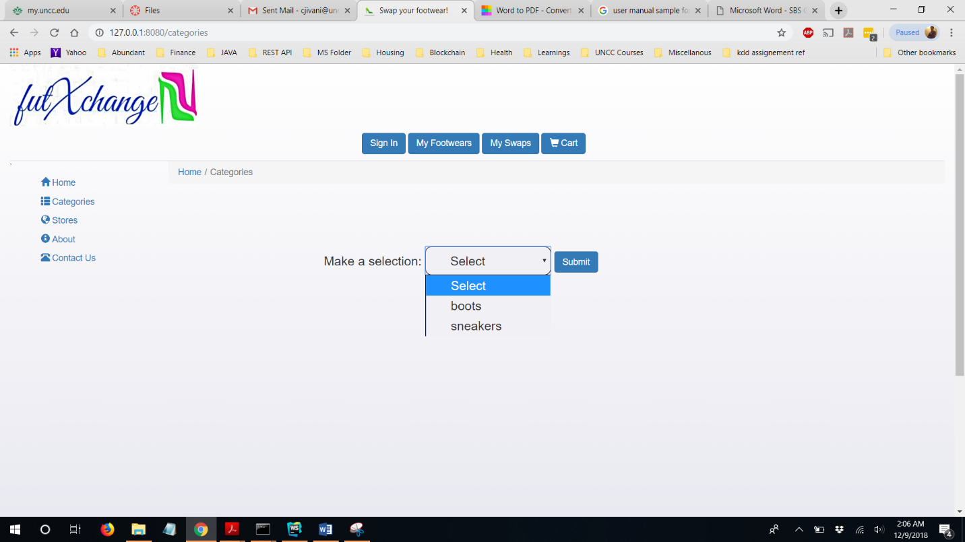Categories

This is the categories page. The link for the same can be found on the left hand side panel of the home page. This page displays the item added by the other users. It is sorted as per the different categories to make it easier for users to browse through the items.

1. 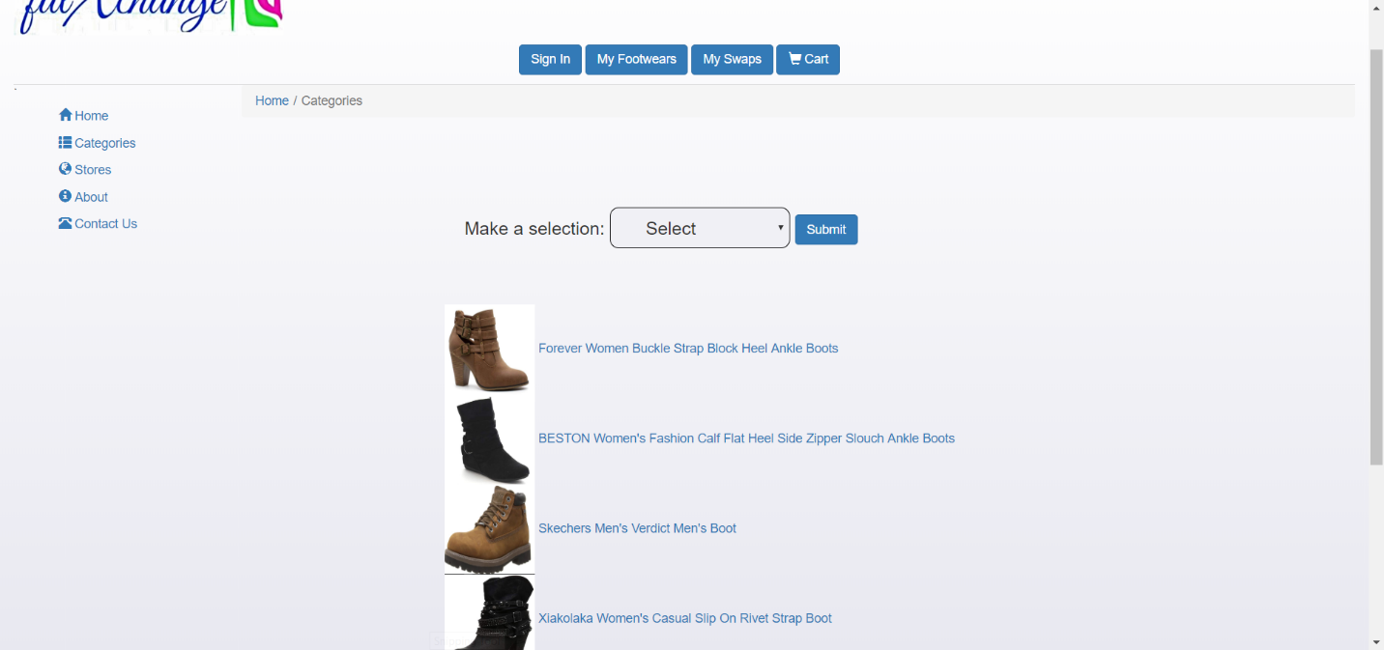Item Page

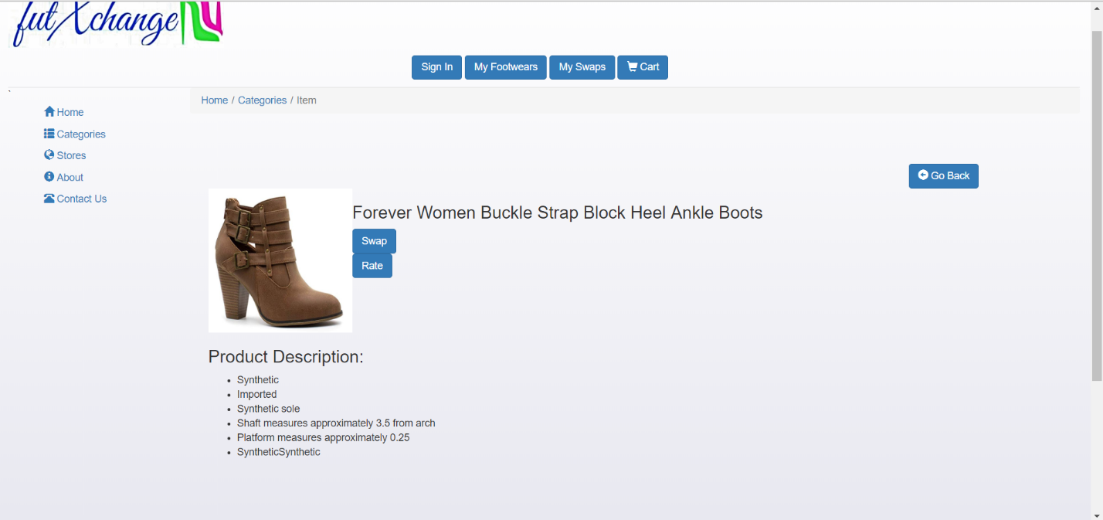

This is the Item page, and which is displayed when the user clicks any of the item from the categories page. This page gives a detailed product description. The registered user can swap or rate the item from this page.

1. 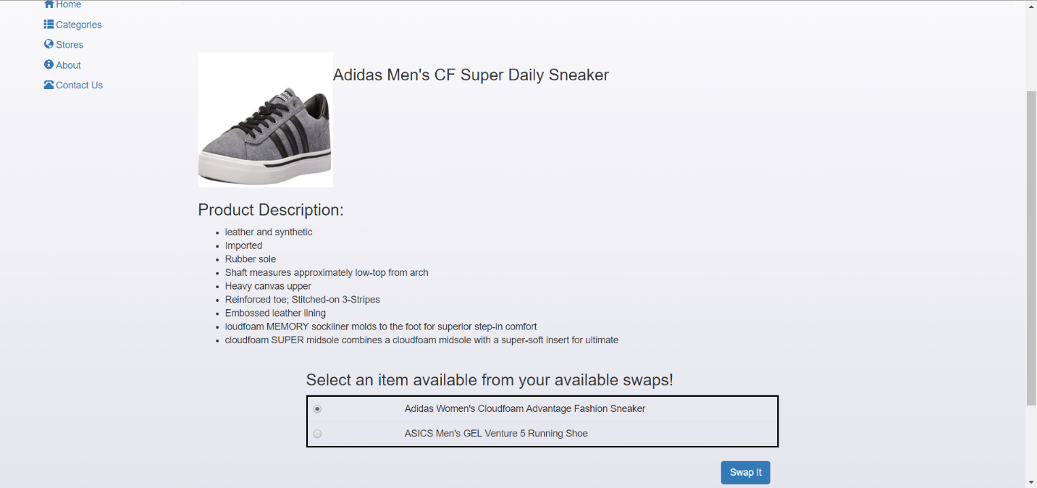Swap Page

This is the swap page which is displayed when the user click on the swap it button from the item page. However this page is only viewable for the registered users. If the user is not registered or signed in, the user is redirected to the Login page to view this page. It displays the list of available items for the signed in user, if he/she wishes to swap it with.

1. Login

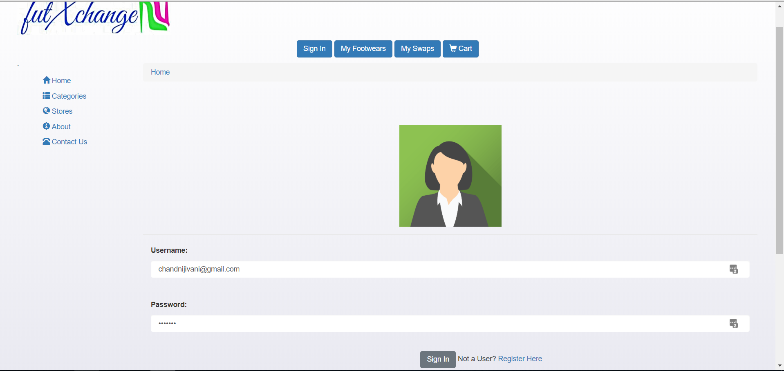



User who are already registered with the website need to enter the credentials on this page. They need to provide their user name and password to view their profile. In not registered, click on Register Here link below.

1. 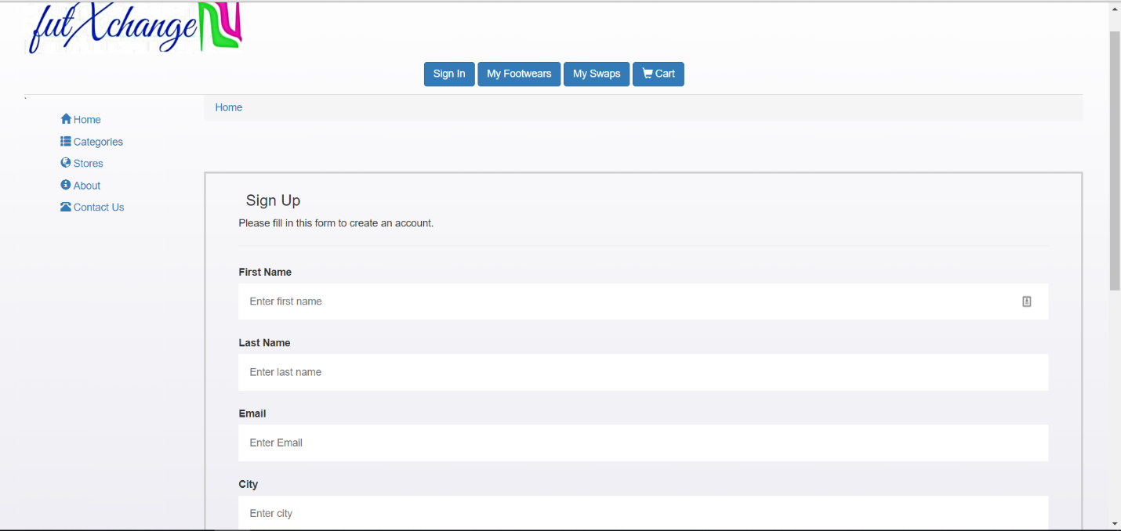Registration

If the user is a new user and if they wish to use the services, they need to sign up by entering their registration details on this page. All the fields are mandatory for the purpose of user registration.

1. 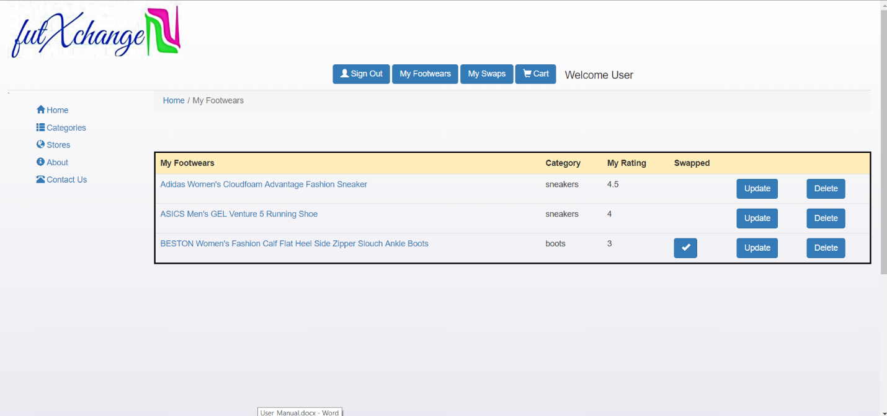Profile Page

This is the profile page which shows all the items added by the user. It shows up when the user logs in. The update and the Delete buttons give user flexibility to update or delete their items.

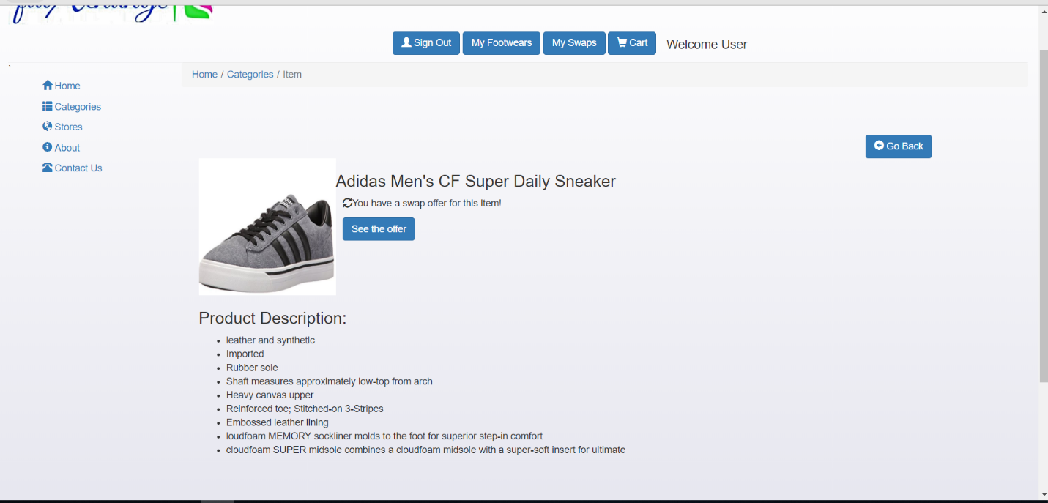

If a user clicks on any of his/her available items, and if they have a swap offer for that item, the same will be displayed on click of the update button.

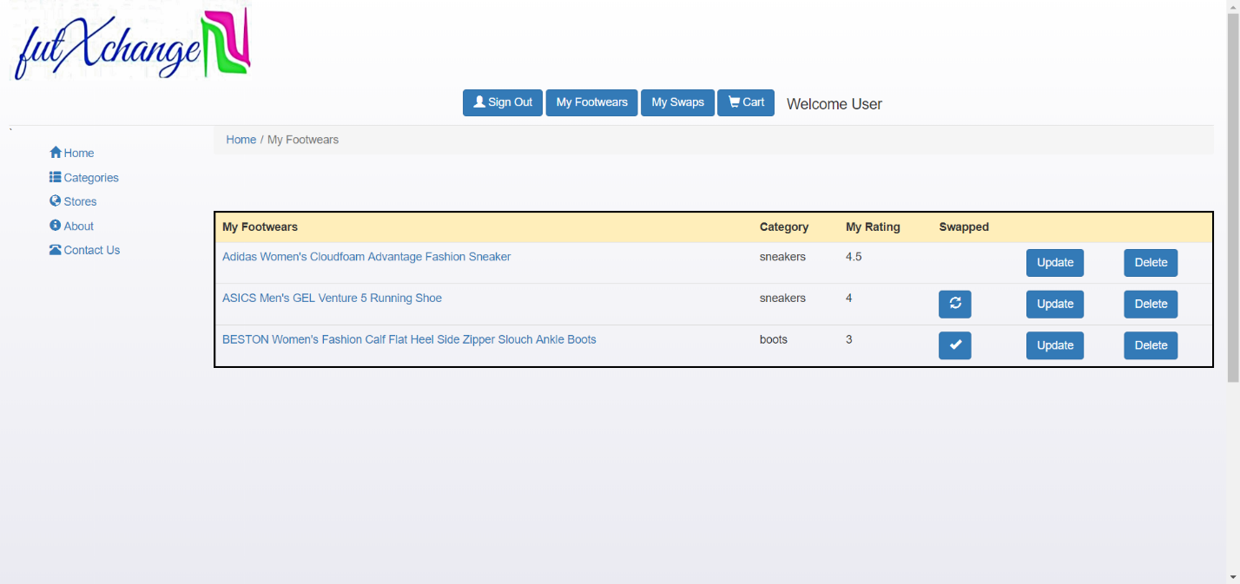

Once the user clicks on see the offer, the status will change to pending for the user.

1. 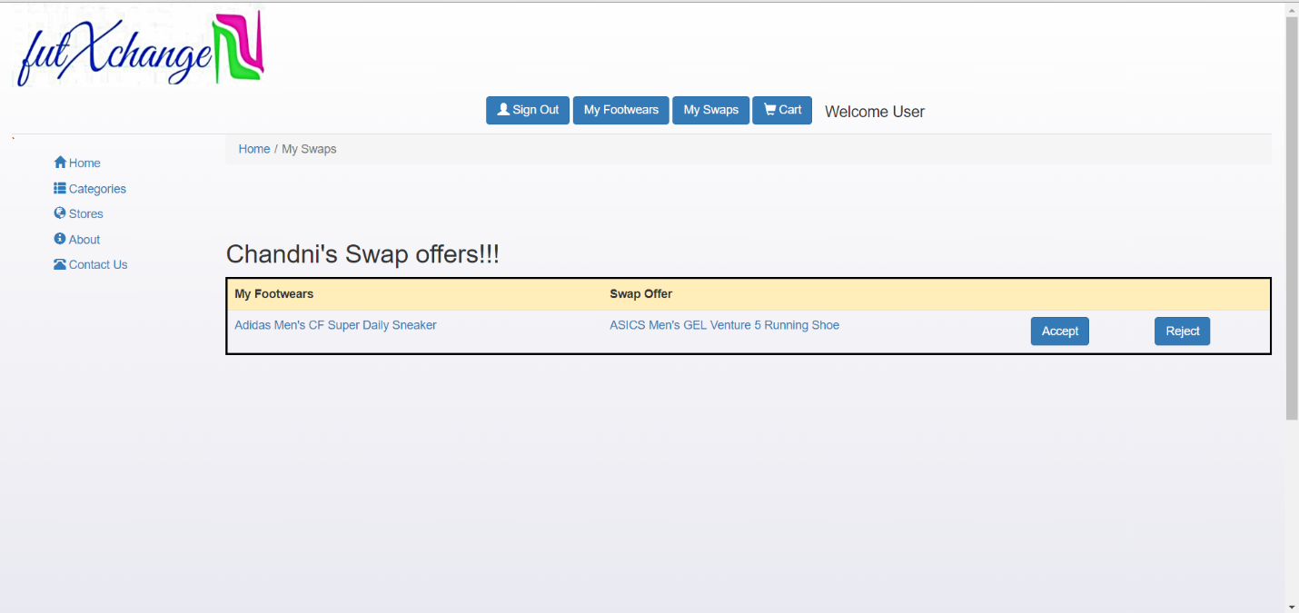My Swaps

This is the My Swaps page. It displays the user items which are yet to be confirmed. They can either be the swap offers initiated by the user or the Swap offers received. The user has now the capability to accept or reject the offer.

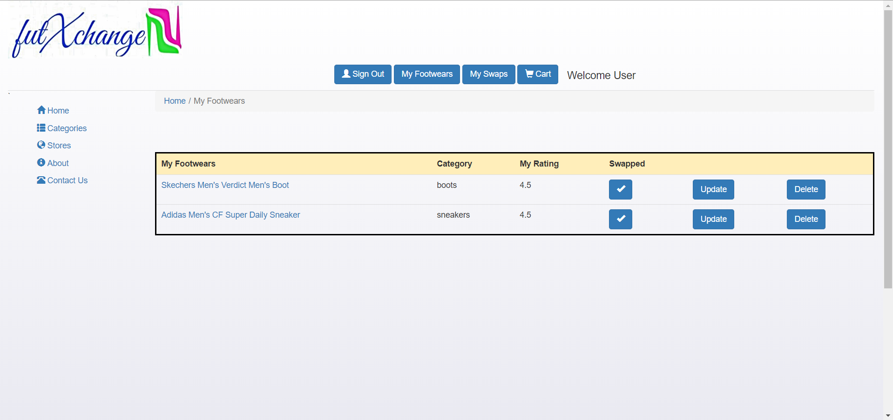

If the user clicks on the “Accept” button, the status will change to swapped and the swap will be completed.

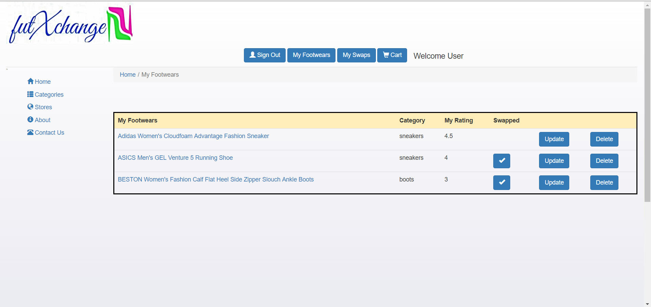

Once the swap offer is accepted by one user, the status for the same will change for the user who initiated the offer.

1. Feedback Page

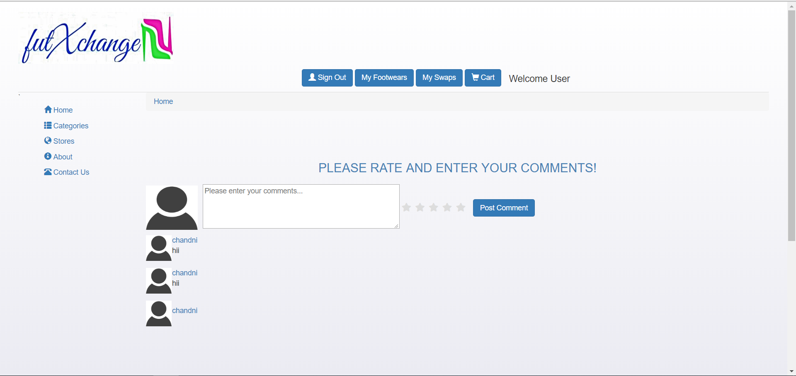

The user can find the “Rate It” button on the Item Page. However, they can only provide the feedback for Items they have swapped. If they have not they can view the comments provided by the other users.