Japan Elderly Population & Consumer Market Size Analysis Report (2020-2050)
Executive Summary
Japan faces an unprecedented demographic shift that is simultaneously a profound social challenge and a significant economic opportunity. By 2050, the elderly population (aged 65 and above) is projected to reach approximately 38.88 million individuals, representing 37.1% of the total population. This represents a net increase of nearly 2.9 million elderly citizens from 2020 levels, despite a declining overall population. The resulting "longevity economy"—encompassing healthcare, nursing care, and lifestyle services—generated approximately 96 trillion yen ($652.5 billion) in 2023 and is projected to expand to 115 trillion yen ($780 billion) by 2040. This analysis examines the demographic trajectory, consumption patterns, and market opportunities across four critical consumption categories: food, housing, clothing, and transportation.^{[1][2]}
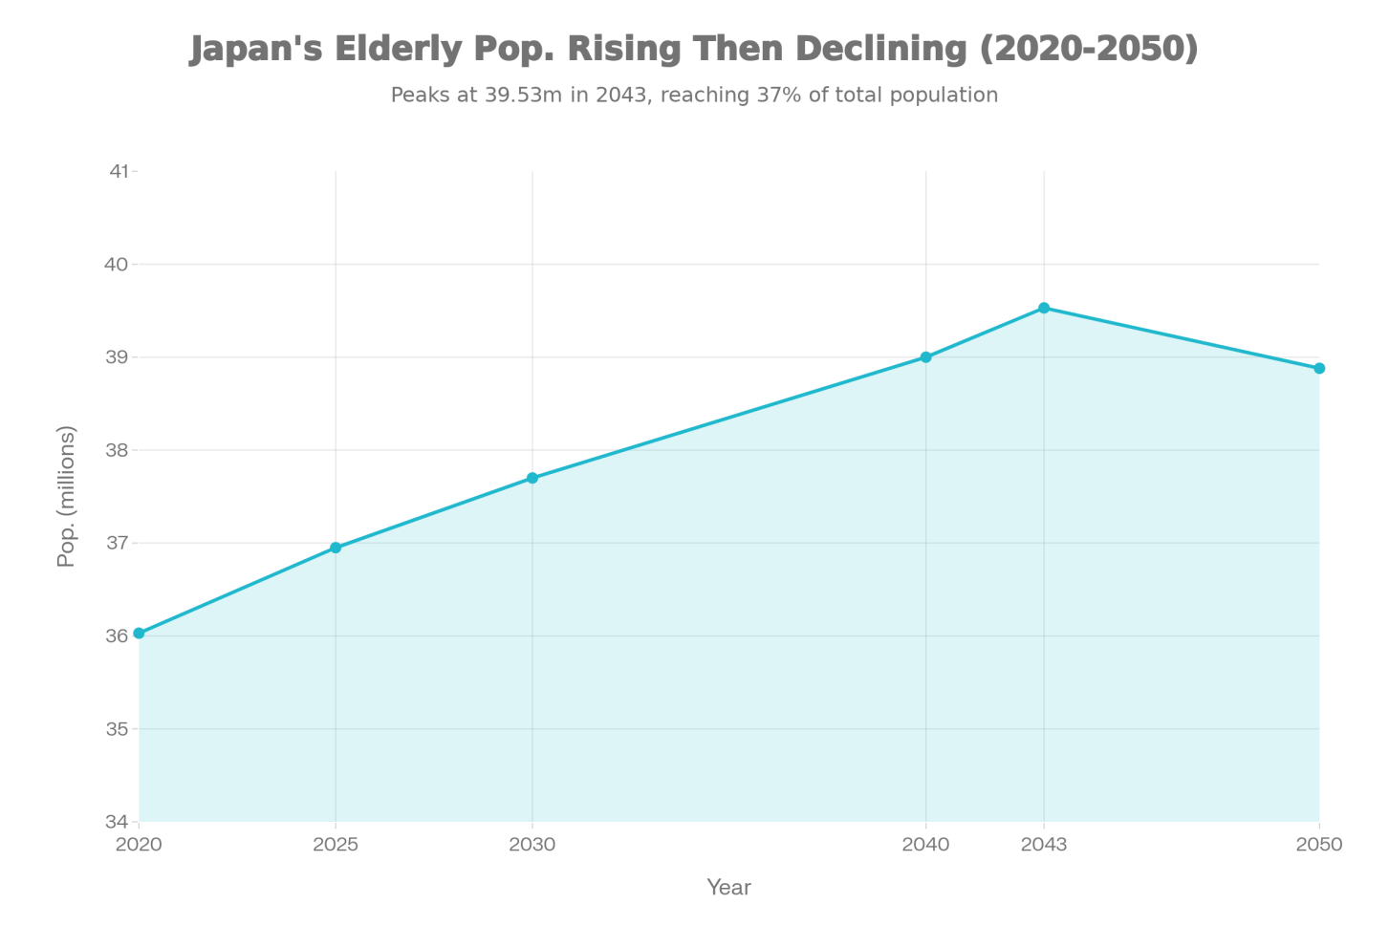
Japan's Elderly (65+) Population Trajectory, 2020-2050
Demographic Landscape: 2020-2050
Population Growth and Composition
As of 2024, Japan has 36.25 million elderly citizens, comprising 29.3% of the total population—the highest proportion globally. The National Institute of Population and Social Security Research projects that the 65+ population will continue growing, reaching approximately 37.7 million by 2030, peaking at 39.53 million in 2043, and declining modestly to 38.88 million by 2050. Critically, the age composition is shifting toward older elderly cohorts: the 75+ population has already surpassed the 65-74 population in size, and by 2024, approximately 10.4% of Japan's entire population (12.9 million individuals) were aged 80 and older.^{[3][4][1]}
The demographic composition has important implications for consumption patterns. The second baby boom generation (born 1971-1974) represents a particularly large cohort that will transition to elderly status between 2035 and 2050, creating sustained demand in elderly-focused markets. Furthermore, life expectancy projections indicate that by 2050, the centenarian population could reach 440,000—a five-fold increase from current levels.^{[5]}
Living Arrangements and Household Structure
A critical trend shaping consumption behavior is the rise of single-person elderly households. By 2050, approximately 10.84 million elderly individuals (nearly 20% of all households) are projected to live alone—a 47% increase from 2020 levels. This shift from multi-generational to single-person households has profound implications for food consumption (smaller portions, ready-to-eat meals), housing design (accessibility features, community amenities), and service demand (meal delivery, social engagement programs).^{[6]}
Market Size and Economic Value
Overall Longevity Economy
The elderly market in Japan represents one of the world's largest consumer demographics with substantial purchasing power. The longevity economy—comprising all goods and services consumed primarily by the 65+ population—was valued at approximately 96 trillion yen in 2023. This encompasses three primary sectors:^{[2]}
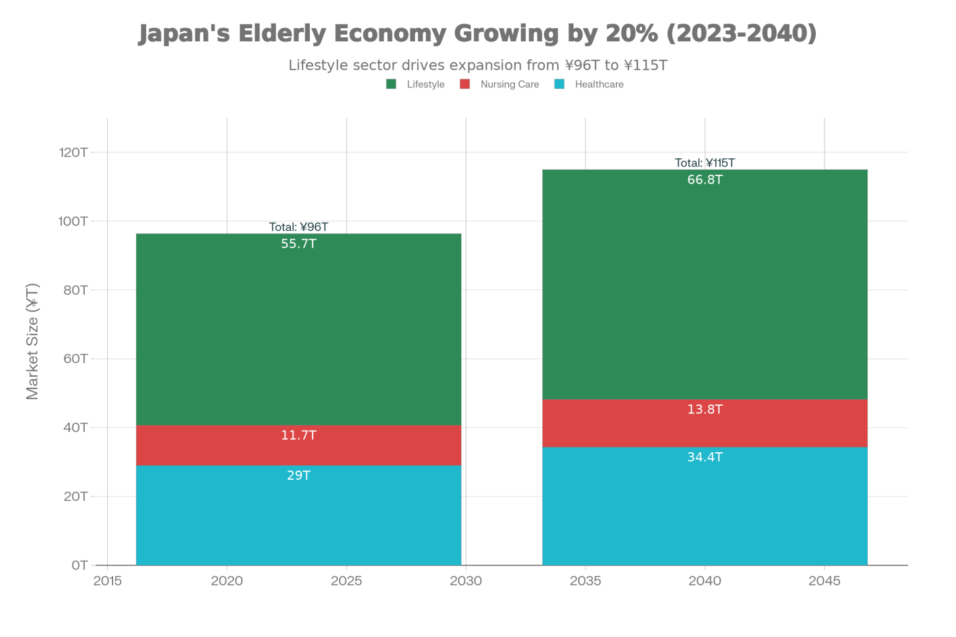
Japan's Elderly Market Size by Sector: 2023 vs. 2040 Projections (Trillion Yen)
Sector | 2023 Market Size | Share of Total | Projected 2040
Healthcare | ¥29 trillion ($195 billion) | 30.2% | ¥34.4 trillion
Nursing Care Services | ¥11.7 trillion ($79 billion) | 12.2% | ¥13.8 trillion
Lifestyle Industries | ¥55.7 trillion ($378 billion) | 57.6% | ¥66.8 trillion
Total | ¥96 trillion | 100% | ¥115 trillion

The longevity economy is projected to grow to 115 trillion yen by 2040, representing a 20% expansion over 17 years. This growth rate (approximately 1.1% annually) is modest relative to overall GDP growth, but reflects the stabilization of the elderly population after 2043, combined with potential increases in per-capita spending.^{[2]}
Healthcare Market Expansion
Healthcare represents the largest and fastest-growing sector within the elderly market. In 2024, elderly care subsidies reached a record 3.86 trillion yen, with the 75+ age group now accounting for over 41% of Japan's total medical spending—up from 34% in 2010. Per-capita medical costs escalate dramatically with age: the 65-69 age group costs approximately ¥490,000 annually, while the 85+ group exceeds ¥1 million per capita.^{[7][8]}
Projections indicate that total medical costs for the elderly will increase from ¥26.4 trillion in FY2020 to ¥28.5 trillion by FY2030. This represents a healthcare cost burden of approximately 2.7% of projected GDP in 2025, potentially rising further as the population ages and life expectancy increases.^{[8]}
Nursing Care and Long-Term Care Services
Long-term care services constitute a rapidly expanding market segment. In FY2021, per-capita long-term care costs averaged ¥140,000 per person, with significant age-related variation: the 65-69 age group cost ¥40,000, while the 90-94 age group exceeded ¥1 million per capita. Total long-term care costs are projected to increase from ¥10.5 trillion in FY2020 to ¥13.4 trillion by FY2030.^{[8]}
Specialized elderly care products (medical devices, mobility aids, incontinence products) represent a sub-market growing at 7.4% annually, with the market projected to expand from $1.75 billion USD (¥175 billion) in 2024 to $3.57 billion USD (¥357 billion) by 2033. Private nursing services in Japan generated $201.5 million USD in 2023 and are expected to reach $297.7 million USD by 2030, growing at 5.7% annually.^{[9][10]}
Category-Specific Consumption Analysis
Food & Beverage Market
Food represents the largest consumption category for elderly households, with average spending of ¥60,300 per month in 2024. Unlike younger cohorts, elderly consumers demonstrate distinct preferences: they prioritize fresh fish, fresh vegetables, and fresh fruits over dining out, reflecting both nutritional awareness and traditional dietary patterns.^{[11][12]}
As the elderly population living alone expands (projected 10.84 million by 2050), demand for portion-controlled, nutritious ready-to-eat meals surges. The ready-to-eat meals market in Japan is projected to reach $3.07 billion USD in 2025, growing at an average annual rate of approximately 3.5-4% through 2030. Elderly consumers seek healthy, low-sodium, high-fiber options with minimal preparation requirements. This trend is evident in the rising market for convenience food products specifically formulated for seniors, and an estimated 70.6% of Japanese municipalities report insufficient food access solutions for elderly consumers.^{[13][14]}
The broader convenience food market, while experiencing slower growth than historical rates due to overall population decline, continues to expand segment-wise for age-tailored products. Market research indicates that demand for elderly-targeted meal services (nutritionally optimized, portion-controlled, socially-aware) represents a multi-trillion yen opportunity not fully captured in traditional food retail metrics.
Housing & Home Modification Market
Housing consumption patterns for elderly residents reflect unique needs: elderly households spend only ¥15,500-18,000 per month on housing, substantially lower than younger cohorts (¥39,000-42,000 for those under 30), primarily due to high home ownership rates among the elderly (approximately 85% own their homes).^{[12]}
However, the housing market is undergoing a substantial transformation toward renovation and aging-in-place solutions. Approximately 44% of homeowners performed renovations in 2025, with the share rising from 38% in 2021. Elderly homeowners increasingly invest in barrier-free design, bathroom modifications, safety enhancements, and accessibility improvements. Roof and exterior repairs represent the largest category, followed by kitchen and bathroom improvements—all aligned with aging-in-place objectives.^{[15]}
The assisted living and senior housing market is expanding rapidly. Global senior living markets are projected to reach $388.55 billion USD by 2032 (from $260.12 billion USD in 2025), with Japan positioned as a market leader. Japan's Long-Term Care Insurance system, while primarily publicly funded, has stimulated growth in private senior housing facilities. The rise of single-person elderly households is driving demand for senior-friendly rental properties, particularly in urban centers where amenities (healthcare proximity, public transit, neighborhood services) are critical decision factors.^{[16]}
Clothing & Apparel Market
Elderly consumers demonstrate distinct clothing preferences, spending approximately ¥3,300-7,000 per month on clothing and footwear. While these absolute spending levels appear modest, the segment is experiencing significant innovation-driven growth. The Japan elderly clothing market is growing at a projected CAGR of 14.6% (2025-2033), compared to 2-3% for the overall apparel market.^{[17][12]}
Growth drivers include: (1) rising consumer awareness of comfort and functional design; (2) technological advances in adaptive fabrics (easy-closure systems, thermal regulation, incontinence-management textiles); (3) growing market acceptance of specialized elderly fashion; and (4) expanding e-commerce channels tailored to older consumers. Investment opportunities center on developing adaptive apparel, expanding online retail platforms dedicated to elderly consumers, and creating personalized shopping experiences (in-home fittings, home delivery services).
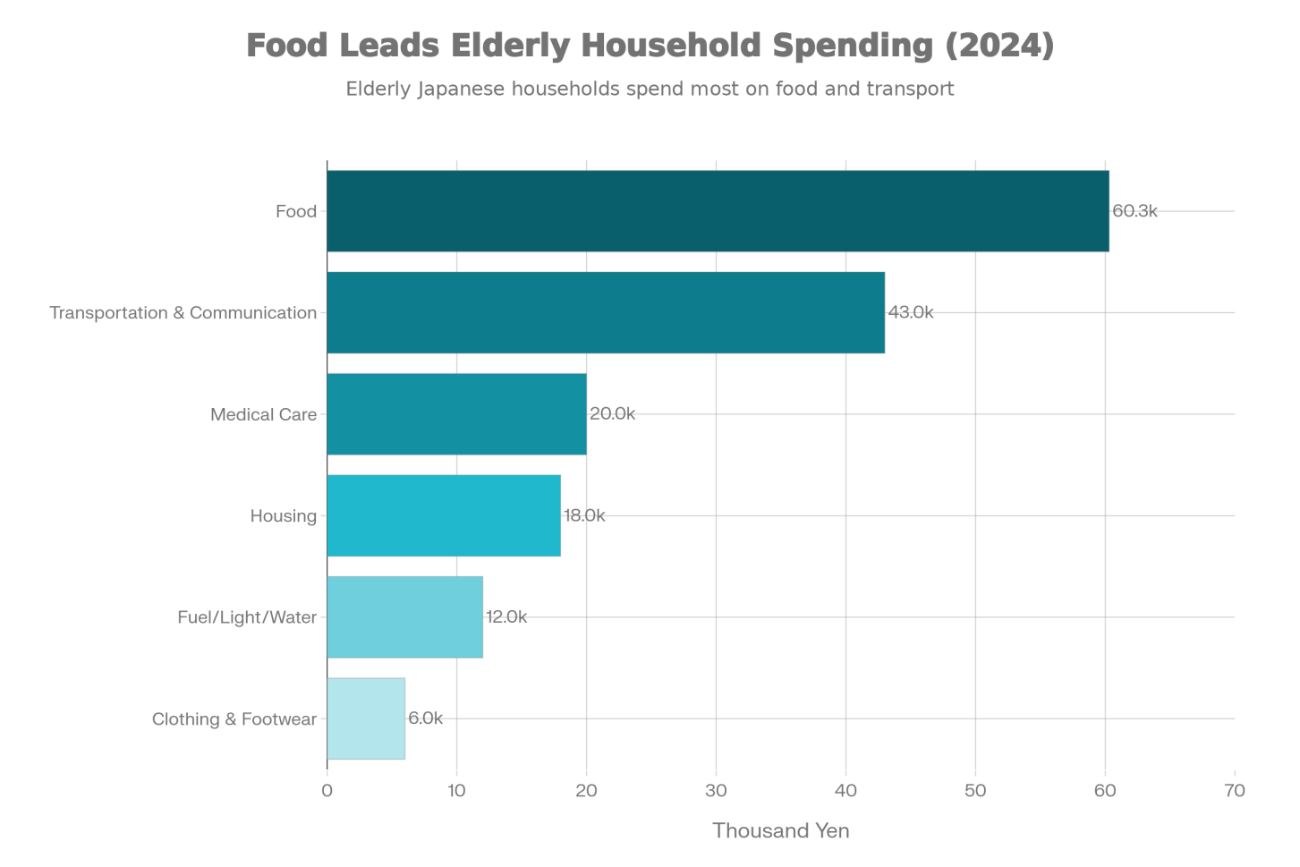
Average Monthly Household Consumption Spending (65+) by Category, 2024
Transportation & Communication Market
Transportation and communication combined represent the second-largest consumption category for elderly households at approximately ¥43,000 per month. This reflects both private vehicle maintenance and public transportation costs. However, this category faces structural headwinds: a growing proportion of elderly individuals voluntarily surrender driver's licenses due to safety concerns, particularly in rural areas where alternative transportation infrastructure is underdeveloped.^{[11]}
This trend has created two countervailing forces: (1) increased demand for public transportation, taxi services, and mobility solutions designed for elderly users; and (2) a growing "food access crisis" affecting elderly consumers, particularly in non-metropolitan areas where retail and food services closures have accelerated. Municipalities report that 89.7% need to implement or expand measures to improve food and service accessibility for elderly consumers, creating opportunities for community transportation services, meal delivery platforms, and neighborhood retail solutions.^{[13]}
Consumer Behavior and Willingness to Pay
Purchasing Power and Financial Capacity
Japanese elderly consumers maintain substantial purchasing power. Cabinet Office surveys indicate that approximately 65% of elderly citizens report either comfortable financial circumstances or minimal financial concerns. This financial security reflects two factors: (1) accumulated savings and home equity among the post-war generation; and (2) public pension systems that, while modest by international standards, provide baseline income security.^{[18]}
Household net assets for those 60+ average over ¥24 million ($180,000 USD), providing a substantial wealth base for discretionary consumption. Single elderly households continue to save despite their spending, suggesting that consumption is constrained not by inability but by perceived need and cultural preferences.^{[19]}
Preferences and Trust Dynamics
Elderly consumers prioritize quality, reliability, and longevity over novelty. Once trust is established with a brand or vendor, loyalty remains high, enabling cross-selling strategies across product categories. However, elderly consumers demonstrate greater reliance on traditional media (television, print) for information compared to younger cohorts, and express higher anxiety about online commerce security—a factor limiting e-commerce penetration rates despite growing digital adoption.
Changing Consumption Patterns Among Younger Elderly Cohorts
The "dankai" baby boomer generation (born 1947-1949) and their successors (born 1950-1965) exhibit markedly different consumption patterns from their elders. This cohort maintains higher activity levels, greater interest in leisure and travel, stronger technology adoption, and more openness to new products and international brands. As this generation ages into the 75+ bracket by 2030-2040, overall elderly consumption is likely to shift toward lifestyle and wellness services, contributing to the 57.6% share of "lifestyle industries" within the longevity economy.^{[20]}
Market Projections and Growth Drivers
Population-Driven Demand Growth
The demographic math is straightforward: with the elderly population projected to reach 39.5 million by 2043 (peak) and remain near 39 million through 2050, absolute demand for elderly-targeted goods and services will expand. Annual consumption growth in elderly-focused markets will be driven primarily by population increase rather than per-capita spending growth, which faces headwinds from declining pension adequacy and rising healthcare cost-sharing.
Sector-Specific Growth Trajectories
- Healthcare: Grows at approximately 0.8-1.2% annually due to population aging and rising per-capita costs, reaching ¥34 trillion by 2040 (18% cumulative increase from 2023).
- Nursing Care Services: Expands at 1.8-2.2% annually due to rising institutionalization rates and expanded service models, reaching ¥13.8 trillion by 2040 (18% cumulative increase).
- Lifestyle Industries: Experiences the most growth potential (1.5-2.0% annually) as discretionary spending among the "active elderly" segment increases, projected to reach ¥66.8 trillion by 2040 (20% cumulative increase).
Structural Constraints on Growth
Despite demographic tailwinds, several factors limit rapid elderly market expansion:
- Fiscal Pressures: Rising pension and healthcare costs are creating fiscal strain. The government is implementing reforms to increase cost-sharing among higher-income elderly citizens, potentially moderating consumption growth.
- Income Inequality Among Elderly: Approximately 54% of those 70+ have annual incomes below ¥2 million, with this low-income proportion rising over time as pension adequacy declines. This bifurcates the market into affluent retirees (high discretionary spending) and constrained retirees (necessities only).
- Population Decline: While the 65+ population remains stable through 2043, overall population decline (from 126 million in 2020 to 104.7 million by 2050) reduces working-age consumers and family caregivers, limiting supplementary spending.
Investment and Business Implications
High-Opportunity Segments
- Technology-Enabled Care Solutions: Care robots, AI-powered health monitoring, telemedicine, and smart home integration represent growth areas. Government subsidies (¥30 billion in 2025) are accelerating adoption.
- Housing and Home Services: Renovation, assisted living facilities, accessibility modifications, and community-based senior housing represent underserved segments with strong growth potential.
- Specialized Food and Nutrition: Ready-to-eat meals, nutritional supplements, meal delivery services, and food access solutions in underserved areas present significant opportunities.
- Financial and Retirement Services: Wealth management, long-term care insurance products, and financial planning services tailored to elderly needs show strong growth potential.
- Leisure and Wellness: Travel, fitness, cultural activities, and hobby-related products cater to the "active elderly" segment with higher disposable incomes and strong growth in participation rates.
Operational Considerations
- Channel Strategy: Physical retail and direct-to-consumer models remain critical given elderly preferences for in-person shopping and information-gathering. However, targeted online strategies (focused on ease-of-use, security assurance, and customer service) show promise.
- Trust and Relationship Building: Quality, reliability, and personalized service are premium positioning attributes.
- Regional Differentiation: Rural and secondary cities face acute elderly population concentrations (with some areas exceeding 50% elderly), creating both acute service gaps and concentrated consumer markets.
Conclusion
Japan's elderly population will remain one of the world's largest and most affluent senior consumer markets through 2050. The 38-39 million elderly individuals projected for that period represent a consumption base of approximately 100 trillion yen annually (at 2023 price levels), with structural growth potential in healthcare, nursing care, and lifestyle sectors. However, growth will be constrained by pension system pressures, income inequality among the elderly, and demographic decline among working-age populations.
The most significant market opportunities lie in segments addressing unmet needs: food security and nutrition services, housing modification and senior living facilities, technology-enabled care and wellness solutions, and lifestyle and leisure offerings for the increasingly active elderly cohort. Success in these markets will require understanding distinct elderly consumer preferences, establishing trust through reliable service delivery, and developing solutions tailored to single-person and isolated elderly households—a growing and underserved demographic segment.
Citations:
Reuters, Japan's elderly population living alone to jump 47% by 2050^{[6]}
Kyodo News, Japan's over-65s hit record high 36.25 mil.^{[3]}
European Parliament, Japan's ageing society^{[5]}
Japan Times, Japan's elderly population^{[4]}
Statista, Japan: monthly consumption spending per senior household^{[11]}
Nippon.com, Consumption Patterns of Japan's Elderly^{[12]}
Carter, Turning Silver into Gold^{[18]}
Demographic Challenge, Silver Business in Japan^{[19]}
Kadence, Inside Japan's Move Toward a Renovation-Led Housing Economy^{[15]}
FoodNavigator Asia, Japan government survey food access^{[13]}
Carter, Japan's Seniors' Market^{[20]}
P4H, Japan's Aging Crisis^{[7]}
IPSS, Population Projections for Japan 2023 revision^{[1]}
WEF, How Japan's longevity economy is creating new opportunities^{[2]}
Coherent Market Insights, Senior Living Market^{[16]}
Statista, Ready-to-Eat Meals Japan^{[14]}
IMARC Group, Japan Elderly Care Products Market^{[9]}
Grand View Research, Japan Private Nursing Services Market^{[10]}
Mitsui, Impact of Japan's Aging Population in 2030^{[8]}
Cognitive Market Research, Elderly Clothing Market Analysis^{[17]}
⁂
- https://www.ipss.go.jp/pp-zenkoku/e/zenkoku_e2023/pp2023e_Summary.pdf
- https://www.weforum.org/stories/2025/09/japans-longevity-economy/
- https://english.kyodonews.net/articles/-/50220
- https://www.japantimes.co.jp/news/2025/09/16/japan/society/japans-elderly-population/
- https://www.europarl.europa.eu/RegData/etudes/BRIE/2020/659419/EPRS_BRI(2020)659419_EN.pdf
- https://www.reuters.com/world/asia-pacific/japans-elderly-population-living-alone-jump-47-by-2050-research-2024-04-12/
- https://p4h.world/en/news/japans-aging-crisis-pushes-health-insurance-premiums-to-record-highs/
- https://www.mitsui.com/mgssi/en/report/detail/__icsFiles/afieldfile/2023/08/30/2307k_suzuki_e_2.pdf
- https://www.imarcgroup.com/japan-elderly-care-products-market
- https://www.grandviewresearch.com/horizon/outlook/private-nursing-services-market/japan
- https://www.statista.com/statistics/1242950/japan-average-monthly-consumption-spending-senior-household-by-category/
- https://www.nippon.com/en/in-depth/a04901/
- https://www.foodnavigator-asia.com/Article/2024/04/23/japan-government-survey-reveals-strong-need-to-improve-food-access-aid-for-elderly-consumers/
- https://www.statista.com/outlook/emo/food/convenience-food/ready-to-eat-meals/japan
- https://kadence.com/en-us/knowledge/inside-japans-move-toward-a-renovation-led-housing-economy/
- https://www.coherentmarketinsights.com/industry-reports/senior-living-market
- https://www.cognitivemarketresearch.com/elderly-clothing-market-report
- https://carterjmrn.com/blog/senior-market-buying-habits-japan/
- https://demographic-challenge.com/files/downloads/6211018f987444a57eedb418895740ba/silver_japan_english20091203.pdf
- https://carterjmrn.com/blog/japans-seniors-market-deeper-look-reveals-ample-opportunities/
- https://en.wikipedia.org/wiki/Aging_of_Japan
- https://www.nippon.com/en/japan-data/h02201/
- https://earth.org/understanding-japans-demographic-crisis-an-alternative-perspective-on-population-decline/
- https://pmc.ncbi.nlm.nih.gov/articles/PMC10615022/
- https://www.statista.com/statistics/1149301/japan-share-of-population-aged-65-and-above/
- https://www.oecd.org/content/dam/oecd/en/publications/reports/2024/04/addressing-demographic-headwinds-in-japan-a-long-term-perspective_85b9a67f/96648955-en.pdf
- https://www.linkedin.com/pulse/japans-silver-currency-initiatives-how-seniors-prem-barthasarathy-mrhwc
- https://tokyoesque.com/the-impact-of-japans-ageing-population-on-the-business-landscape/
- https://www.fao.org/4/ae025e/ae025e00.pdf
- https://onestepbeyond.co.jp/blog/how-japans-aging-population-is-driving-business-innovation/
- https://www.nationalgeographic.com/magazine/article/japan-aging-adapting-shrinking-population-feature
- https://www.statista.com/topics/12848/senior-consumers-in-japan/
- https://zenbird.media/japans-circular-economy-market-projected-to-reach-683-trillion-yen-by-2050/
- https://japannews.yomiuri.co.jp/society/general-news/20231223-157406/
- https://research.rhbtradesmart.com/sites/default/files/attachments/2023-11/reg_ageing_asean_thematic_research_20231108_rhb.pdf
- https://kadence.com/en-us/knowledge/unlocking-japans-market-potential-5-key-consumer-segments-to-target-for-growth/
- https://www.visualcapitalist.com/japans-aging-problem-in-one-chart/
- https://asianinsiders.com/2025/03/11/asia-seeks-investment-in-silver-economy-solutions/
- https://www.linkedin.com/pulse/japan-elderly-clothing-growth-forecast-resource-scarcity-dppgc
- https://www.huduser.gov/portal/sites/default/files/pdf/JapanCaseStudies.pdf
- https://www.marketresearch.com/Renub-Research-v3619/Japan-Convenience-Food-Outlook-Forecast-42383832/
- https://nippontradings.com/navigating-the-japan-2025-problem/
- https://wtocenter.vn/rcep-market/26499-consumer-characteristics-in-japan
- https://www.charlesworth-group.com/blog/japans-key-consumer-segments-marketing-success/
- https://www.bernama.com/en/news.php?id=2257038
- https://extranet.who.int/kobe_centre/sites/default/files/How will population ageing affect health expenditure trends in Japan.pdf
- https://www8.cao.go.jp/kourei/english/annualreport/2024/pdf/2024.pdf
- https://www.foodnavigator-asia.com/Article/2023/08/22/japanese-consumers-seek-healthy-hassle-free-and-affordable-rte-products-in-convenience-stores/
- https://voyen.com/journal/the-elder-care-gold-rush-how-japans-aging-crisis-is-fueling-a-private-equity-boom/
- https://www.linkedin.com/pulse/japan-elderly-clothing-market-key-drivers-challenges-tzfle
- https://www.polarismarketresearch.com/industry-analysis/private-nursing-services-market
- https://www.coherentmarketinsights.com/market-insight/nursing-care-services-market-800
- https://www.aarpinternational.org/file library/arc/countries/full reports/arc-report---japan.pdf

