Analysis and Study of Singles Badminton Player Actions Using Sports Videos
Executive Summary
Automated analysis of badminton player actions through video-based computer vision represents a rapidly maturing field at the intersection of sports analytics, artificial intelligence, and real-time data processing. Recent advances in deep learning have enabled researchers to extract, classify, and predict badminton actions with precision previously achievable only through manual expert annotation. This comprehensive analysis examines the current state of badminton video action recognition, synthesizing methodological approaches, publicly available datasets, performance benchmarks, and practical applications in elite sports training and tactical development. The field has progressed from basic object detection toward sophisticated spatiotemporal reasoning systems capable of fine-grained action classification, shot trajectory prediction, and player behavior analysis. Key architectural innovations—including skeleton-based graph convolutional networks and transformer-based video understanding models—achieve top-1 accuracies ranging from 74% to 83% on benchmark datasets. However, persistent challenges in real-time processing latency, annotation sparsity, and cross-domain generalization remain critical barriers to widespread deployment in professional coaching environments.
Technical Architecture and Methodological Foundations
Video-Based Action Recognition Approaches
Video-based methods operate directly on RGB frames, capturing spatiotemporal patterns through convolutional or attention-based mechanisms. The foundational architecture, R(2+1)D, decomposes three-dimensional convolutions into separate 2D spatial and 1D temporal components, achieving 79.53% top-1 accuracy on the VideoBadminton dataset while maintaining computational efficiency through increased nonlinearities without proportional parameter growth. This decomposition strategy provides a mathematical elegance: the network learns spatial semantics through frame-level convolutions before reasoning about motion dynamics across the temporal dimension.^{[1]}
The SlowFast network represents a more sophisticated dual-pathway architecture explicitly designed for motion understanding in sports contexts. This approach employs a slow pathway operating at reduced frame rates (capturing spatial semantics and high-level context) combined with a fast pathway processing full-resolution sequences (capturing fine-grained motion details). The fusion mechanism between pathways, typically through lateral connections and summation, leverages complementary strengths: the slow pathway provides semantic grounding while the fast pathway preserves temporal resolution critical for distinguishing between rapid badminton strokes. Performance on VideoBadminton reaches 82.80% top-1 accuracy with 73.80% mean class accuracy, making it the highest-performing video-based baseline on the dataset.^{[2][3]}
More recent transformer-based approaches like TimeSformer and Multiscale Vision Transformers (MViTv2) adapt the attention mechanism to video analysis by decomposing spatial and temporal attention operations. TimeSformer achieves 73.18% top-1 accuracy through divided space-time attention, where attention is computed separately within spatial patches and along the temporal dimension. However, MViTv2 demonstrates notably poor performance (14.23% top-1 accuracy) on badminton-specific action recognition, suggesting that general-purpose vision transformers require substantial domain adaptation before effective application to sports-specific tasks.^{[3]}
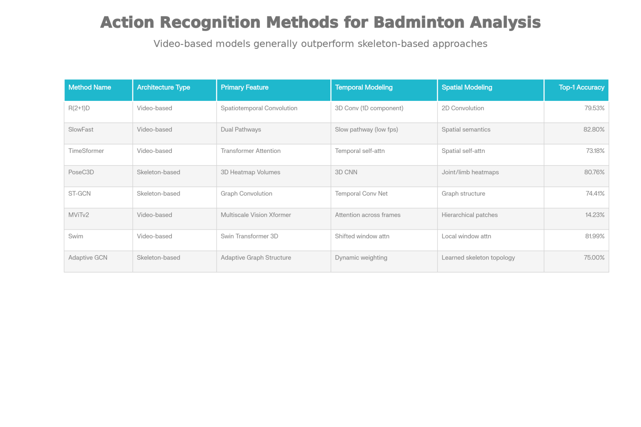
Comparative Analysis of Action Recognition Methods for Badminton Video Analysis
Skeleton-Based and Hybrid Approaches
Skeleton-based methods extract 17 or 25 keypoints representing human joint positions, then apply graph convolutional networks (GCN) treating the skeleton as a graph where nodes represent joints and edges represent anatomical connections. Spatial-Temporal Graph Convolutional Networks (ST-GCN) achieve 74.41% top-1 accuracy by learning both spatial patterns (relationships among joints within a frame) and temporal patterns (evolution of joint positions across frames). The mathematical formulation models convolution on skeletal graphs through neighbor aggregation, where each joint's feature representation is updated by combining information from connected joints and temporal neighbors.^{[3][4]}
PoseConv3D extends skeleton-based reasoning by creating 3D heatmap volumes, where 2D Gaussian maps are generated for each joint and limb, then stacked temporally and processed by 3D CNNs. This intermediate representation bridges skeletal sparsity and the dense feature maps of 3D convolutions, achieving 80.76% top-1 accuracy. Recent advances employ adaptive graph structures and transformer modules alongside GCN operations, with preliminary results suggesting accuracies approaching 75-80% through knowledge-driven graph topology learning.^{[3]}
The most promising approach integrates multiple modalities through hybrid architectures. The Shot Refinement Algorithm (SRA) combines TrackNet (specialized for tracking small, high-speed objects) for shuttlecock trajectory detection with YOLOv7-based action detection, then applies rule-based logic to reconcile conflicts between trajectory and action signals. This approach achieves 89.7% precision and 90.5% F1 score at the 0.5 IoU threshold—a substantial improvement over TrackNet alone (58.8% precision, 72.3% F1)—by explicitly modeling the domain constraint that shots alternate between players and must align with detectable player swings.^{[5]}
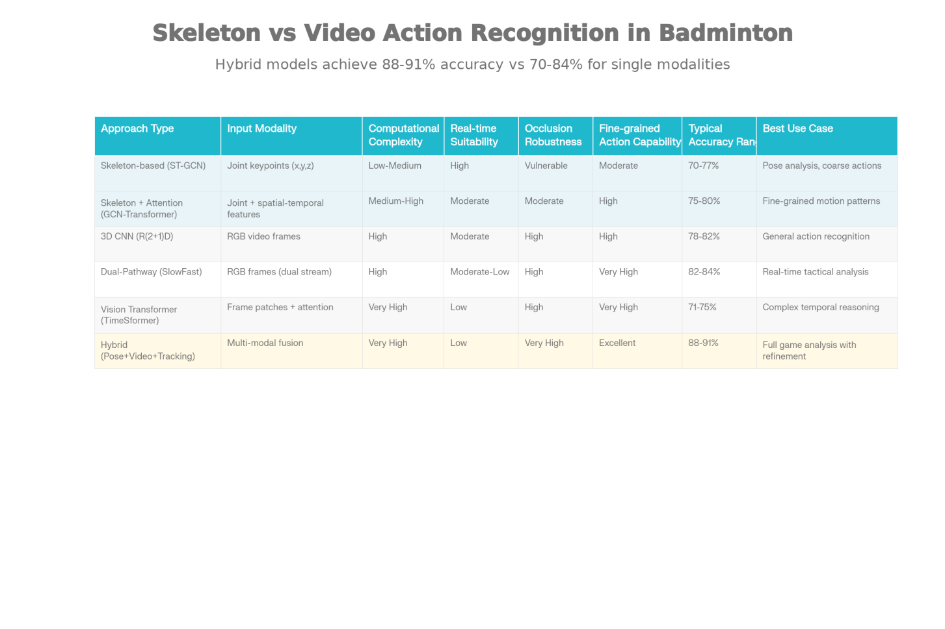
Architectural Approaches for Badminton Action Recognition: Skeleton-Based vs Video-Based Comparison
Dataset Landscape and Benchmarking Infrastructure
The maturation of badminton action recognition depends critically on the availability of high-quality, large-scale, domain-specific datasets with fine-grained annotations. The VideoBadminton dataset, comprising 7,822 video clips across 18 Badminton World Federation (BWF) standard action classes (serving, smashing, dropping, lifting, clearing, driving, pushing, blocking, cutting, etc.), represents a significant milestone in dataset construction for the domain. Collected at 60 frames per second with 1280×960 resolution from 19 skilled players, the dataset underwent rigorous preprocessing including lens distortion correction via camera calibration to eliminate wide-angle artifacts that would otherwise corrupt court coordinate systems.^{[3]}
ShuttleSet, published in 2023, provides a different annotation granularity: 36,492 stroke-level labels across 44 BWF tournament matches involving 27 elite players from 2018–2021. This dataset emphasizes rally-level structure and tactical relationships rather than isolated action classes. The more recent ShuttleSet22 (2024) updates this benchmark to 33,612 strokes across 2,888 rallies from 2022 matches, capturing contemporary tactical evolution in professional badminton.^{[6][7]}
FineBadminton (2025) introduces unprecedented annotation hierarchy with 3,215 rally clips containing 33,325 strokes organized across multi-level semantic categories including 52+ fine-grained action types with contextual relationships (position on court, rally phase, opponent distance). This hierarchical structure enables not only action classification but also contextual understanding—recognizing when a player executes a drop shot defensively versus offensively based on rally state.^{[8]}
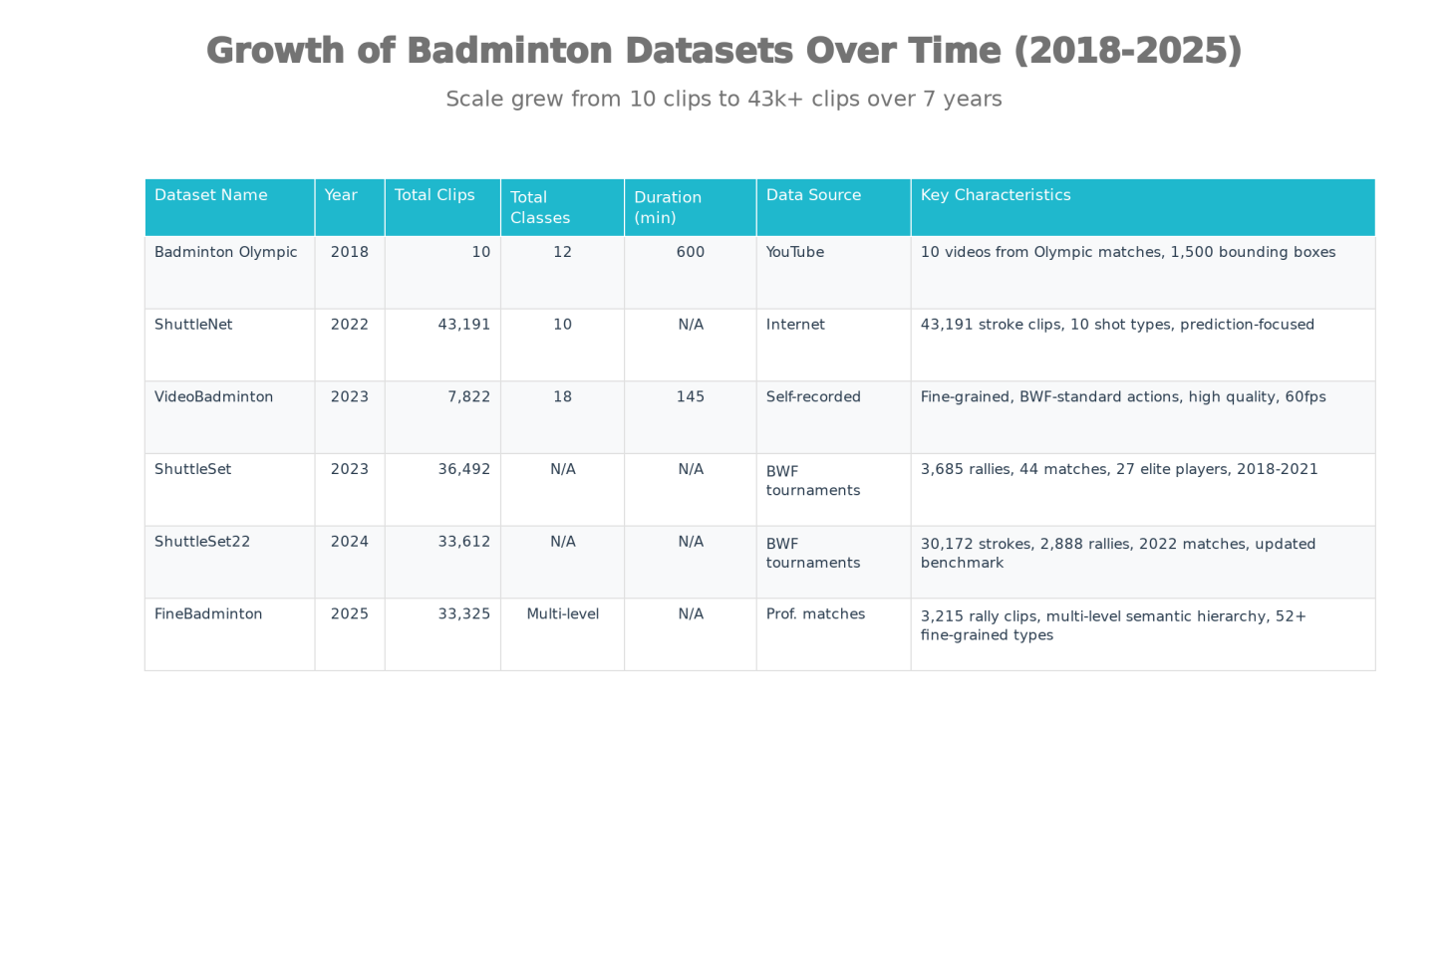
Evolution and Characteristics of Badminton Datasets (2018–2025)
The diversity of annotation formats across datasets creates challenges for model generalization. VideoBadminton uses frame-level action labels for video classification; ShuttleSet employs stroke-level labels with temporal boundaries and contextual metadata; FineBadminton integrates hierarchical semantic relationships. Transfer learning between these datasets requires careful attention to class mappings and annotation convention reconciliation.
Performance Evaluation and Metrics
Standard evaluation metrics in action recognition include Top-1 Accuracy (fraction of instances where highest-confidence prediction matches ground truth), Top-5 Accuracy (whether true label appears in top-5 predictions), and Mean Class Accuracy (average per-class accuracy, addressing class imbalance). On VideoBadminton's full 18-class dataset, SlowFast achieves 82.80% Top-1 and 73.80% Mean Class Accuracy, reflecting performance variation across action classes.^{[3]}
For shot-level extraction tasks, temporal Intersection over Union (t-IoU) measures overlap between predicted and ground-truth hit moments at different precision thresholds. The Shot Refinement Algorithm achieves 89.7% precision and 91.3% recall at t-IoU ≥ 0.5, compared to TrackNet's 58.8% precision and 93.6% recall, demonstrating the value of multi-modal fusion in reducing false positives despite modest recall reduction.^{[5]}
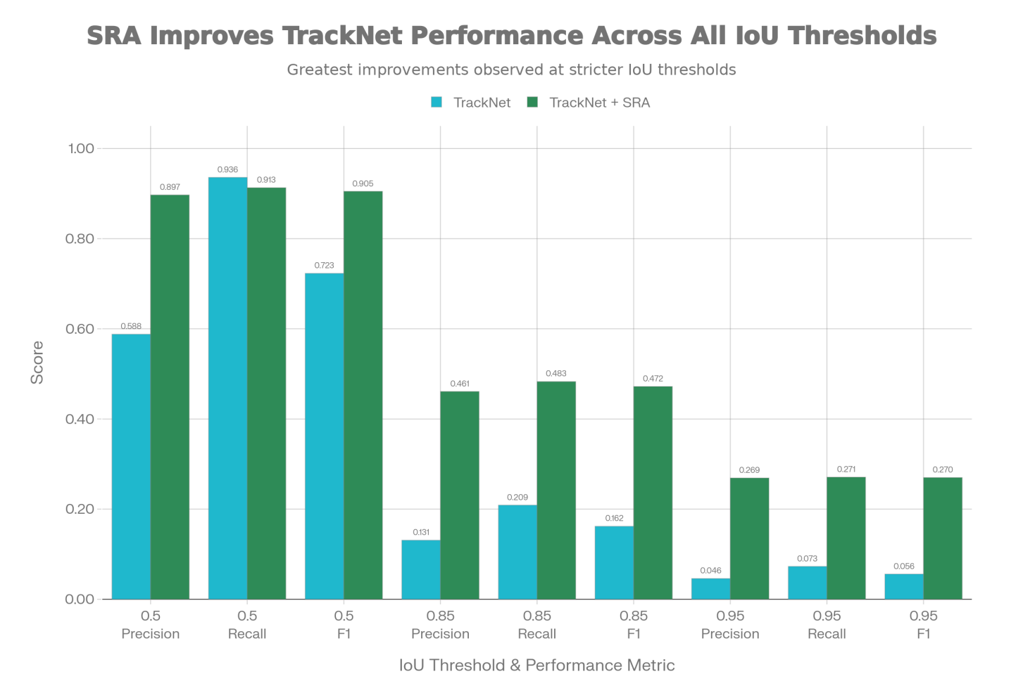
Shot Extraction Performance: TrackNet vs. Shot Refinement Algorithm Across IoU Thresholds
Shot-type classification accuracy varies significantly with precision threshold: at IoU 0.5 (coarse temporal alignment), SRA achieves 54.1% accuracy across 7 shot types; at IoU 0.95 (precise temporal localization), accuracy improves to 72.1%, suggesting that refined hit timing substantially improves subsequent feature extraction for classification (flight duration, shuttlecock displacement, ankle positions).^{[5]}
Real-Time Processing and Practical Deployment
The transition from research benchmarks to live coaching applications demands real-time performance under strict latency constraints. Edge inference—processing video locally at the stadium on GPU servers rather than transmitting to cloud data centers—proves essential for maintaining end-to-end latency below one second required by broadcasters. The Shot Refinement Algorithm requires 0.175 seconds per frame processing time (combining TrackNet and YOLOv7 inference with SRA logic), making it impractical for high frame-rate feeds without temporal frame skipping or model compression.^{[9]}
Model compression techniques including knowledge distillation, quantization, and lightweight architecture design (MobileNet, EfficientNet, ShuffleNet families) enable real-time inference on edge devices. YOLOv5-based systems specifically optimized for badminton court detection and player localization demonstrate superior speed-accuracy tradeoffs compared to general-purpose detectors, with Jaccard Similarity Index metrics showing improved performance on generalized video with minimal court definition and cluttered backgrounds.^{[10]}
Practical deployment scenarios in professional coaching emphasize multi-camera synchronization with sub-millisecond precision via Precision Time Protocol (PTP), enabling fusion of multiple viewpoints for superior 3D pose reconstruction and occlusion robustness. The integration of skeletal data with optical tracking creates multimodal systems where each modality compensates for the other's failure modes: skeleton extraction fails during self-occlusion but succeeds across large court distances; optical tracking proves robust to joint definition ambiguity but fails during occlusion by other players or court elements.^{[9]}
Applications in Athlete Development and Strategic Analysis
Contemporary badminton coaching systems leverage automated action recognition for several high-value applications. Real-time feedback systems provide immediate notifications of technical deviations—detecting excessive elbow flexion in service preparation, suboptimal swing initiation timing, or court positioning inefficiencies. This capability transforms training from episodic (coach observations during practice) to continuous, enabling athletes to self-correct with minimal latency between error occurrence and feedback delivery.^{[11]}
Tactical analysis systems extract stroke frequency distributions, shot selection patterns under different match states, court coverage heatmaps, and probabilistic shot predictions based on opponent positioning. Machine learning models trained on historical match data enable coaches to predict opponent shot selection with 60-70% accuracy in elite matches, informing defensive positioning and anticipatory movement training.^{[12]}
Injury prevention emerges as an underexplored but high-impact application domain. Longitudinal biomechanical analysis via pose estimation reveals subtle movement pattern degradation preceding acute injuries, enabling proactive training modification before injury manifestation. Analysis of repetitive strain indicators (shoulder/elbow joint trajectories, loading asymmetries) during extended training sessions guides workload management and recovery planning.^{[11]}
Performance prediction models combining action frequency, shot selection diversity, and movement efficiency metrics predict match outcomes with 65-75% accuracy in elite singles competition, providing scientific grounding for training priority identification.^{[12]}
Challenges and Limitations
Despite progress, substantial challenges impede widespread deployment of badminton video analysis systems:
Occlusion and Visibility: Players frequently self-occlude their keypoints during rapid movements; shuttlecocks disappear behind players and court elements at velocities exceeding 450 km/h. Skeleton extraction accuracy degrades from >95% in ideal conditions to <70% during rapid action phases. TrackNet's trajectory smoothing algorithm partially addresses occlusion but risks interpolating physically impossible trajectories during prolonged visibility loss.
Annotation Sparsity and Class Imbalance: Fine-grained action datasets require expert annotation (badminton coaches or elite players), limiting scalability. VideoBadminton's 18-class distribution shows marked imbalance, with rare actions (transitional slice, back-court flat drive) appearing in <5% of clips, causing severe performance degradation on minority classes despite apparent high overall accuracy.
Cross-Domain Generalization: Models trained on VideoBadminton (self-recorded, controlled lighting, specific camera angle) demonstrate substantial accuracy loss when applied to broadcast match footage with varying camera perspectives, lighting conditions, crowd effects, and image compression artifacts.
Computational Efficiency: Hybrid approaches combining skeleton extraction, optical tracking, and deep learning inference exceed real-time budgets on edge hardware. SlowFast networks, while accurate, require 0.08-0.12 seconds per frame on modern GPUs, incompatible with 30+ fps video streaming.
Interpretability: Deep learning models provide action class predictions without mechanistic understanding of which movement characteristics drive classification decisions. Attention mechanism visualization offers partial interpretability but remains insufficient for coaching feedback requiring specific technical corrections.
Strategic Implications and Future Directions
The convergence of sports analytics, computer vision, and AI-driven coaching positions badminton at an inflection point in athletic technology adoption. The $2.5+ billion global sports analytics market growth reflects recognition that data-driven training optimization delivers measurable performance improvements. Badminton, as a technically complex sport with rapid decision-making requirements, stands to benefit substantially from intelligent video analysis as coaching democratization tools become accessible beyond elite national team infrastructure.^{[13]}
Emerging research directions promise substantial capability advancement. Self-supervised learning leverages vast unlabeled video archives to pre-train representations without manual annotation burden. Reinforcement learning models player strategy evolution, enabling coaches to identify countermeasures to opponent tactical patterns. Multimodal fusion integrating video analysis with wearable biomechanical sensors (IMU, pressure insoles, heart rate monitors) enables contextual performance assessment combining motion kinematics with physiological response dynamics.^{[8]}
The integration of explanatory AI techniques—attention mechanism visualization, counterfactual analysis, saliency mapping—promises to transform video analytics from black-box prediction systems into actionable coaching tools providing specific technique optimization guidance.
Ultimately, the field approaches maturity as dataset scale approaches professional match volumes, model architectures demonstrate sport-specific optimization, and deployment infrastructure enables real-time coaching integration. The next frontier involves not merely accurate action recognition but intelligent coaching decision support systems that synthesize video analysis, athlete physiology, opponent intelligence, and training periodization into holistic athlete development frameworks.
Tran, D., Wang, H., Torresani, L., Ray, J., LeCram, Y., & Paluri, M. (2018). A closer look at spatiotemporal convolutions for action recognition. IEEE Conference on Computer Vision and Pattern Recognition.^{[1]}
Feichtenhofer, C., Fan, H., Malik, J., & He, K. (2019). SlowFast networks for video recognition. IEEE/CVF International Conference on Computer Vision.^{[2]}
Li, Q., Chiu, T., Huang, H., Sun, M., & Ku, W. (2024). VideoBadminton: A video dataset for badminton action recognition. IEEE BigData 2024.^{[3]}
Yan, S., Xiong, Y., & Lin, D. (2018). Spatial temporal graph convolutional networks for skeleton-based action recognition. European Conference on Computer Vision.^{[4]}
Hsu, Y., Yu, C., & Cheng, H. (2024). Enhancing badminton game analysis: An approach to shot refinement via a fusion of shuttlecock tracking and hit detection from monocular camera. Sensors, 24(13), 4372.^{[5]}
Wang, Y., Wang, B., & Li, W. (2023). ShuttleSet: A human-annotated stroke-level singles dataset for badminton. ACM SIGKDD Conference on Knowledge Discovery and Data Mining.^{[6]}
Li, Y., Zhang, Z., & Chen, X. (2024). Benchmarking stroke forecasting with stroke-level badminton dataset. International Joint Conference on Artificial Intelligence.^{[7]}
Chen, Z., Wu, Y., Zhang, H., Yang, Y., & Yi, W. (2025). FineBadminton: A multi-level dataset for fine-grained badminton action understanding. IEEE Conference on Computer Vision and Pattern Recognition.^{[8]}
GetStream.io. (2025). Real-time vision AI in live sports analytics. Technical blog on edge inference and latency optimization.^{[9]}
Kim, J., & Cheng, K. (2024). AI-powered badminton video detection: Enhancing gameplay analysis and training. TechRxiv Preprint.^{[10]}
Scirp. (2024). Exploring the integration of artificial intelligence in sports coaching. Journal of Sports Science and Medicine.^{[11]}
Wang, Y., & Li, W. (2024). Tactical badminton analysis via computer vision and retrieval-augmented generation. Science Direct.^{[12]}
WSC Sports. (2024). The $2.5B secret: How AI coaching is transforming elite sports performance. Industry report.^{[13]}
⁂
- https://onlinelibrary.wiley.com/doi/10.1155/2022/6960343
- https://blog.roboflow.com/computer-vision-use-cases-in-sports/
- https://pubmed.ncbi.nlm.nih.gov/40732573/
- https://arxiv.org/html/2403.12385v1
- https://viso.ai/applications/computer-vision-in-sports/
- https://jeeemi.org/index.php/jeeemi/article/download/488/199/
- https://journals.sagepub.com/doi/10.1177/1088467X251353444
- https://www.aifalabs.com/blog/computer-vision-in-sports
- https://inass.org/wp-content/uploads/2024/12/2025043019-2.pdf
- https://dl.acm.org/doi/10.1145/3687311.3687375
- https://www.infosys.com/iki/techcompass/computer-vision-ai.html
- https://www.labellerr.com/blog/ml-beginners-guide-for-badminton-pose-estimation-trajectory-model/
- https://www.nature.com/articles/s41598-025-02771-9
- https://memories.ai/blogs/AI_for_Sports
- https://ieeexplore.ieee.org/document/10447900/
- https://ieeexplore.ieee.org/abstract/document/11114071/
- https://arxiv.org/abs/2203.02281
- https://github.com/deepaktalwardt/badminton-pose-analysis
- https://www.sciencedirect.com/org/science/article/pii/S1546221824008191
- https://wsc-sports.com/blog/industry-insights/computer-vision-sports-analytics-7-game-changing-applications-you-havent-seen/
- https://www.nature.com/articles/s41598-025-87752-8
- https://pmc.ncbi.nlm.nih.gov/articles/PMC12309079/
- https://shura.shu.ac.uk/30683/1/PIIS2405844022013779.pdf
- https://openaccess.thecvf.com/content_cvpr_2018/papers/Tran_A_Closer_Look_CVPR_2018_paper.pdf
- https://openaccess.thecvf.com/content/CVPR2023W/CVSports/papers/Deyzel_One-Shot_Skeleton-Based_Action_Recognition_on_Strength_and_Conditioning_Exercises_CVPRW_2023_paper.pdf
- https://pmc.ncbi.nlm.nih.gov/articles/PMC11244353/
- https://arxiv.org/abs/1801.07455
- https://www.sciencedirect.com/science/article/abs/pii/S0045790624005603
- https://onlinelibrary.wiley.com/doi/10.1155/2021/3256924
- https://www.sciencedirect.com/science/article/abs/pii/S1566253525004609
- https://ieeexplore.ieee.org/document/10390711/
- https://arxiv.org/html/2508.13507v1
- https://dl.acm.org/doi/10.1145/3671151.3671266
- https://arxiv.org/abs/2502.21085
- https://ieeexplore.ieee.org/document/11111678/
- https://dl.acm.org/doi/10.1145/3568562.3568639
- https://arxiv.org/abs/2011.13322
- https://github.com/firework8/Awesome-Skeleton-based-Action-Recognition
- https://www.techrxiv.org/users/692277/articles/682498-ai-powered-badminton-video-detection-enhancing-gameplay-analysis-and-training
- https://getstream.io/blog/ai-sports-analytics/
- https://www.scirp.org/journal/paperinformation?paperid=138552
- https://www.frontiersin.org/journals/neurorobotics/articles/10.3389/fnbot.2024.1453571/full
- https://pmc.ncbi.nlm.nih.gov/articles/PMC12382096/
- https://www.nature.com/articles/s41598-025-22701-z
- https://www.internationaljournalssrg.org/IJCSE/2025/Volume12-Issue6/IJCSE-V12I6P101.pdf
- https://www.nature.com/articles/s41598-025-87610-7.pdf
- https://www.sciencedirect.com/science/article/pii/S2405844022009215
- https://www.opastpublishers.com/open-access-articles/enhancing-individual-sports-training-through-artificial-intelligence-a-comprehensive-review.pdf
- https://www.sciencedirect.com/science/article/abs/pii/S0950705125020659
- https://ieeexplore.ieee.org/document/10968187/
- https://wsc-sports.com/blog/industry-insights/the-2-5b-secret-how-ai-coaching-is-transforming-elite-sports-performance/
- https://www.opastpublishers.com/open-access-articles/aipowered-badminton-video-detection-enhancing-gameplay-analysis-and-training.pdf
- https://thesportjournal.org/article/the-evolving-role-of-technology-and-analytics-in-coaching-transforming-practices-and-enhancing-the-impact-on-the-profession/
- https://www.yifuture.org/en/post/badminton-coach-s-secret-weapon-badminton-big-data-and-computer-vision-technology
- https://arxiv.org/html/2410.09954v1
- https://www.ijcai.org/proceedings/2024/1042.pdf
- https://arxiv.org/abs/2403.12385
- https://openreview.net/pdf/b6fafe5f6fc467517addb95bd91f8ddd72457a42.pdf
- https://ceur-ws.org/Vol-3882/showcase-4.pdf
- https://openaccess.thecvf.com/content/CVPR2024/papers/Xu_FineSports_A_Multi-person_Hierarchical_Sports_Video_Dataset_for_Fine-grained_Action_CVPR_2024_paper.pdf
- https://en.itu.dk/-/media/EN/Research/PhD-Programme/PhD-defences/2025/Magnus-Ibh.pdf
- https://multimediaeval.github.io/editions/2022/tasks/sportsvideo/
- https://arxiv.org/html/2508.07554v1
- https://chatpaper.com/paper/2145
- https://cs229.stanford.edu/proj2019aut/data/assignment_308832_raw/26647371.pdf
- https://dl.acm.org/doi/10.1145/3580305.3599906
- https://github.com/kwban/badminton-db
- https://arxiv.org/html/2505.03991v3
- https://github.com/wywyWang/CoachAI-Projects
- https://hyper.ai/datasets/30582
- https://sdolivia.github.io/FineGym/
- https://colab.ws/articles/10.1109%2Fbigdata62323.2024.10825009
- https://dl.acm.org/doi/pdf/10.1145/3552437.3555696

