**Operating System Homework 3 Report**

Student ID: 0416249

Name: Chan Jack Kee

**Detailed description of the implementation:**(Number of threads, the purpose of those threads, how do you use mutex lock and semaphore…etc.)

I use 5 threads for each picture. For each picture, implement 6 thread. 3 for the turn rgb to blur function to cut out the size of the for loop and the left for the function which write the data to the pic_final array.

The semaphore is use for ensure wait for the entire array from rgb to blur function.

**Your speed:**

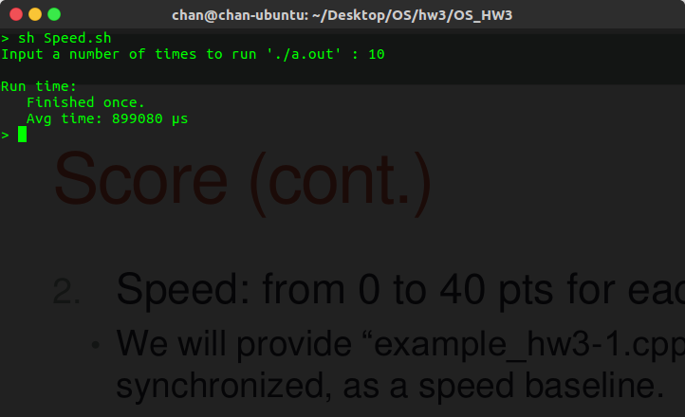

**Problems encountered and solutions:**

it is hard to implement the mutex lock in the code. I had think about the synchronization for a long time.

At the end I give up the mutex lock on my work, try to use semaphore in the code. Then the code works perfectly on homework 3-1.