**Flow chart**

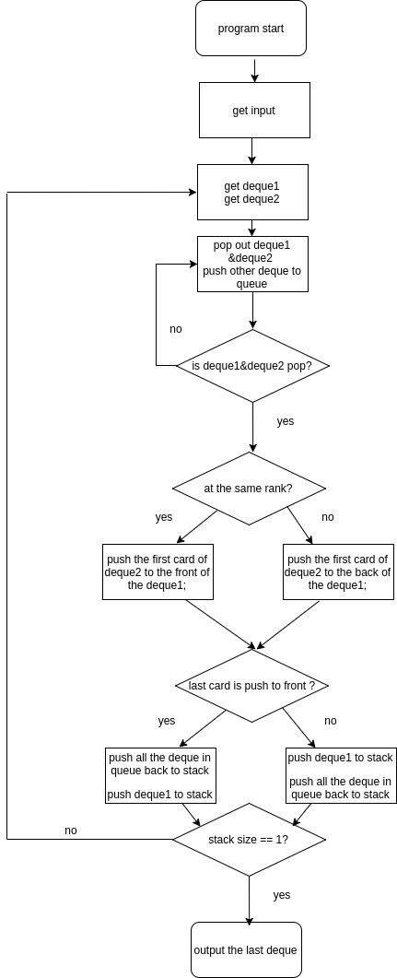

**pseudo code**

while(input!=#)

get the deque and push into stack;

while(stack size != 1)

{

get two number from the file;

deque1 = stack[first number];

deque2 = stack[second number];

while(1)

push the unused deque to queue until the deque1, deque2 are pop out;

while(until the deque2 was empty)

{

compare the first card of deque1 and the first card of deque2;

if (the card in the same rank(same number or same pic))

push the first card of deque2 to the front of the deque1;

else

push the first card of deque2 to the back of the deque1;

}

if (the last card is push to front)

{

push all the deque in queue back to stack;

push deque1 to stack;

}

else

{

push deque1 to stack;

push all the deque in queue back to stack;

}

}

print out the deque in stack;

**time complexity**

7 + 2max(first number, second number) + 5*sizeof(deque2) + 2*sizeof(queue)+1 + 2 + 2*sizeof(deque)

= 10 + 2max(first number, second number) + 5*sizeof(deque2) + 2*sizeof(queue) + 2*sizeof(deque)

= 10 + 2n +5n +2n+ 2n

= 11n+10

= O(n)