Filename: | /media/cirilo/Datos/Proyectos/Agesic/Datos Abiertos/Poder Judicial/TransPJ (copia)/00-parametros.ktr
Name: | 00-parametros
Description:
Long description:
Logging:
Creation: | 2017/07/05 09:32:40.313 by -
Modification: | 2017/07/05 09:32:40.313 by -
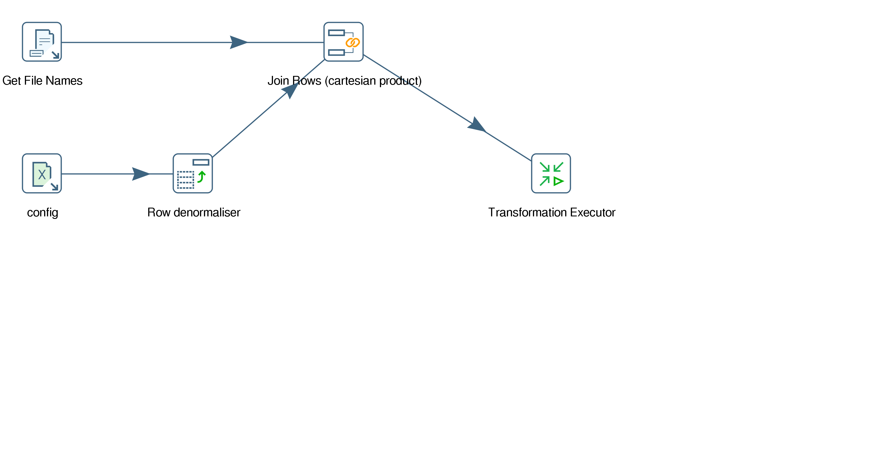
Filename: | /media/cirilo/Datos/Proyectos/Agesic/Datos Abiertos/Poder Judicial/TransPJ (copia)/001-parametros.ktr
Name: | 001-parametros
Description:
Long description:
Logging:
Creation: | 2017/07/05 09:32:40.313 by -
Modification: | 2017/07/05 09:32:40.313 by -
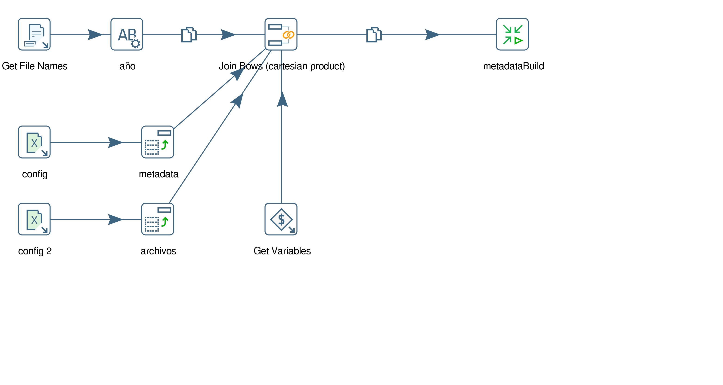
Filename: | /media/cirilo/Datos/Proyectos/Agesic/Datos Abiertos/Poder Judicial/TransPJ (copia)/01-archivos_input.ktr
Name: | leeo_archivos
Description:
Long description:
Logging:
Creation: | 2017/06/26 08:17:44.653 by -
Modification: | 2017/06/26 08:17:44.653 by -
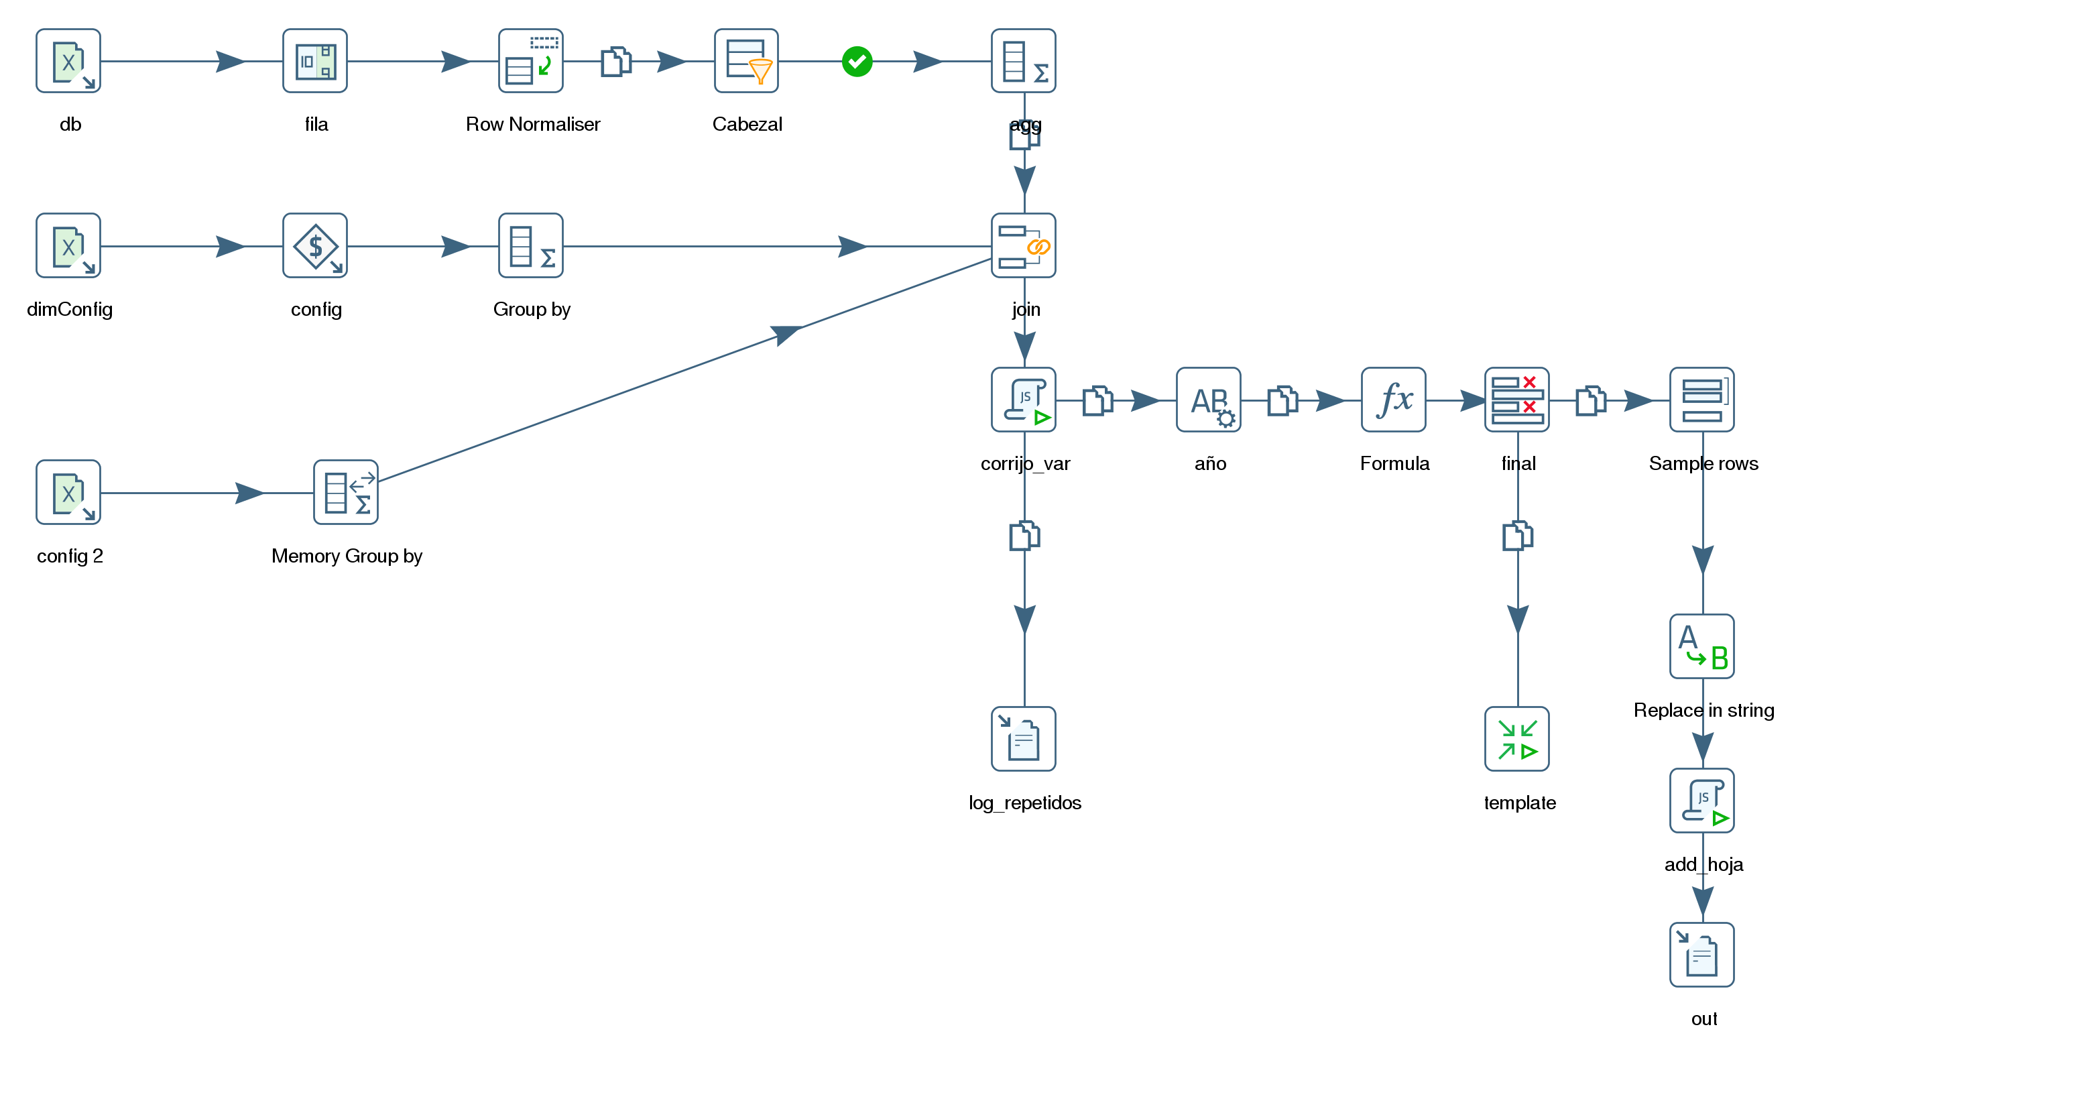
Filename: | /media/cirilo/Datos/Proyectos/Agesic/Datos Abiertos/Poder Judicial/TransPJ (copia)/BAC/001-parametros.ktr
Name: | 001-parametros
Description:
Long description:
Logging:
Creation: | 2017/07/05 09:32:40.313 by -
Modification: | 2017/07/05 09:32:40.313 by -
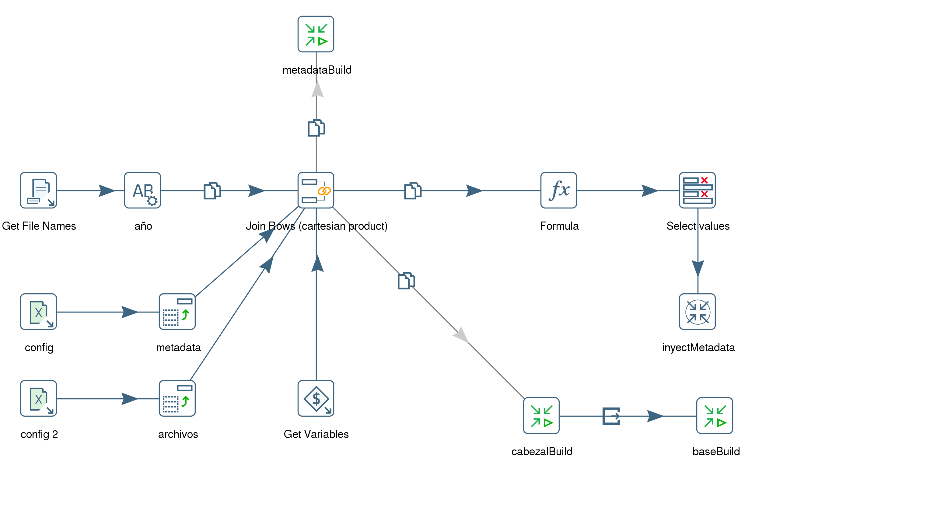
Filename: | /media/cirilo/Datos/Proyectos/Agesic/Datos Abiertos/Poder Judicial/TransPJ (copia)/BAC/json.ktr
Name: | json
Description:
Long description:
Logging:
Creation: | 2017/07/04 11:11:19.521 by -
Modification: | 2017/07/04 11:11:19.521 by -
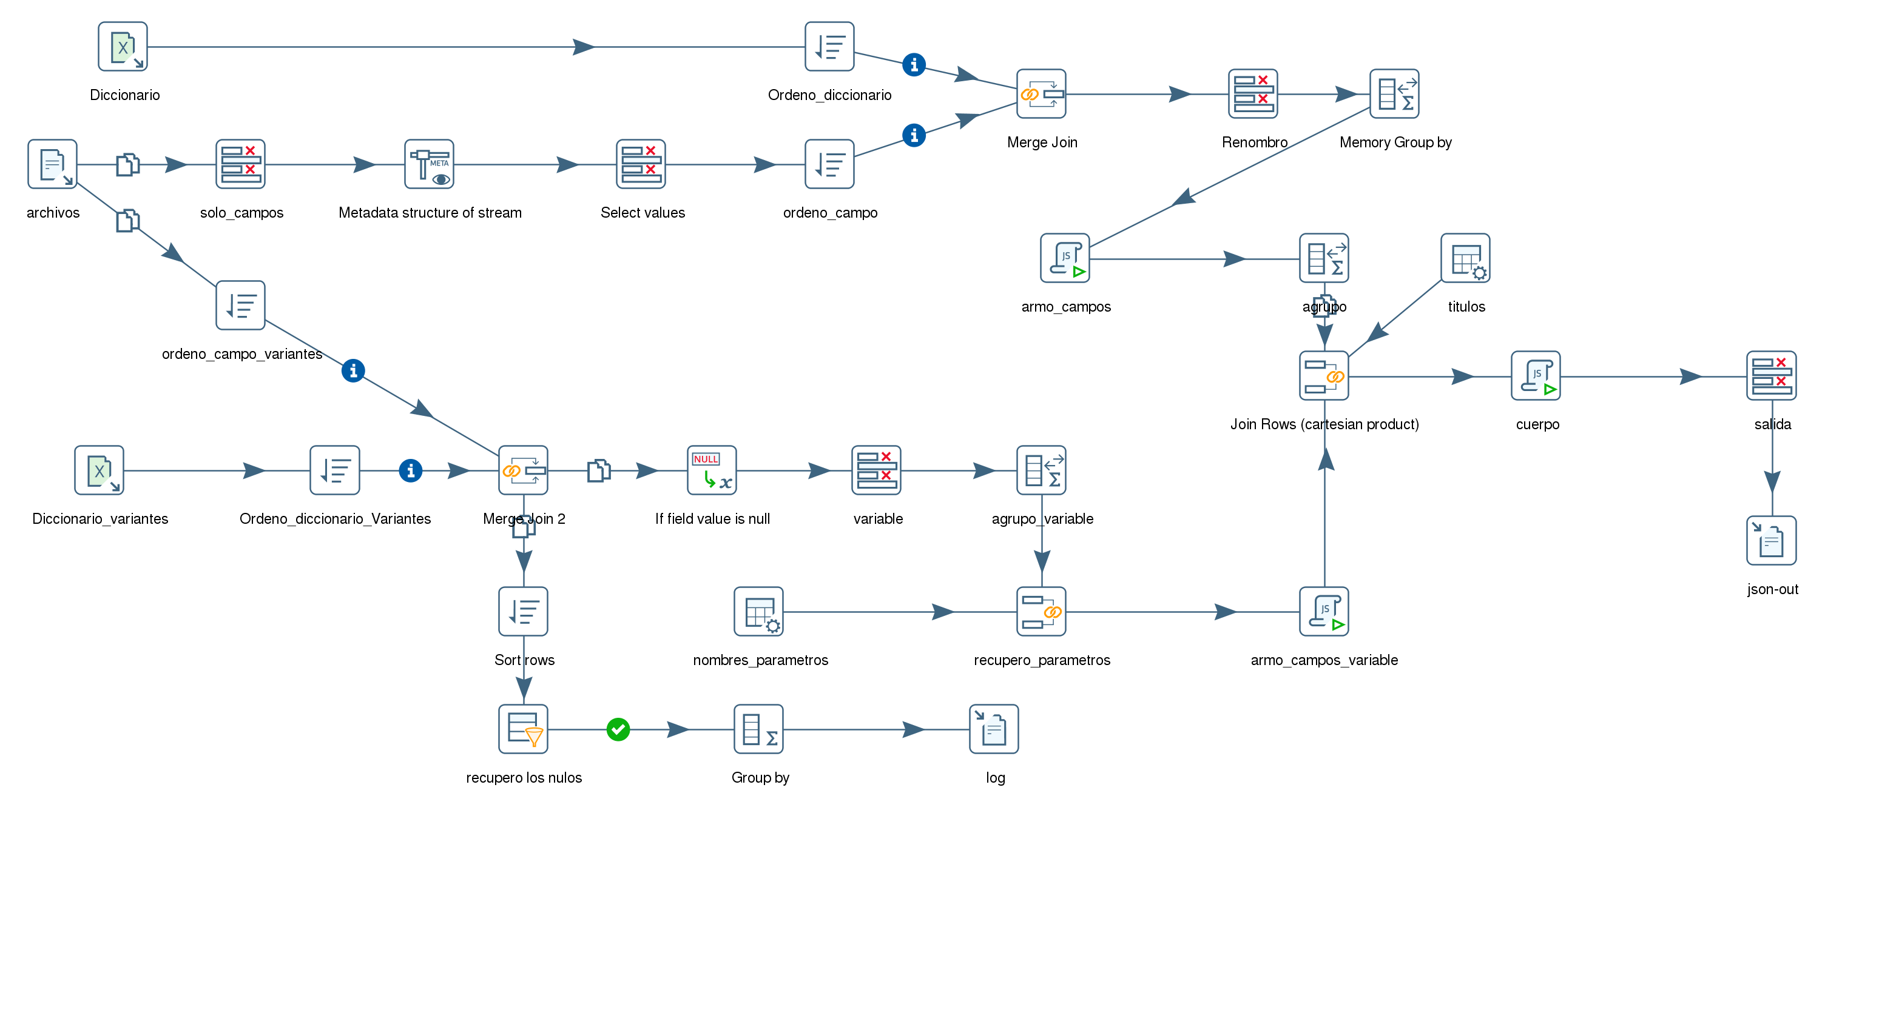
Filename: | /media/cirilo/Datos/Proyectos/Agesic/Datos Abiertos/Poder Judicial/TransPJ (copia)/BAC/metadata.ktr
Name: | metadata
Description:
Long description:
Logging:
Creation: | 2017/07/05 09:32:40.313 by -
Modification: | 2017/07/05 09:32:40.313 by -
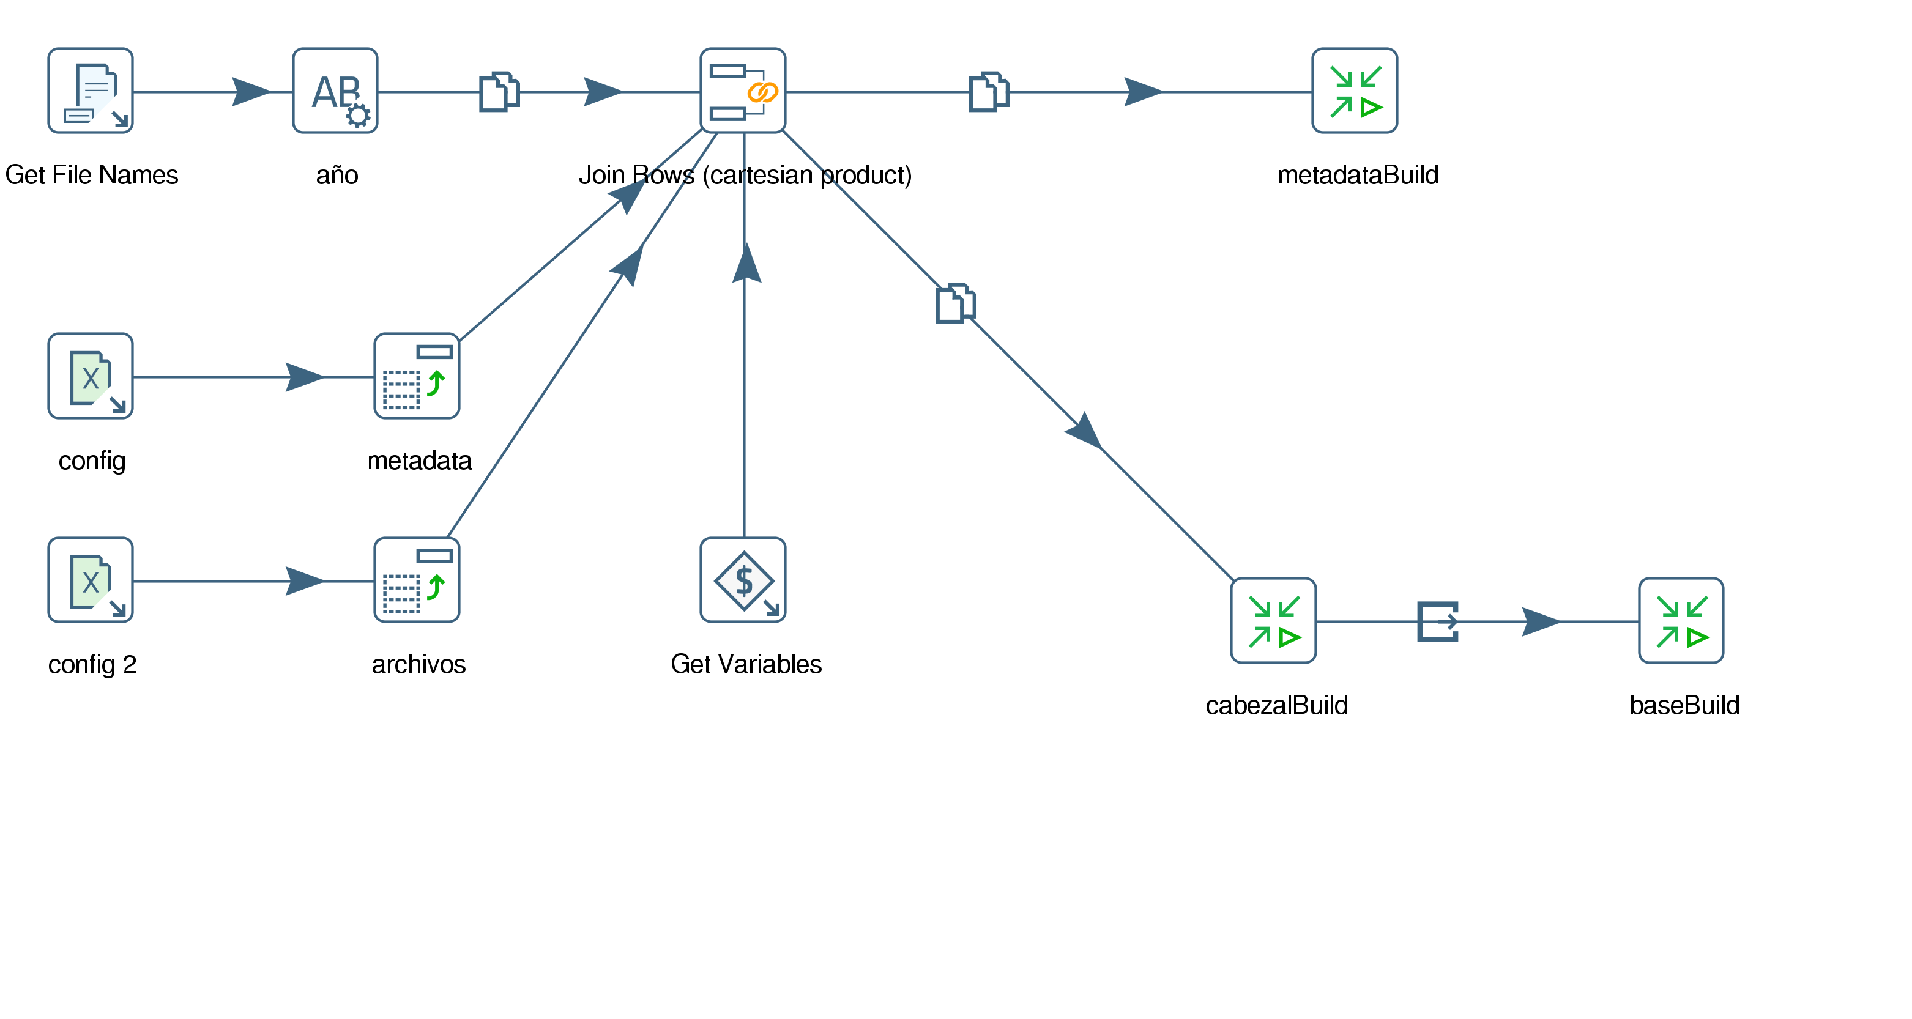
Filename: | /media/cirilo/Datos/Proyectos/Agesic/Datos Abiertos/Poder Judicial/TransPJ (copia)/Documentacion/docAutamatic.ktr
Name: | docAutamatic
Description:
Long description:
Logging:
Creation: | 2017/07/26 15:01:16.519 by -
Modification: | 2017/07/26 15:01:16.519 by -
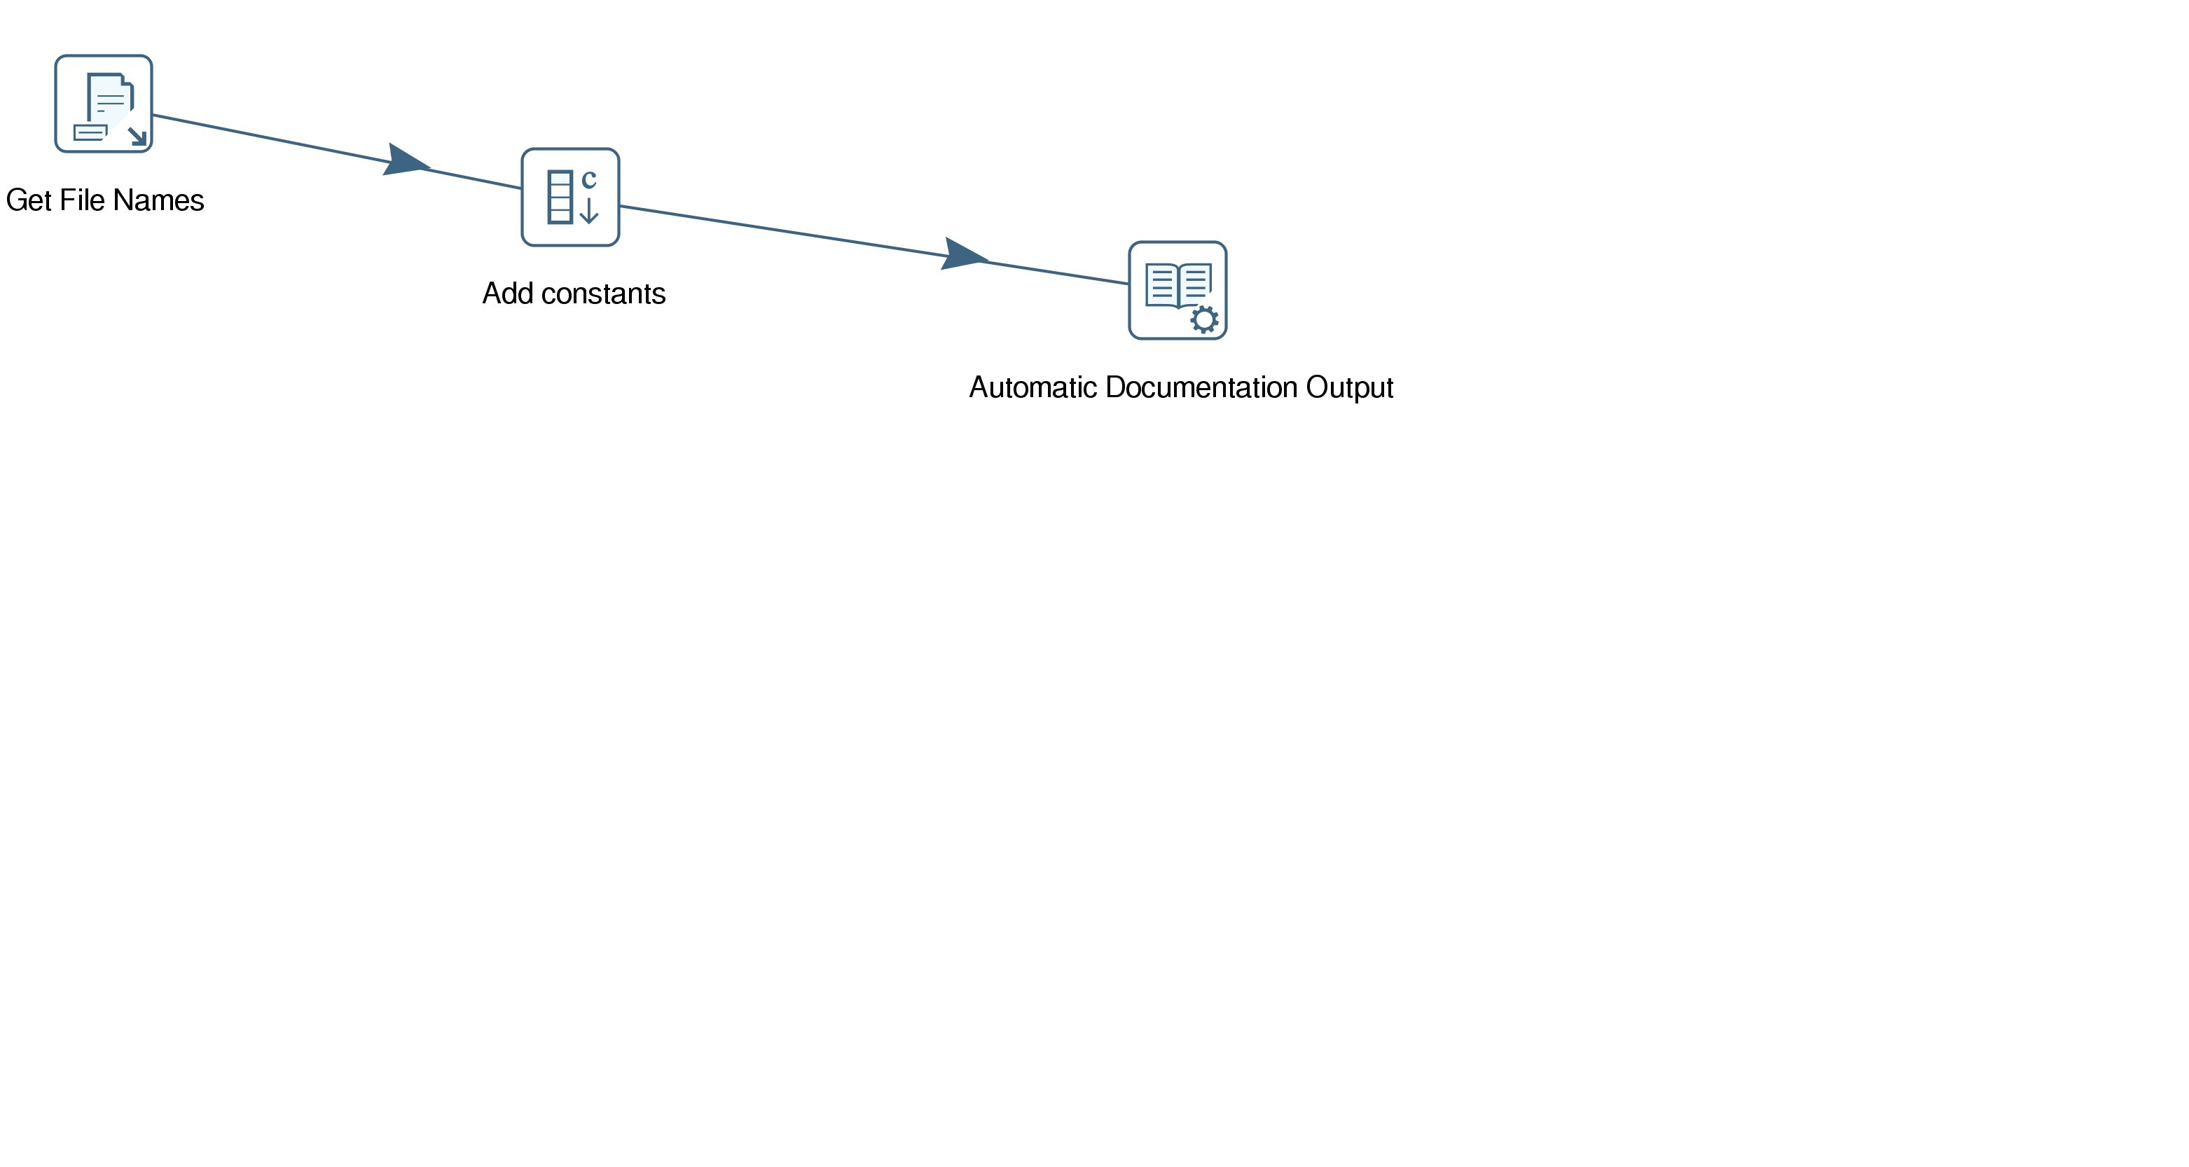
Filename: | /media/cirilo/Datos/Proyectos/Agesic/Datos Abiertos/Poder Judicial/TransPJ (copia)/ktx/baseDatos.ktr
Name: | baseDatos
Description:
Long description:
Logging:
Creation: | 2017/07/19 14:47:47.905 by -
Modification: | 2017/07/19 14:47:47.905 by -
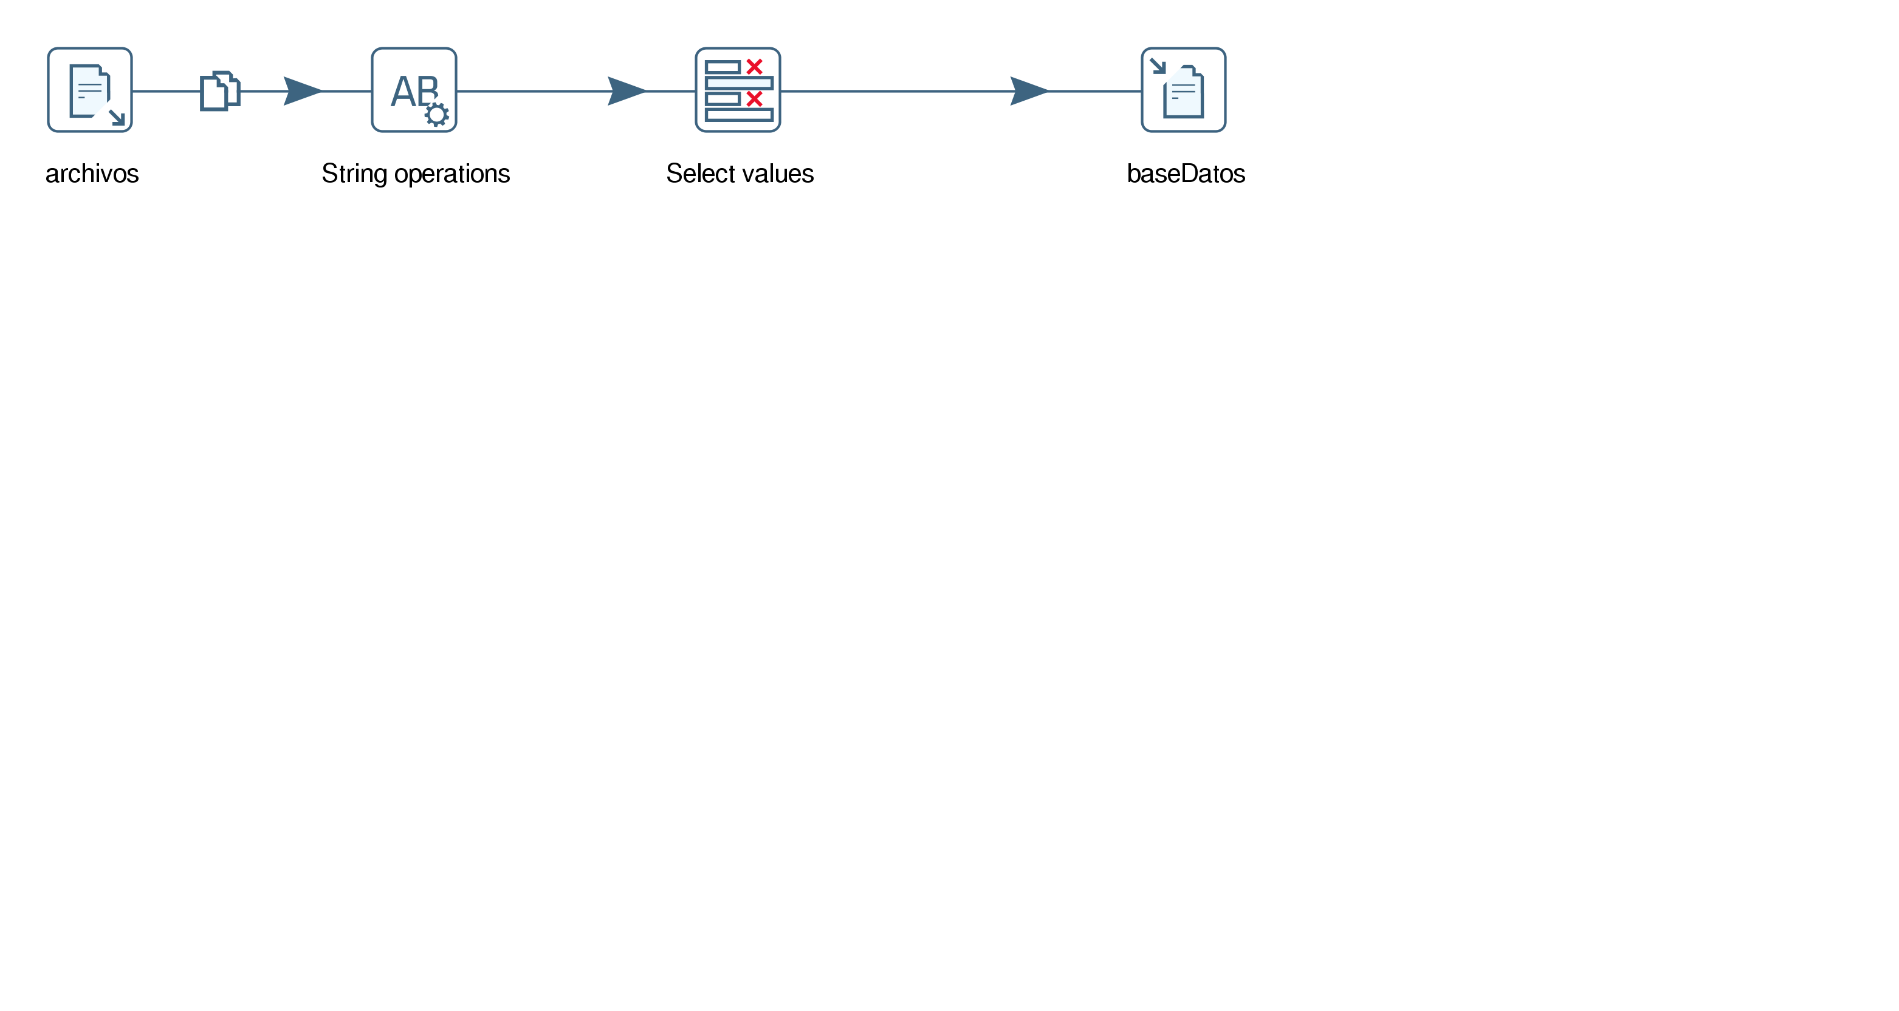
Filename: | /media/cirilo/Datos/Proyectos/Agesic/Datos Abiertos/Poder Judicial/TransPJ (copia)/ktx/cabezal.ktr
Name: | cabezal
Description:
Long description:
Logging:
Creation: | 2017/07/19 14:47:47.905 by -
Modification: | 2017/07/19 14:47:47.905 by -
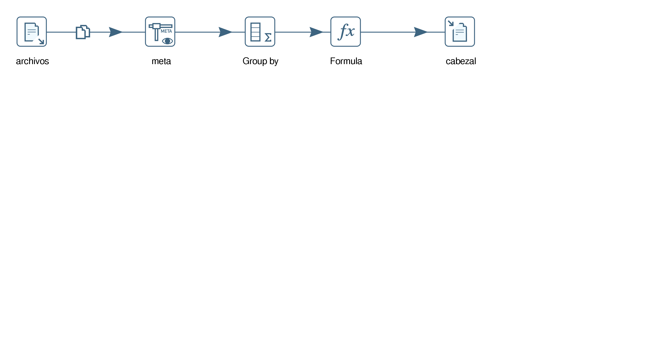
Filename: | /media/cirilo/Datos/Proyectos/Agesic/Datos Abiertos/Poder Judicial/TransPJ (copia)/ktx/genero_templates.ktr
Name: | genero_templates
Description:
Long description:
Logging:
Creation: | 2017/06/26 13:32:10.396 by -
Modification: | 2017/06/26 13:32:10.396 by -
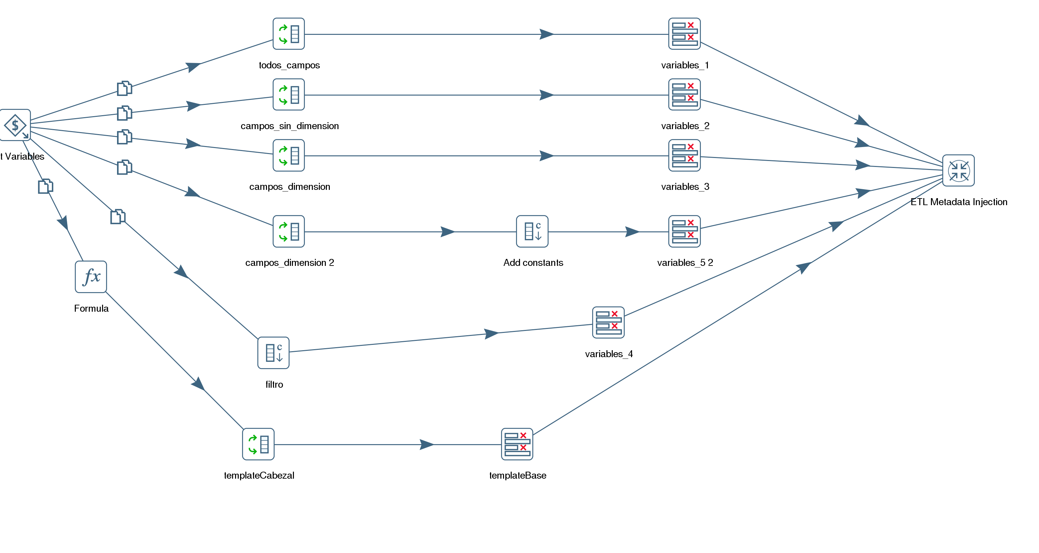
Filename: | /media/cirilo/Datos/Proyectos/Agesic/Datos Abiertos/Poder Judicial/TransPJ (copia)/ktx/json.ktr
Name: | json
Description:
Long description:
Logging:
Creation: | 2017/07/04 11:11:19.521 by -
Modification: | 2017/07/04 11:11:19.521 by -
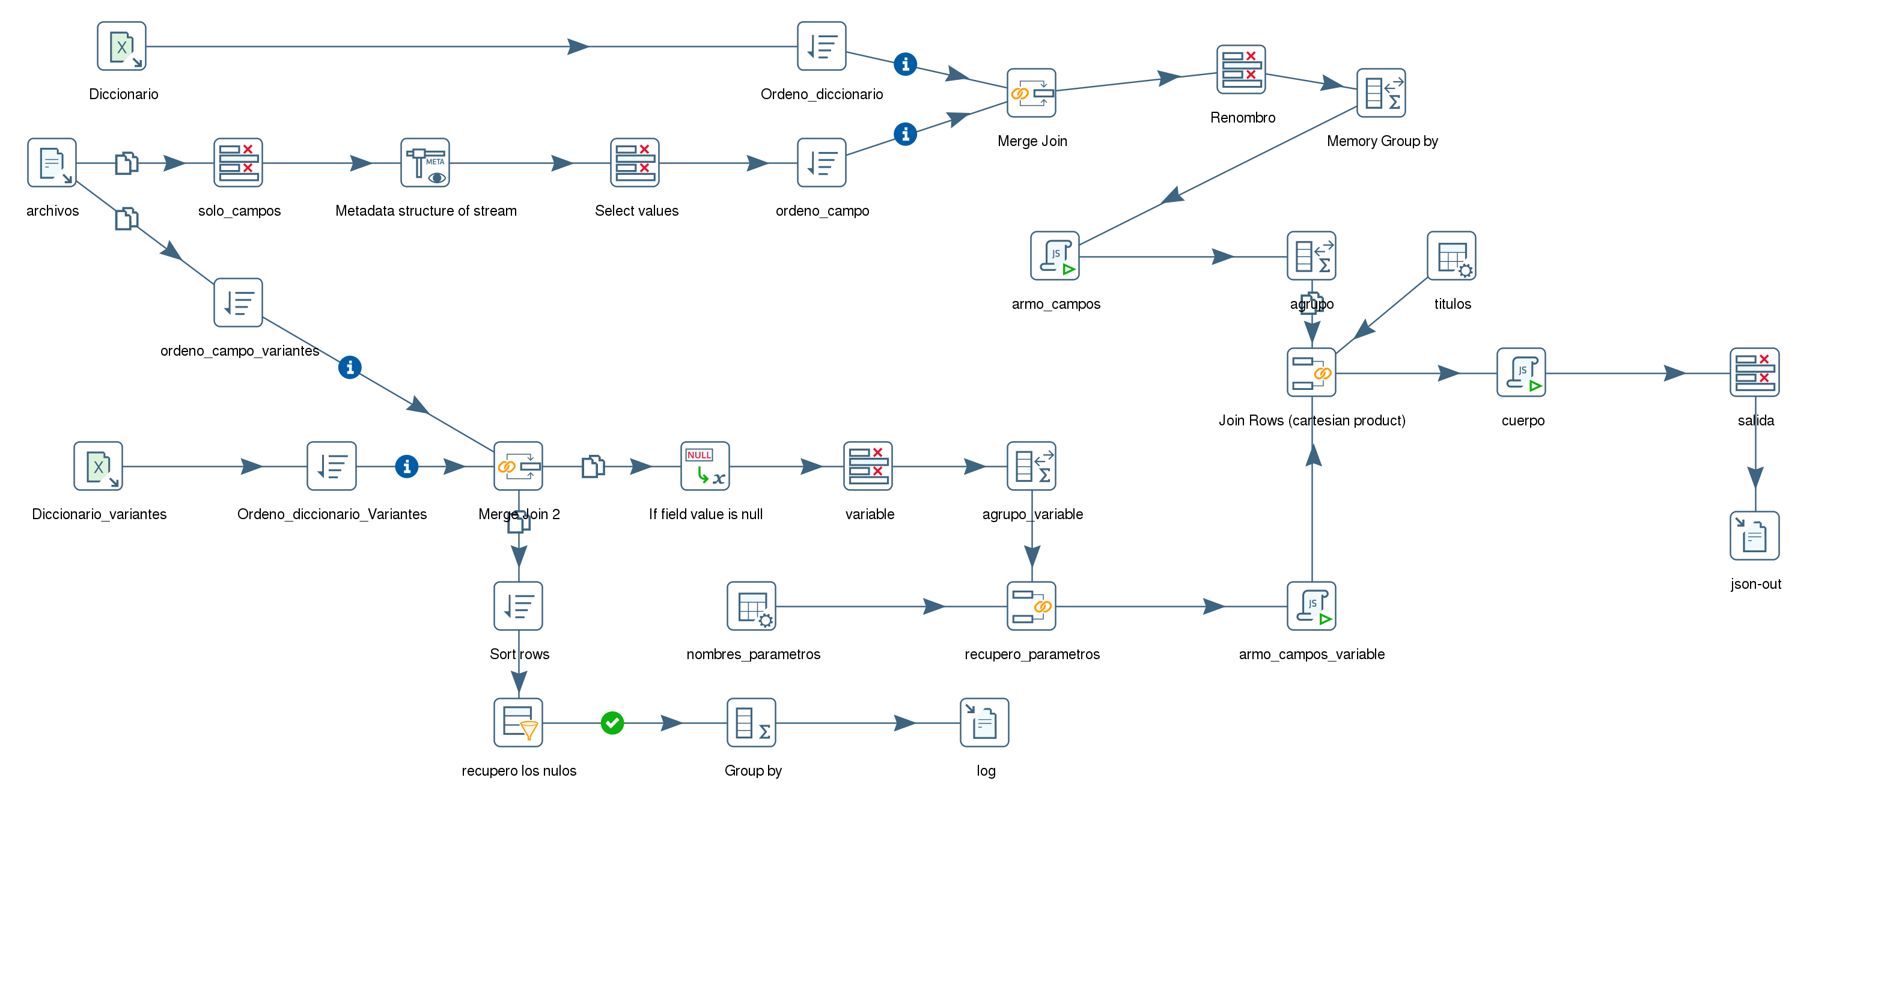
Filename: | /media/cirilo/Datos/Proyectos/Agesic/Datos Abiertos/Poder Judicial/TransPJ (copia)/ktx/metadata.ktr
Name: | metadata
Description:
Long description:
Logging:
Creation: | 2017/06/16 09:31:20.768 by -
Modification: | 2017/06/16 09:31:20.768 by -
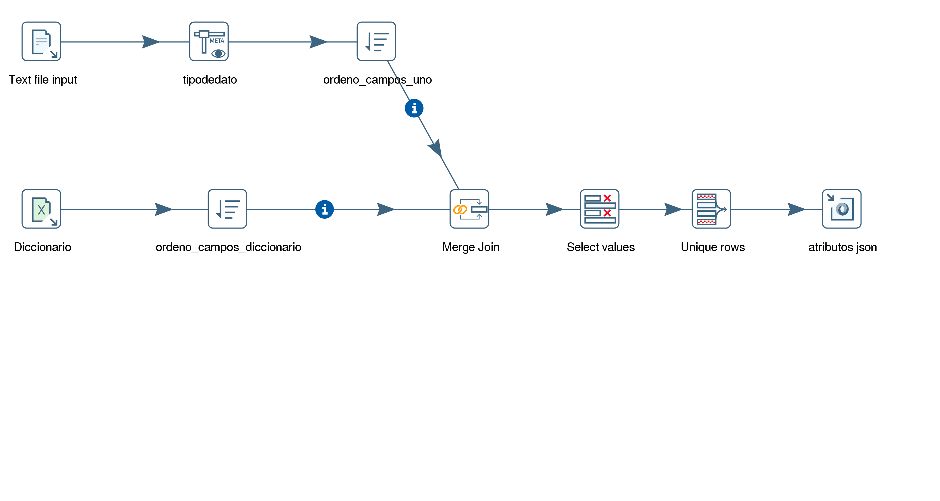
Filename: | /media/cirilo/Datos/Proyectos/Agesic/Datos Abiertos/Poder Judicial/TransPJ (copia)/ktx/metainyMetadata.ktr
Name: | metainyMetadata
Description:
Long description:
Logging:
Creation: | 2017/07/04 11:11:19.521 by -
Modification: | 2017/07/04 11:11:19.521 by -
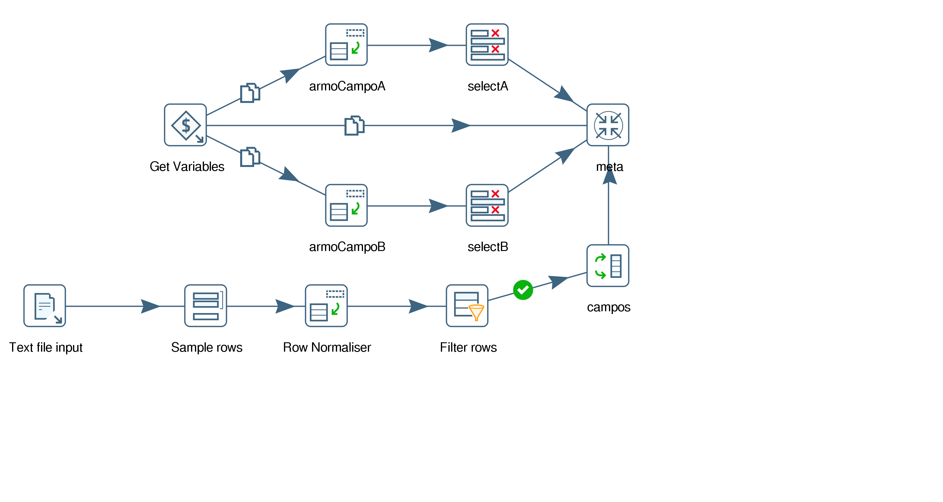
Filename: | /media/cirilo/Datos/Proyectos/Agesic/Datos Abiertos/Poder Judicial/TransPJ (copia)/ktx/reporte1.ktr
Name: | reporte1
Description:
Long description:
Logging:
Creation: | 2017/06/16 09:31:20.768 by -
Modification: | 2017/06/16 09:31:20.768 by -
