**A contrast camera trap imagery in Mojave National Preserve and Carrizo National Monument to examine animal interactions with foundation plant species**

**Nargol Ghazian**

**Honours Thesis**

**Faculty of Science**

**York University**

**Fall-Winter 2017-2018**

**Supervisor: Dr. Christopher Lortie**

**Advisor: Dr. Susan MacDonald**

**Introduction**

1. **Camera traps in ecology**

Topic sentence first – Animal observation is an important form of behavioural and ecological research in many ecosystems. Camera traps provide a mechanism to collect observation data on animals in their natural habitat and interactions with their environment with relatively limited human disturbance (O’Connell et al. 2011). Besides their use in wildlife viewing and hunting, camera traps have been used in studies that focus on nest ecology, detection of rare species, estimation of population size and species richness, behavioural studies, habitat use, and occupation of human-built structures (citations needed for all of these or at least cite a few good reviews). The current technology in most camera traps is able to detect changes in animal movement through heat-in-motion (Francesco Rovero et al. 2013) via a passive-infrared sensor. Then concluding sentence on implications and why this matters..

One of the major uses of the device, particularly in ecology, has been to record vertebrate activity patterns used to determine parameters such as occupancy, abundance and diversity (O’Connell et al. 1998 – need more current citation). Perhaps the greatest advantage of this sampling method as opposed to other efforts is that it can record accurate data without the animal being captured or the researcher being present. The earliest case study concerning abundance was first done by Karanth et al. (1995) for the *Panthera tigris* population using capture-recapture models. Though, studies concerning Jaguars *Panthera onca* have received the most attention with regards to using camera traps to determine abundance and density of populations??? What kind of attention – not sure what you mean here?.Diversity on the other hand can be determined through species richness and composition data from camera traps or some other way? confusing (Rovero et al. 2014). Once used to determine abundance and diversity, the obtained information can be of great importance to conservational biologist for population management-purposes. It is important to note that well-designed studies involving camera traps also include data of covariates of the site. In addition, covariates are chosen based on how they influence the parameter of interest and the detection probability they provide (White 2005). Earlier studies took advantage of the program CAPTURE (https://www.mbr-pwrc.usgs.gov/software/capture.html) able to estimate capture probability and population size for closed populations using capture-recapture data (Otis et al. 1978). However, the advent of the CamtrapR package has allowed for a simpler tool with complete workflow for the processing of camera trap data (Niedballa et al. 2016). – I would cut all this

1. **Geographic setting: Mojave is this subheading format required for thesis? Otherwise just do regular way like for a publication – Intro, Methods, Results etc.**

**This is the Methods**

**Study sites**

The Mojave National Perserve (35.0110° N, 115.4734° W), roughly 150 000 km2, is located in an area incorporating Nevada, California, Utah, and Arizona (Shryock et al. 2017). The climate is generally arid or semi-arid, through the north-to-south-oriented mountain ranges increase climate variability. Furthermore, annual precipitation ranges between 30-300 mm (Hereford et al. 2006). The maximum temperature can surpass 50°C whilst the temperature can fall below 0°C in the winter season. *Larrea tridentata* is a dominant or co-dominant species in shrub canopy that is often found in sandy soils, desert pavements and well-developed cryptogram layer of the Mojave (Sawyer et al. 2009). The shrub is a long-lived evergreen extremely resistant to high temperatures. *Cylindropuntia acanthocarpa,* commonly known as Buckhorn cholla, is perennial herb that is native to California (Engelm et al. 2018). The plant is low water tolerant with a growing season between four to nine months.

Carrizo Plain National Monument (35.1914° N, 119.7929° W) is the largest remnant ecosystem of the San Joaquin Desert (Noble et al. 2016). Located in the south-eastern San Louis Obispo Country, precipitation in the monument ranges from 15 cm in southeast to 25 cm in the northwest. The shrub species of the region are important as they are beneficial to animals (Lortie et al. 2016). In addition, the dominant shrub species are *Ephedra californica*, commonly known as Mormon tea and *Atriplex polycarpa*, known as saltbush (Deborah Stout et al. 2014). The species *E. californica* is a slow-growing shrub which spreads colonially in hot deserts. It is well-adapted to alluvial substrate and shifting sand, generally growing in elevations of 200-1200 m. Although severe fires can kill the plant (Anderson 2004), it is fairly resistant to moderate fires with the ability to sprout.

Are you supposed to write like an essay or like a scientific paper? If like an essay, ignore me ☺ if like a paper, then consider these revisions

1. **Time of the day, circadian rhythm, and animal behaviour ok I guess but we do not really test here – again if essay this stuff is ok, if paper, then typically you only introduce what you directly test in this specific study**

The external light-dark cycles play a vital role as agent of the circadian peacemaker (Meijer and Rietveld 1989). Light effects on the circadian maker by intensity, duration, and at the phase of the circadian rhythm when it’s applied (Meijer et al. 1996). Due to the fact that generally light intensity and duration is dictated by the time of the day or season, it could then be these factors greatly influences the circadian pacemaker. In addition, most animals are able to adapt their physiological functions to match their activity and development to the changing environmental conditions via evolved mechanism (Saunders 1974). Many physiological and behavioural activities of animals are limited to specific time of the day (Sakai and Ishida 2001). Such behaviours include mating and food intake (Morimoto et al. 1977). Additionally, activity level, defined as the proportion of the time an animal is active, can serve as a behavioural indicator of energetics, forging effort, and exposure to risk (Rowcliffe et al. 2014). Activity level can be estimated using camera trap via time-of-detection data. Thus, it could be said that the circadian rhythm of animals influence their various behavioural activities which directly impacts the probability of detection by camera traps.

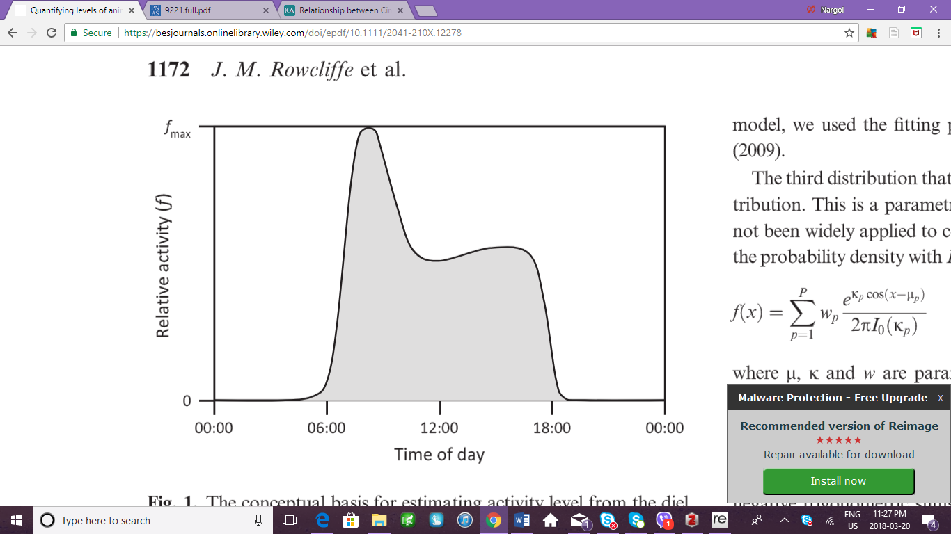

**Figure 5.** Pattern of relative activity over the day. Shaded region is proportional to the total amount of time allocated to activity (Rowcliffe et al. 2014).

1. **Influence of season on habitat selection same – do not test season.**

Vegetation commonly occurs in mosaic of patches which affects the distribution of the herbivores that prefers the particular type of vegetation (Cromsigt and Olff 2006). A study conducted by Bukombe et al. (2018) examining the distribution of ungulates across woodland, grassland and bush grassland found that habitat selection in dry and wet season differed between species and each species changed its selection between seasons in varying ways. This change in vegetation selection in dry and wet seasons could not be explained by predator limitation; a hypothesis which states that if predators limit herbivore abundance, then resources are not the limiting factor, competition will be weak and there habitat selection will not be significantly different between seasons. Shifts in seasonal selection could be due be explained by fluctuations in forge abundance (Sinclair and Arcese 1995), forge quality in relation to species functional differences (Hopcraft et al. 2012), and predation.

1. **Cover characteristics and animal movement YES we do test this.**

Alongside the landscape’s topography and the types of road present, a study by done by Dickson et al. (2005) investigating cougar movement in southern California concluded that the vegetative characteristic of the habitat does in fact influence the amount of time the animal spends in that area and how fast it moves through. Similar conclusions were made in a study tracking the displacement of Eleodes beetles in shortgrass prairie where net displacement was highly influenced by vegetation structure (Crist et al. 1992) cool finding. Furthermore, displacement was found to be the highest in bare or grass areas, whilst being the lowest at cactus and shrub regions – same paper? This is a neat idea – I think you could focus on this more. Although beetles were found to be feeding in the in the vegetative cover types, the feeding frequency was not associated with any of the types. Additionally, the presence of vegetation can predict distribution, abundance and life history traits of herbivores and non-herbivores (Pettorelli et al. 2011). The distribution of herbivores specially depends on the suitability of the physical environment as well as the availability of main plant resources (Mysterud and Østbye1992). Moreover, covers, regardless of whether the cover type is vegetative or not, can impact microclimate, predation risk, food quantity and quality. Furthermore, foundational plant species defined by having a sole impact on the structure and function of an ecosystem (Angelini et al. 2011) can influence other taxa through positive interactions or facilitation (Bruno et al. 2003). These interactions can include but are not limited to shelter, refuge from predation, and seed trapping (Filazzola and Lortie 2014).

Vegetation, landscape, and local differences in seasonality are thus likely important to animals, and previous research has shown that camera traps have the capacity to detect these differences. We hypothesized that foundational plant species investigated in this study (*E. Californica, L. tridentata*, and *C. acanthorpa*) are able to positively act as benefactors for other taxa such as vertebrates through the numerous mechanistic pathways they provide. Camera trap images from two distinct desert ecosystems were used to study the above interactions. GOOD

OK – so intro is very essay like.

You could simplify it all above and move the Methods stuff describing the sites to the Methods and the intro be

Para 1. Cam traps cool and can do this and that.

Para 2. Many things important to animals including vegetation

Para 3. Current final one – given many things important to animals and that cam traps are cool and can detect patterns, we test that here. Actually, we test two things – importance of different veg and ability for cam traps to work right in these systems? That is how I would package up this paper.

**Materials & Methods**

1. **Camera deployment and imagery collected**

Camera traps were set at the Mojave Desert and the Carrizo Plain National Monument. In the Mojave, the sites were divided into two categories corresponding to the shrub type: *L. tridentata* (Larrea) or *C. acanthocarpa* (buckhorn). There was a total of eight microsites chosen at random for buckhorn though, not all sites were recording during the full duration of sampling (Table 1). Put all location data etc in either an appendix or in a Table.

Cameras at the Carrizo were also split into two categories, however in this case one category corresponded to the shrub *E. californica*, whilst the other was simply called ‘open’ and served as control to serve an estimate of important associational patterns with shrubs. Sampling took place for a total of three weeks and three days at 20 different microsites (ten for shrub and ten for open) from May 22nd, 2017 to June 15th, 2017. Unlike the Mojave microsites that remained at the same location for the duration of the sampling period, the Carrizo shrub microsites were altered each week. Table 2 lists the latitude and longitude coordinates of each microsite during each week of the three week period. Oh you already list. Then just explain design for MNP and Carrizo and cite the table listing all details. The open microsites did not have distinct coordinates as they were only few meters from those of the shrubs’. Furthermore, shrub dimension (length, width, and height) were recorded at all microsites in both the Mojave and the Carrizo for *E. californica*, Larrea, and buckhorn (Table 3 and 4). CUT table 3 and 4 and/or move to appendix.

1. **Metadata great section!**

A total of 102,398 and 209,714 images were collected in the Mojave and the Carrizo, respectively, which were saved as Join Photographic Expert Group (JPEG) format. These dataframes were then manually examined for the presence of animals. A datasheet was created where every row corresponded to a unique image. Additionally, data was recorded for the year, region, calendar date, microsite, rep, photo rep, and week number. If a vertebrate was present in the photo, further info on the type of vertebrate, time block, actual time, temperature, and additional observations were also recorded. Images from cameras were clear enough during both day and night (low light condition) to distinguish between animals. An animal was classified as present if as little as a section of a body part (i.e. tail) made it into the captured image. Vertebrates detected in the Carrizo included: jackrabbit (*Lepus californicus*), blunt-nosed leopard lizard (*Gambelia sila*), California kangroo rat (*Dipodomys californicus*), desert cottontail (*Sylvilagus audobonii*), San Joaquin antelope squirrels (Ammospermophilus nelson), and kit fox (*Vulpes macrotis*). With the exception of the lizard and the antelope squirrels, the rest of the vertebrates were also spotted in the Mojave, in addition to the Mohave ground squirrel (*Xerospermophilus mohavensis*) and the Califronia thrasher (*Toxostoma redivivum*). Selected images of animals are provided with the raw data for example of species.

1. **Statistical Analyses**

All analyses were performed using R version 3.4.4 (R Development Core Team, 2017). Statistical workflows are available on:

https://cjlortie.github.io/Camtrap.contrast.2017/#camera\_trap\_contrasts. The “ggmap” function was used to plot the latitude and longitude coordinates of the Carrizo National Monument and the Mojave National Preserve on a Californian map. In order to estimate size of foundational plant species, a smoothed histogram called a density plot was constructed from conditional probabilities of the bindwiths (Hall et al. 2004) using the “ggplot\_build” and “geom\_density” from the “ggplot2” package using Gaussian family distribution (Wickham 2016). Chi-squared test was used to calculate the p-value for the model. Residuals were further examined using the Shapiro-Wilk normality test (Shapiro and Wilk 1965) which examines whether the dataset fits a normal distribution. Tukey-adjustment test was used in conjunction with an ANOVA (post-hoc analysis) to determine whether the means of the three foundational species were significantly different. Furthermore, the “geom\_boxplot” function of the “ggplot2” package was used to depict the total captures and the capture rate per microsite. Captures by foundational species was plotted using the “geom\_point” function, where differences in captured rates was explored using the quasi Poisson distribution. Tukey-adjustment was used again to compare between the four microsites. F-statistics from the ANOVA F-test was estimated to determine the interaction between variables. Linear regression models were fit for the three foundation species, where *p*-values and adjusted r2 values were calculated.Not bad – I would likely cut all the plot stuff and just use . 1. Used r. 2. All code here. 3. Use simple GLMs to test for differences between different factors etc. then have have a one sentence of what a GLM is and citation to a paper about it.

**Table 2.** The latitude and longitude coordinates of the Carrizo shrub microsites are given for each week during the three week period.

|  |  |  |  |  |
| --- | --- | --- | --- | --- |
| **Region** | **Microsite** | **Week** | **Latitude** | **Longitude** |
| Carrizo | Shrub 1 | 1 | 35.11489° | 119.61868° |
| Carrizo | Shrub 2 | 1 | 35.11493° | 119.6188° |
| Carrizo | Shrub 3 | 1 | 35.11472° | 119.61887° |
| Carrizo | Shrub 4 | 1 | 35.11465° | 119.6189° |
| Carrizo | Shrub 5 | 1 | 35.11472° | 119.619° |
| Carrizo | Shrub 6 | 1 | 35.11468° | 119.61913° |
| Carrizo | Shrub 7 | 1 | 35.11472° | 119.61911° |
| Carrizo | Shrub 8 | 1 | 35.1148° | 119.61909° |
| Carrizo | Shrub 9 | 1 | 35.11475° | 119.61929° |
| Carrizo | Shrub 10 | 1 | 35.11494° | 119.61923° |
| Carrizo | Shrub 1 | 2 | 35.11515° | 119.61954° |
| Carrizo | Shrub 2 | 2 | 35.11504° | 119.61957° |
| Carrizo | Shrub 3 | 2 | 35.11493° | 119.61953° |
| Carrizo | Shrub 4 | 2 | 35.11488° | 119.61971° |
| Carrizo | Shrub 5 | 2 | 35.11501° | 119.61988° |
| Carrizo | Shrub 6 | 2 | 35.11507° | 119.61996° |
| Carrizo | Shrub 7 | 2 | 35.11516° | 119.62006° |
| Carrizo | Shrub 8 | 2 | 35.11526° | 119.61982° |
| Carrizo | Shrub 9 | 2 | 35.11532° | 119.6198° |
| Carrizo | Shrub 10 | 2 | 35.11542° | 119.61977° |
| Carrizo | Shrub 1 | 3 | 35.11548° | 119.61973° |
| Carrizo | Shrub 2 | 3 | 35.11543° | 119.6199° |
| Carrizo | Shrub 3 | 3 | 35. 11537° | 119.61993° |
| Carrizo | Shrub 4 | 3 | 35.11543° | 119.61998° |
| Carrizo | Shrub 5 | 3 | 35.11547° | 119.61999° |
| Carrizo | Shrub 6 | 3 | 35.11551° | 119.62013° |
| Carrizo | Shrub 7 | 3 | 35.11554° | 119.62028° |
| Carrizo | Shrub 8 | 3 | 35.11546° | 119.62037° |
| Carrizo | Shrub 9 | 3 | 35.11543° | 119.62035° |
| Carrizo | Shrub 10 | 3 | 35.11539° | 119.62036° |

**CUT or move to appendix. Table 3.** Shrub dimension (length, width, and height) are provided for each buckhorn and Larrea shrub at the Mojave Desert. Dimension are in centimeters.

|  |  |  |  |
| --- | --- | --- | --- |
|  | **Shrub Dimension** | | |
| **Microsite** | **x (length)** | **y (width)** | **z (height)** |
| Buckhorn 1 | 170 | 135 | 146 |
| Buckhorn 2 | 132 | 102 | 122 |
| Buckhorn 3 | 285 | 223 | 128 |
| Buckhorn 4 | 145 | 119 | 113 |
| Buckhorn 5 | 197 | 170 | 145 |
| Buckhorn 6 | 193 | 134 | 115 |
| Buckhorn 7 | 232 | 206 | 145 |
| Buckhorn 8 | 256 | 188 | 153 |
| Larrea 1 | 440 | 414 | 228 |
| Larrea 2 | 363 | 343 | 240 |
| Larrea 3 | 363 | 294 | 165 |
| Larrea 4 | 480 | 425 | 304 |
| Larrea 5 | 406 | 318 | 227 |
| Larrea 6 | 374 | 341 | 263 |
| Larrea 7 | 276 | 292 | 241 |
| Larrea 8 | 403 | 241 | 275 |

**Same - Table 4.** Shrub dimension (length, width, and height) are provided for each *E. califronica* shrub of the three week census. Dimensions are in centimeters.

|  |  |  |  |  |
| --- | --- | --- | --- | --- |
|  | | **Shrub Dimension** | | |
| **Week** | **Microsite** | **x**  **(length)** | **y**  **(width)** | **z**  **(height)** |
| 1 | Shrub 1 | 278 | 226 | 141 |
| 1 | Shrub 2 | 454 | 338 | 174 |
| 1 | Shrub 3 | 207 | 212 | 116 |
| 1 | Shrub 4 | 273 | 204 | 87 |
| 1 | Shrub 5 | 372 | 307 | 134 |
| 1 | Shrub 6 | 297 | 221 | 87 |
| 1 | Shrub 7 | 193 | 197 | 107 |
| 1 | Shrub 8 | 303 | 293 | 84 |
| 1 | Shrub 9 | 353 | 224 | 131 |
| 1 | Shrub 10 | 402 | 248 | 126 |
| 2 | Shrub 1 | 364 | 303 | 119 |
| 2 | Shrub 2 | 314 | 304 | 104 |
| 2 | Shrub 3 | 212 | 189 | 98 |
| 2 | Shrub 4 | 358 | 283 | 108 |
| 2 | Shrub 5 | 397 | 374 | 127 |
| 2 | Shrub 6 | 362 | 383 | 153 |
| 2 | Shrub 7 | 344 | 282 | 113 |
| 2 | Shrub 8 | 168 | 188 | 102 |
| 2 | Shrub 9 | 261 | 291 | 138 |
| 2 | Shrub 10 | 282 | 216 | 98 |
| 3 | Shrub 1 | 334 | 298 | 156 |
| 3 | Shrub 2 | 215 | 214 | 109 |
| 3 | Shrub 3 | 106 | 122 | 81 |
| 3 | Shrub 4 | 265 | 252 | 84 |
| 3 | Shrub 5 | 141 | 18 | 101 |
| 3 | Shrub 6 | 176 | 168 | 116 |
| 3 | Shrub 7 | 347 | 241 | 112 |
| 3 | Shrub 8 | 108 | 101 | 86 |
| 3 | Shrub 9 | 251 | 252 | 116 |
| 3 | Shrub 10 | 159 | 17 | 184 |

ALSO – check rules – but I prefer all figures and tables at the very end of the paper. That ok?

**Results**

**You state the differences found and then cite figure and the statistics. So for instance, There was a significant difference between buckhorn and larrea (Figure X, GLM, x2 = , p = , df = , with post hoc tests). Etc. and also state when no difference.** Plant volume positively predicted the rate of captur of animals for buckhorn (Figure X, Regression analyses, *p*= 0.07434<0.05, r2= 0.2628, *df*=8) but not for the other foundation plant species (Figure Z, Table Z listing stats). Etc…

**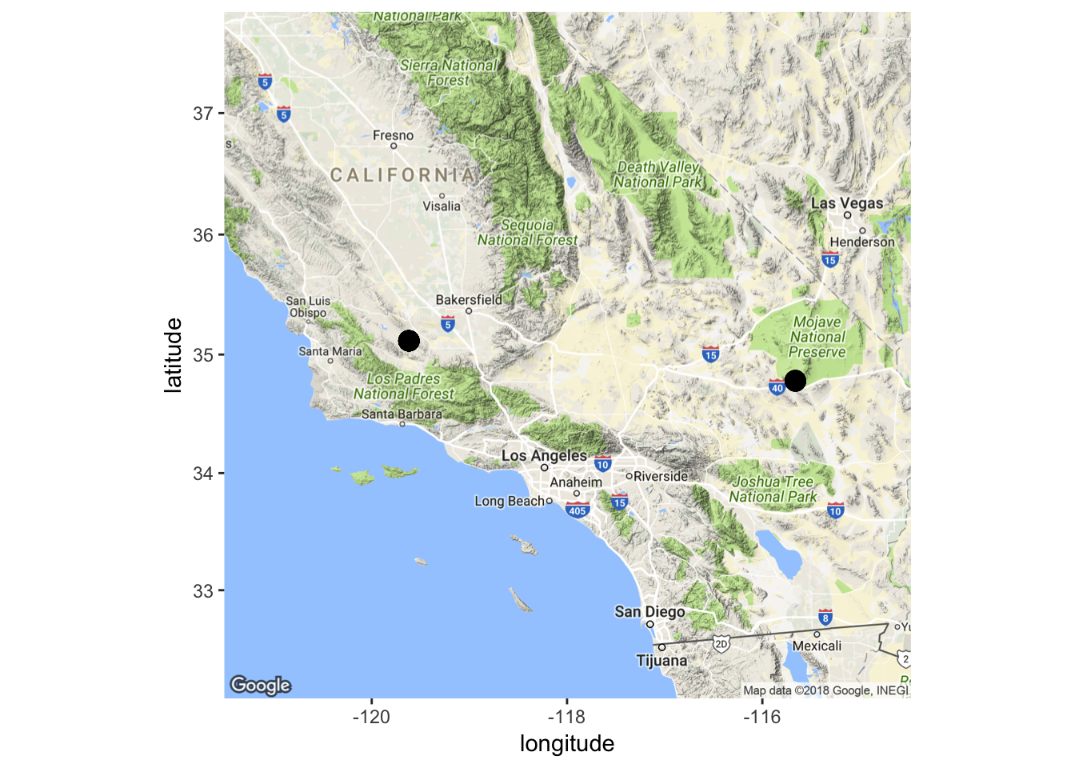**

**Figure 6.** Location of the camera trapping research done at the Mojave National Preserve and the Carrizo National Monument in the growing season of 2017.

**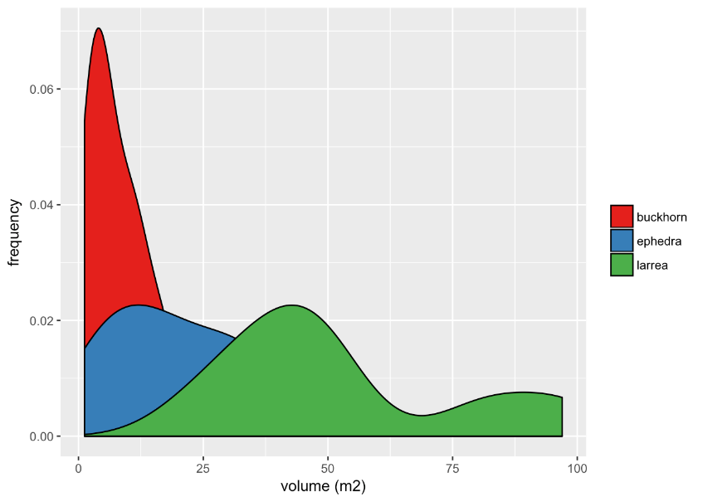**

**Figure 7.** Smoothed density estimate plots for size of foundational species buckhorn, Larrea, and *E. californica.* Volume was calculated using height and width measures, where height is the highest vertical living stem of a given shrub. The frequency estimate demonstrates the probability of those measures occurring at a given volume on the x-axis. Great.

**Table 5.** Analysis of deviance between microsites using means of size.

|  |  |  |  |
| --- | --- | --- | --- |
| **Contrast** | **SE** | **z-ratio** | **p-value** |
| Buckhorn-Ephedra | 0.549 | 3.399 | 0.0038 |
| Buckhorn-Larrea | 0.445 | 2.644 | 0.0409 |
| Buckhorn-Open | 0.313 | 0.817 | 0.8466 |
| Ephedra-Larrea | 0.629 | -1.098 | 0.6910 |
| Ephedra-Open | 0.544 | -2.957 | 0.0164 |
| Larrea-Open | 0.439 | -2.095 | 0.1548 |

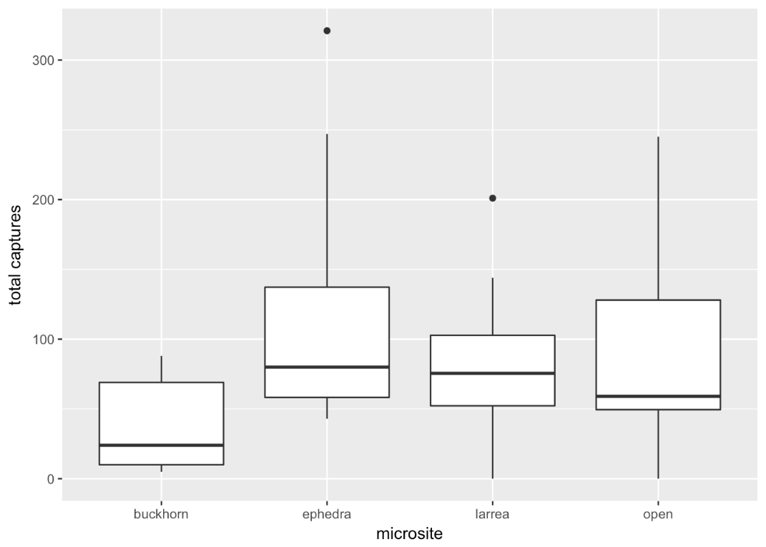

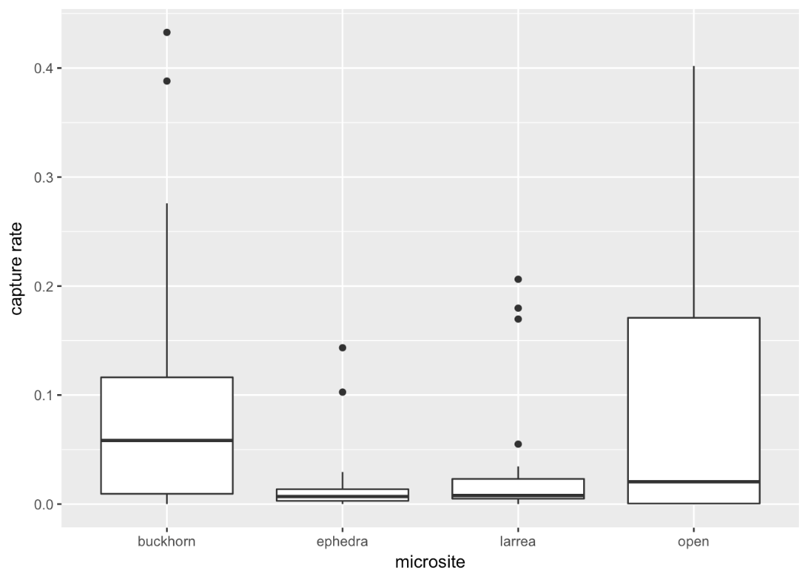

**Figure 8.** Boxplot showing the total captures and the capture rate at each of the four microsites: buckhorn, Ephedra, Larrea, and open. Solid middle lines shows the median of the data, whilst whiskers show 1.5 standard deviation. Solid dots are outliers >1.5 interquartile range (IQR). Good.

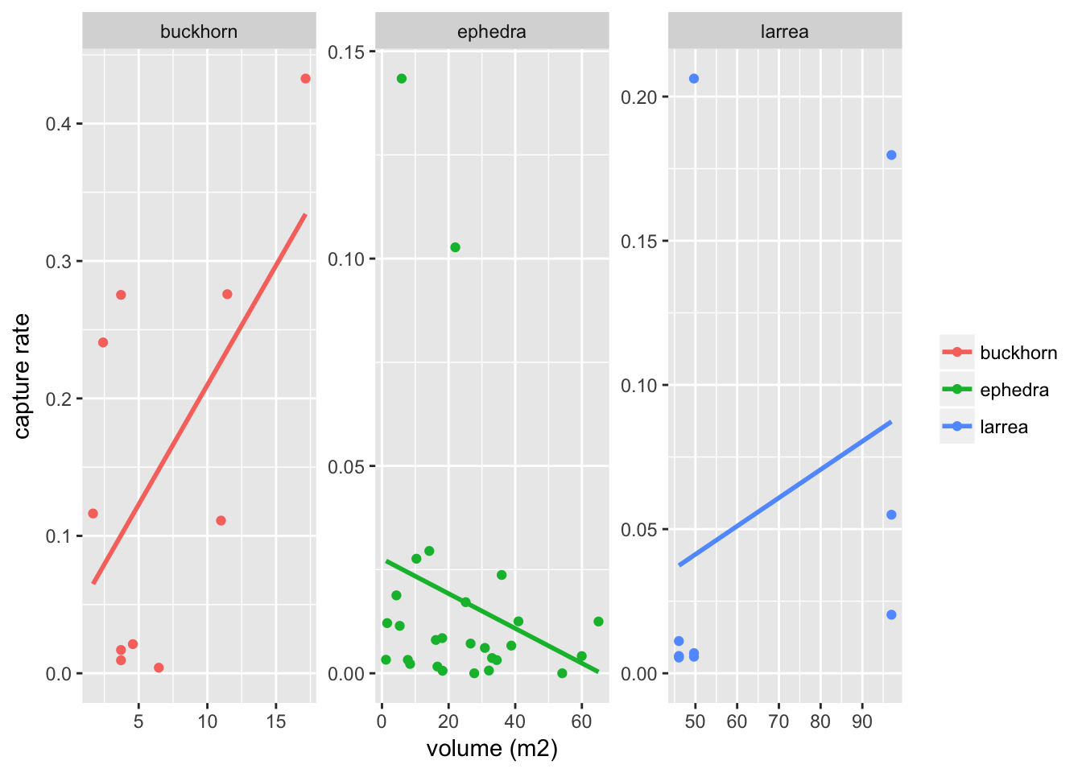

**Figure 9.** Linear regression of the shrub volume versus the capture rate for each foundational plant species. Volume was calculated from width and height measurements. Estimates for buckhorn, Ephedra, and Larrea adjusted r2= 0.2628, 0.01436, -0.0388, *p*= 0.07434, 0.2514, 0.43, and *df*= 8, 25, 7, respectively. Good.

**Discussion**

David L. Otis,

Kenneth P. Burnham, Gary C. White and David R. Anderson

*Wildlife Monographs*

No. 62, Statistical Inference from Capture Data on Closed Animal Populations (Oct., 1978), pp. 3-135

Information on California plants for education, research and conservation,   
with data contributed by public and private institutions and individuals, including the [Consortium of California Herbaria](http://ucjeps.berkeley.edu/consortium/about.html" \t "_blank).   
[web application]. 2018. Berkeley, California: The Calflora Database [a non-profit organization].   
Available: <http://www.calflora.org/>   (Accessed: Mar 26, 2018).