**Introduction**

1. **Camera traps in ecology**

Camera traps allow for the observance of animals in their natural habitat and their interaction with their environment without human disturbance (O’Connell et al. 2011). Besides their use in wildlife viewing and hunting, camera traps have been scientifically used in studies that focus on nest ecology, detection of rare species, estimation of population size and species richness, behavioural studies, habitat use, and occupation of human-built structures. One of the major uses of the device, particularly in ecology, has been to record vertebrate activity patterns used to determine parameters such as occupancy, abundance and diversity (O’Connell et al. 1998). Perhaps the greatest advantage of this sampling method as opposed to other efforts is that it can record accurate data without the animal being captured or the researcher being present. The earliest case study concerning abundance was first done by Karanth et al. (1995) for the *Panthera tigris* population using capture-recapture models. Though, studies concerning Jaguars *Panthera onca* have received the most attention with regards to using camera traps to determine abundance and density of populations.Diversity on the other hand can be determined through species richness and composition data (Rovero et al. 2014). Once used to determine abundance and diversity, the obtained information can be of great importance to conservational biologist for population management-purposes. It is important to note that well-designed studies involving camera traps also include data of covariates of the site. In addition, covariates are chosen based on how they influence the parameter of interest and the detection probability they provide (White 2005). Earlier studies took advantage of the program CAPTURE (https://www.mbr-pwrc.usgs.gov/software/capture.html) able to estimate capture probability and population size for closed populations using capture-recapture data (Otis et al. 1978). However, the advent of the CamtrapR package has allowed for a simpler tool with complete workflow for the processing of 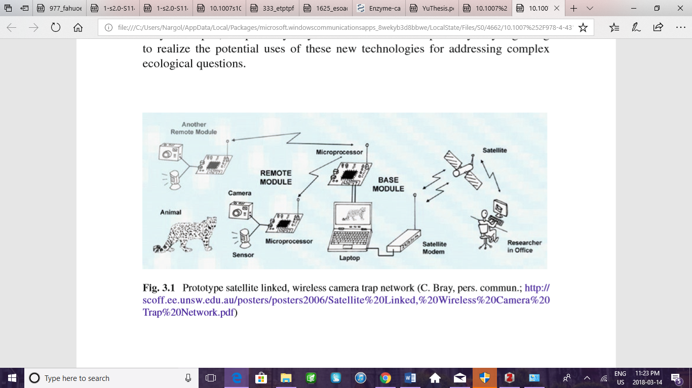camera trap data (Niedballa et al. 2016).

**Figure 1.** Camera trap network with possible wireless, satellite linkage (O’Connell et al. 2011).

1. **Cover characterstics and animal movement**

Alongside the landscape’s topography and the types of road present, a study by done by Dickson et al. (2005) investigating cougar movement in southern California concluded that the vegetative characteristic of the habitat does in fact influence the amount of time the animal spends in that area and how fast it moves through. Similar conclusions were made in a study tracking the displacement of Eleodes beetles in shortgrass prarie where net displacement was highly influenced by vegetation structure (Crist et al. 1992). Furthermore, displacement was found to be the highest in bare or grass areas, whilst being the lowest at cactus and shrub regions. Although beetles were found to be feeding in the in the vegetative cover types, the feeding frequency was not associated with any of the types. Additionally, the presence of vegetation can predict distribution, abundance and life history traits of herbivores and non-herbivores (Pettorelli et al. 2011). The distribution of herbivores specially depends on the suitability of the physical environment as well as the availability of main plant resources (Mysterud and Østbye1992). Moreover, covers, regardless of whether the cover type is vegetative or not, can impact microclimate, predation risk, food quantity and quality.

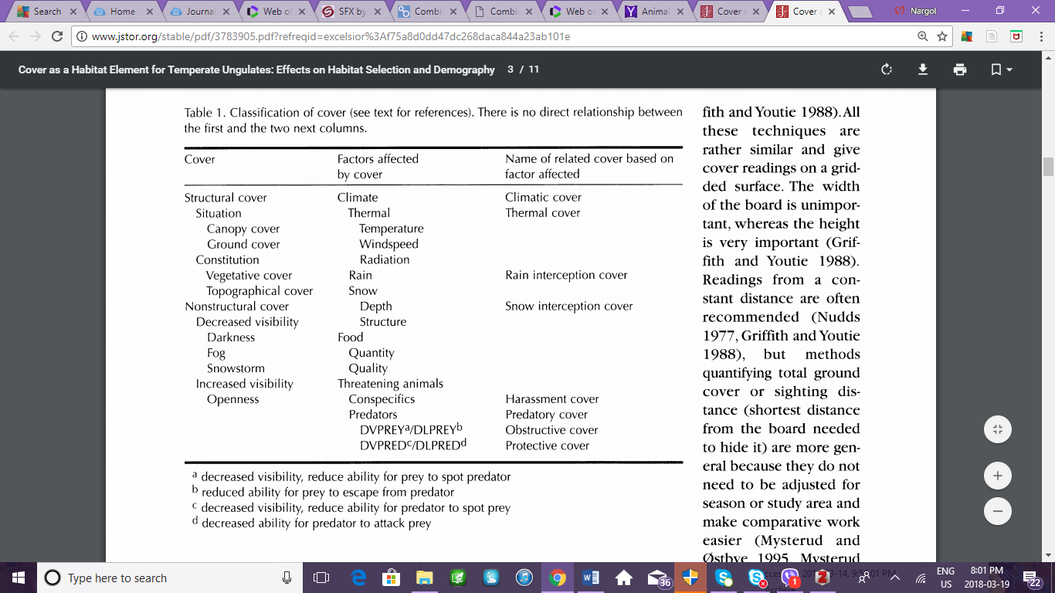**Table 1.** Classification of cover types. Note: there is no direct relationship between the first and second column (Mysterud and Østbye 1992).

1. **Time of the day, circadian rhythm, and animal behaviour**

The external light-dark cycles play a vital role as agent of the circadian peacemaker (Meijer and Rietveld 1989). Light effects on the circadian maker by intensity, duration, and at the phase of the circadian rhythm when it’s applied (Meijer et al. 1996). Due to the fact that generally light intensity and duration is dictated by the time of the day or season, it could then be these factors greatly influences the circadian pacemaker. In addition, most animals are able to adapt their physiological functions to match their activity and development to the changing environmental conditions via evolved mechanism (Saunders 1974). Many physiological and behavioural activities of animals are limited to specific time of the day (Sakai and Ishida 2001). Such behaviours include mating and food intake (Morimoto et al. 1977). Additionally, activity level, defined as the proportion of the time an animal is active, can serve as a behavioural indicator of energetics, forging effort, and exposure to risk (Rowcliffe et al. 2014). Activity level can be estimated using camera trap via time-of-detection data. Thus, it could be said that the circadian rhythm of animals influence their various behavioural activities which directly impacts the probability of detection by camera traps.

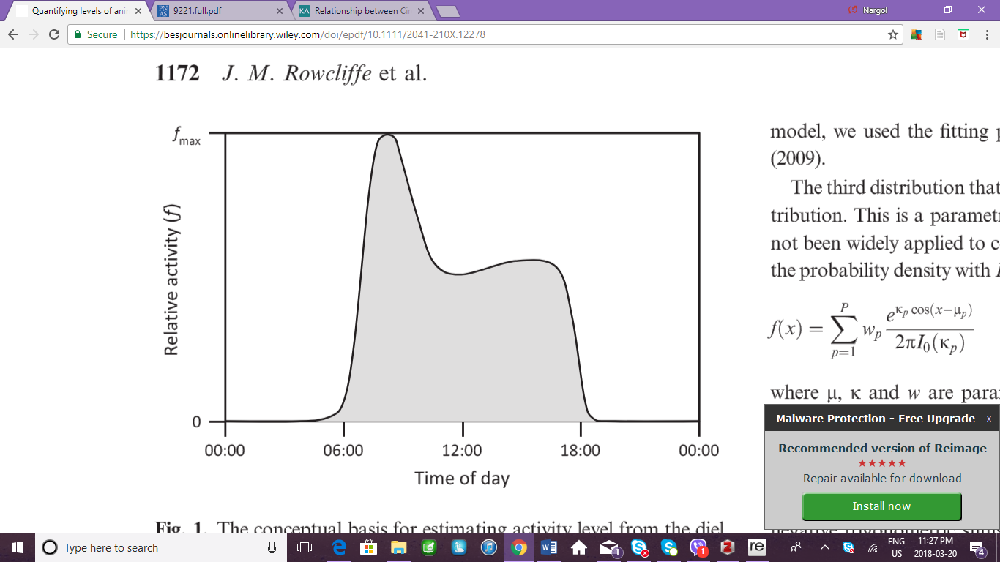

**Figure 2.** Pattern of relative activity over the day. Shaded region is proportional to the total amount of time allocated to activity (Rowcliffe et al. 2014).

1. **Influence of season on habitat selection**

Vegetation commonly occurs in mosaic of patches which affects the distribution of the herbivores that prefers the particular type of vegetation (Cromsigt and Olff 2006). A study conducted by Bukombe et al. (2018) examining the distribution of ungulates across woodland, grassland and bush grassland found that habitat selection in dry and wet season differed between species and each species changed its selection between seasons in varying ways. This change in vegetation selection in dry and wet seasons could not be explained by predator limitation; a hypothesis which states that if predators limit herbivore abundance, then resources are not the limiting factor, competition will be weak and there habitat selection will not be significantly different between seasons. Shifts in seasonal selection could be due be explained by fluctuations in forge abundance (Sinclair and Arcese 1995), forge quality in relation to species functional differences (Hopcraft et al. 2012), and predation.

David L. Otis,

Kenneth P. Burnham, Gary C. White and David R. Anderson

*Wildlife Monographs*

No. 62, Statistical Inference from Capture Data on Closed Animal Populations (Oct., 1978), pp. 3-135