Appendix C

**An example of a meta-analysis conducted in Stata 16.**

The meta-analysis was conducted using the classic Cochrane bronchoconstriction dataset used in many texts to demonstrate meta-analysis. Below are the results from the meta-analysis including bias tests and funnel plots.

. meta esize ne me se nc mc sc, esize(hedgesg)

|  |  |  |  |  |  |  |
| --- | --- | --- | --- | --- | --- | --- |
| source | estimate | se | zval | pval | ci.lb | ci.ub |
| Stata | -1.08 | 0.10 | -10.39 | 0 | -1.28 | -0.87 |

. meta summarize

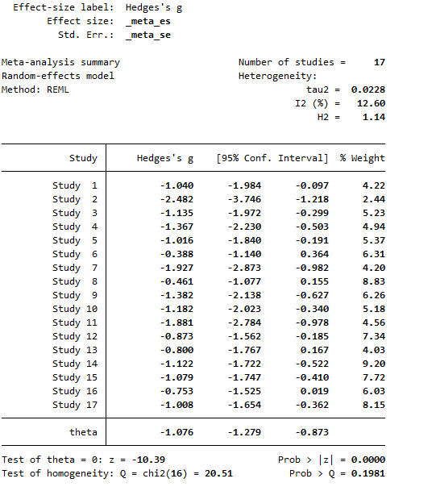

. meta forestplot

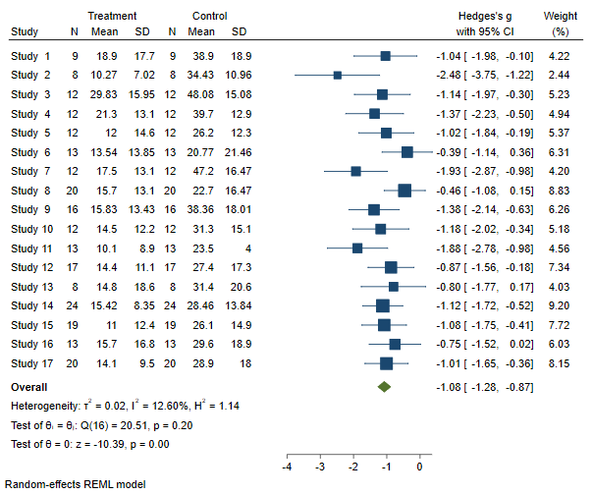

. meta funnelplot

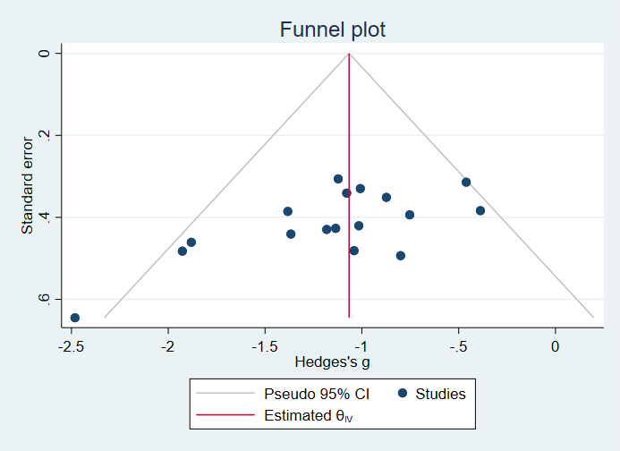

. meta bias, egger

Effect-size label: Hedges's g

Effect size: _meta_es

Std. Err.: _meta_se

Regression-based Egger test for small-study effects

Random-effects model

Method: REML

H0: beta1 = 0; no small-study effects

beta1 = -3.73

SE of beta1 = 1.373

z = -2.72

Prob > |z| = 0.0066