**experimental design cookbook**

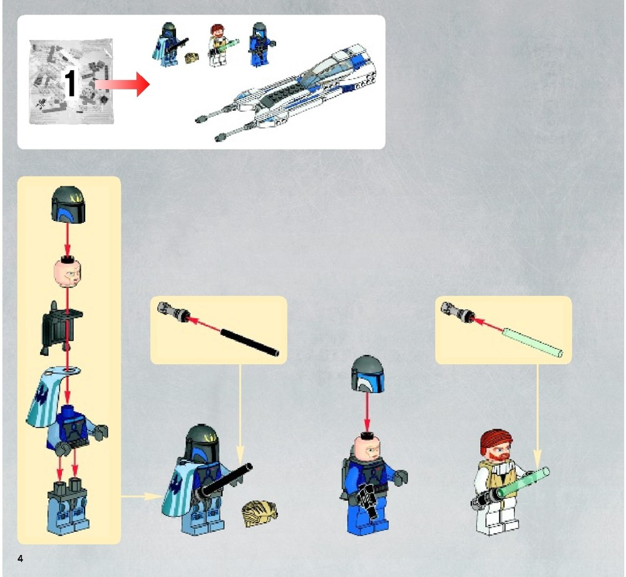

Effective design determines all evidence in science.

Every single day is an experiment - manage and be mindful of the process. #sciencejedi

Christopher J. Lortie

**2019**

**Purpose of experimental design exercises**

**Learning outcomes:**

The primary objective of the labs is to provide you with an opportunity to further develop and refine your experimental design skills. Here are the learning outcomes associated with the activities this exercise set.

1. You will be able to design & execute an effective experiment.

2. You will be able to publish a dataset in a public repository with well-articulated meta-data.

3. You will be able to clearly write a well-structured manuscript suitable for publication in PeerJ pre-prints.

4. You will understand the difference between primary research evidence and scientific synthesis.

5. You will be able to do a deep research synthesis at a level suitable for a graduate school application or grant proposal.

**Skills:**

(1) Experimental design

(2) Data collection

(3) Bibliographic data mining & primary research deconstruction & analyses.

(4) Effective synthesis and writing.



**Schedule**

The schedule is listed on the course website and as a google calendar.

|  |  |
| --- | --- |
| **WK** | **Lab** |
| **1** | No formal meeting. Get cracking on the textbook readings (CH 11). |
| **2** | Logistics, get into groups, discuss labs, & design of first experiment brainstorm. |
| **3** | In field, brainstorm, design experiment for your group. |
| **4** | First week of data collection. |
| **5** | Second week of data collection. |
| **6** | Third week of data collection. |
| **7** | Meet in lab to discuss analysis, reports, and plan write up. |
| **8** | Report due. |
| **9** | Propose & develop deep research review topics in lab. |
| **10** | Discuss systematic reviews. |
| **11** | Final meeting to resolve deep research proposals. |
| **12** | No lab, presentations in lecture component. |
|  |  |

**WK2. Logistics, get into groups, discuss labs, & design of first experiment brainstorm.**

Location: Meet in the lab.

Tasks: Form groups, discuss lab structure with teaching assistant, plan upcoming fieldwork, sketch an experimental design.

Products: Discuss how to design an experiment and do a few sketches including factors, responses, and replication.

**Description**

1. In this lab, please work with the teaching assistant to form small groups of 4-5 individuals. Please ensure that at least one person in the lab has a laptop and is comfortable entering the data for the group directly in the field in the upcoming weeks.

2. The teaching assistant will give a short lecture on the lab format. She/he will also do a tutorial on KNB, Dataverse, and figshare as your data repository items.

3. The teaching will explain the art of experimental design and provide an example of how to sketch out an experimental structurally.

4. If you are unfamiliar with meta-data, also request a tutorial from the teaching assistant.

5. Explore myexperiment.org and consider this tool for sharing your workflows.

**Products**

At least one sketch of an experiment you designed.

At least one directed acyclic graph.

A sample, fun dataset published online.

**Samples**

Most figures posted on figshare here: http://figshare.com/authors/Christopher_Lortie/397067

Browse figshare and slideshare for inspiration in general.

Check knb and figshare for ecological datasets and examples of meta-data.

An overview figure showing the relationships between experiments.

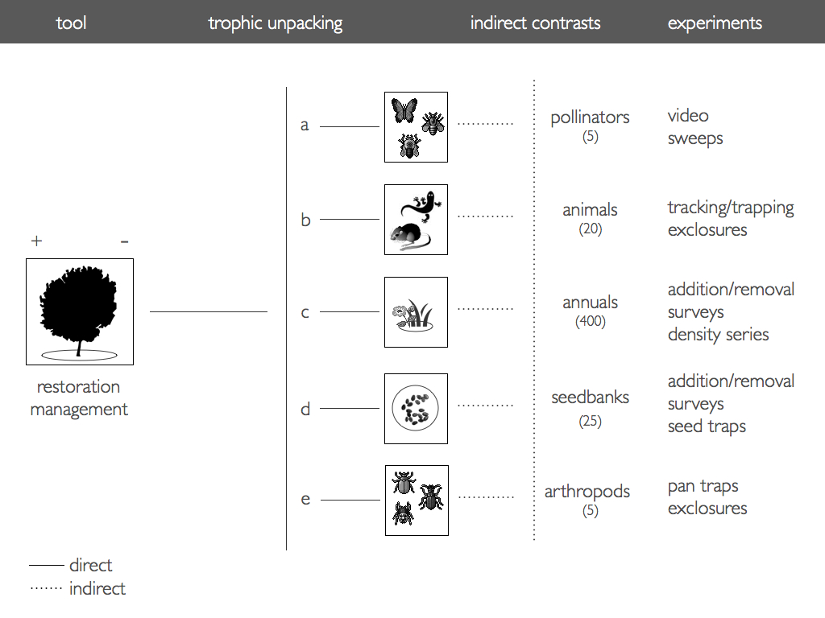

https://figshare.com/articles/Unpacking_the_trophic_effects_of_shrubs_in_arid_and_semi_arid_systems_to_inform_restoration_and_management_/761220

The concept of direct versus indirect interactions mapped out to overlay experiments onto.

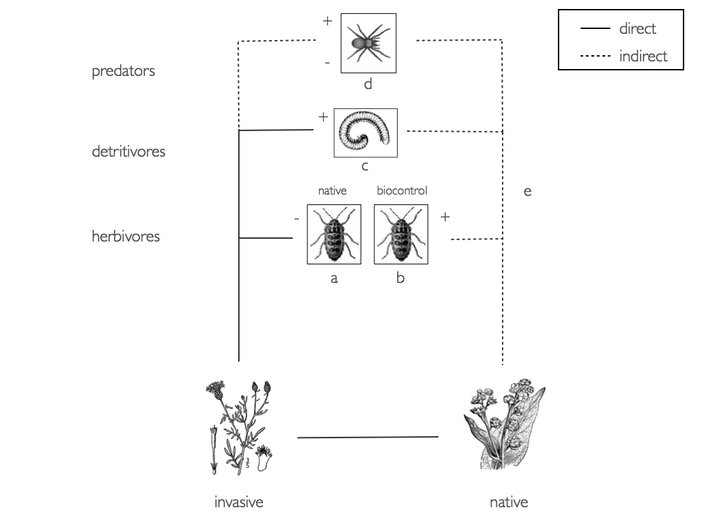

https://figshare.com/articles/Trophic_effects_of_an_invasive_plant_species_/703916

A sketch of field sampling an area.

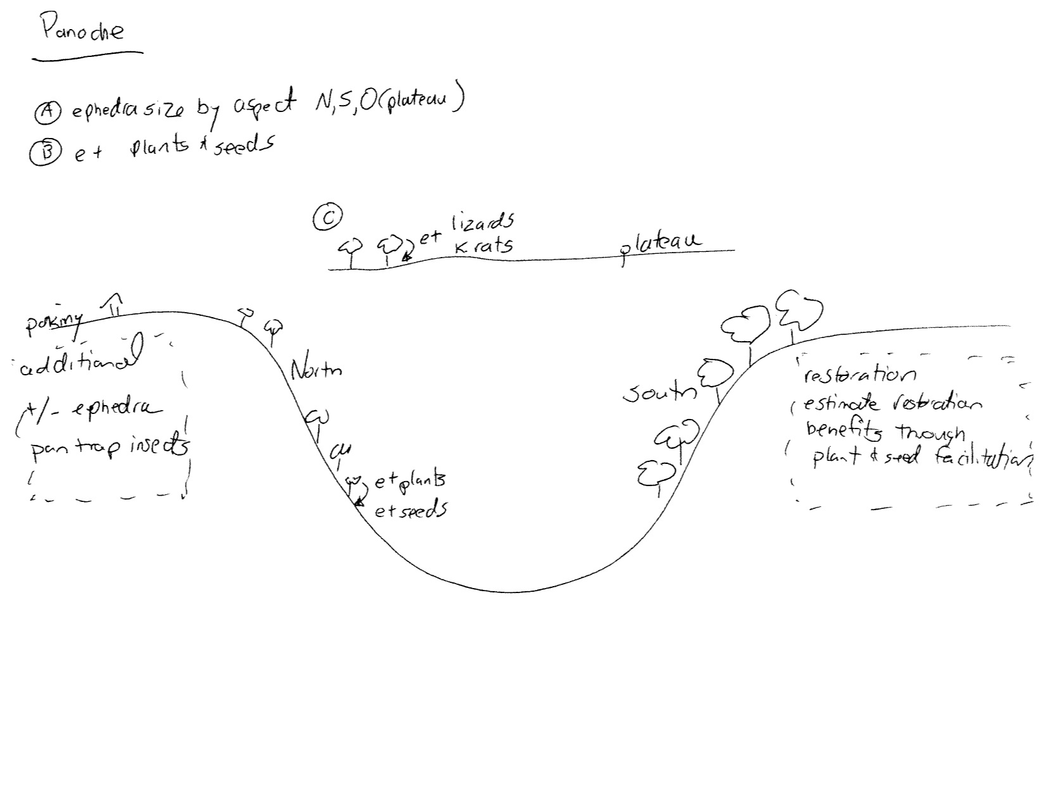

A sketch of how to measure a gradient in the field.

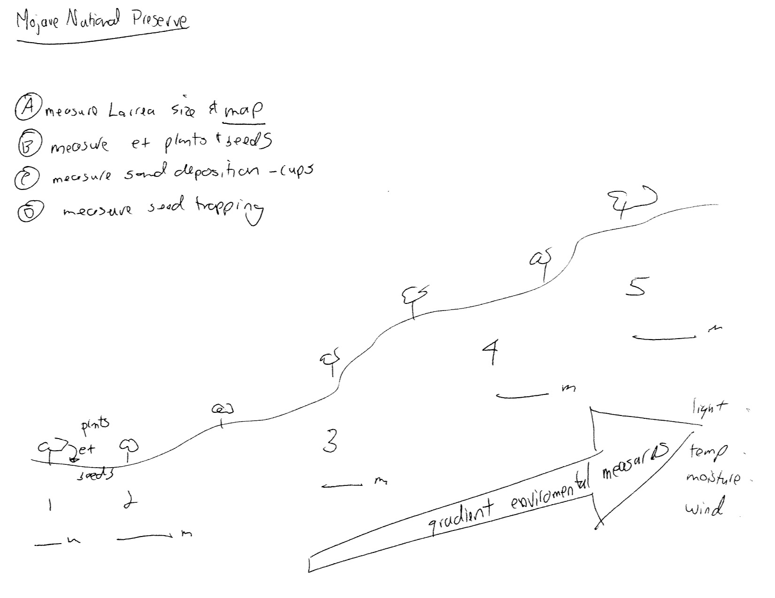

The idea from the field sketches on gradients.

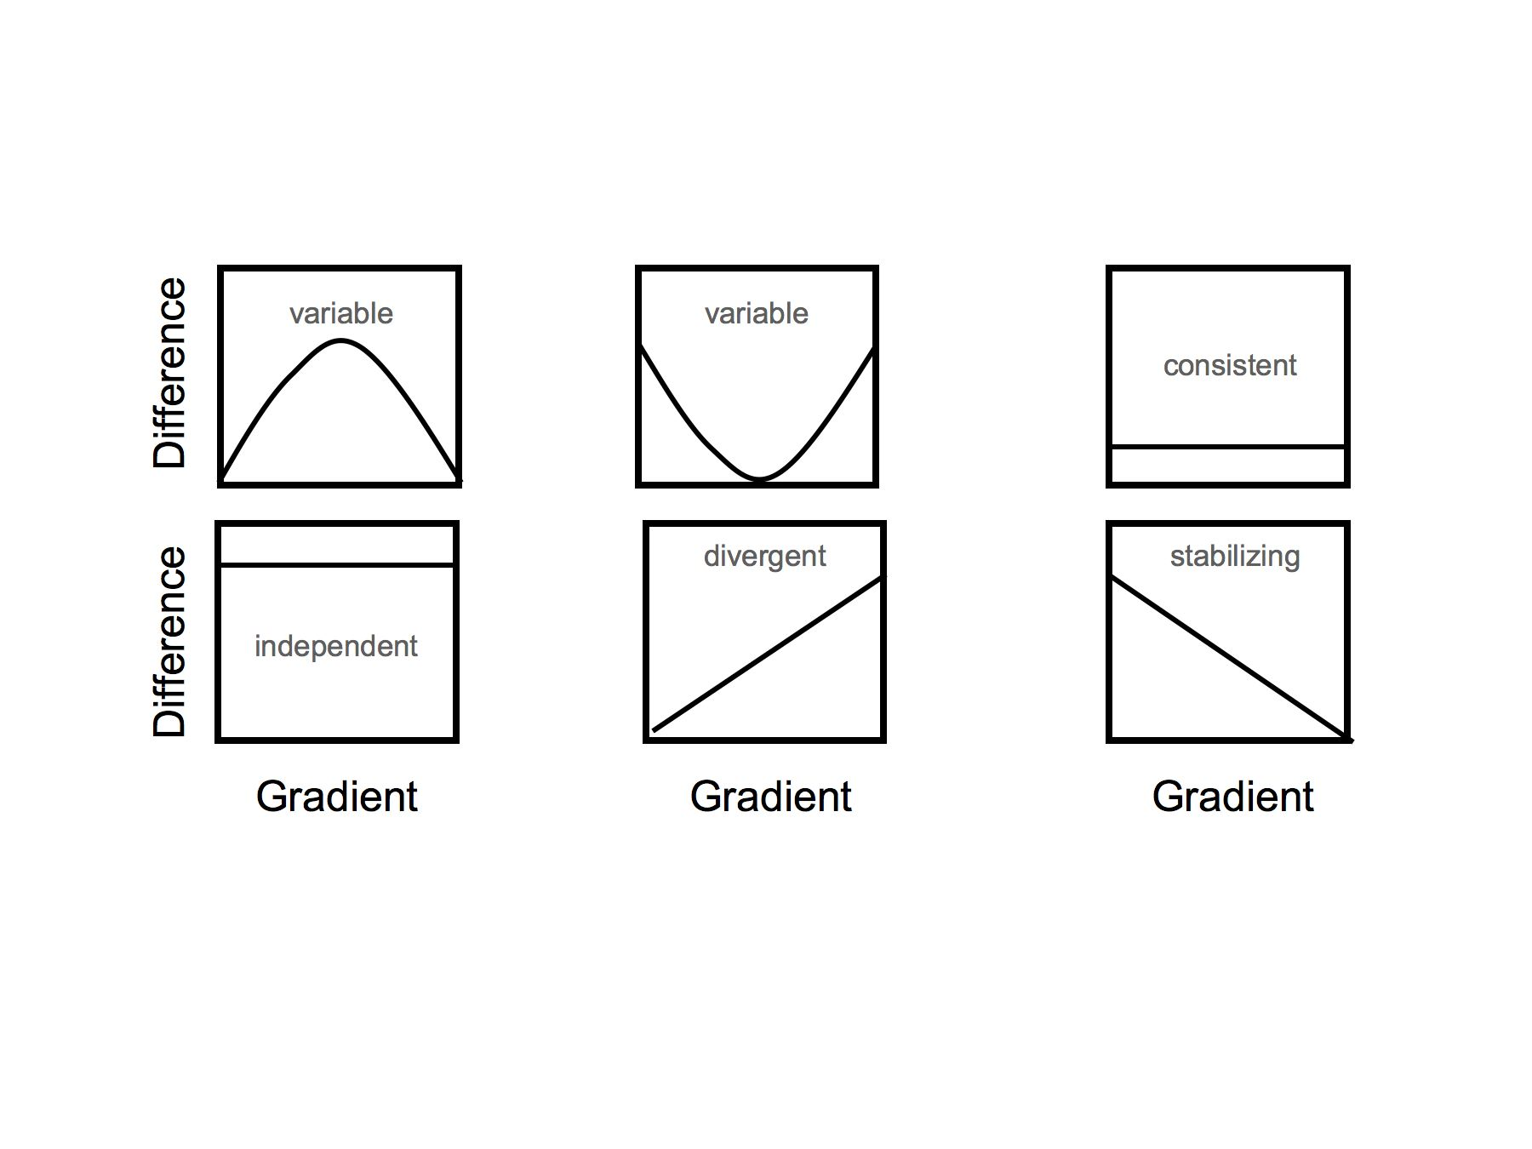

https://figshare.com/articles/Type_of_ecological_stress_gradients/664154

A sketch of growth-chamber trials to test for plasticity.

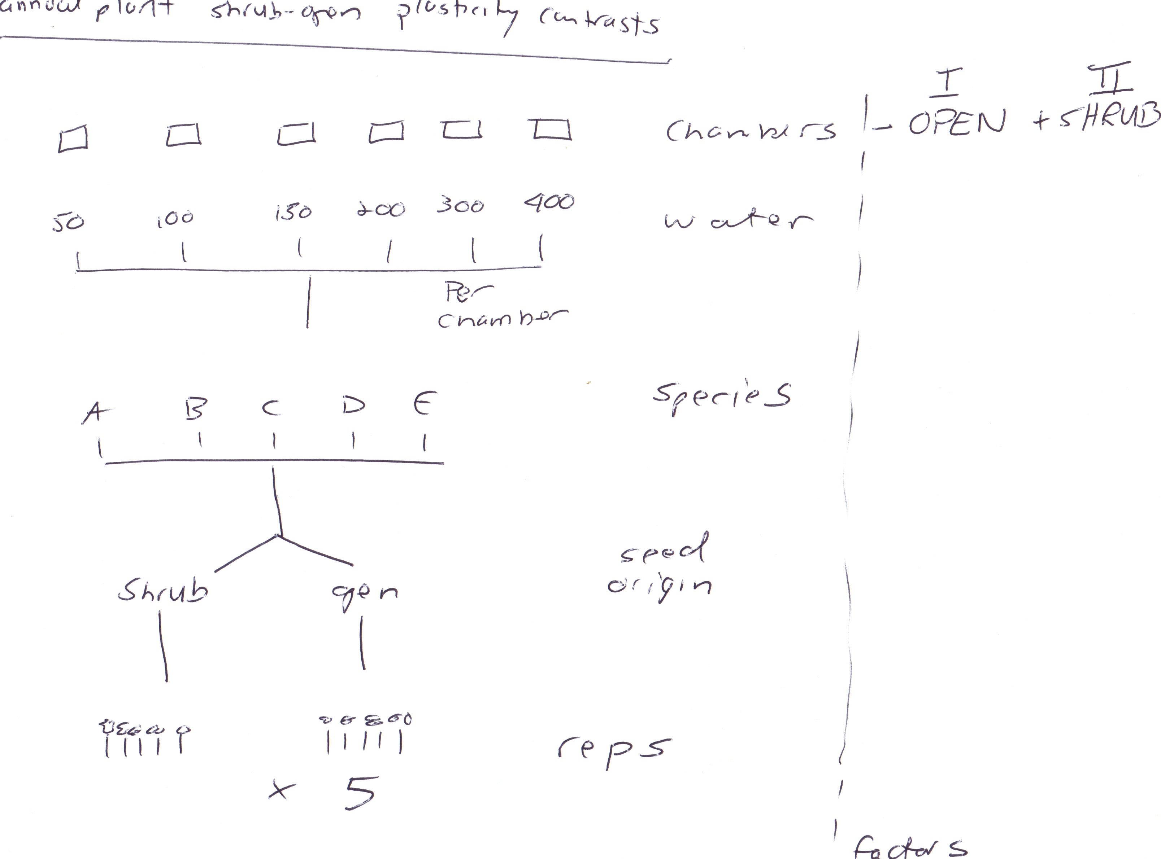

An example of how stress influences individuals.

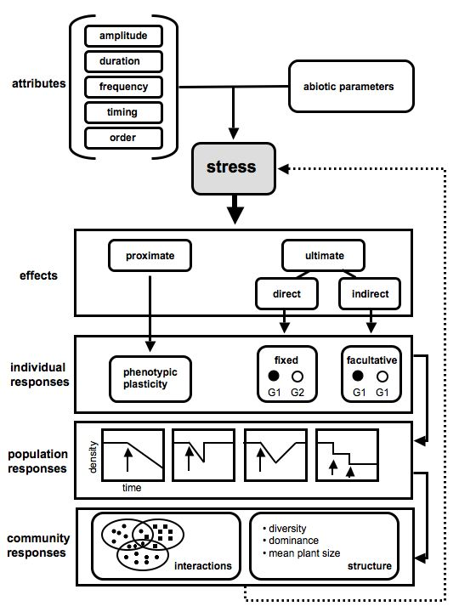

https://figshare.com/articles/Ecological_stress_ontology/664155

An experiment to sample a set of dunes for wind and ecology.

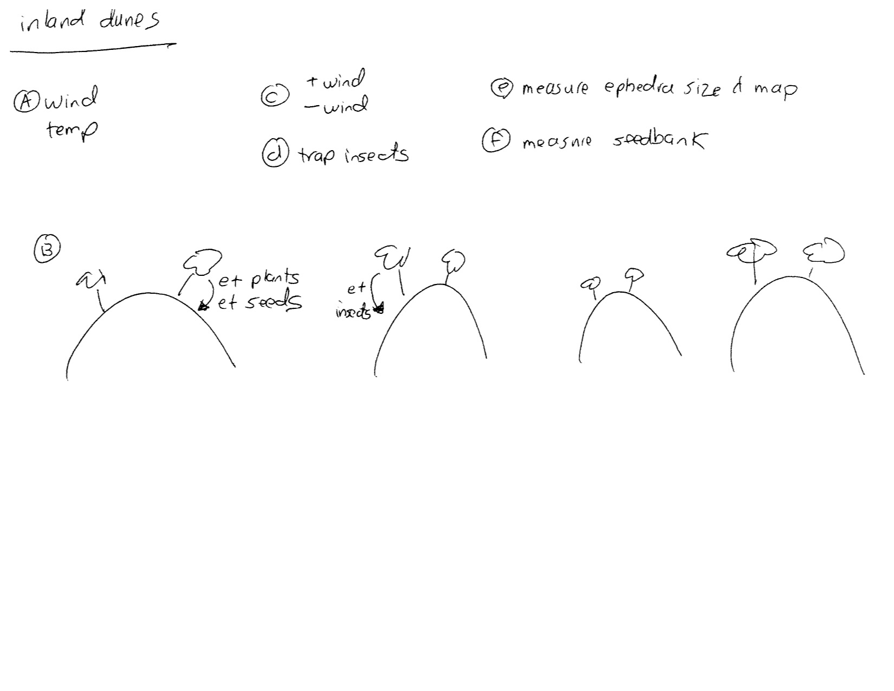

A proposed pipeline for synthesis in ecology.

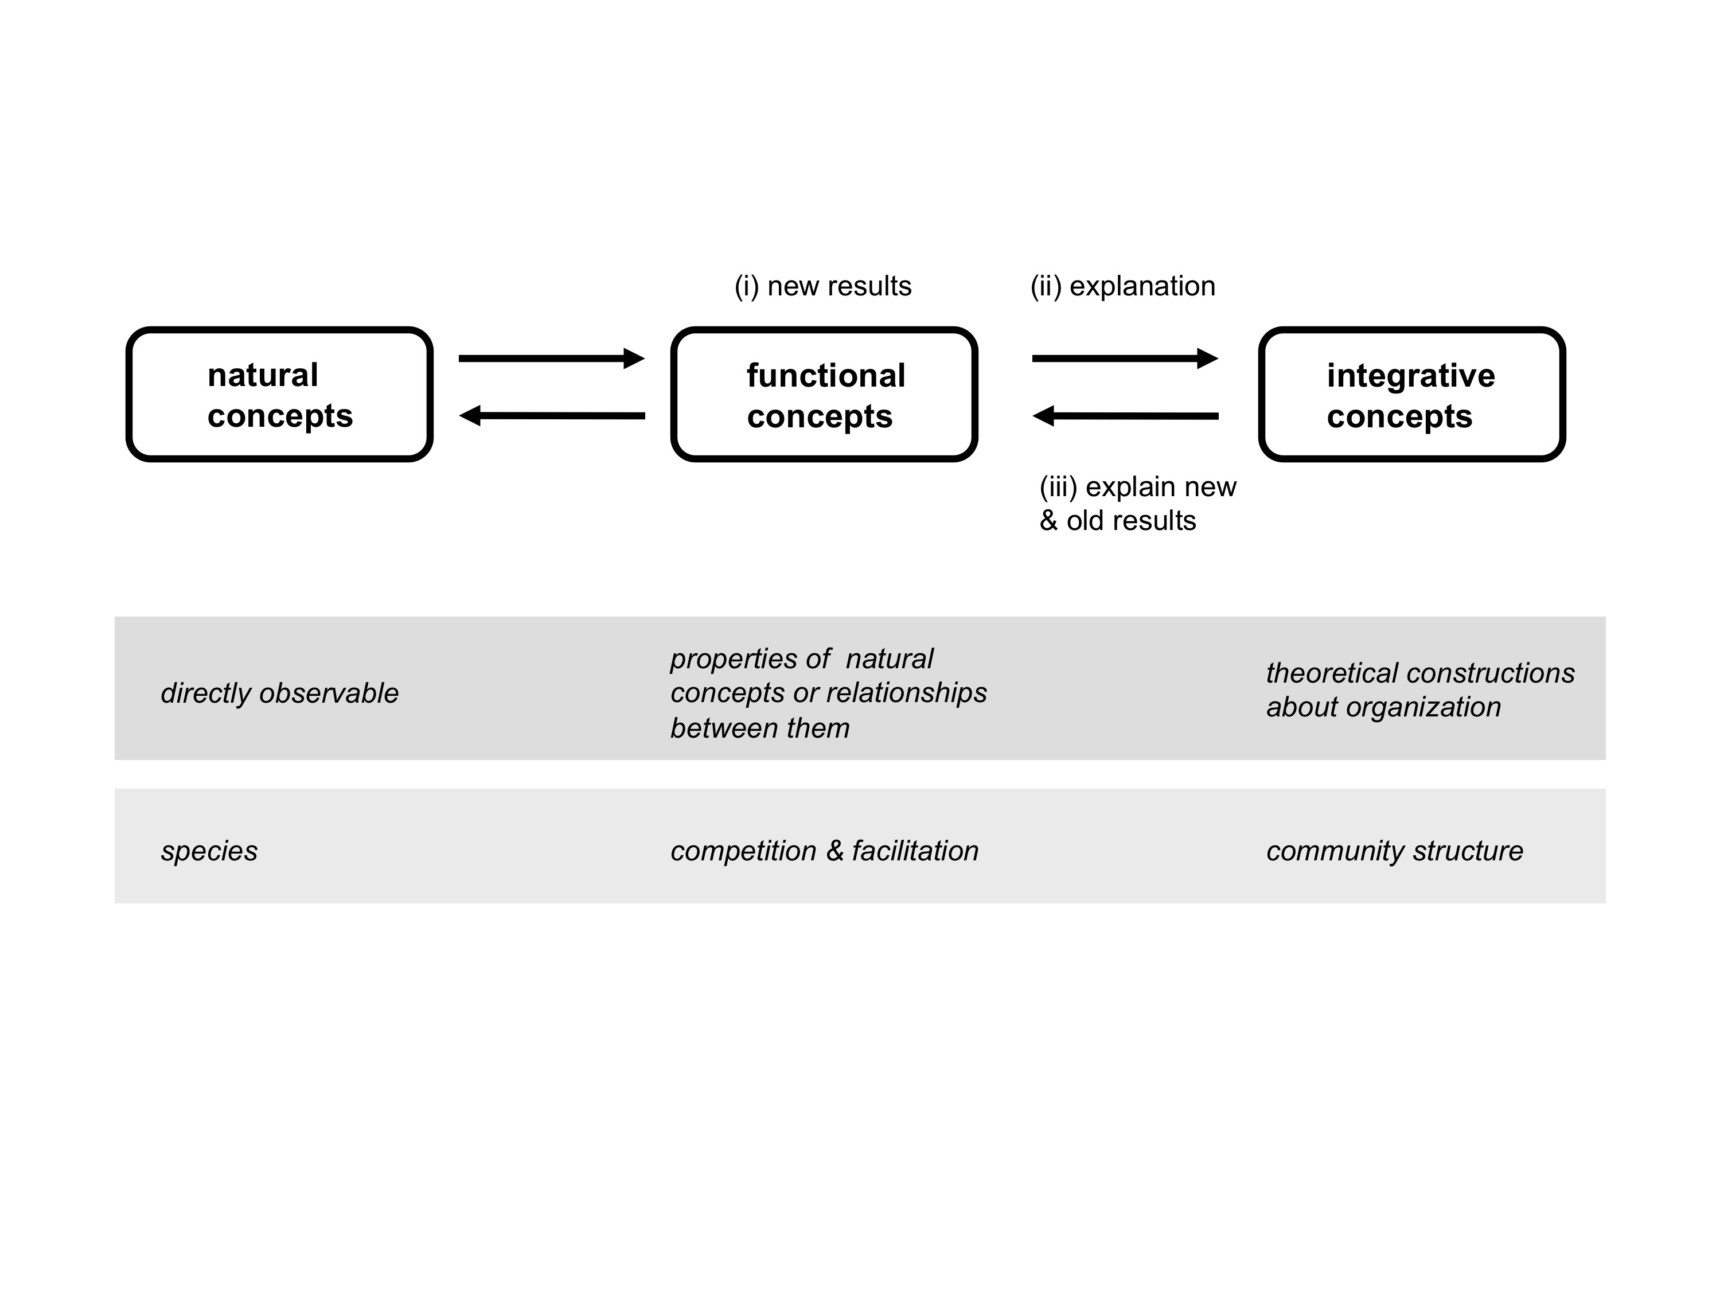

**WK3. Toxic Dump or Garden of Eden. A case study to practice experimental design.**

Location: Meet in the lab then hit the field.

Tasks: Hike corridors, do observations, identify patterns, plan designs.

Products: Outlines & sketches of experiment you will begin next week.

**Description**

The purpose of this component of the labs is to critically think about real world issues and practical methods of testing questions. This will provide you with experience in developing and conducting a proper scientific experimental design from scratch.

1. Meet in lab from 230-240pm. Prompt.

2. Hike to nearby powerlines.

3. Conduct structured observations and identify important natural patterns.

4. Sketch out experimental design in field notebook. Discuss as group.

5. Present designs to teaching assistant whilst in field and ensure they are appropriate.

**Products**

A sketch and outline typed up of your experiment. Publish to figshare.com.

Your methods outlined in reasonable levels of detail.

Sample/template of your datasheets.

You meta-data template.

**Background information**

***Are powerline corridors industrial barrens incapable of supporting life or area of opportunity for conservation biology?***

Powerline corridors cause dramatic changes to the ecology of a landscape. Management of these corridors by Hydro companies often includes vegetation removal through chemicals/pesticides or mowing which "arrests" succession of the ecosystem resulting in limited biodiversity and vegetation (Niering and Godwin 1974). The contrast in vegetation of these corridors from the surrounding natural habitat creates edge effects and habitat fragmentation. The open area may also allow predators to more easily capture prey who would otherwise be protected by the dense vegetation of a forest or grassland. These alterations to the environment are so profound, that powerline corridors are often compared to the way a river defines a riparian habitat. The unique characteristics of these powerline corridors may therefore represent a new ecotype.

Though powerline corridors can negatively affect natural habitat, if properly managed, they can function as "greenways" within an urban centre (Searns 1995). The average powerline corridor in North America has approximately four times greater shrub density than an equivalent area of residential area (Geibert 1980). These utility corridors have the potential to act as source populations by facilitating the growth of plants throughout an urban community, but also the capacity to spread invasive species. Powerline corridors may also function as an animal habitat for insects, birds and rodents in an otherwise inhospitable urban environment. These characteristics make powerline corridors an attractive conservation tool in the management of urban ecosystems, but their effectiveness when compared natural or other urban environments has been poorly tested.

Figure 1: Map of powerline corridors in the Greater Toronto Area.

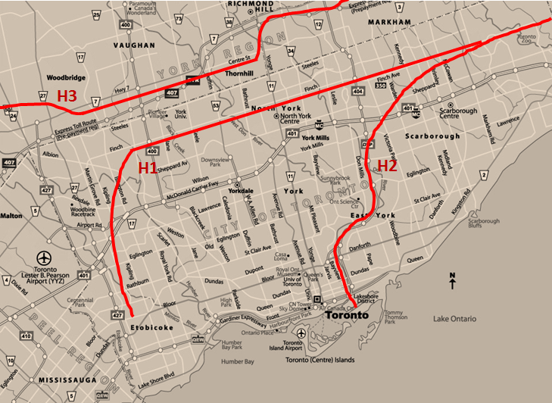

Figure 2: Goldenrod in full bloom along the Finch Hydro Corridor.

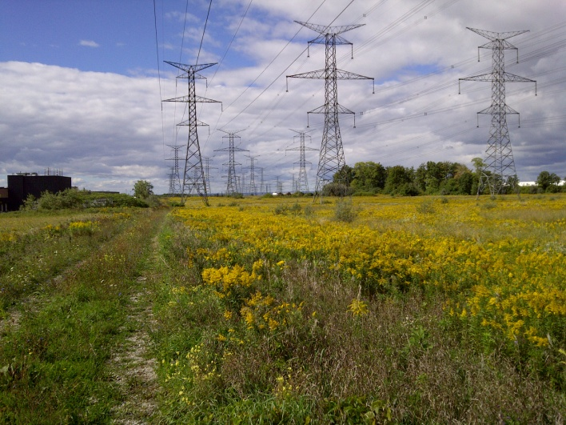

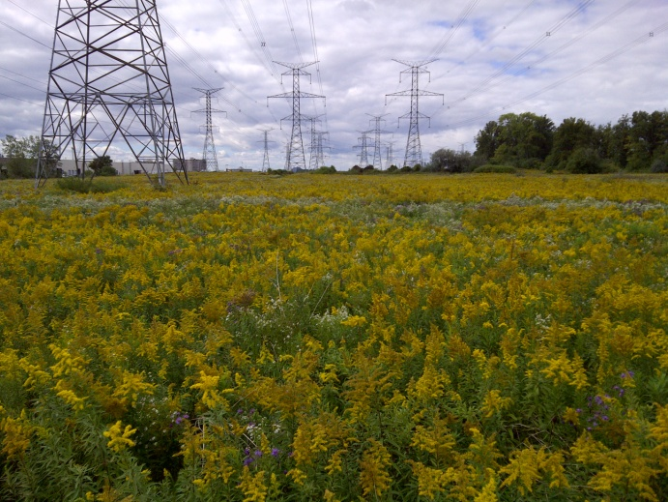

Figure 3: Invasion hypotheses and the mechanisms by which powerline corridors may operate on.

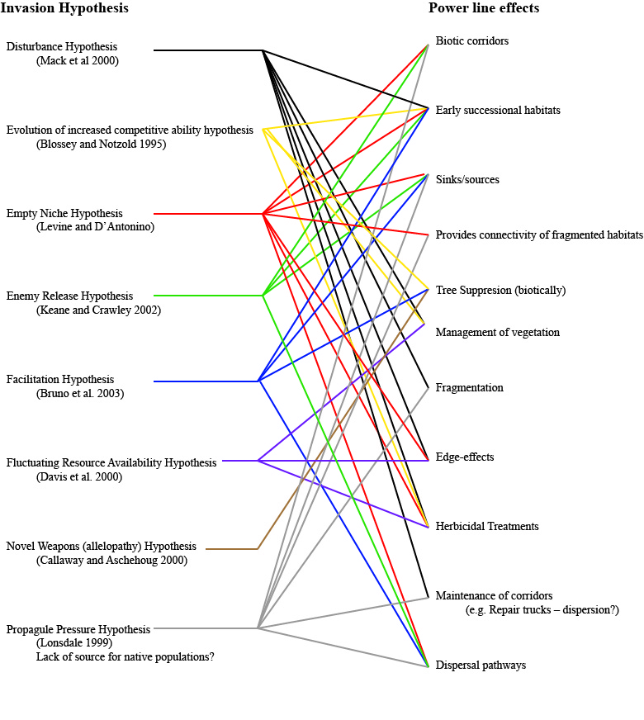

**Sample questions**

Do powerline corridors function as an ecological source?

Is there greater species richness/diversity within corridor when compared to an urban area or natural habitat?

Are there more invasive or native species within the corridor when compared to a natural area?

Are there a greater number of pollinators, insects or other animals when compared to neighbouring areas?

Is the powerline corridor heterogeneous or homogenous throughout its length?

Are sections of corridor surrounded by urban habitat different in composition (vegetation or animal) than areas surrounded by natural habitat?

Are there edge effects?

Is there a difference in composition between the center of the corridor, the edge and a neighbouring area?

**Resources**

1. Beier and Noss. 1998. Do habitat corridors provide connectivity. Conserv. Biol.

2. Clarke et al. 2006. Powerline corridors: degraded ecosystem or wildlife havens? Wildlife Res.

3. Dube et al. 2011. Do power line rights-of-way facilitate the spread of non-peatland and invasive plants in bogs and fens? Botany

4. Geibert 1980. Songbird diversity along an urban power-line right-of-way. Enviro. Mgmt.

5. Kroodsma 1982. Bird community ecology on power-line corridors in east Tennessee. Biol. Conserv.

6. Russel et al. 2004. The potential conservation value of unmowed powerline strips for native bees. Biol. Conserv.

7. Searns 1995. The evolution of greenways as an adaptive urban landscape form. Landscape and Urban planning.

8. Simberloff et al. 1992. Movement corridors: conservation bargains or poor investments. Consev. Biol.

**WKS 4-6. Fieldwork**

Location: Meet in the lab then go immediately to field sites.

Tasks: Collect your datasets. Enter in the field.

Products: Provide/show excel file to teaching assistant every week to solicit feedback.

**Description**

Do your experiments and collect datasets.

**Products**

Excel data files.

Meta-data templates now complted.

Field notes or myexperiment.org project with workflow to show teaching assistant.

Remember, these products in their final forms will be graded. Get all the feedback you need/want now from the teaching assistant to capture the best scientific workflow and set of macroprocedures you can now.

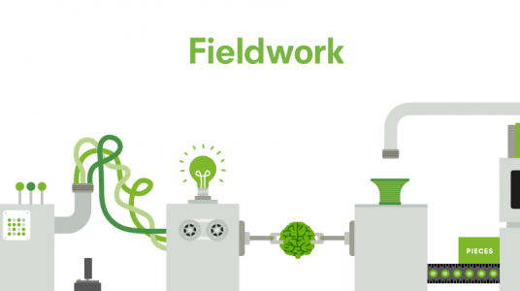

**WK7. Discussion & report planning in lab.**

Location: Meet in the lab.

Tasks: Analyze datasets, meet with teaching assistant, present preliminary findings to lab, and plan report writing.

Products: Visualizations of findings and outline for papers.

**Description**

1. Work in the lab on analyses.

2. Each group should meet with teaching assistant in the first 1.5 hour.

3. In the remaining time, discuss findings as lab and plan reports.

**Products**

At least one plot of findings and outline for paper.

Dataset on figshare with doi and link.

One of your plots on plot.ly OR figshare to share with the lab and/or teaching assistant.

**WK8. Complete report.**

Location: Independent, but you are welcome to meet in lab to discuss with teaching assistant.

Tasks: Submit lab report by midnight.

Products: Lab report.

**Description**

1. Submit lab reports online by midnight.

2. 245pm to 430pm teaching assistant available to resolve final questions

**Products**

Lab report

**Resources**

Ten simple rules for scientists: improving your writing productivity. https://journals.plos.org/ploscompbiol/article?id=10.1371/journal.pcbi.1006379

**WK9. Propose topics for review.**

Location: Meet in the lab.

Tasks: Propose topics to class. Discuss execution, data collection, & write-up.

Products: An Excel file/data table prepared for processing all the publications for topic.

**Description**

1. Propose topics.

2. Discuss in lab.

3. Lecture by teaching assistant on how to process papers, enter data about the papers, and write-up your systematic review paper.

**Products**

Final sketch of design, excel file or table for entering attributes from papers, and statement of purpose for your research proposal.

**WK10. How to do a formal scientific synthesis.**

Location: Meet in the lab.

Tasks: Discuss systematic reviews and critique several published examples.

Products: An outline and visual sketch of how a systematic review is done.

**Description**

1. 230-245pm. Discuss scientific synthesis - what you need to do to learn a topic for research in science and to write a grant proposal well.   
See **Formalized synthesis opportunities for ecology: systematic reviews and meta‐analyses.** https://onlinelibrary.wiley.com/doi/full/10.1111/j.1600-0706.2013.00970.x

2. 245pm to 430pm. Lecture by teaching assistant on systematic reviews. PRISMA reporting, Web of Knowledge, and the Cochrane Collaboration.

3. Critique of several published examples of systematic reviews.

**Products**

At least one sketch of the concepts associated with a systematic review.

Spreadsheet listing all studies that you will check for your grant proposal and deep research project.

**Resources**

1. PRISMA: http://www.prisma-statement.org

2. The Cochrane Collaboration: http://www.cochrane.org

3. The handbook for systematic reviews: http://handbook.cochrane.org

4. The Centre for Evidence-Based Conservation: http://www.cebc.bangor.ac.uk

5. Collaboration for Environmental Evidence: http://www.environmentalevidence.org/EBConservation.htm

6. PLOSONE guidelines: http://www.plosone.org/static/guidelines#systematic

7. PeerJ how to paper: https://peerj.com/preprints/39/

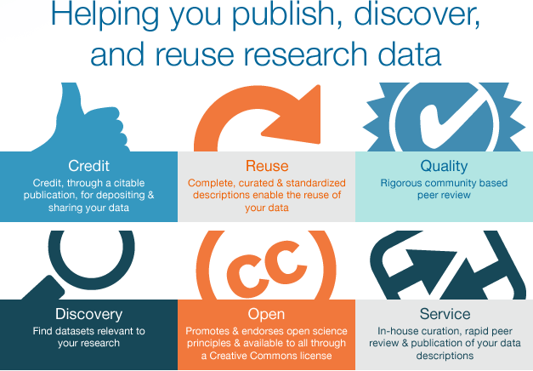

**WK11. Final meeting to resolve systematic review papers.**

Location: Meet in the lab.

Tasks: Discuss any outstanding issues with your systematic reviews.

Products: Review complete that you can use for grant proposal.

**Description**

1. Meet with teaching assistant and groups to clarify and/or resolve any questions.

2. Present any findings to lab for additional feedback or ideas.

**Products**

Draft of research proposal and all the scientific evidence you needed compiled.

Experimental design propsed for grant proposal

Dataset in figshare listing all studies that you checked to do review and write your proposal.

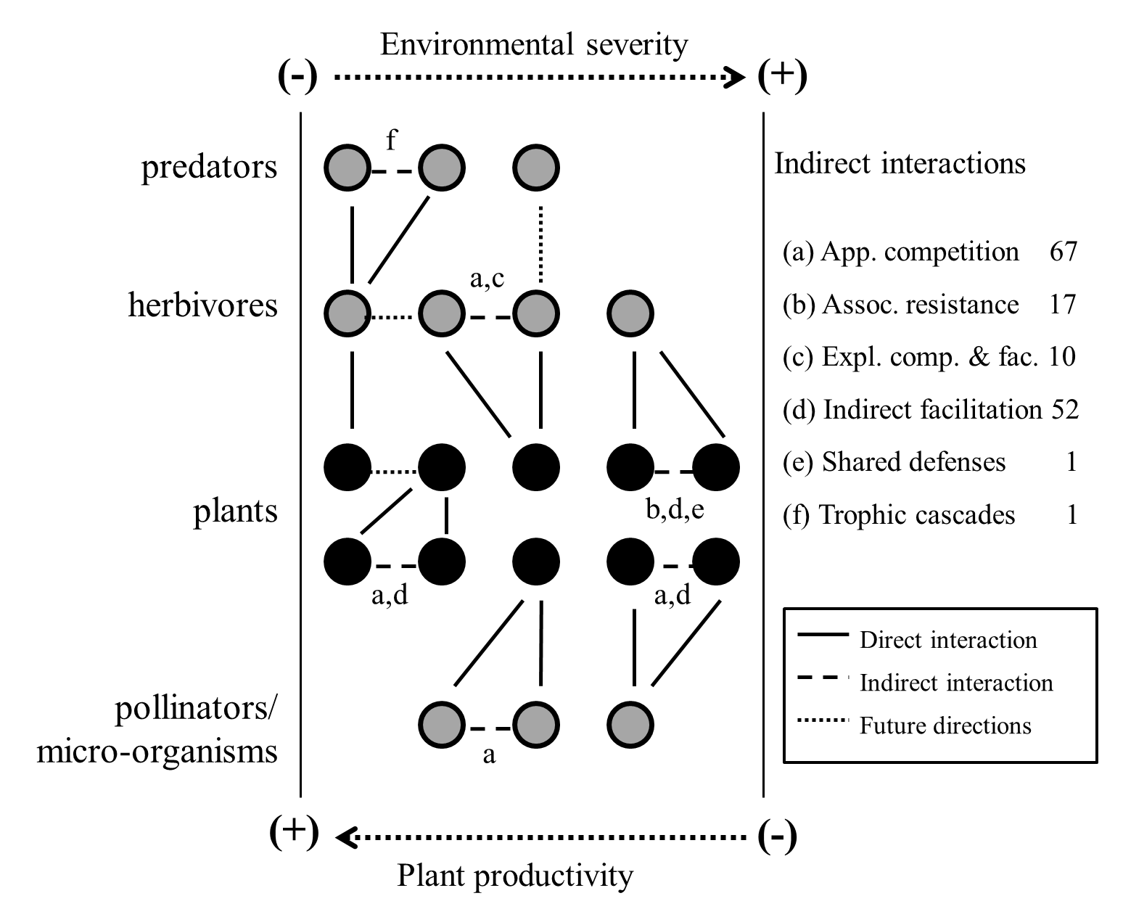

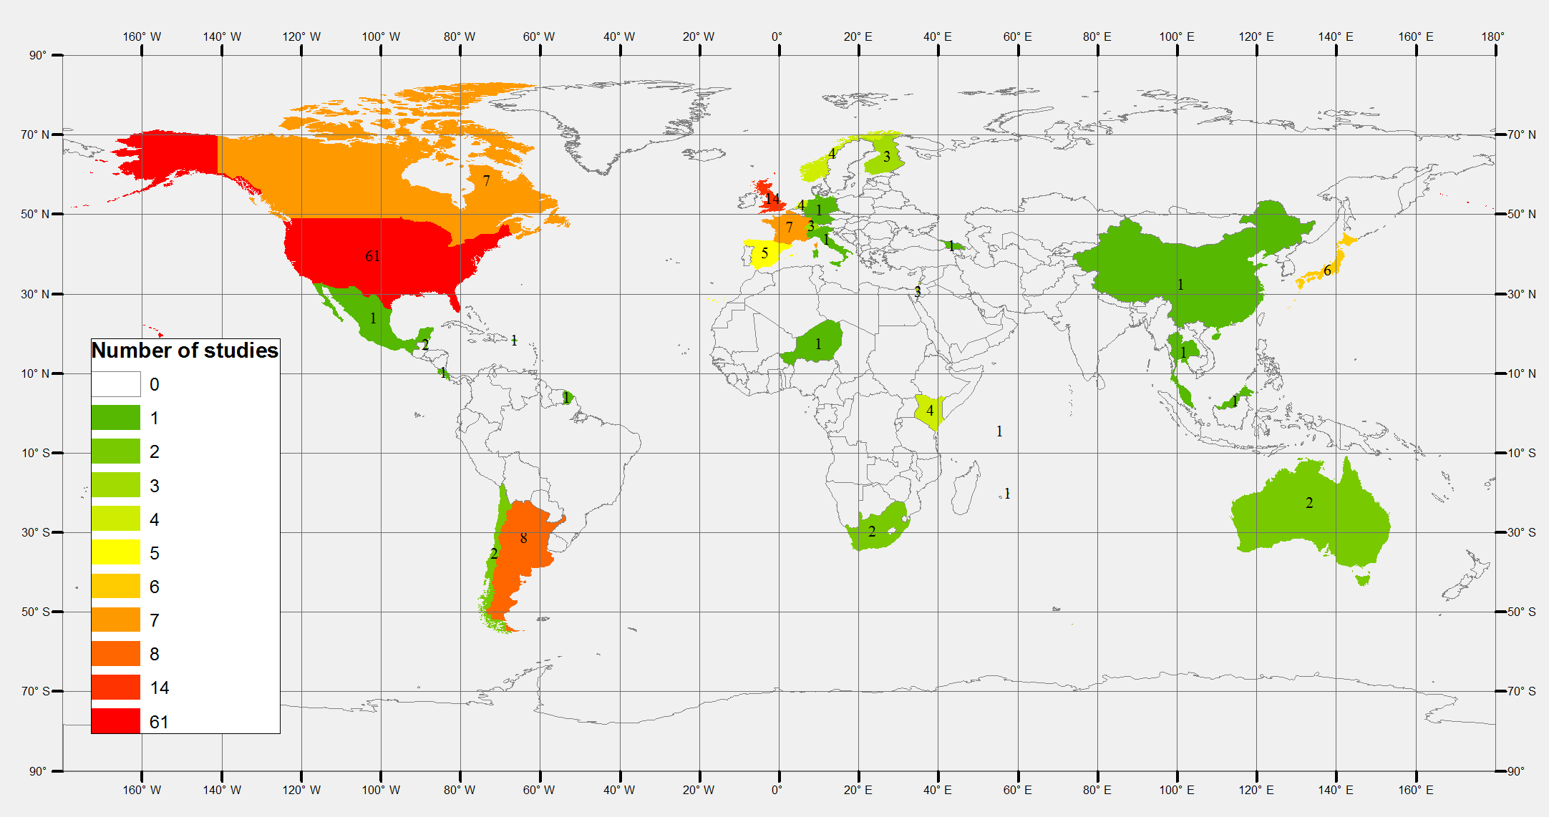

**WK12. No, lab presentations in lecture.**

Location: Meet in lecture.

Tasks: Do short presentation to propose/pitch your research proposal.

Products: Slide deck published.

**Description**

1. Publish slide deck online.

2. Give presentation in lecture.

3. Compare your work to the published examples provided by teaching assistant.

**Products**

Review dataset.

Grant proposal.

PRISMA report.

Presentation slide deck.

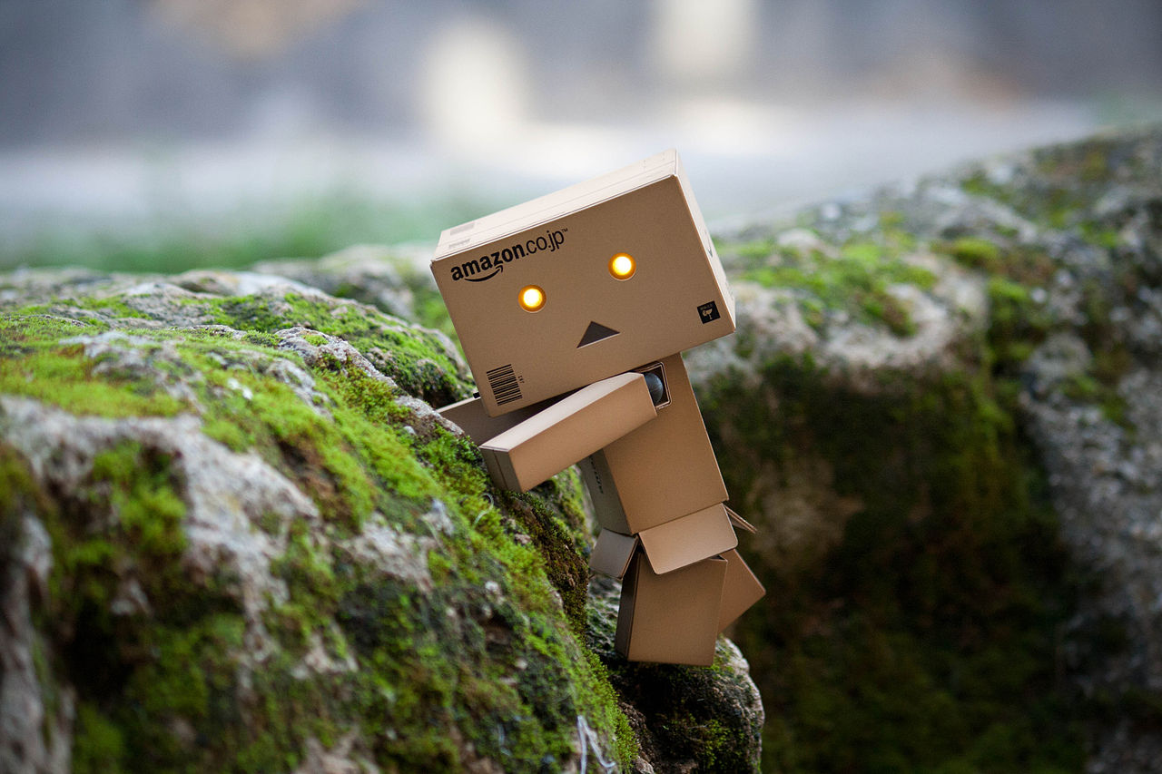

You made it, congratulations!