IA & Machine Learning

Summary
IA & Machine Learning 1
1
1 IA and Machine Learning (ML) 1
2 Image classification: Dense Neural Networks (NN) 2
3 Image classification : Convolutional Neural Networks (CNN) 3
4 Object detection: the Tensorflow Object Detection API (TOD) 4
▸ Learning objectives 4
▸ Preliminaries 4
▸ Installation of git 4
▸ Installation of Visual Studio Build Tools 2019 4
▸ Install a Python Virtual Environnement for the project 4
▸ Typing commands in a command window... 5
▸ Tensorflow installation 5
▸ TensorFlow Object Detection (TOD) API Installation 5
▸ Create and prepare the project root directory: tod_tf2 5
📥 Download and install the TOD API 6
▸ Configure the PYTHONPATH environnement variable 6
▸ Compile protobufs 7
▸ Install the object_detection module 7
▸ Test the installation of TOP API 7
▸ TensorFlow Object Detection (TOD) API Installation 9
📥 Install the COCO tools 10

IA and Machine Learning (ML)
Introducing IA and the different branches of machine learning.
The ingredients of a neural network.
Main applications of the deep machine learning.

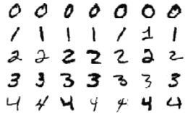
Image classification: Dense Neural Networks (NN)
Understand the architecture of a dense NN for image classification.
Practice:
▸ Build a dense NN with tensorflow & keras.
▸ Train the NN to classify hand written digits using the MNIST database.
▸ Test & operate the trained network, build the confusion matrix.

Practical work:
▸ Launch the command jupyter lab in the console with the Python Virtual Environment (PVE) (tf2) activated then open the notebook XXXXXXX.ipynb.

Image classification : Convolutional Neural Networks (CNN)
Understand the architecture of a CNN.
Practice:
▸ Build a CNN with tensorflow/keras.
▸ Train the CNN to classify hand written digits using the MNIST database.
▸ Test & operate the trained network, build the confusion matrix.

Practical work:
▸ Launch the command jupyter lab in the console with the Python Virtual Environment (PVE) (tf2) activated then open the notebook XXXXXXX.ipynb.

Object detection: the Tensorflow Object Detection API (TOD)

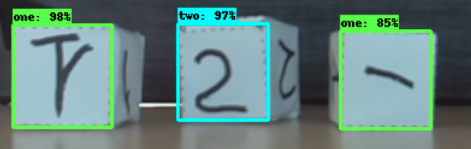
▸ Learning objectives
▸ Understand what Object Detection is?
▸ Install the TOD API and a custom project tree
▸ Choose, download and re-train a pre-trained CNN for detecting objects in custom images using the TOD API

▸ Summary
▸ 1 – Preliminaries
▸ 2 – Tensorflow installation
▸ 3 – TensorFlow Object Detection (TOD) API Installation
▸ 4 – Create your project workspace
▸ 5 – Download a pre-trained NN for Object Detection
▸ 6 – Get and annotate images for the supervised re-training of the NN
▸ 7 – Re-train a pre-trained NN for Object Detection
▸ 8 – Operate a re-trained neural network

▸ 1 – Preliminaries

▸ Installation of git
In order to use some GitHub repositories, you must install git on your machine. Git is a free and open source distributed version control system. Download and install git with this link:
https://github.com/git-for-windows/git/releases/download/v2.36.1.windows.1/Git-2.36.1-64-bit.exe

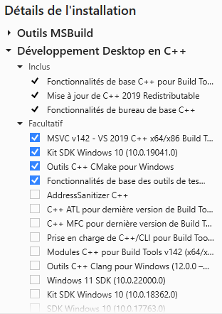
▸ Installation of Visual Studio Build Tools 2019
Some steps in the installation of the TOD API will require a C++ compiler to produce executables from C++ source files: on Windows, you must have the Visual Studio Build Tools 2019 installed.
If you don't have the VS Build Tools 2019 installed follow this link:
https://docs.microsoft.com/en-us/visualstudio/releases/2019/redistribution
and install the Download Community 2019 package :
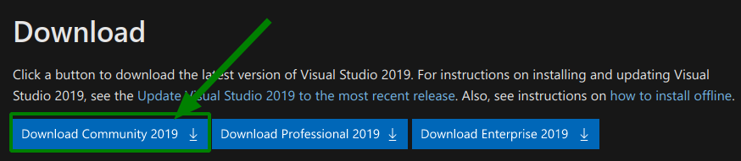
You must install the components as suggested in the figure on the right :

▸ Install a Python Virtual Environment for the project
The state of the art regarding Python programming (Machine Learning, Data processing…) consists in using a Python Virtual Environment (PVE) to encapsulate each project in a dedicated and sustainable environment.
Each PVE provides a dedicated computing environment containing a specific installation of Python:
- independent of other Python installs likely to coexist on the same machine,
- independent of computer updates.
A PVE is based on a dedicated disk tree that houses the version of the Python interpreter and modules that you need for your project. You can delete and re-create an PVE very easily, without impacting the other Python installations present on your computer.
Follow this guide to create your (tf2) PVE : Create a Python Virtual Environnement.odt

▸ Typing commands in a command window...
You will often use a terminal (a.k.a “command window” or “console”) to type in commands that will be executed by the Windows command shell interpreter.
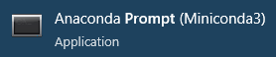
Use the Anaconda prompt (Miniconda3) application to get a terminal which is aware of your miniconda3 installation…
It opens an [Anaconda prompt (Miniconda3)] window which is the terminal you will use for the rest of this activity.
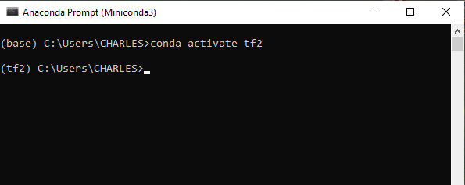
In the terminal activate your PVE (tf2) by typing:
conda activate tf2
the prompt should be now prefixed with the string (tf2) to confirm that the right PVE has been activated.

▸ Tensorflow installation
With the the PVE (tf2) activated, if not already done, install the tensorflow module and some other required modules by typing the commands:
(tf2) C:\...>pip install --ignore-installed --upgrade tensorflow==2.9
... makes some stuff: download and install a lot of Python modules…
(tf2) C:\...>conda install numpy scipy matplotlib jupyter jupyterlab pandas
(tf2) C:\...>pip install scikit-learn scikit-image seaborn pydot rospkg pyyaml opencv-python==4.6.0.66
We will skip the GPU (Graphical Processor Unit) installation which is beyond the scope of this training. If your machine is equipped with a with a compatible CUDA-enabled GPU you can follow later the GPU Support tutorial here.

▸ TensorFlow Object Detection (TOD) API Installation

▸ Create and prepare the project root directory: tod_tf2
The first step is to create the working directory tod_tf2, which will be the root directory of the project in which all the files will be created, and to make it your current working directory.
Use the file explorer to create the directory tod_tf2 somewhere in your user tree, enter tod_tf2 and copy its absolute path name and then paste it as the argument to the command cd (change directory) in the terminal:
REM cd <absolute path to tod_tf2 on the same disk drive>
REM cd /D <absolute_path to tod_tf2 on manother disk drive like D: or E: or Z: ….>
REM Examples:
(tf2) C...>cd C:\Users\CHARLES\tod_tf2
(tf2) C:\Users\CHARLES\tod_tf2>
(tf2) C:\...>cd /D Z:\tod_tf2
(tf2) Z:\tod_tf2>

Then clone the GitHub repository https://github.com/cjlux/tod_tf2_tools.git and copy all the *.py and *.ipynb files from tod_tf2_tools to tod_tf2:
REM From tod_tf2
(tf2) C:\...\tod_tf2>git clone https://github.com/cjlux/tod_tf2_tools.git
…
(tf2) C:\...\tod_tf2>copy tod_tf2_tools\*.py .
…
(tf2) C:\...\tod_tf2>copy tod_tf2_tools\*.ipynb

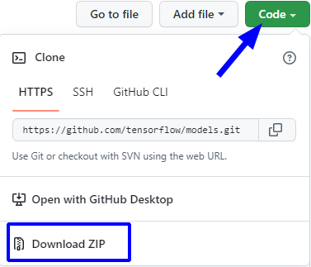
📥 Download and install the TOD API
- Go to https://github.com/tensorflow/models with your preferred internet browser and download the zip file model-master.zip.
- Unzip the file and extract the directory model-master into the tod_tf2 directory.
- Now rename the directory model-master to model.

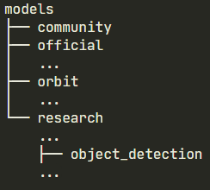
The mains programs for the Object Detection API are in the directory: models/research/objet_detection
Complete your installation with some Python packages useful for working with the TOD API:
(tf2) C:..\tod_tf2>conda install cython contextlib2 pillow lxml protobuf
...
(tf2) C:..\tod_tf2>pip install labelimg
...

▸ Configure the PYTHONPATH environment variable
The PYTHONPATH variable must be created that points to the absolute paths of \models, \models\research, and \models\research\slim directories. Do this by typing the following commands (replace C:\..somewhere..\tod_tf2 by the absolute path-name of the directory tod_tf2 on your machine :
(tf2) C:..\tod_tf2>set PYTHONPATH=C:\..somewhere..\tod_tf2\models
(tf2) C:..\tod_tf2>set PYTHONPATH=%PYTHONPATH%;%PYTHONPATH%\research;%PYTHONPATH%\research\slim
REM lets’s check:
(tf2) C:..\tod_tf2>echo %PYTHONPATH%
C:..\tod_tf2\models;C:..\tod_tf2\models\research;C:..\tod_tf2\models\research\slim

Note: if you want to make the variable PYTHON persistent on your computer, you can create a user environment variable with the Windows system (look for “variable” in the search bar) :
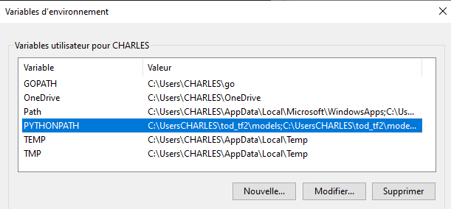

▸ Compile protobufs
The native TOD API uses *.proto files for configuring models and storing training parameters. These files must be translated into *.py files in order for the Python API to function properly:
REM From within tod_tf2:
(tf2) C:..\tod_tf2>cd models\research
(tf2) C:..\tod_tf2\model\research>for /f %i in ('dir /b object_detection\protos\*.proto') do protoc object_detection\protos\%i -–python_out=.
...
This will process all the *.proto files found in the tod_tf2\models\research\object_detection\protos directory.

▸ Install the object_detection module
To finish the installation, from the models/research/ directory type:
REM From within tod_tf2\models\research:
(tf2) C:..\research>copy object_detection\packages\tf2\setup.py .
...
(tf2) C:..\research>python setup.py build
...
(tf2) C:..\research>python -m pip install --use-feature=2020-resolver .
...a really big stuff...

▸ Test the installation of TOP API
To test the installation, run the following command from within ...\tod_tf2\models\research:
REM From within tod_tf2\models\research:
(tf2) C:..\research>python object_detection/builders/model_builder_tf2_test.py
...a lot of stuff
[ OK ] ModelBuilderTF2Test.test_unknown_faster_rcnn_feature_extractor
[ RUN ] ModelBuilderTF2Test.test_unknown_meta_architecture
INFO:tensorflow:time(__main__.ModelBuilderTF2Test.test_unknown_meta_architecture): 0.02s
I0620 23:15:10.175813 5704 test_util.py:2458] time(__main__.ModelBuilderTF2Test.test_unknown_meta_architecture): 0.02s
[ OK ] ModelBuilderTF2Test.test_unknown_meta_architecture
[ RUN ] ModelBuilderTF2Test.test_unknown_ssd_feature_extractor
INFO:tensorflow:time(__main__.ModelBuilderTF2Test.test_unknown_ssd_feature_extractor): 0.0s
I0620 23:15:10.175813 5704 test_util.py:2458] time(__main__.ModelBuilderTF2Test.test_unknown_ssd_feature_extractor): 0.0s
[ OK ] ModelBuilderTF2Test.test_unknown_ssd_feature_extractor
----------------------------------------------------------------------
Ran 24 tests in 44.643s

OK (skipped=1)

No error should appear in the the output !

You can also run a visual test thanks the the notebook object_detection_tutorial.ipynb present in the tod_tf2 folder.

⚠️ Before running the notebook cells, you must correct an error in the file:
.../tod_tf2/models/research/object_detection/utils/ops.py line 850:
replace tf.uint8 with tf.uint8.as_numpy_dtype
Then you can run the jupyter notebook with the commands:

REM From within tod_tf2\models\research:
(tf2) C:..\research>cd ../..
(tf2) C:..\tod_tf2>jupyter notebook
...
this command will create a new tab in your current internet browser (edge, firefox, chrome…) and you can open the notebook object_detection_tutorial.ipynb.

Execute the cells unil the last one. Cell number 7 will download the pre-trained model ssd_mobilenet_v1_coco_2017_11_17 and the model will be tested with two images, showing the detected objects with their labels and their bounding boxes:

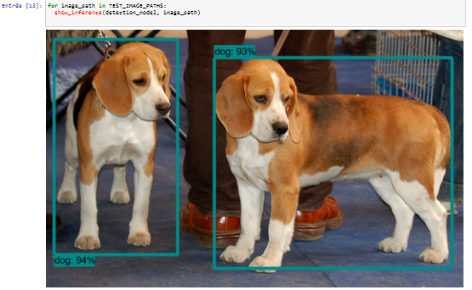

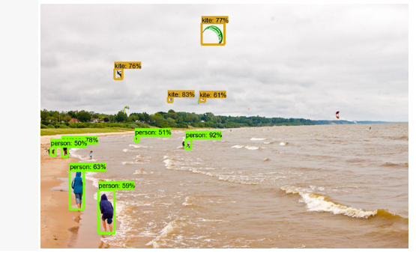

And now you are ready to re-train à pre-trained network using your images….

▸ Create your project workspace
Ddd

▸ Download a pre-trained NN for Object Detection
Ddd

▸ Get and annotate images for the supervised re-training of the NN
Ddd

▸ Re-train a pre-trained NN for Object Detection
Ddd

▸ Operate a re-trained neural network
Ddd

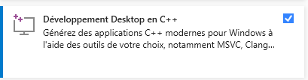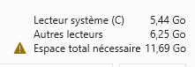

📥 Install the COCO tools
COCO (Common Objects in Context) is a database intended to supply algorithms for object detection, segmentation (see cocodataset.org for tutorials, publications…).
To install the COCO Python API, clone the cocoapi.git site (~ 15 MB) in the /tmp directory then type the make command in the cocoapi/PythonAPI folder. When done, copy the folder pycococtools in your .../models/research/ directory:
(tf2) C:..\tod_tf2>cd /tmp
(tf2) C:..\tod_tf2>git clone https://github.com/cocodataset/cocoapi.git
(tf2) C:..\tod_tf2>cd cocoapi/PythonAPI/
(tf2) C:..\tod_tf2>make
(tf2) C:..\tod_tf2>cp -r pycocotools/ "<absolute path of your tod_tf2 directory>"/models/research/
replace "<absolute path of your tod_tf2 directory>" by the absolute path of the tod_tf2 directory on your machine (for example ~/catkins_ws/tod_tf2).
REM From within tod_tf2:
(tf2) C:..\tod_tf2>cd models\research
(tf2) C:..\tod_tf2\model\research>for /f %i in ('dir /b object_detection\protos\*.proto') do protoc object_detection\protos\%i –python_out=.
...

error: Microsoft Visual C++ 14.0 or greater is required. Get it with "Microsoft C++ Build Tools": https://visualstudio.microsoft.com/visual-cpp-build-tools/

