# INTRODUCTION

# Like most aspects of South African society, municipalities are diverse and operate in unique social, demographic and economic spaces. These characteristics have a significant impact on municipal performance and the subsequent strategies required ensuring a well-functioning local government sphere. The purpose of this project is to visualize the trends and performance of municipality revenues and expenditures. Municipalities are grouped into 3 categories: Metropolitan, Local, and District.

# The two sides of the budget- revenue and expenditure play equally important roles in the country’s economy and social wellbeing. Hence, this report carefully examines the revenue and expenditure performance of municipalities between 2009 and 2017 in order visualize the municipality revenues and expenditure.

# Municipality operating revenue is comprised of several components: service charges, government grants and subsidies, property rates, other revenue sources, RSC levies, investment revenue , fines and contributions and donations from the public.

1. **PROBLEM STATEMENT**

**//Xola**

1. **WAYS OF WORKING //Xola**

CASM

Trello

Project management

Team structure

* Project Activity Plan
* Resource Allocation
* Report back on Data Sources and availability

1. **REQUIREMENTS ENGINEERING //Maidi**

## 3.1 Solution Scope

The Scope of this project is to visualize the RSA Municipality Revenue and Expenditure as follows:

1. Display the total Revenue & Expenditure for certain municipality category per year and the distribution across the municipalities in that category. For example, for 2016 show the total revenue and expenditure for a district municipalities in Eastern Cape province.
2. Display the trend between the Revenue and Expenditure for each municipality over a period time. For example, display the trends for Revenue vs Expenditure for each local municipality in the Gauteng province from the year 2009 to 2017.
3. Display a comparison of annual expenditure among municipalities over a period of time. For example , compare the annual expenditure for metropolitan municipalities in the Gauteng province from 2009 to 2017.
4. Display a comparison of annual revenue among municipalities over a period. For example : compare the annual expenditure for district municipalities in the Mpumalanga province from 2009 to 2017.
5. Compare revenues generation among municipalities over a period. For example : display a comparison of the revenue generated from Property rates for local municipalities in the Western Cape province from 2009 to 2017.
6. Compare the contribution from different revenue sources towards the annual revenue for a particular municipality over a period. For example : Display the revenue source contribution toward 2014 annual revenue for Abaqulusi local municipality in the Kwa-Zulu Natal province.
7. Display the national annual revenue and its distribution among the provinces. For example : display the nation annual revenue in 2011.
8. Rank the national budget deficit by province for a year. For example: Rank the national budget deficit by province for a 2016.

The approached that was used for requirements gathering was as follows:

* The project description provided by the Lecturer was used to write base requirements.
* During meetings, Tasks were divided among the members of the group as follow:

1. **SOFTWARE TOOLS AND TECHNIQUES // All**

For the team to achieve the daily stand-up and project monitoring requirements, the below combination of social media and collaborative productivity toolset were used:

* WhatsApp-
* Zoom-
* Trello-
* Email
* GIT
* Power BI
* AZURE SQL Server
* Drop Box

1. **SYSTEMS DEVELOPMENT, //Jabu and Tawanda**

**High-Level Design**

The RSA Municipality expenditure and revenue analysis application high-level design (HLD) detailing the overview of the entire system. This incorporate segment that are created for the application and interfaces.

The data is extracted from Municipal Data Source. There is an util component that cooperate with municipality source website. The util component extract data from municipal data source using API expose by municipality. Util component is composed of java, Json. After the util component extracted the data, it persists it to the relational database. Azure SQL database was selected as the database of the application. Azure SQL database allow us to store the database on the cloud. Pooling or streaming or listener was not implemented on the util component to frequently pull data. There was no need for frequent pulling of data since municipality update their data source annually. The database compromises of tables and tables views. SQL scripts are used to create the database, tables and the views. The views were created to shape and cache the data and results respectively. Caching plays a crucial role when it comes to application performance.

The fronted end is developed using Power BI. Power BI selected to avoid reinventing the wheels. Power BI gives us simplify and different options for data visualization. The front interacts direct with our views to visualize the results in different displays.

The following diagram shows various components involved and the high level of the RSA Municipality application:

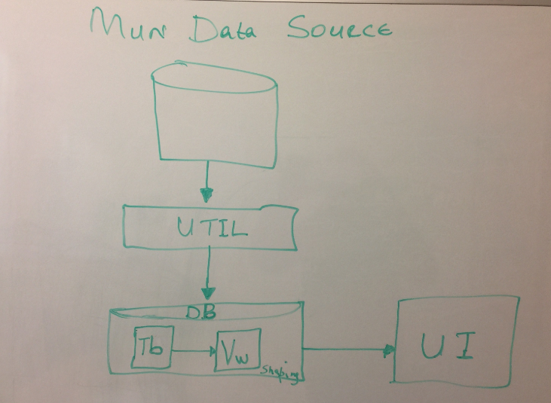

Source: Group 2 team

**Mun Data source**: Source of data residing on the municipality website.

**Util** : component responsible to extract data via API from the source and store it in the relational database tables.

**DB:** Azure SQL database that’s stores all the information about municipality including location, municipalities, provinces, revenues, expenditures.

**UI:** We application hosted on Azure cloud that displays reports on municipality expenditure and revenue details.

**Database Design // Tawanda**

**Git**

Git is chosen as adaptation following instrument to keep our documents and permit colleagues to pull changes any place they are. Git furnished us with that adaptability and its facilitated on the cloud. Git additionally gave us finish following capacity and history of the work we were doing from the earliest starting point.

**Visualization // Tawanda**

1. **CHALLENGES //Maidi**

After the first meeting, the team brainstormed the topic and requirements for the project. One of the team members had a billing data that we could use for the project but the challenge we had was that his company didn’t give him an authorization since it was a raw data.

On the xx of April the team decided to extract the billing dataset or any data that can meet our requirements from Google. The RSA Municipality data was extracted and after analyzing the data, the team found the all our requirements must change to suit the Municipality data.

1. **LESSON LEARNT // Maidi**
2. **FUTURE ENHANCEMENTS**

Based on the amount of scope and time, team didn’t manage incorporate another element of the system. Demography populace could have provided an alternate insight and perspective on the application. Team felt the inclusion of population for all those municipalities could have assisted in drawing full picture. We have could draw analysis of the expenditure and revenue for the municipalities versus the populace for each.

Requirement 8

echart

1. **CONCLUSION**
2. **REFERENCE**