**System Admin Guide**

*Adding a New User*:

To add a new user, simply add the desired username and salted password to the Users.db file.

**User Guide**

*User Login*:

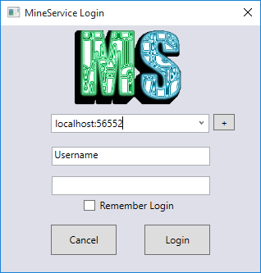

In the first text field put the server in the form of IP:Port (127.0.0.1:55555) that you wish to connect to.

In the next two fields put in the username and password given to you by your administrator.

*Viewing the Home Tab*:

The home tab contains general information about the cluster as long as anything that deals with elements on a cluster level such as settings and users.

Overview (In Progress)

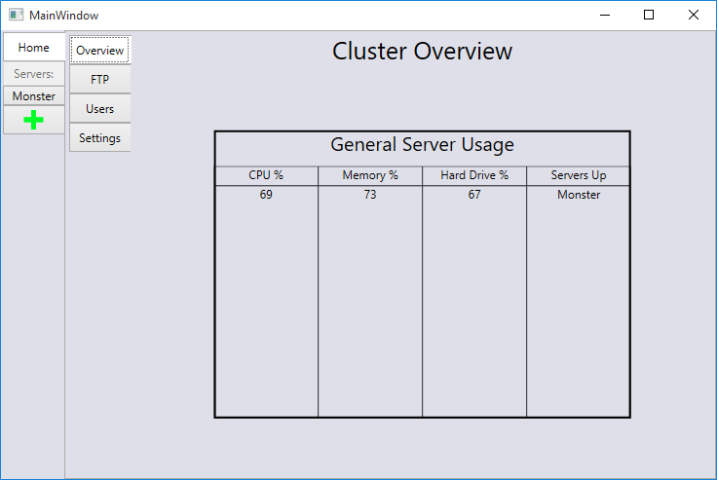

The overview tab is a quick way to see the general status of all the servers on this cluster

*Viewing the FTP Tab (In Progress):*

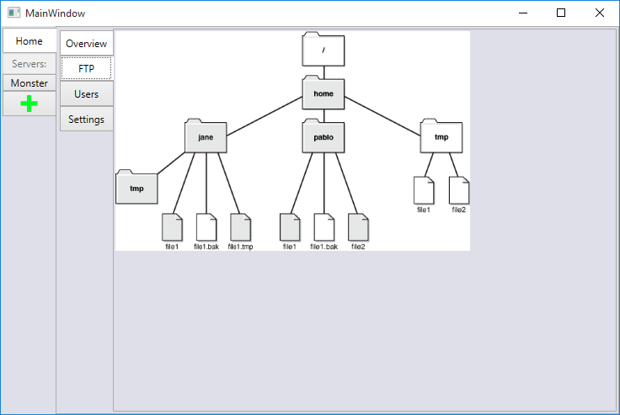

This tab will allow you to make changes to anything in the cluster file tree. This is for experienced users only and is restricted to clients who has full rights on cluster.

*Viewing the Users Tab (In Progress):*

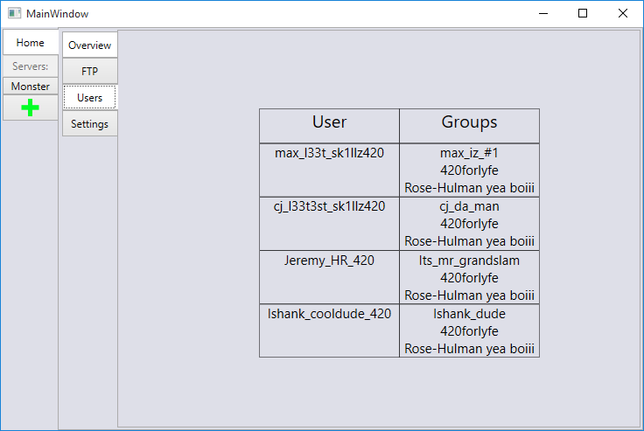

This tab will allow you to add and remove users as well as change their permissions.

*Viewing the Settings Tab:*

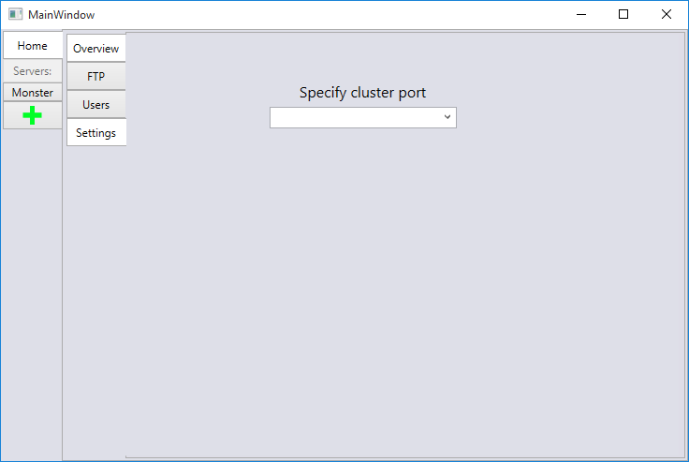

This tab contains the settings for the cluster. Currently only setting is the port number.

*Viewing the Server Tabs:*

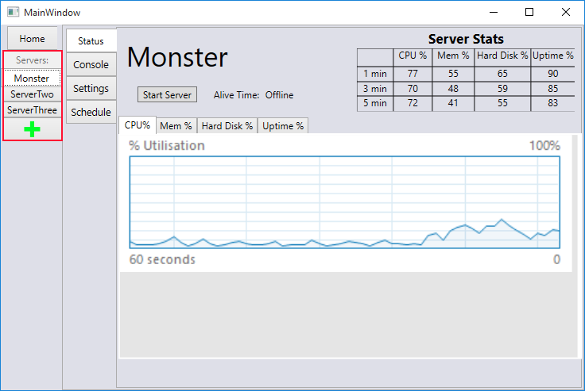

The area marked in red is where any servers on this cluster will show up. The green + is where new servers are added.

*Adding a New Server Tab:*

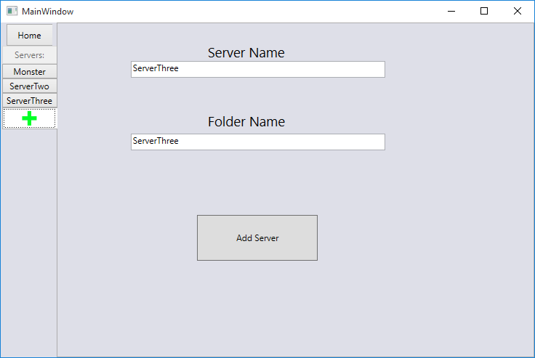

Both the server name and folder name must be unique with what is on the cluster. After putting in two names and hitting add server it will show up with the other servers automatically.

*Viewing a Server:*

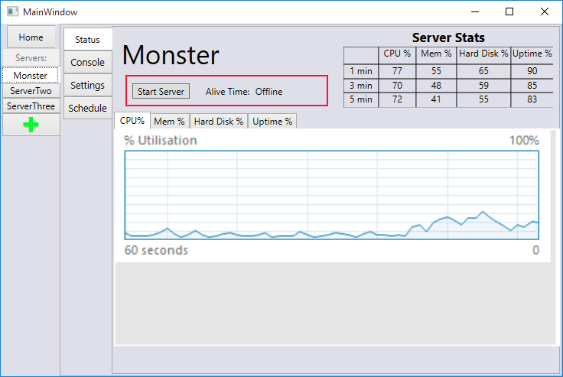

Clicking start server will start the underlying Minecraft server.

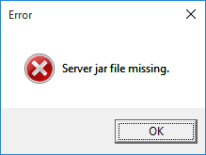

Error will appear if there is no jar that matches the name set in the server settings.

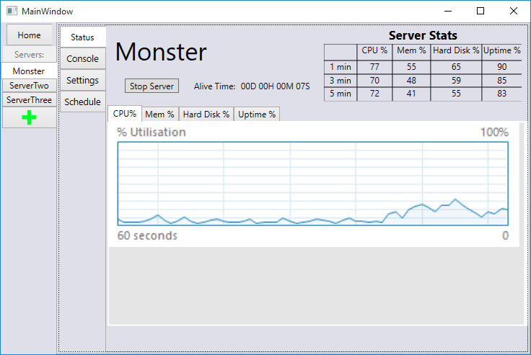

After hitting “Star Server” it will tell the cluster to start the server. If it does start it will change to stop server and start showing the uptime.

*Viewing the Console:*

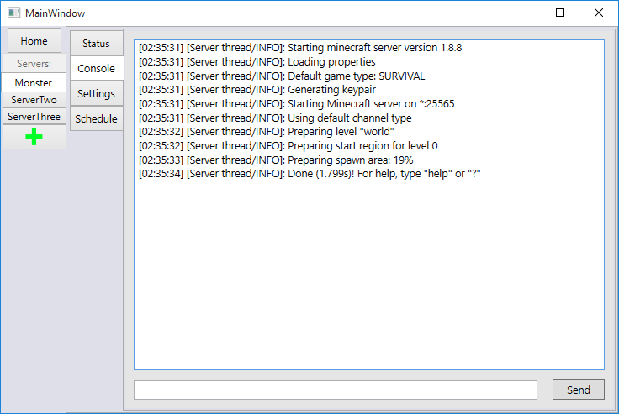

This screen is a direct pipeline to the normal Minecraft Console. Anything inputted in the bottom will be feed directly to the Minecraft server upon hitting Send.

*Selecting Server Settings (In Progress):*

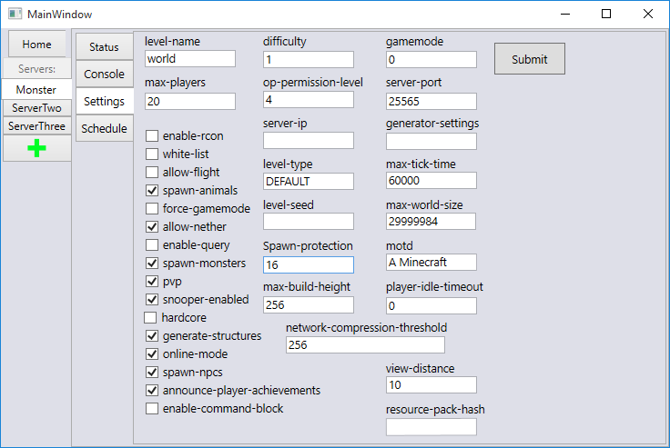

On this page is all the normal settings found in the server.properties file in the Minecraft root directory.

Schedule (Not yet Developed)

Will allow for automatic restarts based on a time schedule.

Installation / Configuration

Run setup.exe from where it