Title: The Effect of Public Transportation Subsidies on Infectious Disease Transmission: Evidence from the 2022 German 9-Euro-Ticket Program

Author: Christian Metzner^{(a)}

Affiliations: ^{(a)}Faculty of Science, University of Zurich, Winterthurerstrasse 190, 8057 Zurich, Switzerland

Corresponding Author: Christian Metzner
Email: christianjakob.metzner@uzh.ch

Abstract
This paper examines whether policies supporting public transportation use increase the risk of infectious disease transmission, using the 2022 German 9-Euro-Ticket program (9ET) as a case study. The 9ET was a nationwide public transportation fare subsidy implemented to offset energy costs and boost declining ridership during the COVID-19 pandemic. By comparing weekly COVID-19 cases in Germany with a synthetic control constructed from European countries without comparable programs, the study finds no significant difference in case rates (p=0.80). Various robustness checks, including a differences-in-differences analysis (p=0.96) and a synthetic control analysis of a Maltese public transportation policy (p=0.76), confirm these results. The findings suggest that public transportation subsidies like 9ET do not significantly increase disease transmission risks, especially when basic precautions like mask mandates are in place. This evidence provides valuable guidance to policymakers trying to balance public health concerns with the environmental and societal benefits of increased public transportation usage.

Keywords
Public transportation, transportation policy, COVID-19 pandemic, infectious disease transmission, synthetic control method

Introduction
In the face of climate change, rising urban density, increasing fuel costs, and the drastic decline in public transportation usage during the COVID-19 pandemic, policymakers around the world have been implementing new programs intended to bolster public transportation usage (Dai et al., 2021; The Guardian Editorial Board, 2022; Hultén et al., 2021; International Energy Agency, 2023). Such policies aim to reap the benefits arising from increased public transportation usage, in particular, reduced carbon emissions, traffic congestion, traffic fatalities, and air pollution (Bailey et al., 2008; Krämer et al., 2022; Litman, 2016; Verbavatz & Barthelemy, 2019). Important concerns surrounding the public health impact of such policies have emerged, particularly in light of the recent COVID-19 pandemic and the increasing risk of future pandemics (Tirachini & Cats, 2020; Gutiérrez et al., 2020; Shen et al., 2020; Wang, 2014). This paper investigates the effect of public transportation subsidies on infectious disease transmission, in the context of a 2022 German program during the penultimate year of the COVID-19 pandemic.
The 2022 German 9-Euro-Ticket program (9ET) provides a natural experiment well-suited to estimate the effects of public transportation subsidies on infectious disease transmission. 9ET was a limited-time public transportation fare subsidy provided by the German government to increase public transportation usage and partially offset household energy costs. It was implemented during the summer of 2022 and, at the time, was unique within Europe (Ammel, 2022). During this implementation period, COVID-19 cases were still being tracked daily across Germany and Europe (Dong et al., 2020). This provides a unique opportunity to examine aggregate data on a highly transmissible and well-understood infectious disease during the implementation of an impactful public transportation subsidy, offering greater insight into the public health risks of higher public transportation usage.
To evaluate these risks, I estimate the causal effect of the 2022 9ET policy on weekly COVID-19 cases in Germany. Since the 9ET policy was unique to Germany and weekly COVID-19 data is aggregated by country, the synthetic control method pioneered by Abadie, Diamond, and Hainmueller (2010) is particularly appropriate for my effect identification strategy. I thus estimate the effect of interest by comparing COVID-19 case development in Germany to a counterfactual synthetic Germany composed of 29 other weighted European countries matched to actual Germany on pre-9ET COVID-19 cases and COVID-19 predictors. The 29 European countries chosen as a donor pool for synthetic Germany consist of all countries belonging to both the European Economic Area and Schengen travel zone that did not implement any policies comparable to 9ET but otherwise resemble Germany in terms of public transportation infrastructure and COVID-19 containment measures (INSERT REFERENCE). Since the synthetic Germany is a convex combination of countries without 9ET or comparable policies, the synthetic German COVID-19 case numbers approximate COVID-19 development in Germany if no 9ET had been implemented. Thus, the difference between actual and synthetic German COVID-19 weekly cases during the 9ET implementation period will provide a causal estimate of the effect of interest.
After applying a permutation-based significance test on my results, I find no significant difference between actual and synthetic Germany in terms of weekly COVID-19 cases during the 9ET implementation period. This finding remains robust to excluding either donor pool countries that did not implement public transportation mask mandates or that directly neighbor Germany. It also remains robust to a comprehensive leave-one-out analysis. An estimate of the effect of a Maltese public transportation policy resembling the 9ET implemented in Fall 2022 on weekly COVID-19 cases leads to a similarly non-significant result.
The key findings of this paper suggest that public transportation subsidies, even ones as significant as the 9ET policy, had little to no effect on COVID-19 transmission. The concerns surrounding public transportation’s role in infectious disease transmission may thus be overstated, given some basic precautions (such as mask wearing in public). My results provide some guidance to current policymakers trying to address the problem of stagnating public transportation usage amid pandemic-related public health concerns and future public health officials attempting to mitigate the disastrous consequences of yet to be seen pandemics.

Background.
The COVID-19 pandemic caused a drastic decline in public transportation usage (Fleming, 2021; Tirachini & Cats, 2020). Evidence suggests that this decline stemmed primarily from individual health concerns about disease transmission rather than government policies (Medlock et al., 2021). These concerns regarding COVID-19 infection persist even after most containment policies have relaxed, making it difficult for public transportation to return to pre-pandemic usage levels (Taylor & Wassermann, 2022).
The exact risks of infectious disease contagion – in general and with regards to COVID-19 specifically – while using public transportation remain somewhat unclear. Some studies modelling disease transmission via public transportation predict influenza-like illness transmission patterns that correlate strongly with observed epidemiological data – however the number of assumptions underlying these mathematically intricate models is substantial, disallowing definite conclusions regarding the externally valid causal relation between disease transmission and public transportation (Goscé & Johansson, 2018; Mossong et al., 2008). One study on airborne respiratory illnesses suggests that public transportation may be an individual-level risk factor but explicitly downplays the effects of population-wide public transportation policy on disease transmission (Troko et al., 2011). Other studies on influenza-like illnesses explicitly find that public transportation use is not correlated with a higher risk of infection (Adler et al., 2014; Castilla et al., 2012). The literature dealing specifically with the risk of COVID-19 infection in public transportation is similarly divided. Some studies find correlations between public transportation usage and COVID-19 infection (Ellingjord-Dale et al., 2022; Heinzerling et al., 2022), while others find “no direct correlation between use of urban public transit and transmission of COVID-19” nor any significant relation to COVID-19 outbreaks (Schwartz, 2020; Joselow, 2020). Thus, the effect of subsidizing public transportation usage on the spread of infectious diseases, specifically COVID-19, is uncertain, even though it could guide policymakers in recovering from past pandemics and preparing for future pandemics (El-Sadr, 2021).
This paper adds to the existing literature by directly assessing the public health impact of a nation-level policy encouraging public transportation, rather than just assessing individual-level risk factors. Additionally, I estimate a causal effect using a well-understood econometric model with straightforward assumptions and real-world data rather than merely establishing non-causal correlative risk factors or specifying an overly intricate model with little external validity. Finally, it is the first study that takes advantage of the high temporal resolution and well-defined reporting standards that characterize country-level COVID-19 data to evaluate the public health impacts of public transportation policy on a national scale.

9-Euro-Ticket Policy.
Between June 1st and August 31st, the 9ET program provided a heavily subsidized monthly ticket for 9 Euros, valid for any local public transportation, but not long-distance transportation, throughout the entire country (Pladson, 2022). The program was financed by the German federal government (Bundesministerium für Digitales und Verkehr, 2022). Implementation was immediate with the Bundestag accepting the program only 12 days before it was offered to the public (Der Spiegel, 2022a).
Before the introduction of the 9ET, there were no country-wide tickets available, and regional monthly tickets ranged in price from 90 to 150 Euros (Kirby, 2022). Rare exceptions included regional Semestertickets for students at selected universities, a free 70+ ticket in Stralsund for residents aged 70 and above for travel within the city, and a free Monheim-Ticket for residents of Monheim am Rhein, a small city in North Rhine-Westphalia, also for travel within the city. However, these subsidized tickets were limited to specific demographic subgroups and locally limited. During the implementation period of the 9ET, these tickets were replaced or superseded by free 9ET tickets. The 9ET could be purchased like any other regional monthly, daily, or one-way ticket, either in person at regular ticket venues or online and was valid for use on any local public transportation within the country (Bundesministerium, 2022). Consequently, the introduction of the 9ET made public transportation more accessible and affordable throughout all of Germany, leading to a significant increase in public transportation usage (Krämer et al., 2022).
The main reasons for the program were to provide financial relief from drastic increases in natural gas, electricity, and transportation costs that occurred in 2022. Additionally, it was intended to boost public transportation usage after the decline during COVID-19 and promote climate-friendly mobility alternatives (Bundesministerium, 2022). To some degree, 9ET was judged to have achieved these goals (Krämer et al., 2022).
Several concerns surrounded the 9ET program from the beginning. Aside from taxpayer costs, many concerns focused on overcrowding available public transportation infrastructure (German Blogs, 2022; Nobis & Kolarova, 2022; Redaktionsnetzwerk Deutschland, 2022; Der Spiegel, 2022b). This motivated significant anxiety regarding the effects of the 9ET on COVID-19 transmission, with most commentators mirroring the concerns around infectious disease transmission in public transportation discussed in the research literature (Karlsruhe News, 2022; Schwarz, 2022; Zimmermann, 2022).

Data
As outcome variable – on which to assess the impact of 9ET – I use weekly per-capita COVID-19 cases per country. I gather COVID-19 daily cases for each EU member state plus Norway, Liechtenstein, Iceland, and Switzerland (EU+) (all part of the European single market and Schengen travel zone) from the global confirmed time series data in the COVID-19 Data Repository from the Center for Systems Science and Engineering (CSSE) at Johns Hopkins University (Dong et al., 2020). I sum daily case numbers by week, thus accounting for country-specific variations in week-by-week COVID-19 reporting deadlines, and then normalize by population size (from the UN World Population Prospects Demographic Indicators dataset) to get per-capita COVID-19 cases for each EU+ country (United Nations, 2022).
A potential difficulty with investigating COVID-19 cases is that symptom onset lags infection. I address this by shifting weekly COVID-19 case rates 2 weeks forward, following previously established methods in investigating policy effects on COVID-19 as well as accounting for most reporting delays (Kogan et al., 2021; Fritz, 2022).
To control for potential effects of different COVID-19 government responses on cases by country, I gather a daily index constructed to reflect the severity of COVID-19 containment policies for each EU+ country from the Oxford COVID-19 Government Response Tracker (OxCGRT; Hale et al., 2021). The index is compiled by OxCGRT experts, rating the total stringency of government-imposed COVID-19-related nonpharmaceutical interventions (e.g., lockdowns, mask mandates, work from home orders, etc.) between 0 (least strict) and 100 (most strict). I find the mean value for the governmental stringency index per week to obtain a measure of COVID-19 government response stringency per week per EU+ country. I also control for differing vaccination rates by including the average total number of vaccinations received per capita in each country each week (counting second doses and booster shots), obtained from the “Our World in Data” COVID-19 dataset (Mathieu et al., 2021).
I also control for various demographic factors that predict COVID-19 case rates. These include 2022 population density and sex ratio, obtained from the UN World Population Prospects Demographic Indicators (United Nations, 2022). Additionally, I gather data on the age composition of each country's population in 2022 from the UN World Population Prospects Population Age Group Survey (United Nations, 2022). To simplify the analysis, I consolidate the original dataset's 10 different 5-year age groups (including the group above 100) into 5 20-year age groups and one 100+ age group. Finally, I obtain the GDP per capita in US dollars for each EU+ country from the National Accounts Main Aggregates Database provided by the United Nations Statistics Division and apply a logarithmic transformation (United Nations Department of Economic and Social Affairs, 2022).
This results in a typical panel data set-up with weekly lagged COVID-19 case rates across multiple countries (in the EU+ donor pool and Germany) and multiple time periods (calendar weeks 1 to 39) with a clearly defined treatment period for Germany (calendar weeks 22 to 34). The government stringency index and average vaccination rates follow the same panel data format, differing across countries and weeks. The other control variables are time-invariant, including the population age shares, density, sex ratio, and the natural log of GDP per capita, which are not available on a week-by-week basis but only for the entire year.

Empirical Identification Strategy
The 9ET was approved only 2 weeks before implementation, was implemented only in Germany, applied to all of Germany uniformly, and was only valid from June 1st to August 31st. This means that 9ET was sharply and uniformly implemented in only one location across a clearly defined treatment period, which is ideal when comparing pre- and post-9ET lagged weekly COVID-19 cases. Still, there are many possible reasons why weekly COVID-19 cases change across the treatment period, making a simple investigation of pre- and post-9ET cases within Germany insufficient for causal effect estimation.
A difference-in-differences analysis (DiD) could offer a causal effect estimate by comparing COVID-19 case across the pre- and post-9ET periods between Germany and other EU+ countries without 9ET or comparable policies. Under the assumption that COVID-19 cases in Germany would parallel COVID-19 cases in other EU+ countries without any policy interventions taking place, any differences in the trajectory of COVID-19 in the post-9ET period could be causally attributed to the 9ET policy (Bertrand et al., 2004). There are several reasons this method is inadequate for my analysis.
First, the parallel trends assumption is unlikely to hold. Even in countries coordinating their policy responses such as the EU+ group, COVID-19 spreads differently in each country due to different population densities, sex ratios, age compositions, and economic factors and even different weekly vaccination rates and non-pharmaceutical government containment measures. Controlling for these factors will still not account for unobserved time-varying factors and selecting a specific subset of EU+ countries as DiD controls where these unobserved time-varying factors are more likely to resemble Germany will require more gut instinct than rigorous methodology. In addition, DiD requires sufficient treated units in order to infer statistically significant effects (Conley & Taber, 2011). In my analysis, 9ET is only implemented in Germany. With at most 29 control units (the maximum size of any EU+ subset), inference in a DiD analysis would not be robust.
Like DiD, the synthetic control method (SCM) pioneered by Abadie, Diamond, and Hainmueller (2010) offers a causal effect estimate. Unlike DiD, SCM does not require a parallel trends assumption. Instead, SCM constructs a synthetic control composed of a convex combination of all possible donor states, weighting the individual components so that the difference between treated unit and synthetic unit is minimized in terms of pre-treatment outcome and control variables across space and time (Abadie, Diamond, and Hainmueller, 2010). The only assumption required is that the synthetic control resembles the actual treated unit across time. Quantitatively weighting donor states based on pre-defined criteria also addresses unobserved time-varying factors using a more data-driven and rigorous method than DiD, making SCM particularly well-equipped for the temporal and spatial complexities of COVID-19 case development (Alfano et al., 2021; Lim et al., 2021; Mader & Rüttenauer, 2022). Additionally, SCM conducts inference by running placebo tests on all donor pool units as if the policy had applied to them which requires less treated units for robust inference, making it better suited to the analysis of the unique 9ET policy (Cameron & Miller, 2015). Thus, SCM is the method of choice for my analysis.
Following the SCM methodology used by Abadie, Diamond, and Hainmueller (2010), I estimate 9ET’s effect on COVID-19 cases by finding the difference in lagged COVID-19 cases between Germany and a synthetic control composed of EU+ countries in 2022. My observations range from calendar weeks 1 to 39, covering the 9ET period (weeks 22 to 34). Let α_{t} be the causal effect of 9ET on COVID-19 cases, $Y_{t}^{9€}$ be lagged per-capita COVID-19 cases for Germany, and ${\hat{Y}}_{t}^{C}$ be lagged per-capita COVID-19 cases estimated for synthetic Germany. Then:
$${\hat{}}_{t}= Y_{t}^{9€}-{\hat{Y}}_{t}^{C}$$
$Y_{t}^{9€}$ is directly observed while ${\hat{Y}}_{t}^{C}$ is constructed. The synthetic control outcomes $Y_{it}^{C}$ (for any country i whether it had a 9ET policy or not) are given by the following model:
$$Y_{it}^{C}=δ_{t}+βZ_{it}+ L_{it}+ε_{it}$$
$δ_{t}$ represents an unobserved effect common to all countries (including Germany), $Z_{it}$ is a matrix of controls by week and country (composed of the controls gathered in the Data section), $L_{it}$ is a matrix of unobserved effects on COVID-19 cases by week and country, and $ε_{it}$ is an error term (with zero-conditional mean since I include $L_{it}$). Given j countries, and denoting Germany with i=1 and the 9ET starting week as t₀, I construct ${\hat{Y}}_{1t}^{C}$ by finding j-1 weights (w₁, w₂, …, w_{j-1}) and weighting each EU+ donor country to minimize:
${\left({\left(\sum_{i=2}^{j}{w_{i}Y_{it}^{C}}-Y_{1t}^{9€}\right)}^{2}\right)}^{1/2}for t<t_{0}$ and ${\left({\left(\sum_{i=2}^{j}{w_{i}Z_{it}}-Z_{1t}\right)}^{2}\right)}^{1/2}$
I constrain weights between 0 and 1 to avoid interpolation errors (with a 5% margin of flexibility). Then the lagged COVID-19 cases for synthetic Germany are estimated as such:
$${\hat{Y}}_{1t}^{C}=\sum_{i=2}^{j}{w_{i}Y_{it}^{C}}$$
For my estimated effect to be interpreted as causal, I must make the key assumption that my synthetic control will resemble my treated group, e.g., that my control EU+ countries resemble a counter-factual untreated Germany if they are weighted correctly.
One potential violation of this lies within the variation in COVID-19 containment policies applied by EU+ governments, especially the policies regulating public transportation. To address this, I adjust the weights of donor pool countries by matching the control indices for their COVID-19 containment stringency. In addition, I chose the EU+ group as a donor pool given that significant COVID-19 policy alignment occurred within the EU and European Economic Area in 2022 (Besart, 2022). Nevertheless, 4 Nordic countries did not comply with the EU+ norm of mandating masks in public transportation (Community Initiatives, 2020). To ensure that these policy differences do not influence my results, I evaluate the effect of 9ET on COVID-19 case development including and excluding these 4 countries.
Another assumption for my estimated effect to be interpreted as causal is that there were no spillover effects of the 9ET policy into control countries. Unlike the 9ET policy, COVID-19 is not constrained by national borders. Increased travel within Germany may have caused more cross-border COVID-19 outbreaks. To address this, I reviewed national and local news, finding no significant instances of cross-border COVID-19 outbreaks in 2022. Evidence highlighting the minimal effect of border closures within Europe during the height of the pandemic supports this conclusion (Dieminger et al., 2022). In addition, 9ET only applied to local public transportation and not long-distance travel, decreasing the likelihood that 9ET-related COVID-19 increases in Germany transferred to neighbor countries. Thus, spillover effects appear to have been nonexistent. For good measure, I also perform an analysis excluding all EU+ countries directly bordering Germany (where spillover effects are most likely to occur).
A final concern is that other EU+ countries may have had programs comparable to 9ET, making these countries ineligible for use as controls. Out of all EU+ controls, only 3 country-wide policies seem comparable to 9ET. In Luxembourg, the government introduced countrywide free public transportation starting on March 1st, 2020 (Ünveren, 2022). Due to the obvious similarity to 9ET, I exclude Luxembourg from the donor pool of controls. In 2021, France banned short domestic air travel if suitable public transportation alternatives were available, possibly encouraging more public transportation use. This policy only impacted 5 travel routes, did not directly subsidize public transportation, and mostly affected a small group of business travelers (Gitlin, 2021). Thus, I don’t consider the French policy a violation of the assumption that controls are untreated. Finally, Malta introduced free public transportation starting on October 1st, 2022. Although this policy resembles that of Luxembourg and 9ET, I only consider the period leading up to October 1st for my analysis (since 9ET ended on August 31st). Thus, I don’t exclude Malta, only the period in which Malta implemented a 9ET-like policy. Within Germany itself, no public transportation subsidy compares in exhaustiveness or scale to the 9ET (as previously discussed).
For inference, I use the permutation test applied by Abadie, Diamond, and Hainmueller (2010), performing a set of placebo tests evaluating the effect of passing into the 9ET implementation period on COVID-19 case development using a synthetic counterpart for each EU+ control country. The statistical significance for the 9ET effect estimates can then be assessed via the probability of any placebo effects being more extreme than the effect seen in Germany, as measured by the ratios of post- and pre-9ET mean squared prediction error (MSPE) and residual plots.
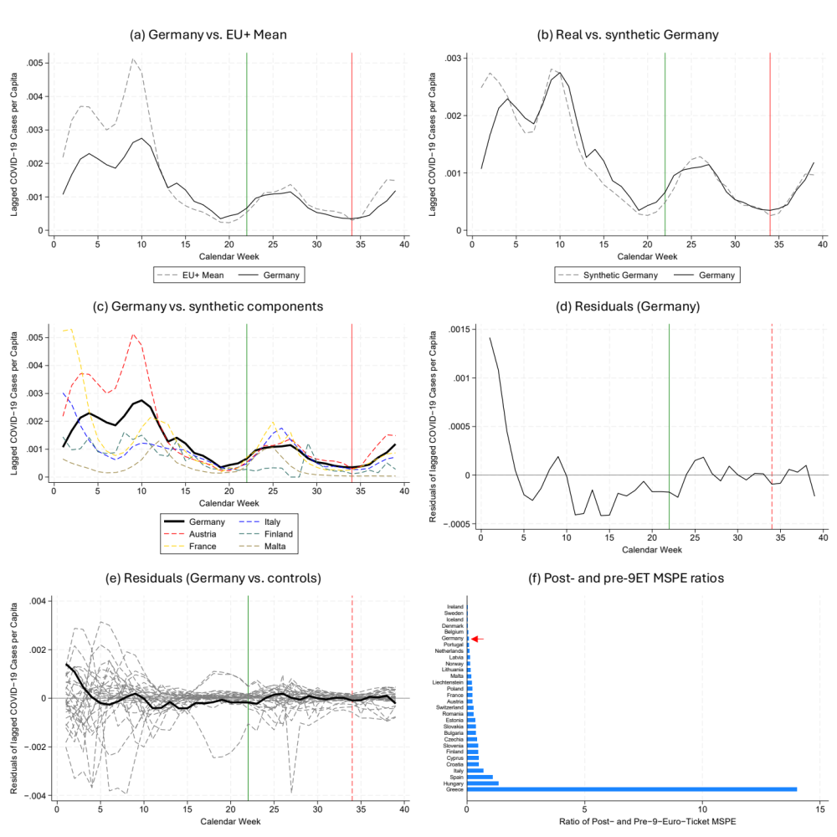
Figure 1. Baseline synthetic control construction and analysis. (a), (b), and (c) compare the per-capita lagged COVID-19 cases in Germany to the mean of the EU+ donor pool, the constructed synthetic control, and the separate components of the synthetic control. (d) shows the residuals in per-capita COVID-19 cases between Germany and its synthetic control. (e) shows the residuals between Germany and its synthetic counterpart (solid black line) and real and synthetic counterparts for each possible EU+ donor country (grey dashed lines). (d) shows the ratio of the MSPE from the synthetic control before 9ET and after 9ET intervention from all possible EU+ donor countries. The red error indicates the MSPE ratio for Germany.

Results
START WITH DEMONSTRATING INCREASE IN RIDERSHIP, MAKE FIGURE 1 INCLUDE RIDERSHIP IN GERMANY, SHOWING STATISTICALLY (AND PRACTICALLY) SIGNIFICANT INCREASE IN RIDERSHIP AFTER START OF 50 EURO TICKET (SHOW THAT SOME PREVIOUS YEAR, ideally 2019, DID NOT HAVE AS LARGE OF AN INCREASE IN RIDERSHIP!!!) IDEALLY FIGURE 1 SHOWS THAT TRAIN RIDERSHIP INCREASED ENORMOUSLY WITH ONSET OF 9EURO TICKET POLICY AND INCREASED ENORMOUSLY RELATIVE TO 2019
Fig. 1 panel (a) plots weekly average per-capita lagged COVID-19 cases over time for Germany and the averaged EU+ control group. Note that the two peaks in the first quarter of the year coincide but that the EU+ peaks are higher than Germany’s. Nevertheless, both Germany and the mean EU+ per-capita lagged COVID-19 cases drop in the 2nd quarter and then rise simultaneously in the 3rd quarter around the time of 9ET implementation, suggesting
Table 1. COVID-19 predictors
Variables | Germany |  | Mean of 29 EU+  control countries
Variables | Real | Synthetic | Mean of 29 EU+  control countries
Lagged COVID-19 cases per Capita | 0.00154 | 0.00154 | 0.00085
Total Vaccinations per Capita | 2.10 | 2.12 | 1.83
Population Sex Ratio | 0.974 | 0.967 | 0.966
Government Stringency Index | 59.93 | 59.27 | 37.79
Population Density | 239.18 | 198.85 | 178.27
ln(GDP per Capita) | 10.84 | 10.71 | 10.52
Share of inhabitants
… aged 0 to 19 | 0.185 | 0.188 | 0.206
… aged 20 to 39 | 0.242 | 0.241 | 0.251
… aged 40 to 59 | 0.275 | 0.285 | 0.278
… aged 60 to 79 | 0.222 | 0.221 | 0.212
… aged 80 to 99 | 0.075 | 0.065 | 0.053
… aged 100 or more | < 0.001 | < 0.001 | < 0.001
that combining 29 EU+ control countries into a synthetic Germany should be feasible.
Using the Stata synth package (Abadie, Diamond, & Hainmueller, 2010), I construct synthetic Germany as a convex combination of the EU+ control countries that most closely resemble real Germany in terms of pre-9ET lagged per-capita COVID-19 cases and the other controls. Table 1 compares pre-treatment lagged per-capita COVID-19 cases and the other control variables for Germany, synthetic Germany, and the EU+ donor pool. Real Germany matches synthetic Germany very closely in terms of pre-9ET lagged COVID-19 case means and control variable means. The difference in population density is the most noticeable, although it carries little practical significance given the good match on all other control variables. Using a simple average, my 29 EU+ control variables do not resemble either real or synthetic Germany, indicating the appropriateness of the synthetic control strategy for evaluating the effect of 9ET.
Table 2 shows the relative weights of each EU+ donor country composing synthetic Germany. Austria and Italy stand out as contributing the most. This seems reasonable given that Austria closely resembles Germany with respect to quality of life, infrastructure, healthcare system, economy, and culture (Country Comparison). Similar arguments could be made for Finland and France. Italy is more surprising given the climate and subjectively perceived cultural differences between Germany and its southern counterpart. Still, within the EU, Italy is comparable to Germany in terms of size, population density, healthcare, life expectancy, and cost of living (Country Comparison). Therefore, when matching on a health outcome such as COVID-19, it seems reasonable that Italy could contribute significantly to synthetic Germany.
Table 2. EU+ country weights in synthetic Germany
Country | Weight | Country | Weight
Austria | 0.422 | Latvia | 0
Belgium | 0 | Luxembourg | -
Bulgaria | 0 | Liechtenstein | 0
Croatia | 0 | Lithuania | 0
Cyprus | 0 | Malta | 0.043
Czechia | 0 | Netherlands | 0
Denmark | 0 | Norway | 0
Estonia | 0 | Poland | 0
Finland | 0.122 | Portugal | 0
France | 0.052 | Romania | 0
Greece | 0 | Slovakia | 0
Hungary | 0 | Slovenia | 0
Iceland | 0 | Spain | 0
Ireland | 0 | Sweden | 0
Italy | 0.361 | Switzerland | 0

Fig. 1 panel (b) shows the per-capita lagged COVID-19 cases for Germany versus synthetic Germany. Note that synthetic Germany matches the real German COVID-19 trajectory much better than the EU+ mean plotted in Fig. 1 panel (a). There are some discrepancies in earlier weeks of the year aligning with the arrival of the Omicron COVID-19 variant which hit Italy and France somewhat earlier than Germany. This can be seen more clearly in Fig. 1 panel (c) which plots the lagged COVID-19 cases of the components of synthetic Germany. Still, the overall shapes of lagged per-capita COVID-19 case development in synthetic and real Germany develop in parallel prior to the implementation of 9ET, as indicated by the pre-9ET root mean squared prediction error (RMSPE) of 0.00046 (in units of lagged per-capita COVID-19 cases). Together with the balance check from Table 1, this gives me confidence that synthetic Germany will reasonably approximate COVID-19 development in real Germany, had the 9ET program not been implemented.
The effect of 9ET on per-capita lagged COVID-19 cases in Germany is estimated by the residual between actual and synthetic Germany, shown in Fig. 1 panel (d). After implementation of 9ET, there seems to be no significant divergence between actual and synthetic Germany. Any post-9ET gaps that appear follow no consistent pattern, showing both small increases of per-capita lagged COVID-19 cases relative to synthetic Germany and vice versa. The ratio of post- to pre-9ET MSPE is about 0.061, indicating that synthetic and real lagged per-capita COVID-19 cases match better after 9ET implementation, likely due to the difficulty of fitting the pre-9ET Omicron variant surge. Either way, these results suggest that 9ET had little to no effect on COVID-19 case development in Germany.
Permutation tests confirm the significance of this conclusion. Fig. 1 panel (e) shows the plotted residuals for each placebo test, e.g., every EU+ control country versus their synthetic counterpart, as dashed grey lines. For comparison, Germany’s residual is plotted as a black line. Overall, the synthetic control method provided a relatively good fit for most EU+ control countries, indicated by an average pre-9ET RMSPE of 0.00065 (slightly higher than that of synthetic Germany), although the average ratio of pre- and post-9ET MSPE is much higher at 0.78. Fig. 1 panel (e) further underlines that the estimated effect of the 9ET program on Germany’s lagged per-capita COVID-19 cases is highly insignificant when compared to placebo effects from the 29 EU+ countries that did not implement 9ETs or comparable programs. In Fig. 1 panel (f), the ratios of post- and pre-9ET MSPE show that the probability of seeing greater divergence in the post- versus pre-9ET period than Germany lies at 24/30=0.8, mirroring the residuals plot, while the average ratio of pre- and post-9ET MSPE across all EU+ placebo tests is much higher than Germany’s MSPE ratio at 0.78.

Differences-In-Differences.
While the differences-in-differences method is unlikely to produce a causal estimate of the effect of 9ET on lagged COVID-19 cases (see Identification Strategy), it may serve as a useful complement to the synthetic control analysis. Controlling for population density, sex ratio, vaccination rates, age distribution, log-transformed GDP per capita, and non-pharmaceutical government containment measures, I perform a differences-in-differences effect estimation at the country level. The point estimate for the treatment effect lies at $-4.93 x{10}^{-6}$ with a standard error of 0.0001074 (p=0.964). This effect is miniscule and statistically not significantly different from 0, confirming my previous results.
Figure 2. Synthetic control results, excluding countries without mask mandates from the donor pool. (a) compares per-capita lagged COVID-19 cases between Germany and this synthetic control, constructed excluding countries without mask mandates. (b) shows the residuals between Germany and its synthetic counterpart (solid black line) and real and synthetic counterparts for the included EU+ donor countries (grey dashed lines). (c) shows the ratio of the MSPE from the synthetic control before 9ET and after 9ET intervention for included EU+ donor countries. The red error indicates the MSPE ratio for Germany.

Excluding countries without mask mandates.
Given the diverging masking policies within public transportation in Sweden, Norway, Finland, and Denmark, I also run an analysis excluding this group of countries from the donor pool. Since Finland is part of the original synthetic Germany, this necessitates constructing a new synthetic control. Fig. 2 panel (a) shows real German cases plotted against the new synthetic Germany created when excluding countries without mask mandates. The pre-9ET RMSPE is 0.00055, indicating a relatively close fit, and the post- to pre-9ET MSPE ratio is 0.059, indicating less divergence between synthetic and actual Germany after the 9ET compared to before. After running a permutation test, I find that the average post- to pre-9ET MSPE ratio across the 25 placebo tests is 0.86, significantly higher than that of synthetic Germany. Fig. 2 panels (b) and (c) substantiates this by demonstrating the results of a permutation test for both residuals and MSPE ratios. Even excluding the countries without mask mandates, the probability of seeing a post-9ET effect greater than Germany remains high (22/26=0.85 for MSPE ratios). Thus, my previous result, finding no significant effect of 9ET on COVID-19, remains robust to the exclusion of countries without mask mandates.
Figure 3. Synthetic control results, constructed to avoid spillover effects by excluding all countries neighboring Germany. (a) compares per-capita lagged COVID-19 cases between Germany and this synthetic control, constructed excluding all neighboring countries. (b) shows the residuals between Germany and its synthetic counterpart (solid black line) and real and synthetic counterparts for the included EU+ donor countries (grey dashed lines). (c) shows the ratio of the MSPE from the synthetic control before 9ET and after 9ET intervention for included EU+ donor countries. The red error indicates the MSPE ratio for Germany.

Excluding neighboring countries.
I construct another synthetic control for Germany and repeat my permutation tests, this time excluding all EU+ countries bordering Germany to alleviate any remaining concerns about potential COVID-19 spillover into control countries due to 9ET. Fig. 3 panel (a) shows the real German COVID-19 case rates compared to those from the new synthetic Germany constructed without neighbor countries. With a pre-9ET RMSPE of 0.0007 fits have worsened somewhat compared to previous analyses since my most natural donor group, Germany’s immediate neighbors, has been excluded. The post-9ET synthetic COVID-19 cases also deviate more from actual case numbers relative to the pre-9ET period as reflected in a post- to pre-9ET MSPE ratio of 0.12 – significantly higher than in previous analyses. The residuals and MSPE ratios resulting from permutation placebo tests excluding Germany’s neighbors are seen in Fig. 3 panels (b) and (c). Despite Germany’s higher post- to pre-9ET MSPE ratio, the probability of finding a more extreme placebo effect remains relatively high (14/23=0.61 for MSPE ratios). These results largely concur with my previous analyses and indicate that spillover effects are not biasing the estimates of the impact of 9ET on COVID-19.
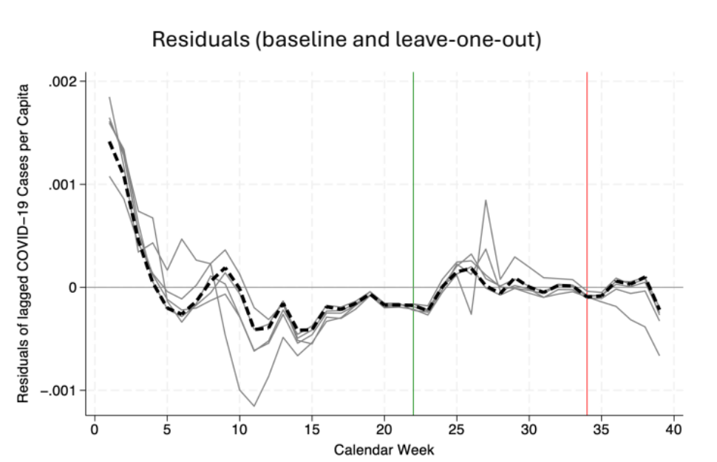
Figure 4. Residuals for Germany for the baseline analysis (dashed black) and successively leaving out each of the component donor countries (solid grey).

“Leave-one-out”.
To mitigate concerns about the individual influence of any particular donor country on my results, I construct a set of new synthetic controls for Germany, successively leaving out each of the donor countries composing the baseline synthetic Germany (i.e., Austria, France, Italy, Finland, and Malta). Fig. 4 shows the residuals for each of these new synthetic controls in addition to the residuals from the baseline analysis. The results are robust to leaving out individual donor countries, showing only insignificant deviations from baseline residuals. Fig. 5 reinforces this by comparing the residuals for each “leave-one-out” synthetic control with the corresponding EU+ control residuals generated from successive placebo tests. Under every “leave-one-out” condition, the treatment effect is insignificant compared to the placebo tests, just as observed in the baseline analysis. Statistical significance based on MSPE ratios is reported in Table 3 for each “leave-one-out” condition.

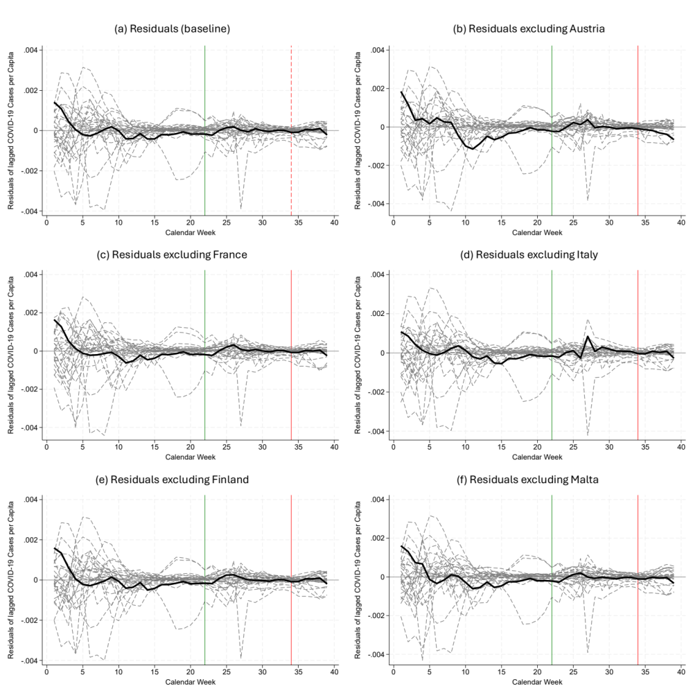Figure 5. Residuals for Germany (solid black) vs. EU+ controls (dashed grey), for the baseline analysis and successively excluding each component donor country.

Figure 6. Synthetic control results for Malta, excluding Germany from the donor pool. (a) compares per-capita lagged COVID-19 cases between Malta and its synthetic control, constructed from the EU+ donor pool excluding Germany. (b) shows the residuals between Malta and its synthetic counterpart (solid black line) and real and synthetic counterparts for the included EU+ donor countries (grey dashed lines). (c) shows the ratio of the MSPE from the synthetic control before and after the October public transportation intervention for Malta and included EU+ donor countries. The red error indicates the MSPE ratio for Malta.

Effect estimation for Maltese public transportation subsidy in Fall 2022.
To confirm that programs comparable to 9ET yield similar results, I ran a limited analysis using Malta’s free public transportation as a treatment starting on October 1st (week 39). Here, I included all the data past October 1st (with lagged COVID-19 cases and other controls running until November 14th). While this timeframe is limited, it allows me to conduct a rough check on whether a policy comparable to 9ET resulted in COVID-19 effects. Using the same procedure as for Germany, I construct a synthetic Malta seen in Fig. 6 panel (a). Since Malta’s population density is very high compared to EU+ average, I am not surprised by the imperfect visual fit, although the pre-October RMSPE of 0.000595 is comparable to my previous analyses. Supplementary Table S1 compares predictor means between real Malta, synthetic Malta, and the 29 EU+ control countries (excluding Germany and Luxembourg). Fig. 6 panel (b) shows the residuals between real and synthetic Malta, and between each EU+ control country and its respective synthetic counterpart. Like 9ET, Malta’s free public transportation scheme appears to have no significant effect on lagged per-capita COVID-19 cases in its short 1.5 months. The probability of finding a higher MSPE ratio than Malta’s lies at 22/29=0.76, as seen in Fig. 6 panel (c).

Overall Statistical Significance.
Table 3 summarizes statistical significance for the various effects. Note that the effect of 9ET on lagged per-capita COVID-19 cases in Germany is statistically insignificant in all estimation procedures used.
Table 3. Statistical significance of different effect estimates. MSPE Ratio Significance refers to the probability of seeing a higher MSPE ratio than seen for the treated group. Visual Significance refers to the significance of the treated country’s residual compared to control group residuals. Luxembourg is excluded for all.
Treatment | Control group | Statistical significance of effect
Treatment | Control group | MSPE Ratio Significance | Visual Significance
9ET (Germany) | All 29 EU+ countries | 0.80 | Not significant
9ET (Germany) | Excluding Sweden, Denmark, Finland, and Norway | 0.85 | Not significant
9ET (Germany) | Excluding German neighbors | 0.61 | Not significant
9ET (Germany) | Excluding Austria | 0.70 | Not significant
9ET (Germany) | Excluding Italy | 0.31 | Not significant
9ET (Germany) | Excluding Malta | 0.79 | Not significant
9ET (Germany) | Excluding France | 0.76 | Not significant
9ET (Germany) | Excluding Finland | 0.79 | Not significant
Free public transportation (Malta) | Excluding Germany | 0.76 | Not significant
*Statistically significant beyond the 5% level

Conclusion
None of the analyses performed yielded evidence of any causal effect of the 9ET program on COVID-19 case development in Germany. This indicates that 9ET did not lead to an increase in COVID-19 transmission in Germany. In addition to seeing no effect for 9ET, I found no evidence for a causal link between Malta’s free public transportation scheme and COVID-19 case development. Taken together, these results suggest that increased public transportation use had at most limited consequences with regards to the spread of COVID-19.
Nevertheless, the external validity of my conclusions regarding 9ET is restricted. Germany’s public transportation infrastructure is highly advanced. Buses and trains are equipped with air filtering systems and passenger numbers are controlled and accounted for, all potentially mitigating COVID-19 transmission risks (Nürnberger, 2020; Meyer, 2015). In addition, a very broad segment of German society uses public transportation (in terms of income, age, and other demographic variables), ensuring that Germany’s public transportation users reflect the wider population with regards to COVID-19 vulnerability (Buehler & Pucher, 2012). Thus, my results carry less validity in countries like the United States, where public transportation users often disproportionately represent lower income groups that that are particularly vulnerable to COVID-19 (Parolin & Lee, 2022). Finally, I note that above 70% of Germany’s population was fully vaccinated against COVID-19 in 2022 (Bundesministerium für Gesundheit, 2022). My results are therefore not applicable in many low-income countries which had COVID-19 vaccination rates of around 25% in 2022 (Mathieu et al., 2020).
The wider validity of my conclusions regarding the effect of 9ET on COVID-19 cases remains to be investigated in more depth. Luxembourg’s free public transportation scheme starting at the height of the pandemic in March 2020 could provide an additional case study for further investigations of causal links between public transportation subsidies and COVID-19 transmission. Many other city-wide public transportation subsidies were introduced over the past 3 years, including in Tallin, Dunkirk, and Żory (Ünveren, 2022). All of these provide fertile ground for studies that could help policymakers better navigate the post-COVID realities of public transportation.

Data Statement
All code used in analysis is available upon email request to the corresponding author. All data sources are referenced.

Declaration of Generative AI and AI-assisted Technologies in the Writing Process
During the preparation of this work the author used ChatGPT to check spelling and grammar and find suitable synonyms for enhanced readability. After using this tool/service, the author reviewed and edited the content as needed and takes full responsibility for the content of the publication.

Acknowledgements
I thank J. Pope at the Department of Economics of Brigham Young University encouraging the completion and publication of this paper.

References
Abadie, A., Diamond, A., & Hainmueller, J. (2010). Synthetic Control Methods for comparative case studies: Estimating the effect of California’s tobacco control program. Journal of the American Statistical Association, 105(490), 493–505. https://doi.org/10.1198/jasa.2009.ap08746
Adler, A. J., Eames, K. T., Funk, S., & Edmunds, W. J. (2014). Incidence and risk factors for influenza-like-illness in the UK: Online surveillance using Flusurvey. BMC Infectious Diseases, 14(1). https://doi.org/10.1186/1471-2334-14-232
Alfano, V., Ercolano, S., & Cicatiello, L. (2021). School openings and the COVID-19 outbreak in Italy. A provincial-level analysis using the Synthetic Control Method. Health Policy, 125(9), 1200–1207. https://doi.org/10.1016/j.healthpol.2021.06.010
Ammel, R. (2022, October 14). 9ET: Alles Wissenswerte. ADAC. Retrieved November 13, 2022, from https://www.adac.de/news/9ET/
Bailey, L., Mokhtarian, P. L., & Little, A. (2008). The broader connection between public transportation, energy, carbon emissions and greenhouse gases ICF International. https://onlinepubs.trb.org/onlinepubs/tcrp/docs/TCRPJ-11Task3-FR.pdf
Bertrand, M., Duflo, E., & Mullainathan, S. (2004). How much should we trust differences-in-differences estimates? The Quarterly Journal of Economics, 119(1), 249–275. https://doi.org/10.1162/003355304772839588
Besart, K. (2022, August 12). Timeline of EU member states reopening their borders. SchengenVisaInfo.com. Retrieved November 13, 2022, from https://www.schengenvisainfo.com/news/timeline-of-eu-member-states-reopening-their-borders/
Buehler, R., & Pucher, J. (2012). Demand for public transport in Germany and the USA: An analysis of rider characteristics. Transport Reviews, 32(5), 541–567. https://doi.org/10.1080/01441647.2012.707695
Bundesministerium für Digitales und Verkehr. (2022). Fragen und Antworten zum 9-Euro-Ticket ab Juni 2022 - Bundesregierung. Die Bundesregierung informiert. https://www.bundesregierung.de/breg-de/suche/faq-9-euro-ticket-2028756
Bundesministerium für Gesundheit. (2022, November 10). Das Offizielle Dashboard Zur Impfkampagne der Bundesrepublik Deutschland. COVID-19 Impfdashboard. Retrieved December 7, 2022, from https://impfdashboard.de/en/
Cameron, A. C., & Miller, D. L. (2015). A practitioner’s guide to cluster-robust inference. Journal of Human Resources, 50(2), 317–372. https://doi.org/10.3368/jhr.50.2.317
Castilla, J., Godoy, P., Domínguez, Á., Martín, V., Delgado-Rodríguez, M., Martínez-Baz, I., Baricot, M., Soldevila, N., Mayoral, J. M., Astray, J., Quintana, J. M., Cantón, R., Castro, A., González-Candelas, F., Alonso, J., Saez, M., Tamames, S., & Pumarola, T. (2012). Risk factors and effectiveness of preventive measures against influenza in the community. Influenza and Other Respiratory Viruses, 7(2), 177–183. https://doi.org/10.1111/j.1750-2659.2012.00361.x
Community Initiatives. (2020, July 19). What countries require or recommend masks in public? #Masks4All. Retrieved November 13, 2022, from https://masks4all.co/what-countries-require-masks-in-public/p
Conley, T. G., & Taber, C. R. (2011). Inference with “difference in differences” with a small number of policy changes. Review of Economics and Statistics, 93(1), 113–125. https://doi.org/10.1162/rest_a_00049
Country comparison. Worlddata.info. (n.d.). Retrieved December 7, 2022, from https://www.worlddata.info/country-comparison.php
Dai, J., Liu, Z., & Li, R. (2021). Improving the subway attraction for the post-covid-19 era: The role of fare-free public transport policy. Transport Policy, 103, 21–30. https://doi.org/10.1016/j.tranpol.2021.01.007
Der Spiegel. (2022a). Neun-Euro-Ticket: Bundesrat stimmt für Entlastungspaket der Ampel. DER SPIEGEL. Retrieved November 13, 2022, from https://www.spiegel.de/auto/neun-euro-ticket-tankrabatt-bundesrat-stimmt-fuer-entlastungspaket-der-ampel-a-93d57847-4b3a-4867-a81e-32d3a82fe141
Der Spiegel. (2022b). Neun-Euro-Ticket an Pfingsten: 400 überfüllte Züge. DER SPIEGEL. Retrieved May 13, 2023, from https://www.spiegel.de/wirtschaft/9-euro-ticket-an-pfingsten-400-ueberfuellte-zuege-a-e65ff67d-8e01-41a1-a51f-7034525611ff
Dieminger, L., Kamenshchikova, A., Hoebe, C. J. P. A., & Horstman, K. (2022). Perspectives of public health professionals on border control practices for covid-19 management in Europe. Public Health, 210, 83–90. https://doi.org/10.1016/j.puhe.2022.06.020
Dong, E., Du, H., & Gardner, L. (2020). An interactive web-based dashboard to track COVID-19 in real time. The Lancet Infectious Diseases, 20(5), 533–534. https://doi.org/10.1016/s1473-3099(20)30120-1
El-Sadr, W. (2021, September 13). CUIMC infectious disease expert weighs in on commuting, Covid-19. Columbia University Irving Medical Center. Retrieved November 13, 2022, from https://www.cuimc.columbia.edu/news/cuimc-infectious-disease-expert-weighs-commuting-covid-19
Ellingjord-Dale, M., Kalleberg, K. T., Istre, M. S., Nygaard, A. B., Brunvoll, S. H., Eggesbø, L. M., Dahl, J. A., Kjetland, E. F., Ursin, G., & Søraas, A. (2022). The use of public transport and contraction of SARS-COV-2 in a large prospective cohort in Norway. BMC Infectious Diseases, 22(1). https://doi.org/10.1186/s12879-022-07233-5
Fleming, S. (2021, February 4). This is how the pandemic has affected public transport use. World Economic Forum. Retrieved November 13, 2022, from https://www.weforum.org/agenda/2021/02/public-transport-covid-data/
Fritz, M. K. (2022). Wave after wave – determining the temporal lag in COVID-19 infections and deaths using spatial panel data from Germany. Journal of Spatial Econometrics, 3, 9. https://doi.org/10.21203/rs.3.rs-447920/v2
German Blogs. (2022). 9-Euro-Ticket, Feten, festivals: Feiert Corona im Sommer Ein comeback?. Germanblogs. https://germanblogs.de/9-euro-ticket-feten-festivals-feiert-corona-im-sommer-ein-comeback/
Gitlin, J. M. (2021, April 12). France bans air travel that could be done by train in under 2.5 hours. Ars Technica. Retrieved November 13, 2022, from https://arstechnica.com/cars/2021/04/france-bans-air-travel-that-could-be-done-by-train-in-under-2-5-hours/
Goscé, L., & Johansson, A. (2018). Analysing the link between public transport use and airborne transmission: Mobility and contagion in the London Underground. Environmental Health, 17(1). https://doi.org/10.1186/s12940-018-04275
The Guardian Editorial Board. (2022). The guardian view on buses: A subsidy for £2 fares is money well spent | editorial. The Guardian. https://www.theguardian.com/commentisfree/2022/dec/22/the-guardian-view-on-buses-a-subsidy-for-2-fares-is-money-well-spent
Gutiérrez, A., Miravet, D., & Domènech, A. (2020). Covid-19 and Urban Public Transport Services: Emerging Challenges and Research Agenda. Cities and Health, 5(1). https://doi.org/10.1080/23748834.2020.1804291
Hale, T., Angrist, N., Goldszmidt, R., Kira, B., Petherick, A., Phillips, T., Webster, S., Cameron-Blake, E., Hallas, L., Majumdar, S., & Tatlow, H. (2021). A global panel database of pandemic policies (Oxford Covid-19 Government response tracker). Nature Human Behaviour, 5(4), 529–538. https://doi.org/10.1038/s41562-021-01079-8
Heinzerling, A., Vergara, X. P., Gebreegziabher, E., Beckman, J., Wong, J., Nguyen, A., Khan, S., Frederick, M., Bui, D., Chan, E., Gibb, K., Rodriguez, A., Jain, S., & Cummings, K. J. (2022). Covid-19 outbreaks and mortality among public transportation workers — California, January 2020–May 2022. MMWR. Morbidity and Mortality Weekly Report, 71(33), 1052–1056. https://doi.org/10.15585/mmwr.mm7133a4
Hultén, J., Hedegaard Sørensen, C., Lång, E., Hirschhorn Zonana, F., & Alm, J. (2021). Public transport funding under pressure: Challenges, opportunities, and new pathways caused by the COVID-19 pandemic in Sweden. DIVA. http://www.diva-portal.org/smash/record.jsf?pid=diva2%3A1589708&dswid=3245
International Energy Agency. (2023). National and regional public transport subsidies – policies. IEA. https://www.iea.org/policies/17486-national-and-regional-public-transport-subsidies
Joselow, M. (2020). There is little evidence that mass transit poses a risk of coronavirus outbreaks. Scientific American. Retrieved November 13, 2022, from https://www.scientificamerican.com/article/there-is-little-evidence-that-mass-transit-poses-a-risk-of-coronavirus-outbreaks/
Karlsruhe News. (2022). Ist das 9ET für Karlsruhes hohe Corona-Inzidenz mitverantwortlich? Das sagt das Gesundheitsamt: Ka-News. ka-news.de. Retrieved November 13, 2022, from https://www.ka-news.de/region/karlsruhe/ist-das-9ET-fuer-karlsruhes-hohe-corona-inzidenz-mitverantwortlich-das-sagt-das-gesundheitsamt-art-2813802
Kirby, J. (2022, August 27). Public transit for nine bucks a month? Germany tried it. Vox. Retrieved November 13, 2022, from https://www.vox.com/world/2022/8/27/23316718/nine-euro-ticket-germany-energy-crisis-public-transportation
Kogan, N. E., Clemente, L., Liautaud, P., Kaashoek, J., Link, N. B., Nguyen, A. T., Lu, F. S., Huybers, P., Resch, B., Havas, C., Petutschnig, A., Davis, J., Chinazzi, M., Mustafa, B., Hanage, W. P., Vespignani, A., & Santillana, M. (2021). An early warning approach to monitor COVID-19 activity with multiple digital traces in near real time. Science Advances, 7(10). https://doi.org/10.1126/sciadv.abd6989
Krämer, A., Wilger, G., & Bongaerts, R. (2022). The 9-Euro-Ticket: Experiences, impact mechanisms and follow-up. Wirtschaftsdienst, 102(11), 873–879. https://doi.org/10.1007/s10273-022-3313-2
Lim, J. T., Maung, K., Tan, S. T., Ong, S. E., Lim, J. M., Koo, J. R., Sun, H., Park, M., Tan, K. W., Yoong, J., Cook, A. R., & Dickens, B. S. (2021). Estimating direct and spill-over impacts of political elections on covid-19 transmission using synthetic control methods. PLOS Computational Biology, 17(5). https://doi.org/10.1371/journal.pcbi.1008959
Litman, T. (2016). Evaluating public transportation health benefits - Michigan distilled. Victoria Transport Policy Institute. https://www.michigandistilled.org/tran_health.pdf
Mader, S., & Rüttenauer, T. (2022). The effects of non-pharmaceutical interventions on COVID-19 mortality: A generalized synthetic control approach across 169 countries. Frontiers in Public Health, 10. https://doi.org/10.3389/fpubh.2022.820642
Mathieu, E., Ritchie, H., Ortiz-Ospina, E., Roser, M., Hasell, J., Appel, C., Giattino, C., & Rodés-Guirao, L. (2021). A global database of COVID-19 vaccinations. Nature Human Behaviour, 5(7), 947–953. https://doi.org/10.1038/s41562-021-01122-8
Mathieu, E., Ritchie, H., Rodés-Guirao, L., Appel, C., Giattino, C., Hasell, J., Macdonald, B., Dattani, S., Beltekian, D., Ortiz-Ospina, E., &; Roser, M. (2020). Coronavirus (COVID-19) vaccinations. Our World in Data. Retrieved December 7, 2022, from https://ourworldindata.org/covid-vaccinations
Medlock, K. B., Temzelides, T., & Hung, S. Y. (2021). Covid-19 and the value of safe transport in the United States. Scientific Reports, 11(1). https://doi.org/10.1038/s41598-021-01202-9
Meyer, S. (2015, October 3). Deutsche Bahn: Wie viele Passagiere in einen ICE hineinpassen. DIE WELT. Retrieved December 7, 2022, from https://www.welt.de/reise/nah/article13271085/Wie-viele-Passagiere-in-einen-ICE-hineinpassen.html
Mossong, J., Hens, N., Jit, M., Beutels, P., Auranen, K., Mikolajczyk, R., Massari, M., Salmaso, S., Tomba, G. S., Wallinga, J., Heijne, J., Sadkowska-Todys, M., Rosinska, M., & Edmunds, W. J. (2008). Social contacts and mixing patterns relevant to the spread of infectious diseases. PLoS Medicine, 5(3). https://doi.org/10.1371/journal.pmed.0050074
Nobis, C., & Kolarova, V. (2022). The decline transport of public transport during the COVID-19 pandemic and the impact of the 9-Euro-ticket in the summer 2022. European Transport Conference. https://elib.dlr.de/193279/
Nürnberger, D. (2020, August 7). Reise mit der Bahn - wie sicher sind Klimaanlagen in den Zügen? Deutschlandfunk. Retrieved December 7, 2022, from https://www.deutschlandfunk.de/reise-mit-der-bahn-wie-sicher-sind-klimaanlagen-in-den-100.html
Parolin, Z., &amp; Lee, E. K. (2022). The role of poverty and racial discrimination in exacerbating the health consequences of covid-19. The Lancet Regional Health - Americas, 7, 100178. https://doi.org/10.1016/j.lana.2021.100178
Pladson, K. (2022, August 30). Did Germany's 9-Euro Train and bus ticket pay off? – DW – 08/30/2022. dw.com. Retrieved November 13, 2022, from https://www.dw.com/en/9ET-germany-winds-down-experiment-with-low-cost-train-travel/a-62962871
Redaktionsnetzwerk Deutschland. (2022). ÖPNV-Traumreisen im Sommer? Chancen und Risiken des 9-Euro-tickets. RND.de. https://www.rnd.de/reise/9-euro-ticket-chancen-und-risiken-im-vergleich-PE3Q4KR27ZYDXW6R2QZWXOOYZM.html
Schwartz, Sam. (2020). Public Transit and COVID-19 Pandemic: Global Research and Best Practices. American Public Transportation Association. Retrieved from https://www.apta.com/wp-content/uploads/APTA_Covid_Best_Practices_09.29.2020.pdf.
Schwarz, F. (2022, June 2). 9ET: Steigt Streeck trotz Corona in eine überfüllte U-bahn? „Darauf gibt es zwei Antworten". Merkur.de. Retrieved November 13, 2022, from https://www.merkur.de/deutschland/9ET-corona-hendrik-streeck-virologe-ueberfuellte-zuege-prognose-neue-welle-sommer-herbst-91585627.html
Shen, J., Duan, H., Zhang, B., Wang, J., Ji, J. S., Wang, J., Pan, L., Wang, X., Zhao, K., Ying, B., Tang, S., Zhang, J., Liang, C., Sun, H., Lv, Y., Li, Y., Li, T., Li, L., Liu, H., … Shi, X. (2020). Prevention and control of COVID-19 in public transportation: Experience from China. Environmental Pollution, 266, 115291. https://doi.org/10.1016/j.envpol.2020.115291
Taylor, B., & Wassermann, J. (2022, September 8). Transportation and Covid-19. UCLA Institute of Transportation Studies. Retrieved November 13, 2022, from https://www.its.ucla.edu/news/for-the-press/transportation-coronavirus-covid19/
Tirachini, A., & Cats, O. (2020). COVID-19 and Public Transportation: Current Assessment, Prospects, and Research Needs. Journal of public transportation, 22(1), 1–21. https://doi.org/10.5038/2375-0901.22.1.1
Troko, J., Myles, P., Gibson, J., Hashim, A., Enstone, J., Kingdon, S., Packham, C., Amin, S., Hayward, A., & Van-Tam, J. N. (2011). Is public transport a risk factor for acute respiratory infection? BMC Infectious Diseases, 11(1). https://doi.org/10.1186/1471-2334-11-16
United Nations. (2022). World Population Prospects. United Nations. Retrieved November 13, 2022, from https://population.un.org/wpp/Download/Standard/CSV/
United Nations Department of Economic and Social Affairs. (2022). Basic data selection. United Nations. https://unstats.un.org/unsd/snaama/Basic
Verbavatz, V., & Barthelemy, M. (2019). Critical factors for mitigating car traffic in cities. PLOS ONE, 14(7). https://doi.org/10.1371/journal.pone.0219559
Wang, K.-Y. (2014). How change of public transportation usage reveals fear of the SARS virus in a City. PLoS ONE, 9(3). https://doi.org/10.1371/journal.pone.0089405
Zimmermann, L. (2022, July 15). Zukunft des 9ETs: Denkt bitte auch an vulnerable Gruppen und Pendler. kreiszeitung.de. Retrieved November 13, 2022, from https://www.kreiszeitung.de/politik/zukunft-des-euro-tickets-denkt-bitte-auch-an-vulnerable-gruppen-und-pendler-91663210.html
Ünveren, B. (2022, June 5). Free public transport gains traction in Europe. dw.com. Retrieved November 13, 2022, from https://www.dw.com/en/free-public-transport-in-europe/a-62031236

